Week | Reading | Summary | Map
 | Ch 1 | Zeb is plowing when his little brother and sister tell him mom received a letter and is crying. The letter from Father saying they are moving to Ohio. Mom is worried about the Native Americans, but Zeb tells her they will be safe in the fort. They have a week to pack. | New Jersey (birth place)  Easton, Philadelphia (current farm)
 | Ch 2 | The family arrives in a wagon the day before Father is going down the river. It takes two months to reach Cincinnati, the small town close to Fort Washington | Ohio River, Pittsburg, Cincinnati,  Ohio, West Virginia
 | Ch 3 | At 15 Zeb joins army and is trained to be an officer. He works taking supplies down the Ohio river to the other forts. In Kentucky he meets Clara, who runs away to Cincinnati to marry him against her Father’s wishes. | Kentucky  More of Ohio River  Indiana
 | Ch 4a  ( - pg 43) | Called to St. Louis and given commission to go up Mississippi river to see if it was navigable and greet the Native Americans. He goes up to Iowa and comes to the first village of the Sac people. | St. Louis, Missouri, village near Keokuk, Iowa, Illinois, Mississippi River  Sac  Chouteau Mansion in St. Louis
 | Ch 4b  (start first full paragraph on pg 43) | He explores up the Mississippi to St. Anthony Falls and meets the Sioux. Then leaves most men and goes in search of Mississippi source which determines is Lake Leech. By the time he gets back to St. Louis, he was gone 9 months. | Falls of St. Anthony (Minneapolis)  Lake Leech ; Lake Itaska, Wisconsin, Minnesota  Souix  Historic Fort Snelling
 | Ch 5 | Pike tells wife and daughter stories of his trip and teaches his daughter that the Native Americans are people to be treated well. He tells his wife he’s being sent to explore the Southwest. Dr. John Robinson asks to go along. Before agreeing, Pike confirms Robinson has respect for the Native Americans. | n/a – label other states?
 | Ch 6 | In July the party leaves down the Missouri River. Lt Wilkenson comes to escort Osage peoples who had been kidnapped back to their home, but he is very unkind to them. Pike treats them well and when they are near their home, one Osage man – Running Deer - offers to stay with Pike as a thank-you for his kindness. He will be a hunter for the party. From the Missouri River, they take the Osage River. | Missouri River, Osage River
 | Ch 7a | When they arrive at the Osage village, Running Deer tells the people that not all “white men” are bad because these ones helped. Pike convinces several Osage people to accompany him to peace talks with the other nations. | Osage (peoples)
 | Ch 7b | Dr. Robinson goes on ahead to the Pawnee village while the rest of the party dries out after rains and lets Lt Wilkenson get well. When they arrive, all is arranged for a peace treaty, with a show of strength. After agreeing to peace, there is a great celebration. | Pawnee (peoples)
 | Ch 8 | The night before leaving the Pawnee, White Wolf tells them of the Spanish who came in search of Pike and claiming this land for Spain. They are confused how the Spanish knew they were coming. They go to the Arkansas River and spend a month. Wilkenson takes canoes south to the Mississippi River and they head West into Colorado | Arkansas River (to Mississippi – down to coast)  Oklahoma, Colorado  Kaw (people)
 | Ch 9a | They cross into CO and Pike sees a “blue cloud” through his telescope that after looking at it as they get closer, he confirms is a big mountain. He and a few men decided to take a day trip to climb it. But it was much farther away than it looked. They climbed Cheyenne Mountain and realized they would be unable to climb the large mountain. He calls it Grand Peak and sometime later it is renamed to Pike’s Peak | Rocky Mountains, Pike’s Peak, Cheyenne Mountain
 | Ch 9b | When they get back to camp, they continue following the Arkansas River to its source. They camp at Royal Gorge while searching. When done, instead of heading back the same way, the decide to follow the Red River so they go south til they find it. Dr. Robinson says he wants to go to Santa Fe, so goes on his own since the military can’t cross into Spanish territory. | Royal Gorge  Texas  Red River  Louisiana
 | Ch 10 | While recovering, Spanish troops find Pike’s party and demand to know what they are doing in Mexico in Spanish territory. He realizes he is at the Rio Grande, no the Red River. He is taken to Santa Fe, where the governor questions him and he hears Dr. Robinson was arrested as a spy. The governor says he believes him but is sending him to Chihuahua to his superior. | New Mexico  Santa Fe  Rio Grande
 | Ch 11 | He is escorted to Albuquerque where he finds Dr. Robinson who is also being escorted out of the country. They go to Chihuahua where they say Pike can go home, but has to leave all his papers. So they cross Texas and get to the Red River. All along people are talking about the American army ready to invade and Pike keeps denying it. | Albuquerque  Chihuahua
 | Ch 12 | He gets across the Red River to find there has been a conspiracy with former VP Burr to take American troops and conquer Mexico. His General Wilkenson was involved so he was under suspicion and had to go to DC to defend himself before Congress. He was exonerated. President Jefferson recommended he write a book about his adventures. He lived in Baton Rouge then was called to the war of 1812 where he captured Toronto (then called York) but died from a wound that happened after the fighting ended. He was 34. | Natchitoches  Washington DC  Maryland  Baton Rouge  Lake Ontario  Sacketts Harbor  Toronto  New York

Map:

Chapter 1

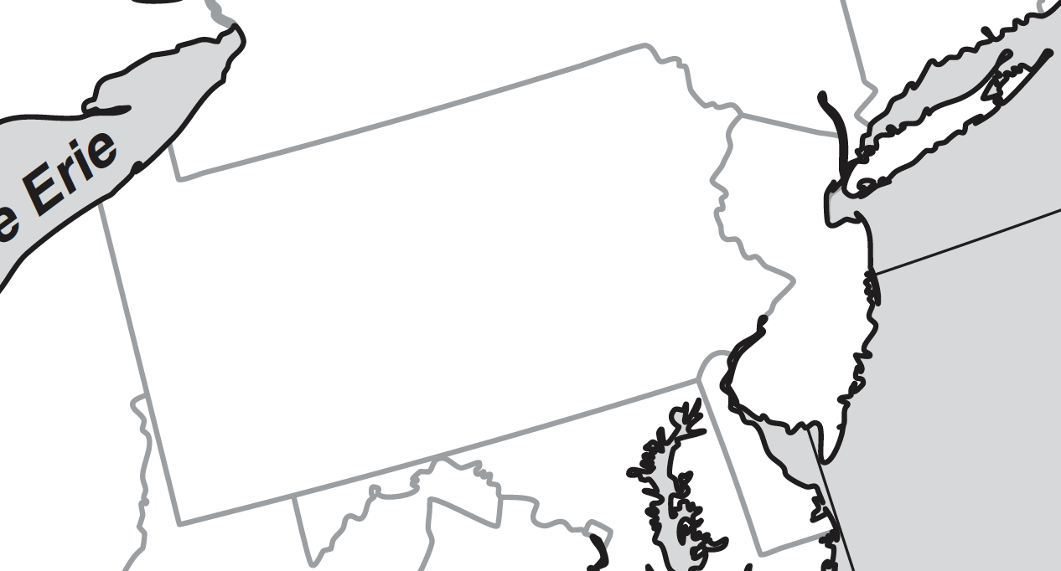
Pennsylvania
Easton
New Jersey

Chapter 2:
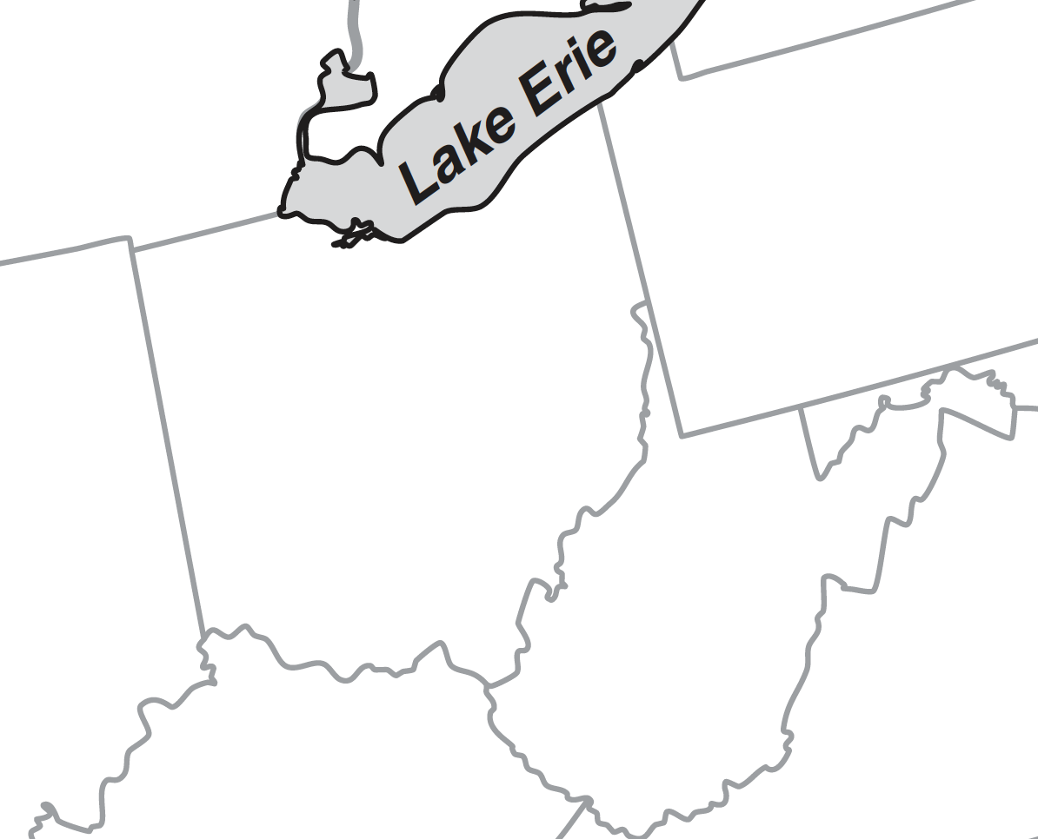
Cincinnati
West
Virginia
Ohio
Ohio River
Pittsburgh
Ch 3

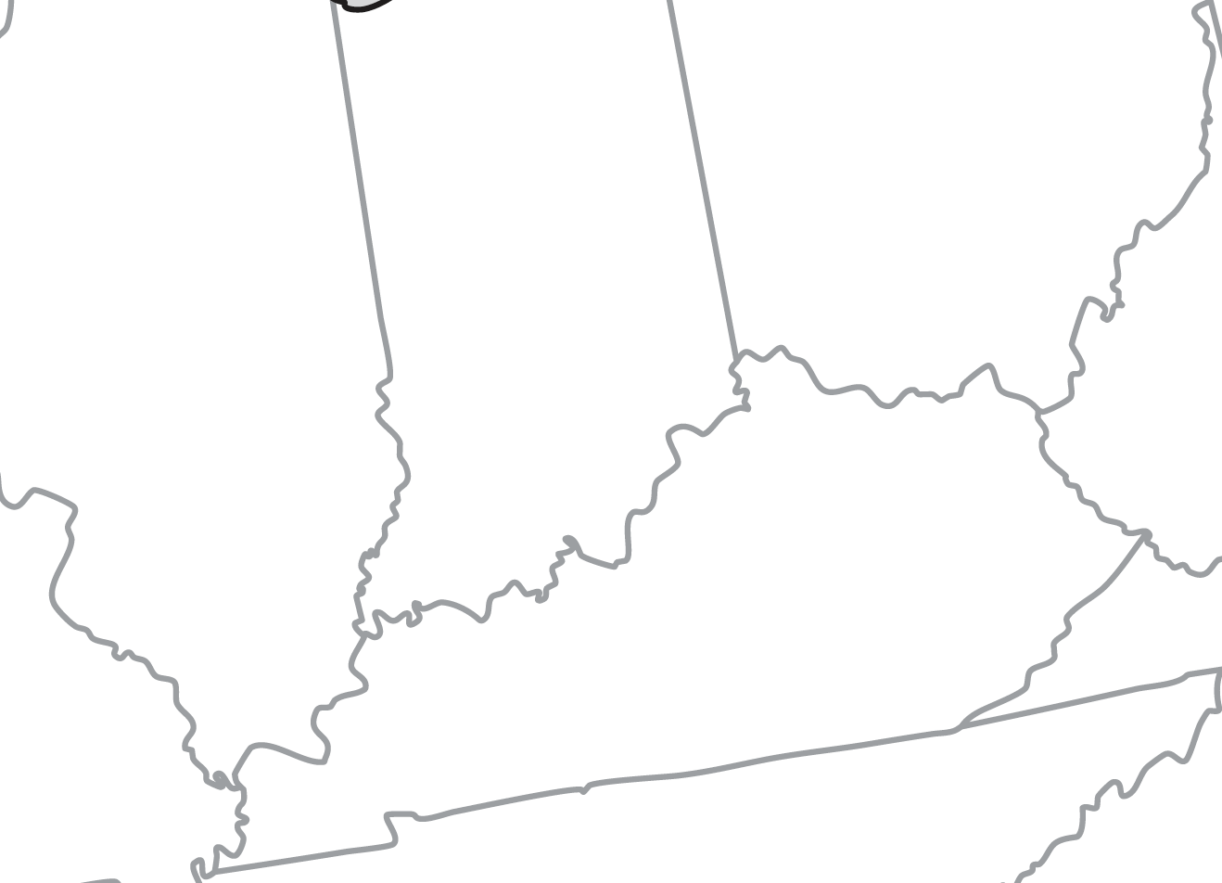
Kentucky
Indiana

Chapter 4a

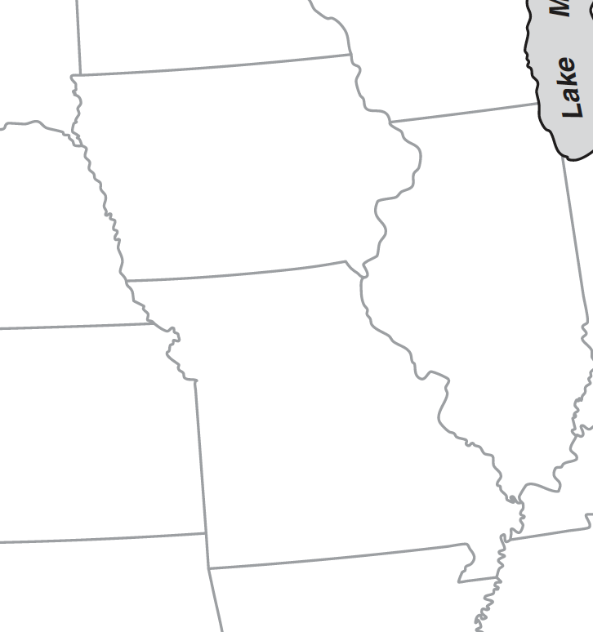
St. Louis
Missouri
Illinois
Sac Village
Mississippi River
Iowa
Chapter 4b

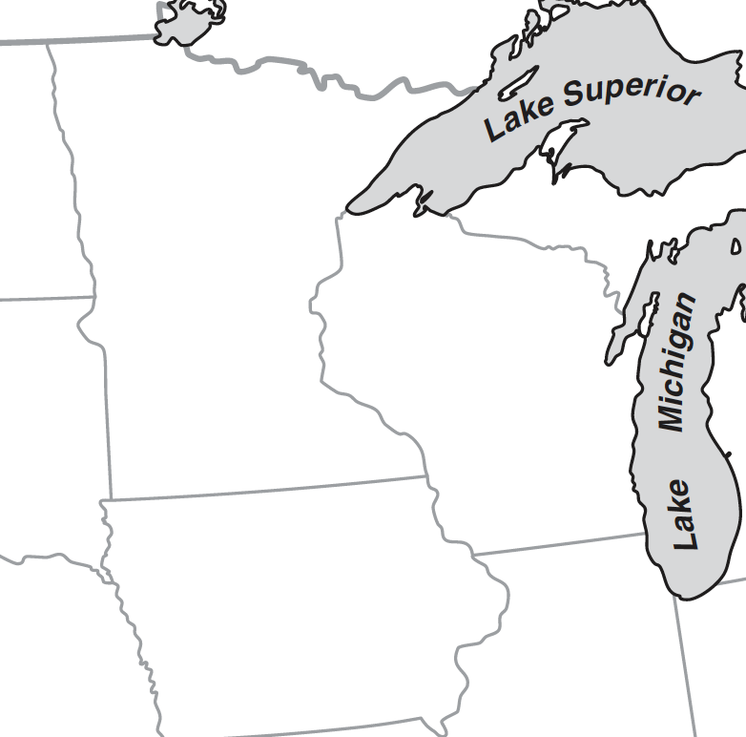
Souix
Wisconsin
Minnesota
Lake Leech
Lake Itasca
St. Anthony Falls

Chapter 5 (n/a)
Chapter 6
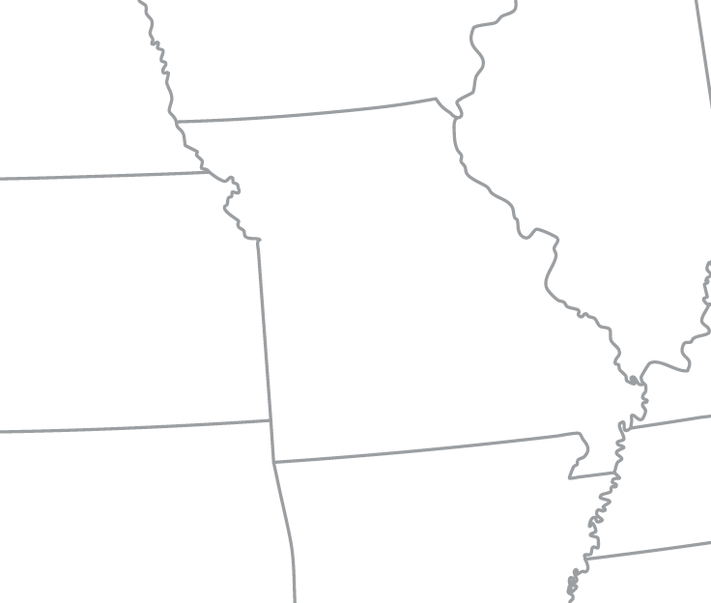
Osage River
Missouri River
Arkansas

Ch 7a – Osage peoples

Osage

Ch 7b

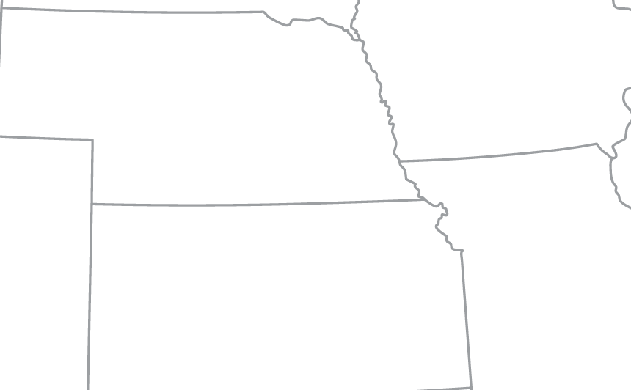
Pawnee
Nebraska
Kansas

Ch 8
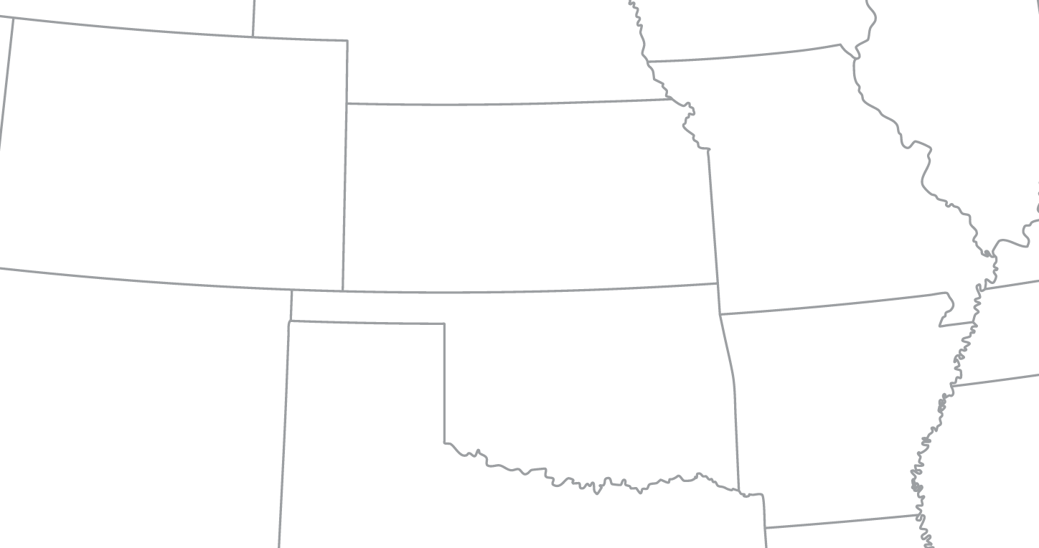
Larned Camp
Arkansas River
Kaw
Oklahoma
Colorado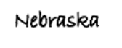

Ch 9a: Pike’s Peak from distance and Cheyanne Mountain in front of it
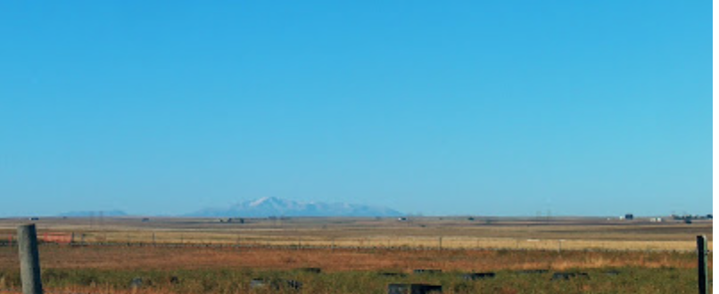
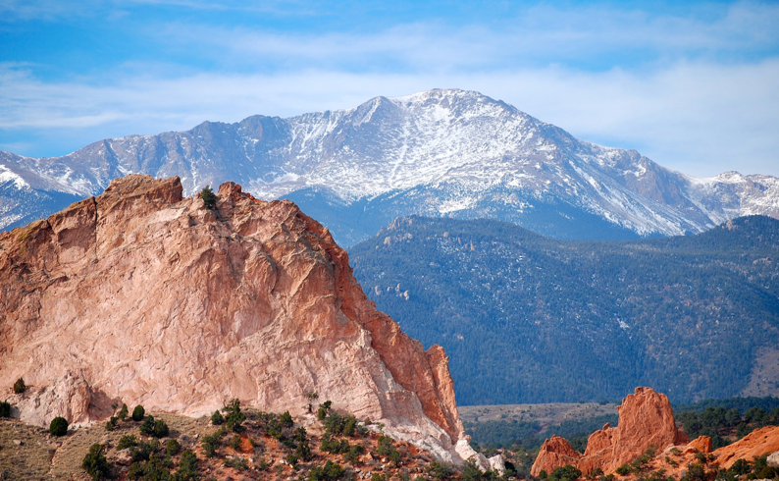

Ch 9a continued:
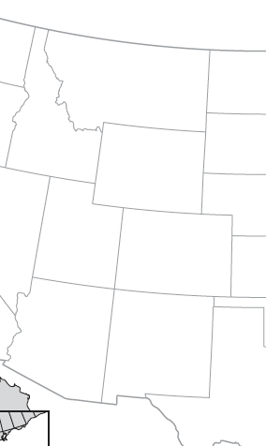
Rocky Mountains
Pike’s Peak

Ch 9b:

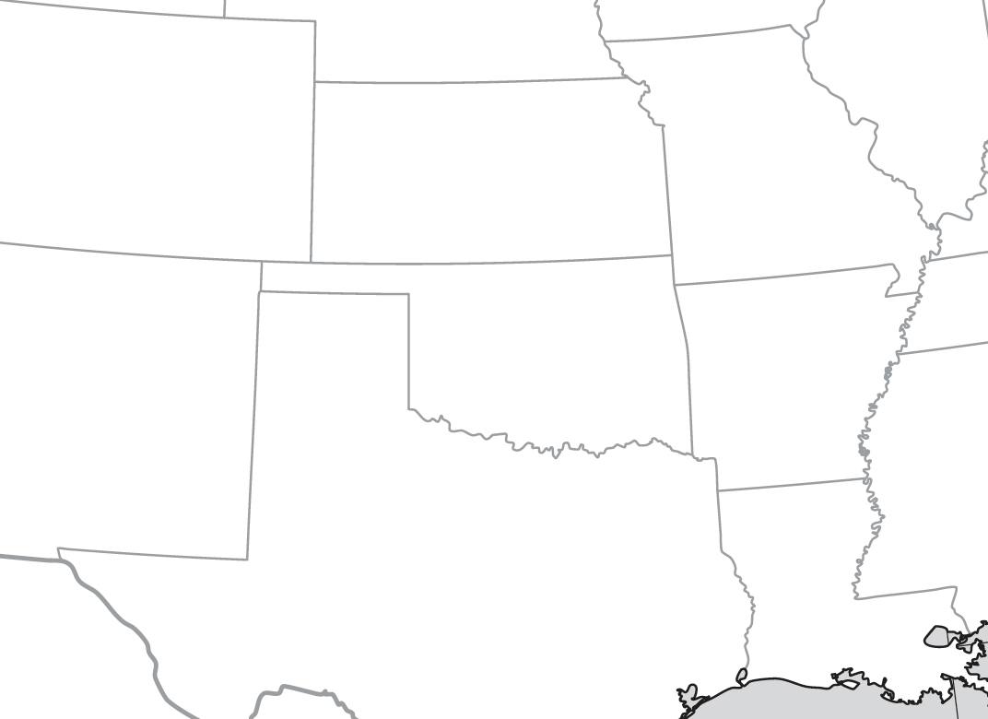
Louisiana
Texas
Red RIver

Ch 10
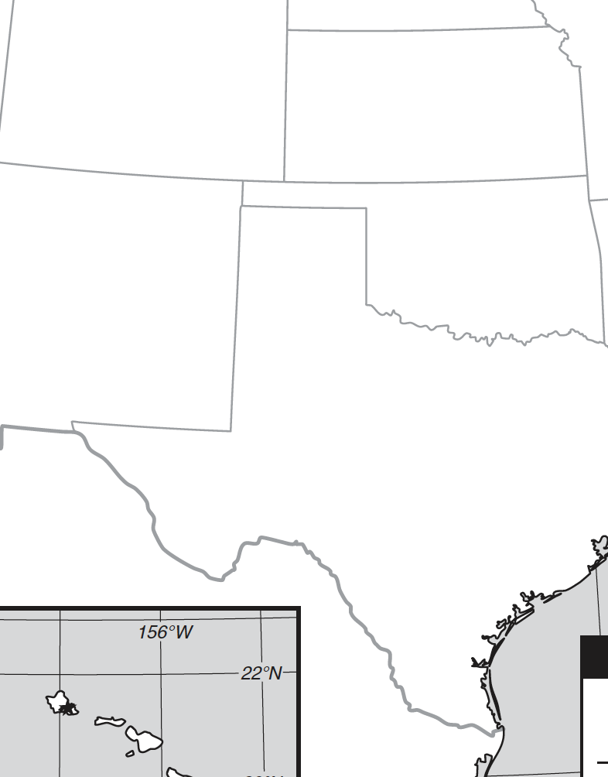
Sante Fe
Rio Grande
New Mexico

Ch 11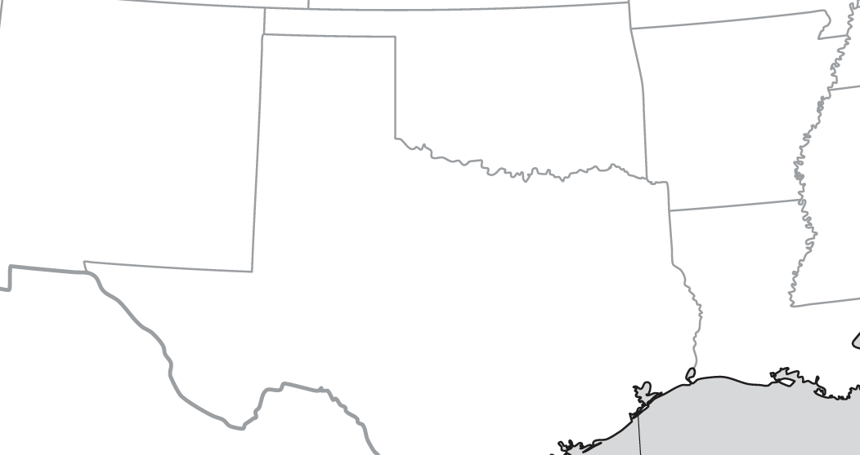
Mexico
Chihuahua

Ch 12
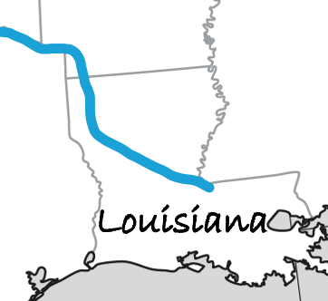
Baton Rouge
Natchitoches

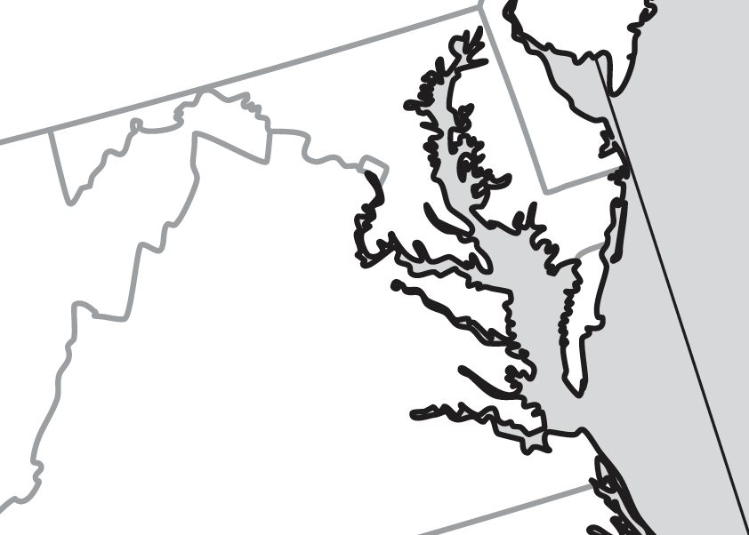
Virginia
Maryland
Washingon DC

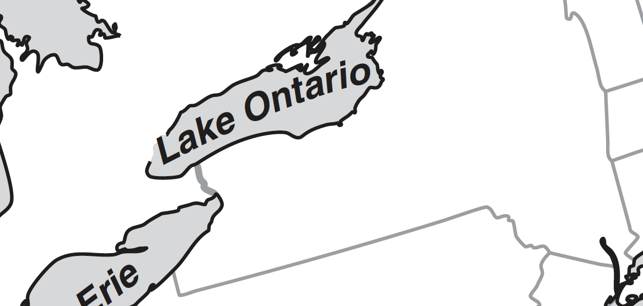
Toronto (York)
Sackets Harbor
New York

