Full map of trail: Discover Lewis & Clark
Weekly map segments below

Week | Assigned Reading | Narration | Find on Map | Resources
1 | 13-20 | Jefferson inaugurated. Offers Lewis post as secretary ; Flashback to Lewis as kid who liked to hunt and then went to school. Then he chose the army as a profession. | Potomac River ; Washington D.C. ; Blue Ridge Mountains ; Charlottesville, VA ; Georgia
2 | 20-27 | Goes to Pittsburg then sent out to battles with Native Americans in Indiana. There he meets his old friend William Clark. Accepts Jefferson’s post. They plan expedition & recruit Clark. | Pittsburg ; Pennsylvania Alleghenies ; Indiana ; Philadelphia ; Ohio River ; Cincinnati ; Kentucky, Louisville
3 | 29-37 | The get to Missouri too late in winter to start. They stock up and train. They get news of LA Purchase is official. In Spring they start up river and make it to Platte River. | Finish Ohio River, Mississippi River, St. Louis, Missouri, Missouri River, Platte River, Nebraska | Missouri River Map ;  Platte River Map  The Barge
4 | 38-45 | Expedition meets some Otoes, their first encounter with Native Americans. It is peaceful. They meet Sioux and leave a man to help with peace among the tribes | Continue Missouri River, Council Bluffs, Iowa, South Dakota | Chief Blackbird
5 | 46-55 | They watch festivities in a Sioux camp but fear they are trying to stop them. One leader comes with them to get them safely out of Sioux territory. They go up river and meet the Ricara & Mandans who are peaceful. | Continue up Missouri river to Fort Mandan ; North Dakota
6 | 56-61 | They build a fort near the Mandan village. Sacajawea comes to the fort. They start to starve so a hunting expedition goes out up the river. | Fort Mandan
7 | 63-69 | They send the barge back to St. Louis and head off in canoes to the Yellowstone River. | Yellowstone River | Map of Yellowstone river
8 | 70-77 | They start coming across Grizzley bears and have to climb trees and jump in rivers to escape. They come to a fork. Lewis goes North and Clark goes South. They decide South is Missouri and send Lewis to make sure. He finds the Missouri falls. | Continue on Missouri River to The Falls of the Missouri ; Marias River | Rivers of Montana  The Great Falls
9 | 78-86 | They portage around the falls, survive a flash flood, and go through a canyon they call the Gates of the Rockies. They stop at the Three Forks. Clark gets sick so Lewis decides to go find a guide and horses. | Gates of the Rockies, Three Forks | Gates of the Rockies gallery
10 | 86-94 | Lewis crosses the mountains, finds the Shoshone and convinces them to come back to Three Forks where he was to meet Clark. The Shoshone are suspicious, but finally come. When the parties meet, Sacajawea finds her brother and friends. | Lemhi Pass  Idaho,  Rocky Mountains
11 | 95-98 | Clark crosses the Rockies looking for a river to follow to the Columbia. Lewis convinces the Shoshone to help with horses and a guide and they all go to the Shoshone camp.
12 | 100-111 | They cross the Rockies in two groups, Clark going first and Lewis following. They stay with Ootlasoots, get instructions, fresh horses, and guides. They go down the Kooskooskee River to the Columbia and have to portage over many falls and rapids. | Traveler’s Rest, Kooskooskee (Snake) River, Columbia River, Fort Rock (The Dalles), Mount Hood, Oregon, Washington | Columbia River Map  Fort Rock, Snake River Map,
13 | 111-122 | They get to the Pacific, find a place to winter and build a fort. They see a whale carcass and trade with the tribes in the area. | Beacon Rock, Pacific Ocean, Meriweather’s Bay, Fort Clatsop | Beacon Rock, Meriweather’s Bay (Young’s Bay)
14 | 122-130 | They leave Fort Clatsop in March and make their way up the river, trading canoes for horses to help get around all the falls. They are helped by the Wollahwollah people.
15 | 131-136 | They try going up the mountains, but the snow is too deep and they lose the trail. They go back for guides, who take them up the mountains to Traveler’s Rest. They decide to separate and meet back up on the Missouri River.
16 | 136-145 | Clark’s party splits up, some take the horses and Clark takes the river. He names Pompey’s Pillar and etches his name with the Native drawings. There are lots of mosquitos. Clark meets the horse party on the Missouri river – the horses had been stolen and they build bull boats. Then Lewis joins and tells the story of Camp Disappointment. He is wounded | Pompey’s Pillar, Camp Disappointment, Yellowstone River (already drawn) | Pompey’s Pillar
17 | 145-152 | Lewis tells the story of meeting some Native Americans who pretended to be friends but in the middle of the night stole their guns and horses. Lewis and his men recovered the stolen property but killed two men. When they met the party of canoes on the Missouri, they let their horses go. Out hunting, Lewis was accidentally shot the day before meeting Clark and the rest of the men.
18 | 153-163 | The stay at Ft. Mandan for several days while Lewis heals. Sacajawea and her husband leave them here. Then head down the river and make it to St. Louis in Sept 1806. They send a report to President Jefferson. The report is published but does not sell. 100 year later is it published again. | Ft. Mandan, Mississippi River, St. Louis (all already mapped)

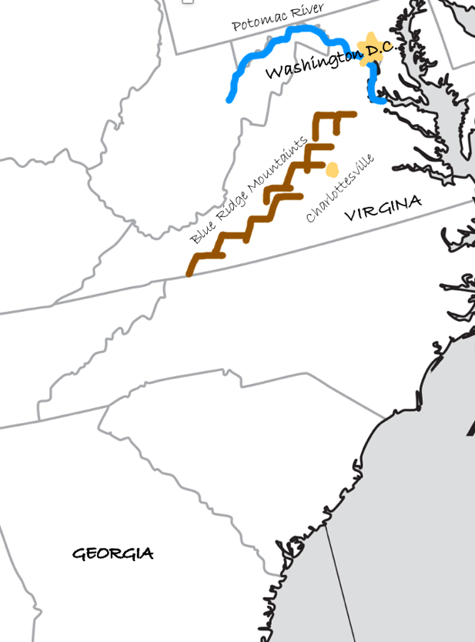

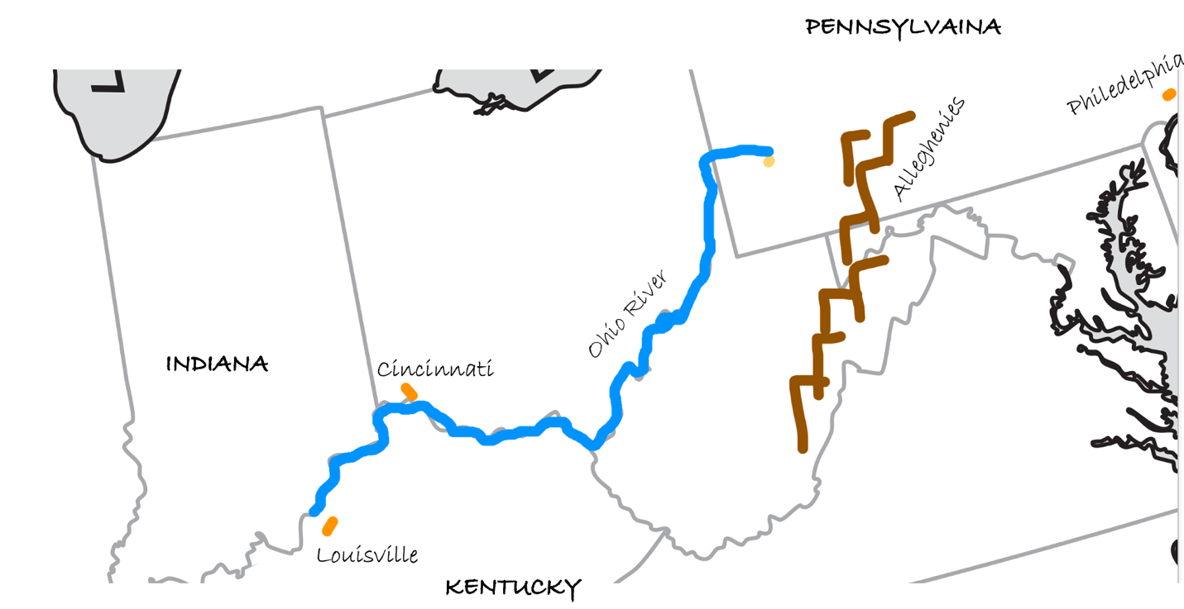

3.
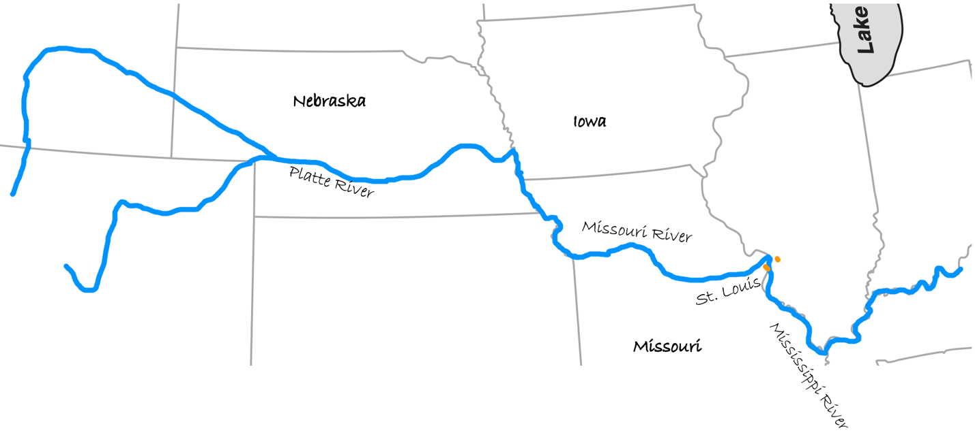
4.
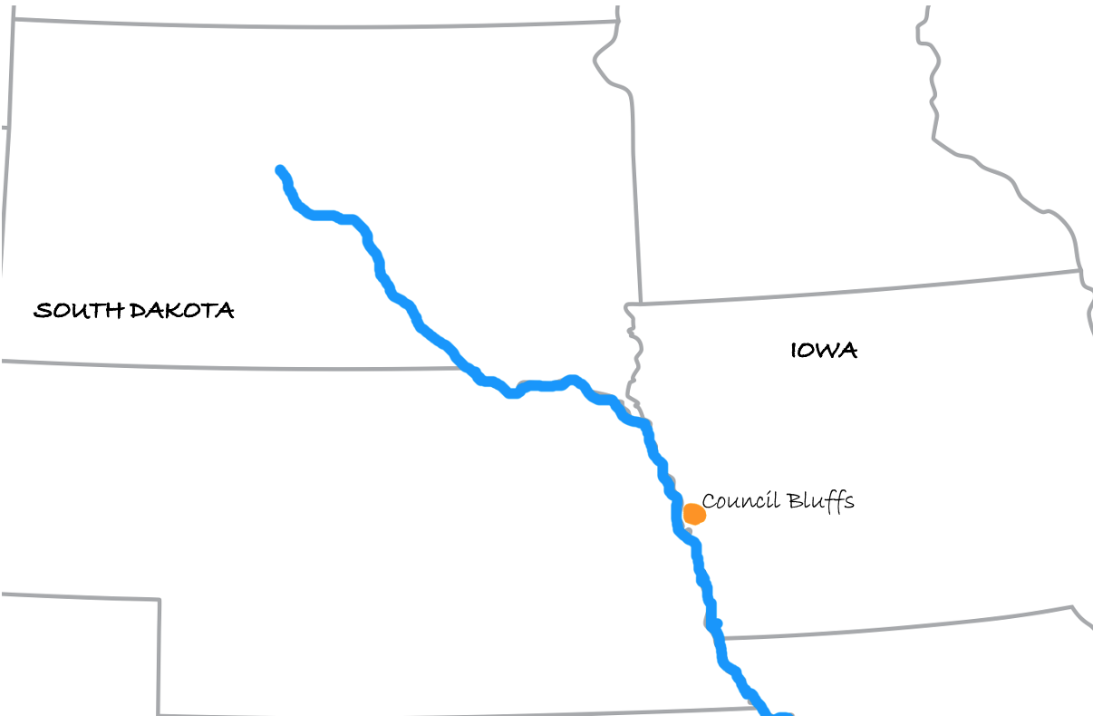

5.

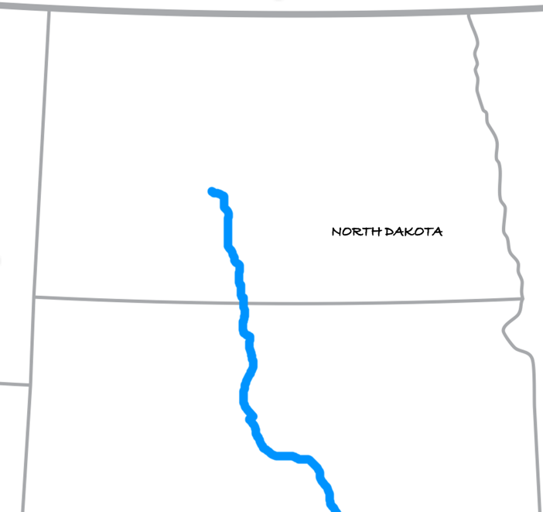

6.

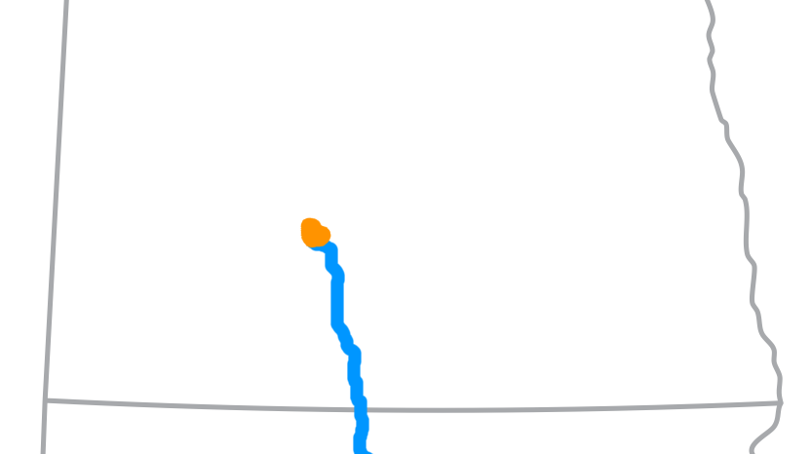
Fort Mandan

7.

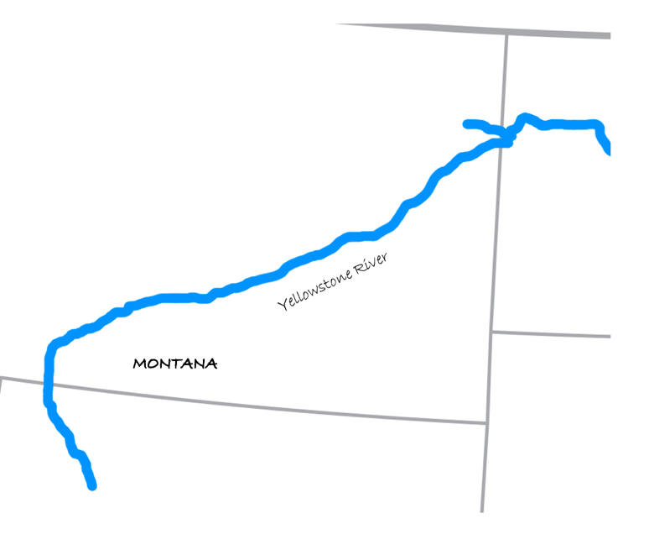

8.

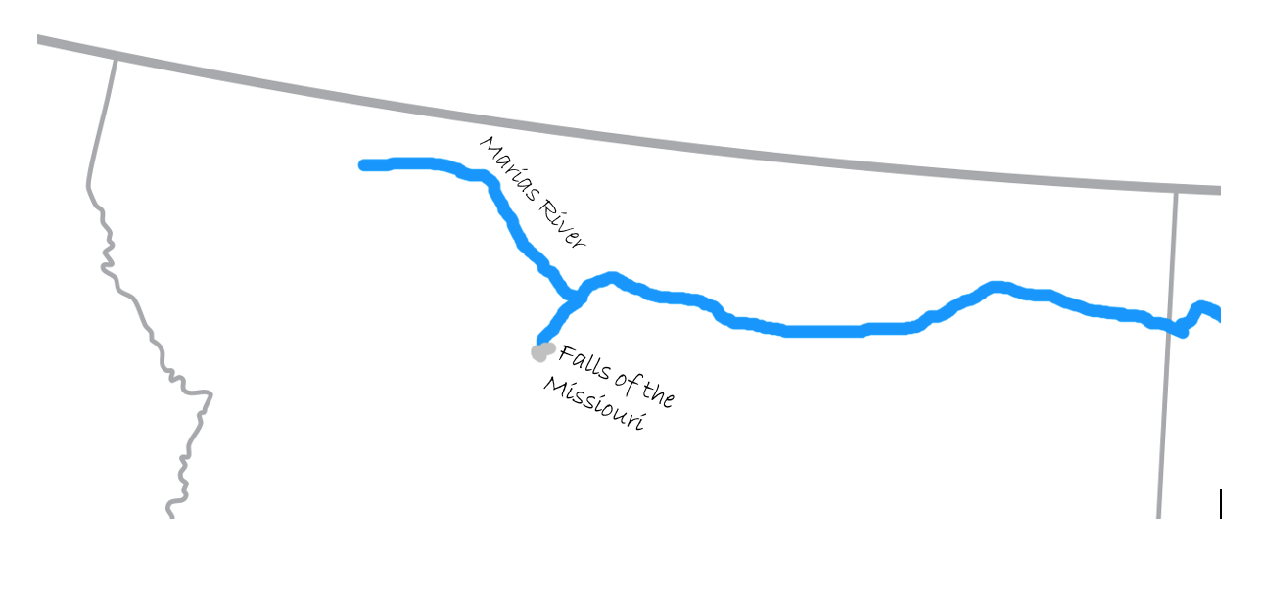

9.

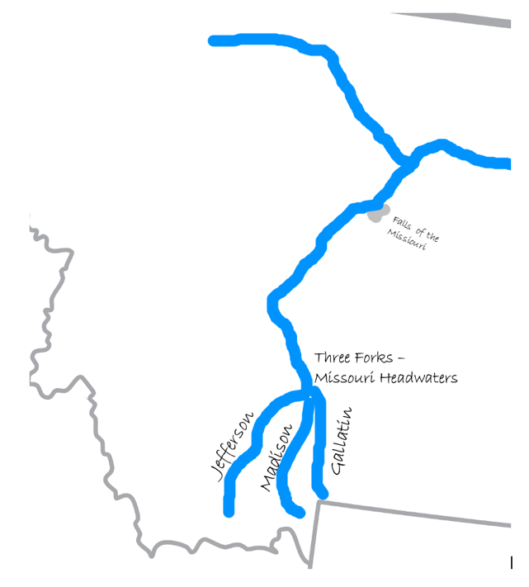

10.

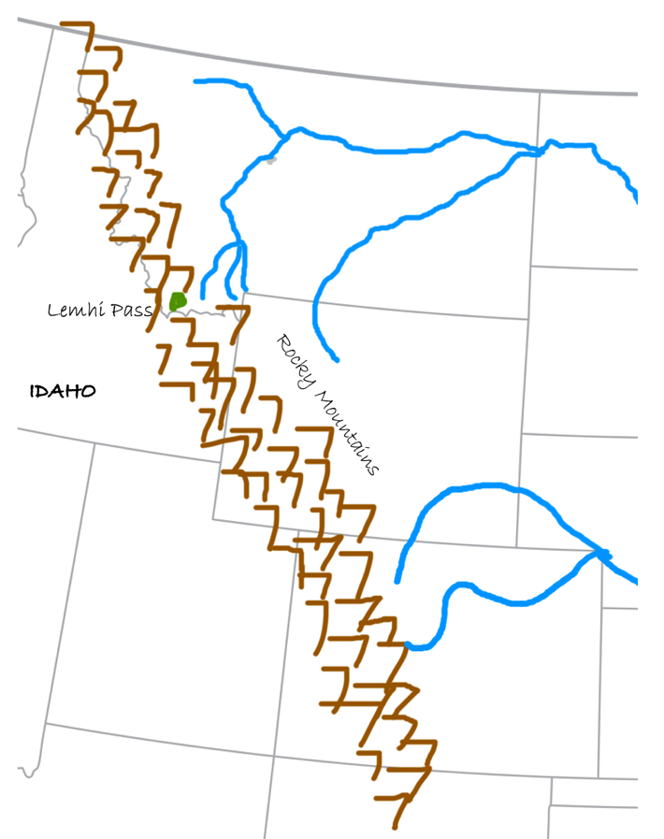

11.

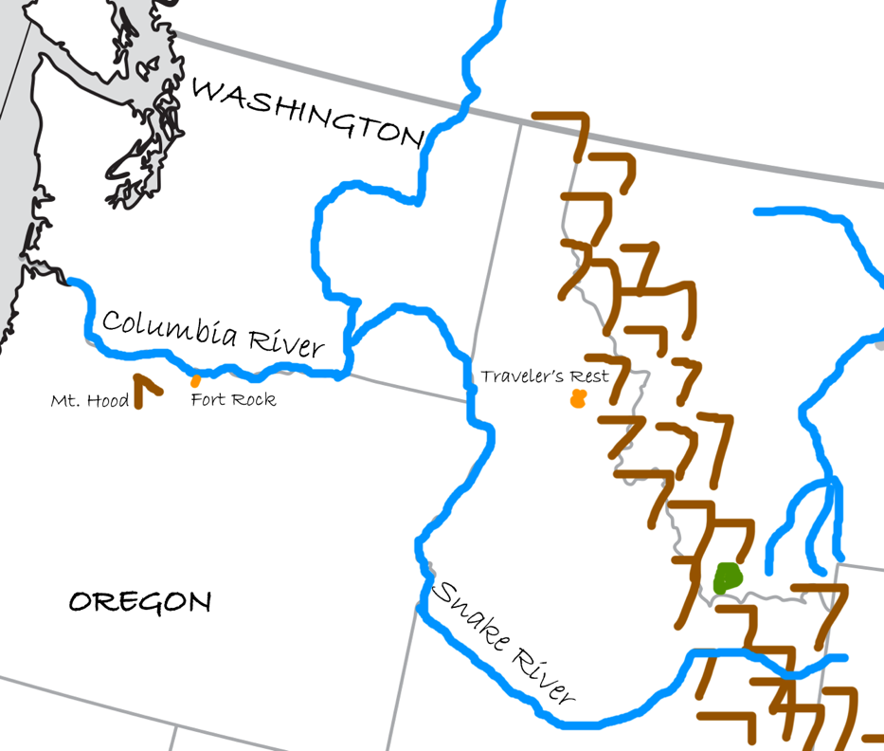

12.

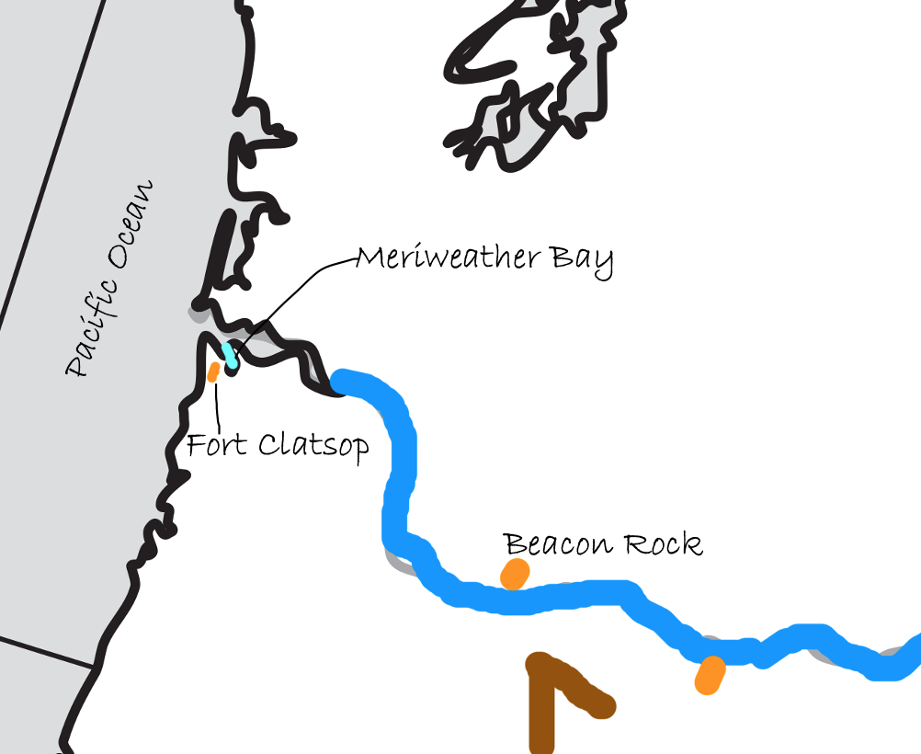

13.

