- Scheduled (almost) every day for about 5-10 min of reading plus recap and narration.
- Using the Kindle version and following along to the audiobook narrated by Enid Otun.
- Use a century chart to document Marie Curie’s life. Ideas for century chart included in notes.
Week | Reading | Summary | Notes
1 | Ch 1  Audiobook: 8:55 min  Day 1 - 2 | Manya Singing  Manya is 5 and not supposed to read even though she’s known how for a year. Her parents don’t want her pressured. We learn that there is a Russian Director at the school where her father teaches. They all call him The Ogre. They are not allowed to speak polish and were supposed to be Russian now that Russia occupied the part of Poland that she lived in. We learn Manya is interested in the scientific instruments in her father’s study. | Define: whatnot, barometer  Map: Poland (which wasn’t a sovereign nation at the time), Russia  Century Chart: 1867 Marie Curie born
1 | Ch 2  Audiobook: 12:58 min  Day 3 - 5 | Manya Learning  The teacher secretly teaches Polish history and the girls in the class all know how to hide their Polish books when the inspector comes. Marya is questioned by the inspector but hates to be the one picked. She misses her sister who died of typhus. She is worried about her sick mother. She learns her lessons quickly and helps the others as they struggle to do math and French lessons in Russian. When she is reading, nothing distracts her. They have taken in boarders. When she is 11 her mother dies. She is described as headstrong and not at all submissive. | Map: Warsaw  Century Chart: 1877 mother dies
2 | Ch 3  Audiobook: 12:18 min  Day 1-2 | Rebels  Manya is in High School. A (Russian) government school. She finds that at school even Russians and Poles, Germans and Jews can get along. Some of the teachers are sympathetic to the Polish. A friend’s brother is hanged for being “involved in a plot.” | Define: Patois (regional dialect of the common people, not the standard of the rest of the country) ; girls who are out  Century Chart: 1880
2 | Ch 4  Audiobook:  13:15 min  Day 3-5 | A Whole Year’s Holiday  She finishes school early, so her father gives her a year off. She spends some of it with an uncle in the plains and then goes to another uncle in the Carpathian mountains. There she experiences a Kulig – a winter fete. Then goes to stay with a friend of the family who is a Countess where there is more merriment. | Map: Carpathian Mountains  Century Chart: 1883
3 | Ch 5  Audiobook: 18:83 min  Day 1-4 | People  She is home and needs to earn money, so she has to teach. She joins a secret society of women who are studying sciences. She convinces her older sister to go to school in Paris and she’ll send money and then when she’s a dr, it will be Manya’s turn. Manya becomes a governess to a rich, but cruel, family to earn money. Then she moves further out in the country to another family. There she and the eldest daughter start a secret Polish school for the village children. | Century Chart: 1884
4 | Ch 6  Audiobook:  11:32 min  Day 1-3 | Fortunate Misfortune  The oldest son of the family, Casimir Z comes home and falls in love with Manya. But the family won’t allow a marriage. Manya is angry and feels depressed. A book reminds her that that is not who she is, but she doesn’t know how her life will change. | Century Chart: about 1886
4 | Ch 7  Audiobook:  9:14 min  Day 4-5 | Change  Manya takes a job in Belgium and is treated well by the wealthy family. Her sister in Paris gets married so Manya moves home with her father. She is still meeting Casimir who still wants to marry her. A friend who is the director of a local museum teaches science at night and she learns and starts experimenting. She decides to go to Paris and live with her sister and go to University. | Map: Belgium ; Paris  Century Chart: 1890
5 | Ch 8  Audiobook: 19:22 min  Day 1-4 | I Take the Sun and Throw It  She arrives in Paris and is excited at the freedom. She starts spelling her name Marie. She attends the Sorbonne but finds she her French, math, and physics inadequate so works hard to catch up. She lives with her sister among other Polish immigrants. But she wants to be closer to school and have less distraction so she gets an attic room for herself. She lives on very little money and almost starves herself because of lack of money and being too busy to eat. She does well and receives a bursary to continue studying. | Define: bursary (scholarship)  Link: Pictures of the Sorbonne  Century Chart: 1891 moves to Paris
6 | Ch 9  Audiobook:  14:19 min  Day 1-3 | Maria’s Love Story  Marie needs lab space, so a friend introduced her to Pierre Curie. Pierre is already famous for several scientific discoveries. He falls in love with her and even offers to give up Paris and move to Poland with her. Finally she agrees and they get married and stay in Paris. | Century Chart: 1895 married
7 | Ch 10  Audiobook: 14:59 min  Day 1-3 | Madame Curie  They take a bike ride through the forests as a honeymoon. They live in a flat, but have very little there so Marie has very little to clean. She learns to learn by scientific experiment. They both work hard and ceaselessly. She has a daughter named Irene. | Century Chart: 1897 daughter Irene born
8 | Ch 11  Audiobook:  14:10 min  Day 1-3 | The Great Discovery  She wants a doctorate so for her topic she chooses Uranium and discovers that there must be another radioactive element. Pierre starts to work with her to find it and they figure out there must be two. They find one element and Marie names it Polonium for Poland. The second one they name Radium. | Timeline: 1898 Curies discover Radium
8 | Ch 12  Audiobook:  13:48 min  Day 4-5 | A Light in the Dark  They pay for pitchblende dust to be transported to the only place they can find to store it – a broken old shed. They work for four years, barely surviving on Pierre’s salary. So they both get teaching positions to supplement. But finally she measures the Radium and sees it glowing. | Define: Pitchblende  Century Chart: 1902 measures radium
9 | Ch 13  Audiobook:  9:02 min  Day 1-2 | Not for Sale  The world is interested in the discovery. Scientists find radium gives off helium. And the “light” is given to objects near it. Pierre purposely and Marie accidentally, burn themselves with the radium. They agree not to patent the process of extracting radium. | Century Chart: probably still 1902
9 | Ch 14  Audiobook:  11:33 min  Day 3-4 | Darkness  She becomes the first woman to receive the Nobel Peace Prize. She is bothered by the press. Has another daughter, Eve. She is given an official paid appointment in Pierre’s lab. They take a family vacation and when they get back Pierre is killed in an accident. | Century Chart: 1903 she receives Nobel Peace Prize ; 1904 Eve born ; 1906 Pierre dies.
10 | Ch 15  Audiobook:  16:01 min  Day 1-3 | Whatever Happens  She is offered, and takes, Pierre’s position at the Sorbonne. She is the first woman in such a position. She moved to the country with Pierre’s father. She is given a second Nobel Peace Prize – the first person in history to receive two. People started attacking her success and lying about her. She is offered a position in Warsaw, but stays in Paris to build a lab in Pierre’s honor. She is friends with Einstein. | Century Chart: 1911 receives a second Nobel Peace Prize (first in history to do so) ; 1914 Institut du Radium Pavilion Curie opens
11 | Ch 16  Audiobook:  13:59 min  Day 1-3 | War  When war starts, Marie creates a Radiology Car to take x-rays to the front hospitals. She installed over 200 x-ray machines in hospitals. She decides to stay in Paris, but takes her radium to a bank in Bordeaux for safe-keeping for a while. She trains radiologists in the new institute. | Century Chart: 1914 – Germany invaded France and WWI starts ; 1918 – war is over & Poland is free and independent
11 | Ch 17  Audiobook:  10:37 min  Day 4-5 | At Home  Marie and her daughters now live in a large home on the Ile St-Louis. She continues teaching and keeping busy. She needed an operation to see and didn’t want anyone to know she was almost blind. She had four operations to help her eyes. | Century Chart: 1934 – her daughter and son-in-law discover artificial radioactivity.  Map: Ill St-Louis (see map at bottom)
12 | Ch 18  Audiobook:  14:19 min  Day 1-3 | Abroad  In 1920 she in interviewed by an American journalist and says she needs a gram of radium for her research but can’t afford it. So the woman starts a fund to buy it for her. She goes to America to accept it from President Harding. She starts to travel around the world. She joined the International Committee on Intellectual Cooperation and helped them make a list of all scientific books and discoveries. She founds the Radium institute in Warsaw and the ladies in America raise money for another gram for that institute. | Century Chart: 1920 - goes to America to receive a gram of Radium ; 1925 – opens the Radium Institute in Warsaw
12 | Ch 19  Audiobook:  7:59 min  Day 4-5 | Holiday  She vacations in Larcouest on the coast. The Radium is making her sick in a mysterious way. | Century Chart: 1934 she dies  Map: Larcouest

Chapter 17: Marie lives on Ile St-Louis
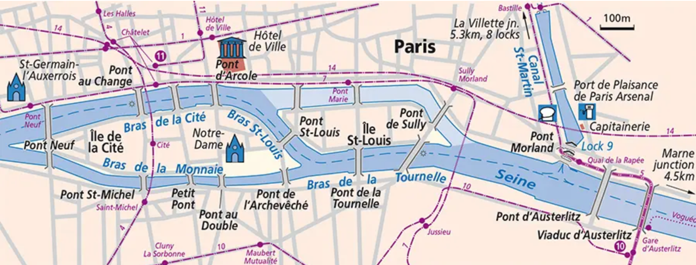
Map from: https://www.french-waterways.com/waterways/seine/lower-seine/

