AO 5 Term 3
Maps for each chapter at end of document

Week | Reading | Summary | Notes
25 | Ch 1 | Born in 1858 in NYC second of 4 kids. He had asthma and often sick. Spent summers in Berkshire Hills. At 7 yrs old, started collecting & studying wildlife. When 11, they spent a year in Europe. His father told him he needed to work hard to make his body strong to keep up with his mind. He exercised & took boxing lessons. At 14 yrs, he started shooting animals and learned taxidermy to study and preserve them. Family went to Egypt and he studied the birds – brought back 100+ specimens! He studied hard for two years and went to Harvard at age 17. Went to Adirondacks with friends and wrote a book on the birds there. While at Harvard, his father died. | Places to Map: New York City ; Berkshire Hills ; Dobbs Ferry ; Oyster Bay Long Island ; Harvard ; Adirondacks  Links: Birds of Egypt – Sardinian warbler, storks, ibises, egrets, kestrels, bulbuls, hoopoes, dunlins, ziczacs
26 | Ch 2 | Gets engaged and married to Alice after graduating. Goes to Columbia Law School in NYC. Dr tells him his heart is bad so he needs to stay quiet. He disregards this and tells no one. He starts getting involved in local politics even if it is “ungentlemanly.” On a break from school, he and Alice go to Europe on a honeymoon. He climbs mountains, including the Matterhorn. When home, he gets elected to the state assembly and quits law school. The other assemblymen laughed at him until he beat one in a bar fight. He was reelected and got a reputation as a reformer. He gets sick but recovers at a spa in the Catskills. Then in the fall goes bison hunting in the Dakotas and bought into a cattle farm. | Places to Map: Matterhorn ; Albany, NY ; Catskill Mountains ; Dakota Badlands ; Little Missouri River  Links: Matterhorn ; Badlands  To discuss: pg 37 – says “now that the Indians had given up their rights” to the land.
27 | Ch 3 | In Feb while he is Albany, Alice has a baby but not doing well. He comes home, and his mother dies then Alice dies. He never talks about her again, even in his autobiography. Goes to Republican convention, but his candidate loses. He heads to Dakota and buys a ranch and hunts & writes. He has his house on Oyster Bay built and his sister takes care of Little Alice. He meets an old childhood friend, Edith, and gets secretly engaged (because it’s only 2 years since Alice died). A dry summer and predicted hard winter make things tough out west. He worries about money. He comes back to NY, & at the request of the Republicans, he runs for mayor but comes in last. He heads to London to marry Edith and go on a European honeymoon. | Places to Map: Elkhorn Ranch ; Bighorn Mountains  To discuss: Teddy’s grief.
28 | Ch 4 | The harsh winter decimated his ranch. He sold out. He was appointed to the Civil Service Commission and fought corruption. He continued to write. He and Edith economized and he turned down a chance to run NY Mayor because of the cost. He joins Boone & Crocket Club that fights to conserve the land & animals and helps start the National Park system. They had 5 more children. Was appointed NYC police commissioner and fought corruption. He helped campaign for McKinley and got appointed Asst. Secretary of the Navy (his dream job). In this position he gets the U.S. ready to fight Spain and free Cuba. When war is declared, he quits his job and gets permission to raise a volunteer cavalry. He goes to Texas to train, bringing extra glasses with him. He is second in command. | Places to Map: Cuba ; Havana ; Philippines ; Hong Kong
29 | Ch 5 | After much trouble with transportations, part of Roosevelt’s Rough Riders (as his regiment was called) make it to Cuba. They fight in the jungle in a confused manner. Then they fight at San Juan Hill near Santiago where Teddy is put in charge of his regiment. They captured San Juan Hill and after two weeks of fighting, the Spanish surrendered. Teddy came home to New York a hero and is elected governor. | Places to Map: Tampa, Florida ; Santiago, Cuba ; San Juan Hills ; Montauk Point, New York  Links: Cuban Red Crabs  Date for Timeline: 1898 Battle of San Juan  To Discuss: Spanish American War (see page below)
30 | Ch 6 | As governor he made reforms and kept twice daily meetings with reporters (!). He went against the Republican party and passed legislation to tax big corporations. He gets elected VP almost against his will. Several months after the inauguration, McKinley is fatally shot and Teddy becomes president – the youngest in history at age 42. | Places to Map: Buffalo, NY ; Mount Marcy (tallest mountain in NY); Lake Tear of the Clouds (Source of Hudson River)
31 | Ch 7 | The family moves into the White House and is rambunctious. Teddy is criticized for not being presidential. When hunting in Mississippi he refuses to kill a bear (the story goes) and a cartoon is made of it and then a stuffed toy – the Teddy Bear. He keeps big business in check and protects the laborers. He helps the Panamanians in a revolution to become their own country (no longer part of Colombia) so that America can build a canal on the 50-mile isthmus. He wins the election for the second term. Helps broker peace between Russia & Japan. Continues his conservancy by creating laws to protect wildlife and creating national monuments. He declines a third term as did Washington and heads off on an African safari. | Places to Map: Panama ; Colombia ; Panama Canal  Links: Building the Panama Canal
32 | Afterword | When he came home from Africa, he saw Taft was not doing what he had hoped. So he ran for president again, even though he knew he would lose. He split the vote, came in second to Woodrow Wilson, the Democratic candidate. He went to Brazil to find the source of the River of Doubt. He wanted to go to war in Europe, but he was too old (WWI). He died at 60 in 1919. | Places to Map: River of Doubt (Rio Teodoro)

Chapter 5 - To Discuss: The Spanish-American War

The Spanish-American war lasted 10 weeks in 1898 and ended with Spain granting ownership of Puerto Rico, Guam, and the Philippine Islands to the U.S. The U.S. also gained temporary control of Cuba. The U.S. occupied Cuba until 1902 when the U.S. relinquished control and the Republic of Cuba was born. (See State Department History webpage)

The Philippines were under U.S. control until 1946. (See State Department History webpage)

Puerto Rico is still a territory of the U.S. In 1900 U.S. gave Puerto Rico autonomy, but it is still a U.S. territory. Today it’s citizens are U.S. citizens, but unable to vote for president or be represented in Congress. (See History.com)

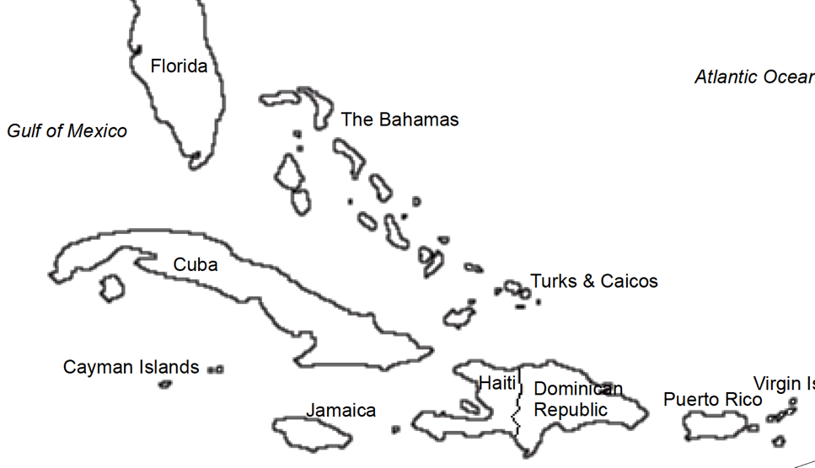
Guam is still a U.S. territory. During the Spanish-American war, Guam surrendered to the U.S. and then was made a territory at the peace treaty. Today it’s citizens are U.S. citizens, but unable to vote for president or be represented in Congress. (See History.com)

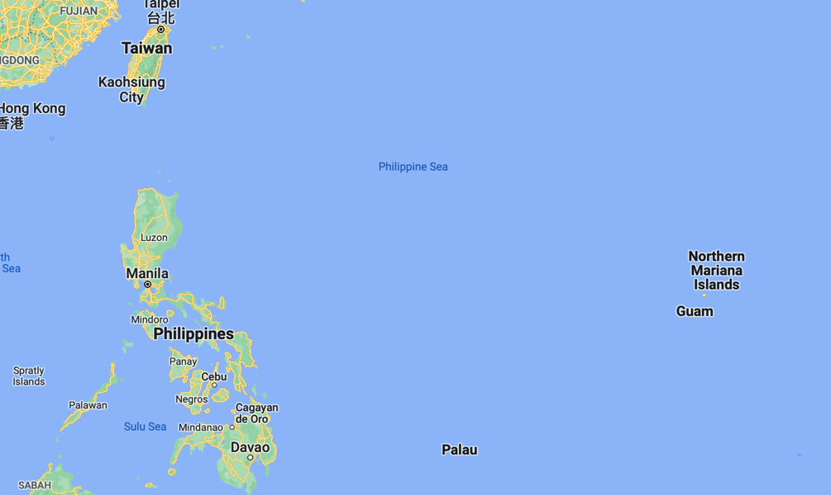

Chapter 1:

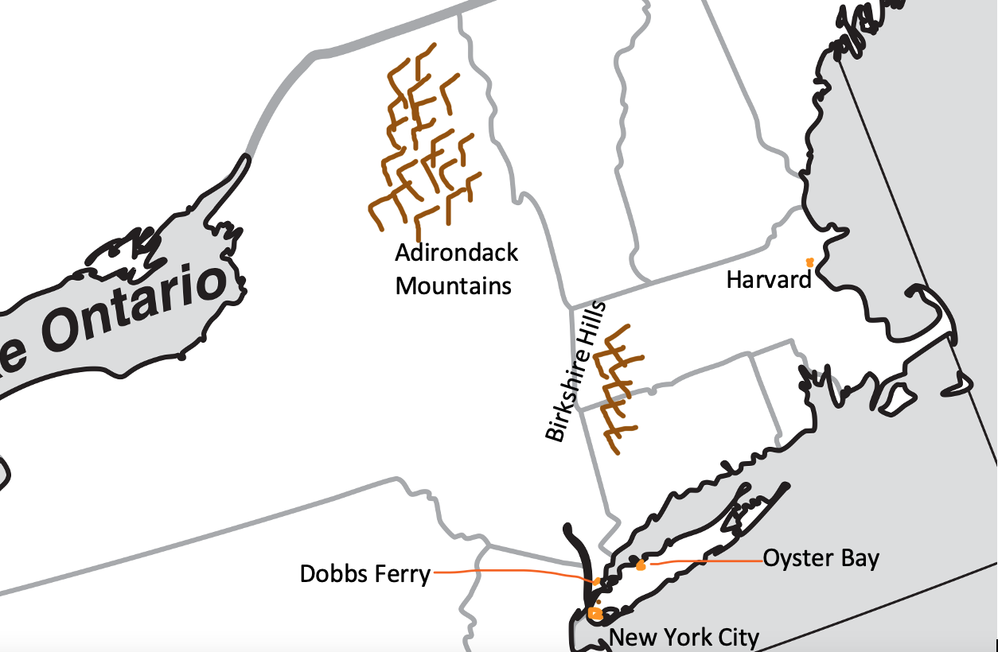

Chapter 2:

- Matterhorn

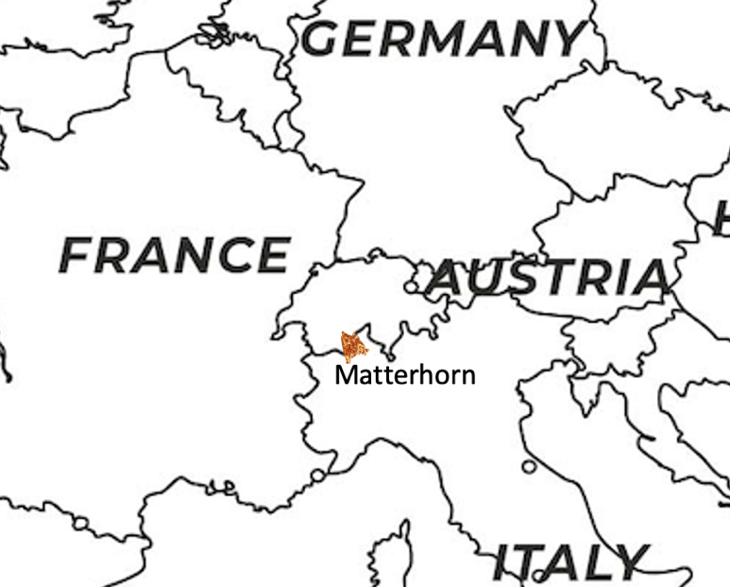

Chapter 2 (continued):

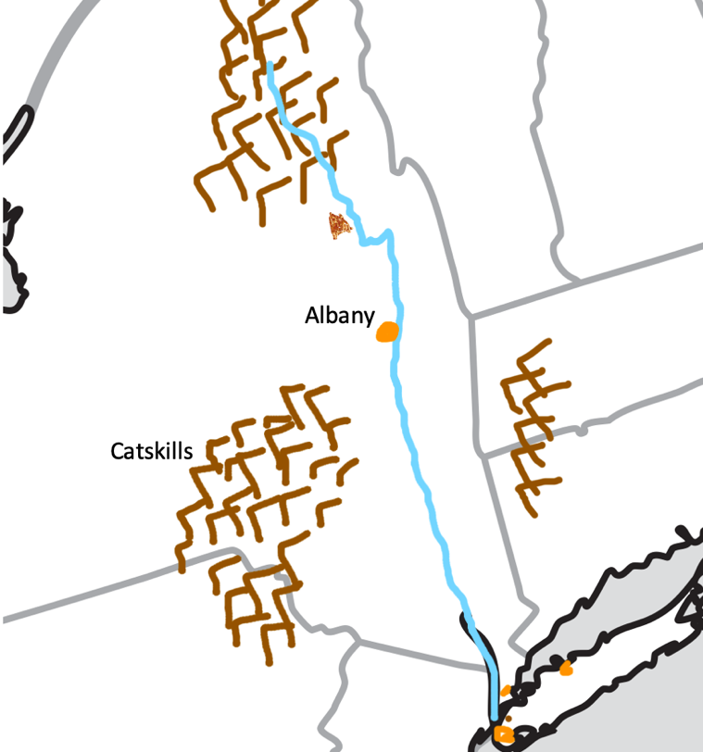

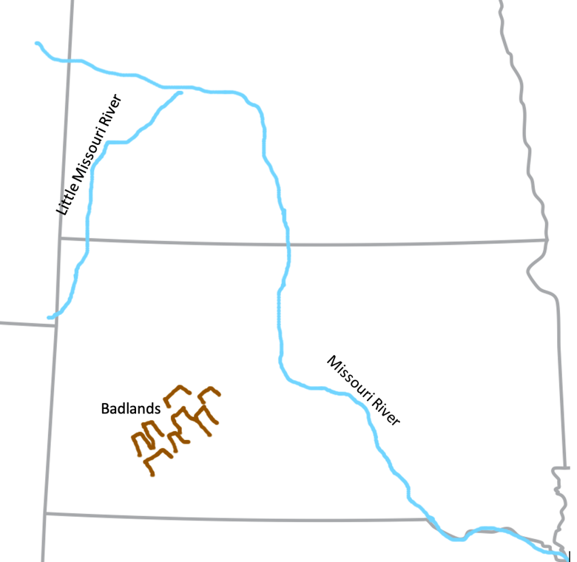

Chapter 3:

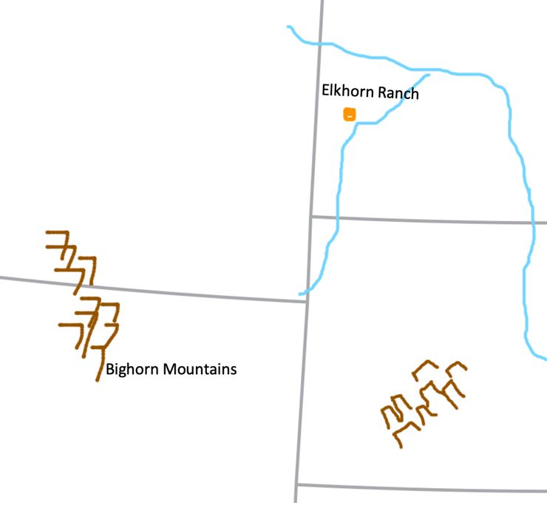

Chapter 4:

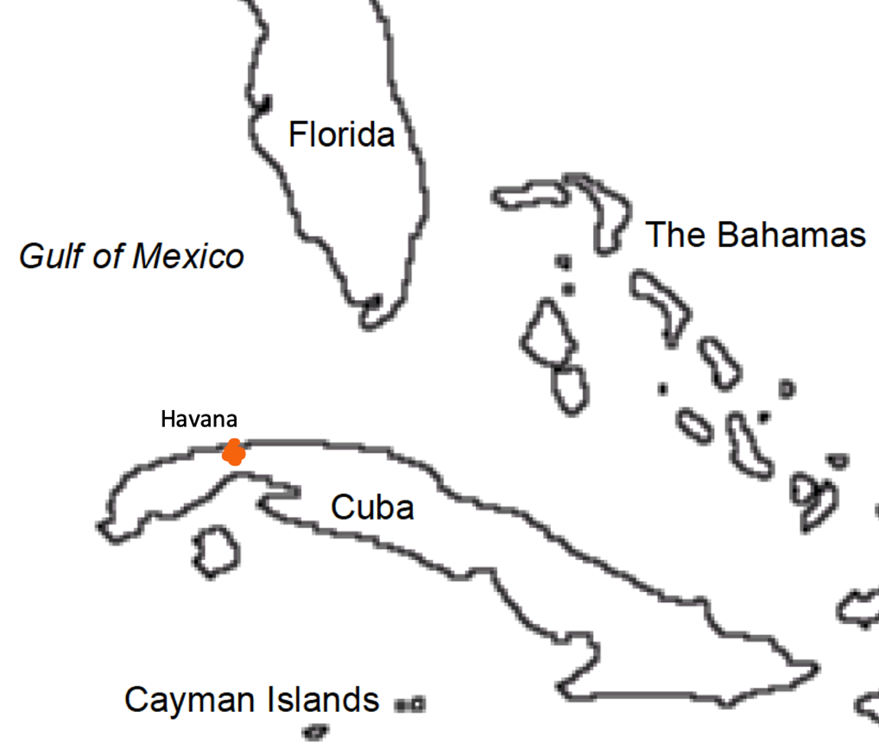

Chapter 4 (continued):

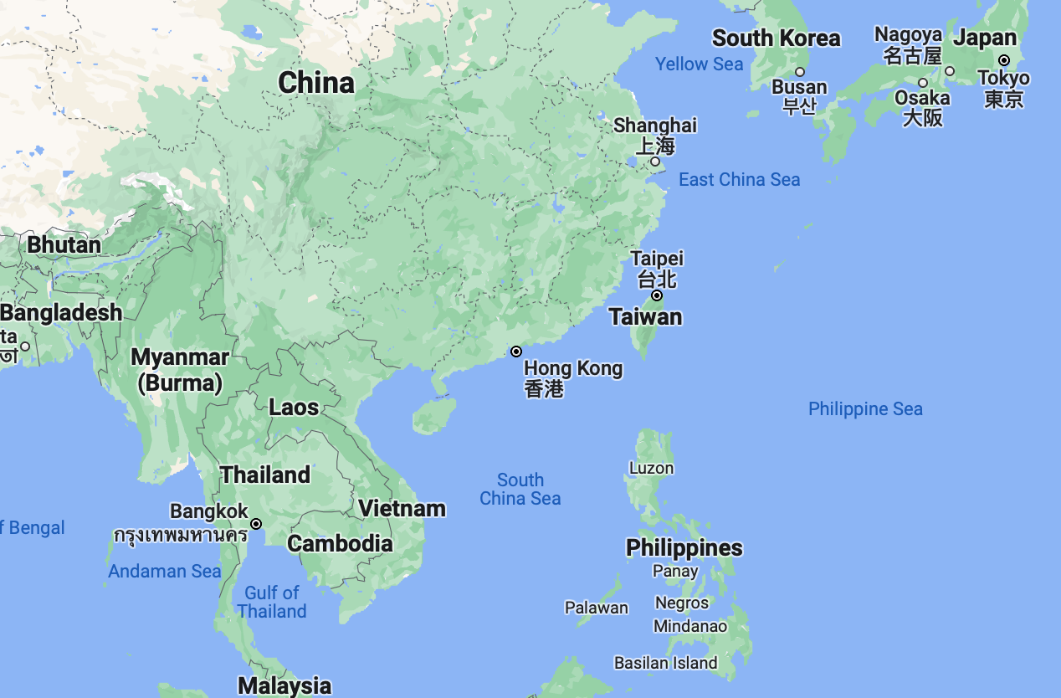

Chapter 5:

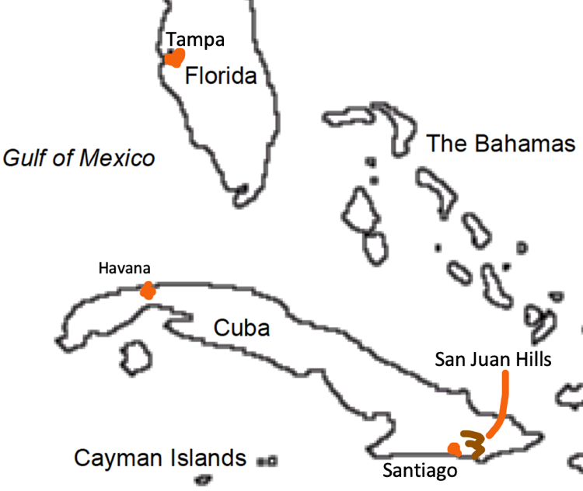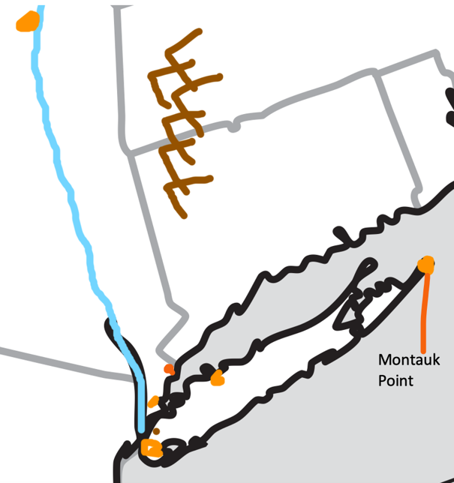

Chapter 6:
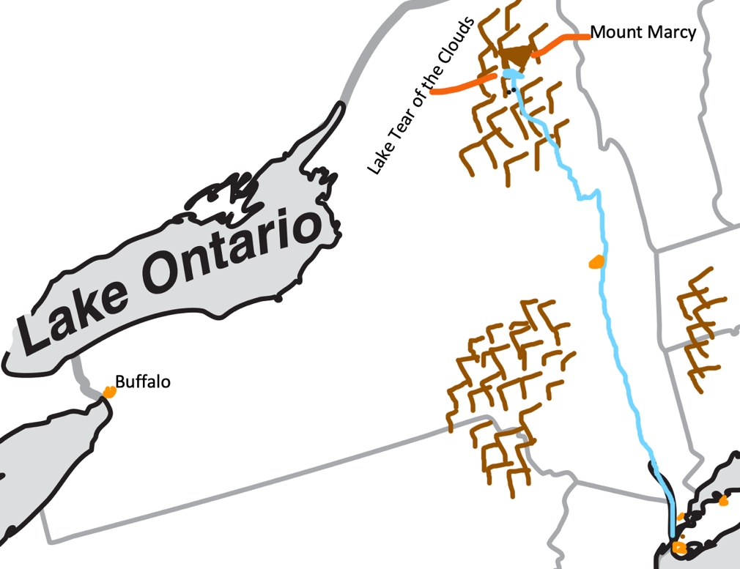

Chapter 7:
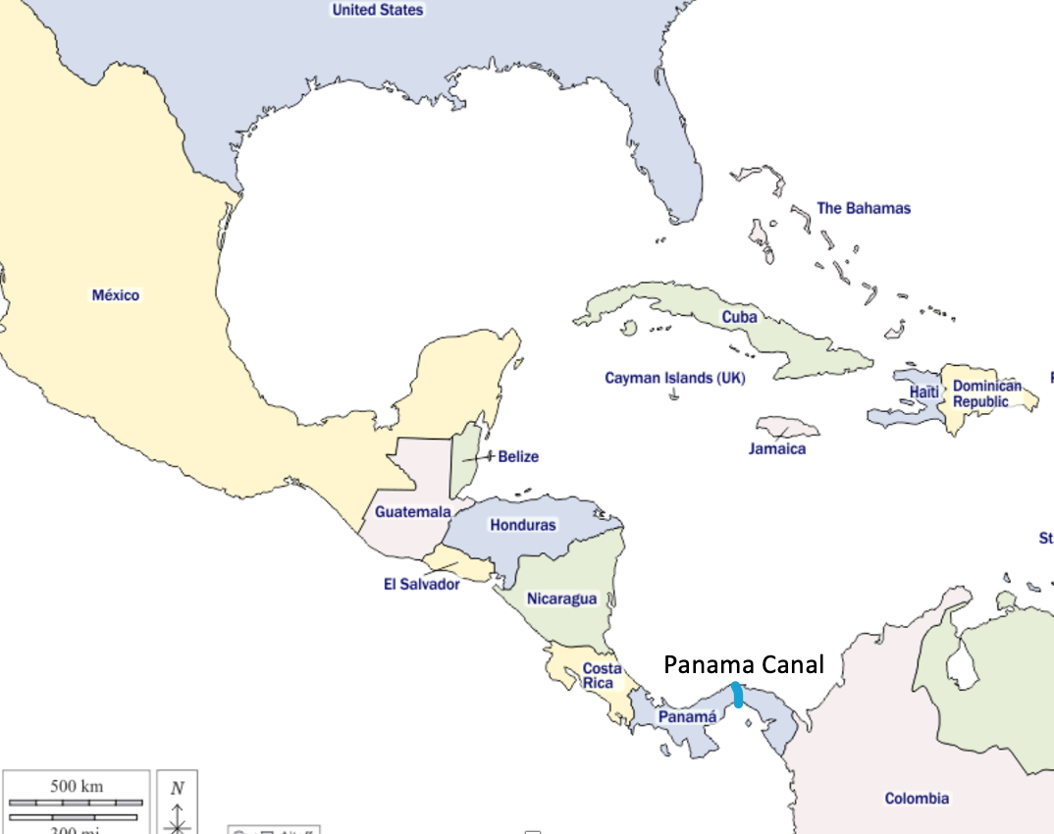

Afterword:

