YEAR 4
Week | Reading | Narration | Notes
4 | Intro p. 6 | When Declaration of Independence declared all free, they did not mean the Black slaves. The British took advantage of this and offered freedom, so many fought for the British. Others fought for the US hoping for freedom.
5 | Pt 1 Fighting for Freedom | When war broke out, slaves were not allowed to enlist because the owners thought they would rise up against them too. Free blacks were allowed. British offered freedom and took everyone, not just young men. After US had trouble getting enough soldiers, they allowed slaves, sometimes promising them freedom.
9 | Ch 1 Boston King (1/2 - to page 21) | Born on plantation near Charleston, his parents were in better positions than other slaves. He was apprenticed to carpenter who beat him at first. When British took Charleston, he took the offer of freedom and went to New York. He was kidnapped and sold to slavery in New Jersey and then escaped back to New York. | Map: Charleston South Carolina – Appalachians of North & South Carolina – New York City – New Jersey – Raritan River – New York City –
10 | Ch 1 Boston King (1/2 – pg 21-27) | At end of war he and wife moved to British colony in Novia Scotia. He started preaching after conversion experience. He used carpentry skills and fished to survive. English convinced freed slaves to go to Sierra Leone to teach skills and evangelize. He preached and taught school, but did not succeed in converting adults. He thought he was not having success because of his lack of education so governor sent him to England where he attended school and wrote his autobiography. He returned to Africa and taught in villages. | Map: Novia Scotia, Canada – Sierra Leone – Bristol, England
14 | Ch 2 Agrippa Hull (1/2: 29-32) | Born free in Massachusetts, his mother had to sell the farm and look for work when his father died. He joined the army at 18 and fought in Saratoga. He was orderly for a general and was reassigned to a polish miliary engineer Kosciuszko who became a friend. | Map: Stockbridge, Mass – Hudson River Valley – Saratoga, New York – Valley Forge –
15 | Ch 2 Agrippa Hull (1/2: 32 – 37) | He fought for years in the south with little supplies. When the fighting was finally over, they sailed from Charleston to Philadelphia. Kosciuszko offered him a position in Poland, but he went home and ended up buying land. At end of life he went to West Point to an unveiling of a statue in honor of Kosciuszko. | Map: North Carolina & “South” – Charleston – Philadelphia – Stockbridge – New York City – Stockbridge – West Point, New York  NOTE: N word on page 36
22 | Ch 3 James A. Lafayette (½: 39-42) | Enslaved in Northern VA, his owner let him enlist. He joined Lafayette’s troops. He was ordered to pose as a runaway slave to the British and spy. He sent verbal messages back. He became British General Cornwallis’ servant and heard the plans for Yorktown. Then Cornwallis ordered him to spy on the Americans, so he became a double agent, able to cross all lines without questioning. | Map: Northern Virginia ; Yorktown
23 | Ch 3 James A. Lafayette (½: 42 – 47) | As a double agent, he gave valuable information to Lafayette and false information to Cornwallis. When the war was over, he was not given his freedom. After many years the VA assembly granted his freedom, but no soldiers pensions. After many years he was finally granted a pension.
26 | Pt 2 Cradle of Liberty | Massachusetts had had slaves since its first settlers. There was not written law, but lots of customs. When the colonies started talking about freedom, African Americans started asking for it too, even sending petitions to the Massachusetts Assembly.
29 | Ch 4 Phillis Wheatley (½: 53 – 61) | At 7 she was auctioned off just off the ship from Africa. The Wheatley’s saw her sick and bought her and brought her home and treated her like family. She was educated and started writing poetry. Her poetry was religious, but also about current events and was published. She became famous. She wrote a book that was paid for by a British Countess and after an examination, had a forward saying that she really did write them. She went to London to promote the book. | Read her poems during Poetry time
30 | Ch 4 Phillis Wheatley (½: 61-68) | She played tourist in London but rushed back home to be with her sick mistress who soon after died. John Wheatley gave her her freedom. She still lived with the family but now had to earn money. The War was starting and she writes against slavery. She meets Washington who has her poem about him published. The Wheatley’s die and she marries and her first two babies die. Her husband is in & our of debtors prison and she can’t get another book published. She & her 3rd child die the same day. Her second book of poetry was lost.

YEAR 5
Week | Reading | Narration | Notes
5 | Ch 5: Elizabeth “Mumbet” Freeman part 1  Pg 71-76 | Mumbet born in Dutch Hudson River Valley but moved to Massachussetts when owners daughter – Hannah - inherits her and gets married to John Ashley. Hannah is cruel. Mumbet hears Ashley & guests discussing new Massachusettes constitution that says all men are equal & free. She goes to lawyer, Mr. Sedgwick, in town who wrote it and says she should be free too. He takes her case but also includes an enslaved man. | Map: Hudson Valley, New York ; Sheffield Massachusetts
6 | Ch 5: Elizabeth “Mumbet” Freeman part 2  Pg 76-79 | They won the case and two years later slavery was declared unconstitutional in Massachusetts. Mumbet changed her name to Elizabeth Freeman and went to work for Mr. Sedgwick. She faced armed mauraders and saved the Sedgwick house and treasure from them. She eventually bought property and lived with her daughter & grandchildren.
19 | Ch 6: Prince Hall Part 1  Pg 81-85 | Prince Hall is owned by a leather worker and learns the trade. He is freed by his owner and sets up his own shop. Boston Freemasons won’t allow him to join so he joins the British Freemasons and is allowed to set up the first black masonic lodge. | Map: Boston
20 | Ch 6: Prince Hall Part 2  Pg 86 - 91 | Though slavery was outlawed in Massachusetts, slave ships could still do business. When friends were kidnapped by a slave ship, Hall joined with white ministers to petition the legislature to outlaw slave ships and to get his friends back. He petitioned for school for black children and after 9 years got permission.
26 | Part 3: Women in the South | Summary of status of enslaved women and next three chapters
28 | Ch 7: Mary Perth Part 1  Pg 97 - 102 | We don’t know where Mary was born, but the first record of her is her sale to the Willoughby family when she was about 28. She would sneak out at night to attend a Methodist gathering of slaves. She often preached. Willoughby was accused of being a loyalist and his slaves were seized, but many of them escaped and took refuge with the English governor who freed them. She moved to New York City which was held by the British. She married. When the Americans won, Washington demanded the British return the slaves, but the British said they were free now. Mary went to Novia Scotia where she could be free, but she was still not equal. | Map: Norfolk Virginia ; New York City ; Nova Scotia  Define: Loyalist (to England) & Patriot (American)
29 | Ch 7: Mary Perth Part 2  Pg 102 - 107 | She joins the Sierra Leone Company and builds a successful business. | Map: Freetown, Sierra Leone ;
32 | Ch 8: Ona Judge Part 1 Pg 109-114 | Ona was enslaved by Washingtons. Her mother had been owned by Martha and her father was an indentured servant who left when he had served his time. She was a seamstress. When Washington became president, they took some enslaved peoples to Philadelphia. The enslaved peoples hoped they would be free when the Washingtons died, but then Martha told Ona she was going to give Ona to her granddaughter. So she walked out of the house, hid with friends and sailed to New Hampshire. Washingtons offered a reward for her return. | Map: Mount Vernon ; Philadelphia ; Portsmouth, New Hampshire
33 | Ch 8: Ona Judge Part 2 Pg 114 - 118 | Washington tries to have Ona kidnapped and brought back but she evades. She gets married to a free sailor. When Washington’s nephew visits New Hampshire, he attempts to bring her back but she hides in another town. The New Englanders are against slavery and protect her. At the end of her life she gives interviews to newspapers telling her story. Washington did free his slaves when he died. But Martha did not.

YEAR 6
Week | Reading | Narration | Notes
7 | Ch 9: Sally Hemmings Pt 1 Pg 122-125 | Sally was the daughter of an enslaved woman, Betty, and her owner Mr. Wayles. When Mr. Wayles died, his daughter Martha (Sally’s half-sister) inherited Sally. Martha was married to Thomas Jefferson. Because she had light skin, she worked in the house instead of the fields. When Jefferson goes to Paris, Sally eventually comes with his daughter and then becomes his personal servant. Slavery was outlawed in France, so Jefferson paid Sally and the others. Sally becomes pregnant by Jefferson and he convinces her to come back to VA instead of staying in France where she could be free. He promises her children will be free when they turn 21. She has 4 children by Jefferson that lived to adulthood. | Note: Pg 124 says “Sally Hemmings, a teenager and forty-six year old Thomas Jefferson began a sexual relationship.”
8 | Ch 9: Sally Hemmings Pt 2 Pg 125 - 130 | Sally’s children grow up and two move out and are “freed.” When Jefferson dies, Sally and the two youngest move to Charlottesville. He freed only several slaves at his death, including the two youngest and told his daughter to give Sally “her time.” Then when she dies they move on. All of them “passed as white.” | Map: Monticello ; Charlottesville, VA  Link: Life of Sally Hemmings (Monticello) ; Poplar Forest
16 | Pt 4 Freedom Beginning | The North abolished slavery gradually. Enslaved people ran away to the North to escape. The Fugitive Slave Law gave the enslavers power to get them back. Even those whites who were against slavery rarely thought that blacks were equal with whites.
17 | Ch 10: Paul Cuffe Pt 1 Pg 139 - 145 | Paul’s mother was Wampanoag and his father from Africa, but they were free and lived on Cuttyhunk island. They were boatbuilder and had a farm. Paul started working on whaling boats at a teenager where the workers were integrated. He and his brothers refused to pay taxes, using the same “no taxation without representation” because they could not vote but had to pay taxes. After a years long fight, Massachusetts allowed black property owners the right to vote. He became a successful sea captain and in Maryland (a slave state) the people were amazed to see a black man as captain. He was a Quaker. He built an integrated school. | Map: Westport, Massachusetts ; Nantucket Island ; Cuttyhunk Island ; West Indies  Link: West Indies explained
18 | Ch 10: Paul Cuffe Pt 2 Pg 145 - 153 | He wants to stop the slave trade so he goes to Sierra Leone in hopes of helping the people to trade other things besides their captive enemies. Goes to England and is supported and returns to SL but they won’t let him trade. When he got back to America the War of 1812 meant his ship was seized. He had to go to the President to get it back. He continued to peacefully fight for the end of slavery. | Map: Sierra Leone (see map from ch 1 and ch 7)
21 | Ch 11: John Kizell Pt 1 Pg 155-161 | Kidnapped in Africa at 13 yrs, he is sold to an Inn keeper in Charleston, S.C. During the Revolutionary War, he sides with the British for his freedom, then escapes to NYC at the end of the war so he is not enslaved again. Then he moves to Novia Scotia then to Nova Scotia where life is hard. The black settlers are governed by white British. Governor sends him to England and when he returns he finds the town had been attacked by the French. He works with Paul Cuffe to establish trade. Moves to Sherbo Island and continues trading. | Map: Charleston, South Carolina ; New York City ; Nova Scotia, Freetown, Sierra Leone ; Sherbo Island
22 | Ch 11: John Kizell Pt 2 Pg 161 - 167 | Kizell remembers the language and customs and is able to mediate between the people of Sierra Leone and the British. He works with governor on plan to replace slave trade with farming and trading with the village. But he meets resistance in the villages. He spends the rest of his life trying to fight slavery.
28 | Ch 12: Richard Allen Pt 1  Pg 169-176 | His family was sold to Mr. Sturgis who sold half of them. Richard became a Christian and slowly Sturgis let him participate in services them have them at the house. He brought in a farmer who had freed his enslaved people and Sturgis agreed to free his. Richard worked odd jobs while he preached and ended up in back in Philadelphia. During a yellow fever epidemic in the city, the mayor asked the Black residents to take care of the sick (it was thought they were immune). They did it and the mayor thanked them, but a newspaper printed lies about them. | Map: Philadelphia (see ch 2 map)
29 | Ch 12: Richard Allen Pt 2  Pg 176 - 182 | Wrote pamphlet defending their work during the epidemic and were the first Black people to be granted a copywrite. Founded the AME church. Discussed moving to Africa, but people of Philadelphia all wanted to stay. Started fighting slavery with a boycott of goods made with slave labor & joined the Underground Railroad. He preached non-violence.
33 | Ch 13: Jarena Lee Pt 1  Pg 185 - 190 | Born in NJ a free person after the Revolutionary War was over. Worked as a housemaid as a child. As an adult, she was part of Richard Allen’s AME church. She had a vision that she was called to preach, but Allen wouldn’t allow it. She was much depressed and even suicidal. She married a pastor who died. She approached Allen again and he gave her a license as a traveling pastor though it wasn’t technically allowed. | New Jersey ; Philadelphia ; Snow Hill
34 | Ch 13: Jarena Lee Pt 1  Pg 190 - 196 | She became a traveling preacher and met more resistance for being a woman than being black. Allen let her preach from the pulpit and attend leaders conventions. When he died, she was no longer allowed to preach except Thursday nights. But she keep preaching. In Canada she inspires the free Blacks to build schools for their children. Back home she joins the abolitionists. In her 50s she writes her autobiography (first African American woman to do so). She fought for women’s equality too. | Maryland, Delaware, Pennsylvania, New York State, Erie Canal, Ohio, Canada
35 | Epilogue  Pg 199 - 201 | Summary

Chapter 1 Boston King
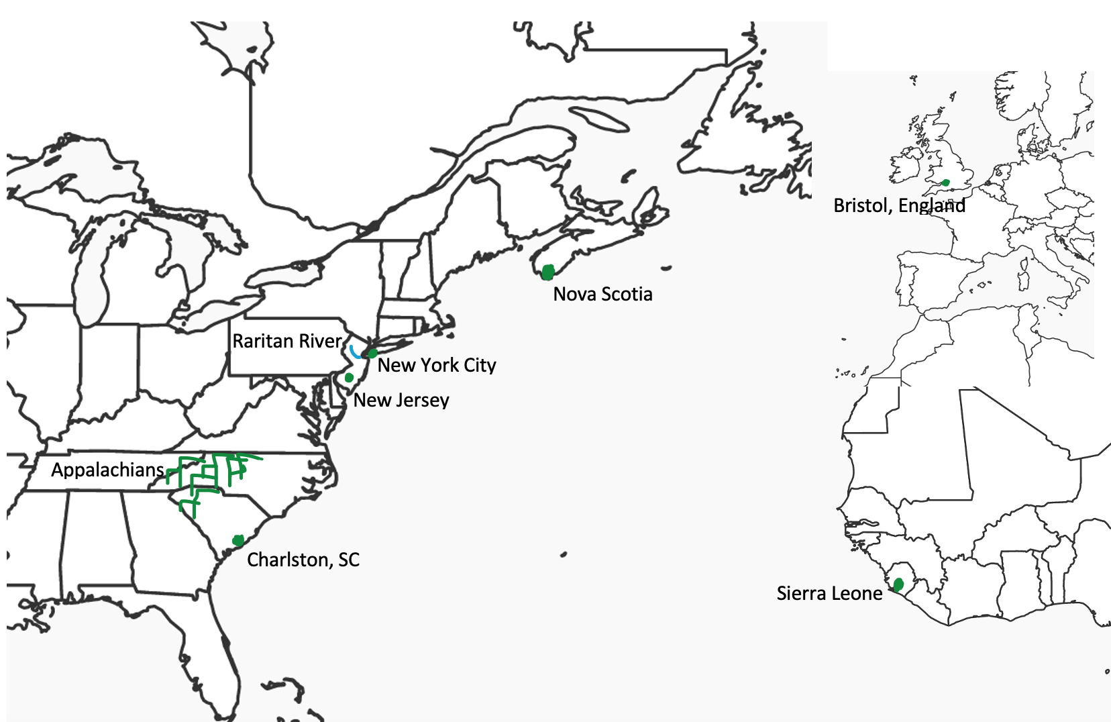

Chapter 2 Agrippa Hull

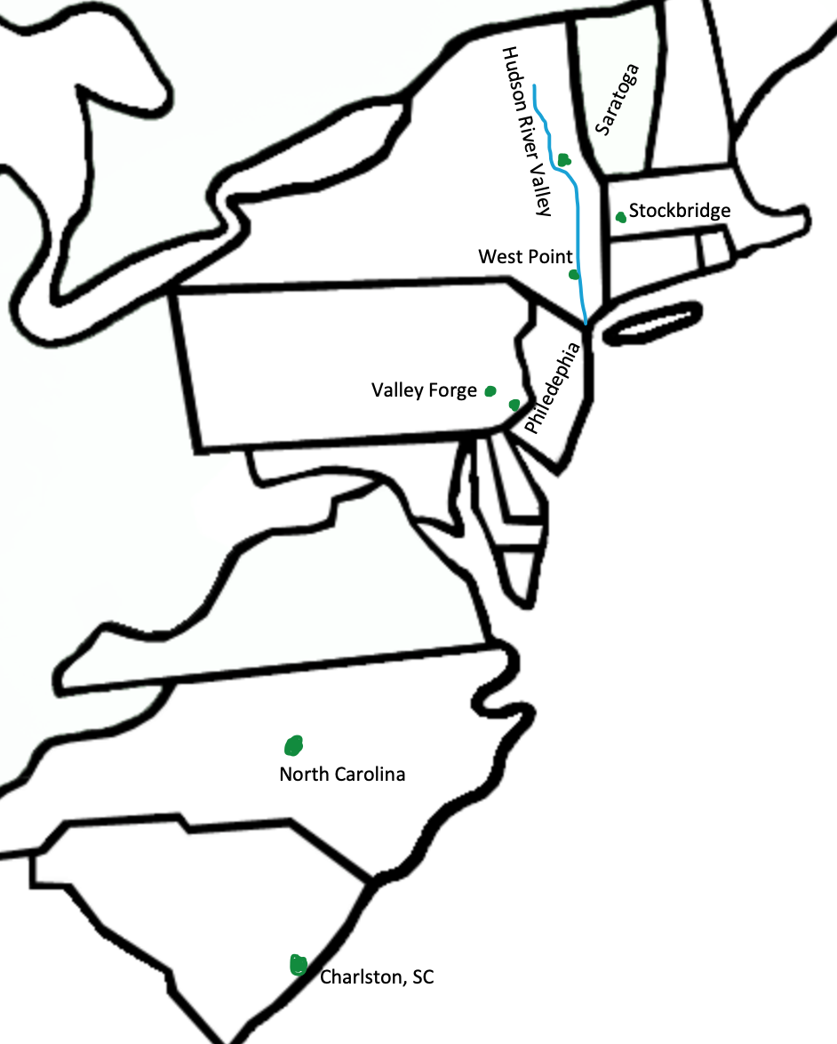

Chapter 5: Elizabeth “Mumbet” Freeman

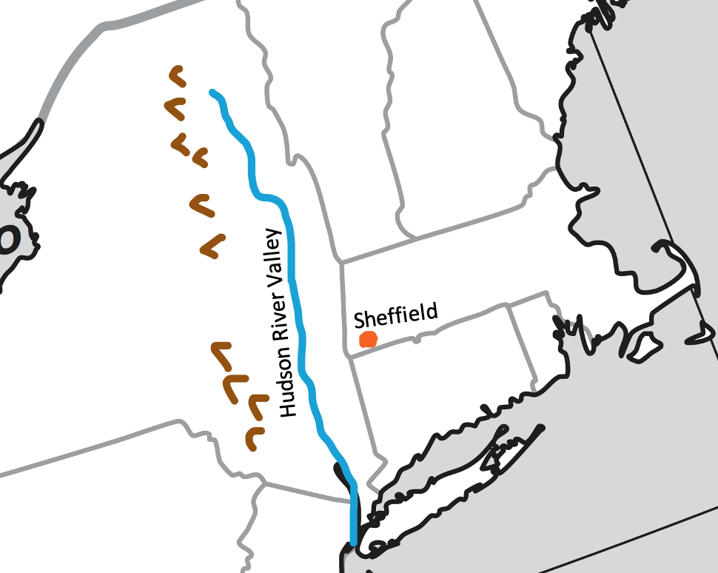

Chapter 7: Mary Perth

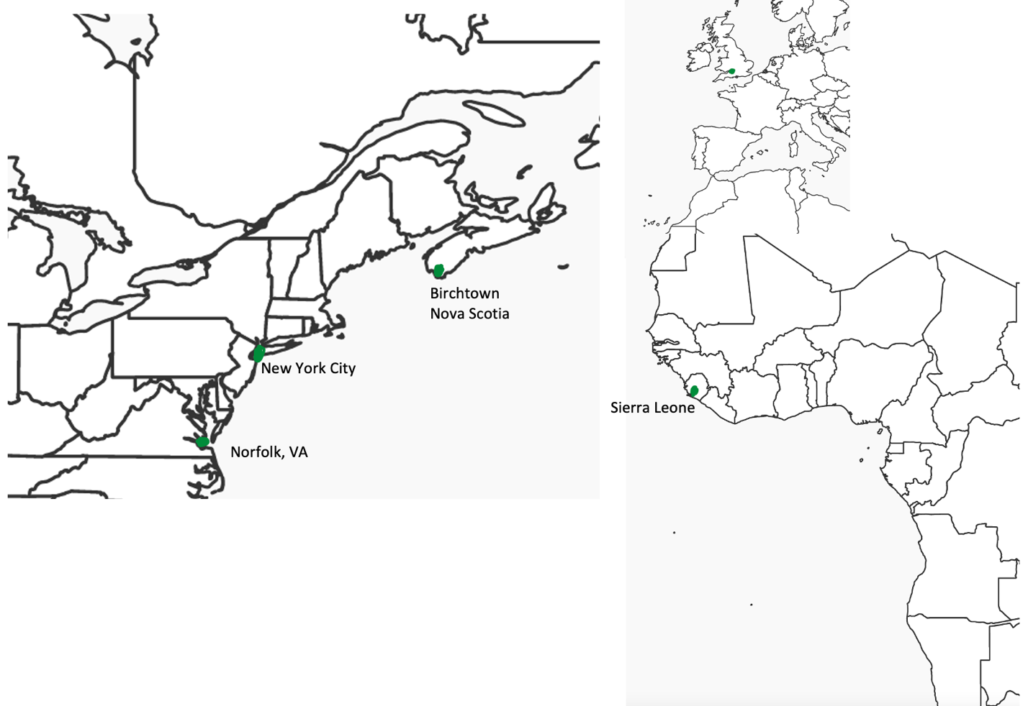
Chapter 8: Ona Judge
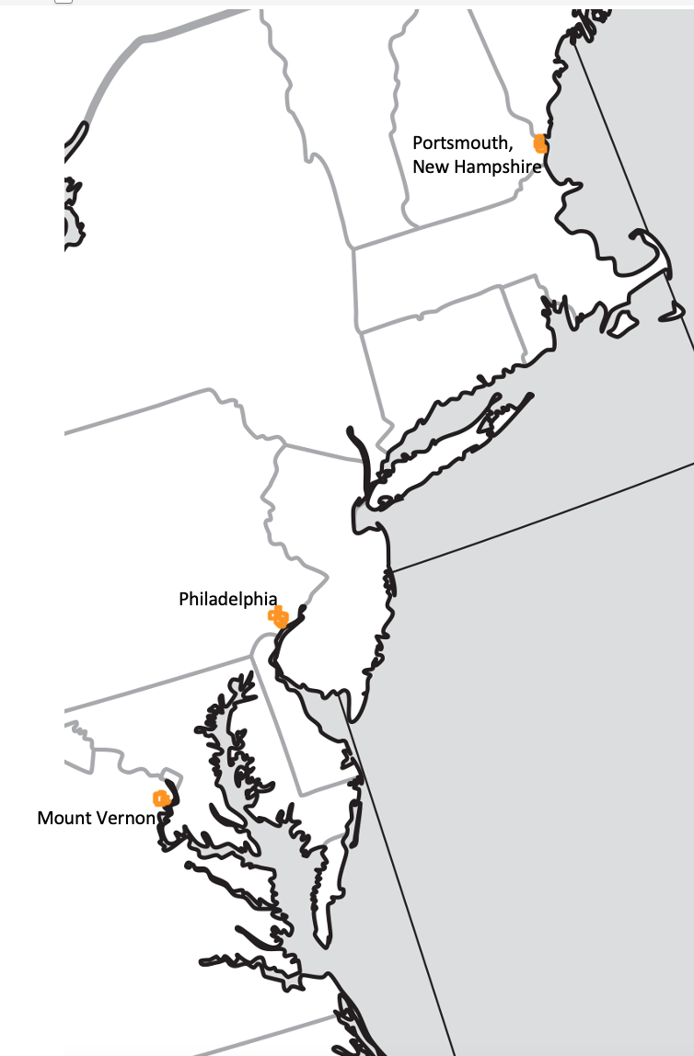

Chapter 9: Sally Hemmings

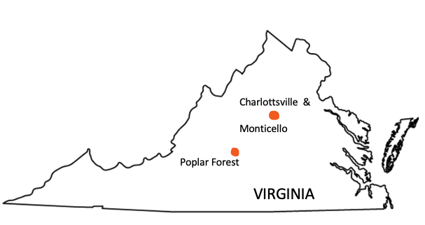

Chapter 10: Paul Cuffe

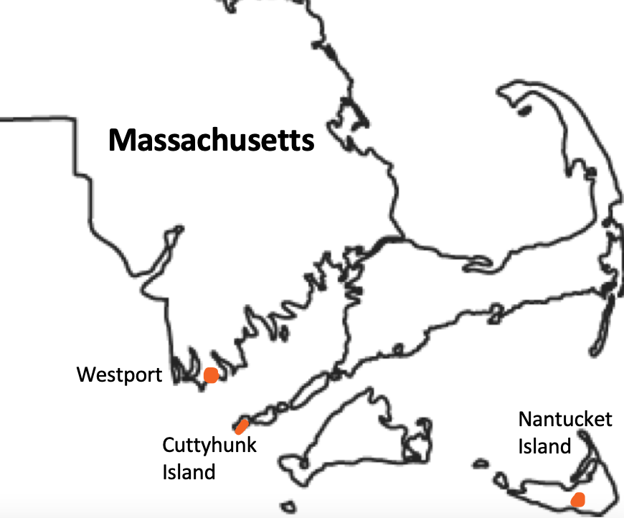

Chapter 10: Paul Cuffe (continued)

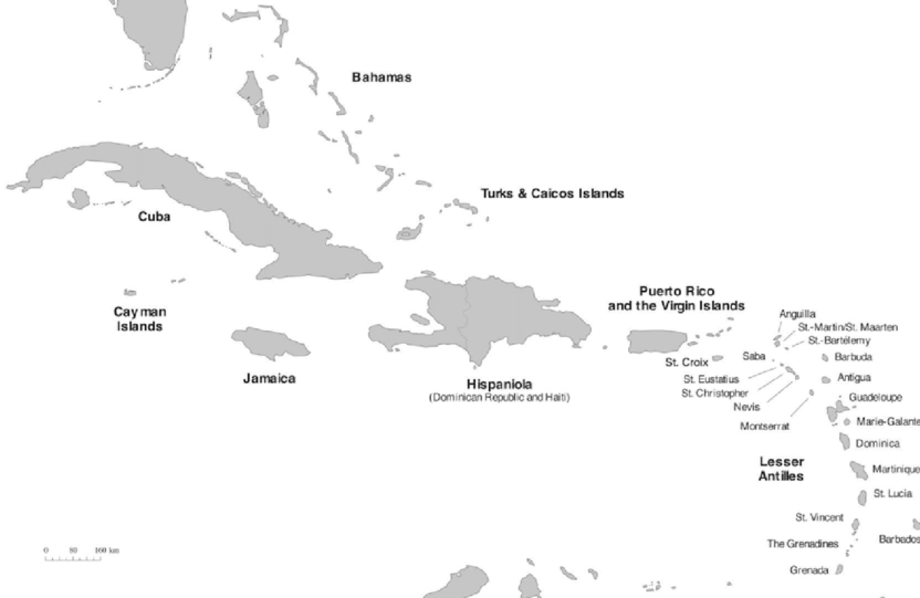
West Indies
Chapter 11: John Kizell

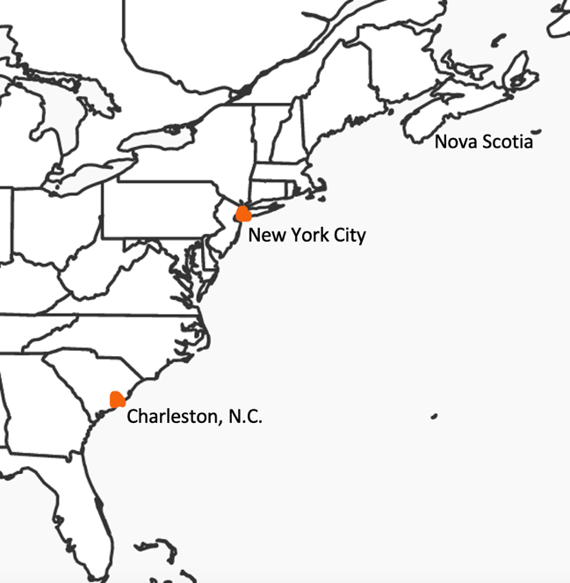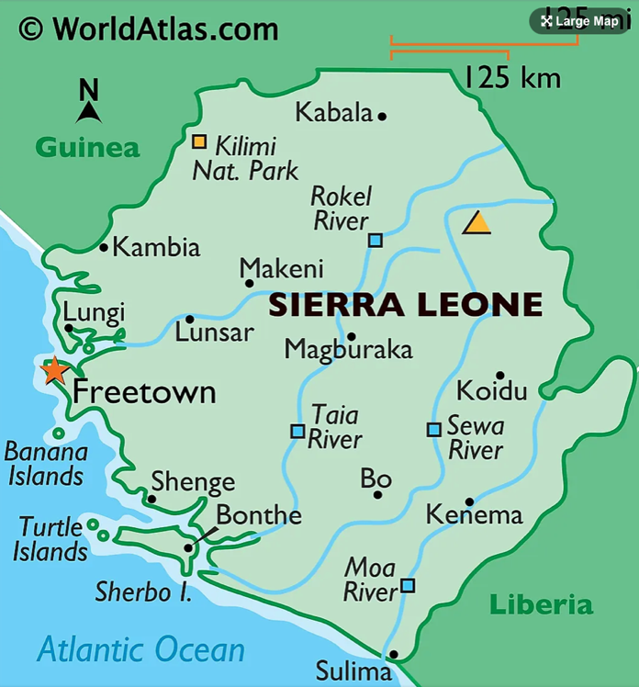

Chapter 13: Jarena Lee

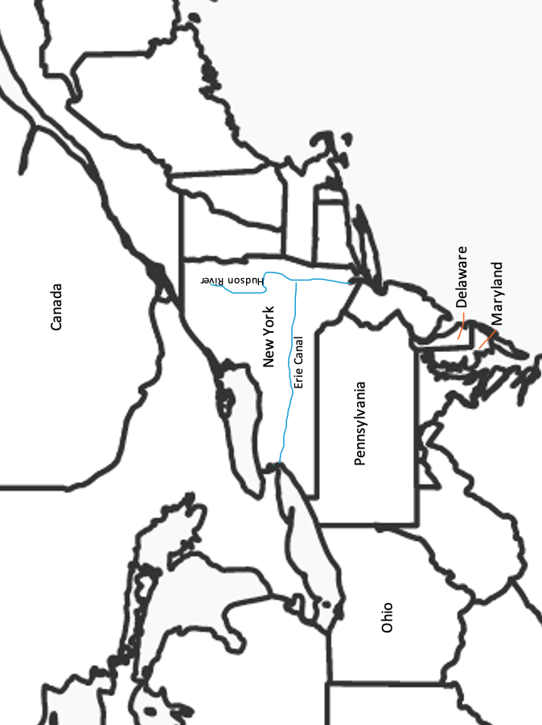

Ohio
Pennsylvania

Nova Scotia
New York City
Westport

