To be read by independently 20-30 min per week, starting Term 2.
Book available on Archive.com.
Maps at end of document.
Other Resources:
- George Washington Carver Museum & Cultural Center (includes videos)
- George Washington Carver National Park Service

Week | Reading | Summary | Resources
13 | Ch 1  Pg 1-11 | Dr. Carver arrives in Washington to give a speech to Congress. The porter does not recognize him so he gets his own taxi with a black taxi driver and asks for a tour. They go to the zoo and he identifies a fungus on a plant. The men waiting for him wonder where he is. | Define: Red Cap/porter ; Negro ; colored person ; mycologist (studies fungi)
14 | Ch 2  Pg 12-19 | As a baby, Carver & his mother had been kidnapped. When they caught up to trade a horse for them, the thieves tricked them and took the mother and left the baby. He was sick and coughing and they think his vocal cords are damaged because he does not talk. This happened during the civil war. | Note: This chapter jumps into past to when George was a baby  Define: Frau (Mrs.) ; raus mit (out with)  Map: Ozark Hills, Missouri  Link: George Washington Carver National Monument
15 | Ch 3  Pg 20-31 | Frau Carver shows the new neighbor the garden Carver has built. He says the animals and flowers talk to him and that’s how he knows how to take care of them. He risks a whipping for not getting the wood cut in order to go save some fish.
16 | Ch 4  Pg 32-43 | He’s about 10 years old and talking now. Farmer Carver has started growing grapes. He meets Farmer Jaeger who is making a new strain of grapes and teaches Carver how. Jaeger tells Carver that he has a special gift and must work for God. He gives Carver a book that he can’t read yet. On the way home, Farmer Carver tells Carver that there is a school for black children he can go to. | Define: Squatting (living on land not purchased)  Map: Neosho, Missouri
17 | Ch 5  Pg 44-61  (long reading) | The Carvers send him to school, where for the first winter he lives in a barn and finds odd jobs. Then he is found in the barn by the Martins and he lives with them until they move West. Then Aunt Mariah takes him in to her one room. He continues to go to school but now he wants to go to the school in Kansas to learn more. So he heads out. | Map: Kansas ; Fort School (at Fort Scott) ; Marmaton River
18 | Ch 6  Pg 62-79 | In Ft Scott, 13 year old Carver finds a hotel to work in and takes in extra laundry to earn more money. He goes to school and works before and after. He misses the woods and garden but is reading everything he can and drawing what he remembers. After 3 years he spends the summer as a cook on a railroad crew. He spends some time in New Mexico before returning to Kansas for school in the fall. He stays with “Aunt” Lucy in Olathe helping her and going to school. They move to Minneapolis, Kansas and Carver goes to High School. After graduating, he returns home to visit the Carvers and Aunt Mariah. | Links: Angustifolia Yucca ; George with his painting ;  Map: Olathe, Kansas ; Minneapolis, Kansas ; Diamond [Grove], Missouri
19 | Ch 7  Pg 80-89 | Dr. Carver testifies before Congress on a tariff bill. He tells them about the many uses of the peanut so that it will be added to the tariff bill. | Note: Chapter jumps into the future of Ch. 1  Define: Ways & Means Committee ; tariff bill ; coolies ;  Map: Tuskegee, Alabama
20 | Ch 8  Pg 93 – 123 | While visiting the Carters, he applies for college and gets in with a scholarship. But when he shows up, they won’t admit him because he is Black. He decides to try homesteading in Beeler, Kansas. After several years he heads to Iowa and works in a hotel and finds a church to attend. He makes friends at the church and trades gardening for piano lessons. Their nephew tells him about a college that will accept him. While at school, he does laundry & ironing & sewing to earn money. After 2 years he leaves for Iowa State College at Ames to study botany (is now 27 years old). He is required to join the National Guards, makes friends, continues to paint & in 1894 graduates. They offer him a position teaching botany. | Note: Chapter jumps back to where we were at the end of ch 6.  Map: Beeler, Kansas ; Winterset, Iowa ; Indianola, Iowa  Year: 1894 – graduates from Iowa State
21 | Ch 9  Pg 124-130 | Booker T. Washington is trying to get the Tuskegee Institute running and figure out how to teach the people how to grow crops. He sends a letter to Carver, who decides to leave Iowa and help at Tuskegee. | Map: Tuskegee Alabama
22 | Ch 10  Pg 131-143 | Carver moves to Tuskegee and becomes great friends with Booker T. Washington. There is no lab or garden or greenhouse, just dirt. Students don’t want to be in agriculture – they want to learn a trade previously reserved only for whites. But soon the students find Carver to be different and stay in agriculture. Since they have no lab or supplies, he sends his students on a scavenger hunt to find supplies in trash and discards. Carver discovers he can use the clay to make paint and paints a church in Montgomery. | Year: 1896
23 | Ch 11  Pg 144 - 152 | Carver enjoys the Sunday night singing in the chapel. He goes on a concert tour playing the piano around the South to raise money for his department. While on tour he sees the needs of the poor farmers. Washington had held an annual conference for farmers to help improve their farms and lives, but Carver suggests going out to them. They create the first Movable School of Agriculture that eventually also included a nurse to teach basic healthcare. Tuskegee was becoming successful, but Carver turned down a raise. | Link: I Got a Home In That Rock  Year: 1906 - Movable School of Agriculture
24 | Ch 12  Pg 153 - 161 | The cotton crop was becoming more profitable. Then the boll weevil killed the crops. Carver gets everyone to plant peanuts, but then the price of peanuts drops so low that they get mad at Carver. So he locks himself in his lab, prays, and develops new products using peanuts. He has figured out how to make “synthetic” products from the peanut. Then he does the same thing with the sweet potato. Booker T. Washington dies. | Note: “n” word used on page 156.  Year: 1915 – Booker T. Washington dies
25 | Ch 13  Pg 162 - 167 | Carver is honored, though he does not think he deserves it. He lives in two rooms at the college, cleans them himself, wears old clothes he patched, and rarely goes out to official gatherings. He continues to help farmers and make new discoveries.
26 | Ch 14  Pg 171 - 187 | It’s after his visit to Washington now. Tuskegee gets more funding and Carver gets a new lab. European royalty is coming to visit him and he is invited to speak often. But he worked alone and did not have colleagues to discuss is work with. Edison offers him a lab & large salary, but Carver says they needed him at Tuskegee where he promised Booker T. Washington that he would help relieve poverty. He is an expert in finding plant diseases and molds. He makes cream from peanuts. He rarely cashes his checks and has a stockpile of years’ worth of checks at the bank. People want to pay him for solving their problems and giving them advice, but he refuses the money and does it for free.
27 | Ch 15  Pg 188 - 203 | People from all over the world ask for Carver’s advice. Locals bring him their problems – including a sick dog! He seems to have cured infantile paralysis with peanut oil rubbing. He never patented but did have a company manufacture some of the items he created. He is honored by John Hopkins University when he visits Morgan College in Baltimore (while wearing his old clothes!). When the Peanut Company wants to honor him at Tuskegee the college orders him an academic gown to wear against his wishes. He let few people into his lab, but he finally gets Austin Curtis as an assistant to help out and train to take over the lab. | Map: Baltimore  Year: 1930 – receives award from John Hopkins ; 1933 – receives award from Tom Houston Peanut Company
28 | Ch 16  Pg 204 - 214 | He receives the Roosevelt Award and helps again with the war effort finding substitutes for items and food in short supply. Carver befriends Henry Ford, who had been working with soybeans. They build a farm and experiment station in Georgia. Carver goes to work in a Ford lab and Ford builds him a log cabin. Austin Curtis puts together the Carver Museum back at Tuskegee. Carver bequeaths all his money to a foundation at Tuskegee. | Define: Henry Ford (creator of first mass produced car)
29 | Ch 17  Pg 215 - 224 | Carver shares a newspaper article with “kitchen gang” that a portrait of him won an award. He is given more awards and honors, a movie company comes to document his life and another artist to paint him. Many students now are in uniform since the Tuskegee Airbase nearby is training black men to be pilots. Carver falls and injures himself. | Links:  - Portrait of Carver by Arthur Leroy Bairnsfather at the Birmingham Museum of Art  - Portrait of Carver by Betsy Reyneau at the Smithsonian National Portrait Gallery  - Carver’s birthplace museum
30 | Ch 18  Pg 225 - 228 | Carver dies. A ship is named for him. | Year: January 5, 1943 Carver dies

Chapter 2: Ozarks

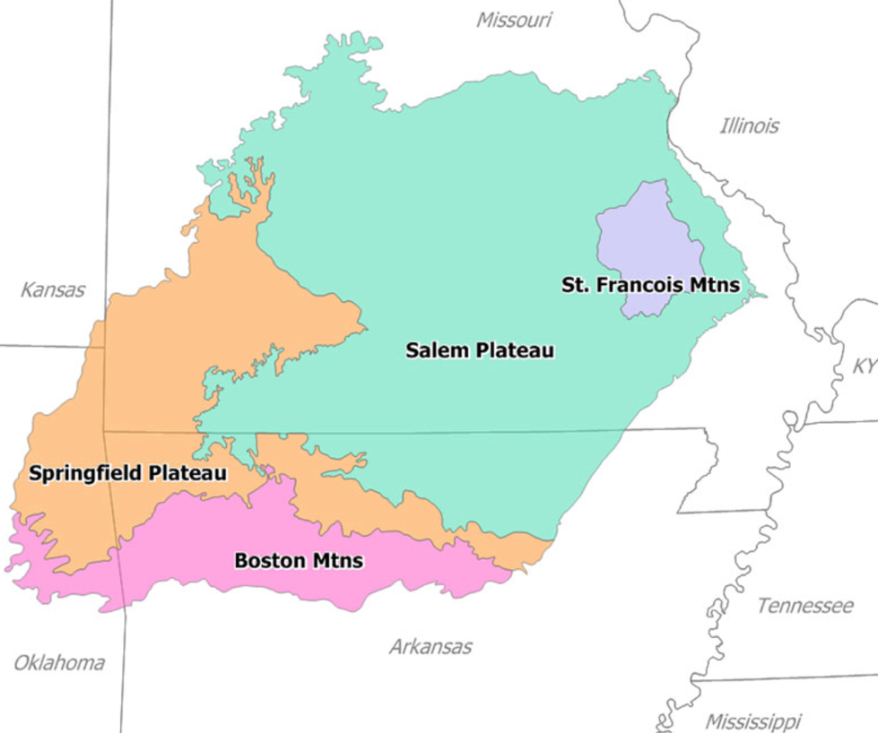

Map from Wikipedia

Chapter 4: Neosho

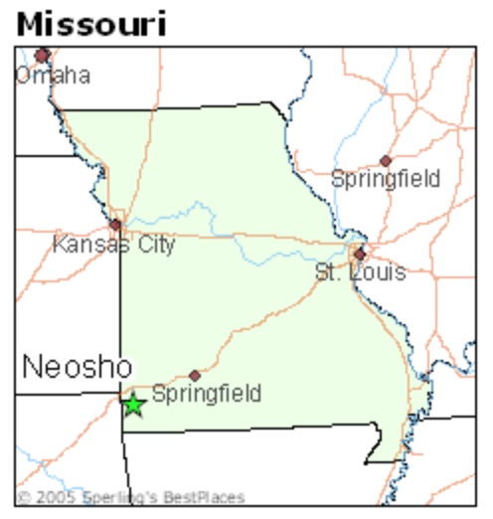
Map from Google image search

Chapter 5: Fort Scott and Marmaton River

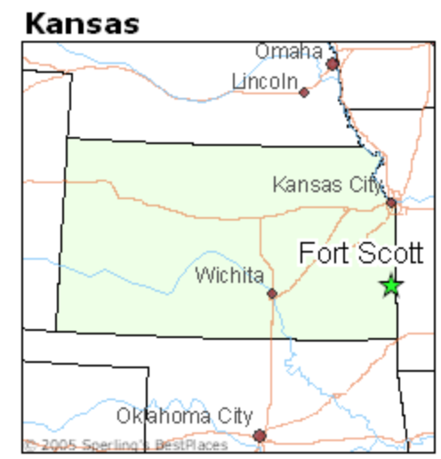

Map from Google image search

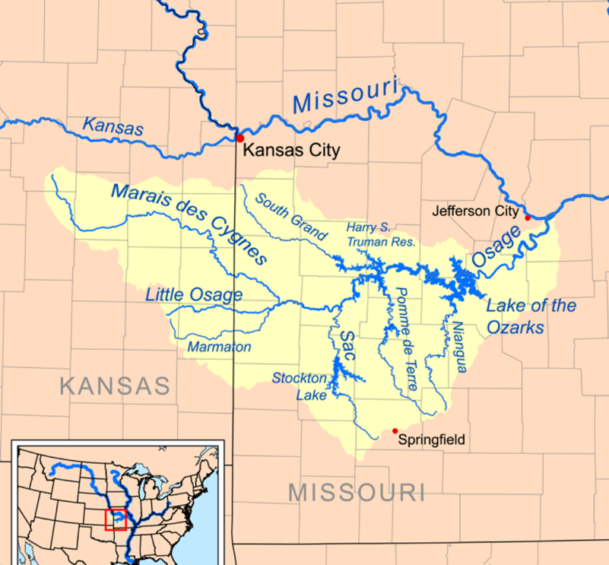

Map from Wikipedia
Chapter 6: Olathe & Minneapolis, Kansas and Diamond Missouri

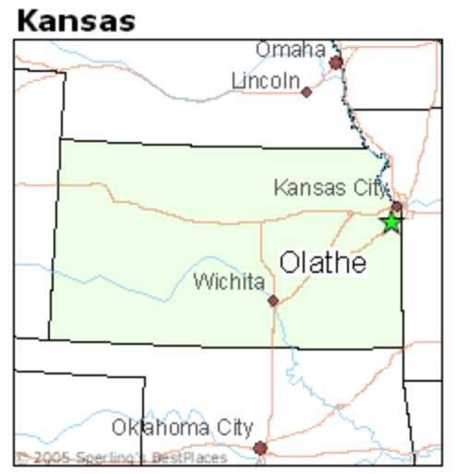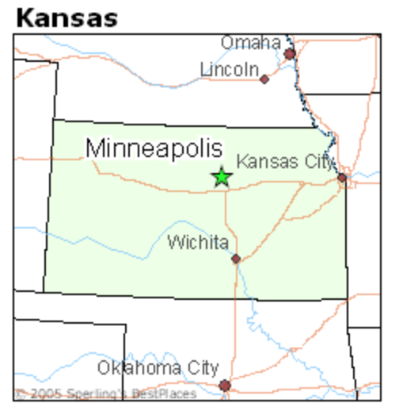

Map from Google image search Map from Google image search

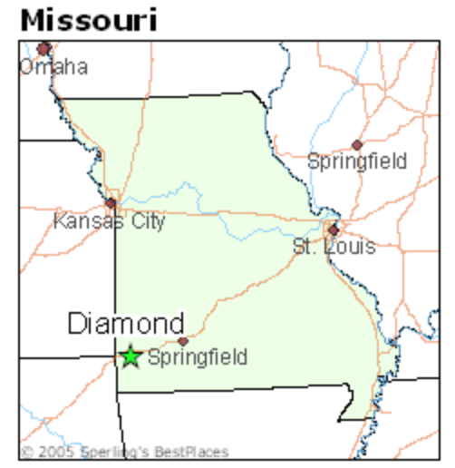

Map from Google image search

Chapter 7: Tuskegee, Alabama

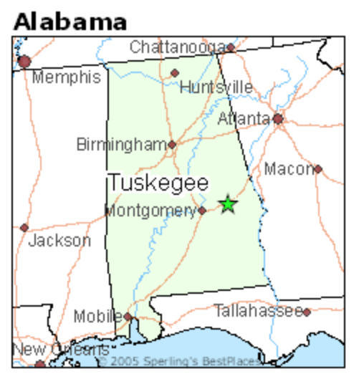

Map from Google image search

Chapter 8: Beeler, Kansas & Winterset, Iowa & Indianola, Iowa

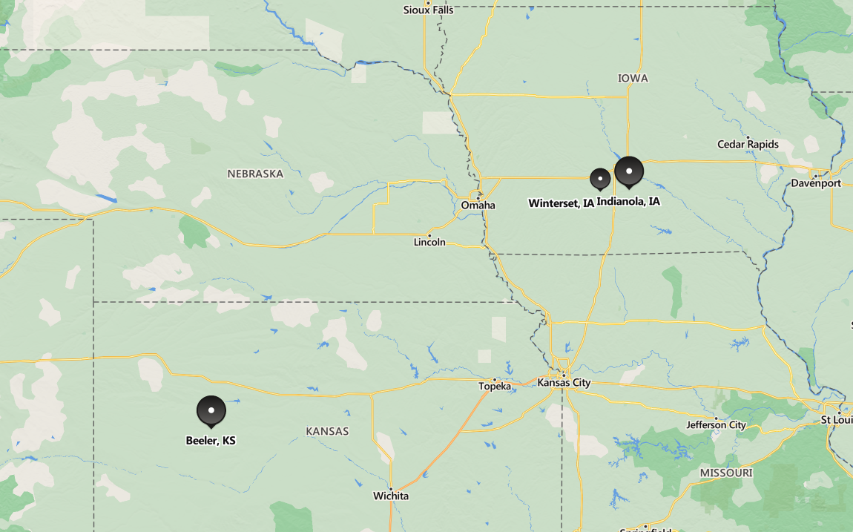

Map from Bing.com maps
Chapter 9: Tuskegee

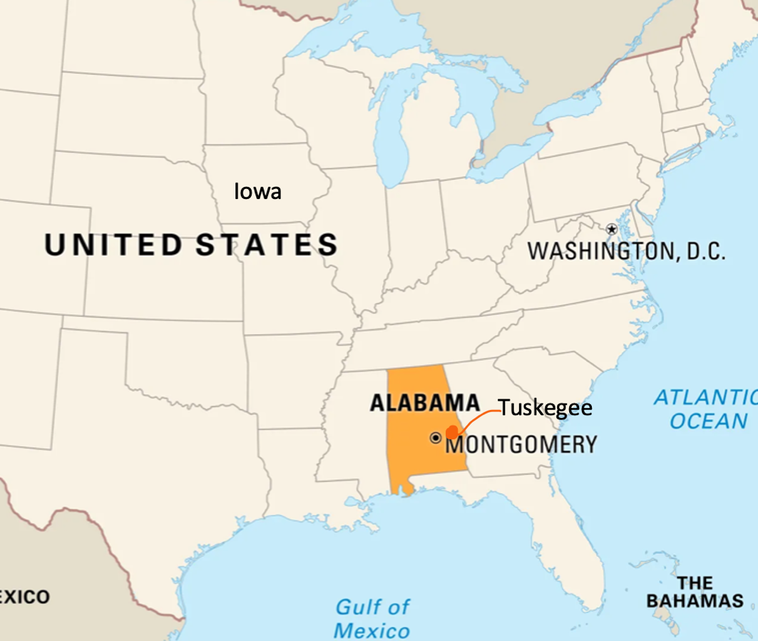

Chapter 9: Baltimore

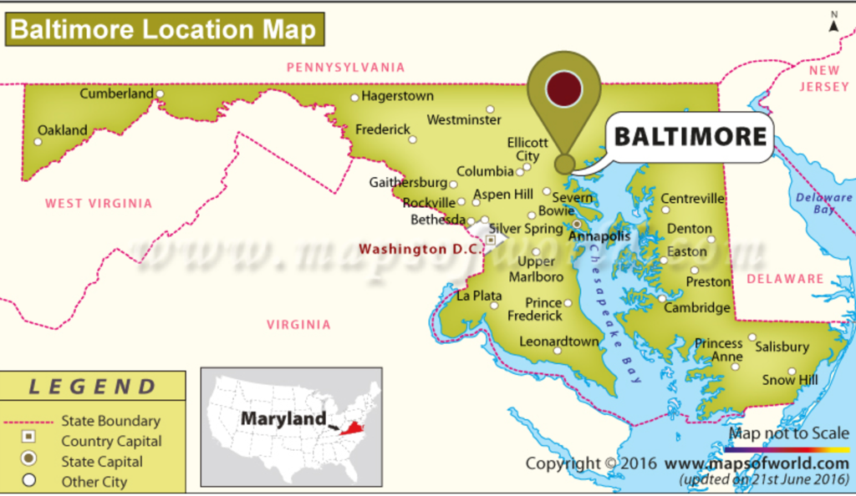

Map from mapsoftheworld.com

