Links:
Blank Map
Molly PItcher
Washington Rallying the Troops at Monmouth by Emanuel Leutze

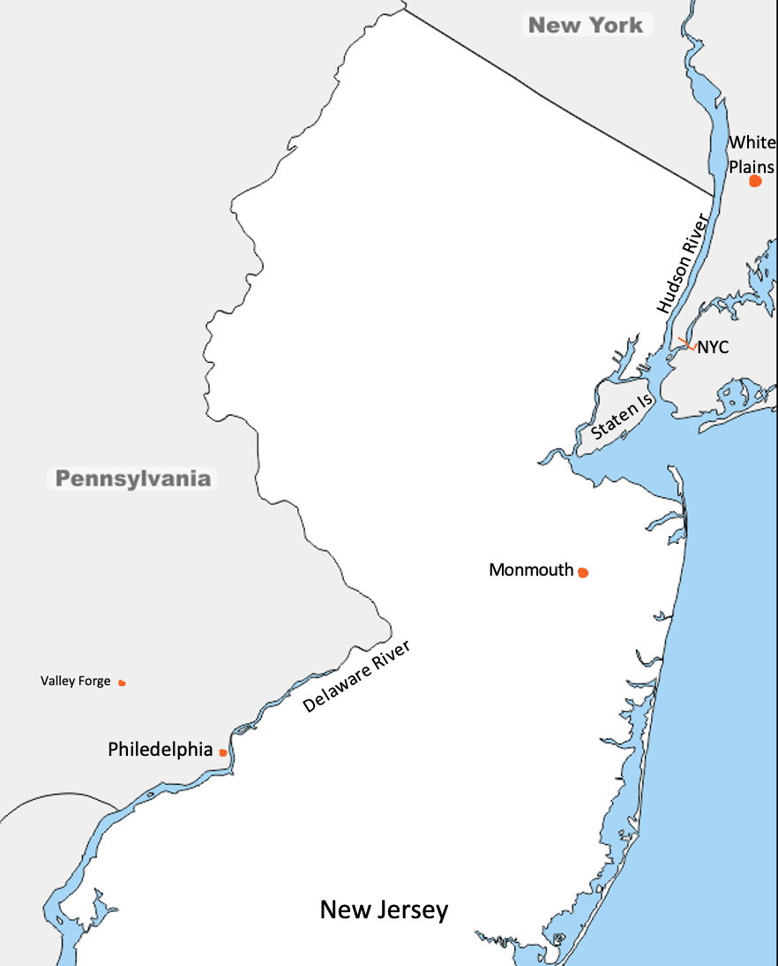
Monmouth
Staten Is
Hudson River
White Plains
NYC
New Jersey
Valley Forge
Philedelphia
Delaware River
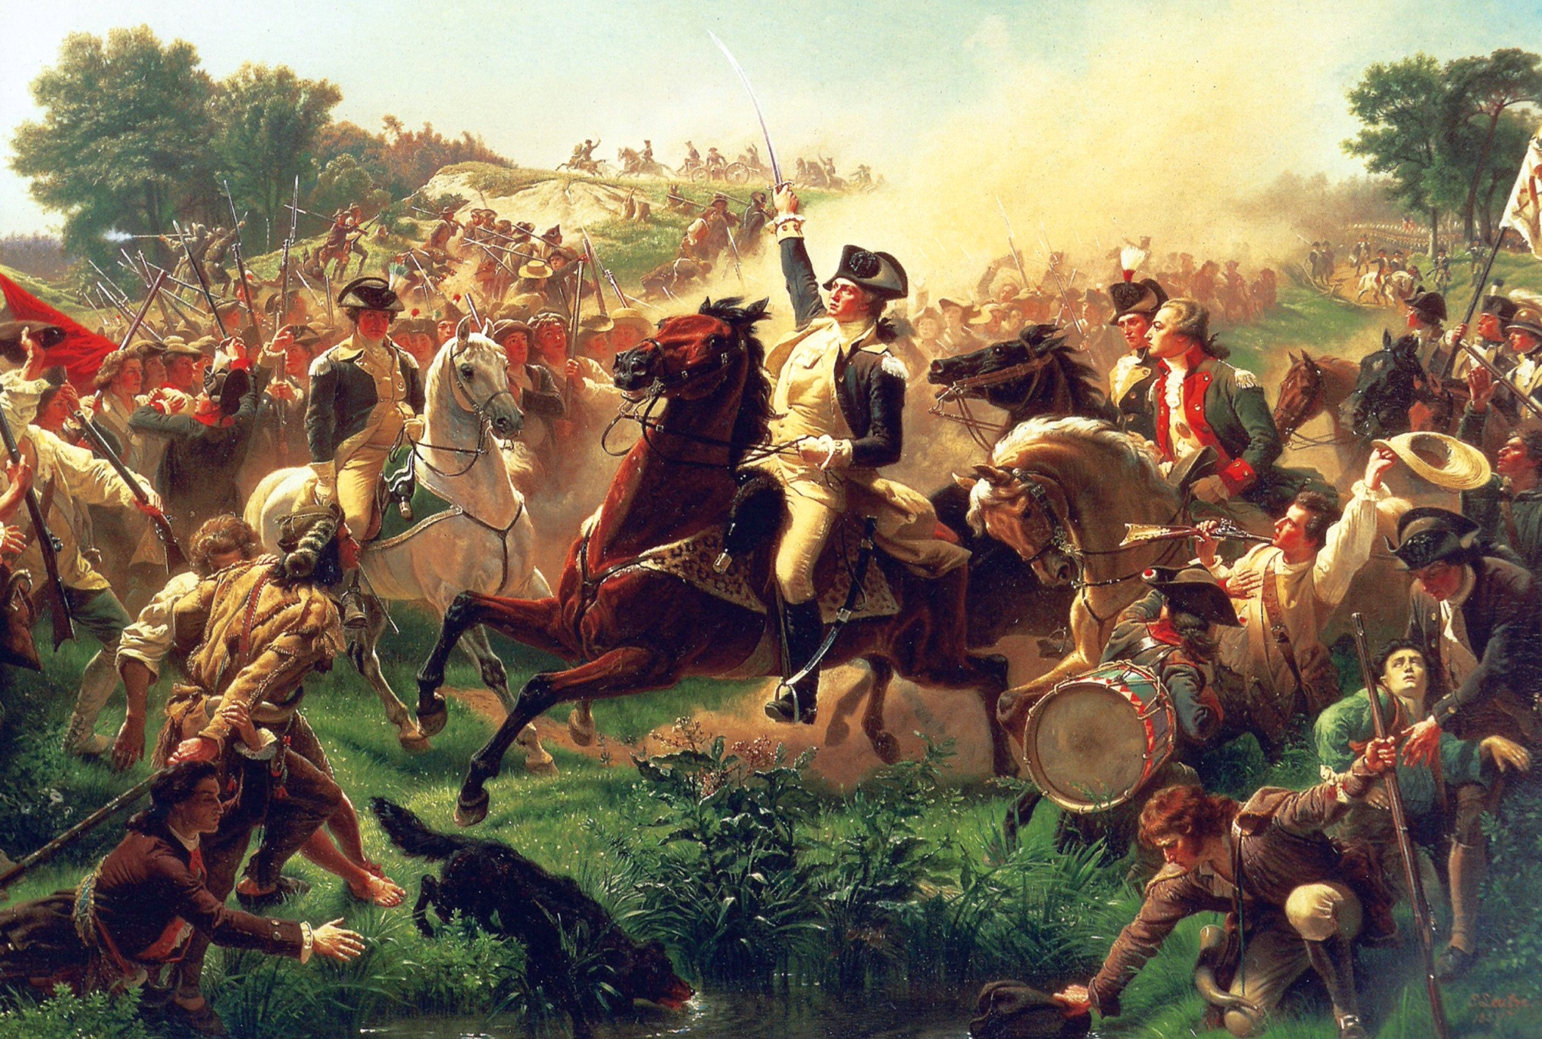
Washington Rallying the Troops at Monmouth
by Emanuel Leutze

