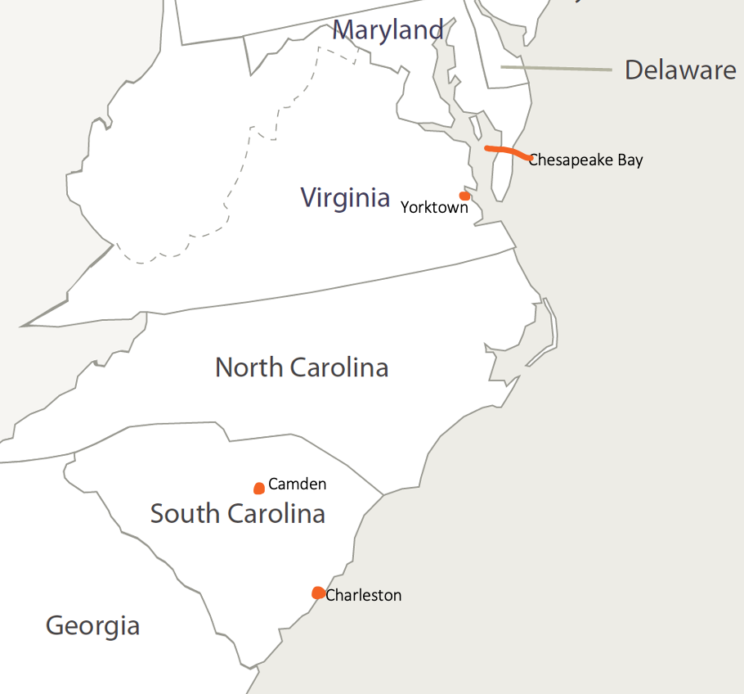

Map from Seterra
Surrender of Lord Cornwallis by John Trumbull – displayed in U.S. Capitol rotunda
Yorktown Tour Guide
The World Turned Upside Down
Yorktown / The World Turned Upside Down – from Hamilton

U.S. Territory after the Treaty of Paris

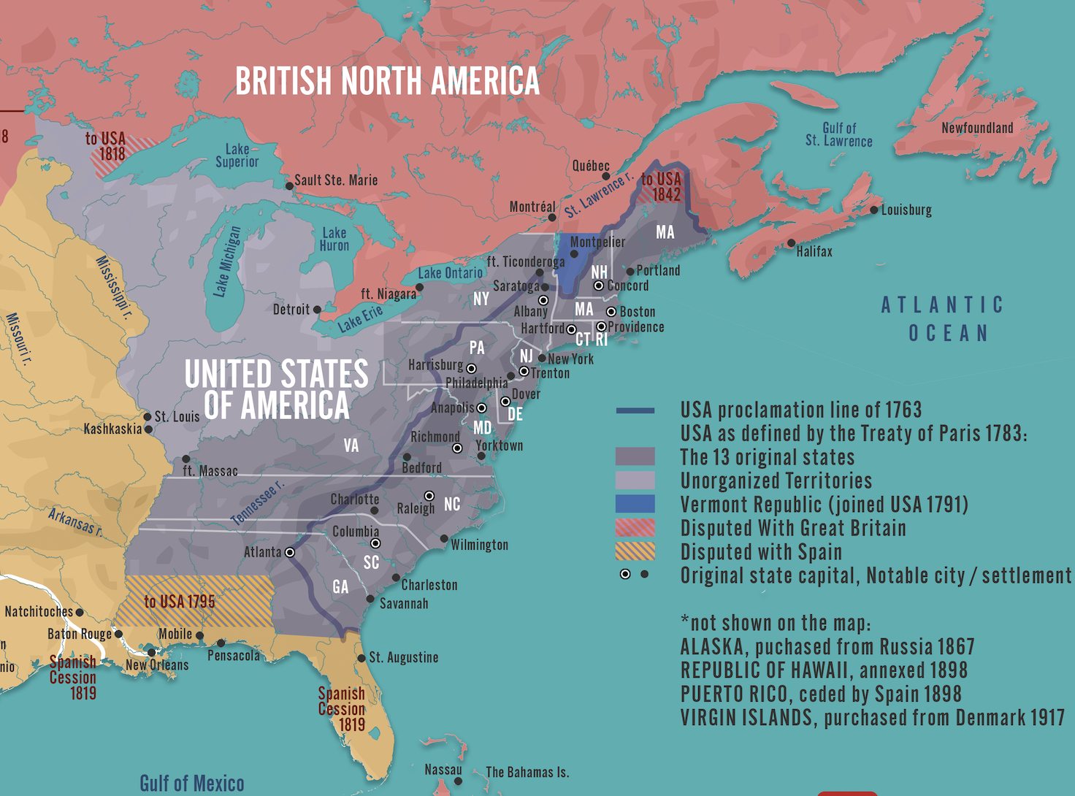

Downloadable map from worldhistory.org

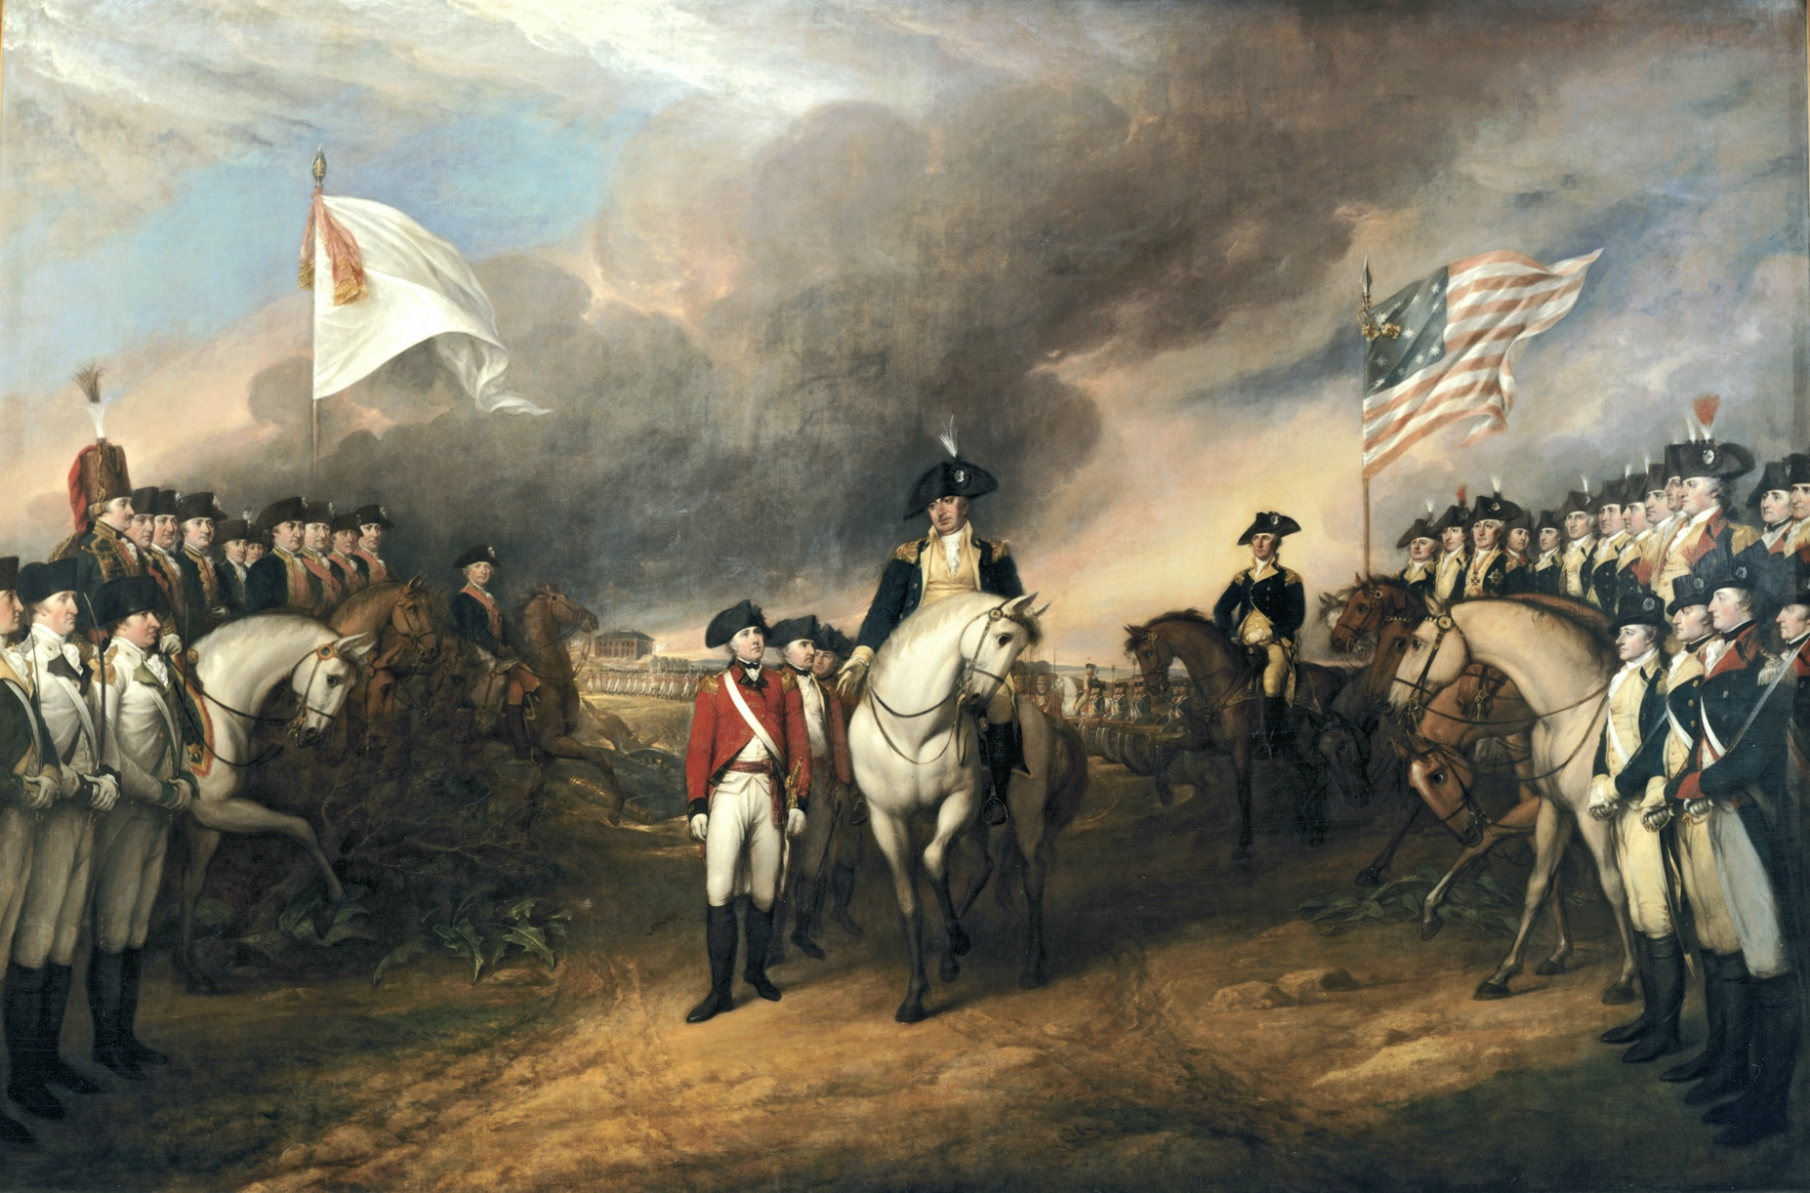
Surrender of Lord Cornwallis
by John Trumbull – displayed in U.S. Capitol rotunda

