Lisa Cotting
amblingtogether.com
United States geography
Southern States

Table of Contents
About This Guide 2
Why we study each state: 2
How we study each state: 3
Florida 4
Georgia 5
Alabama 6
Mississippi 7
Louisiana 8
South Carolina 9
North Carolina 10
Tennessee 11
Arkansas 12
Virginia 13
Quick Reference by State 15

About This Guide

Why we study each state:

Charlotte Mason recommends studying the geography of the child’s country. In Book VI, she says the children “are engaged with the counties of England, county by county, for so diverse are the counties in aspect, history, and occupation, that only so can children acquire such a knowledge of England as will prove a key to the geography of every part of the world, whether in the way of comparison or contrast.” She describes the principle to be followed as the child gets older and starts studying other countries: “vivid descriptions, geographical principles, historical associations and industrial details, are afforded which should make, as we say, an impression, should secure that the region traversed becomes an imaginative possession as well as affording data for reasonable judgements.”

Inspired by her study of the counties of England, I have made time in our Together Time to study the geography of all 50 states. For each state I try to find what will make “an impression” so that the state “becomes an imaginative possession” of each child. I decided to focus on mapping the physical features, reading a book or two about the culture, history, or nature of the state, and watching several videos to compliment these topics.

While using Miss Mason’s principles for teaching geography and choosing which features to map or which books to read and videos to watch, I consider the following goals: We will be familiar with major cities and landmarks – understanding how mountains and waterways divide and define, we will know a little about the original inhabitants of the land, we will have an understanding of what (some of) the state looks like and we will be familiar with some of the stories and culture from the area. I will not cover all of these topics for each state, but hope that in general we’ll know our country in this way by the time we’re finished.

How we study each state:

I have spaced this study over two years. Each week we will study one state. I have scheduled 20 minutes 2 mornings a week to read the book, watch the videos, and draw the geographical features on our U.S.A. map. When time permits, we draw the state freehand to help us notice the features of the boarder. For some states I have scheduled two weeks - either because the state has so much (such as New York – a week on Long Island/Manhattan and a week on Upper State) or because it has special meaning to our family (relatives live in or are from the state).

At the beginning of each lesson, I review the states we’ve covered so far. When we have covered enough of them so that it is no longer feasible to review everything in a couple minute review, I choose major features and change up the minor features each day. Then at the end of the lesson we review the new state we’ve learned that week.

In the guide below I have listed books and links that I have read and watched myself. The ones with the asterisk * are the ones I will prioritize. The others are alternative or additional resources. At the end of the guide is a list of geographical features for each state. I use this as a quick review before mapping the current week’s state. Every week as I am planning, I will request books from the library for several weeks in advance so I have them in time.

The maps I have drawn for each state are a basic rudimentary drawing for me to use as reference so I can easily find the landmarks in an atlas or “real” map. The children will use the “real” maps as reference for drawing their own maps.

Additional Resources:
- Map used with students: Beautiful Feet Books U.S.A. Map
- Map used for this document: worldmapblank.com and State Outline Maps
- Maps used to draw locations and physical features in each state: freeworldmaps.net
- Quick Facts: National Geographic Kids - U.S. States and Territories
- US Department of the Interior: Indian Affairs Office – Origin of State Names
- Book: How the States Got Their Shape by Mark Stein

Florida

Origin of Name
Spanish colonists (possibly Ponce de Leon) named it La Florida meaning “place of flowers”

Book to Read
* Marjory Saves the Everglades: The Story of Marjory Stoneman Douglas by Sandra Neil Wallace
- This is the Way to the Moon: A Children's Classic by Miroslav Sasek
- Sam the Sea Cow by Francine Jacobs

Links to View
* Everglades National Park (3 min, animals, no talking)
* Everglades National Park (6 minutes, descriptive talking)
- Curious Kids - History of Southwest Florida (28 minutes)

Geographical Features to Map
Capital: Tallahassee ; Lake Okeechobee ; Everglades ; Florida Keys

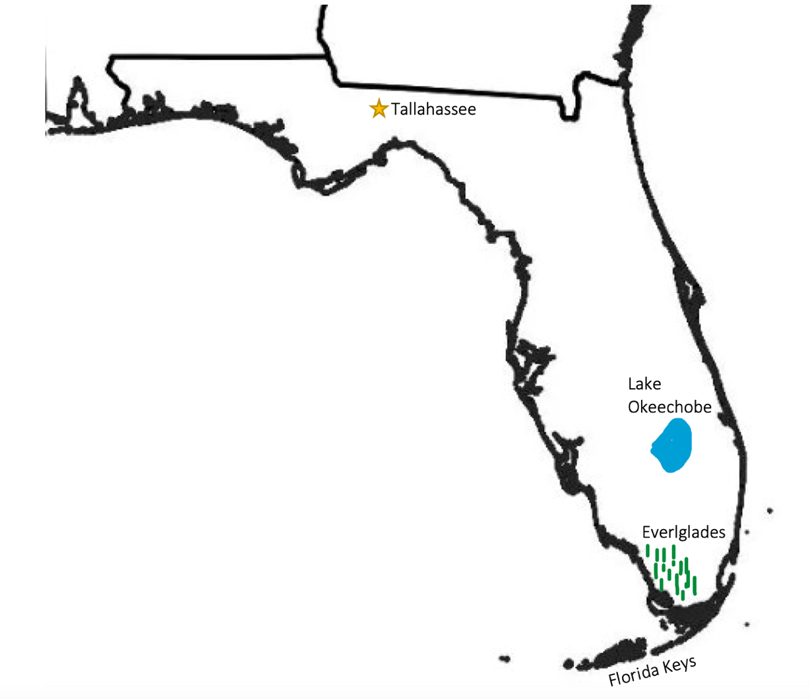

Georgia

Origin of Name
King George II approved the colony’s charter in 1732

Book to Read
* And the Tide Comes In...: Exploring a Coastal Salt Marsh by Merryl Alber
- The First Strawberries: A Cherokee Story retold by Joseph Bruchac

Links to View
* Okefenokee Swamp – Georgia DNR (10 min)
* Okefenokee Swamp | Georgia's Physical Features (2 ½ min)
* Experience Savannah's Rich Gullah Geechee Heritage (3 min)
- Explore Georgia, USA - Unravel Travel TV (3 min travel video)

Geographical Features to Map
Capital: Atlanta ; Chattahoochee River ; Altamaha River ; Okefenokee Swamp ; Suwannee River ; Appalachian Mountains
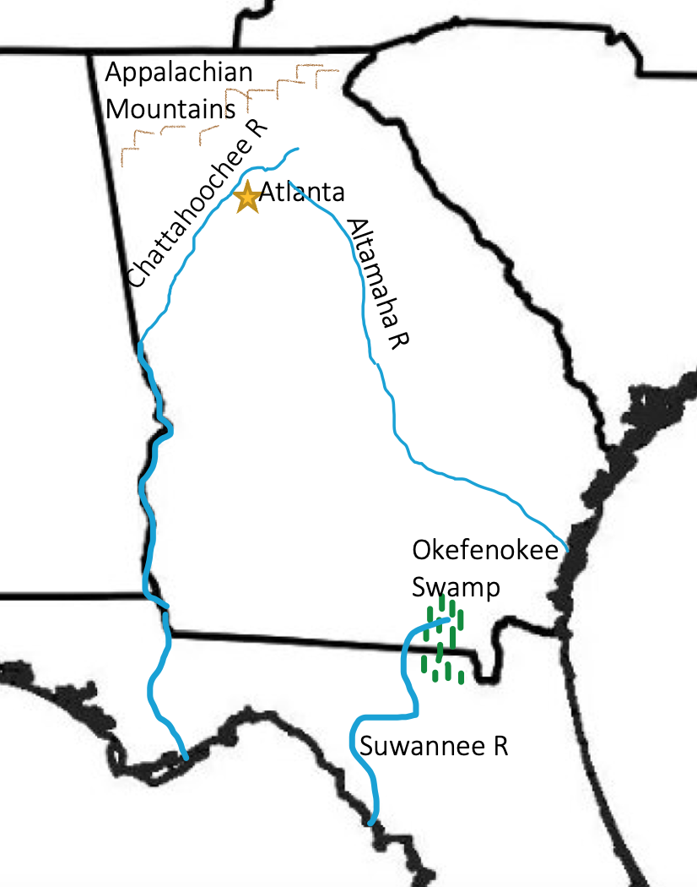

Alabama

Origin of Name
Indigenous People of the territory

Book to Read
* Stitchin' and Pullin': A Gee's Bend Quilt by Patricia McKissack
* It Jes' Happened by Don Tate (About artist Bill Taylor)
* With Books and Bricks: How Booker T. Washington Build a School by Suzanne Slade

Links to View
* Alabama: From the Mountains to the Coast (4 1/2 min, no words)
* Outdoor Alabama: In The Field (4 min ; about wildlife)
* Chattahoochee River – GPB Education (2:45 min)
* The Folk Art of Bill Taylor – CBS Sunday Morning (5 min)
* Women Who’ve Made Gee’s Bend Quilts Are Finally Receiving Their Due - Today (4 min)

Geographical Features to Map
Capital: Montgomery ; Beginning of Appalachian Mountains ; Mobile Bay; Tennessee River ; Alabama River ; Chattahoochee River
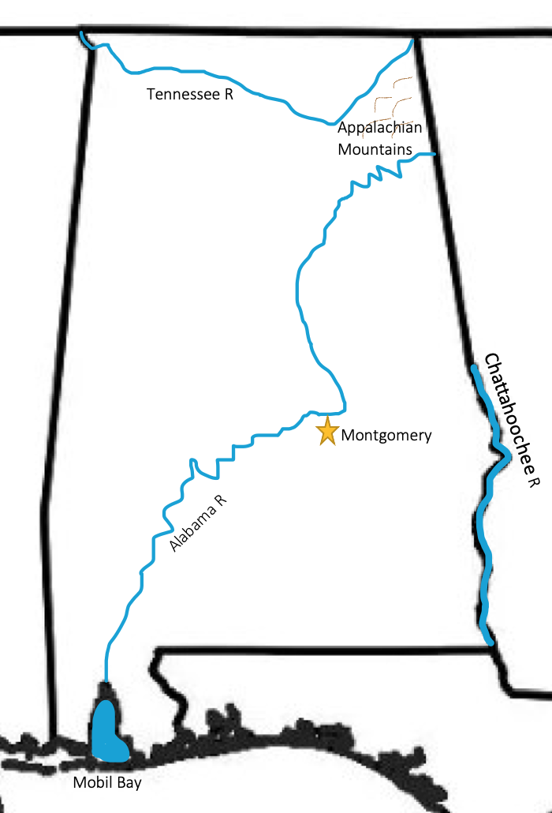

Mississippi

Origin of Name
Ojibwe people of Minnesota name for the river meaning “big river.”

Book to Read
* Crossing Bok Chitto: A Choctaw Tale of Friendship & Freedom by Tim Tingle
* The Secret World of Walter Anderson by Hester Bass (artist who painted on Horn Island)
- Lucy's Cave: A Story of Vicksburg, 1863 by Karen B. Winnick
- Elvis: The Story of the Rock and Roll King by Bonnie Christensen

Links to View
* Traces Through Time: Natchez Trace Parkway (17 min)
* Natchez Trace Parkway – NPS map
* The Mississippi Delta – Mississippi Public Broadcasting (4 min)
* The Mississippi Sandhill Crane National Wildlife Refuge (3 min)
* The Mississippi Petrified Forest – Mississippi Public Broadcasting (8 min)
- Walter Anderson Art

Geographical Features to Map
Capital: Jackson ; Mississippi River ; Pearl River ; Yazoo / Tallahatchie Rivers ; Delta ; Natchez Trace ; Horn Island (see Walter Anderson book)
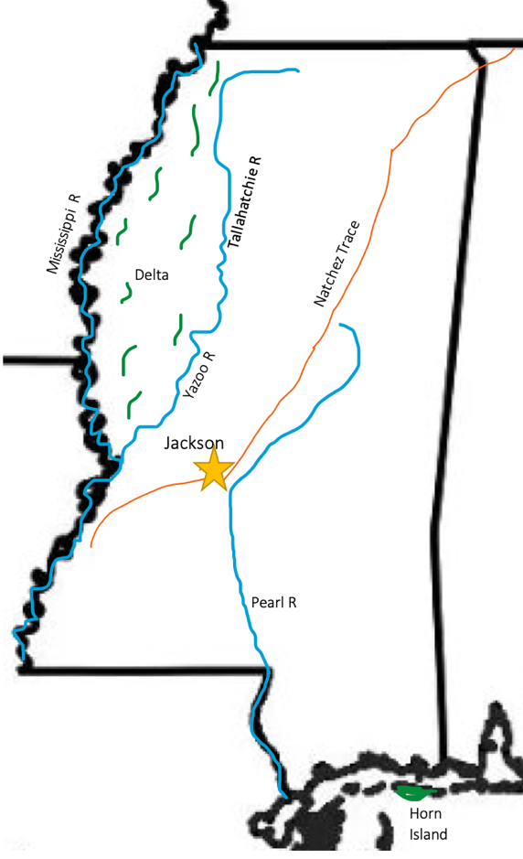

Louisiana

Origin of Name
In honor of King Louis XIV when the land was claimed for France

Book to Read
* Trombone Shorty by Troy Andrews
* Over in the Wetlands: A Hurricane-on-the-Bayou Story by Caroline Starr Rose

Links to View
* Louisiana’s Northshore Swamp (4 min)
* How Avery Island Became a Refuge for Birds – Smithsonian Channel (3 min)
* New Orleans: The Birthplace of Jazz (3 min)
- Where did Louisiana Acadians come from? (7 ½ min)
- French Quarter Tour (9 ½ min)

Geographical Features to Map
Capital: Baton Rouge ; Mississippi River ; New Orleans ; Lake Pontchartrain ; Sabine River ; Red River ; Barataria Bay ; Atchafalya Bay ; Swamps
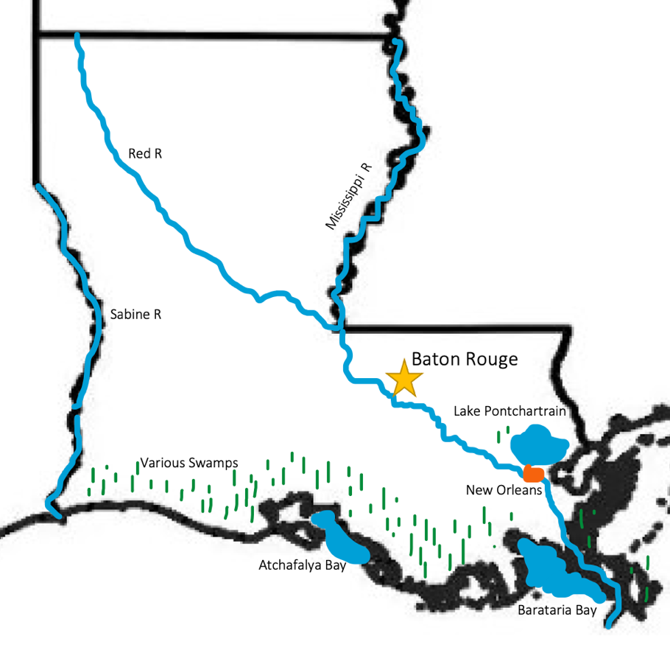

South Carolina

Origin of Name
Originally French explorers named a fort there after their King Charles IX (citation). The British kept the name In honor of King Charles – Carolus is Latin for Charles.

Book to Read
* Palmetto: Symbol of Courage by Kate Salley Palmer
- Circle Unbroken by Margot Theis Raven
- Turtle Tracks by Sally Harman Plowden

Links to View
* Discover Congaree National Park (to min 3:19)
* Savannah River (2 min)
* Gullah Traditions of the South Carolina Coast (6 min)
- Gullah Culture (resources, map of Sea Islands, and videos)
- The Colony of South Carolina Founded in 1663 – includes info on Charleston (3 min)
- The Art of Sweetgrass Baskets (4 min)

Geographical Features to Map
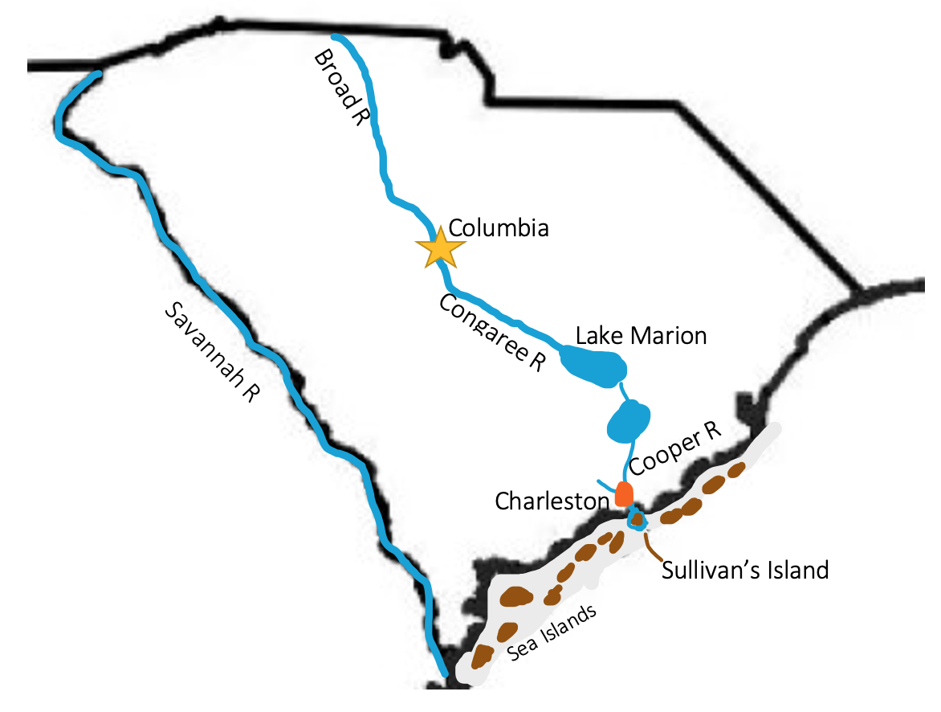
Capital: Columbia ; Savannah River ; Charleston & Sullivan’s Island ; Broad River, Congaree River, Lake Marion, Copper River ; Sea Islands

North Carolina

Origin of Name
Originally French explorers named a fort there after their King Charles IX (citation). The British kept the name In honor of King Charles – Carolus is Latin for Charles.

Book to Read
* An Island Scrapbook: Dawn to Dusk on Barrier Island by Virginia Wright-Frierson
- North Carolina’s Amazing Coast by David Bryant
- Miss Dorothy and Her Bookmobile by Gloria Houston
- First Flight: The Story of Tom Tate and the Wright Brothers (I Can Read Level 4)

Links to View
* The Ecology of the Outer Banks (4 min)
* Ashe County: The New River (to min 2:40)
* This Is Where the Wright Brothers First Flew (2 min)
* North Carolina Gold Rush (4 min) – see NC State Park

Geographical Features to Map
Capital: Raleigh; Appalachian Mountains ; New River Source ; Outerbanks ; Kill Devil Hills ; Roanoke River ; Albemarle Sound ; Pamlico Sound ; Reed Gold Mine
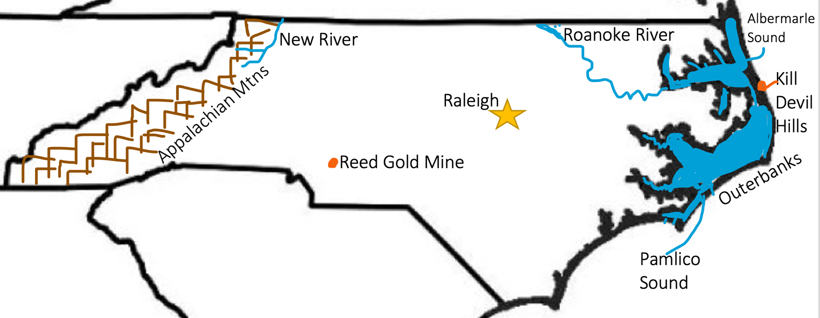

Tennessee

Origin of Name
A Cherokee tribal village called Tanasee or Tanasi

Book to Read
* Sequoyah: The Cherokee Man Who Gave His People Writing by James Rumford
- John Philip Duck by Patricia Polacco (fictional story of the Peabody Ducks)

Links to View
* The Singing River of the Yuchi People (2 min)
* All Things Cherokee – About Tanasi Village site
- Peabody Ducks (5 min)
- Tennessee River Valley (15 min – start at min 4:44)

Geographical Features to Map
Capital: Nashville ; Memphis ; Tanasee (Cherokee unofficial capital) ; Appalachian Mountains ; Tennessee River ; Cumberland River ; Mississippi River
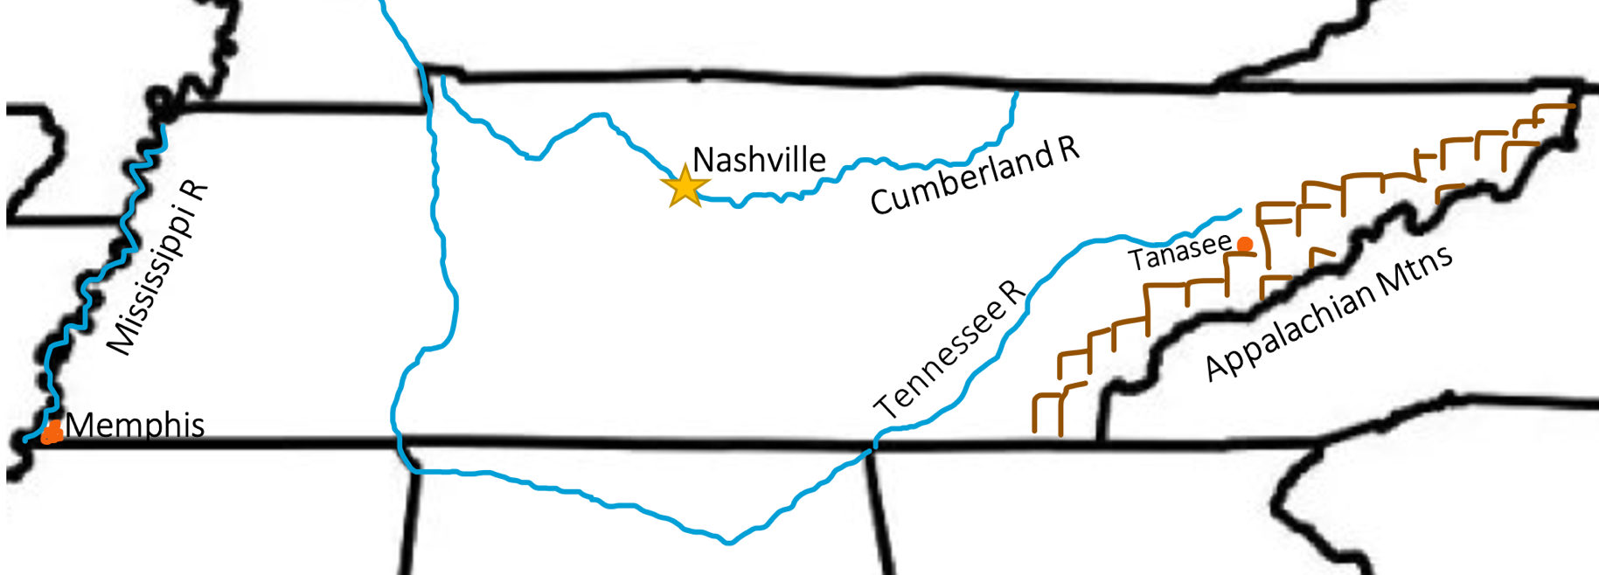

Arkansas

Origin of Name
An Algonkian word from the peoples of the Ohio Valley referring to the Quapaw people as “south wind.” The Quapaw people lived in current day Arkansas.

Book to Read
* n/a

Links to View
* Ozark Plateau (2 ½ min)
* Ouachita Mountains pt 1 (1 ½ min)
* Ouachita Mountains pt 2 (2 min)
* Arkansas River Valley (2 min)
* Arkansas River Valley 2 (9 min)
- Arkansas Secretary of State: How Did Arkansas Get Its Name
- Arkansas’s First People – PBS (1 ½ hours)

Geographical Features to Map
Capital: Little Rock ; Ozarks; Ouachita Mountains ; Arkansas River ; Mississippi River ; Crater of Diamonds
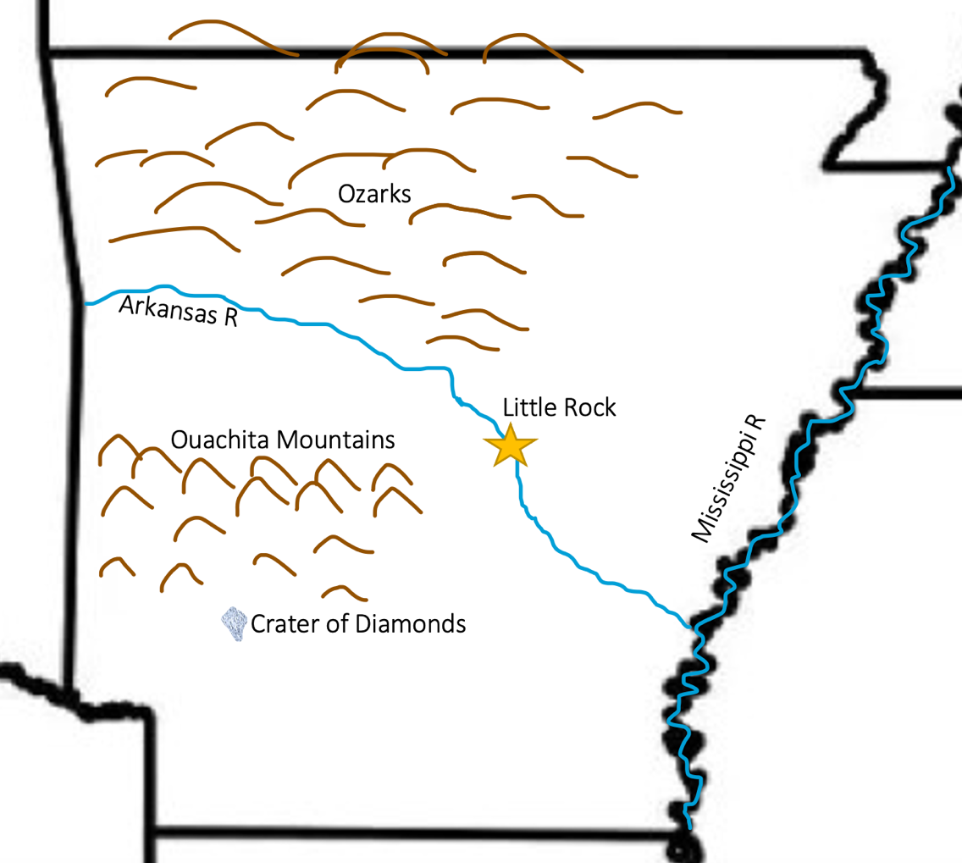

Virginia

Origin of Name
Sir Walter Raleigh named the state in honor of Queen Elizabeth, the “Virgin Queen of England.”

Book to Read
* Captain John Smith’s Big and Beautiful Bay by Rebecca C. Jones
- Thomas Jefferson Builds a Library by Barb Rosenstock
- Fifty Cents and a Dream: Young Booker T. Washington by Jabari Asim

Links to View
* Virginia’s First People (30 min, recommended: to 7:00 then 23:07 - end)
* Blue Ridge Parkway (5 min)
- Nansemond Indian Nation: Restoring Connections Through Oysters (3 ½ min)
- Historic Jamestown (10 ½ min)
- James River Facts and Trivia (7 min)
- James River Batteau (1 min)

Geographical Features to Map
Capital: Richmond ; Jamestown ; Appalachian Mountains ; Blue Ridge Mountains ; Shenandoah Valley ; New River ; James River ; Roanoke River ; Delmarva Peninsula ; Chesapeake Bay ; Nansemond River
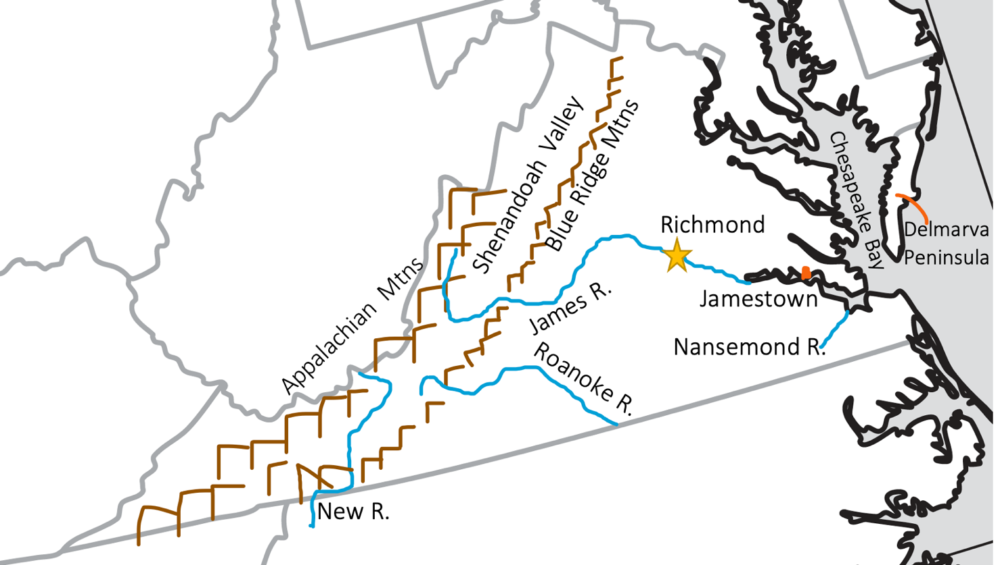
Kentucky

Origin of Name
Origin debated. Probably derived from a Native American word.

Book to Read
* Lift Your Light a Little Higher: The Story of Stephen Bishop: Slave-Explorer by Heather Henson (You Tube read-a-loud of the book)
- Last Black King of the Kentucky Derby by Crystal Hubbard

Links to View
* Woodland Native American Mounds (7 min)
* Mammoth Cave National Park (5 min)
* Daniel Boone’s Wilderness Road - Cumberland Gap (3 min)
- Inside the Heavily Guarded Fort Knox (6 min)

Geographical Features to Map
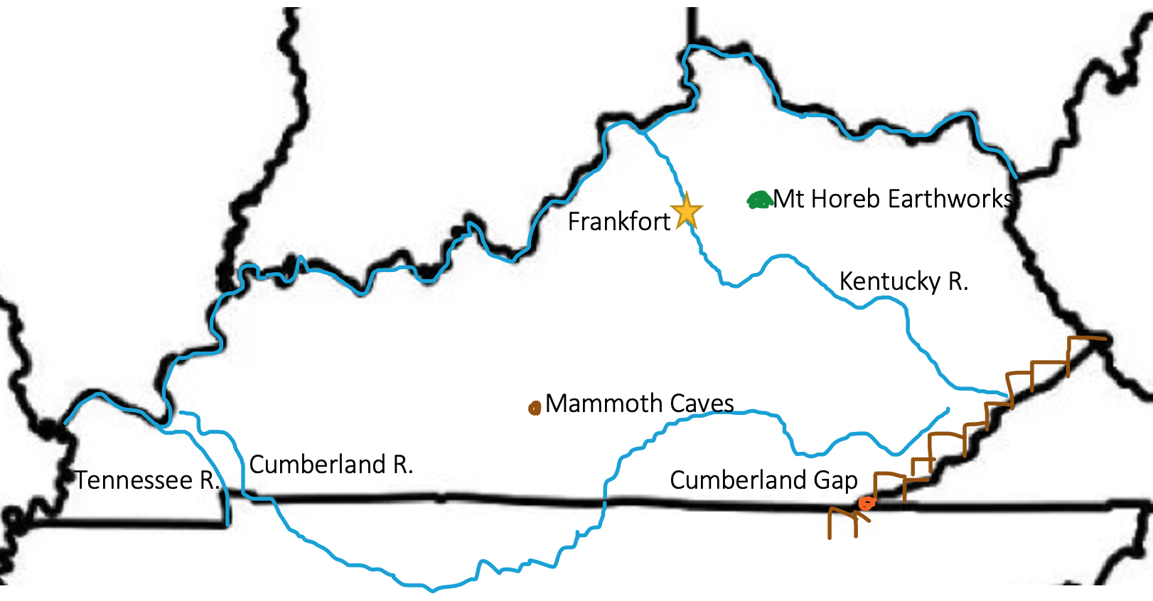
Capital: Frankfort ; Ohio River ; Kentucky River ; Cumberland River ; Tennessee River ; Mammoth Caves ; Appalachian Mountains ; Cumberland Gap

Quick Reference by State

Alabama: Capital: Montgomery ; Beginning of Appalachian Mountains ; Mobile Bay; Tennessee River ; Alabama River ; Chattahoochee River

Florida: Tallahassee ; Lake Okeechobee ; Everglades ; Florida Keys

Georgia: Capital: Atlanta ; Chattahoochee River ; Altamaha River ; Okefenokee Swamp ; Suwannee River ; Appalachian Mountains

Kentucky: Capital: Frankfort ; Ohio River ; Kentucky River ; Cumberland River ; Tennessee River ; Mammoth Caves ; Appalachian Mountains ; Cumberland Gap

Louisiana: Capital: Baton Rouge ; Mississippi River ; New Orleans ; Lake Pontchartrain ; Sabine River ; Red River ; Barataria Bay ; Atchafalya Bay ; Swamps

Mississippi: Capital: Jackson ; Mississippi River ; Pearl River ; Yazoo / Tallahatchie Rivers ; Delta ; Natchez Trace ; Horn Island

North Carolina: Capital: Raleigh ; Appalachian Mountains ; New River Source ; Outerbanks ; Kill Devil Hills ; Roanoke River ; Albemarle Sound ; Pamlico Sound ; Reed Gold Mine

South Carolina: Capital: Columbia ; Savannah River ; Charleston & Sullivan’s Island ; Broad River, Congaree River, Lake Marion, Copper River ; Sea Islands

Tennessee: Capital: Nashville ; Memphis ; Tanasee (Cherokee unofficial capital) ; Appalachian Mountains ; Tennessee River ; Cumberland River ; Mississippi River

Virginia: Capital: Richmond ; Jamestown ; Appalachian Mountains ; Blue Ridge Mountains ; Shenandoah Valley ; New River ; James River ; Roanoke River ; Delmarva Peninsula ; Chesapeake Bay ; Nansemond River

