Chapter 1. The Sahara Yawns

Summary: Northern Africa turned into a desert. People learned to live in the changing habitats. The first African communities developed around the Nile River – Kush and Egypt.

Timeline: 62,000 BCE invention of bow and arrow

Links: Africa Map with Sahara Desert ; Seterra printable maps of Africa ; Maps of Ancient Egypt ; Egypt about 1500 BC

Map: Sahara, Nile River, Kush, Egypt
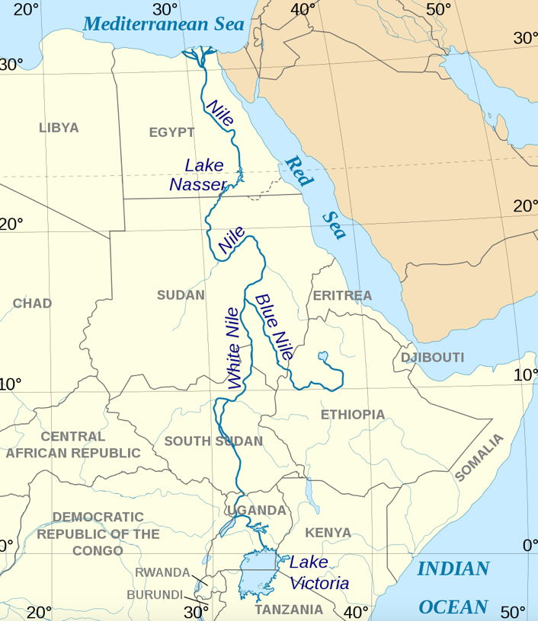
Map from Wikimedia

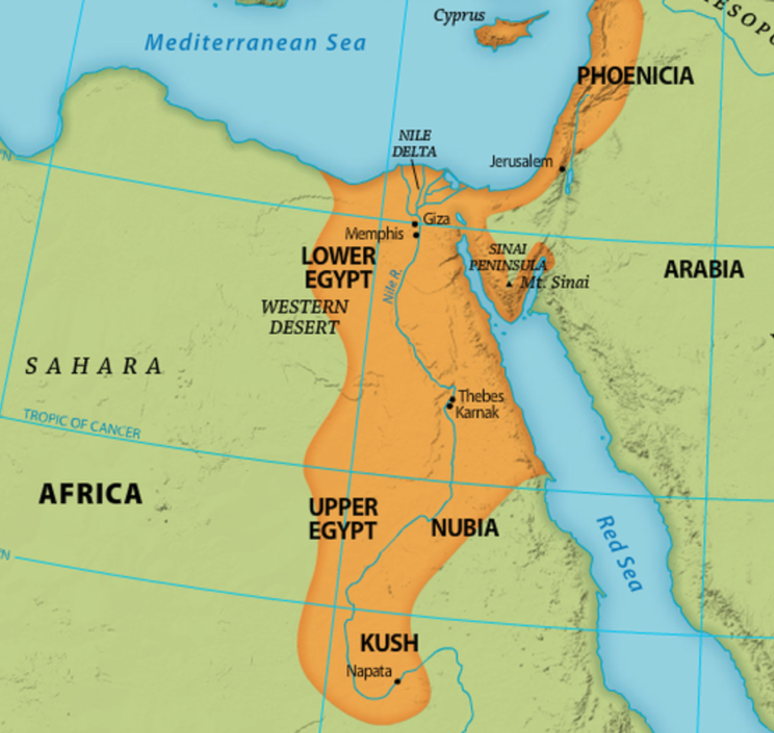

Map from here

Name:__________________________________ Date:_____________

Chapter 1. The Sahara Yawns

MAP: Sahara, Nile River, Kush, Egypt

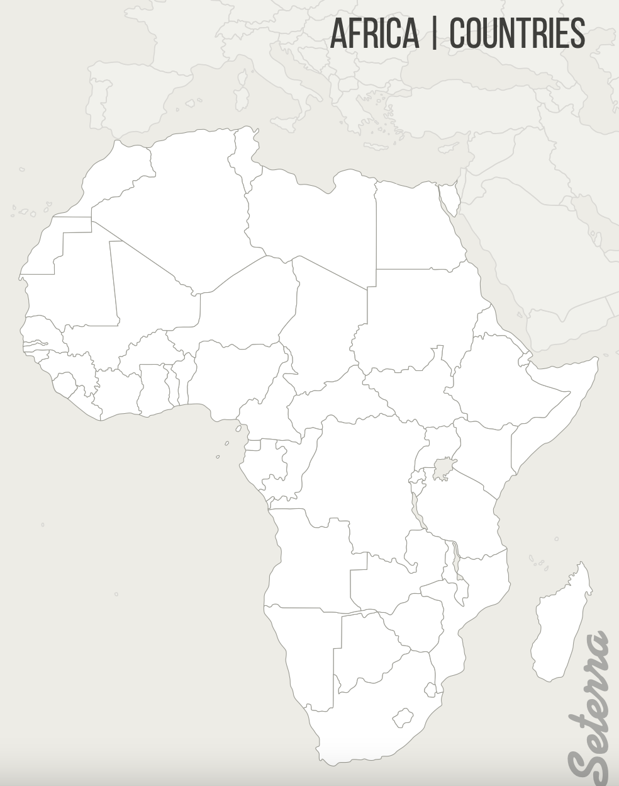
Map from Seterra maps

Chapter 2. Menes: Creator of Dynasties

Part 1 (Pages 6-10)

Summary: Menes is from Upper Egypt. He unites Upper and Lower Egypt becoming the first Pharoah (though he was not called that until later). He uses religion to unite the people, telling them he is a deity and the god Horus’ representative on earth. He marries a woman from Lower Egypt to further unite the country.

Timeline: 3032 BCE – Menes unites Egypt & becomes first Pharoah

Links: Video – The First Pharaoh

Map: Upper Egypt, Lower Egypt, Nile River, Mediterranean Sea

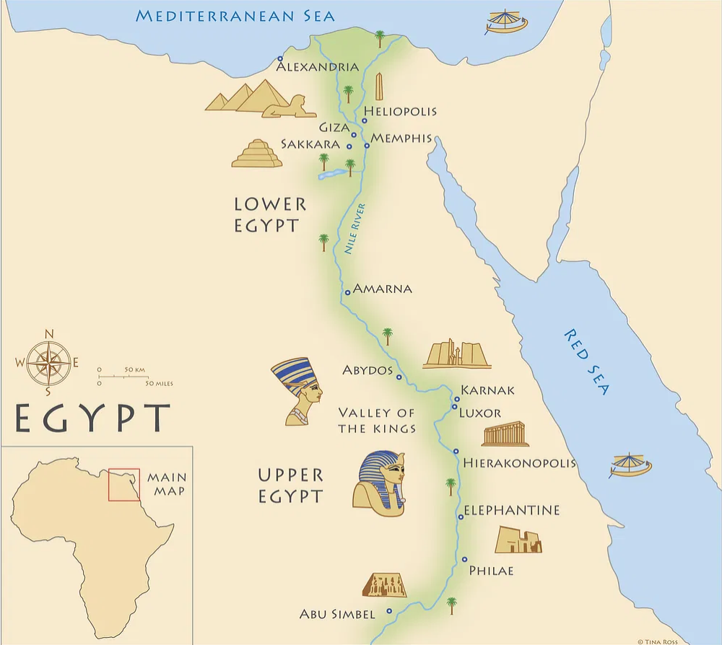
Map from worldhistory.org

Name:__________________________________ Date:_____________

Chapter 2. Menes: Creator of Dynasties - Part 1

MAP: Upper Egypt, Lower Egypt, Nile River, Mediterranean Sea

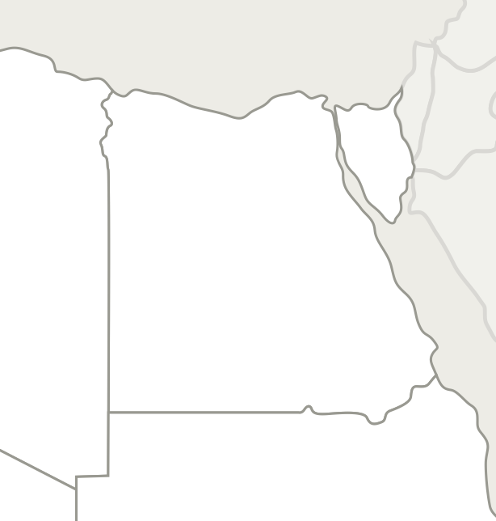
Map from Seterra maps

Chapter 2. Menes: Creator of Dynasties

Part 2 (Pages 10-15)

Summary: Menes sets out to further unite the country by building a capital at the border between the regions. He has to reroute the Nile to do so. He builds the city on an island. It is originally called White Walls, and later Memphis. It is where current-day Cairo is located. When Menes dies, one of his wives – Neithotep - takes over ruling until one son becomes the next Pharoah. Menes is buried in Abydos in an elaborate ceremony that includes killing all the people who will accompany him to the afterlife.

Timeline: n/a

Links: Abydos Wikipedia ; Abydos – World Monument Fund

Map: Abydos, Memphis (Cairo), Nile River

Map from worldhistory.org

Name:__________________________________ Date:_____________

Chapter 2. Menes: Creator of Dynasties - Part 2

MAP: Abydos, Memphis (Cairo), Nile River

Map from Seterra maps

Chapter 3. Merneith: A Queen Erased

Summary: Merneith was the granddaughter of Menes. When her father died, her brother Djer became Pharoah and she became one of his wives. When Djer died, their son Den was selected to succeed, but he was only 10. Merneith reigned as regent. We know about her from her tomb and writing on her son’s tomb.

Timeline: n/a

Map: Memphis, Sinai, Nile, Abydos

Sinai
Peninsula
Map from worldhistory.org

Name:__________________________________ Date:_____________

Chapter 3. Merneith: A Queen Erased

MAP: Memphis, Sinai, Nile, Abydos

Map from Seterra maps

Chapter 4. The Dawn of Egypt

Summary: Egypt was trading with nations all around the Mediterranean. There was a strict social hierarchy in place.

Timeline: n/a

Map: Mediterranean, Kush, Nile River, Byblos Lebanon, Syria, Cyprus, Crete, Greece, Italy, Rome
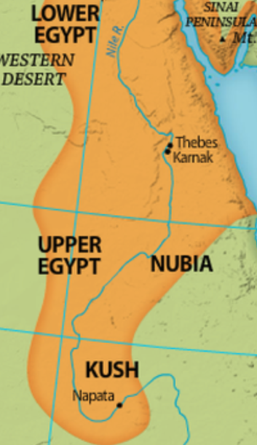
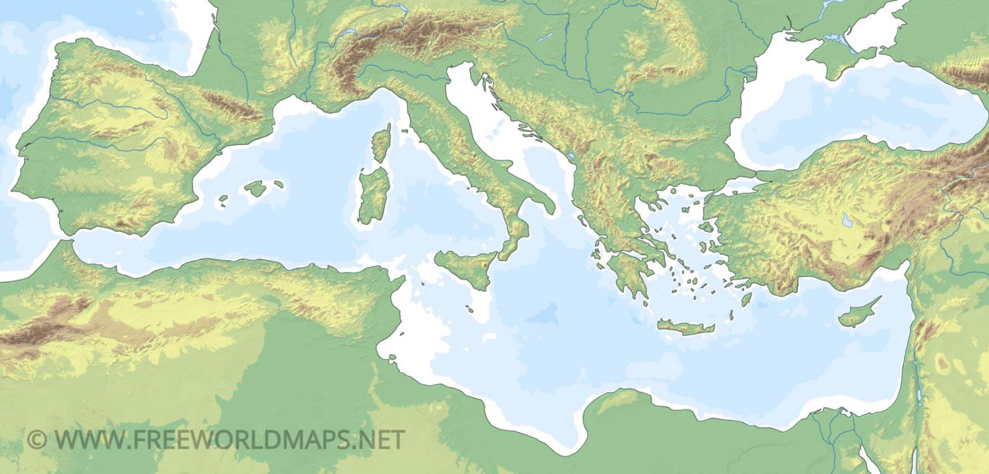
Rome
Byblos
Italy
Greece
Cyprus
Crete
Mediterranean Sea
Lebanon
Syria
Map from freeworldmaps.net

Syria

Name:__________________________________ Date:_____________

Chapter 4. The Dawn of Egypt

MAP: Mediterranean Sea, Nile River, Byblos Lebanon, Syria, Cyprus, Crete, Greece, Italy, Rome

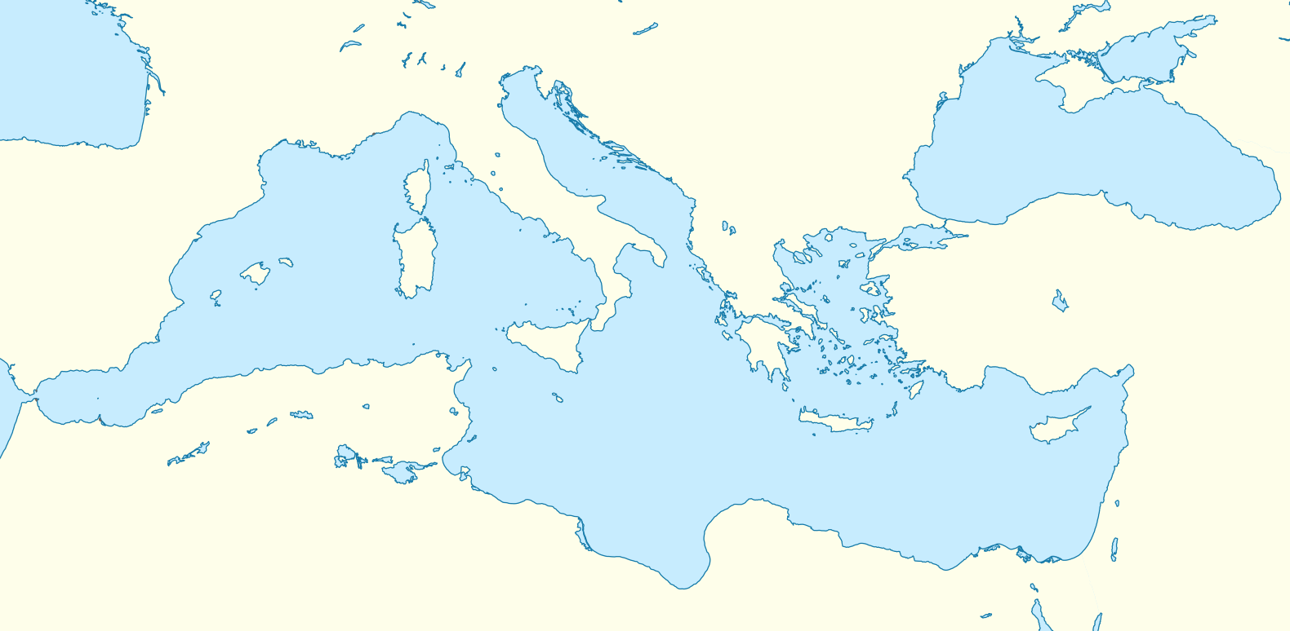
Map from Wikimedia

Chapter 5. Imhotep: From Peasant to God

Summary: Imhotep is born of lower class, his father an architect. He becomes a doctor to the Pharoah and then vizier for Pharoah Djoser who brings back peace and prosperity, even expanding the empire. Imhotep builds the first pyramid for Djoser and writes medical texts. After he died he was worshiped as a god.

Timeline: 2700 BCE - Imhotep builds first pyramid (Step Pyramid)

Links: Egypt’s First Pyramid ; Nat Geo Video: Inventor of the First Pyramid

Map: Sinai, Libya, Nubian lands, Elephantine, Saqqara

Libya
Sinai
Peninsula
Nubian
Lands

Map from worldhistory.org

Name:__________________________________ Date:_____________

Chapter 5. Imhotep: From Peasant to God

MAP: Sinai, Libya, Nubian lands, Elephantine, Saqqara

Map from Seterra maps

Chapter 6. Metal Bonds

Summary: Copper was mined throughout Africa and it was at first more prized than gold. Then Egyptians liked that gold did not rust and imported it from all over.

Timeline: 1000 BC Iron Discovered

Map: (See Map on page 48) equator, Bembe, Angola, Zimbabwe, Mauritania, Niger, Kush, Lake Chad, Nigeria, Mali

Mali
Nigeria
Lake Chad
Nile River
Kush
Niger
Mauritania
Angola
Zimbabwe
Bembe
Equator
Map from Seterra maps

Name:__________________________________ Date:_____________

Chapter 6. Metal Bonds

MAP: Equator, Bembe, Angola, Zimbabwe, Mauritania, Niger, Kush, Lake Chad, Nigeria, Mali

Map from Seterra maps

Chapter 7. Aesop: The Wisest Man in the Ancient World

Summary: Aesop was Ethiopian but captured and was enslaved in Greece.

Timeline: About 500 BCE – Aesop lived

Map: Ethiopia, Samos, Mediterranean Sea, Aegean Sea
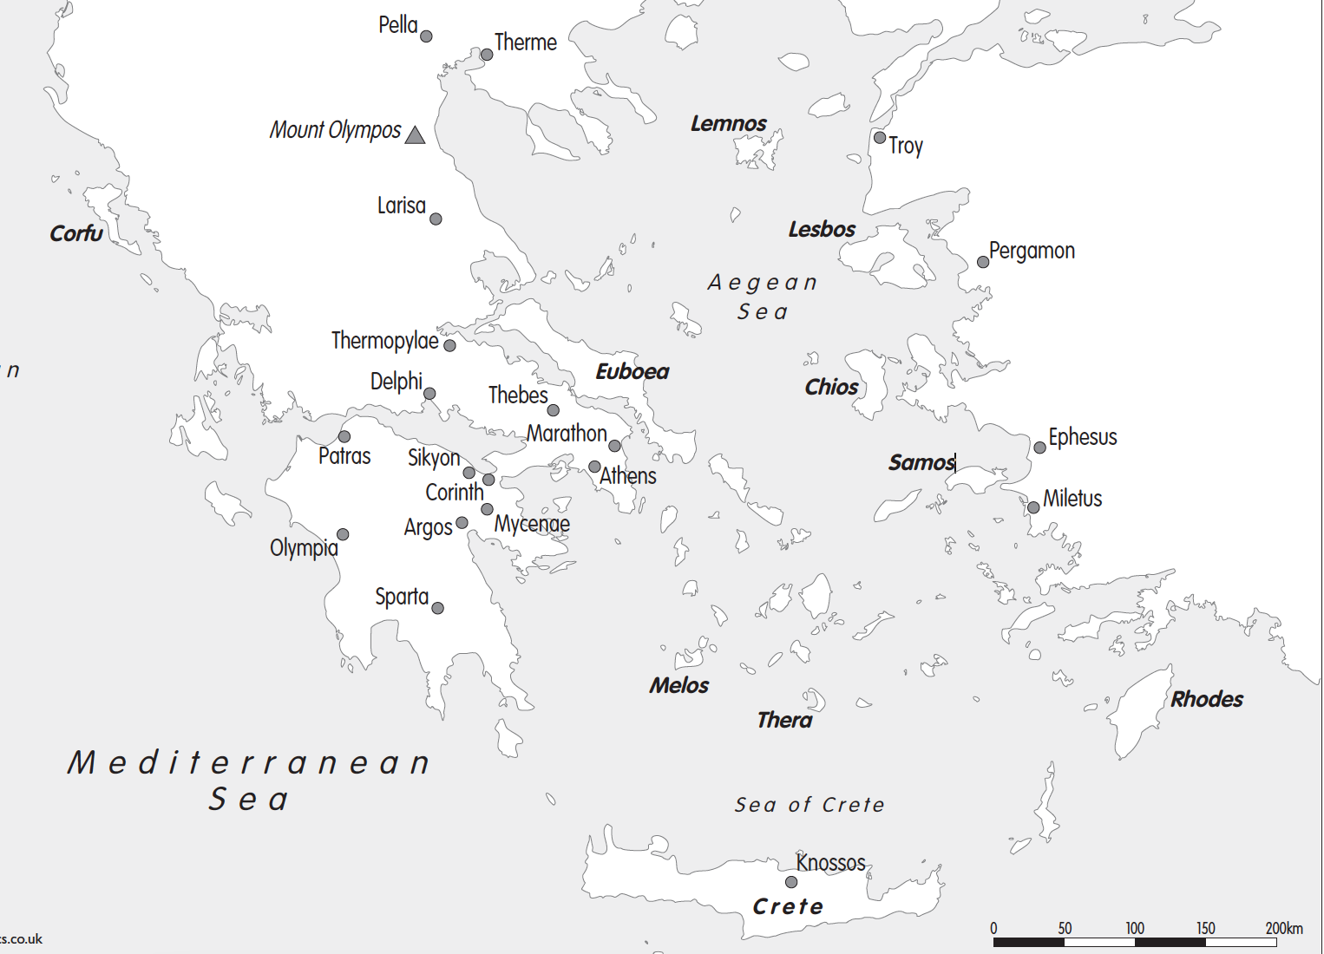

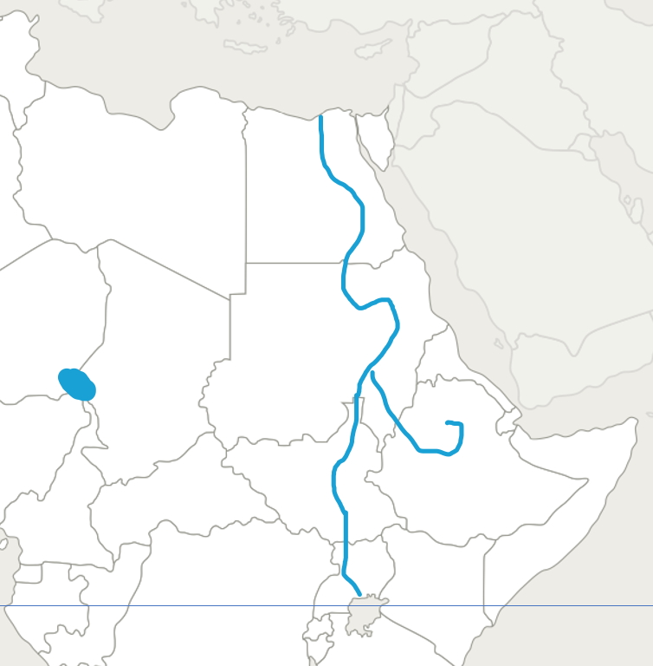
Map from Cosmographic.com

Ethiopia

Name:__________________________________ Date:_____________

Chapter 7. Aesop: The Wisest Man in the Ancient World

MAP: Ethiopia, Samos, Mediterranean Sea, Aegean Sea

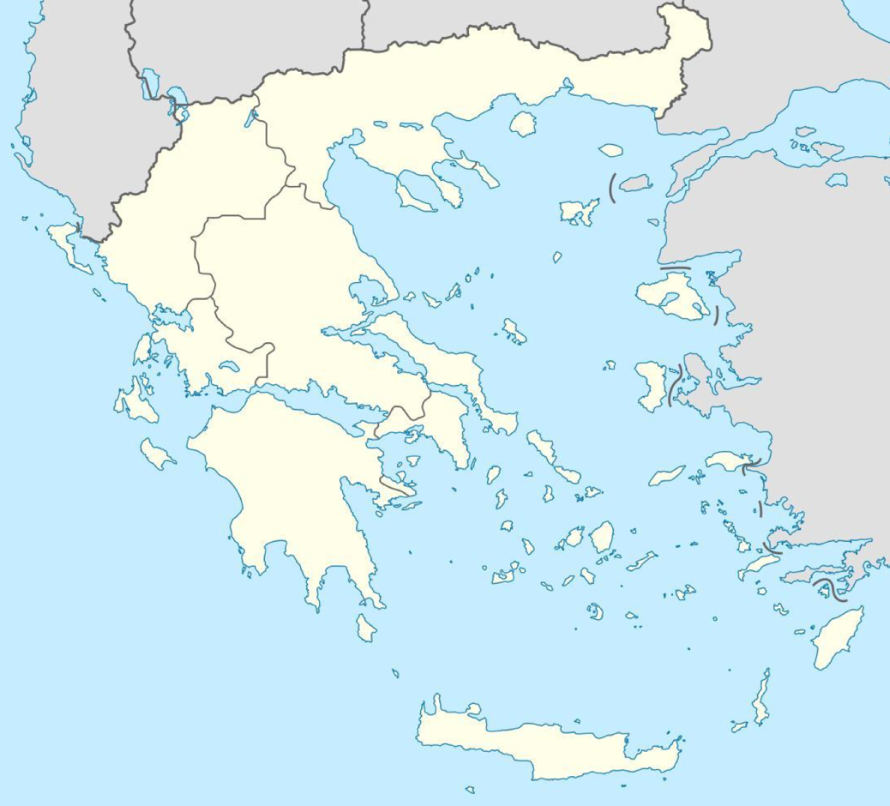

Map from greecemap360.com

Chapter 8. Across the Waves

Summary: Carthage becomes a major center of trade and is a rival of Rome.

Timeline: n/a

Link: Map of Carthage territory in 323 BCE ; About Ancient Phonecia ; Phoneician territory map

Map: Carthage, Greece, Rome, France, Spain, Phonecia, Libya, Egypt, Sicily, Balearic Islands, Sardinia, Corsica
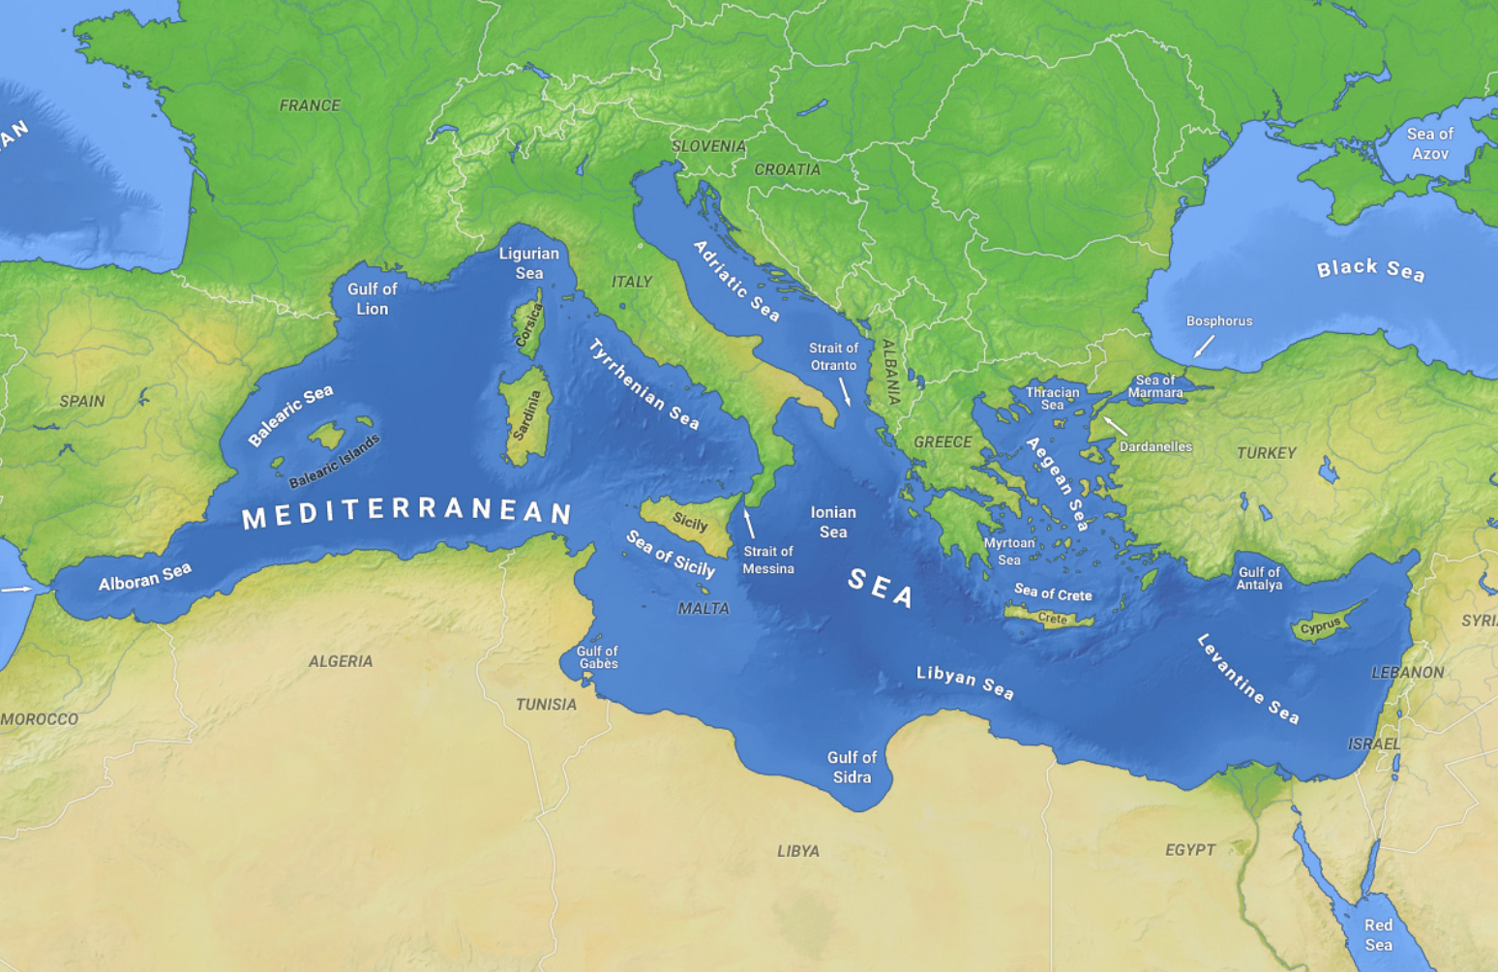
Phonecia
Rome
Carthage

Map from Wikipedia

Name:__________________________________ Date:_____________

Chapter 8. Across the Waves

MAP: Carthage, Greece, Rome, France, Spain, Phonecia, Libya, Egypt, Sicily, Balearic Islands,

Sardinia, Corsica
Map from Wikimedia

Chapter 9.Hannibal Barca: Unparalleled Military Strategist

Summary: Hannibal was born in Carthage during first Punic War. His father was general. Rome won that war and Carthage had to pay tribute. Hannibal elected general and attacks Roman city of Saguntum in Spain, starting Second Punic War. He then crosses the Alps to fight Rome. He tricks the Romans by tying lanterns to cows. He ultimately loses the war but his military genius lives on.

Timeline: 202 BCE Scipio triumphs over Hannibal, ending Second Punic War

Link: Map of Carthage territory in 323 BCE ; About Ancient Phonecia

Map: Carthage, Rome, Spain, Saguntum, Alps, Lake Trasimene, Capua, Cannae, Numidia
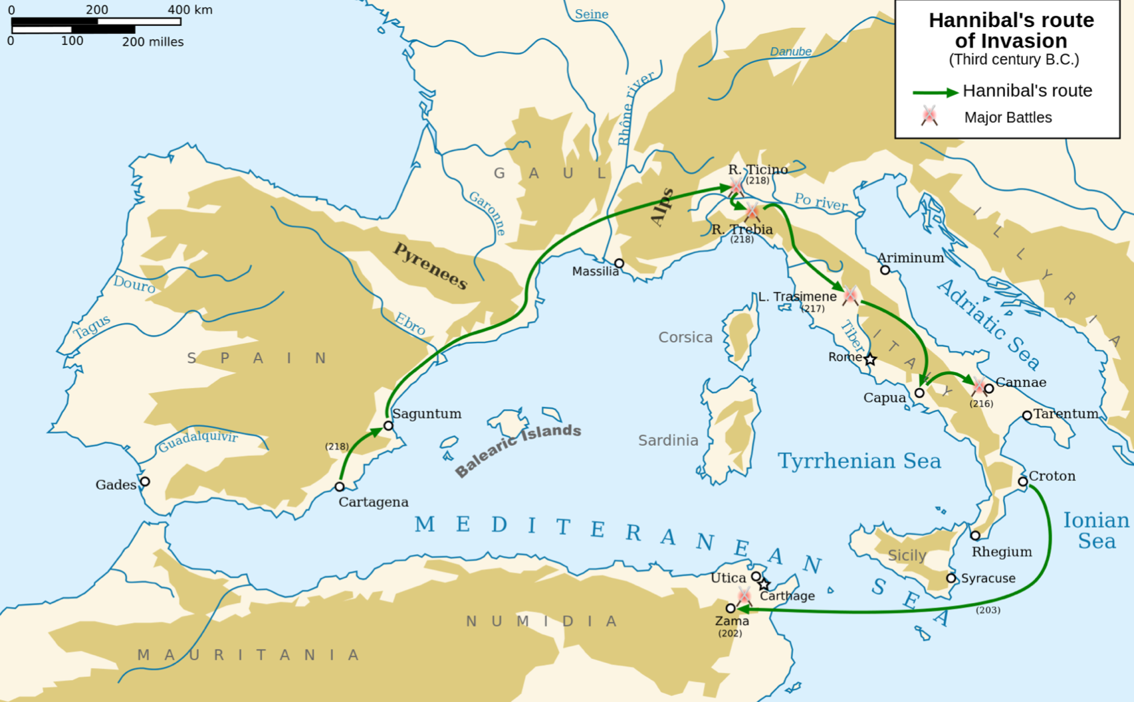

Map from Wikipedia

Name:__________________________________ Date:_____________

Chapter 9.Hannibal Barca: Unparalleled Military Strategist

MAP: Carthage, Rome, Spain, Saguntum, Alps, Lake Trasimene, Capua, Cannae, Numidia
Map from Wikimedia

Chapter 10. Terence: North African Playwright

Summary: Terrence was a slave in Rome from Carthage, whose owner recognized his storytelling ability and set him free. Terence developed a new style called the comedy of manners, taking characters from multiple Greek plays and writing a new story for the Romans.

Timeline: n/a

Map: Carthage, Rome

Rome

Carthage

Map from Wikipedia

Name:__________________________________ Date:_____________

Chapter 10. Terence: North African Playwright

MAP: Carthage, Rome

Map from Wikimedia

Chapter 11. Amanirenas: Warrior, Diplomat, Queen

Summary: Rome conquered Egypt because it needed the food grown in Egypt. Then it tried expanding into Kush for its resources. Amanirenas fought and eventually negotiated a peace that included a trade deal. She had a head of a statue of Caesar Augustus under temple steps so she and the Kush people could trample it every day. It was not discovered until 1910.

Timeline: n/a

Link: Ancient Kingdom of Kush ; City of Philae ; City of Syene ; City of Qsar Ibrim

Map: Kush, Egypt, Nile River, Arabia, Syene, Philae, Napata, Qsar Ibrim

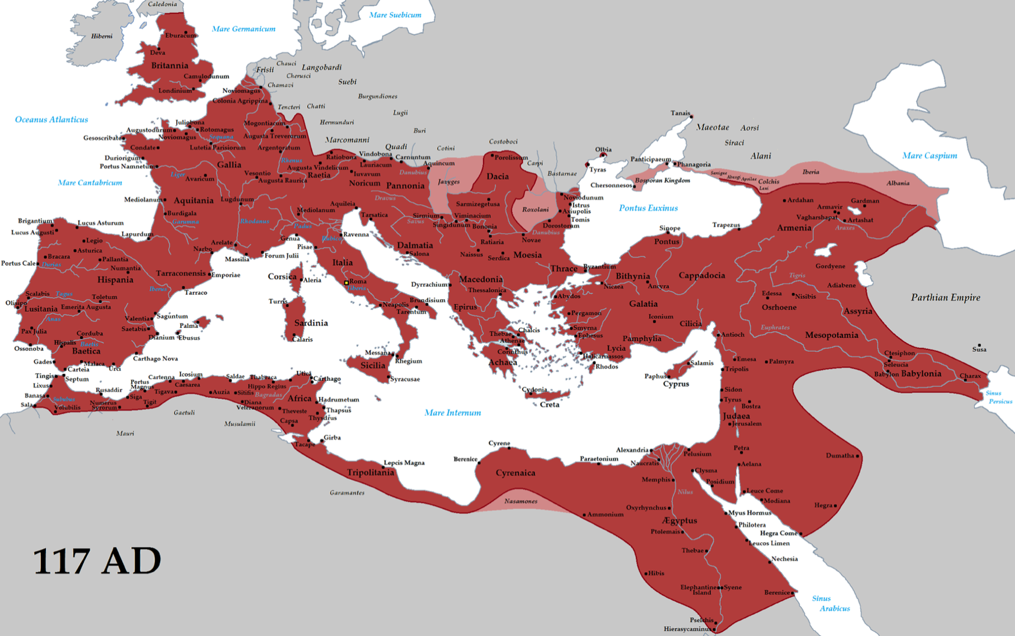
Roman Empire:

Map from Wikipedia

Chapter 11. Amanirenas - Continued

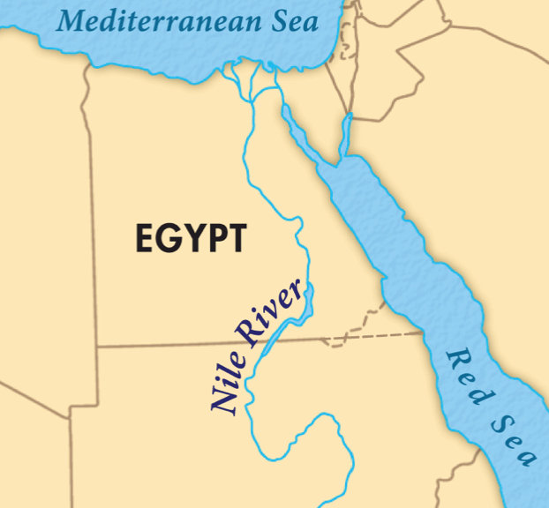
Qsar Ibrim
Philae &
Syrene
Napata
Kush
Arabia

Map from Britannica

Name:__________________________________ Date:_____________

Chapter 11. Amanirenas: Warrior, Diplomat, Queen

MAP: Kush, Egypt, Nile River, Arabia, Syene, Philae, Napata, Qsar Ibrim

Map from Seterra maps

Chapter 12. Where Few Dared to Tread

Summary: Romans tried to cross the Sahara but gave up trying, Egyptians never bothered. But Berber people, originally from Carthage, had it figured out. They used camels and knew how to navigate it. They didn’t trade; they were bandits.

Timeline: n/a

Map: Sahara, Carthage, Morocco, Egypt

Sahara Desert
Carthage
Morocco
Egypt
Map from Seterra maps

Name:__________________________________ Date:_____________

Chapter 12. Where Few Dared to Tread

MAP: Sahara, Carthage, Morocco, Egypt
Map from Seterra maps

Chapter 13. Tin Hinan: Founding a City on the Dunes

Summary: From the Tuareg peoples, who were part of the Berber, Tin Hinan was a woman who had a bent back and needed a cane to walk. Yet she found an Oasis in the Sahara desert to build a city to facilitate trading across the Sahara. She was the first Tuareg queen and started a matrilinear culture in which the men were veiled. Her grave was found in 1925.

Timeline: 4th century CE

Links: The Tomb of Tin Hinan ; Wikipedia – legends of Tin Hinan ; Hoggar Mountains

Map: Sahara, Tafilalet (region), Morocco, Ahaggar Moutains, Algeria, Ghana
Tafilalet Region
Sahara Desert
Ghana
Ahaggar Mountains
Algeria
Morocco
Map from Seterra maps

Name:__________________________________ Date:_____________

Chapter 13. Tin Hinan: Founding a City on the Dunes

MAP: Sahara, Tafilalet (region), Morocco, Ahaggar Moutains, Algeria, Ghana

Map from Seterra maps

Chapter 14. Across the Golden Sand

Summary: Description of trading happening now that the Sahara was crossable. Islam spread through-out the continent as well.
Bure Mine
Bambuk Mine
Kingdom
of Axum
Ethiopia
Kush
Persia
(see full map here)
Saudi Arabia
Great Zimbabwe
Spain
Guinea
Niger River
Mali
Cote d’Ivoire
Ghana
Burkina Faso
Senegal
Nile River
Taghaza
Audaghost
Mauritania
Sijilmasa
Niger
Takedda
Tangier
Algiers
Cairo
Tripoli
Tunis

Name:__________________________________ Date:_____________

Chapter 14. Across the Golden Sand

Chapter 15. Mansa Musa: The Richest Man of All Time (Part 1)

Summary (to page 106): Sundiata Keita, Mansa’s grandfather, established the kingdom of Mali. His brother Abubakari II inherited the throne. He was an explorer and when he didn’t return from an attempt to sail across the Atlantic, Mansa Musa ruled. Mansa expanded the territory and ruled his people well during a time of peace.

Timeline: 1312, Mansa Musa comes to full power

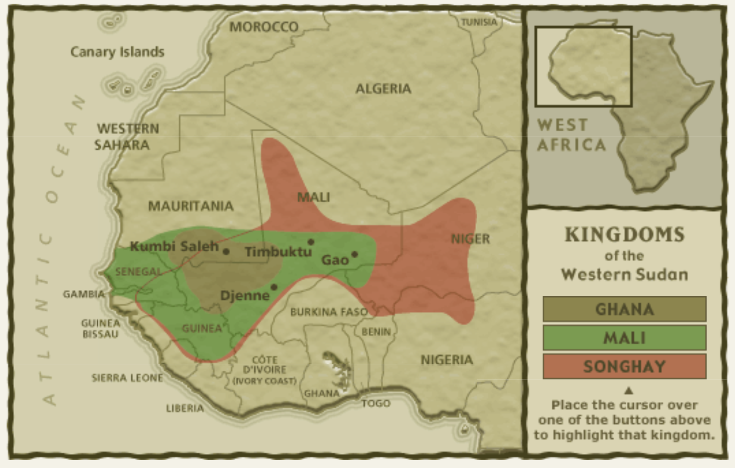
Map: Ancient Mali, Ancient Empire of Ghana, City of Gao, Niger River, Gambia
Niger River

Map from Africa.si.edu

Name:__________________________________ Date:_____________

Chapter 15. Mansa Musa: The Richest Man of All Time (Part 1)

MAP: Ancient Mali, Ancient Empire of Ghana, City of Gao, Niger River, Gambia

Map from Seterra maps

Chapter 15. Mansa Musa: The Richest Man of All Time (Part 2)

Summary: Mansa takes a pilgrimage (hajj) to Meca, spreading his wealth along the way and making diplomatic contacts. He brings back architect Abu Ishaz al-Sahili and commissions mosques in a new style.

Timeline: 1324 Mansu Musa goes on a pilgrimage to Meca

Links: Mansa’s pilgrimage route (a different route than described in the book) ; Video: Timbuktu Mosque

Map: Mecca, Saudia Arabia, Red Sea, Takedda Mines, kingdom of Kanem-Bornu, Cairo, Egypt, Andalusia, Timbuktu (Djinguereber Mosque)
Takedda
Red Sea
Cairo
Egypt
Andalusia
Kingdom of
Kanem-Bornu
Saudia Arabia
Mecca
Timbuktu

Map from Seterra maps

Name:__________________________________ Date:_____________

Chapter 15. Mansa Musa: The Richest Man of All Time (Part 2)

MAP: Mecca, Saudia Arabia, Red Sea, Takedda Mines, kingdom of Kanem-Bornu, Cairo, Egypt, Andalusia, Timbuktu (Djinguereber Mosque)

Map from Seterra maps

Chapter 16. The Catalan Atlas

Summary: King Pedro of Aragon (Spain) commissioned Abraham Cresques to create a map of the known world as a gift for King Charles V of France.

Timeline: 1375 – Catalan Map created

Links: Video: The Catalan Atlas (22 min)

Map: n/a

Chapter 17. The Power of The Griot

Summary: Description of the role of the Griot – the historian/poet/storyteller

Timeline: n/a

Links: n/a

Map: n/a

Chapter 18. Libraries in the Sand

Summary: Timbuktu was a trading city on a route between North and South. After Mansa Musa it became a center of learning. When Morocco (and later France) invaded and what little was left was hidden by the people.

Timeline: 1593 Moroccan invasion of Timbuktu

Map: Timbuktu, Niger valley, Fez, Cairo, Tripoli, Cordoba, Songhai Empire

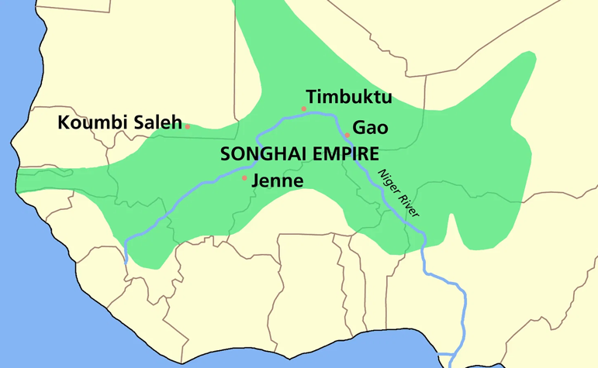
Cordoba
Tripoli
Cairo
Fez
Map from worldhistory.org and Seterra maps

Name:__________________________________ Date:_____________

Chapter 18. Libraries in the Sand

MAP: Timbuktu, Niger valley, Fez, Cairo, Tripoli, Cordoba, Songhai Empire

Map from worldhistory.org and Seterra maps

Chapter 19. Winds of Change

Summary: The Europeans learned how to navigate the Atlantic and no longer needed the overland trade routes. Soon the Europeans were colonizing Africa and stealing people to enslave them.

Timeline: Around the 15th century

Links: What is a caravel

Map: Kingdom of Benin, Niger River, Mande-speaking people, Kongo, Mozambique, Berber, Tuareg, Bantu (territories based on description in book)
Kingdom of Benin
Niger R
Mande
Berber
Kongo
Taureg
Bantu
Mozambique

Name:__________________________________ Date:_____________

Chapter 19. Winds of Change

MAP: Kingdom of Benin, Niger River, Mande-speaking people, Kongo, Mozambique, Berber, Tuareg, Bantu (territories based on description in book)

Chapter 20. Queen Idia, Kingmaker

Summary: Idia was Queen and fought along with her husband. When he died, she helped her son win a civil war to become king. He honored her by giving her an official position and commissioned artwork of her.

Timeline: early 1500s

Map: Kingdom of Benin, Niger River, Benue River, Benin City, Udo, Igala People

Udo
Benin City
Benin
Igala
Benue R
Niger R
Map from Seterra maps

Name:__________________________________ Date:_____________

Chapter Queen Idia, Kingmaker

MAP: Kingdom of Benin, Niger River, Benue River, Benin City, Udo, Igala People

Map from Seterra maps

Chapter 21. Culture Lost

Summary: The Europeans came with guns and overpowered Africans. African culture and history was lost as the artifacts were destroyed and the people taken away so that stories were no longer passed down. But archeologists are discovering how advanced the African peoples were and how they many of their artifacts were traded to or stolen by European countries.

