Lisa Cotting
amblingtogether.com
United states geography
Eastern States

Table of Contents
How I Used This Guide 2
Why we study each state: 2
How we study each state: 3
Maine 4
New Hampshire 5
Vermont 6
Massachusetts 7
Rhode Island 8
Connecticut 9
New York (Long Island) 10
New York (Upstate) 11
New Jersey 12
Pennsylvania 13
Delaware 14
Maryland 15
West Virginia 16
Ohio 17
Quick Reference by State 18

How I Used This Guide

Why we study each state:

Charlotte Mason recommends studying the geography of the child’s country. In Book VI, she says the children “are engaged with the counties of England, county by county, for so diverse are the counties in aspect, history, and occupation, that only so can children acquire such a knowledge of England as will prove a key to the geography of every part of the world, whether in the way of comparison or contrast.” She describes the principle to be followed as the child gets older and starts studying other countries: “vivid descriptions, geographical principles, historical associations and industrial details, are afforded which should make, as we say, an impression, should secure that the region traversed becomes an imaginative possession as well as affording data for reasonable judgements.”

Inspired by her study of the counties of England, I have made time in our Together Time to study the geography of all 50 states. For each state I try to find what will make “an impression” so that the state “becomes an imaginative possession” of each child. I decided to focus on mapping the physical features, reading a book or two about the culture, history, or nature of the state, and watching several videos to compliment these topics.

While using Miss Mason’s principles for teaching geography and choosing which features to map or which books to read and videos to watch, I consider the following goals: We will be familiar with major cities and landmarks – understanding how mountains and waterways divide and define, we will know a little about the original inhabitants of the land, we will have an understanding of what (some of) the state looks like and we will be familiar with some of the stories and culture from the area. I will not cover all of these topics for each state, but hope that in general we’ll know our country in this way by the time we’re finished.

How we study each state:

I have spaced this study over two years. Each week we will study one state. I have scheduled 20 minutes 2 mornings a week to read the book, watch the videos, and draw the geographical features on our U.S.A. map. When time permits, we draw the state freehand to help us notice the features of the boarder. For some states I have scheduled two weeks - either because the state has so much (such as New York – a week on Long Island/Manhattan and a week on Upper State) or because it has special meaning to our family (relatives live in or are from the state).

At the beginning of each lesson, I review the states we’ve covered so far. When we have covered enough of them so that it is no longer feasible to review everything in a couple minute review, I choose major features and change up the minor features each day. Then at the end of the lesson we review the new state we’ve learned that week.

In the guide below I have listed books and links that I have read and watched myself. The ones with the asterisk * are the ones I will prioritize. The others are alternative or additional resources. At the end of the guide is a list of geographical features for each state. I use this as a quick review before mapping the current week’s state. Every week as I am planning, I will request books from the library for several weeks in advance so I have them in time.

The maps I have drawn for each state are a basic rudimentary drawing for me to use as reference so I can easily find the landmarks in an atlas or “real” map. The children will use the “real” maps as reference for drawing their own maps.

Additional Resources:
- Map used with students: Beautiful Feet Books U.S.A. Map
- Map used for this document: worldmapblank.com and State Outline Maps
- Maps used to draw locations and physical features in each state: freeworldmaps.net
- Quick Facts: National Geographic Kids - U.S. States and Territories
- US Department of the Interior: Indian Affairs Office – Origin of State Names
- Book: How the States Got Their Shape by Mark Stein

Maine

Origin of Name
Possibly after a French province by early explorers or in reference to “the mainland” by early fishermen.

Book to Read
* Andre the Famous Harbor Seal by Fran Hodgkins
* The Lighthouse Keeper’s Daughter by Arielle North Olson
- Surrounded by Sea: Life on a New England Fishing Island by Gail Gibbons
- Miss Rumphius by Barbara Cooney
- One Morning in Maine by Robert McCloskey

Links to View
* The Wabanaki People of Maine (6 min – can start at min 3:14)
* Way of the Wabanaki (6 min)
* Acadia National Park – tour guide video (7 min, skip through)

Geographical Features to Map
Capital: Augusta ; Appalachian Mountains ; Acadia National Park ; Penobscot River ; Kennebec River ; St. Croix River ; St. John River
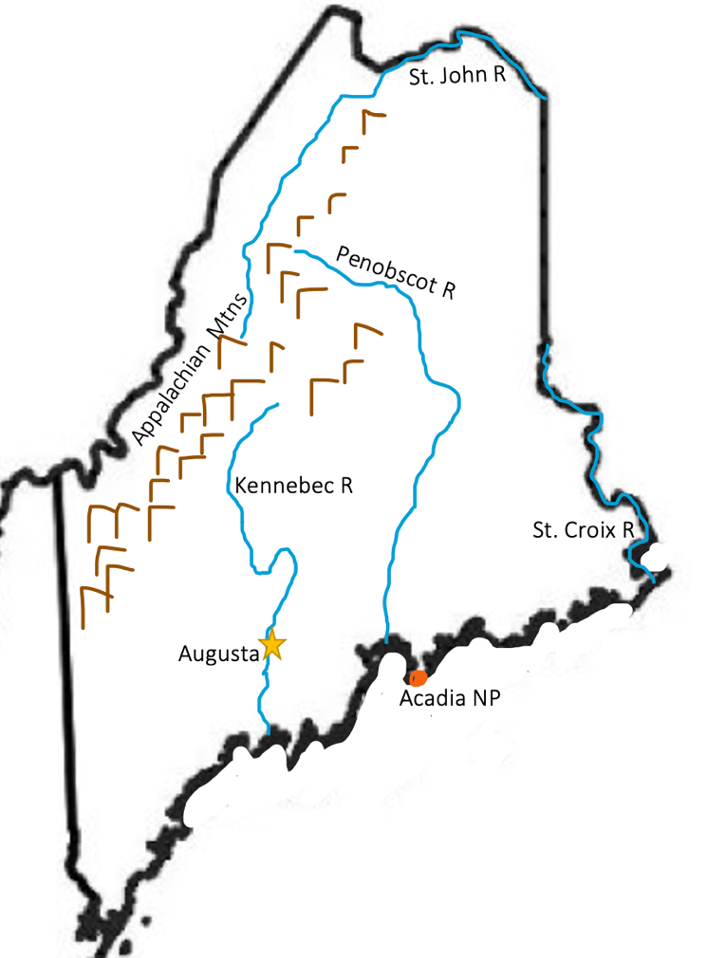

New Hampshire

Origin of Name
For the English county of Hampshire

Book to Read
* The Legend of the Old Man of the Mountain by Denise Ortakales
* Cat in the Clouds by Eric Pinder
- Papa is a Poet: A Story about Robert Frost by Natalie Bober (available on Hoopla)

Links to View
* Old Man of the Mountain Historic Site (3 min)
- New Hampshire’s Wildlife (1 ½ min)

Geographical Features to Map
Capital: Concord ; Merrimack River ; Connecticut River ; Appalachian Mountains ; Mount Washington ; Lake Winnipesaukee
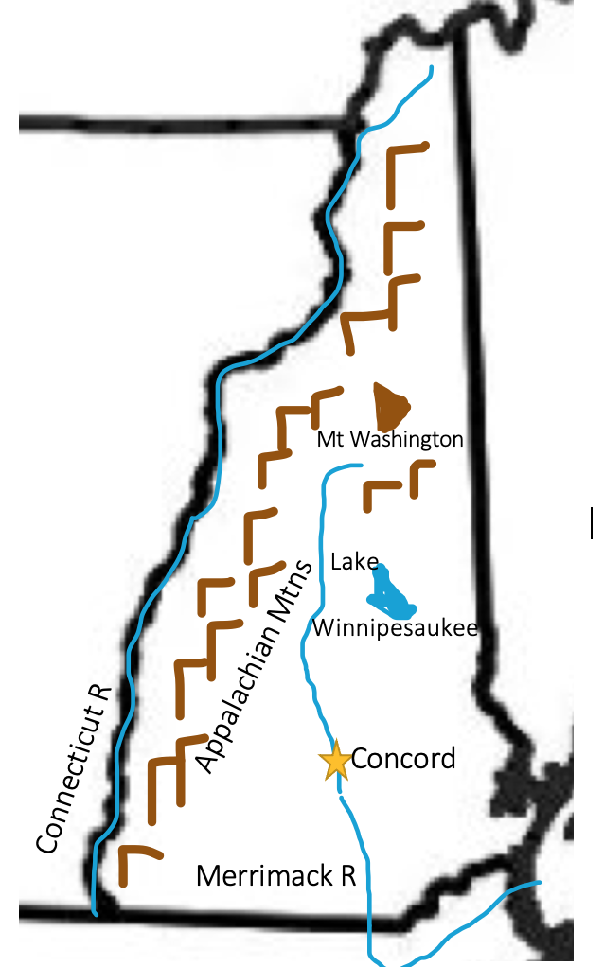

Vermont

Origin of Name
Named by Champlain for the Green Mountains – Vert Mont in French

Book to Read
* The Two Brothers by William Jaspersohn
- Snowflake Bentley by Jacqueline Briggs Martin

Links to View
* This Place in History: Native Americans in the Champlain Valley – Isle La Motte (4 min)
* Fossil Reef of Isle La Motte (5 ½ min)
- Natural History of Lake Champlain (8 min)

Geographical Features to Map
Capital: Montpelier ; Lake Champlain ; Appalachian Mountains ; Green Mountains ; Chimney Point ; Isle La Motte
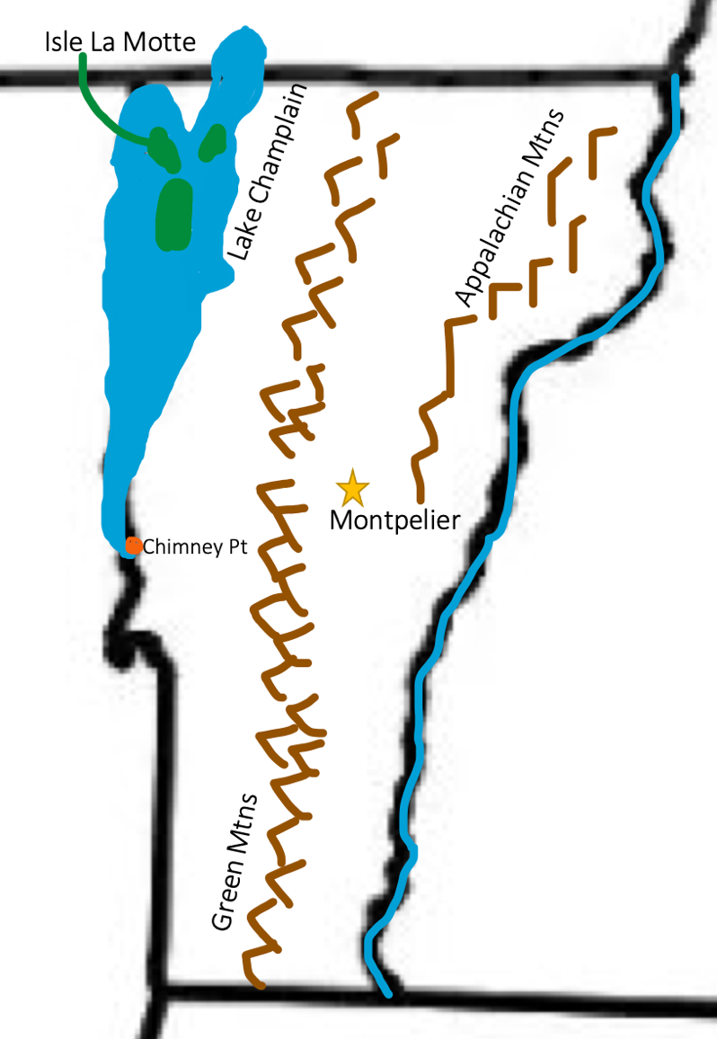

Massachusetts

Origin of Name
From the Algonquin word “Massadchu-es-et” which translates to “great-hill-small-place.” This might be in reference to the hills around Boston.

Book to Read
- Henry and the Cannons by Don Brown
- Mumbet’s Declaration of Independence by Gretchen Woelfle
- Obadiah the Bold by Brinton Turkle

Links to View
* The Wampanoag Way (7 ½ min)
* Cape Cod National Seashore (14 min)
- Nature Lovers Flock to the Berkshires (2 min)
- Pilgrim Life (6 min)

Geographical Features to Map
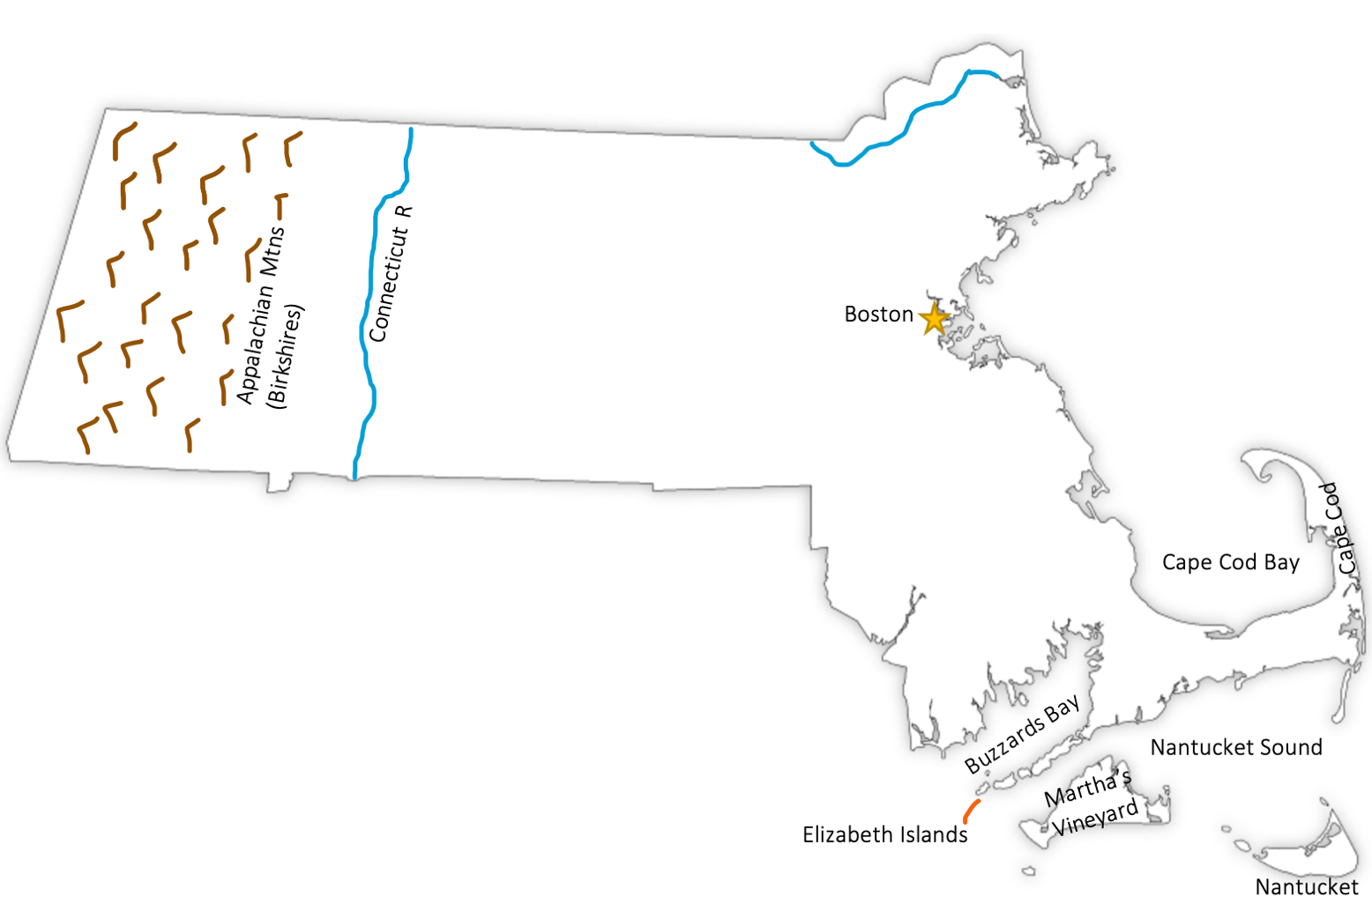
Capital: Boston ; Connecticut River ; Appalachian Mountains (Berkshires) ; Cape Cod ; Cape Cod Bay ; Nantucket Sound ; Buzzards Bay ; Martha’s Vineyard ; Nantucket ; Elizabeth Islands

Rhode Island

Origin of Name
From the Dutch “Roode Eylandt” meaning Red Island for the redness of the clay.

Book to Read
* Finding Providence: The Story of Roger Williams by Avi
- The Black Regiment of the American Revolution by Linda Crotta Brennan

Links to View
* How the Birds Got Their Song - Narragansett Nation story (8 min) & Wood Thrush Song
- The Colony of Rhode Island Founded in 1636 (2 ½ min)

Geographical Features to Map
Capital: Providence ; Pawcatuck River ; Wood River ; Block Island ; Narragansett Bay ; Aquidneck Island
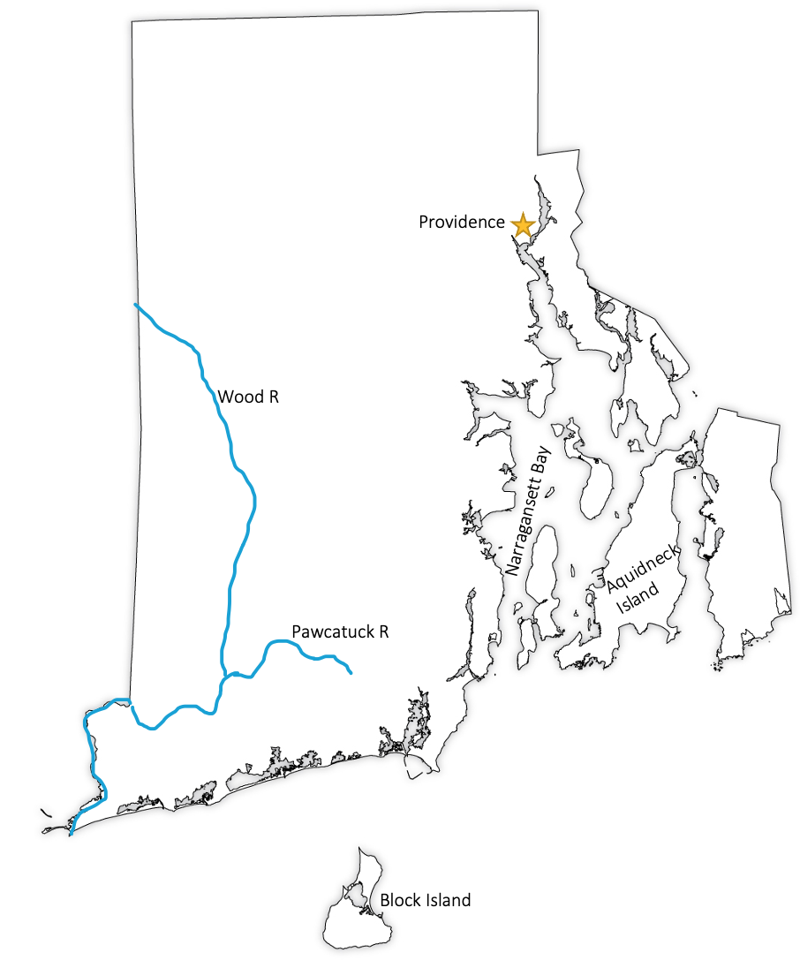

Connecticut

Origin of Name
Thought to be from a Native American word “Quonoktacut” that could mean “river whose water is driven by tides” or “long river.”

Book to Read
* The Legend of Hobbomock: The Sleeping Giant by Jason J. Marchi

Links to View
* Sleeping Giant Park
* Connecticut River (2 ½ min)
* Falkner Island (2 min)
- Southwick Jog (5 min)
- The Mashantucket Pequot Museum (especially min 3:52 – 9:30)

Geographical Features to Map
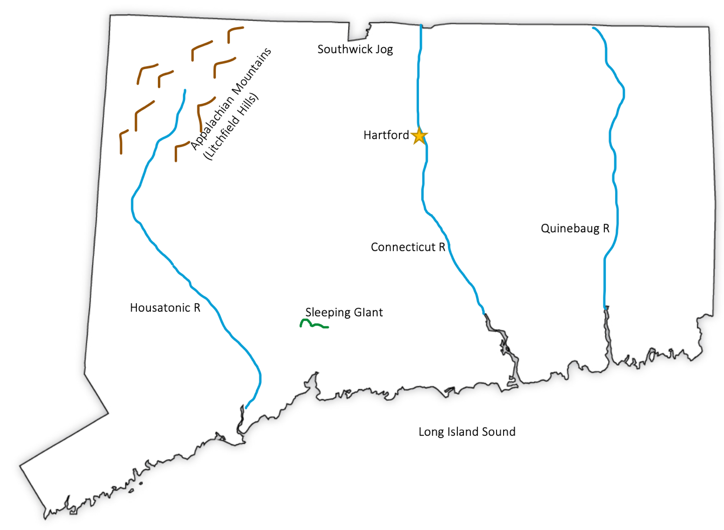
Capital: Hartford ; Connecticut River ; Housatonic River ; Quinebaug River ; Appalachian Mountains ; Southwick Jog ; Long Island Sound ; Sleeping Giant

New York (Long Island)

Origin of Name
British changed New Netherlands to New York, after the Duke of York when they took over.

Book to Read
* Secret Engineer: How Emily Roebling Built the Brooklyn Bridge by Rachel Dougherty
* Sky Boys: How They Built the Empire State Building by Deborah Hopkinson
- A Subway for New York by David Weitzman (longer read, but good)
- Saving Lady Liberty by Claudia Friddell
- Subway Sparrow by Leyla Torres (for young children)

Links to View
* Where the Lenape Dwell (4 min)
* How the Earth Was Made: New York (3 min)
* The Feud That Formed New York City’s Skyline (8 min)
- These Men Risked Their Lives to Build 1920s New York Skyscrapers (2 min)
- One of the Most Epic Engineering Feats in History - Brooklyn Bridge (5 min)
- New Netherlands (3 ½ min)

Geographical Features to Map
Long Island ; Manhattan ; Staten Island ; Hudson River ; East River ; Great and Little Peconic Bay ; Shelter Island
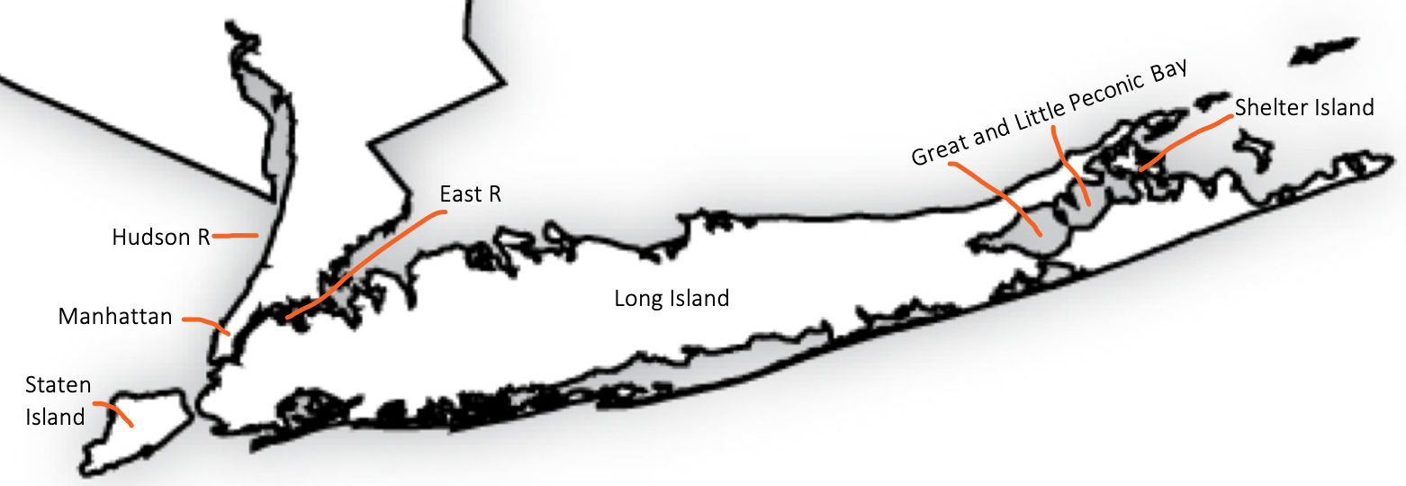

New York (Upstate)

Origin of Name
British changed New Netherlands to New York, after the Duke of York when they took over.

Book to Read
* Hiawatha and the Peacemaker by Robbie Robertson
- A Farmer Boy Birthday by Laura Ingalls Wilder (or Farmer Boy full book)
- Redcoats and Petticoats by Katherine Kirkpatrick
- The Erie Canal by Peter Spier (for young children, but a nice history and folk song in back)
- Out of School and Into Nature: The Anna Comstock Story by Suzanne Slade

Links to View
* The Iroquois Confederacy (8 min)
- Niagara Falls for Kids (6 min)
- The Largest Area of Protected Wilderness in U.S. – Adirondacks (2 min)
- Haudenosaunee’s Legendary Founding – Hiawatha’s Story for older kids (6 min)

Geographical Features to Map
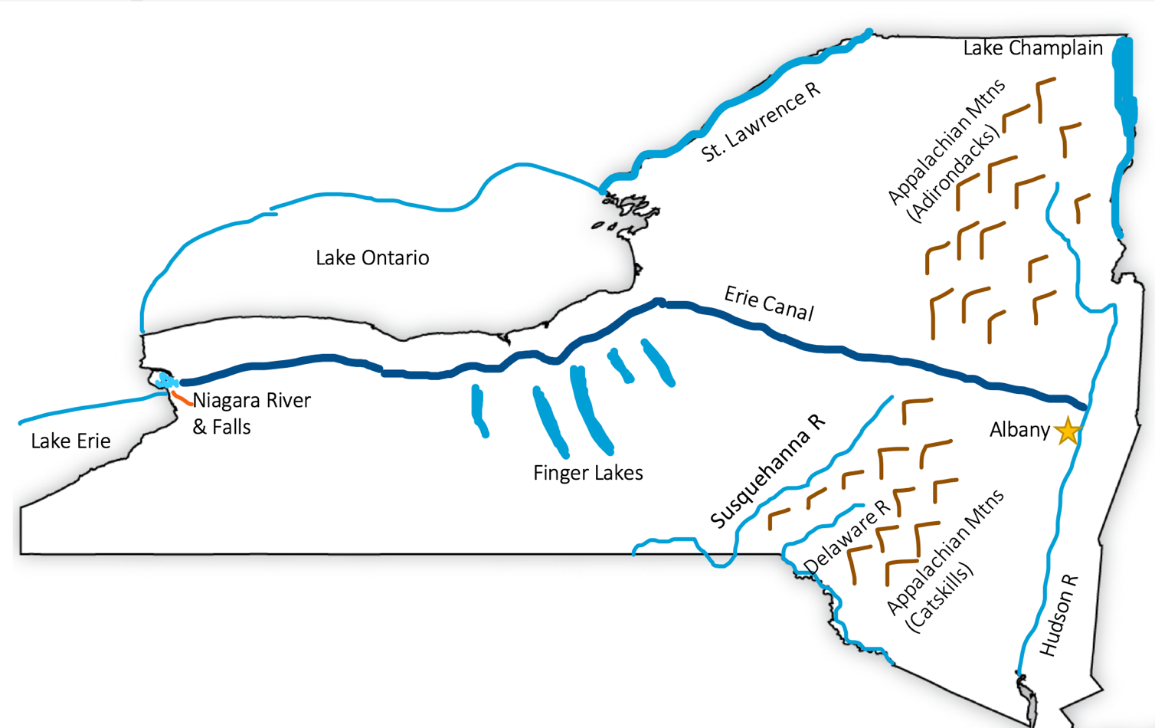
Capital: Albany ; St. Lawrence River ; Lake Ontario ; Lake Erie ; Niagara River and Falls ; Appalachian Mountains (Catskills and Adirondacks) ; Finger Lakes ; Erie Canal ; Delaware River l Susquehanna River

New Jersey

Origin of Name
For the Isle of Jersey off the Coast of England

Book to Read
* The Legend of the Cape May Diamond by Trinka Hakes Noble
- Heroes of the Surf by Elisa Carbone

Links to View
* Founding of New Jersey (1 ½ min)
* Paterson, NJ: Birthplace of U.S. Industry? (2 min)
* New Jersey’s Hidden Coast (5 ½ min)

Geographical Features to Map
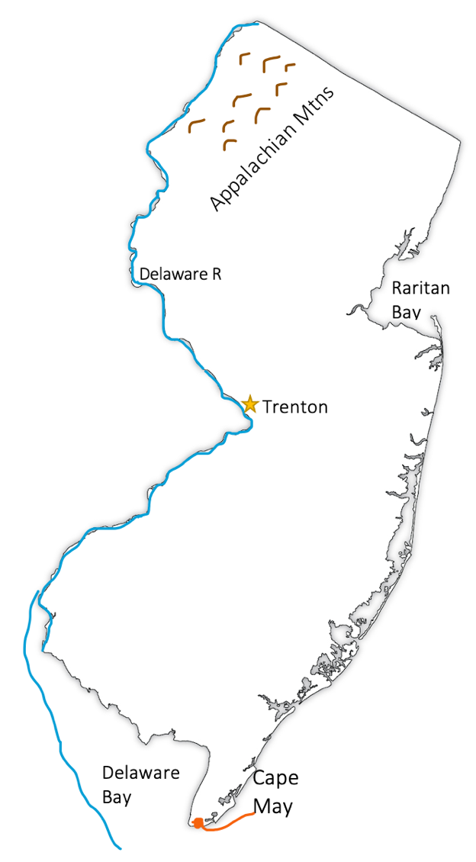
Capital: Trenton ; Delaware River ; Delaware Bay ; Appalachian Mountains ; Raritan Bay ; Cap May

Pennsylvania

Origin of Name
Named for its founder, William Penn, who wanted to call it “Sylvania” because of the forests (Latin for forest).

Book to Read
* Saving the Liberty Bell by Megan McDonald

Links to View
* Native Peoples of the Woodlands (12 min)
- Pennsylvania Anthracite Coal Mining History (15 min)
- Amish Life (6 min)

Geographical Features to Map
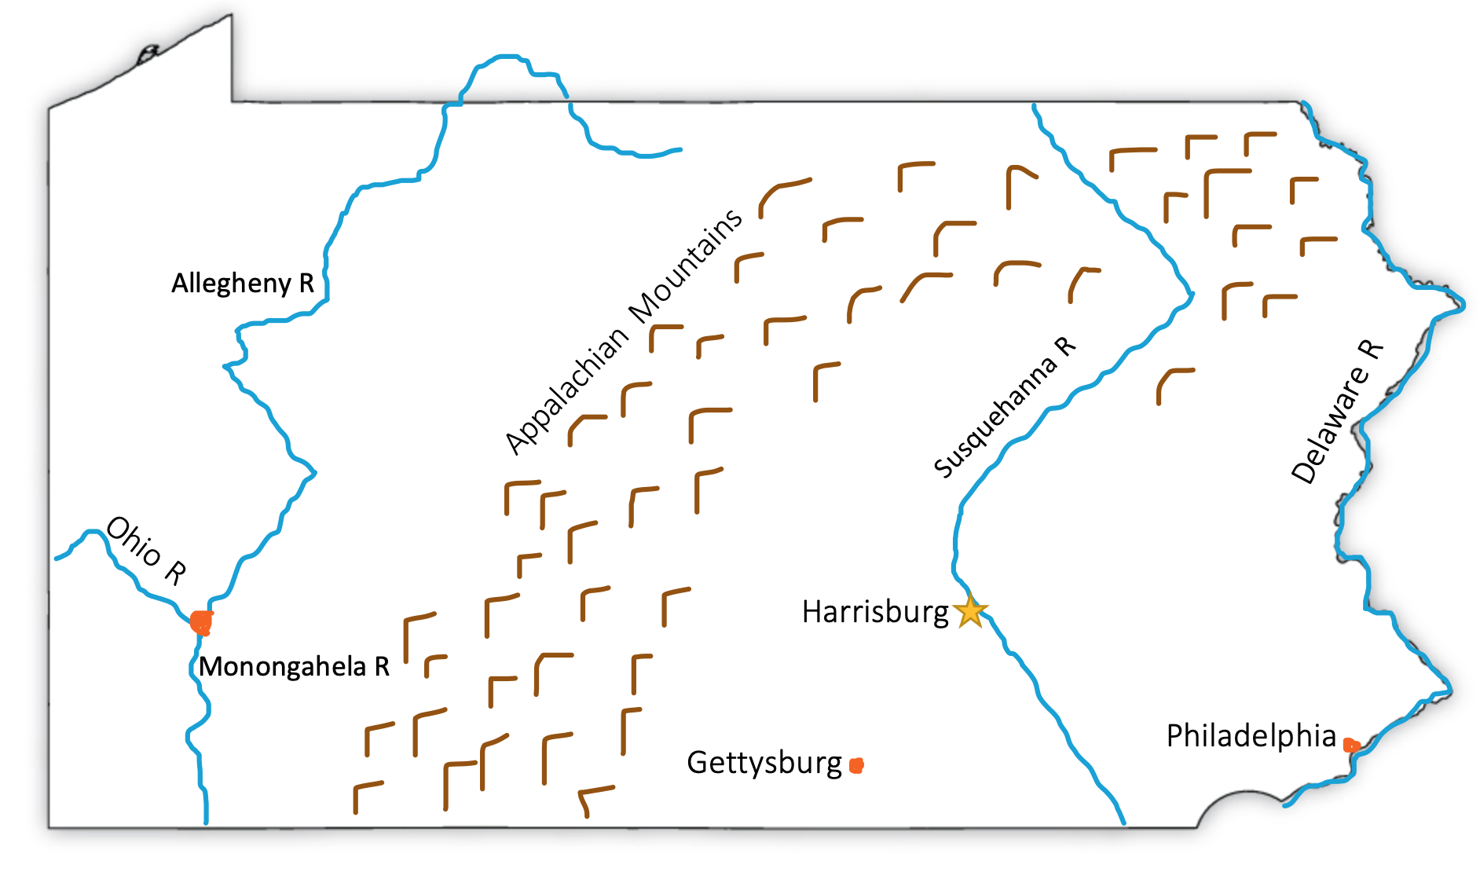
Capital: Harrisburg ; Pittsburg ; Philadelphia ; Gettysburg ; Delaware River ; Susquehanna River ; Allegheny River ; Monongahela River ; Ohio River ; Appalachian Mountains

Delaware

Origin of Name
For Lord De La Warr, explorer and first governor of the state

Book to Read
* Horseshoe Crabs and Shorebirds: The Story of a Food Web by Victoria Crenson
* When the Shadbush Blooms by Messinger

Links to View
* Nanticoke Lenni-Lenape Regalia (6 min)
* 30 Million Horseshoe Crabs (8 min – start at min :35 to cut out unsuitable language)
* Delaware Wild Lands (3 ½ min)
- Wetlands Project (2 min)
- Once a Spawn at Time: Horseshoe Crabs Mob the Beach (5 min)

Geographical Features to Map
Capital: Dover ; (Delmarva Peninsula) ; Delaware Bay ; Rehoboth Bay ; Indian River Bay ; Little Assawoman Bay
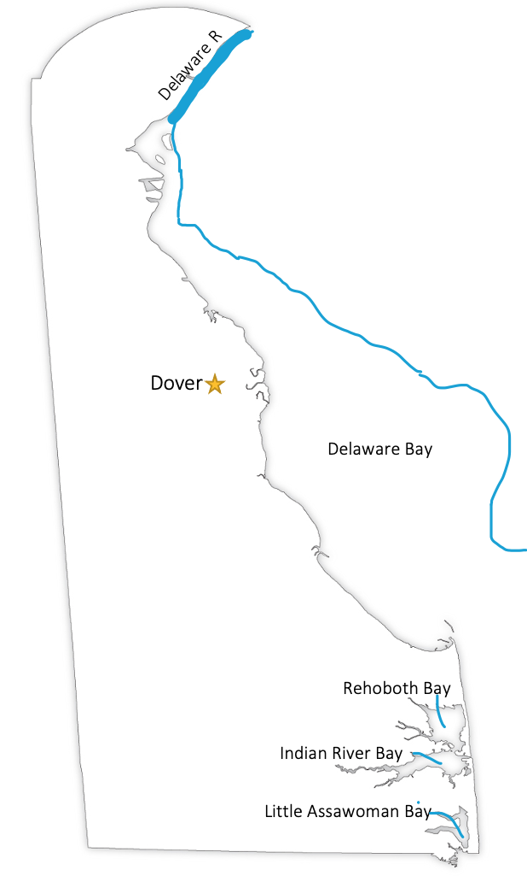
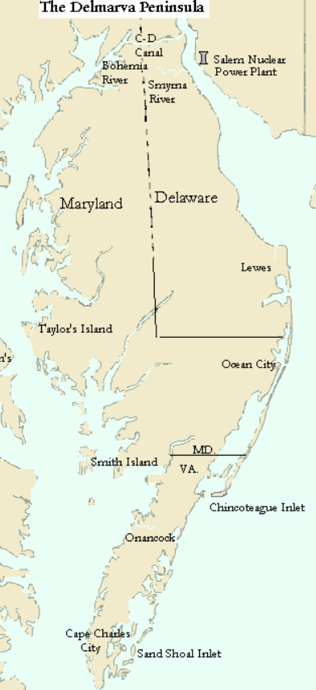

Maryland

Origin of Name
For Queen Henrietta Maria, wife of King Charles I of England

Book to Read
* The Biggest Flag that Ever Flew by Rebecca Jones (flag at Smithsonian ; Anthem)
- Words Set Me Free: The Story of Young Frederick Douglas by Lesa Cline-Ransome

Links to View
* Natural Resources and Native Americans (5 min)
* The Incredible Oyster Reef (10 min) – includes discussion of oyster reproduction
* How Oysters Filter Water (2 min)
- How Many Species Can We Find on the Chesapeake Bay? (12 min)

Geographical Features to Map
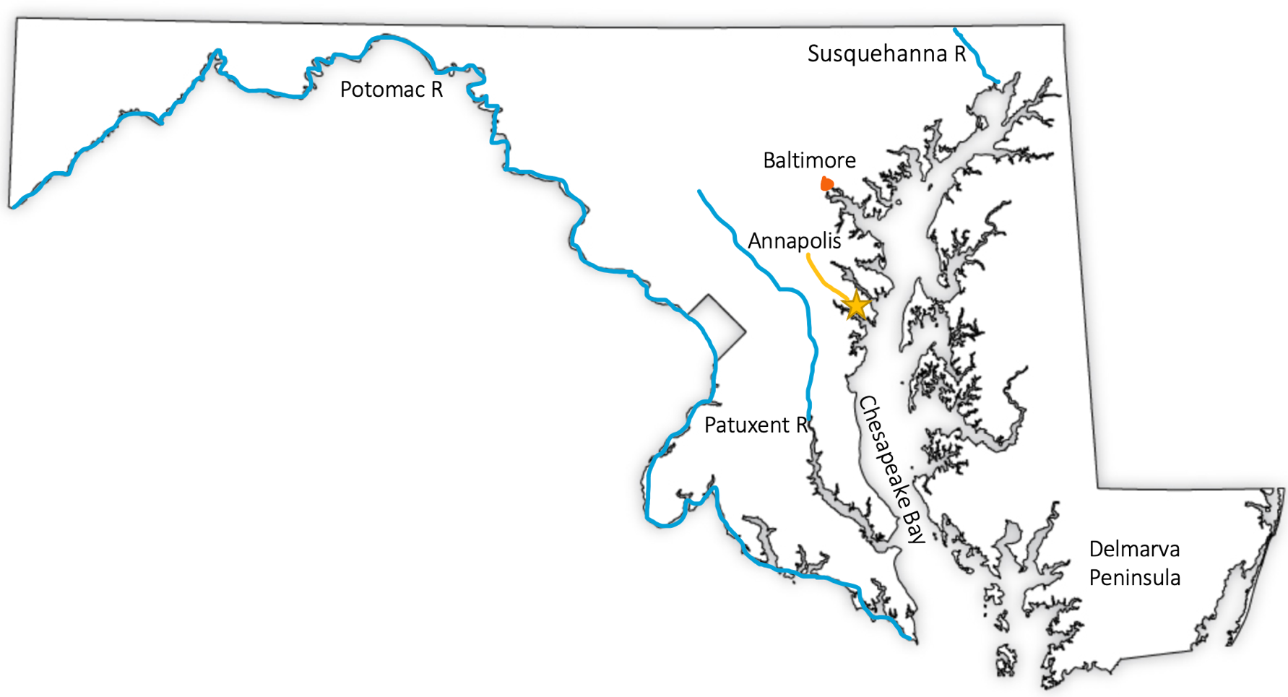
Capital: Annapolis ; Chesapeake Bay ; Potomac River ; Baltimore ; Susquehanna River ; Patuxent River ; Delmarva Peninsula

West Virginia

Origin of Name
Formerly part of Virginia. When Virginia seceded from the Union, this territory stayed and renamed itself West Virginia.

Book to Read
- In Coal Country by Judith Hendershot

Links to View
* Introduction to the Grave Creek Mound (3 ½ min)
* The Story of the New River Gorge (especially min 7:30 – 8:30 and 10:52 – 14:09)
- Monongahela National Forest: Birthplace of Rivers (7 min)
- West Virginia (4 min)
- The Greenbrier Resort: The Secret Nuclear Bunker (2 min)

Geographical Features to Map
Capital: Charleston ; Appalachian Mountains ; White Sulphur Springs ; Ohio River ; Monongahela River ; Potomac River ; Kanawha River ; New River
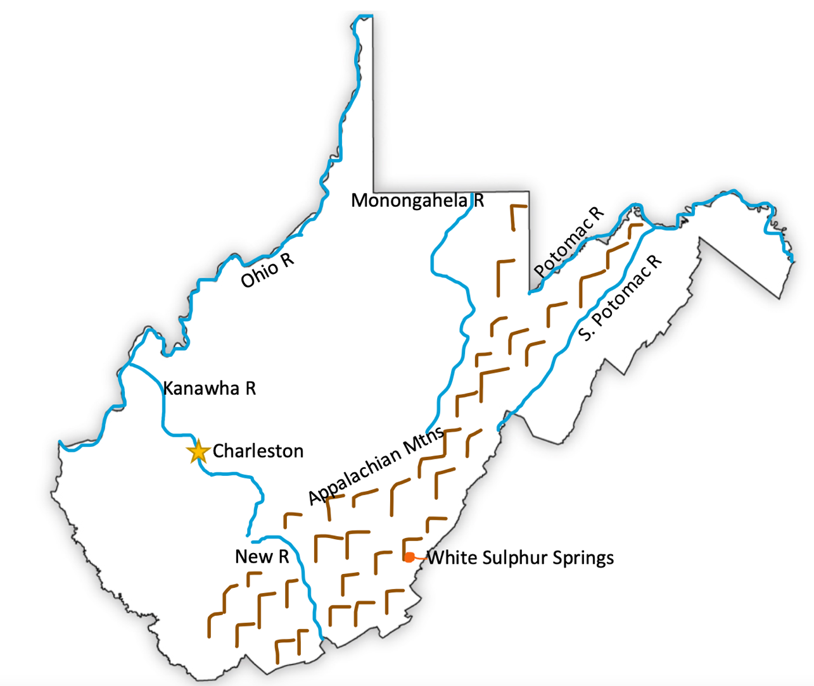

Ohio

Origin of Name
Iroquois name for the Ohio river meaning “beautiful river”

Book to Read
* In Coal Country by Judith Hendershot
* Freedom River by Doreen Rappaport

Links to View
* The Great Serpent Mound (4 min)
* First Farmers (6 min)
* Hopewell Ceremonial Earthworks (9 min)
* Ohio’s Pawpaw Trees (3 min)

Geographical Features to Map
Capital: Columbus ; Ohio River ; Lake Erie ; Cincinnati ; Cleveland ; Snake Mound ; Sandusky Bay
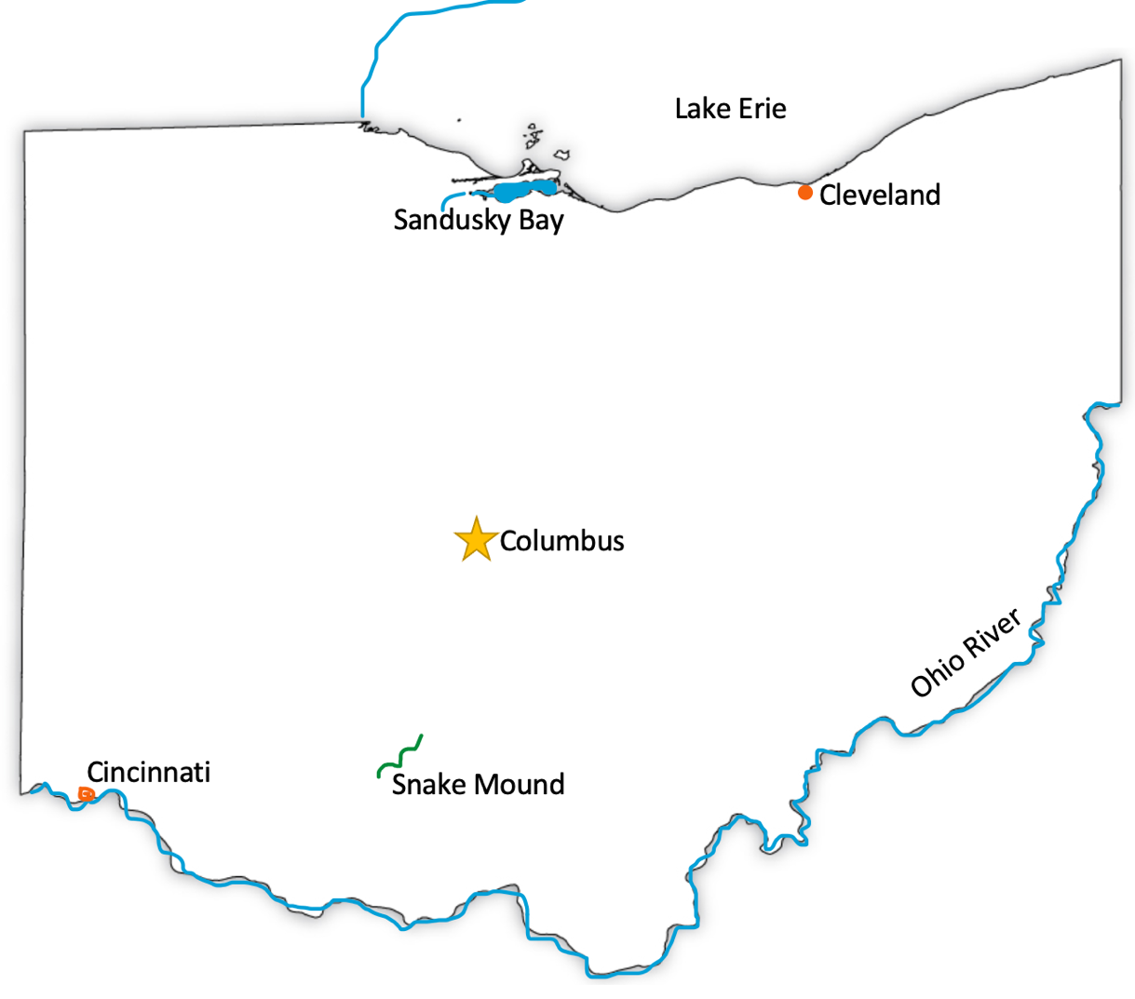

Quick Reference by State

Connecticut: Capital: Hartford ; Connecticut River ; Housatonic River ; Quinebaug River ; Appalachian Mountains ; Southwick Jog ; Long Island Sound ; Sleeping Giant

Delaware: Capital: Dover ; (Delmarva Peninsula) ; Delaware Bay ; Rehoboth Bay ; Indian River Bay ; Little Assawoman Bay

New Hampshire: Capital: Concord ; Merrimack River ; Connecticut River ; Appalachian Mountains ; Mount Washington ; Lake Winnipesaukee

Maine: Capital: Augusta ; Appalachian Mountains ; Acadia National Park ; Penobscot River ; Kennebec River ; St. Croix River ; St. John River

Maryland: Capital: Annapolis ; Chesapeake Bay ; Potomac River ; Baltimore ; Susquehanna River ; Patuxent River ; Delmarva Peninsula

Massachusetts: Capital: Boston ; Connecticut River ; Appalachian Mountains (Berkshires) ; Cape Cod ; Cape Cod Bay ; Nantucket Sound ; Buzzards Bay ; Martha’s Vineyard ; Nantucket ; Elizabeth Islands

New Jersey: Capital: Trenton ; Delaware River ; Delaware Bay ; Appalachian Mountains ; Raritan Bay ; Cap May

New York (Long Island): Long Island ; Manhattan ; Staten Island ; Hudson River ; East River ; Great and Little Peconic Bay ; Shelter Island

New York (Upstate): Capital: Albany ; St. Lawrence River ; Lake Ontario ; Lake Erie ; Niagara River and Falls ; Appalachian Mountains (Catskills and Adirondacks) ; Finger Lakes ; Erie Canal ; Delaware River l Susquehanna River

Ohio: Capital: Columbus ; Ohio River ; Lake Erie ; Cincinnati ; Cleveland ; Snake Mound ; Sandusky Bay

Pennsylvania: Capital: Harrisburg ; Pittsburg ; Philadelphia ; Gettysburg ; Delaware River ; Susquehanna River ; Allegheny River ; Monongahela River ; Ohio River ; Appalachian Mountains

Rhode Island: Capital: Providence ; Pawcatuck River ; Wood River ; Block Island ; Narragansett Bay ; Aquidneck Island

Vermont: Capital: Montpelier ; Lake Champlain ; Appalachian Mountains ; Green Mountains ; Chimney Point ; Isle La Motte

West Virginia: Capital: Charleston ; Appalachian Mountains ; White Sulphur Springs ; Ohio River ; Monongahela River ; Potomac River ; Kanawha River ; New River

