Lisa Cotting
amblingtogether.com
UNITED STATES GEOGRAPhy
MIDDLE STATES

Table of Contents
How I Used This Guide 2
Why we study each state: 2
How we study each state: 3
Michigan 4
Indiana 5
Illinois 6
Wisconsin 7
Minnesota 8
Iowa 9
Missouri 10
Kansas 11
Nebraska 12
South Dakota 13
North Dakota 14
Oklahoma 15
Texas 16
Quick Reference by State 17

How I Used This Guide

Why we study each state:

Charlotte Mason recommends studying the geography of the child’s country. In Book VI, she says the children “are engaged with the counties of England, county by county, for so diverse are the counties in aspect, history, and occupation, that only so can children acquire such a knowledge of England as will prove a key to the geography of every part of the world, whether in the way of comparison or contrast.” She describes the principle to be followed as the child gets older and starts studying other countries: “vivid descriptions, geographical principles, historical associations and industrial details, are afforded which should make, as we say, an impression, should secure that the region traversed becomes an imaginative possession as well as affording data for reasonable judgements.”

Inspired by her study of the counties of England, I have made time in our Together Time to study the geography of all 50 states. For each state I try to find what will make “an impression” so that the state “becomes an imaginative possession” of each child. I decided to focus on mapping the physical features, reading a book or two about the culture, history, or nature of the state, and watching several videos to compliment these topics.

While using Miss Mason’s principles for teaching geography and choosing which features to map or which books to read and videos to watch, I consider the following goals: We will be familiar with major cities and landmarks – understanding how mountains and waterways divide and define, we will know a little about the original inhabitants of the land, we will have an understanding of what (some of) the state looks like and we will be familiar with some of the stories and culture from the area. I will not cover all of these topics for each state, but hope that in general we’ll know our country in this way by the time we’re finished.

How we study each state:

I have spaced this study over two years. Each week we will study one state. I have scheduled 20 minutes 2 mornings a week to read the book, watch the videos, and draw the geographical features on our U.S.A. map. When time permits, we draw the state freehand to help us notice the features of the boarder. For some states I have scheduled two weeks - either because the state has so much (such as New York – a week on Long Island/Manhattan and a week on Upper State) or because it has special meaning to our family (relatives live in or are from the state).

At the beginning of each lesson, I review the states we’ve covered so far. When we have covered enough of them so that it is no longer feasible to review everything in a couple minute review, I choose major features and change up the minor features each day. Then at the end of the lesson we review the new state we’ve learned that week.

In the guide below I have listed books and links that I have read and watched myself. The ones with the asterisk * are the ones I will prioritize. The others are alternative or additional resources. At the end of the guide is a list of geographical features for each state. I use this as a quick review before mapping the current week’s state. Every week as I am planning, I will request books from the library for several weeks in advance so I have them in time.

The maps I have drawn for each state are a basic rudimentary drawing for me to use as reference so I can easily find the landmarks in an atlas or “real” map. The children will use the “real” maps as reference for drawing their own maps.

Additional Resources:
- Map used with students: Beautiful Feet Books U.S.A. Map
- Map used for this document: worldmapblank.com and State Outline Maps
- Maps used to draw locations and physical features in each state: freeworldmaps.net
- Quick Facts: National Geographic Kids - U.S. States and Territories
- US Department of the Interior: Indian Affairs Office – Origin of State Names
- Book: How the States Got Their Shape by Mark Stein

Michigan

Origin of Name
Algonquin word “Mishigamaw” meaning “big lake”

Book to Read
* The Legend of Mackinac Island by Kathy-Jo Wargin
* The Legend of Sleeping Bear by Kathy-Jo Wargin (sad story)
* Nature’s Friend: The Gwen Frostic Story by Lindsey McDivitt (Gwen Frostic Art)
- If You Want to See a Caribou by Phyllis Root

Links to View
* Norton Indian Mounds, Grand Rapids Michigan (3 min)
* On the Shores of the Great Lakes (2 min)
- What’s so great about the Great Lakes? (5 min)
- Native American Heritage – Michigan (2 ½ min)
- Archaeologists have discovered a mystery at the bottom on Lake Huron (4 min)
- Underwater Stonehenge Found in Lake Michigan (7 ½ min)

Geographical Features to Map
Capital: Lansing ; Detroit ; Grand Rapids ; Grand River ; Upper Peninsula ; Lake Superior ; Lake Michigan ; Lake Huron ; Lake Erie ; Saginaw Bay ; Lake St. Clair ; Mackinac Island ; Isle Royale ; Sleeping Bear Dunes
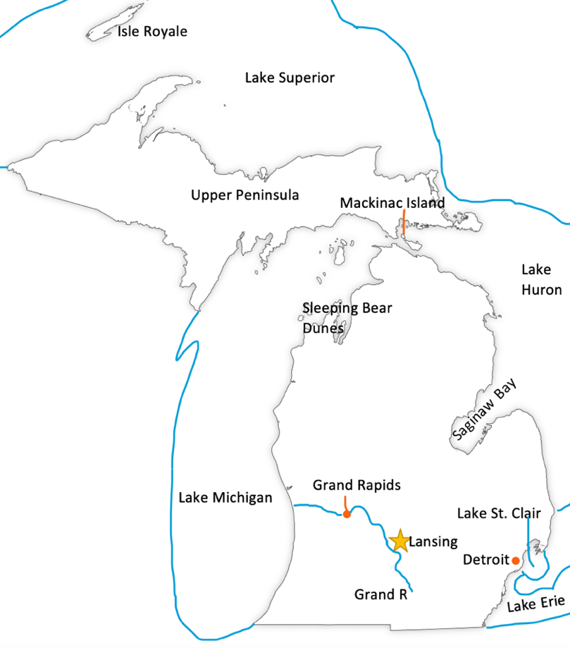

Indiana

Origin of Name
Possibly because the land along the Ohio River was purchased from “Indians.”

Book to Read
- Abe Lincoln: The Boy Who Loved Books by Kay Winters

Links to View
* The Battle for Indiana (4 ½ min)
* History of the Mounds at Mounds State Park (6 min)
* Layers in Time at Clifty Falls State Park (4 ½ min)
- A History Tour of the Wabash River (5 min)
- Biological Diversity at Indiana State Parks (3 ½ min)
- Indianapolis Motor Speedway (3 ½ min) and History of the Indianapolis 500 (4 min)

Geographical Features to Map
Capital: Indianapolis ; Gary ; Lake Michigan ; Ohio River ; Wabash River
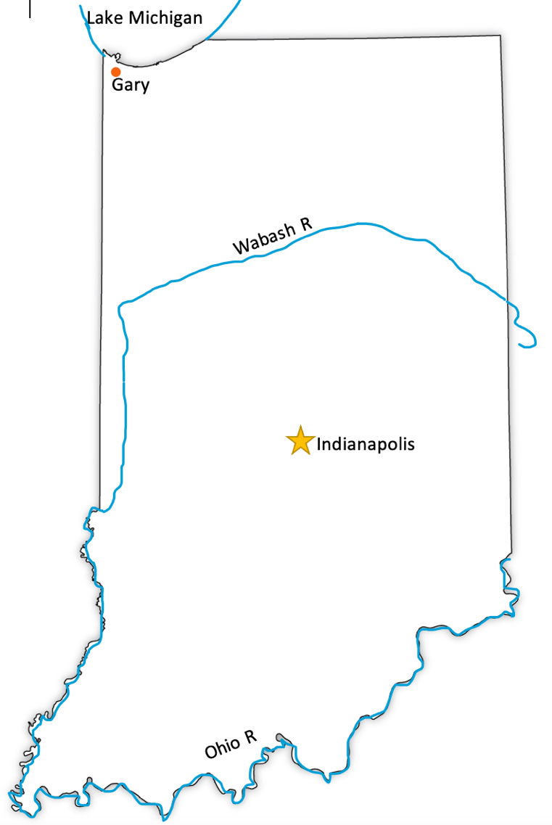

Illinois

Origin of Name
From the Illini word meaning “men” or “warriors” with a French adjective ending “ois”

Book to Read
* Journey to Cahokia: A Boy’s Visit to the Great Mound City by Albert Lorenz
- The House That Jane Built by Tanya Lee Stone
- Auntie Yang Great Soybean Picnic by Ginnie Lo
- John Deere, That’s Who! By Tracy Nelson Maurer

Links to View
* The Mystery of the Magnificent Monks Mound – Cahokia Mounds (2 min)
- Illinois Wild Mammals (12 min)
- Cahokia’s Celestial Calendar - Woodhenge (2 min)
- Native People of Illinois (12 min)
- Chicago’s Historic Bridges (3 min)

Geographical Features to Map
Capital: Springfield ; Lake Michigan ; Mississippi River ; Ohio River ; Wabash River ; Illinois River ; Chicago ; Cahokia Mounds
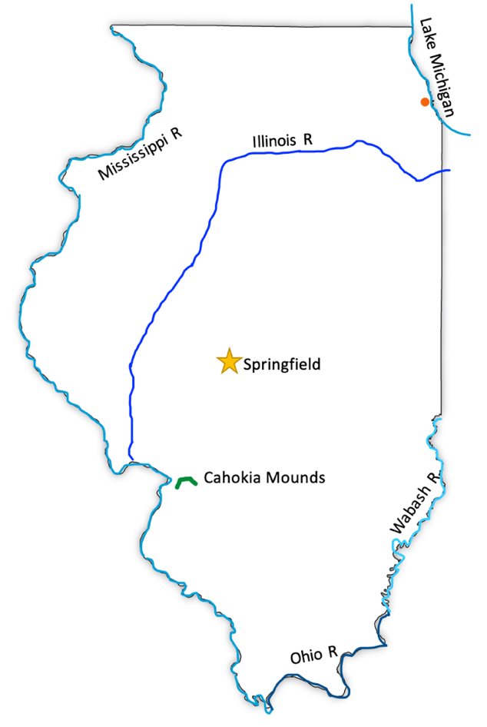

Wisconsin

Origin of Name
Uncertain origin. Originally the name of the river. Possibly Native American word meaning “wild rushing channel.”

Book to Read
- Winter Days in the Big Woods by Laura Ingalls Wilder (or the Little House in the Big Woods)
- Farmer Will Allen and the Growing Table by Jaqueline Briggs Martin
- On Sand Island by Jaqueline Briggs Martin
- Wakanda Whooper: The Curious Cinnamon Crane by Sandia Kosmo (Chapter Book with illustrations)

Links to View
* Aztalan: National Historic Landmark (9 min) and Wikipedia page
* Lake Winnebago Ecosystem (5 min – start at min :51)
- Why is Wisconsin Called The Badger State? (3 min)
- History of Wisconsin (10 ½ min – start at min :58)

Geographical Features to Map
Capital: Madison ; Lake Superior ; Lake Michigan ; Mississippi River ; Wisconsin River ; St. Croix River ; Lake Winnebago ; Green ; Bay Fox River ; Milwaukee ; Aztalan ; Apostle Islands

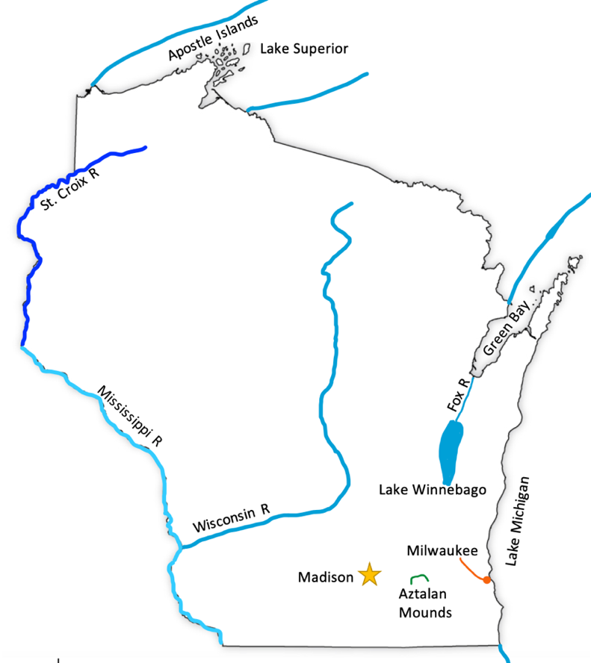

Minnesota

Origin of Name
From the Sioux word meaning “cloudy water” originally applied to the river.

Book to Read
* Indian Boyhood: The True Story of a Sioux Upbringing by Charles Alexander Eastman
* Big Belching Bog by Phyllis Root
- Plant a Pocket of Prairie by Phyllis Root
- One Summer Up North by John Owens (wordless)

Links to View
* Dakota Place Names in Minnesota (4 ½ min)
* Why is There A Chunk of the US Inside Canada? (4 min)
* Why are the Rocks Tilted at Jay Cooke State Park? (5 ½ min)
- Interstate State Parks: St. Croix Falls WI and Taylor Falls, MN (7 min)
- The Unexpected History of Minnesota’s Logging Industry (3 min)
- Traditional Dakota Flute (3 ½ min)
- Big Bog State Recreation Area

Geographical Features to Map
Capital: St. Paul ; Minneapolis (Twin Cities) ; Mississippi River ; Lake Itasca ; Lake Superior ; St. Croix River ; Minnesota River ; Red River ; Lake of the Woods ; Northwest Angle ; Red Lakes ; Leech Lake ; Lake Winnibigoshish ; Mille Lacs Lake ; Bogs

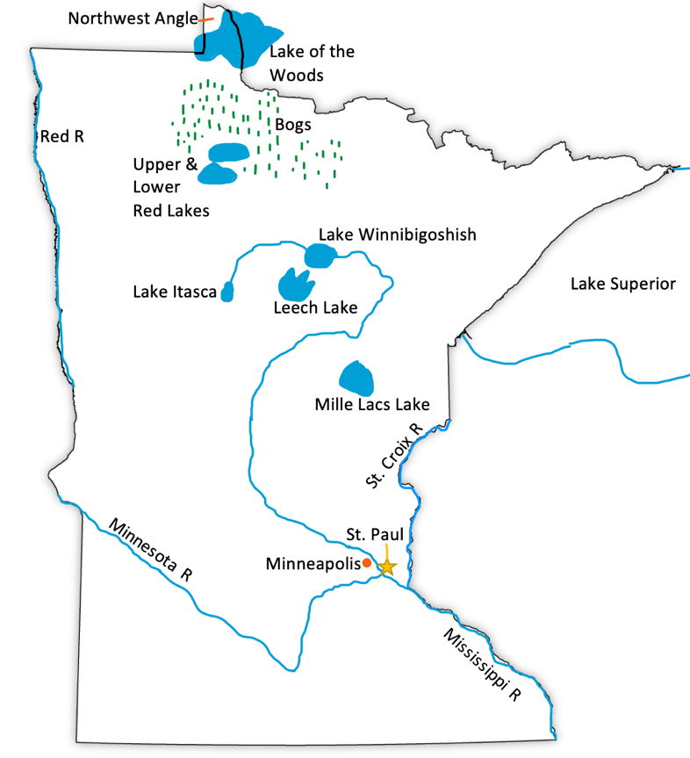

Iowa

Origin of Name
A Native American Tribe’s name for themselves “Ah-hee-oo-ba” meaning “sleepy ones.” They named the river they lived near for their tribe and the state was named for it.

Book to Read
* Two Scarlet Songbirds: A Story of Anton Dvorak by Carole Lexa Schaefer (American Quartet, 3rd Movement ; Scarlet Tanager Singing)
* American Gothic: The Life of Grant Wood by Susan Wood (Woods Artwork)

Links to View
* Effigy Mounds National Monument: Sacred Lands and Waters (4 min)
* The Formation and Sustainability of Iowa’s Loess Hills (2 ½ min)
- Exploring Iowa’s Coldwater Cave, Winneshiek County, Iowa (8 ½ min)
- Land Formation in Iowa (4 min)
- Meskwaki Tribe: Culture and Traditions (6 min)

Geographical Features to Map
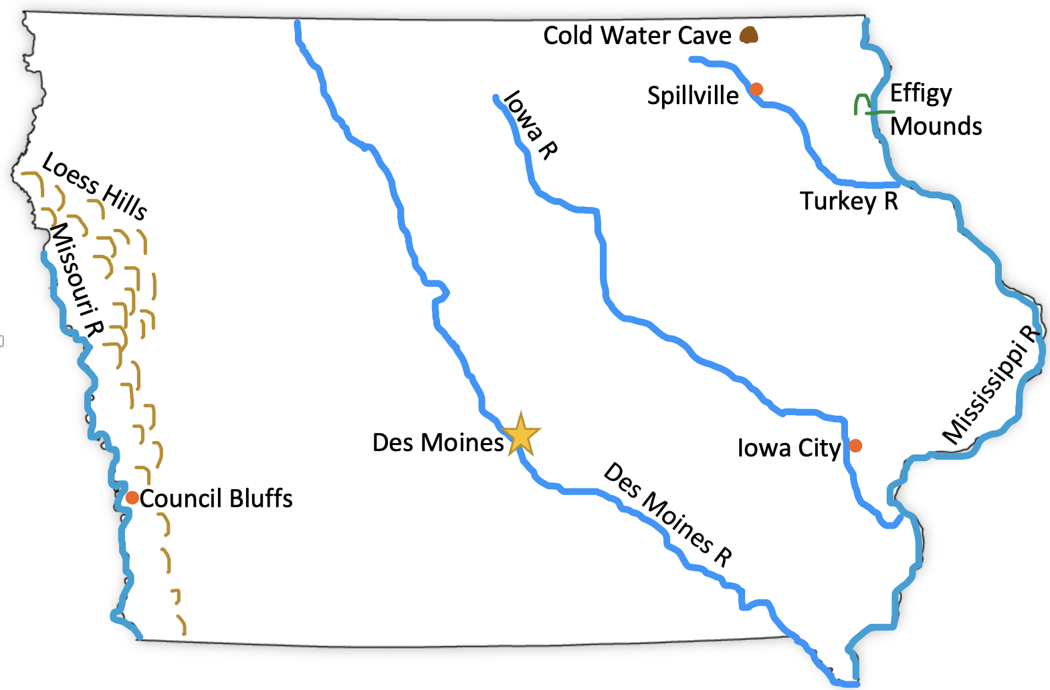
Capital: Des Moines ; Mississippi River ; Missouri River ; Des Moines River ; Iowa River ; Council Bluffs ; Spillville ; Turkey River ; Iowa City ; Loess Hills ; Effigy Mounds ; Cold Water Cave

Missouri

Origin of Name
Native American tribal name meaning “muddy water” in reference to the river

Book to Read
* n/a

Links to View
* Missouri History (4 min)
* Glades in Missouri (2 min)
* Santa Fe Trail – Heading Out from Independence (2 ½ min)
- The Lewis and Clark Expedition (4 ½ min)
- St. Louis Gateway Arch (6 min)
- The Lay of the Land (10 min – start at min 1:43)

Geographical Features to Map
Capital: Jefferson City ; St. Louis ; Kansas City ; Independence ; Missouri River ; Mississippi ; St. Francis River ; Bootheel ; Santa Fe Trail ; Ozark Mountains
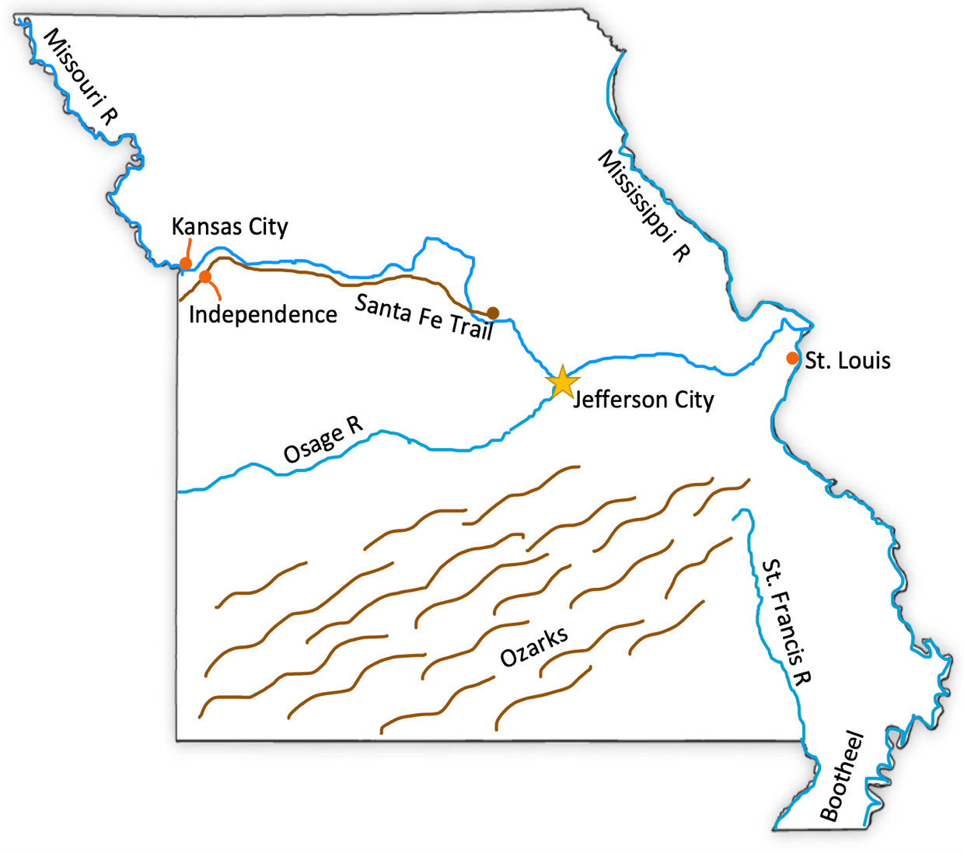

Kansas

Origin of Name
The Kanza tribe of the Sioux who lived along the river of the same name. Translates to “south wind people”

Book to Read
* Sod Houses on the Great Plains by Glen Rounds
* Green City: How One Community Survived a Tornado and Rebuilt for a Sustainable Future by Allan Drummond

Links to View
* Native Peoples of the Plains (12 ½ min)
* Turning Prairie into Promised Land (stop at min 2:20)
- Operating a grain silo (4 ½ min)
- Exploration Kansas (14 min)
- Story of Flint Hills (12 min)

Geographical Features to Map
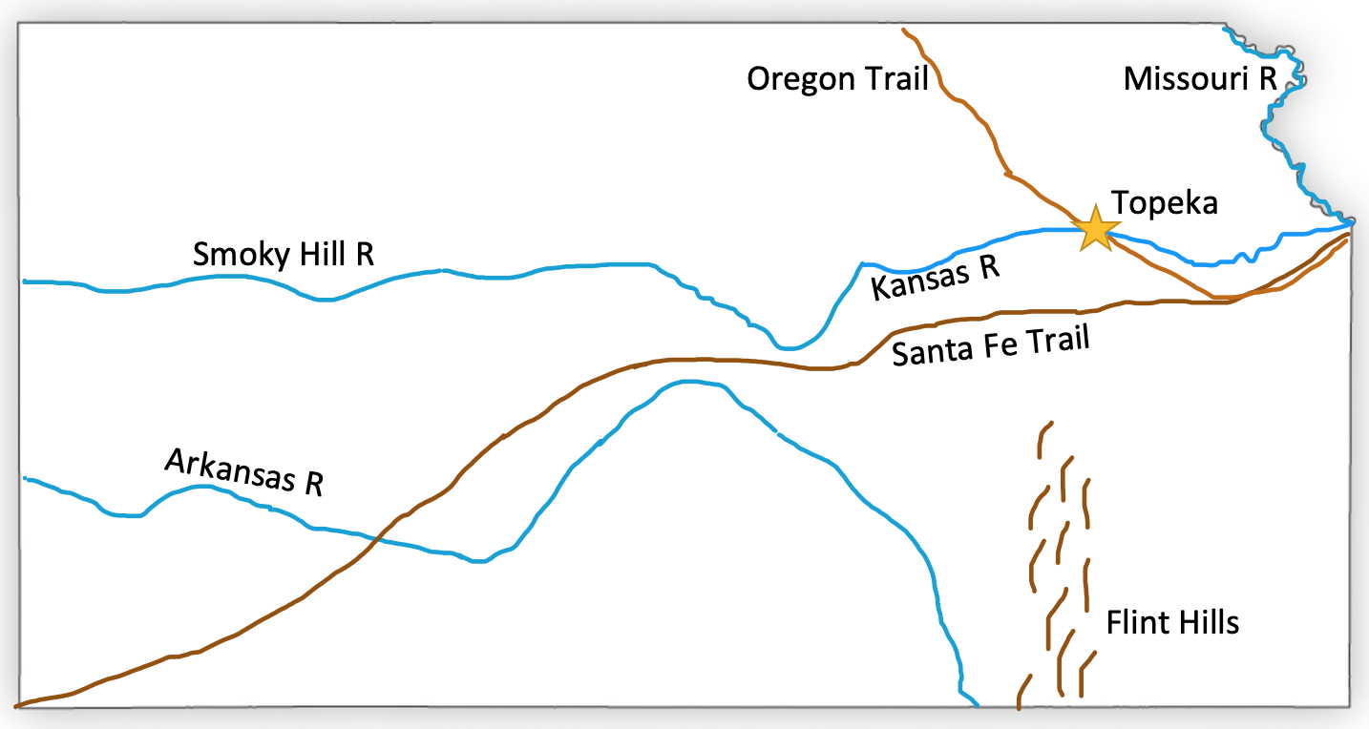
Capital: Topeka ; Arkansas River ; Missouri River ; Smoky Hill River ; Kansas River ; Santa Fe Trail ; Flint Hills ; Oregon Trail

Nebraska

Origin of Name
Either a Sioux word meaning “shallow water” River or an Otos word meaning “flat river” naming the Nebraska River.

Book to Read
* Corn is Maize: The Gift of the Indians by Aliki
- Death of the Iron Horse by Paul Goble

Links to View
* Saline Wetlands (25 min: start at min 1:58 – 5:36 ; Tiger Beatle: 8:34-11:36)
* The Great Plains Are Not as Dry as They Seem (4 min)
* Sandhills Critters (4 min)
* America’s First Successful Homestead (2 ½ min)
* Saving Sacred Seeds (3 min)
- Prairie Immersion: Animals (10 min)
- Sandhill Cranes (5 min)
- Nebraska’s Dinosaur Tracksite (7 min)
- Wetlands of Nebraska (30 min)

Geographical Features to Map
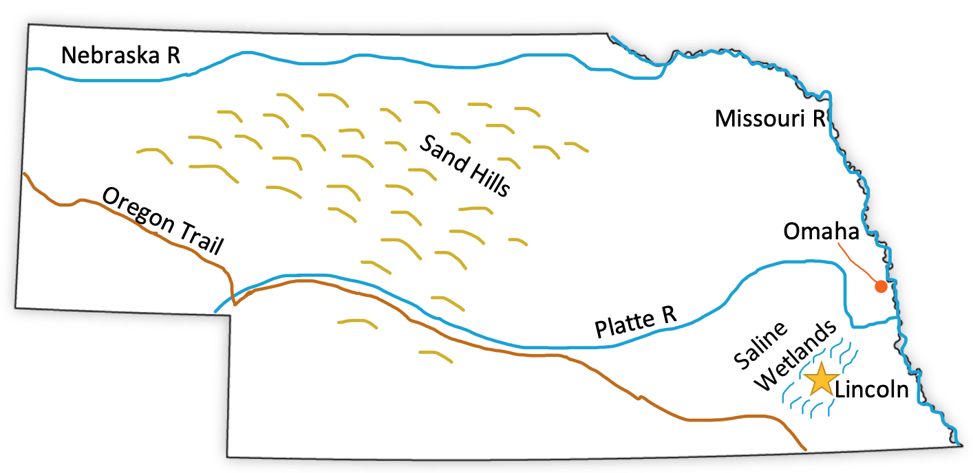
Capital: Lincoln ; Omaha ; Missouri River ; Platte River ; Nebraska River ; Oregon Trail ; Sand Hills ; Saline Wetlands

South Dakota

Origin of Name
Dakota (or Lakota, Nakota, Lahkota) is a Sioux word meaning “allies” meaning all the joined Sioux tribes

Book to Read
* n/a

Links to View
* The Geology of Badlands National Park (12 min)
* Sacred Hills: Preserving Lakota Sioux Culture in South Dakota (3 min)
- What are Badlands (7 min)
- Black Hills Human and Physical Geography (3 ½ min)

Geographical Features to Map
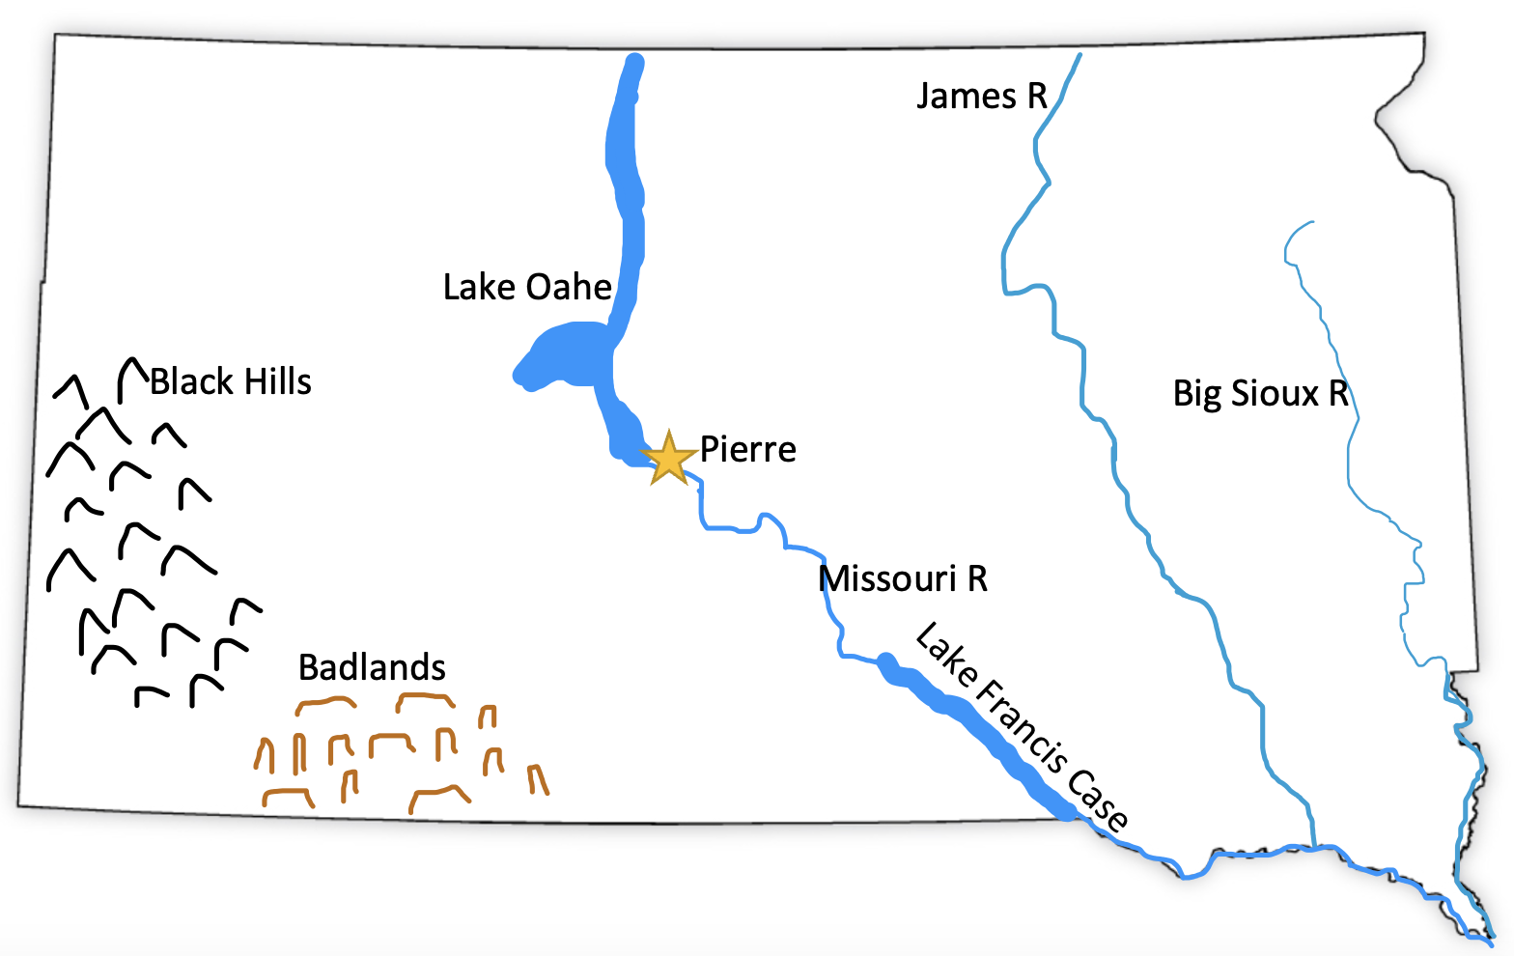
Capital: Pierre ; Missouri River ; Lake Oahe ; Lake Francis Case ; James River ; Big Sioux River ; Black Hills ; Badlands

North Dakota

Origin of Name
Dakota (or Lakota, Nakota, Lahkota) is a Sioux word meaning “allies” meaning all the joined Sioux tribes

Book to Read
* Gift Horse: A Lakota Story by S.D. Nelson
* Buffalo Bird Girl: A Hidatsa Story by S.D. Nelson

Links to View
* Return of the American Bison (14 min)
* How North Dakota Transformed Theodore Roosevelt (2 ½ min)
* Beautiful Badlands – North Dakota (

Geographical Features to Map
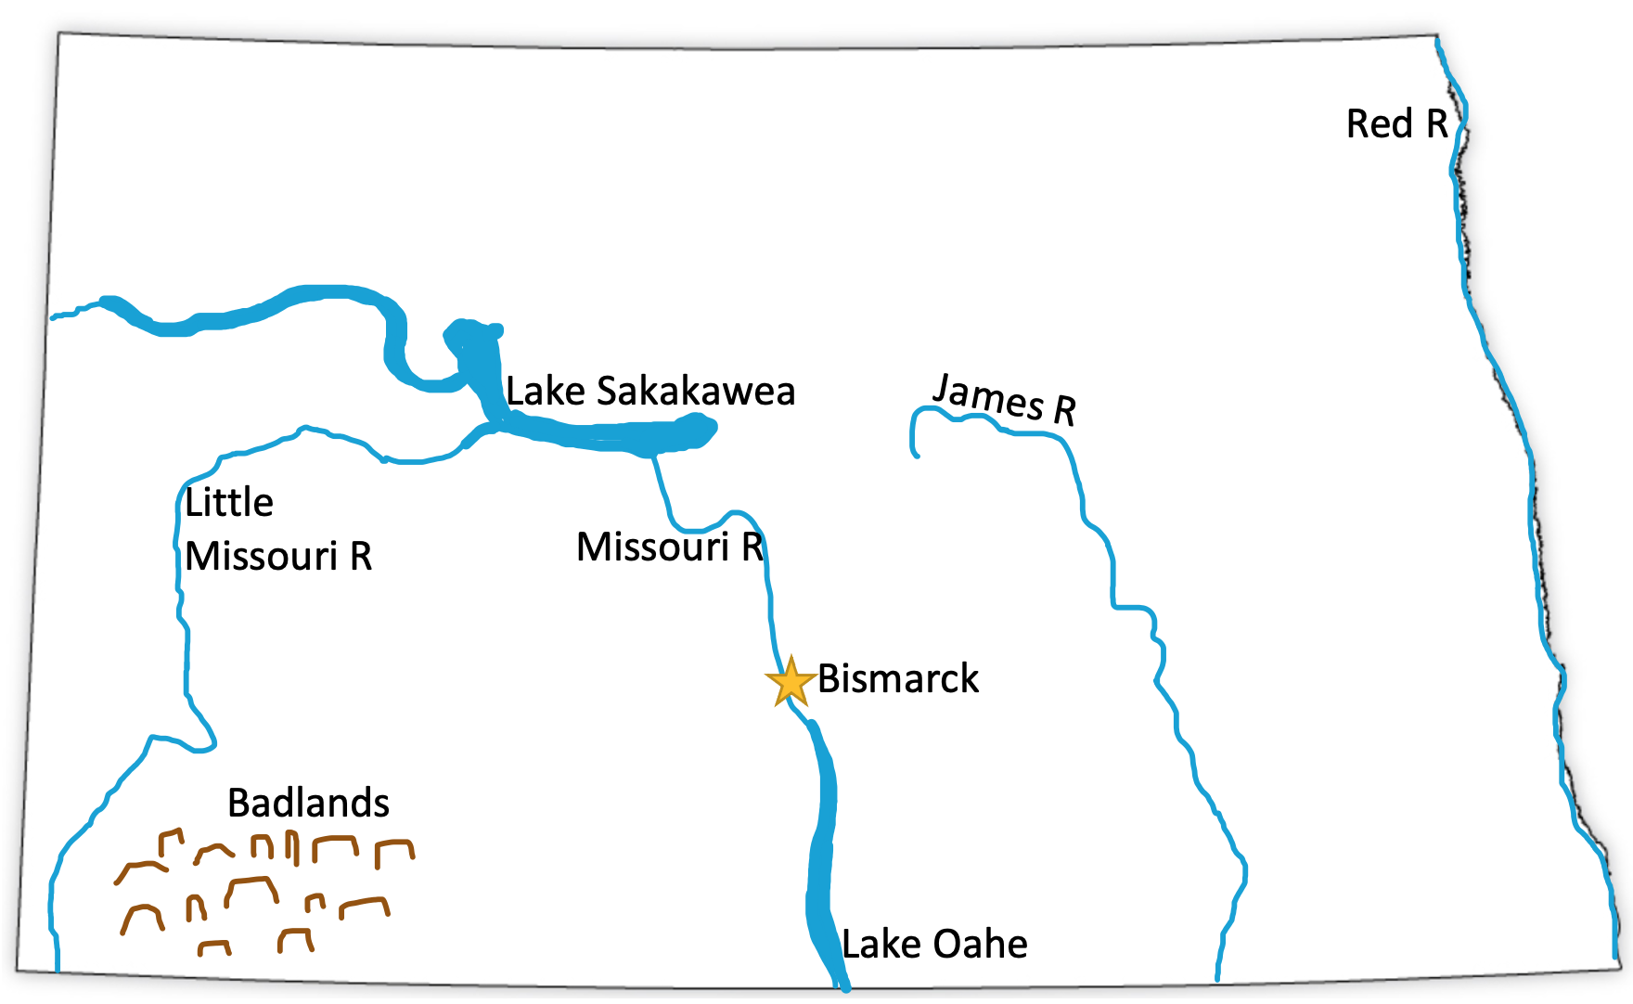
Capital: Bismarck ; Missouri River ; Little Missouri River ; James River ; Red River ; Lake Sakakawea ; Lake Oahe ; Badlands

Oklahoma

Origin of Name
Choctaw word meaning “red people”

Book to Read
* The Oklahoma Land Run by Una Belle Townsend

Links to View
* Oklahoma’s Strangest Scenery (3 min)
* Geology of Arbuckle Mountains (8 ½ min – start at 2:20)
- Sea Salt: The Oklahoma Great Salt Plains (2 min)
- The Geology of Turner Falls (5 min)

Geographical Features to Map
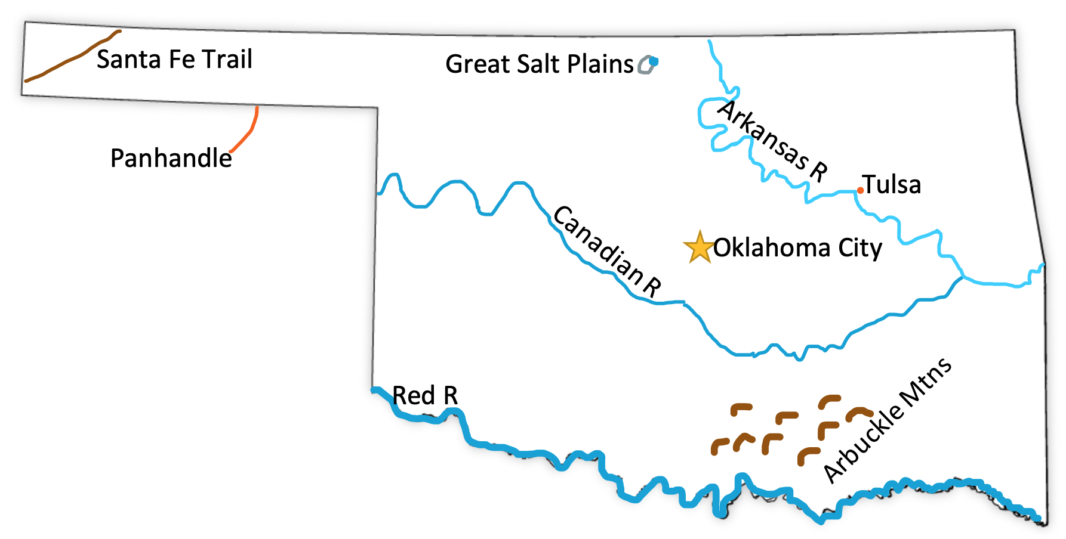
Capital Oklahoma City ; Tulsa ; Red River ; Arkansas River ; Canadian River ; Santa Fe Trail ; Great Salt Plains ; Arbuckle Mountains ; Panhandle

Texas

Origin of Name
Probably from a Native American word “tejas” meaning “friends” or “allies”

Book to Read
* Bloomin’ Tales: Seven Favorite Wildflower Legends by Cherie Foster Colburn
* All Different Now: Juneteenth, The First Day of Freedom by Angela Johnson
- Enrique Esparza and the Battle of the Alamo by Susan Taylor Brown

Links to View
* The Bargain That Lured American Settlers to Texas (3 ½ min)
* How Longhorn Cattle First Came to Texas (2 ½ min) and The Chisholm Trail
* The U.S. Army’s Legendary Buffalo Soldiers (3 min)
* Palo Duro Canyon State Park, Texas (3 min)
- Snakes in the Chihuahuan Desert (4 min)

Geographical Features to Map
Capital: Austin ; Rio Grande ; Red R; Sabine R ; Canadian R ; Brazos R ; Dallas ; Fort Worth ; Houston ; San Antonio / Alamo ; Palo Duro Canyon ; Panhandle ; Gulf of Mexico
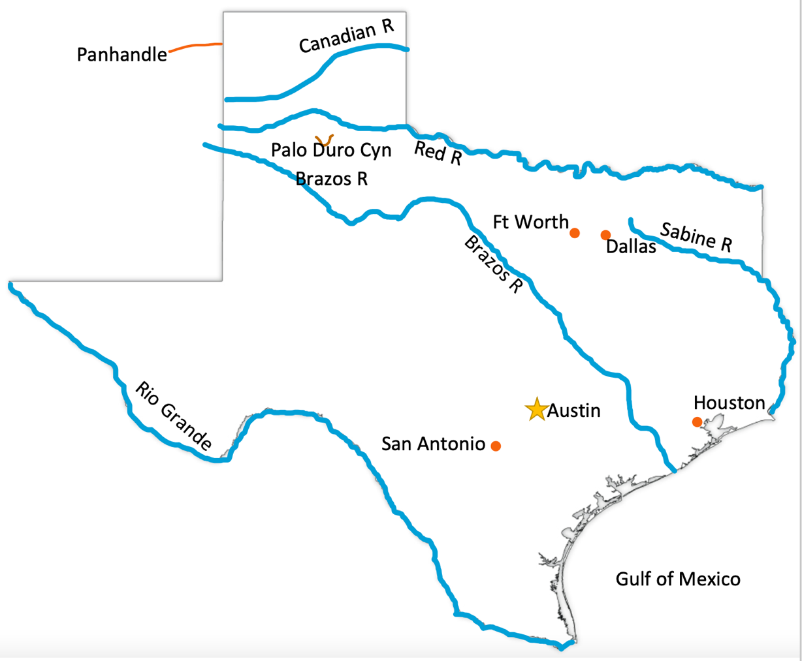

Quick Reference by State

Illinois: Capital: Springfield ; Lake Michigan ; Mississippi River ; Ohio River ; Wabash River ; Illinois River ; Chicago ; Cahokia Mounds

Indiana: Capital: Indianapolis ; Gary ; Lake Michigan ; Ohio River ; Wabash River

Iowa: Capital: Des Moines ; Mississippi River ; Missouri River ; Des Moines River ; Iowa River ; Council Bluffs ; Spillville ; Turkey River ; Iowa City ; Loess Hills ; Effigy Mounds ; Coldwater Cave

Kansas: Capital: Topeka ; Arkansas River ; Missouri River ; Smoky Hill River ; Kansas River ; Santa Fe Trail ; Flint Hills ; Oregon Trail

Michigan: Capital: Lansing ; Detroit ; Grand Rapids ; Grand River ; Upper Peninsula ; Lake Superior ; Lake Michigan ; Lake Huron ; Lake Erie ; Saginaw Bay ; Lake St. Clair ; Mackinac Island ; Isle Royale ; Sleeping Bear Dunes

Minnesota: Capital: St. Paul ; Minneapolis (Twin Cities) ; Mississippi River ; Lake Itasca ; Lake Superior ; St. Croix River ; Minnesota River ; Red River ; Lake of the Woods ; Northwest Angle ; Red Lakes ; Leech Lake ; Lake Winnibigoshish ; Mille Lacs Lake ; Bogs

Missouri: Capital: Jefferson City ; St. Louis ; Kansas City ; Independence ; Missouri River ; Mississippi ; St. Francis River ; Bootheel ; Santa Fe Trail ; Ozark Mountains

Nebraska: Capital: Lincoln ; Omaha ; Missouri River ; Platte River ; Nebraska River ; Oregon Trail ; Sand Hills ; Saline Wetlands

North Dakota: Capital: Bismarck ; Missouri River ; Little Missouri River ; James River ; Red River ; Lake Sakakawea ; Lake Oahe ; Badlands

Oklahoma: Capital Oklahoma City ; Tulsa ; Red River ; Arkansas River ; Canadian River ; Santa Fe Trail ; Great Salt Plains ; Arbuckle Mountains ; Panhandle

South Dakota: Capital: Pierre ; Missouri River ; Lake Oahe ; Lake Francis Case ; James River ; Big Sioux River ; Black Hills ; Badlands

Texas: Capital: Austin ; Rio Grande ; Red R; Sabine R ; Canadian R ; Brazos R ; Dallas ; Houston ; San Antonio / Alamo ; Chihuahuan Desert ; Palo Duro Canyon ; Panhandle

Wisconsin: Capital: Madison ; Lake Superior ; Lake Michigan ; Mississippi River ; Wisconsin River ; St. Croix River ; Lake Winnebago ; Green ; Bay Fox River ; Milwaukee ; Aztalan ; Apostle Islands

