Lisa Cotting
amblingtogether.com
United states geography
Western States

Table of Contents
How I Used This Guide 2
Why we study each state: 2
How we study each state: 3
New Mexico 4
Colorado 5
Wyoming 6
Montana 7
Idaho 8
Utah 9
Nevada 10
Arizona 11
Washington 12
Oregon 13
California 14
California - Map 15
Alaska 16
Hawai’i 17
Quick Reference by State 18

How I Used This Guide

Why we study each state:

Charlotte Mason recommends studying the geography of the child’s country. In Book VI, she says the children “are engaged with the counties of England, county by county, for so diverse are the counties in aspect, history, and occupation, that only so can children acquire such a knowledge of England as will prove a key to the geography of every part of the world, whether in the way of comparison or contrast.” She describes the principle to be followed as the child gets older and starts studying other countries: “vivid descriptions, geographical principles, historical associations and industrial details, are afforded which should make, as we say, an impression, should secure that the region traversed becomes an imaginative possession as well as affording data for reasonable judgements.”

Inspired by her study of the counties of England, I have made time in our Together Time to study the geography of all 50 states. For each state I try to find what will make “an impression” so that the state “becomes an imaginative possession” of each child. I decided to focus on mapping the physical features, reading a book or two about the culture, history, or nature of the state, and watching several videos to compliment these topics.

While using Miss Mason’s principles for teaching geography and choosing which features to map or which books to read and videos to watch, I consider the following goals: We will be familiar with major cities and landmarks – understanding how mountains and waterways divide and define, we will know a little about the original inhabitants of the land, we will have an understanding of what (some of) the state looks like and we will be familiar with some of the stories and culture from the area. I will not cover all of these topics for each state, but hope that in general we’ll know our country in this way by the time we’re finished.

How we study each state:

I have spaced this study over two years. Each week we will study one state. I have scheduled 20 minutes 2 mornings a week to read the book, watch the videos, and draw the geographical features on our U.S.A. map. When time permits, we draw the state freehand to help us notice the features of the boarder. For some states I have scheduled two weeks - either because the state has so much (such as New York – a week on Long Island/Manhattan and a week on Upper State) or because it has special meaning to our family (relatives live in or are from the state).

At the beginning of each lesson, I review the states we’ve covered so far. When we have covered enough of them so that it is no longer feasible to review everything in a couple minute review, I choose major features and change up the minor features each day. Then at the end of the lesson we review the new state we’ve learned that week.

In the guide below I have listed books and links that I have read and watched myself. The ones with the asterisk * are the ones I will prioritize. The others are alternative or additional resources. At the end of the guide is a list of geographical features for each state. I use this as a quick review before mapping the current week’s state. Every week as I am planning, I will request books from the library for several weeks in advance so I have them in time.

The maps I have drawn for each state are a basic rudimentary drawing for me to use as reference so I can easily find the landmarks in an atlas or “real” map. The children will use the “real” maps as reference for drawing their own maps.

Additional Resources:
- Map used with students: Beautiful Feet Books U.S.A. Map
- Map used for this document: worldmapblank.com and State Outline Maps
- Maps used to draw locations and physical features in each state: freeworldmaps.net
- Quick Facts: National Geographic Kids - U.S. States and Territories
- US Department of the Interior: Indian Affairs Office – Origin of State Names
- Book: How the States Got Their Shape by Mark Stein

New Mexico

Origin of Name
Mexican territory north and west of the Rio Grande as referenced by the Mexicans

Book to Read
* How the Chile Came to New Mexico by Rudolfo A. Anaya

Links to View
* The Ancient Civilizations the Thrived in Extreme Conditions - Chaco Culture (5 min)
* History of the Carlsbad Caverns National Park (3 min)
- How A Native American Potter Uses The Tradition of Horsehair Pottery (7 min)
- Chaco Culture: NPS National Historic Park

Geographical Features to Map
Capital: Santa Fe ; Albuquerque ; Rio Grande ; Pecos River ; Canadian River ; Rocky Mountains (Sangre de Christo Mountains) ; Pueblo Bonito ; Carlsbad Caverns ; Santa Fe Trail
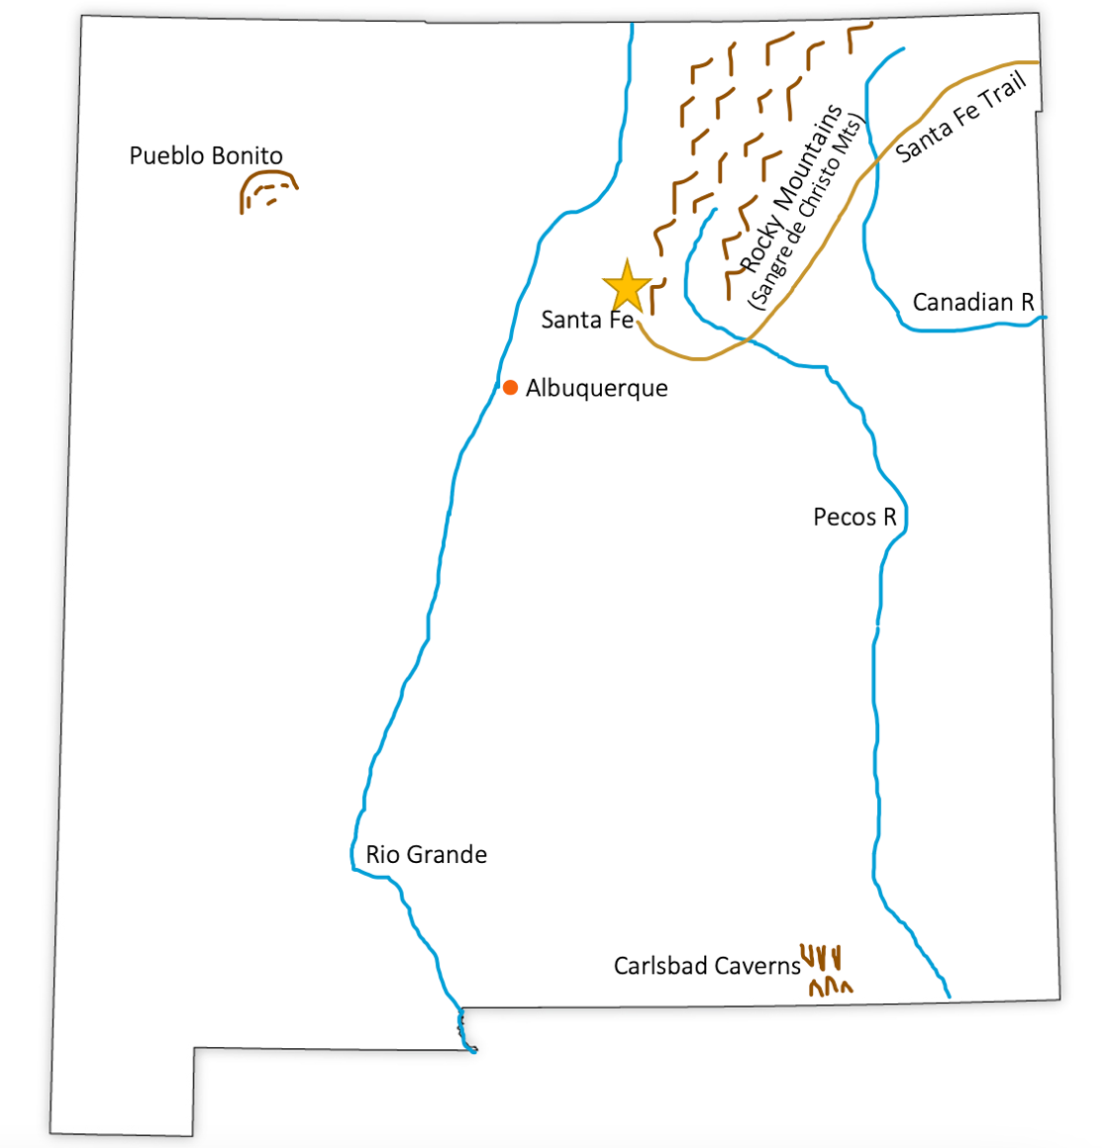

Colorado

Origin of Name
Possibly named by Spanish explorers for the reddish, muddy river

Book to Read
Option: Read this book from the Utah week:
* Dinosaur Mountain: Digging into the Jurassic Age by Deborah Kogan Ray

Links to View
* Mesa Verde Cliffside Dwellings (2 min)
* 9 Native American Sites to Explore in Colorado
* Rockies Thrust Up (5 min)
- Where Does The Colorado River Start and End? (19 min), especially through min 2:42)
- The Importance of the Continental Divide (to min 1:25)

Geographical Features to Map
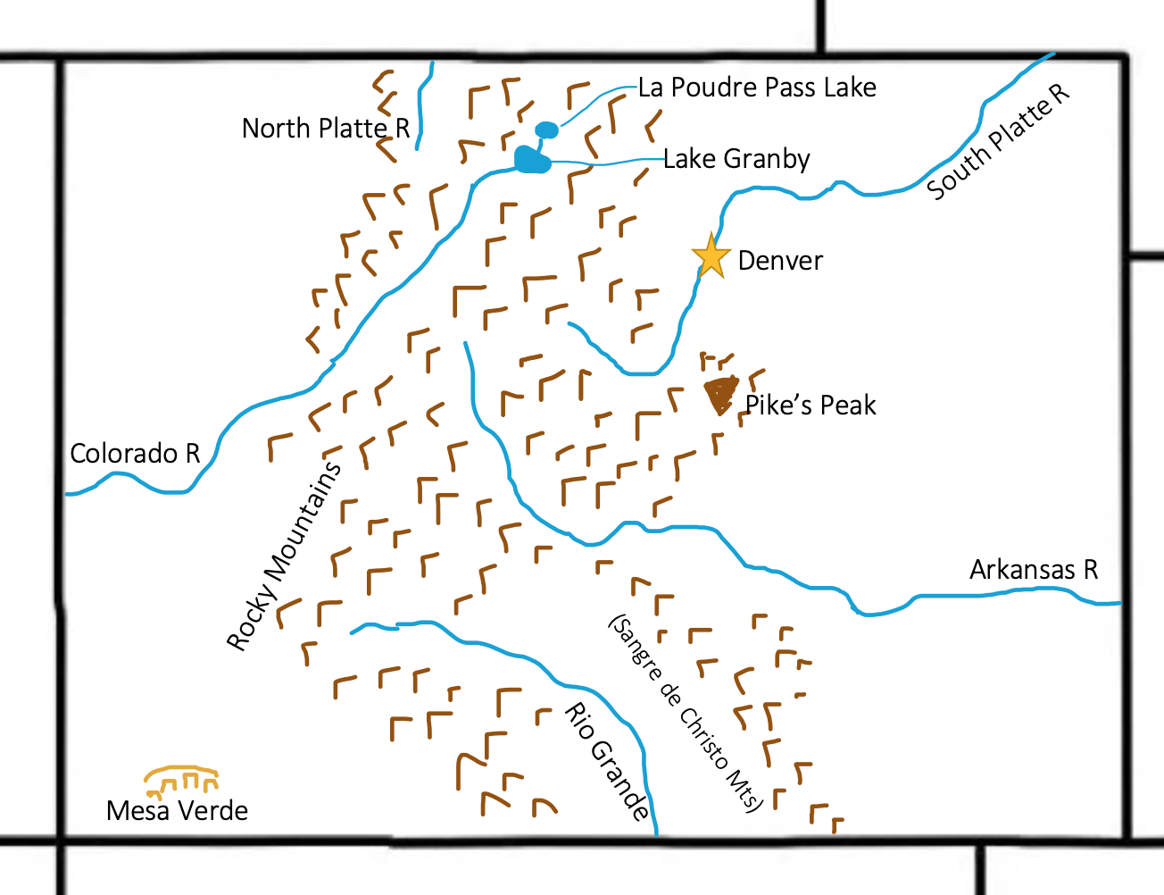
Capital: Denver ; Rocky Mountains ; Pike’s Peak ; Colorado River ; La Poudre Pass Lake ; Lake Granby ; Rio Grande ; North and South Platte River ; Arkansas River ; Mesa Verde

Wyoming

Origin of Name
Unclear origin. Possibly from the Leni-Lenape word “maugh-wau-wama” meaning “extensive plains” or possibly meaning “mountains with valleys alternating.” It could also be a Munsee word meaning “at the big river flat” or an Algonquin word meaning “a large prairie place.”

Book to Read
* Volcano Dreams: A Story of Yellowstone by Janet Fox
* The Wolves are Back by Jean Craighead George

Links to View
* Who are the People of Wind River Reservation? (4 min)
* How Wolves Change Rivers (4 ½ min)
- Who are the Northern Arapaho? (9 min)
- The Ancient Volcano in Wyoming: Devil’s Tower (4 min)
- Grand Teton National Park: Wildlife (4 ½ min)

Geographical Features to Map
Capital: Cheyenne ; Laramie ; Sheridan ; Yellowstone NP ; Yellowstone Lake ; Grand Teton NP ; Rocky Mountains ; North Platte River ; Big Horn River ; Snake River ; Devil’s Tower ; Wind River (Valley) ; Oregon Trail
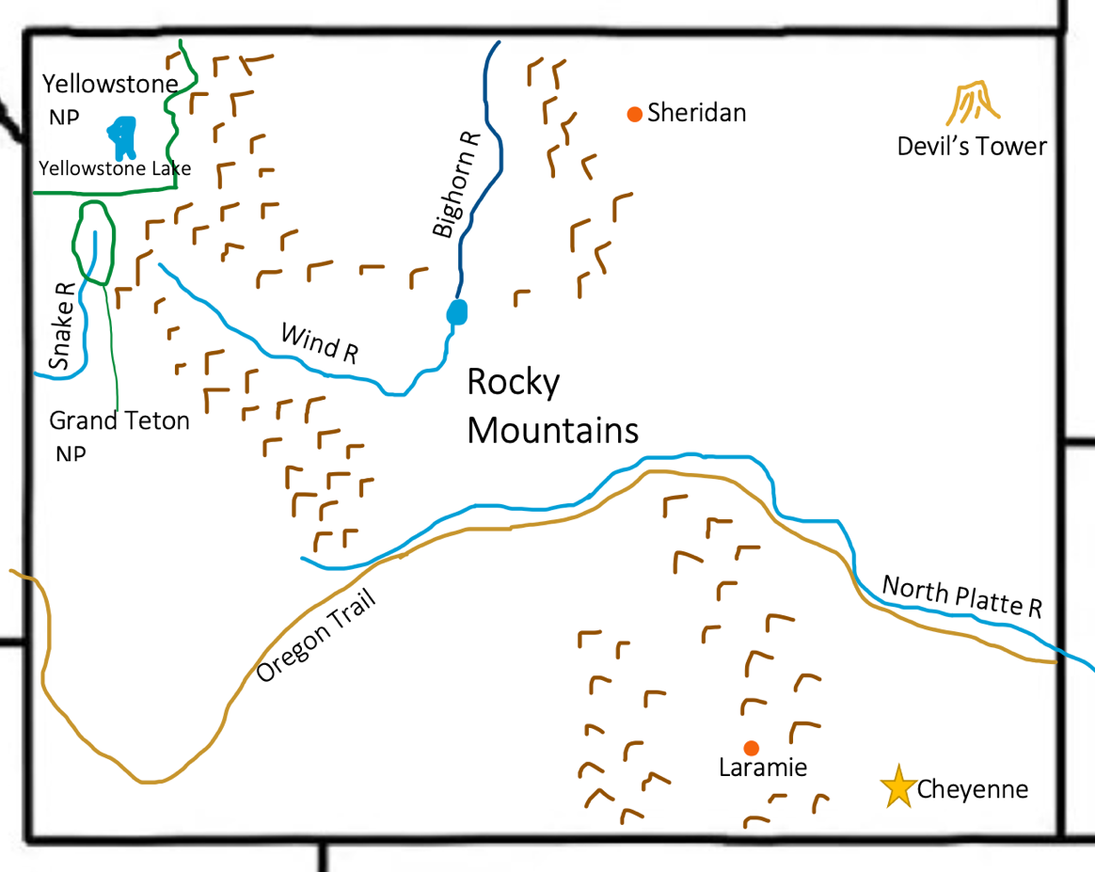

Montana

Origin of Name
Though the origin language is unsure, but word means “mountainous.”

Book to Read
* When Sue Found Sue by Toni Buzzeo
- Crow Chief: A Plains Indian Story by Paul Goble

Links to View
* Pompey’s Pillar National Monument (3 min)
* Take a Trip to Glacier National Park (3 min)
- Montana Tribes and their unique tipis (13 min)
- Museum of the Rockies: Montana Dinosaur Trail (3 ½ min)

Geographical Features to Map
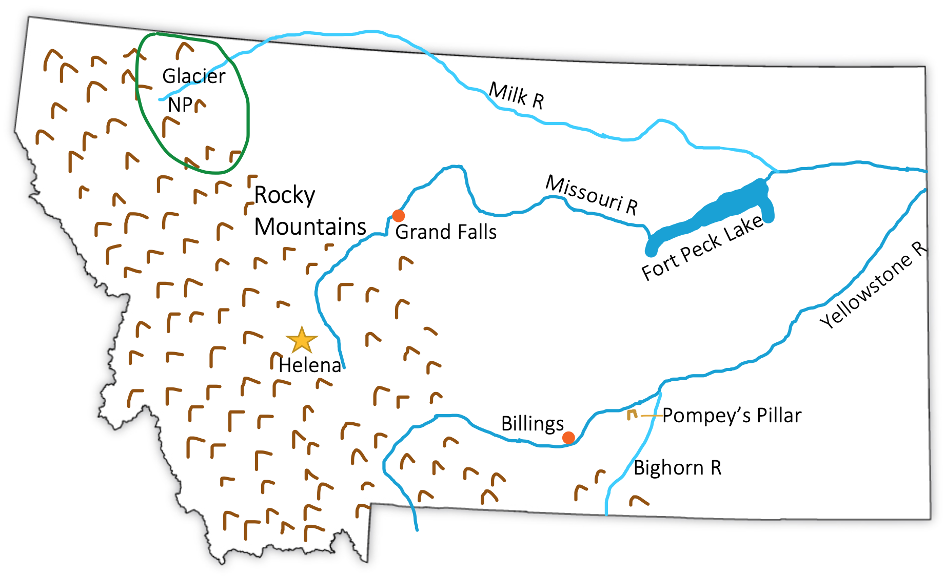
Capital: Helena ; Billings ; Great Falls ; Glacier NP ; Rocky Mountains ; Missouri River ; Yellowstone River ; Milk River ; Bighorn River ; Pompey’s Pillar ; Fort Peck Lake

Idaho

Origin of Name
Unknown origin – much speculation on different Native American words

Book to Read
- Mailing May by Michael O. Tunnell (fun true story, but not much geography)

Links to View
* Idaho Waterfalls (2 min)
* Frank Church Wilderness Area (3 ½ min)
- Idaho Potato Harvest (3 ½ min)

Geographical Features to Map
Capital: Boise ; Idaho Falls ; Coeur d’Alene ; Snake River ; Salmon River ; Rocky Mountains ; Shoshone Falls ; Oregon Trail

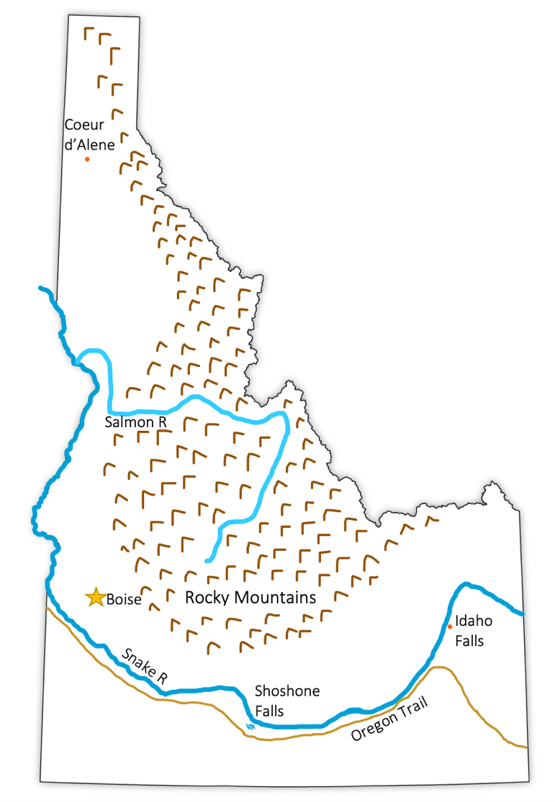

Utah

Origin of Name
From the Ute Native Americans who lived in the area

Book to Read
- Coolies by Yin
- Iron Horses by Verla Kay (for young children) or Ten Mile Day: And the Building of the Transcontinental Railroad by Mary Ann Fraser (for older children)
- Dinosaur Mountain: Digging into the Jurassic Age by Deborah Kogan Ray (optional: read in Colorado week)

Links to View
* The Utes and Colorow (10 min)
* A Short History of Utah Lake (5 ½ min – at least through min 2:29)
* Pando the Quaking Aspen (4 min)
- What Makes Great Salt Lake so Great? (2 min)
- Utah’s Otherworldly Landscapes (2 min)
- The Golden Spike and the Transcontinental Railroad (12 min – especially min 6:12 - 10:00)

Geographical Features to Map
Capital: Salt Lake City ; Provo ; Great Salt Lake ; Antelope Island ; Utah Lake ; Golden Spike ; Rocky Mountains ; Colorado River ; Lake Powell ; Bonneville Salt Flats ; Pando
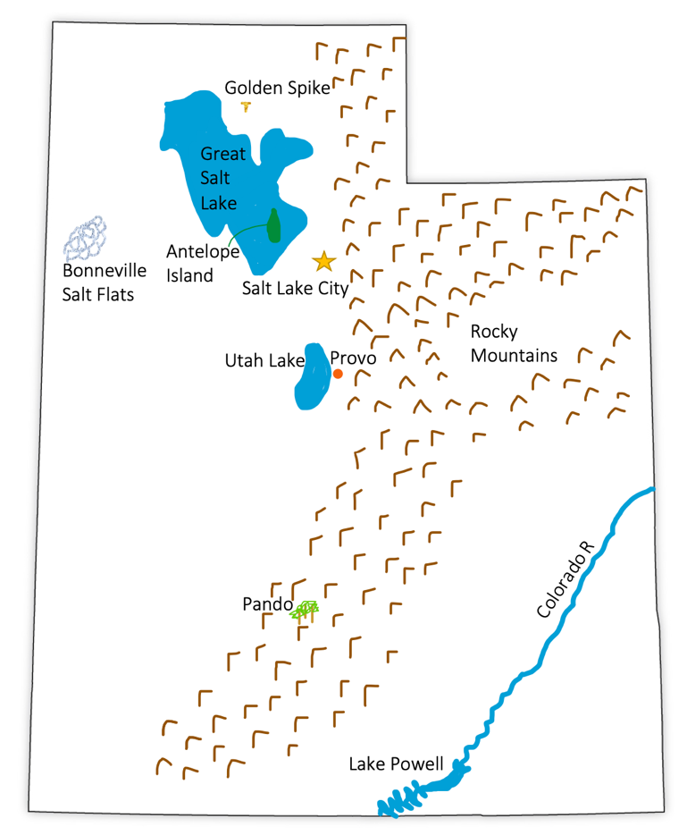

Nevada

Origin of Name
From the Spanish word that means “snowy”

Book to Read
Option: move this book from Arizona week
* Down the Colorado: John Wesley Powell, the One-Armed Explorer by Deborah Kogan

Links to View
* Basin and Range: Wild Nevada (2 min)
* Great Basin National Park (24 min – especially min 2:50 – 6:52 ; 7:52 – 10:44 ; 14:03 – 17:00 ; 20:13 – 21:22)
* What is the Great Basin? (link with maps and photos)
* How the Hoover Dam was Built (5 min)
- Why Wild Horses Are at Risk (2 ½ min)

Geographical Features to Map
Capital: Carson City ; Las Vegas ; Reno ; Lake Tahoe ; Pyramid Lake ; Truckee R ; Lake Mead ; Hoover Dam ; Colorado River ; Humboldt River ; Carson River ; Carson Sink ; California Trail (first wagons) ; Great Basin ; Great Basin Ranges
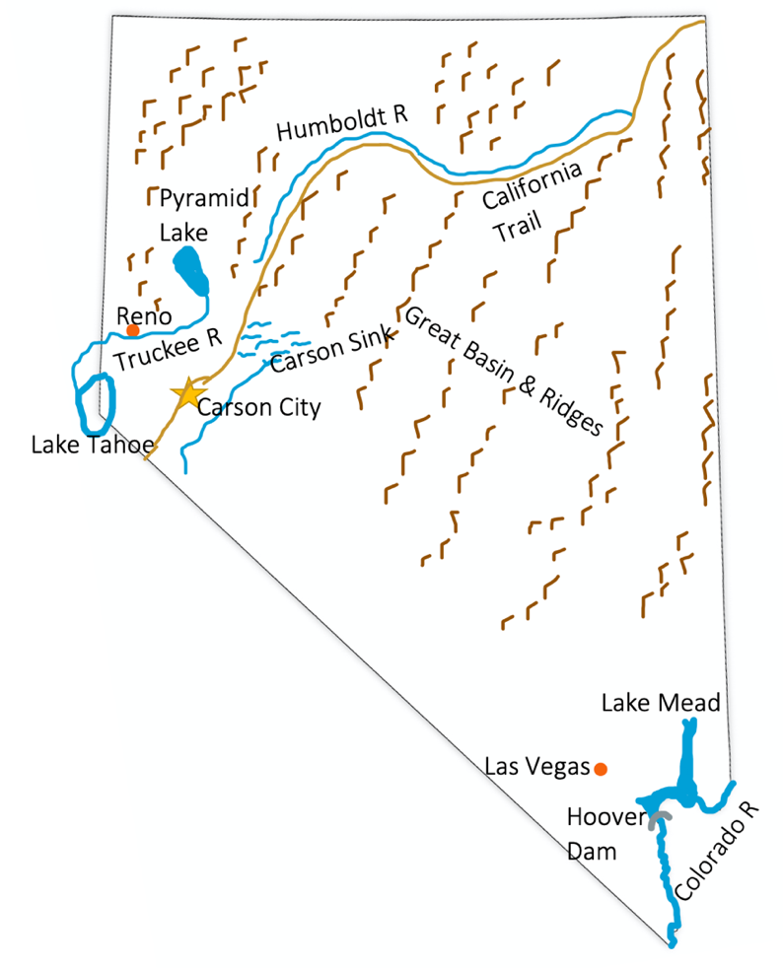

Arizona

Origin of Name
Unclear origin – There are many theories relating it to multiple native words

Book to Read
* Grand Canyon by Jason Chin
* Desert Giant: The World of the Saguaro Cactus by Barbara Bash
* Down the Colorado: John Wesley Powell, the One-Armed Explorer by Deborah Kogan Ray (maybe read for Nevada week)
- How the Stars Fell Into the Sky by Jerrie Oughton

Links to View
* Casa Grande Ruins National Monument (7 min)
* Best of Saguaro National Park (3 min – no talking, but labels of wildlife)
* Arizona’s Jaw-Dropping Mile-Long Meteor Crater (1 min)
* The Majesty of Monument Valley (3 min)
- Canyon de Chelly National Monument (9 min)
- Petrified Forest National Park (4 ½ min)

Geographical Features to Map
Capital: Phoenix ; Flagstaff ; Tucson ; Casa Grande ; Colorado River ; Grand Canyon ; Gila River ; Sonoran Desert ; Chihuahuan Desert ; Meteor Crater ; Petrified Forest ; Canyon de Chelly
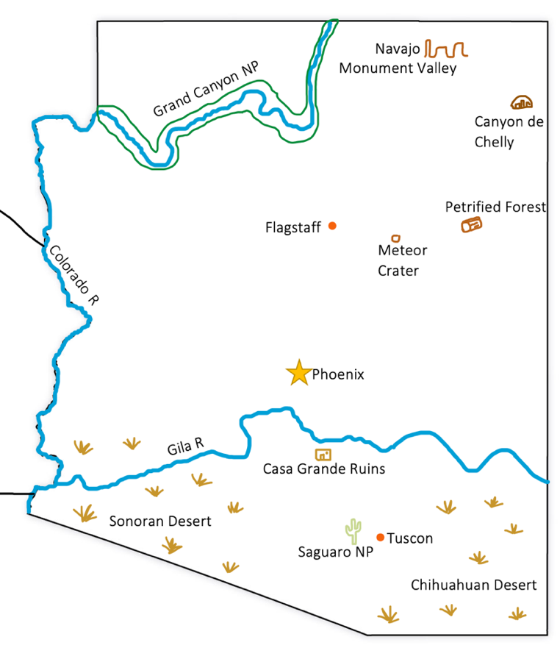

Washington

Origin of Name
For George Washington

Book to Read
* Raven: A Trickster Tale from the Pacific Northwest by Gerald McDermott

Links to View
* Totem Pole Carving (5 ½ min)
* Hoh Rain Forest (6 min)
- Lake Chelan – Battle of the Ice Sheets (4 ½ min)
- A Glimpse into Mt. Rainier (2 min)

Geographical Features to Map
Capital: Seattle ; Spokane ; Columbia River ; Snake River ; Mt. Rainier ; Mt. Olympus / Olympic National Park ; Puget Sound ; San Juan Islands ; Willapa Bay ; North Bay ; Lake Chelan
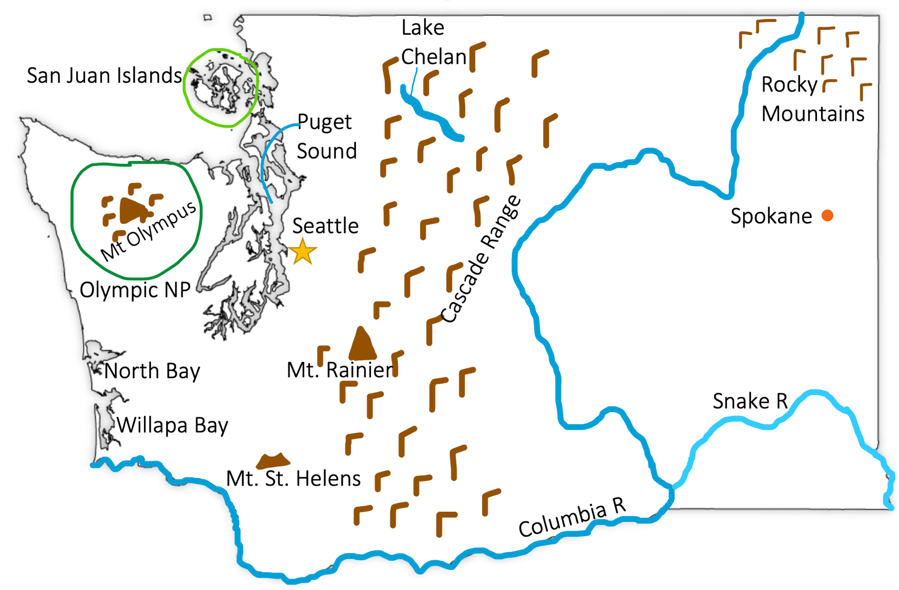

Oregon

Origin of Name
Origin debated

Book to Read
* n/a

Links to View
* How salmon shaped the Northwest (12 min especially through min 7:06)
* Crater Lake Formation (3 min) or The Collapsing Volcano – Virtual Junior Ranger Program (5 min)
- Tidepooling on the Oregon Coast (7 min)
- Hole in the Ground: Breathtaking Crater in Oregon’s High Desert (7 min – through min 4:00)

Geographical Features to Map
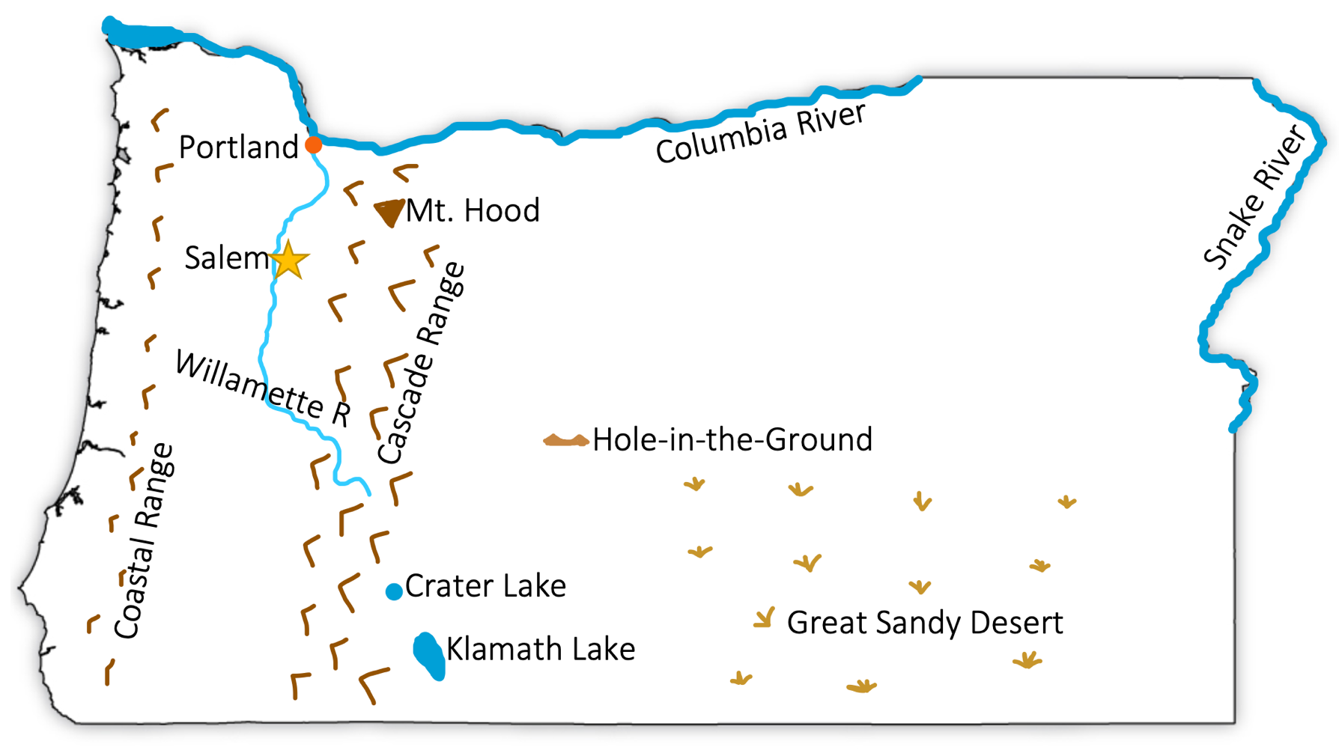
Capital: Salem ; Portland ; Columbia River ; Snake River ; Cascade Mountains ; Coastal Range ; Willamette River and Valley ; Crater Lake ; Klamath Lake ; Great Sandy Desert ; Hole in the Ground Crater

California

Over 2 weeks – see also a 36-week study of California at Amblingtogether.com

Origin of Name
For the fictional Warrior Queen, Califia of the island of California in Garci Rodriquez de Montalvo’s epic (Origin story)

Book to Read
* The Camping Trip that Changed America by Barb Rosenstock
* Mountain Chef: How One Man Lost His Groceries, Changed His Plans, and Helped Cook Up the National Park Service by Annette Bay Pimentel
* Redwoods by Jason Chin
- Song of the Swallows by Leo Politi
- Pop’s Bridge by Eve Bunting

Links to View
* Miwok grinding stones (2 min)
* Junipero Serra (4 min)
* The Story of the Gold Rush (3 min)
* Tulare Lake (8 min ; especially min 1:08 – 5:34)
- Channel Islands National Park (24 min especially 2:06 – 5:15)
- Death Valley National Park (2 ½ min)
- Making Shawii (10 min)
- How Los Angeles Gets its Water (18 min ; especially min 1:47-5:49)
- History of Native California (through min 2:21 – mature content after)

Geographical Features to Map
Capital: Sacramento ; San Francisco ; Los Angeles ; San Diego ; Coastal Ranges ; Sierra Nevada, Transverse Ranges ; San Francisco Bay ; Monterey Bay ; Channel Islands ; Lake Tahoe ; Salton Sea ; Mount Whitney ; Mojave Desert ; Sonoran Desert ; Sacramento River ; American River ; San Joaquin River ; Owens River ; Salinas River ; Yosemite NP ; Death Valley NP ; Sequoia NP ; Redwood NP ; Los Angeles Aqueduct ; California Aqueduct ; Colorado Aqueduct

(map on next page)

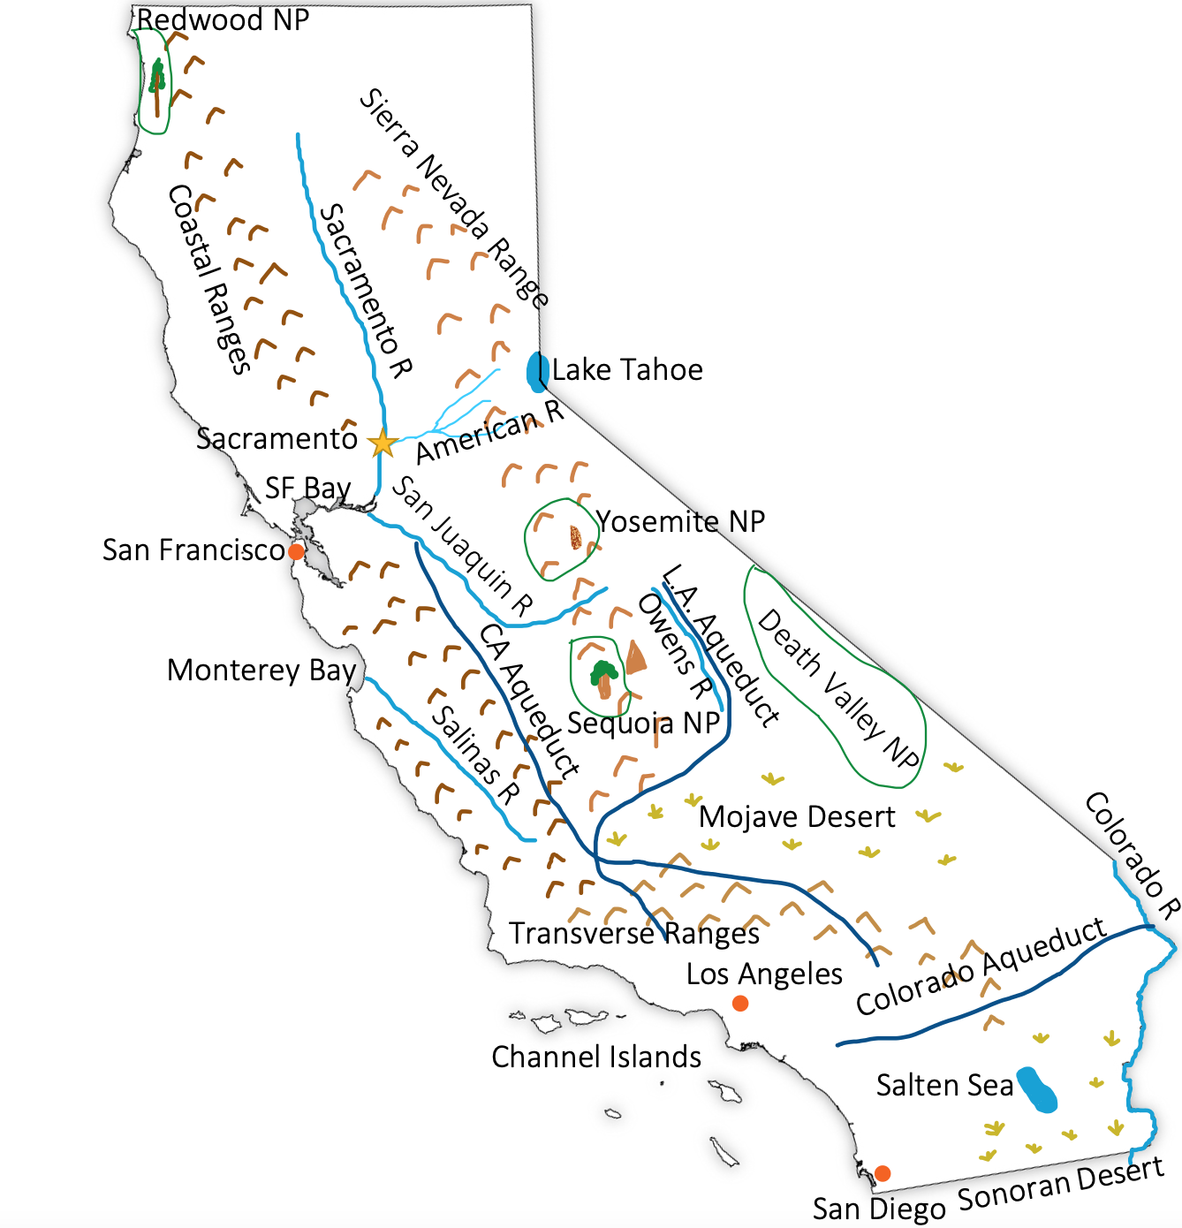
California - Map

Alaska

Origin of Name
The Eskimo word “alakshak” meaning peninsula or great lands

Book to Read
* Up on Denali: Alaska’s Wild Mountain by Shelley Gill
* Benny’s Flag by Phyllis Krasilovsky
* Arctic Lights, Arctic Nights by Debbie S. Miller
- Whale Snow by Debby Dahl Edwardson

Links to View
* Denali Has One of the Deepest Canyons in the World (3 min)
* How a Diphtheria Outbreak Spawned the Iditarod (2 ½ mim)
- Why are Kodiak Bears so Massive (5 min)
- Alaska’s Glaciers Take Up More Space than All of West Virginia (4 min)
- Dalton Discoveries: Arctic Plants (2 min)
- What the Most Northern Town in America is Like (Barrow) (6 min)

Geographical Features to Map
Capital: Juneau ; Anchorage ; Nome ; Fairbanks ; Barrow ; Mt. Denali ; Kodiak Island ; Aleutian Islands ; Seward Peninsula ; Bering Sea ; Arctic Ocean ; Gulf of Alaska ; Prince William Sound ; Alaskan Peninsula ; Kenai Peninsula ; Resurrection Bay ; Alaska Range ; Brooks Range ; Yukon River ; Tanana River
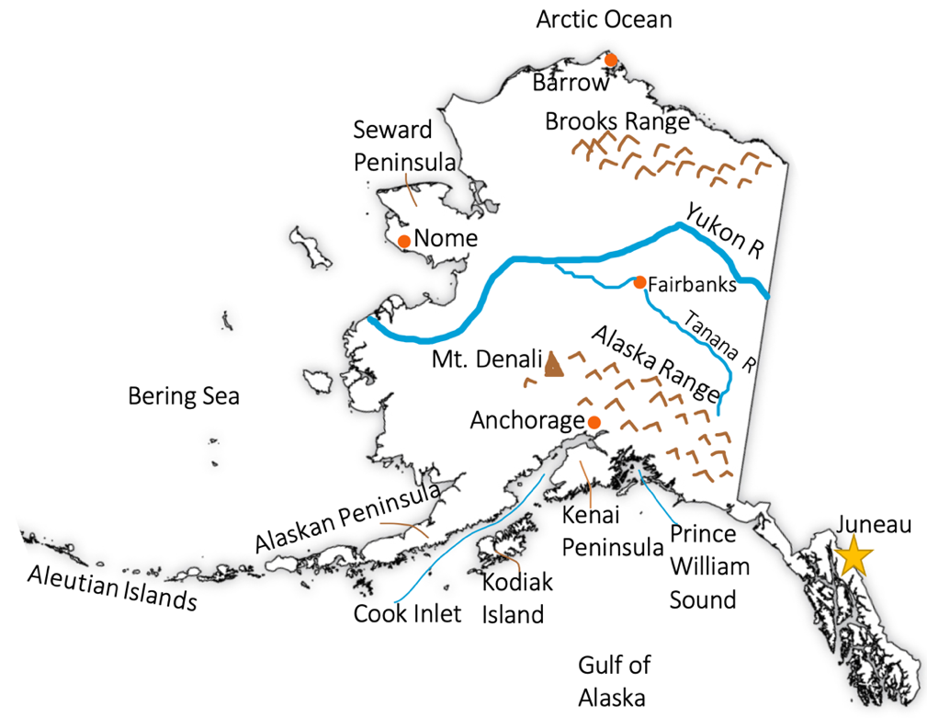

Hawai’i

Origin of Name
Debated, but one explanation is it being named for Hawai’iloa who legend says discovered and settled the islands. Another is its similarity to the Proto-Polynesian word meaning “homeland.”

Book to Read
* Island Below the Star by James Rumford
* The Last Princess: The Story of Princess Ka’iulani of Hawai’i by Fay Stanley
*. The Story of Hula by Carla Golembe

Links to View
* Hawai’i’s Forgotten Islands (9 min)
* Hawai’i: Exploring Oceans (4 min)
* The Volcanoes of Hawai’i (2 ½ min)
* Kapaemahu - a native story (9 min)
- The Most Active Volcanoes on the Hawai’ian Islands
- Hawai’iloa and the Discovery of Hawai’i
- How Did Hawai’i Form? (2 ½ min)

Geographical Features to Map
Capital: Honolulu ; Island of Hawai’I ; Maui ; Molokai’I ; Lanai ; Kaho’olawe ; O’ahu ; Kauai ; Ni’ihau ; Pearl Harbor ; Haleakala ; Hualalai ; Mauna Loa ; Kilaue ; Loihi
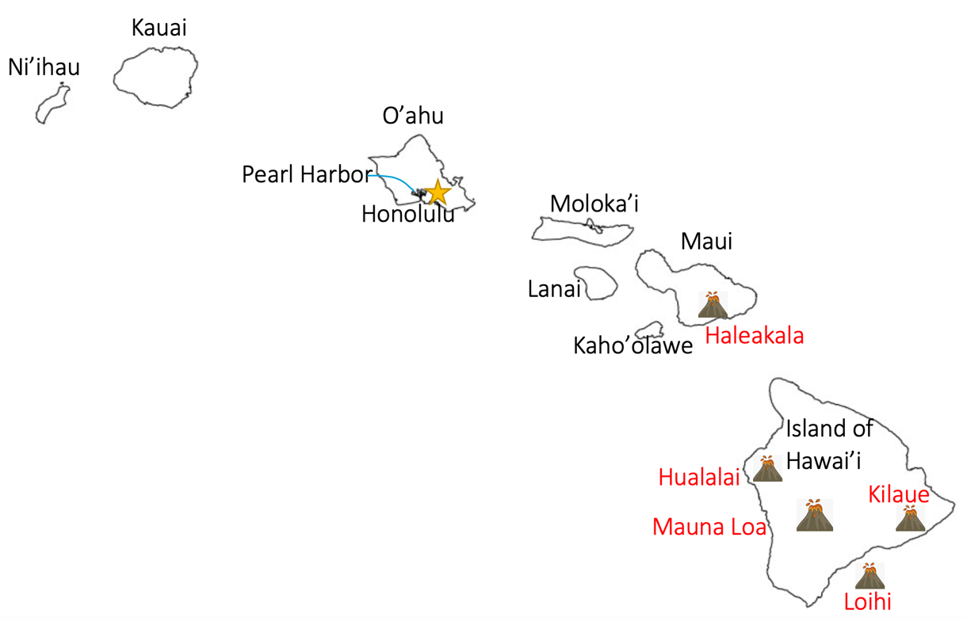

Quick Reference by State

Alaska: Capital: Juneau ; Anchorage ; Nome ; Fairbanks ; Barrow ; Mt. Denali ; Kodiak Island ; Aleutian Islands ; Seward Peninsula ; Bering Sea ; Arctic Ocean ; Gulf of Alaska ; Prince William Sound ; Alaskan Peninsula ; Kenai Peninsula ; Resurrection Bay ; Alaska Range ; Brooks Range ; Yukon River ; Tanana River

Arizona: Capital: Phoenix ; Flagstaff ; Tucson ; Casa Grande ; Colorado River ; Grand Canyon ; Gila River ; Sonoran Desert ; Chihuahuan Desert ; Meteor Crater ; Petrified Forest ; Canyon de Chelly

California: Capital: Sacramento ; San Francisco ; Los Angeles ; San Diego ; Coastal Ranges ; Sierra Nevada, Transverse Ranges ; San Francisco Bay ; Monterey Bay ; Channel Islands ; Lake Tahoe ; Salton Sea ; Mount Whitney ; Mojave Desert ; Sonoran Desert ; Sacramento River ; American River ; San Joaquin River ; Owens River ; Salinas River ; Yosemite NP ; Death Valley NP ; Sequoia NP ; Redwood NP ; Los Angeles Aqueduct ; California Aqueduct ; Colorado Aqueduct

Colorado: Capital: Denver ; Rocky Mountains ; Pike’s Peak ; Colorado River ; La Poudre Pass Lake ; Lake Granby ; Rio Grande ; North and South Platte River ; Arkansas River ; Mesa Verde

Hawaii: Capital: Honolulu ; Island of Hawai’I ; Maui ; Molokai’I ; Lanai ; Kaho’olawe ; O’ahu ; Kauai ; Ni’ihau ; Pearl Harbor ; Haleakala ; Hualalai ; Mauna Loa ; Kilaue ; Loihi

Idaho: Capital: Boise ; Idaho Falls ; Coeur d’Alene ; Snake River ; Salmon River ; Rocky Mountains ; Shoshone Falls ; Oregon Trail

Montana: Capital: Helena ; Billings ; Great Falls ; Glacier NP ; Rocky Mountains ; Missouri River ; Yellowstone River ; Milk River ; Bighorn River ; Pompey’s Pillar ; Fort Peck Lake

New Mexico: Capital: Santa Fe ; Albuquerque ; Rio Grande ; Pecos River ; Canadian River ; Rocky Mountains (Sangre de Christo Mountains) ; Pueblo Bonito ; Carlsbad Caverns

Nevada: Capital: Carson City ; Las Vegas ; Reno ; Lake Tahoe ; Pyramid Lake ; Truckee R ; Lake Mead ; Hoover Dam ; Colorado River ; Humboldt River ; Carson River ; Carson Sink ; California Trail (first wagons) ; Great Basin ; Great Basin Ranges

Oregon: Capital: Salem ; Portland ; Columbia River ; Snake River ; Cascade Mountains ; Coastal Range ; Willamette River and Valley ; Crater Lake ; Klamath Lake ; Great Sandy Desert ; Hole in the Ground Crater

Utah: Capital: Salt Lake City ; Provo ; Great Salt Lake ; Antelope Island ; Utah Lake ; Golden Spike ; Rocky Mountains ; Colorado River ; Lake Powell ; Bonneville Salt Flats ; Pando

Washington: Capital: Seattle ; Spokane ; Columbia River ; Snake River ; Mt. Rainier ; Mt. Olympus / Olympic National Park ; Puget Sound ; San Juan Islands ; Willapa Bay ; North Bay ; Lake Chelan

Wyoming: Capital: Cheyenne ; Laramie ; Sheridan ; Yellowstone NP ; Yellowstone Lake ; Grand Teton NP ; Rocky Mountains ; North Platte River ; Big Horn River ; Snake River ; Devil’s Tower ; Wind River (Valley) ; Oregon Trail

