Column Types. (pg 44-59)

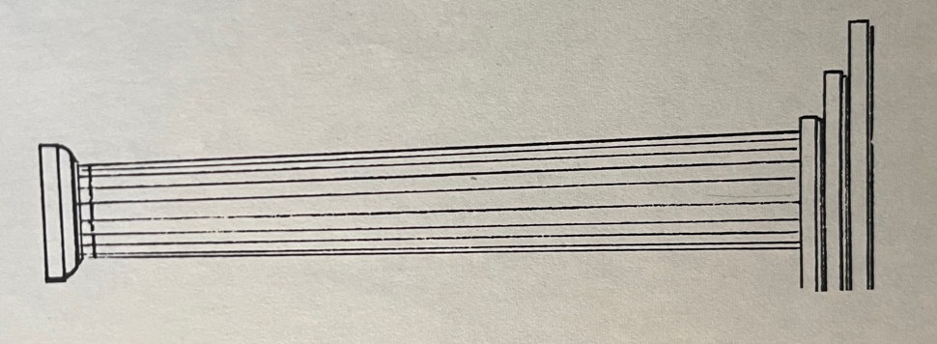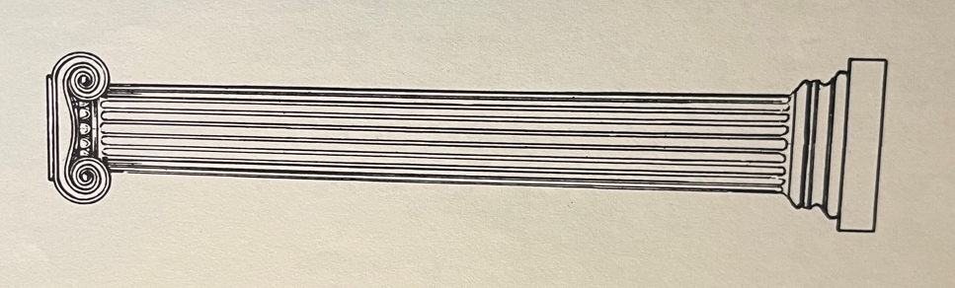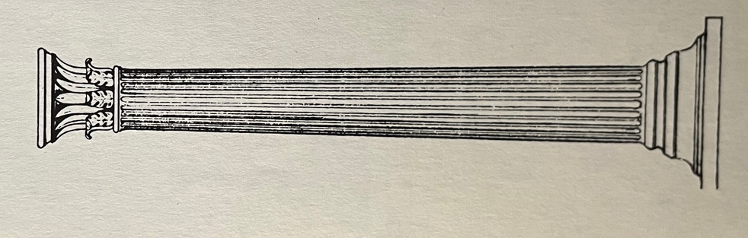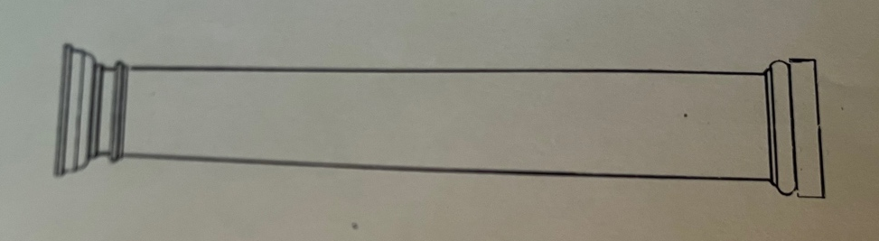
Doric – “man’s style”
No base, tapers slightly, slight bulge (entasis), fluted, simple saucer shaped capital (Greek)
Etruscan Doric – base, no flutes, no saucer shape in capital (Romans)
Corinthian – like Ionic with acanthus leaves & curve on capital instead of curls (Greek, but prefered by Romans)
Ionic – “woman’s”
Curls at top (volutes), fluted, on a base (Greek)

Composite – large curls (volutes) of Ionic, acanthus leaves (Roman)
