Erechtheum and the Caryatid(pg 50-55)

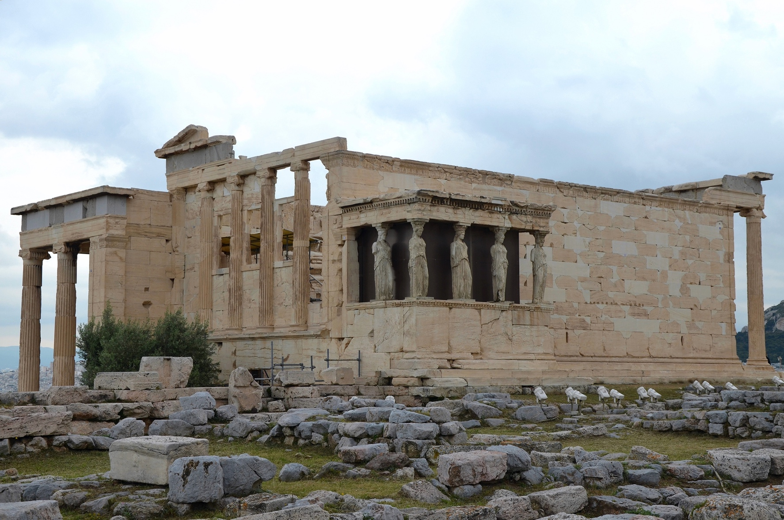

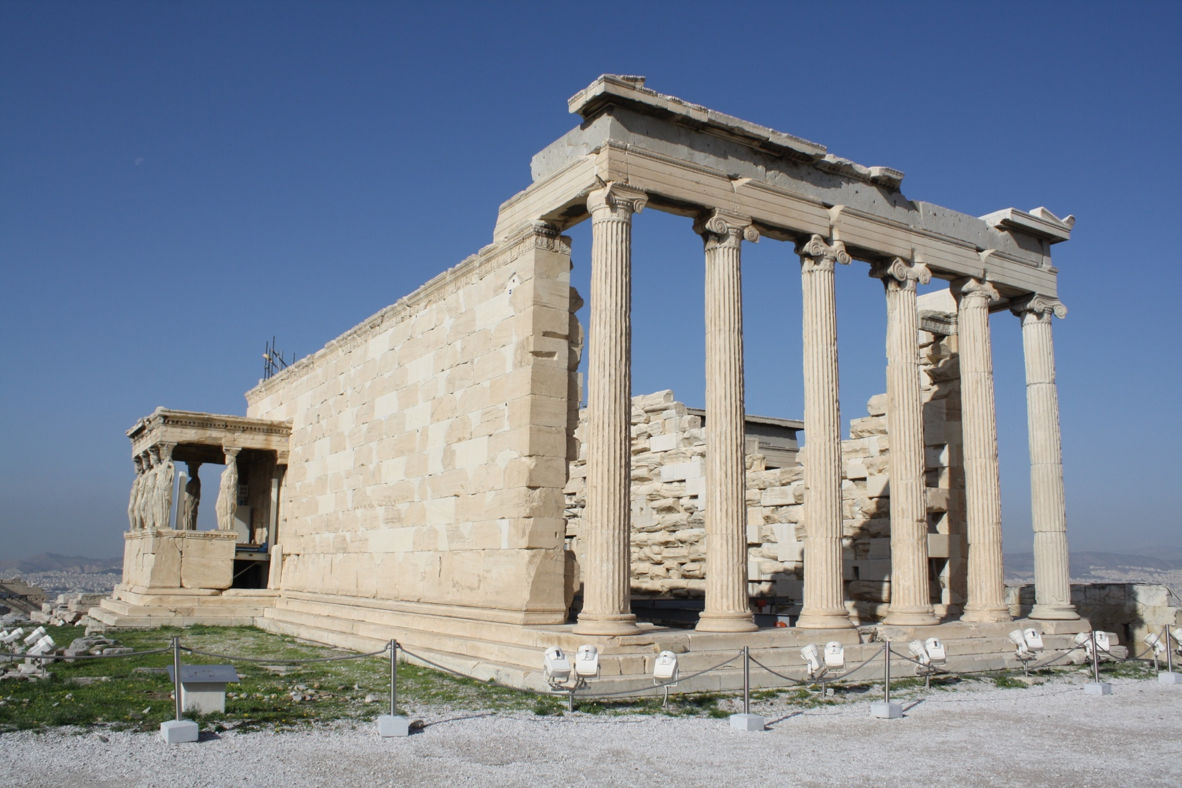

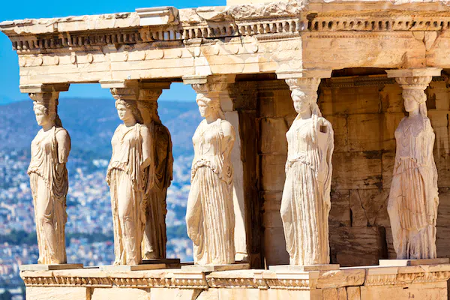

Porch of the Maidens

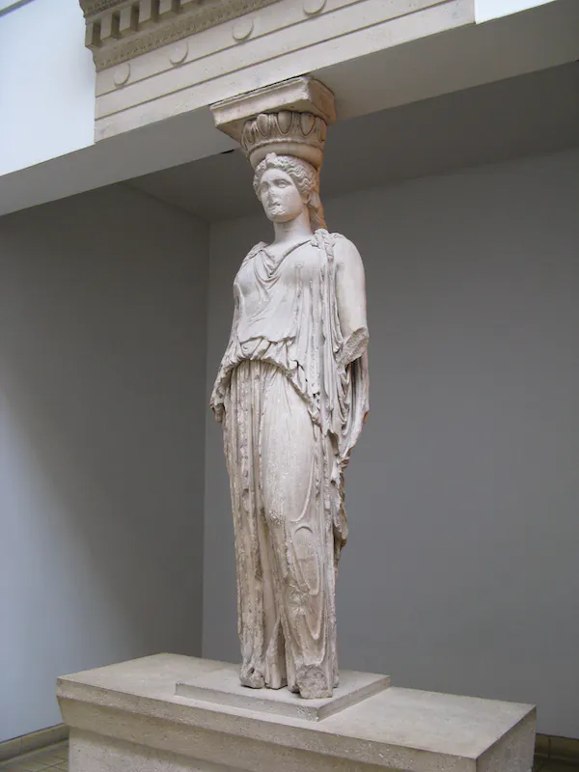

The caryatid taken by Elgin from the Erechtheion displayed at the British Museum

