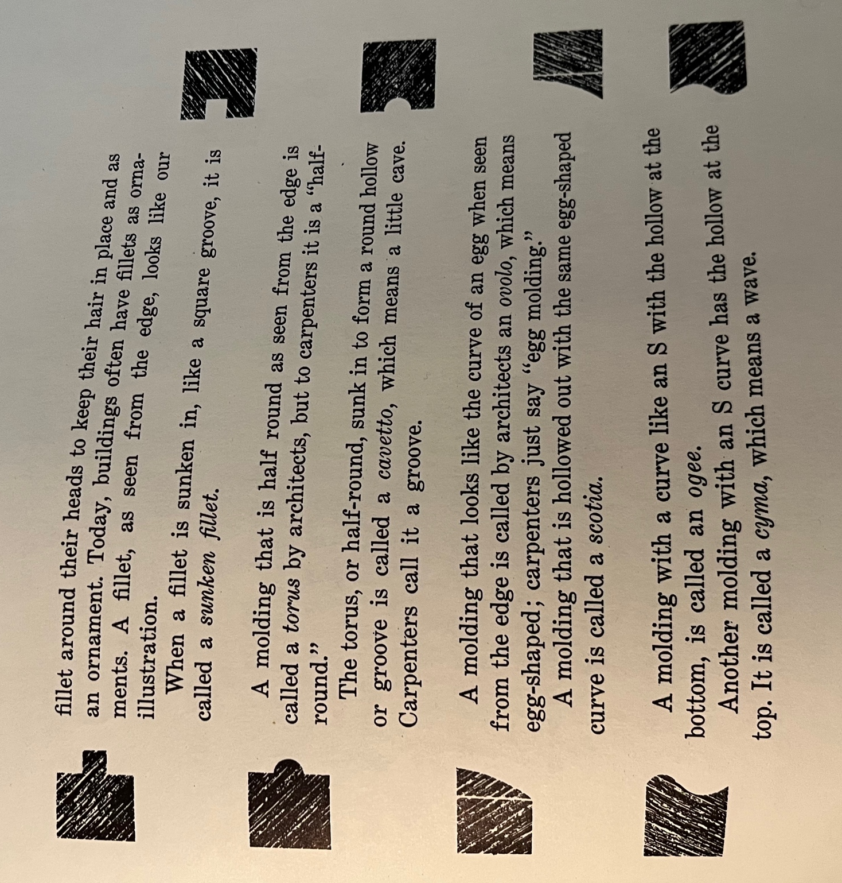
Molding Types. (pg 82-84)
Square and simple is a fillet.

