Classic Border Types. (pg 84-85)

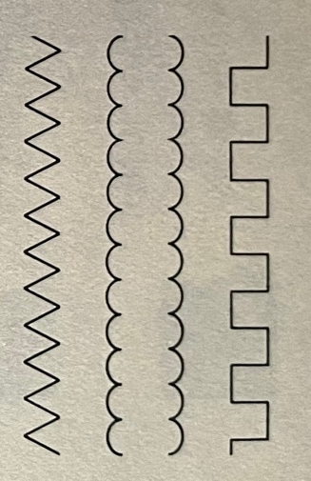
Embattled
Scalloped
Chevron

Meander

Fret or Key

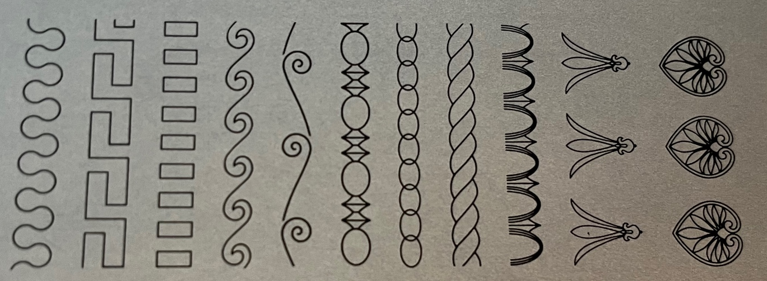
Anthemion
(often used with Greek Lily)
Greek Lily
Egg and Dart
Rope
Chain
Astrangal
Running Scroll
Wave
Dentil

