Study Guide Prepared by Lisa Cotting
amblingtogether.com
La salle of the Mississippi
By Ronald Syme

Table of Contents
Week 1: Chapter 1 – The Unknown Country Part 1 3
Week 3: Chapter 1 – The Unknown Country Part 2 4
Week 5: Chapter 2 - The Lonely Explorer Part 1 5
Week 7: Chapter 2 - The Lonely Explorer Part 2 6
Week 8: Chapter 3 - The Mystery of the Griffin Part 1 7
Week 10: Chapter 3 - The Mystery of the Griffin Part 2 8
Week 12: Chapter 4 - The Fort on the River Part 1 9
Week 14: Chapter 4 - The Fort on the River Part 2 10
Week 16: Chapter 5 – The Iroquois on the Warpath Part 1 11
Week 18: Chapter 5 – The Iroquois on the Warpath Part 2 12
Week 19: Chapter 6 – Down the Mississippi Part 1 13
Week 21: Chapter 6 – Down the Mississippi Part 2 14
Week 23: Chapter 7 – The Lost River Part 1 15
Week 25: Chapter 7 – The Lost River Part 2 16
Week 26: Chapter 8 – The Lonely Village Part 1 16
Week 28: Chapter 8 – The Lonely Village Part 2 18
Week 30: Chapter 9 – LaSalle and the Mutineers Part 1 19
Week 32: Chapter 9 – LaSalle and the Mutineers Part 2 20
Week 34: Chapter 10 – The End of the Journey 21

Why we are using this book:

This reading is replacing Minn of the Mississippi by Holling C. Holling in the AO schedule for Year 4. Minn follows a turtle from the source the mouth of the Mississippi River. This story includes much reference to history, geology, science, natural history, inventions, as well as physical geography. For us, though it was full of information, it was difficult to read. As my first son did not understand most of the references, much of the story was not retained. I decided to find an alternative that would better engage my second son.

LaSalle of the Mississippi does not cover the entire Mississippi River or give information about the history, science, geology, or natural history of the river. But it is a living book with which we can follow the geography of the Great Lakes and Mississippi River. It is a fast paced adventure story of a fearless and determined man and the places he explored. I also like that this book gives us a look at the settlement of North America from a French perspective – which we get only a little of in This Country of Ours.

How we are using this book:

The schedule below assigns equivalent reading the same weeks that Minn of the Mississippi readings were assigned, ending one week early.

In my pre-read, I have used a pencil to remove the use of language that speaks offensively of the Native Americans such as using the word “savage”. There is not a significant amount, and I have noted below where there are passages I will not be reading. I will be reading this aloud so that I can make the necessary changes.

Each chapter (but the last) is split into two readings, with about 7-10 pages for each reading.

Resources for the Book:

Book available on Archive.com

Graphic of LaSalle’s explorations: historymuseum.ca
Map of LaSalle’s several explorations

We will be following the journey down the Mississippi with the BFBooks map. The map does not include every location mentioned in the book, so we will look at the maps I have in the pages below.

We may also use a Century Chart or other Timeline to follow along with the story.

Week 1: Chapter 1 – The Unknown Country Part 1

Reading Assignment:
Ch 1 pg. 1-9 (end at “nearly the entire fortune.”)

Summary:
As a schoolboy, LaSalle dreams of America. When he is older and hears of Radisson & Groseilliers description of the Messipi, he decides to go to America.

Timeline:
1657 – story starts
1666 – La Salle sails for America

Resources:
Example of a Map of North America from 1650

Map:
Rouen
Map from etc.usf.edu
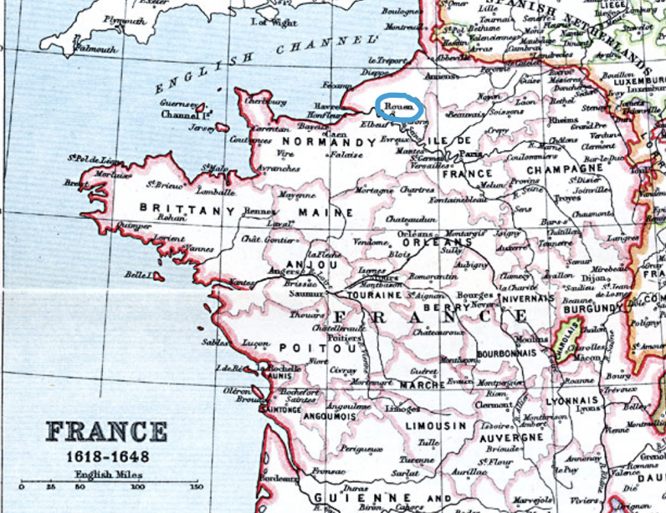

Week 3: Chapter 1 – The Unknown Country Part 2

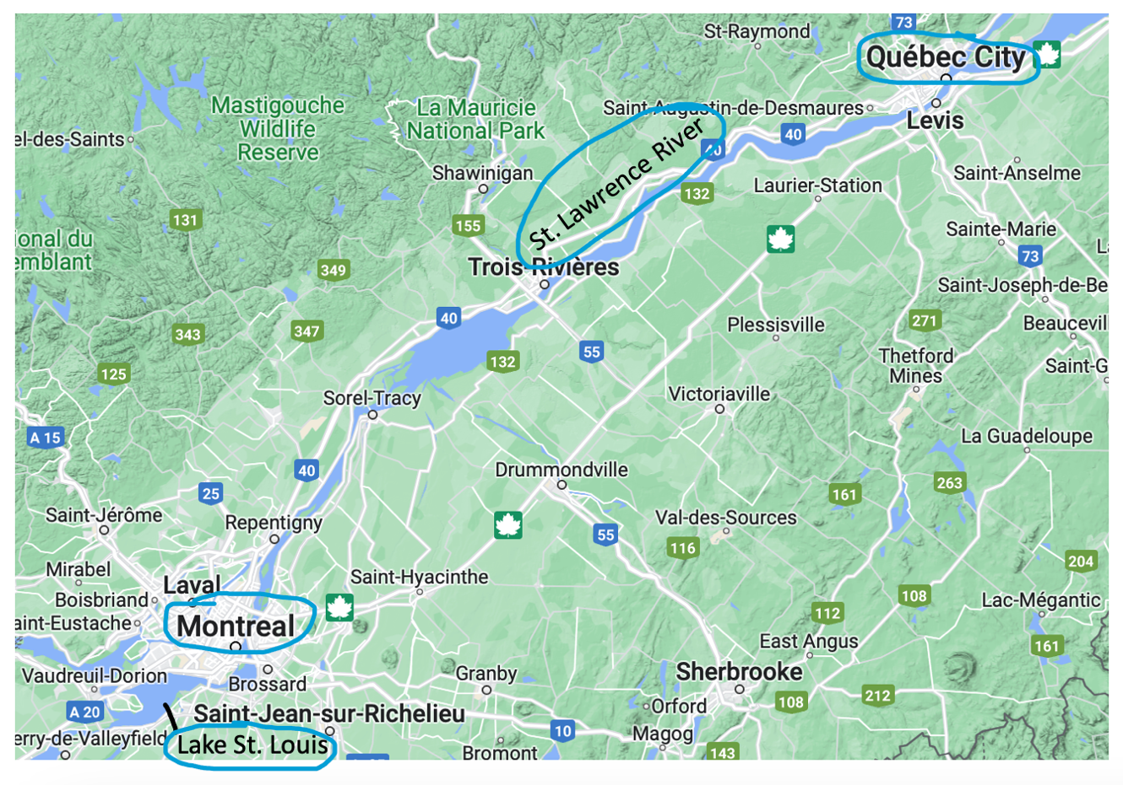
Reading Assignment:
Ch 1 pg. 9-19 (end of chapter)

Summary:
La Salle comes to Montreal and is given land to rent out to tenants. He is earning money and learning the languages of the Iroquois peoples. After two years, he goes to see the governor in Quebec and asks permission to search for the Ohio River. Permission is granted, but he must pay for it himself. He sells his land to fund his journey. He is joined by other Catholic explorers lead by Dollier who had been planning to explore the great lakes.

Timeline:
1669 – leaves Montreal in search of the Ohio River

Resources:
1650 Map of New France
Map:
Montreal, Quebec, Lake St. Louis, St. Lawrence River
Map from Google Maps

Week 5: Chapter 2 - The Lonely Explorer Part 1

Reading Assignment:
Ch 2 pg. 20-30 (end at “…died in the wintery wilderness.”)
Note: There are several paragraphs (pg. 25-26 I will skip due to content)
Summary:
The party makes their way to Lake Ontario and stays at a Seneca village for a couple weeks. Dollier and his party decide they want to go North after all, so they split. Dollier will make it to Lake Superior and back to Montreal – the first good map of the Great Lakes comes from this journey. Meanwhile, La Salle heads to Lake Erie. There more men desert. He heads south and finds the Ohio River and makes canoes. They start heading down the river. After 400 miles the other 6 men leave LaSalle and go in search of Virginia.
Timeline:
It is still 1669

Resources:
N/A
Map:
Lake Ontario, Lake Erie, Lake Huron, Lake Michigan, Lake Superior, Ohio River
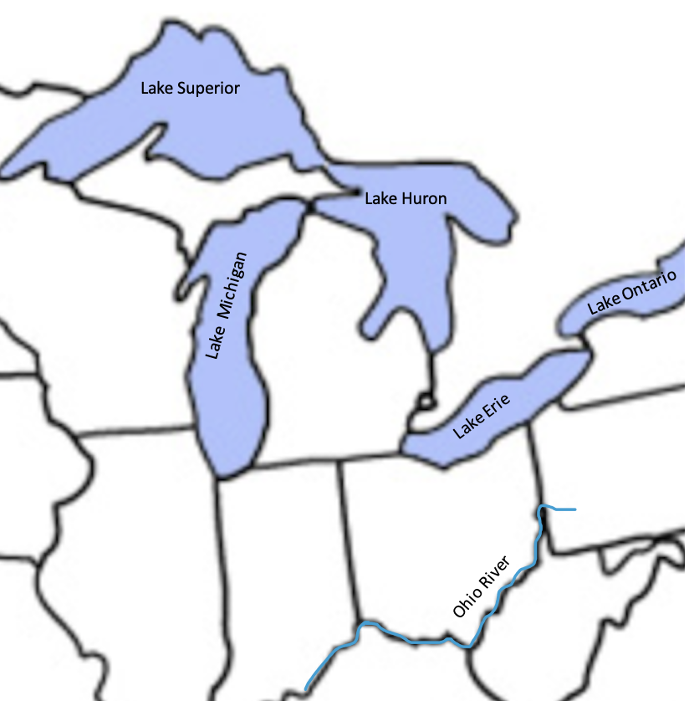

Reading Assignment:
Ch 2 pg. 30-40 (start at bottom of pg. 30 “Finding myself alone…”)
Summary:
Since he is alone, LaSalle heads back up the Ohio. When he reaches Lake Erie, he decides to explore the Great Lakes & makes it to Lake Michigan. He discovers the Illinois River and takes it to the Mississippi before he turns around and goes back to Montreal. There people mock him. Meanwhile, Joliet and Marquette find the Mississippi from the North and make it to the Arkansas River before turning around. LaSalle asks the governor’s permission to explore the Mississippi. Joliet tells LaSalle of his journey so he’s more certain it will lead him to the Gulf. The governor tells LaSalle to return to France to get the King’s permission.
Timeline:
Spring 1670 – returns to Lake Erie (probably)
Fall 1670 – returns to Montreal
Fall 1674 – Journey’s back to France

Resources:
Map of Illinois River ; map of Great Lakes and rivers (used below)
Map:
Lake Erie, Detroit River, Lake St. Clair, Lake Huron, Straits of Michilimackinac, Lake Michigan, Illinois River. Lake Superior, Wisconsin River, Mississippi River (to Arkansas River).

Week 7: Chapter 2 - The Lonely Explorer Part 2

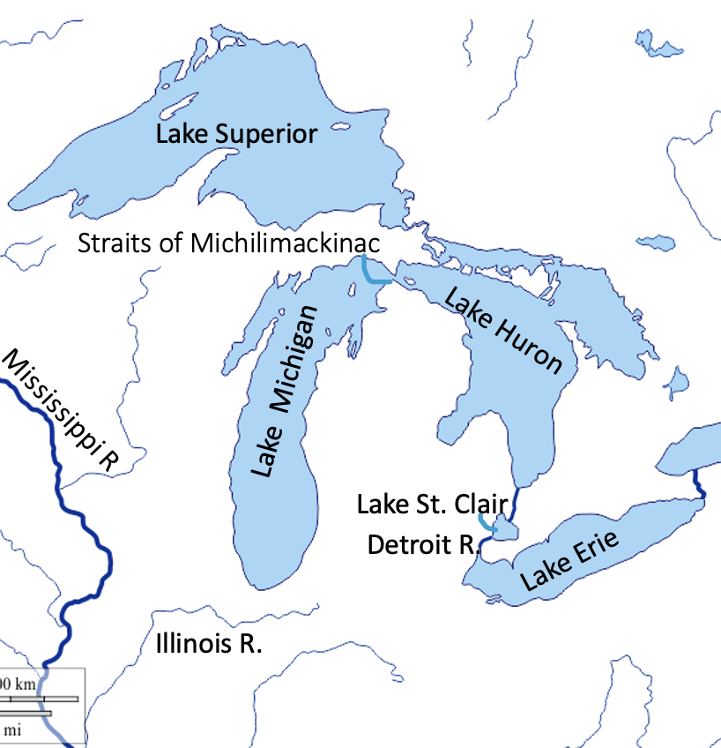

Week 8: Chapter 3 - The Mystery of the Griffin Part 1

Reading Assignment:
Ch 3 pg. 41 – 51 (end at “…in America Henry Tonty.”)
Summary:
At Versailles, King Louis XIV places LaSalle in command of Fort Frontenac and agrees to the idea of future forts. LaSalle returns and takes command of the fort. He is successful, but his enemies don’t want him making a fortune in trading. They attempt to poison him. LaSalle returns to France to report on his success to the King, who allows him to build more forts, but says he’ll have to get funding himself. As he leave the palace, he is introduced to Henry Tonty. Tonty is a one-armed banker who wants to see America. LaSalle is hesitant until Tonty shows he can defend himself.
Timeline:
Spring 1675 – returns to Canada
Fall 1677 – Sails to France

Resources:
Chateau de Versailles ; Portrait of Louis XIV ; Fort Frontenac ; Map used below
Map:
Fort Frontenac
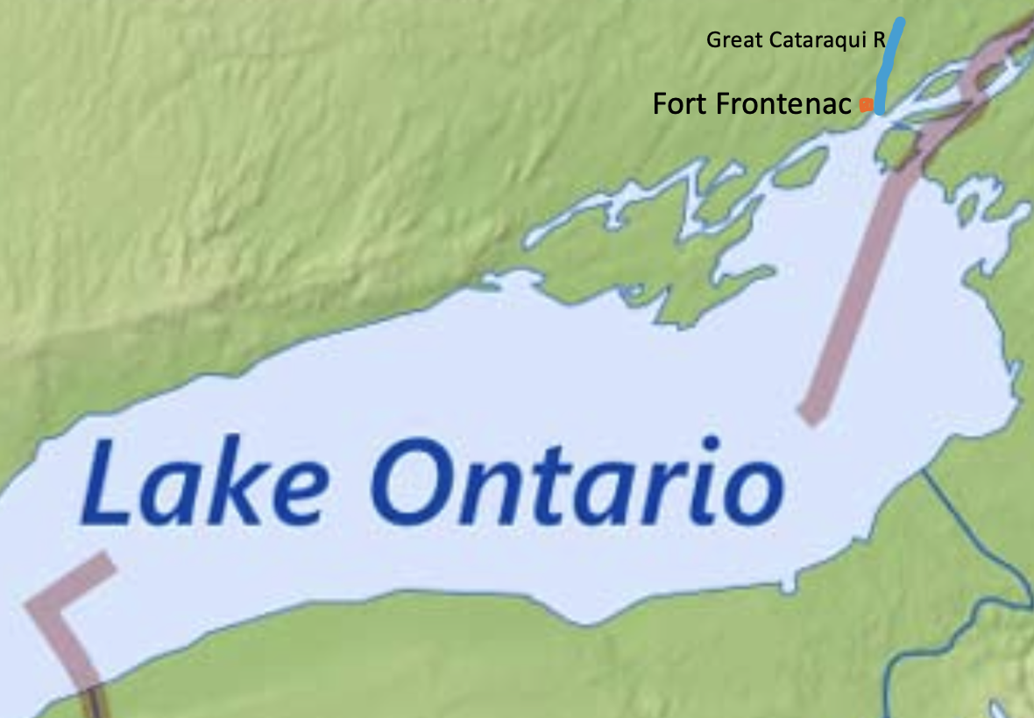

Week 10: Chapter 3 - The Mystery of the Griffin Part 2

Reading Assignment:
Ch 3 pg. 51-60 (start at “LaSalle, Tonty, and a number of new settlers…”)
Summary:
LaSalle returns to Canada and assembles a crew to build a sailing ship on the Niagara River. They have to guard the ship so the Seneca do not damage it. They sail through Erie, to Lake Huron. There is a 12-hour storm, but they survive. The arrive at Green Bay and trade with friendly Native Americans. LaSalle decides to send back the beaver pelts to pay off some debt. The Griffin leaves but is never seen again.
Timeline:
July 1678 – Leaves France to sail back to Canada
September 1679 – Griffin leaves Green Bay to sail back to Montreal

Resources:
What Happened to the Le Griffon? ; map of Great Lakes and rivers (used below)
Map:
Niagara River, Lake Erie, Detroit River, Lake St. Clair, Lake Huron, Lake Michigan, Green Bay
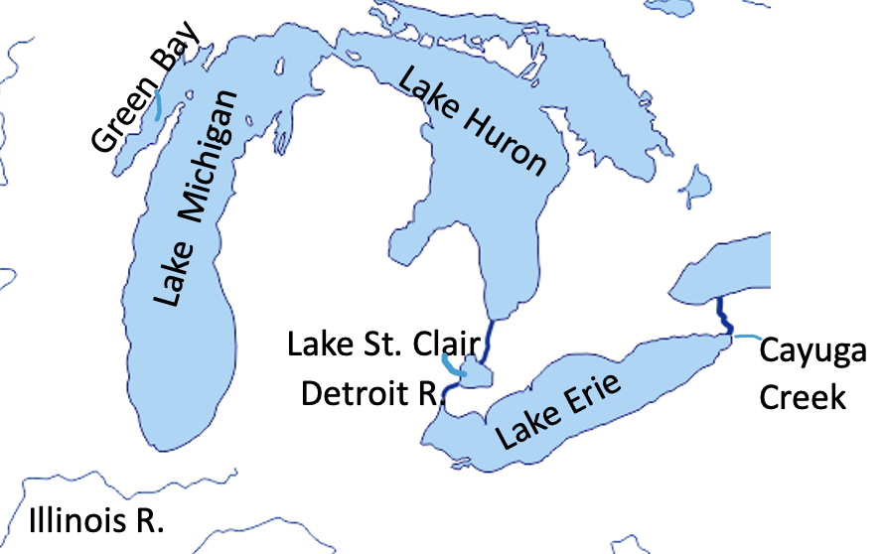

Week 12: Chapter 4 - The Fort on the River Part 1

Reading Assignment:
Ch 4 pg. 61-73 (stop at “…perilous journey.”)
Summary:
La Salle heads down Lake Michigan, encountering storms. It is winter and snowing when they reach the bottom. One night LaSalle is lost in the woods. One night Native Americans steal their supplies but the next morning LaSalle holds one of them hostage until they give back the stolen goods. They make it to the Illinois River but have difficulty finding food. They steal food from a Native American cache in an empty village - the Illinois tribe has gone hunting for the winter. Further up the river they come across the tribe and after alarming them, they make friends. They tell LaSalle the Mississippi can’t be navigated and there are monsters. Five men desert in the night.
Timeline:
December3, 1679 – they come to the bottom of Lake Michigan

Resources:
La Salle arrives at Illinois Village by George Catlin ; map of Great Lakes and rivers (used below)
Map:
Lake Michigan, Illinois River, Peoria Lake
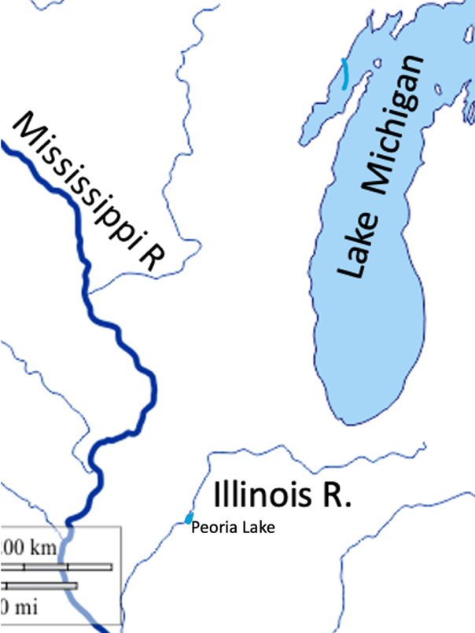

Week 14: Chapter 4 - The Fort on the River Part 2

Reading Assignment:
Ch 4 pg. 73 – 85 (start at “When the weather became…”)
Summary:
LaSalle finds a place to build a fort and names it Fort Crevecoeur (Brokenhearted). He wants to build a ship to go down the Mississippi, but the carpenters have deserted. So he starts work himself and the men join him. He decides he needs to go check on the Griffin, so he heads up the frozen river with several men. The ship is not at Lake Michigan, so he cuts across Michigan. When he finally gets to Niagara, 2 men are ill, and he discovers the Griffin is lost.
Timeline:
March 1680 – LaSalle crosses Michigan

Resources:
map of Great Lakes and rivers (used below) ; map of Fort Crevecoeur
Map:
Fort Crevecoeur, Ottowa, Joliet, Lake Michigan, Michigan, Huron River, Lake Erie, Niagara
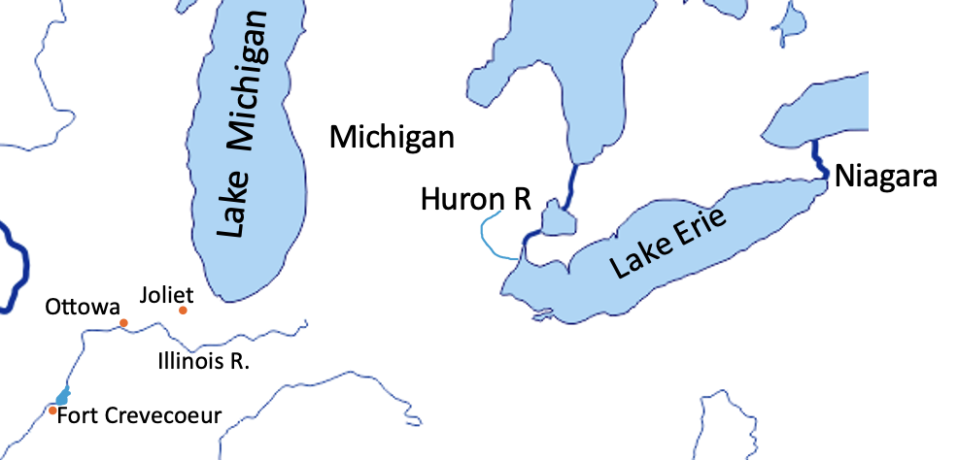

Week 16: Chapter 5 – The Iroquois on the Warpath Part 1

Reading Assignment:
Ch 5 pg. 86-94 (stop at “…I will continue alone.”)
Summary:
Back at Fort Crevecoeur, Tonty goes out exploring for several days. The men LaSalle had sent from Lake Michigan arrive and tell the men at the fort that the Griffin is lost and LaSalle is bankrupt. The men loot and destroy the fort and desert. When Tonty returns, he sends two men to LaSalle to tell him what happened. Then he and Renault join the Illinois in their summer camp. While there, the Iroquois attack the village and Tonty agrees to join the battle and fight for the Illinois.
Timeline:
Spring 1680

Resources:
map of Great Lakes and rivers (used below)
Map:
Fort Crevecoeur, Illinois River, Starved Rock,
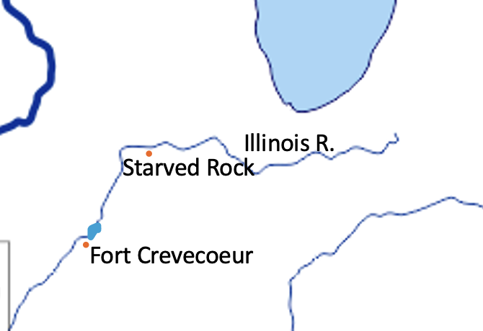

Week 18: Chapter 5 – The Iroquois on the Warpath Part 2

Reading Assignment:
Ch 5 pg. 95 -103 (start at “Gradually the Iroquois…”)
Summary:
Tonty ticked the Iroquois into not fighting the Illinois. Each tribe sent a person to stay with the others. The Illinois man told the Iroquois that Tonty lied about how many men they had. So the Iroquois conquered the Illinois and told Tonty to leave. He headed to Green Bay, starving and freezing until an Ottowa tribe took him in. In the Spring they paddled a canoe to Fort Frontenac and found LaSalle, who was ready to try again to find the mouth of the Mississippi.
Timeline:
Spring 1680

Resources:
map of Great Lakes and rivers (used below)
Map:
Starved Rock, Green Bay, Lake Michigan, Fort Frontenac
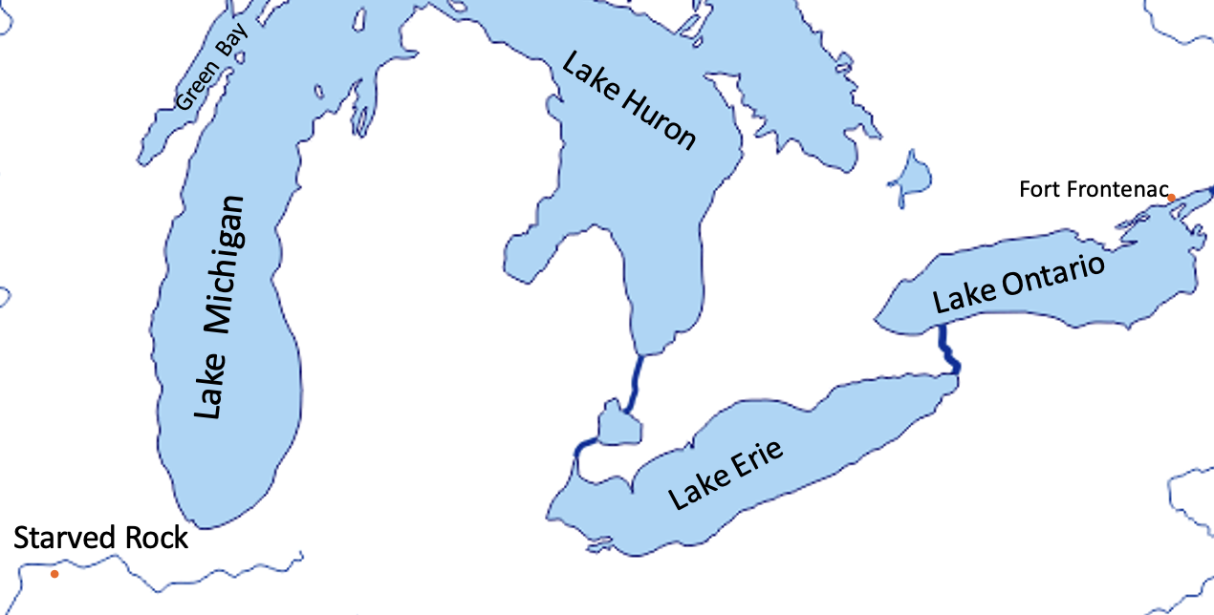

Week 19: Chapter 6 – Down the Mississippi Part 1

Reading Assignment:
Ch 6 pg. 104 – 114 (stop at “…early Spanish explorers.”)
Summary:
LaSalle tries to find 40 men to go with him down the Mississippi, but only 23 will. He decides to go anyway, hoping to recruit some Native Americans. In Green Bay some do, including women and children. They put the canoes on sleds and go to the Illinois River, passing the pillaged Starved Rock village and the plundered For Crevecoeur. They get to the Mississippi and see the Missouri. At one stop in Tennessee a Frenchmen is lost for a week before he is returned by Native Americans. They name the fort they build there after him. They leave some men at the fort and then come across an Arkansas village unlike any Native American village they had seen before.
Timeline:
- Summer 1681 – LaSalle recruits men to accompany him
- December 1681 – The party leaves Lake Michigan
- February 6, 1682 – The party reaches the Mississippi
- March 1682 – Visits Arkansas Tribe

Resources:
Catlin Painting of LaSalle’s Party Entering the Mississippi in Canoes ; Map below of Mississippi River
Map:
(See Previous Maps: Fort Frontenac, Green Bay, Lake Michigan, Illinois River, Starved Rock, Lake Peoria, Fort Crevecoeur) Mississippi River, Missouri River, Fort Prudhomme (somewhere in Tennessee)

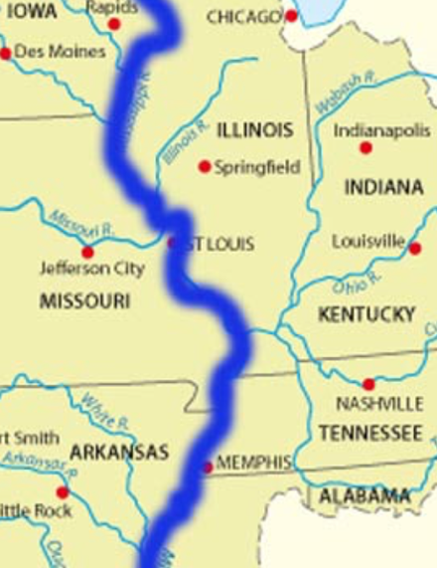

Week 21: Chapter 6 – Down the Mississippi Part 2
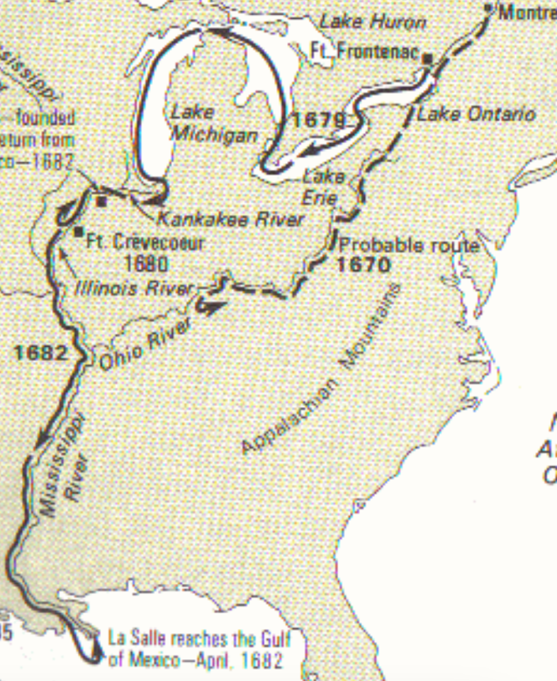
Reading Assignment:
Ch 6 pg. 114-121 (starting at “The fog still lingered…”)
Summary:
The party makes it to the Gulf and claims all the land he calls Louisiana for France. Then turns around and heads back up. At a Quinnipissas village they trade, but then are attacked. They were prepared so escape unharmed. LaSalle gets sick and stays at Fort Prudenhamme, sending Tonty and most of the crew back telling him to meet him between Lake Michigan and Lake Huron. LaSalle is sick for months but makes it to Tonty in September. Tonty wants LaSalle to rest at Fort Frontenac, but LaSalle is determined to go back to Fort Crevecoeur to maintain France’s claim on the land.
Timeline:
- April 9, 1682 – LaSalle’s party reaches the Gulf

Resources:
Georg Catlin’s painting of LaSalle’s Claiming Louisiana for France ; map below
Map:

Week 23: Chapter 7 – The Lost River Part 1

Reading Assignment:
Ch 7 pg. 122-129 (stop at “…want for your expedition?”)
Summary:
LaSalle builds a fort on top of Starving Rock and invites the Illinois to settle close to him. His enemies in Montreal convince the new governor to cut off supplies and send his own men to oversee the fort. LaSalle reports to King Louis who writes a letter condemning the governor’s actions. The King then asks about building a fort at the mouth of the Mississippi.
Timeline:
- Spring 1683 – Fort St. Louis is completed
- November 1683 – La Salle visits King Louis in France

Resources:
Picture of Starved Rock and Starved Rock State Park and map below
Map:
Fort St. Louis (at Starved Rock)
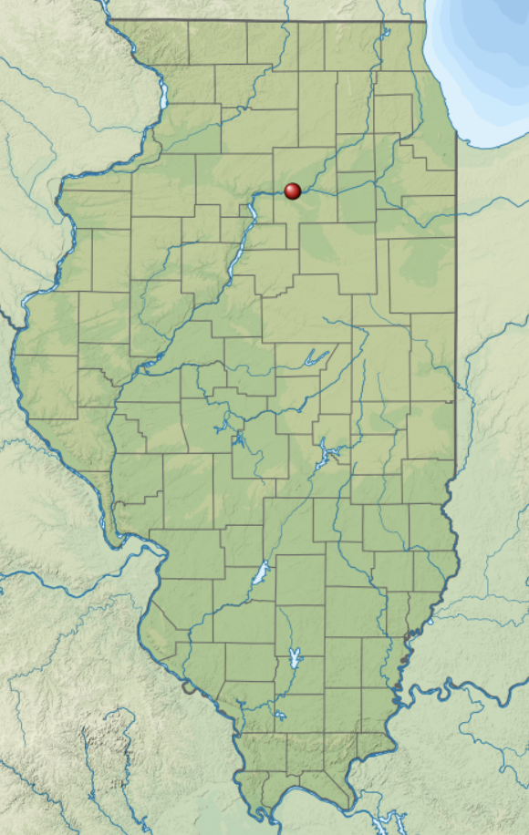

Week 25: Chapter 7 – The Lost River Part 2

Reading Assignment:
Ch 7 pg. 129-138 (start at “LaSalle asked for…”)
Summary:
The King supplies LaSalle with for ships, soldiers, and settlers to set up a colony at the mouth of the Mississippi. One ship is lost to pirates. LaSalle gets sick again at Santo Domingo and they stay for 2 months. When they finally find the Gulf Coast, they are hundreds of miles east of the Mississippi. They finally decide to land. The biggest ship runs into a reef and the boat is lost.
Timeline:
- July 24, 1684 – Fleet leaves France for Gulf of Mexico
- November 1684 – Fleet leaves Santo Domingo
- December 28, 1684 – Gulf Coast is sighted
- January 20, 1685 – Fleet lands at Matagorda Bay
Map:
Santo Domingo, Caribbean Sea, Galveston Bay, Matagorda Bay

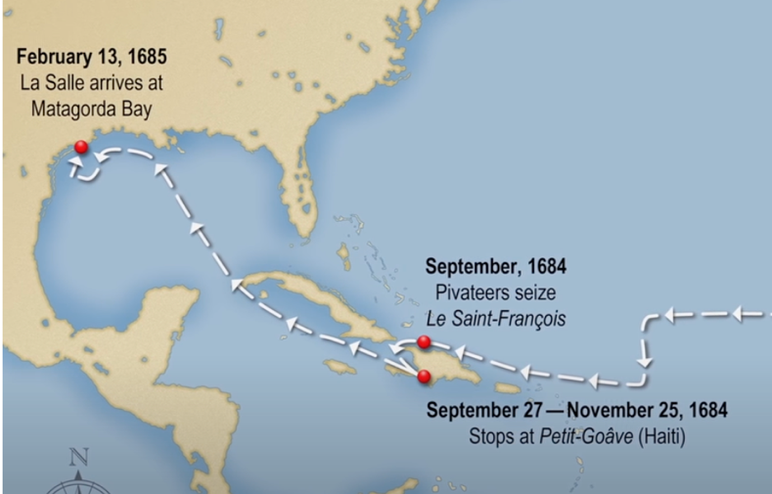
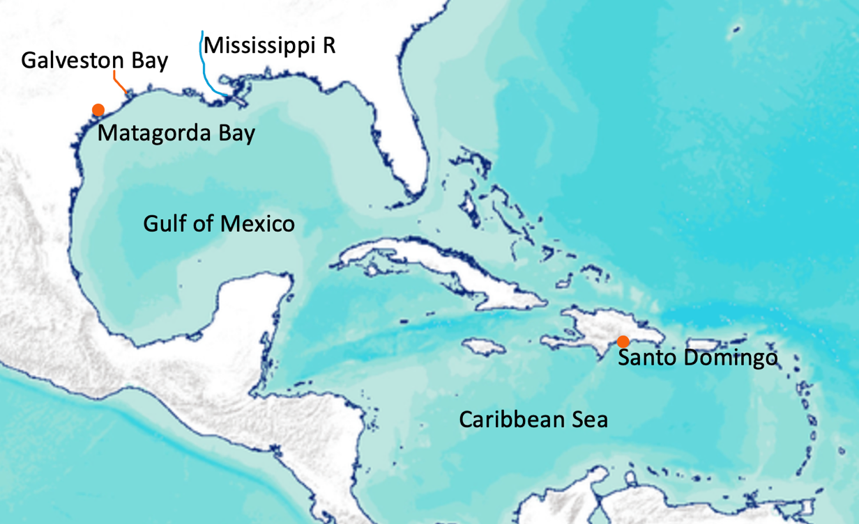
Week 26: Chapter 8 – The Lonely Village Part 1
Map left from data basin
Map below from La Salle Odyssey

Reading Assignment:
Ch 8 pg. 139 – 146 (stop at “…looking for the Mississippi.”)
Summary:
When the biggest ship sinks, they save some supplies, but most are lost. The Native Americans are not friendly. There isn’t much food. People get sick and some desert or plan mutiny. The captain decides he’s going back to France. He takes the larger ship, leaving the smaller and 150 people. LaSalle figures out they are nowhere near the Mississippi, so decides to take the people up the river and build a settlement. Then he goes looking for the Mississippi.
Timeline:
March 12, 1685 – Joly leaves to return to France

Resources:
Lavaca River naming,
Map:
n/a

Week 28: Chapter 8 – The Lonely Village Part 2

Reading Assignment:
Ch 8 pg. 146-155 (start at “The little settlement…”)
Summary:
The settlers move inland. The livestock flourishes, the seeds are sprouting, there is plenty of game to hunt. But many of the people are idle. LaSalle sends some men east in the Belle, but they end up sinking her and only a few survive. LaSalle decides he to go east on foot to find the Mississippi and go up it to get help.
Timeline:
- Spring 1686 – Belle lost

Resources:
Map below from Texas State History Online
Map:

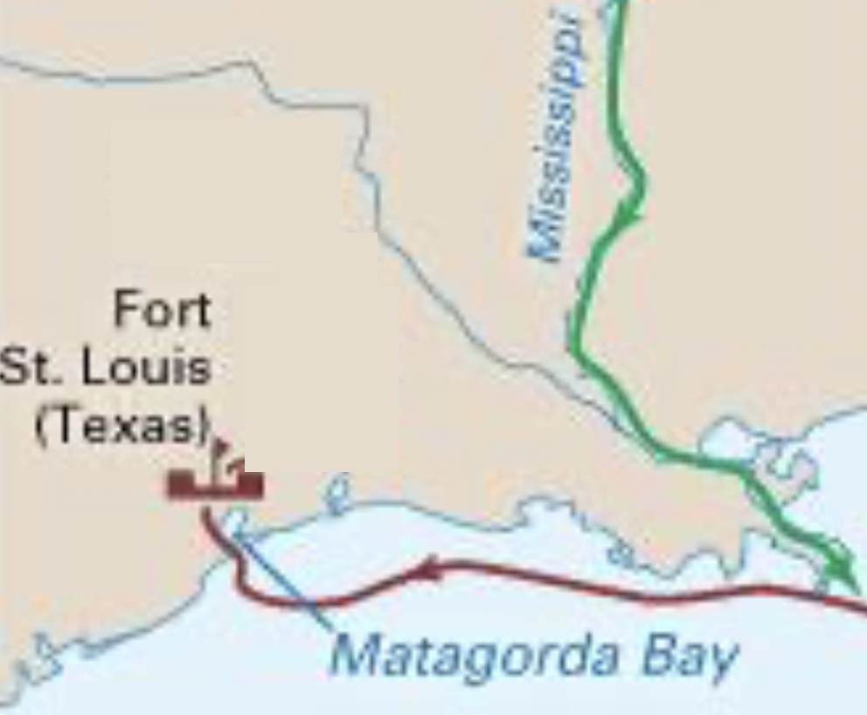

Week 30: Chapter 9 – LaSalle and the Mutineers Part 1

Reading Assignment:
Ch 9 pg. 156-163 (stop at “…the march continued.”)
Summary:
The party heads east. They meet Native Americans who help them. Many of the men grumble and complain, and some desert. At one river LaSalle’s raft is swept downstream, but he eventually comes back up stream on the other side.
Timeline:
- December 12, 1687 – LaSalle leads a party out to find the Mississippi (other sources say this is a year earlier)

Resources:
n/a
Map:
n/a

Week 32: Chapter 9 – LaSalle and the Mutineers Part 2

Reading Assignment:
Ch 9 pg. 163 – 171 (start at “LaSalle led his party…”)
Summary:
They keep marching east. One party goes out hunting and several men decide to kill LaSalle and his loyal followers.
Timeline:
- March 19, 1687 LaSalle is murdered (the book has this later)

Resources:
Map below from Texas State History Online
Map:

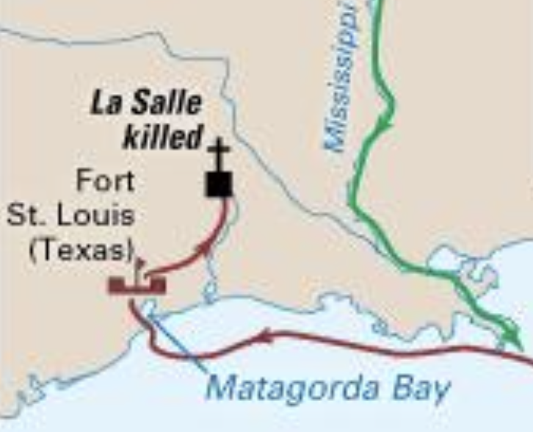

Week 34: Chapter 10 – The End of the Journey

Reading Assignment:
Ch 10 pg. 172-183
Summary:
The murderers return to camp and Joutel and others loyal to LaSalle are guarded. They start heading east again. The murderers fight among themselves, killing two and the remaining two stay in a Native American village. Joutel leads the rest northeast to the Mississippi. When he finds it, he meets with a party from Tonty heading back. When Tonty hears the news, he sets out to find the settlement at Matagorda Bay but does not make it before turning around. He lives out his life at Fort St. Louis, helping the Illinois fight the Iroquois. Joutel and others go back to France. Spanish settlers hear about the settlement at Matagorda Bay and when they find it, no one is left alive.
Timeline:
n/a

Resources:
n/a
Map:
See maps above

