
Archimedes and the door of science
Chapter summaries for AO 6


Prepared by Lisa Cotting
amblingtogether.com

January 2024

Table of Contents
Chapter 1: Who was Archimedes? 2
Chapter 2: The World of Archimedes 3
Chapter 3: Alexandria! 4
Chapter 4: Archimedes and His Lever 5
Chapter 5: Archimedes and King Hiero’s Crown 6
Chapter 6: Archimedes and Astronomy 6
Chapter 7: Archimedes and Mathematics 7
Chapter 8: The Measurement of a Circle 7
Chapter 9: Archimedes and Numbers 7
Chapter 10: Archimedes and the Center of Gravity 8
Chapter 11: The Sphere and the Cylinder 8

Chapter 1: Who was Archimedes?

Reading Schedule:
Week 12, Day 1: Pg. 1-8 (entire chapter) on one day

Summary: Archimedes is born to Phidias, an astronomer. When he grows up, he is interested in science and mathematics, but there had been only few discoveries in his time. So he has to start from the beginning. What he will discover in his life will be foundational for other scientists and mathematicians to make further discoveries.

Timeline: 287 B.C. Archimedes is born

Mapwork: Syracuse, Sicily

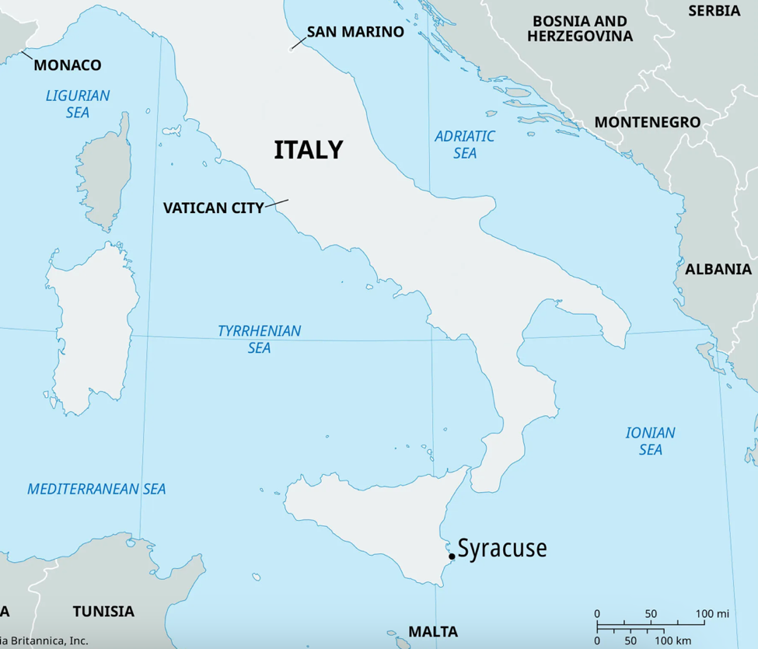
Map from Britannica.com

Chapter 2: The World of Archimedes

Reading Schedule:
Week 13, Day 2: Pg 9-15 (stop at “…living in the king’s palace.”)
Week 13, Day 3: Pg 15 (start at “When he was eight…”) to end on page 23

Summary:
Part 1: The Greeks at the time of Archimedes didn’t know much of the world – only around the Mediterranean really. They were a curious people who enjoyed debating. Children were taught to think and question and curiosity was valued. The city of Syracuse was a port city where ships from the known world came.

Part 2: Archimedes started school at age 8. He learned many different subjects. The Greeks valued science and math for knowledge sake, not just practical use. They believed a healthy mind needed a healthy body, so exercise was important as well. And they educated their sons to become active and healthy citizens. Greeks had many books and enjoyed the theatre as well. Much of the work in Greece was done by slaves (who had most likely been captured in war.)

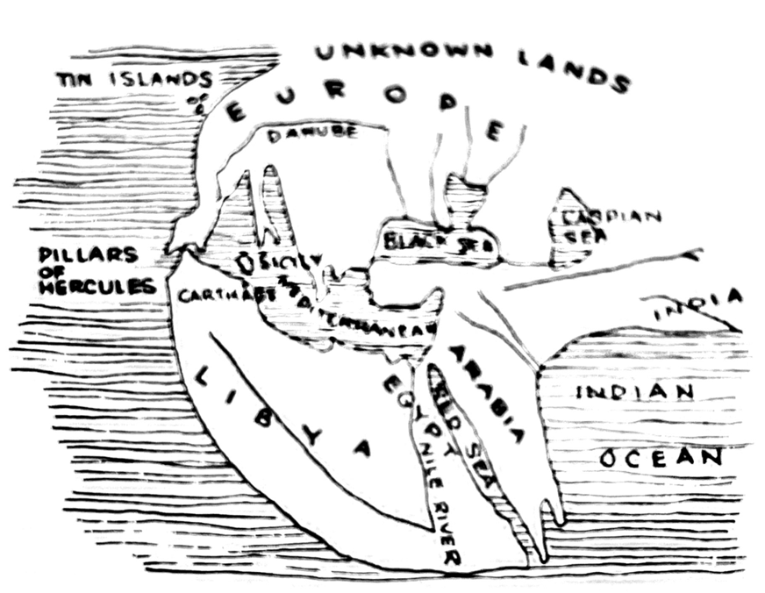
Mapwork: (maps from book)

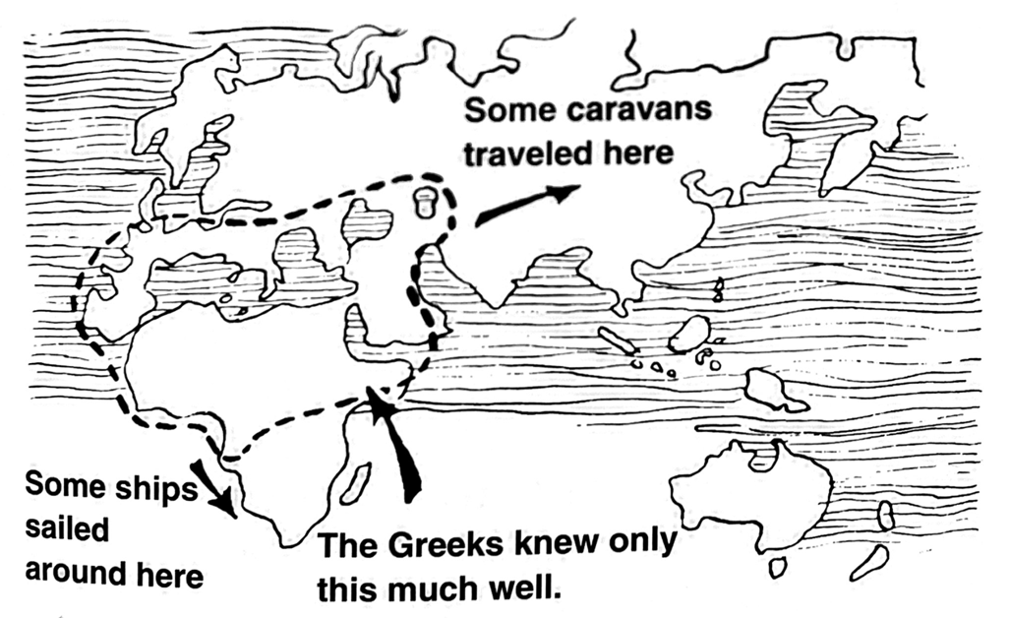

Chapter 3: Alexandria!

Reading Schedule:
Week 14, Day 1: Pg 24-31 (stop at “…important science of its own.”)
Week 14, Day 2: Pg 31 (start at “Archimedes’ teacher of mathematics…”) – to end on 38

Summary:
Part 1: Archimedes sails to Alexandria after finishing school locally. Sailing was dangerous, but it was the main method of transportation around the Mediterranean. Alexandria, named and planned by Alexander the Great but built by Ptolemy, his successor in the region, was a center of learning where the government supported the academics. Euclid, who developed a form of geometry used for thousands of years since had studied there before Archimedes lived.

Part 2: Archimedes spends all his time in the Museum. He studies the stars and invents the Archimedean Screw.

Videos:
- Legendary Library of Alexandria (3:06 min)
- The Lighthouse of Alexandria (3:07 min)
- What Really Happened to the Library of Alexandria? (4:52 min)
- Archimedes’ Screw (0:18 min)
- Make Your Own Archimedes’ Screw (2:19 min)
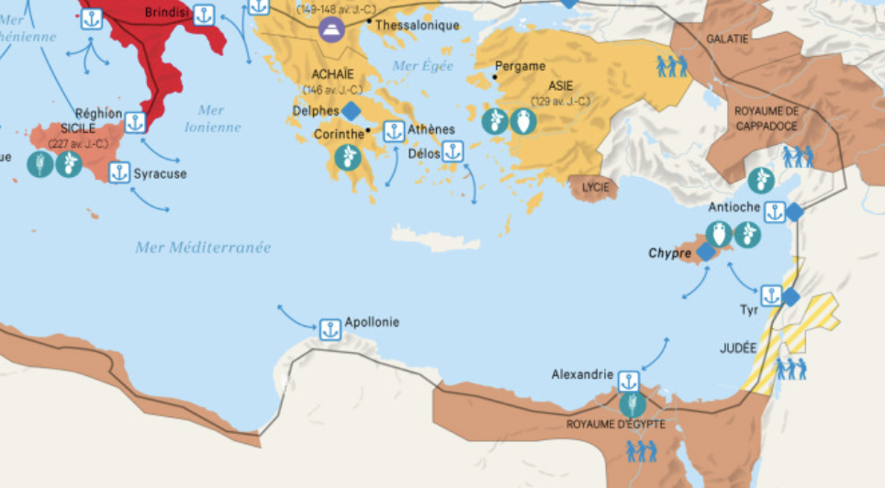
Mapwork:

Map from Maps on the Web

Map from Wikipedia
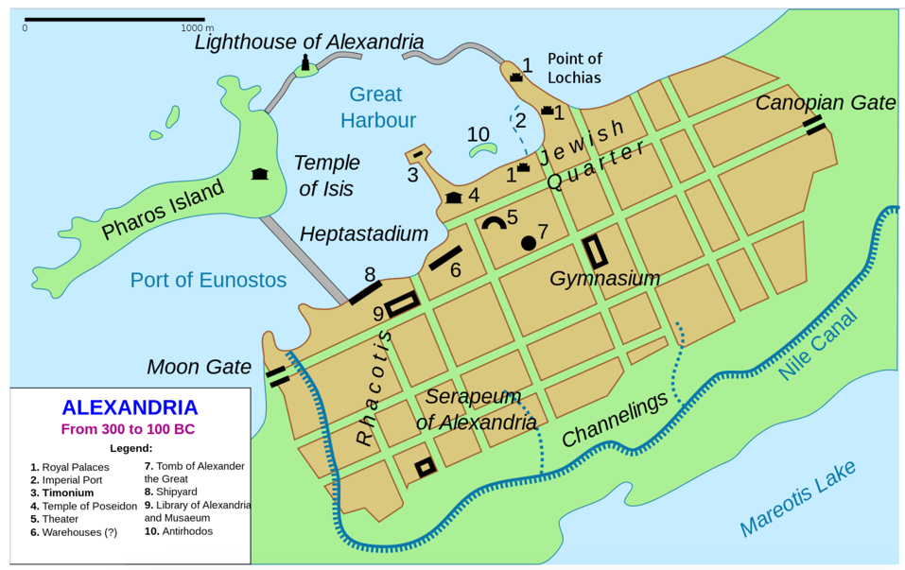

Chapter 4: Archimedes and His Lever

Reading Schedule:
Week 15, Day 1: Pg 39-44 (stop at “…anything he says.”)
Week 15, Day 2: Pg 44 (start at “What does the pulley…”) to end on 53

Summary:
Part 1: Archimedes returns to Syracuse and befriends King Hiero. They enjoy debating, with Archimedes saying pure reasoning was best and King HIero saying it meant nothing if not put to practical use. Archimedes says he could move the earth if he could stand on another earth. King Hiero challenges him to move his new ship. Archimedes surprises everyone by using a pulley and one hand to move the boat.

Part 2: Description of levers (including pulleys), mechanical advantage, and the types of machines (only two – levers and inclined planes)

Videos:
- Types of Levers (3:24 min)

Chapter 5: Archimedes and King Hiero’s Crown

Reading Schedule:
Week 16, Day 1: Pg. 54 to 60 (stop at “…had cheated him!”)
Week 16, Day 2: Pg . 60 (start at “What Archimedes discovered…”) to end on 64 (stop at “…measuring many substances)
Week 16, Day 3: Pg 64 (start at “While he was experimenting…”) to end on 69

Summary:
Part 1: King Hiero had a new crown, but it felt too lite. He thought the goldsmith might have cheated him. So he asked Archimedes who used water displacement to determine the crown was part silver and therefore the goldsmith had cheated the king.

Part 2: Discussion of density, specific gravity, and hydrometers

Part 3: Discussion of buoyancy and the Archimedes Principle: how a floating body displaces its own weight in water. Archimedes also discovered that the surface of liquid is curved. The studies Archimedes did are called hydrostatics.

Activity
For Part 2: Create a hydrometer (as described in chapter or here)
For Part 3: Buoyancy experiment from chapter (or here)

Chapter 6: Archimedes and Astronomy

Reading Schedule:
Week 17: Pg. 70-80 (entire chapter) on one day

Summary:
Archimedes’ father and friends were astronomers, so he spent a lot of time thinking about the universe. He thought about the size of the planets, including earth. He said the earth went around the sun. He worked on measuring the year and figuring out the movement of the planets to fix the calendar that was constantly in chaos.

Chapter 7: Archimedes and Mathematics

Reading Schedule:
Week 18: Pg. 81-85 (entire chapter) on one day

Summary:
Archimedes loved mathematics and wrote essays for other mathematicians, not textbooks for students like Euclid did. He made many discoveries in geometry and how to measure volume.

Chapter 8: The Measurement of a Circle

Reading Schedule:
Week 19: Pg. 86-91 (entire chapter) on one day

Summary:
Archimedes worked out ways to find the area of the circle before there was a decimal system or pi was known.

Chapter 9: Archimedes and Numbers

Reading Schedule:
Week 20: Pg. 92-98 (entire chapter) on one day

Summary:
Archimedes contemplates really big numbers and shows that the numbers never end – he contemplates infinity! This was a difficult thing for him to do using Greek numbers. Discussion of square and triangular numbers.

Chapter 10: Archimedes and the Center of Gravity

Reading Schedule:
Week 21: Pg. 99-104 (entire chapter) on one day

Summary:
Archimedes demonstrates that the center of gravity is the basis for mechanics. The description of the center of gravity is where the weight of an object is balanced and Archimedes proved that this is not always at the center of the object. He figured out how to find the center of gravity for many different shaped items.

Activity:
- Balance a spoon as described on page 101 or as described in Center of Gravity video (7:08 min)
- Make a mobile with three layers as described on page 103 or like the one here.

Chapter 11: The Sphere and the Cylinder

Reading Schedule:
Week 22: Pg. 105-109 (entire chapter) on one day

Summary
Archimedes thought his work with measuring and comparing spheres and circles was the most important discoveries of his life and even wanted a figure of them on his tomb! He also measured other 2 and 3 dimensional objects. Archimedes developed a method for looking at problems that led him logically dismiss false conclusions and find the correct one.

Chapter 12: The War Machines of Archimedes

Reading Schedule:
Week 23, Day 1: Pg. 110 to 116 (stop at “…placing the machines.”)
Week 23, Day 2: Pg. 116 (start at bottom, “Here is the account…”) to end on 123

Summary:
Part 1: Carthage and Rome are fighting on either side of Syracuse. King Hiero asks Archimedes for help, convincing him a man of science should help. Archimedes designed machines and King Hiero had them built, kept in working order, and men trained to use them at all times. After King Hiero’s death, Rome prepares for attack with large war machines and many men. The new leader, Hippocrates, goes to Archimedes for help and Archimedes gets his machines ready.

Part 2: Archimedes’ machines inundated the enemy with projectiles and attacked the boats by picking them up. He broke the Roman’s machine with large rocks and they withdrew and planned to come close to the walls at night. They figured they’d be too close for Archimedes’ machines to get them. But Archimedes had holes in the walls for just such an occasion. The Romans decide on a blockade.

Mapwork: (from book, page 112)
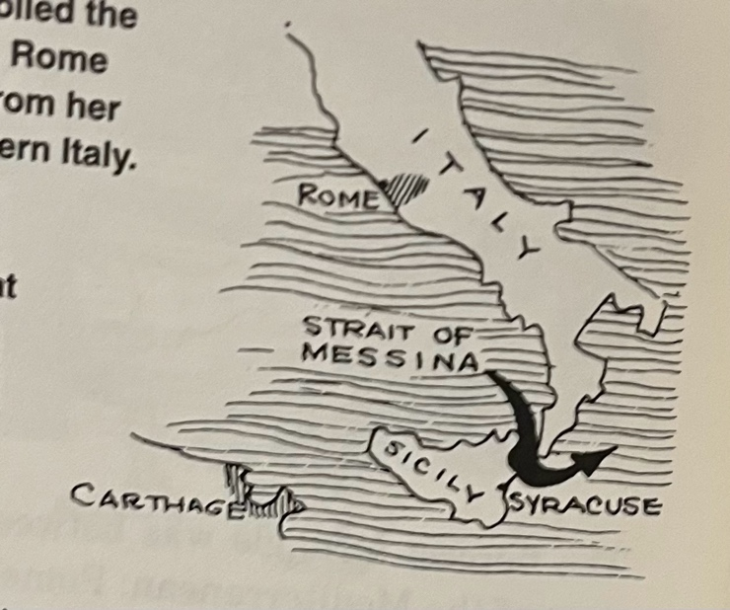

Chapter 13: The End of Archimedes

Reading Schedule
Week 24, Day 1: Pg. 124-128 (entire chapter) on one day

Summary:
Syracuse was under siege for three years. Then Marcellus noticed an unguarded area where he snuck his men in and attacked. He ordered no harm to come to Archimedes and for him to be brought to him. But the soldier killed Archimedes when he would not come. Marcellus honored Archimedes and had that soldier killed as a murderer.

Chapter 14: No End to Archimedes

Reading Schedule:
Week 24, Day 2: Pg. 129-131(entire chapter) on one day

Summary:
Some say Archimedes was the greatest mathematician of all time. Discoveries he made are still used and expanded on today.

