I Kings |  | Bible Project Video:  min 2:37-3:30
Bible Project Video:  to min 1:36 |  | 12:1-24 (map of 2 kingdoms)
Bible Project Video:  to min 1:36 |  | 12:25-33
1:1-27 (Beware verse 4) |  | 13:1-34
1:28-53 |  | 14:1-20
2:1-12 |  | 14:21-31
2:13-27 |  | 15:1-24
2:28-46 |  | 15:25-34
Bible Project Video:  min 1:36-2:37 |  | 16:1-20
Bible Project Video:  min 1:36-2:37 |  | 16:21-34
3:1-15 |  | Bible Project Video:  min 3:30-6:00
3:16-28 |  | Bible Project Video:  min 3:30-6:00
4:20-34 |  | 17:1-24
5:1-18 |  | 18:1-15
6:1-38 (3D images of temple) |  | 18:16-46
7:1-12 (13-51 optional) |  | 19:1-21
8:1-21 |  | 20:1-12
9:1-28 |  | 20:13-34
10:1-29 |  | 20:35-43
11:1-13 |  | 21:1-28
11:14-25 |  | 22:1-28
11:26-43 |  | 22:29-53

II Kings |  | 13:10-25
II Kings |  | 14:1-22
1:1-25 |  | 14:23-29
2:1-27 |  | 15:1-16
3:1-27 |  | 15:17-38
4:1-37 |  | 16:1-20
4:38-44 |  | 17:1-23
5:1-27 |  | 17:24-41
6:1-23 |  | Bible Project Video:  min 7:00 - end
6:24 - 7:2 (optional: cannibalism) |  | Bible Project Video:  min 7:00 - end
7:3-20 |  | 18:1-16
8:1-15 |  | 18:17-37
8:16-29 |  | 19:1-19
Bible Project Video:  min 6:00 – 7:00 |  | 19:20-37
Bible Project Video:  min 6:00 – 7:00 |  | 20:1-21
9:1-13 |  | 21:1-18
9:14-37 |  | 21:19-26
10:1-17 |  | 22:1-20
10:18-35 |  | 22:1-30
11:1-21 |  | 22:31-37
12:1-21 |  | 23:1-20
13:1-9 |  | 24:1-21
 |  | 24:22-30

Northern Kingdom - Israel
King | 
1.
2
3
4
5
6
7
8
9
10
11
12
13
14
15
16
17
18
19
20
Southern Kingdom - Judah
King
1.
2
3
4
5
6
7
8
9
10
11
12
13
14
15
16
17
18
19
20

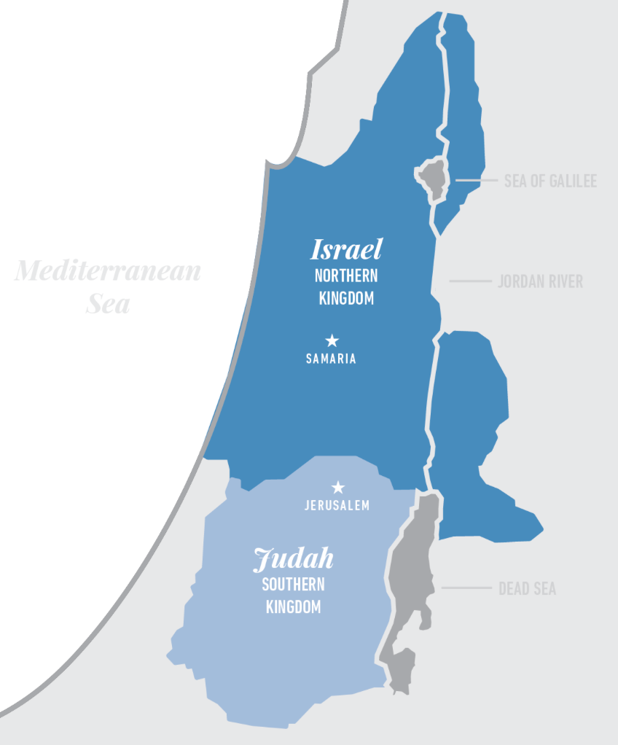
Above map from: The Bible Initiative

Additional Maps and Timelines available at HistoryintheBible.com
Kings of Israel and Judah Printable Chart

