
Lawrence of Arabia
By Alistair Maclean
Chapter Summaries & Mapwork for AO6

Prepared by Lisa Cotting
amblingtogether.com

Spring 2024


Table of Contents
Chapter 1: The Land of Arabia 2
Chapter 2: The Training of a Desert Fighter 3
Chapter 3: First Victory 4
Chapter 4: The March on Aqaba 5
Chapter 5: Guerilla Warfare 6
Chapter 6: Failure and Success 7
Chapter 7: Forward Again! 8
Chapter 8: Victory on All Sides 9
Chapter 9: The Rout of the Turks 10
Chapter 10: A Triumphant Entry into Damascus 11
Chapter 11: A Peaceful Settlement (and Afterward) 12

Lawrence of Arabia by Alistair Mclean available on archive.org

Chapter 1: The Land of Arabia

Reading Schedule:
Day 1: Pg. 3-10 (stop at “…no more from life.”)
Day 2: Pg.10 – 17 (begin at “In the early years…”)

Summary:
Day 1: Defining the term “Arabia” by geographical features and a description of the Bedouin people.

Day 2: The Turks (rulers of the Ottoman Empire), kept the northern Arabs in line through terror. The Turks and Arabs were all of the Muslim faith. The Ottoman Empire sides with Germany in WWI and though the leaders of Hejaz did not want to fight Muslims with the British Christians, they also wanted to fight off the Ottomans Empire. Feisal, son of the Sherif of Hejaz, lead an attempt to take over the cities of Hajaz. But the Turks won and the Arabs went back to the desert, hopeless.

Timeline:
1916: Feisal attempts an Arab Revolt that fails

Resources:
Video: Discover the Bedouin People of Jordan (3:20 min) ; Maps: Growth of the Ottoman Empire by century ; Portrait of Colonel T.E. Lawrence by Augustus John OM at the Tate

Mapwork: (map from beginning of book)
Arabia: Aegean Sea, Turkey, Iran, Middle Eastern Mountains, Rub Al Khali, Mount Lebanon, Fertile Crescent/Euphrates Valley, Nejd, Hejaz
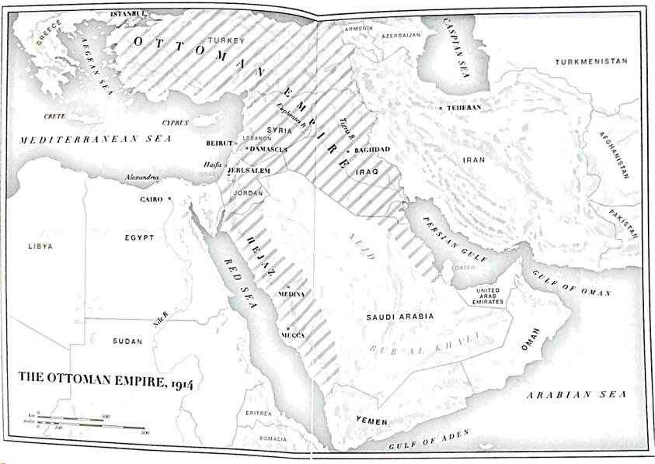

Chapter 2: The Training of a Desert Fighter

Reading Schedule:
Day 1: Pg. 18-24
Day 2: Pg 25-30

Summary:
Day 1: As a schoolboy, Lawrence trained himself to go long periods of time without food, water, or sleep. He became interested in archeology, especially Crusades castles. He went alone to Syria to study the castles and lived with the Arab peoples. When back in England, he still desired to help the Arab people be free of Ottoman rule. He spent 4 years in Syria on a British Museum excavation, which he described as the happiest of his life. He traveled and documented the country.

Day 2: When WWI begins, he is assigned as a desk officer in Cairo. Almost 2 years later he is transferred to the Arab division. After Feisal’s defeat, Lawrence, on his own leave time, accompanies a British official to the Red Sea to assess what is happening. Here he meets Feisal.

Timeline:
1888: Thomas Edward Lawrence is born

Chapter 3: First Victory

Reading Schedule:
Day 1: Pg. 31-36 (stop at “…war by themselves.”)
Day 2: Pg 36- 42 (start at “Accordingly, Lawrence wrote…”)

Summary:
Day 1: Lawrence meets Emir Feisal ibn Hussein, the third son of the Sherif of Mecca and finds someone who he hopes will be a leader to unite the different Arab tribes against the Turks. After meeting the Arab fighters, Lawrence realized they would be better suited to guerilla warfare. He also knew that it would be unwise to have the British troops in the Hejaz because the Arabs would not like Christians coming to help them fight other Muslims but also, Lawrence feared with the British there, the Arab goal of independence from the Turks would not happen.

Day 2: Lawrence wrote to the British telling them his assessment, and they agreed to make him a liaison officer. The Arabs take over the Turk held port of Wejh (Lawrence and Feisal were not there yet). The victory brought more Arabs to the fight. The British and Arabs then wanted to attack the large garrison of Turks in the Holy City of Medina. Lawrence convinced them to instead attack the Hejaz Railroad to cut off their supplies.

Timeline:
1916: Lawrence meets Feisal and helps start the Arab revolt
1917: January – port of Wejh taken from Turks

Resources:
Video: In the footsteps of Lawrence of Arabia (9:40 min – but at least through min 4:56)

Mapwork:
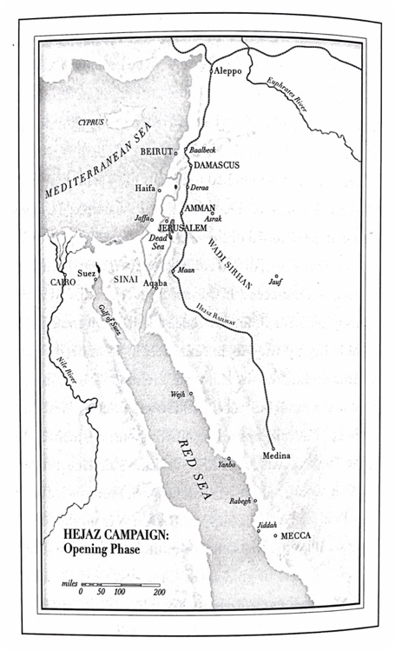
Wejh, Medina, Hejaz Railroad

(map from book, pg 44)

Chapter 4: The March on Aqaba

Reading Schedule:
Day 1: Pg 45 – 53 (stop at “…almost invariably died.”)
Day 2: Pg 53 – 60 (start at “Sheik Auda now went…”)

Summary:
Day 1: They need a northern base of operations, so Lawrence decides to take Aqaba back. He enlists the help of Sheik Auda abu Tayi a famed fighting warrior chief who hates the Turks. Lawrence accompanies Auda to Wadi Sirhan to get permission of Emir Ruwalla to use the area as a base for attacking Aqaba. The journey through the desert is arduous and Lawrence proves himself to the Arabs.

Day 2: Lawrence rides alone Northward to spread rumors of Arabs coming to attack Turks in the north and then works with Emir Ruwalla to deceive the Turks into preparing for an attack on Damascus. On the way to attack Aqaba, they find the Turks in their way at Abu el Lissal so they attacked and won the battle. When they finally arrived at Aqaba, the Turks surrendered without a fight.

Resources:
What is a Wadi (Wikipedia)

Mapwork:
Aqaba, Red Sea, Wadi Sirhan, Juaf, Deraa, Abu el Lissal (see also map on pg 44, copied above)

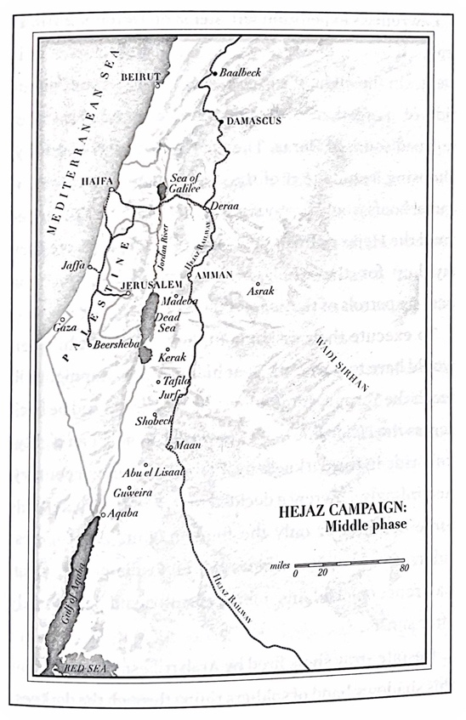

(map from book, page 75)

Chapter 5: Guerilla Warfare

Reading Schedule:
Day 1: Pg 61-66 (stop near bottom at “…move of the Arab army.”)
Day 2: Pg 66-72 (start on bottom at “But if Lawrence…”)

Summary:
Day 1: Lawrence leaves Aqaba soon after the victory in search of food and supplies for all those now in the city. He crosses the Sinai Desert in 50 hours to reach Suez and then on to Ismailia where he sends food to Aqaba and meets with General Allenby. Allenby agreed with Lawrences’ tactics and commissioned him to work with Feisal east of the Jordon River to harass the Turks. Feisal and his father agree to joining the British in the North.

Day 2: Correspondence is intercepted indicating Auda was starting to turn to the Turks. Lawrence rushes back to Aqaba and convinces him (with reports of British support and funding) to stay. The Turks are aware of the threat at Aqaba and start sending more troops south, leaving their position in Palestine vulnerable. Lawrence & Feisal use guerilla warfare tactics to trap the Turks in larger garrisons with little supplies getting through.

Mapwork:
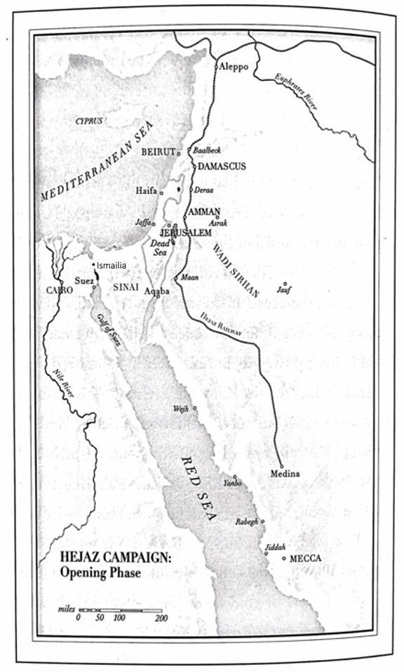
Aqaba, Sinai Desert, Suez, Ismailia, Red Sea, Wejh, Jiddah, Maan, Abu el Lissal

(map from book, pg 44)

Chapter 6: Failure and Success

Reading Schedule:
Day 1: Pg. 73-81 (stop at “…were yet to come.”)
Day 2: Pg. 81-90 (start at “Lying in his tent…”)

Summary:
Day 1: Lawrence plans to blow up one of the train bridges on the Yarmuk railroad to stop supplies and troops getting south and therefore help Allenby’s attack on Palestine. His first attempt is failure when one man drops his rifle and alerts the guards to their presences. He decides to blow up a troop train instead and is badly wounded.

Day 2: He plans to attack Deraa next, so goes to find a secret passage in. He is mistaken for a deserter and flogged by the Turks. He escapes and finds the passage. Allenby takes Jerusalem and honors Lawrence there. Allenby asks the Arab army to take Tafila and interrupt the food supply to the Turks. Taking Tafila is the only full-scale battle Lawrence directs, but it is considered a masterpiece.

Resources:
Photos of bridges over the Yarmouk (Yarmuk) River

Mapwork:
Damascus, Deraa, Sea of Galilee, Haifa, Jaffa, Gaza, Jerusalem, Azark, Tafila, Jurf

Chapter 7: Forward Again!

Reading Schedule:
Day 1: Pg 91-97 (stop at “…hills well satisfied.”)
Day 2: Pg 97-105 (start at “His satisfaction did…”)

Summary:
Day 1: The winter is a hard one, the British don’t send warm clothing, and the Arabs lose many men to the cold and starvation. They are unable to attack Kerak and Madeba as planned. Lawrence has heard rumors of a secret plan of the British and French to divide up the middle east and not allow an Arab state. He wants the Arabs to be in at the final battle in Damascus to ensure they get their independence. Lawrence takes men and goes through extreme winter conditions to Guweira to get the gold to buy supplies and pay the Arabs to stay. The money is entrusted to Prince Zeid.

Day 2: While Lawrence is on reconnaissance trips, Zeid gives all the gold away. He is in despair and goes to Allenby to resign but is made a colonel instead. Lawrence opposes Allenby’s plan to attack Amman and Maan and is proven correct when the British fail. Allenby’s troops are recalled to France and Lawrence gets their camels. He readies the Arab troops to march on Damascus.

Timeline:
March, April, May of 1918: British defeats

Mapwork:
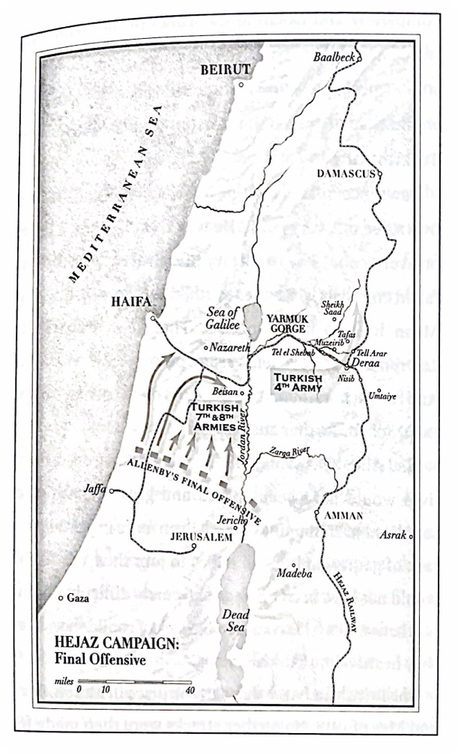
Guweira, Beersheba, Amman, Medina, Maan, Azrak

(Map from page 101)

See also map on page 44

Chapter 8: Victory on All Sides

Reading Schedule:
Day 1: Pg. 106 – 113 (stop at “…army in Palestine.”)
Day 2: Pg. 113 – 121 (start at “…Lawrence then conceived…”)

Summary:
Day 1: British ask Lawrence to attack Deraa, so he makes the Turks think he is attacking Amman. When the Turks send troops to Amman, he bombs a bridge above Amman so troops cannot be sent back to Deraa. Instead of attacking Deraa, he attacks the rail lines, destroying 10 miles of it north of the city and the station house, rail line, and telegraph to the west.

Day 2: He then heads south to the Tell el Shebab bridge. The Arabs with him at first refuse to go, but then follow him to find the bridge unguarded (the Turks had been drawn up to Nisib to fight the Arabs there). Destroying this bridge cuts Deraa off on all sides. Allenby is also successful in Palestine by also deceiving the Turks where he was going to attack. Only the Turks’s fourth army is left, trapped east of the Jordan.

Mapwork:
Deraa, Amman, Umtaiye, Tel Arar, Nisib, Jericho, Nazareth, River Jordan, Beisan

(Map from page 101)

Chapter 9: The Rout of the Turks

Reading Schedule:
Day 1: Pg 122-127 (stop at “…booty was captured.”)
Day 2: Pg 127 – 134 (start at “They traveled overnight…”)

Summary:
Day 1: Lawrence and the Arab army are attacked by Turk airplanes, so he tries to attack their airfield but only destroys one plane. So he goes to Allenby and convinces him to give the Arab army two fighter planes and a bomber. With these they ward of the Turk air attacks. Lawrence plans to attack the retreating Fourth Army on its way to Damascus and positions the Arab army at the point where the only two roads north converge at Sheik Saad.

Day 2: The first part of the Turk army is in disarray and are easily captured as they head north. Then a British plane warns Lawrence there are two huge armies coming, one about 2000 strong, and another about 7000 strong. On their way, the Turks burn Tafas. This enrages the tired Arab army who kills the smaller army completely and then attacks the larger army by night. Lawrence then hurries back to Deraa to make sure the Arabs have it fully in their control because the British had promised whatever the Arabs could take, they would get after the war. Then he heads to Damascus, hopeful to get that under Arab control as well.
Mapwork:
Deraa, Sheik Saad, Umtaiye, Tafas

(from map from page 101)

Chapter 10: A Triumphant Entry into Damascus

Reading Schedule:
Day 1: Pg. 135 – 141 (stop at “…taking it over themselves.”)
Day 2: Pg. 141 – 148 (start at “Lawrence found Sherif Nasir…”)

Summary:
Day 1: Lawrence heads north to Damascus in his car he called “Blue Mist.” He enlists some of the British troops to help the Arabs route the remaining Turkish troops. The Turks retreated from Damascus and Lawrence makes sure Sherif Nasir and Emir of Ruwalla are first to enter the city to claim it for the Arabs. He then needs to make sure the Arabs have control of the city so the British can be held to their promise to give the Arabs whatever they capture.

Day 2:Lawrence instills Shukri Pasha as governor before a Turkish leaning man can take over. He then restored power, water, and cleaned the city up. When Allenby and Feisal arrived the city was in order and Allenby told Feisal he would recognize Arab rule, but Lawrence did not believe him. Lawrence requested to go home to England.

Timeline:
October 1918: Arabs enter Damascus
November 11, 1918: Lawrence returns to England, WWI is over

Resources:
Photo of Lawrence in “Blue Mist” (Wikipedia)

Mapwork:
Damascus

Chapter 11: A Peaceful Settlement (and Afterward)

Reading Schedule:
Day 1: Pg. 149 – 154 (stop at “…yet to come.”)
Day 2: Pg. 154 – 159 (start at “At the beginning…”)

Summary:
Day 1: Lawrence attends the Peace Conferences at Versailles with Feisal as a spokesman and interpreter. The British and French will not allow an Arab state but keep the middle east for themselves. The French originally allow Feisal to rule from Damascus but under French control. When the Arabs try to declare Feisal king of Syria, the French take Damascus and run the Arabs off.

Day 2: Unrest in the area makes the British send Churchill and Lawrence to Cairo. Lawrence only comes because they agree to Arab independence. The French have total control of Syria, but Lawrence is able to make Feisal king of Iraq and his brother Abdullah ruler of Trans-Jordan.

Timeline:
March 1920: French take back control of Damascus from Feisal
May 1935: Lawrence of Arabia dies

Resources:
News Reel: Lawrence of Arabia – Simple Funeral (1935)

