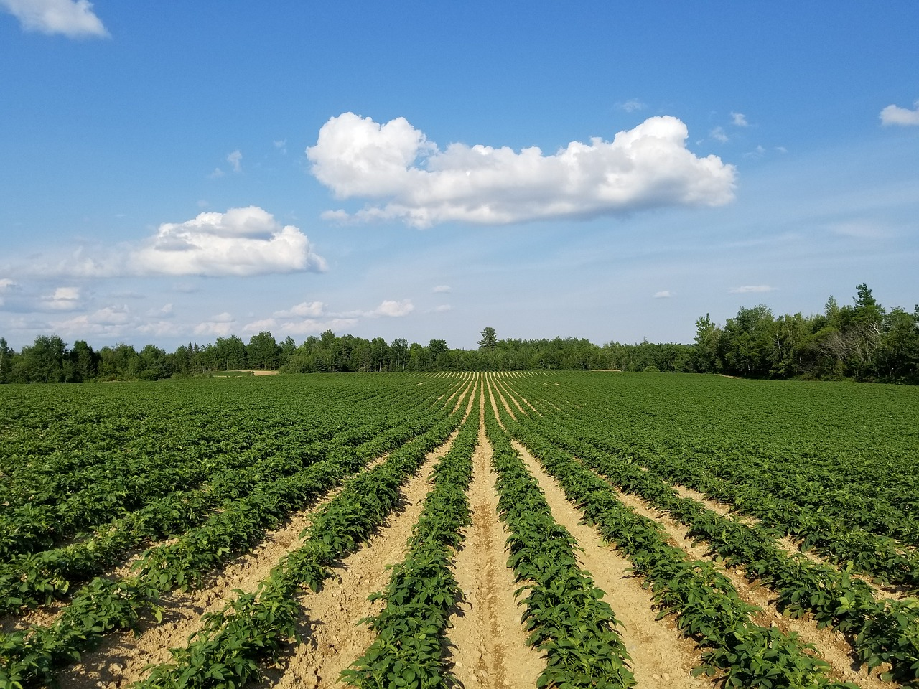
2024-2025 School Year
Prepared By: Lisa Cotting
amblingtogether.com
Cultivated Crops
Nature Study Schedule
About This Document 2
Week 1: Intro to Cultivated Crops 3
Week 2: Potatoes 3
Week 3: Strawberries 4
Week 4: Clover (specifically Red Clover) 4
Week 5: Tomatoes 5
Week 6: Basil 5
Week 7: Grapes 6
Week 8: Onions (specifically green onions/scallions) 6
Week 9: Peas 7
Week 10: Pumpkin 7
Week 11: Cotton 8
Week 12: Farming Practices 8
Alternative Weeks 9
Quick Facts 11
Potato 12
Strawberry 13
Red Clover 14
Tomatoes 15
Basil 16
Grapes 17
Green Onions or Scallions 18
Peas 19
Pumpkin 20
Cotton 21
Lavender 22
Peaches 23
Corn 24

About This Document
Prepared for: 2024-25 Term 1 for AO 6 and AO 3 children who live in a desert in Southern California

Notes:
- Many of these crops will be planted in the Spring or Summer before the term. To make the most of the observations, plan your garden and early. Most of the observation times will be done over the growing period, not exactly in the week we do the object lesson on the plant.
- The order of the weeks is arbitrary. Rearrange or substitute your own crops.
- I chose the variety of crops here to show a use for all parts of the plants – seeds, fruit, stem, leaves, roots etc.

Using these Main Resources:
- Handbook of Nature Study (HoNS – pages listed below are from my paper copy)
- Vegetables by Barbara Beck – available on archive.org
- The Tomato and Other Fruit Vegetables by Millicent Selsam – available on archive.org
- Vegetables from Stems and Leaves by Millicent Selsam – available on archive.org
- The Rose Family by Olive Lydia Earle – available on archive.com
- Weeds by Dorothy Hogner – available on archive.com
- The Story of Grains: Wheat, Corn, and Rice by Peggy Parish – good section on early civilization and farming and history of corn – available on archive.com
- The Amazing Potato: A Story in Which the Incas, Conquistadors, Marie Antoinette, Thomas Jefferson, Wars, Famines Immigrants, and French Fries All Play a Part by Milton Meltzer – available on archive.org

Additional Resources:
- Plants We Eat by Millicent Selsam – available on archive.org
- About the Vegetables on Your Plate by Veva Elwell Allee – available on archive.org
- Pumpkin: The Curious History of an American Icon by Cindy Ott – an interesting background read for me on the history of the pumpkin
- Nature Lore Books: Sabbath Mood Homeschooling (scroll down for a list by category, including Cultivated Crops)

Biography and other picture book ideas to read during the term:
- The Secret Garden of George Washington Carver by Gene Barretta and/or A Weed is a Flower: The Life of George Washington Carver by ALIKI
- Dr. Welch and the Great Grape Story by Mary Lou Carney available on archive.com
- Cotton Growing by Lois F. Harvey available on archive.org
- I Am a Farmer by Baptiste Paul, Miranda Paul, and Elizabeth Zunon – for younger children

Week 1: Intro to Cultivated Crops
Day 1: What is a Cultivated Crop? | Day 2: Fruit vs. Veggie
Read: Vegetables by Barbara Beck pg. 3-6 | Watch: Why Tomatoes are Fruits, and Strawberries Aren’t Berries (4:08 min)
Watch: History of Agriculture (to min 3:00)
Observation: Go to the grocery story/farmer’s market/local farm and determine which part of the plant the produce is from. For fun – is it a fruit or a veggie?
Additional Resources: Video - What’s the difference between fruits & vegetables (8 min)
Nature Lore: The Amazing Potato Ch 1 and Part of Ch 2, pg. 1-13 (stop at break)

Week 2: Potatoes
Day 1: |  | Day 2:
Read: Vegetables from Stems and Leaves by Millicent Selsam pg. 18 - 24 |  | Read: Vegetables by Barbara Beck pg. 6-8
Watch: Potato: How Does it Grow? (5:58 min) or Earthy Potatoes: How do Potatoes Grow? (1:56) |  | Watch: Examples of Stem Tubers – What Are They? (3:35 min), The process of vegetative propagation (1:49 min)
Observation: Plant Potatoes (prepare potatoes and soil in previous weeks). Instructions for planting potatoes using grocery store potatoes. Use nature journal to document planting and growth. Alternatively, visit a grocery store or farmer’s market and observe the types of potatoes. Purchase several types and notice differences, including taste. Use one or more potato to grow in a window sill (like this example).
Additional Resources: Ted-Ed Video – History through the eyes of the potato (3:46 min) ; What is a Bulb, Corm, Tuber, Rhizome, Tuberous Roots (12:35 min) ; Book – More Potatoes! By Melissa Selsam, available on archive.com
Nature Lore: The Amazing Potato finish Ch 2, pg. 13-22 (Note for Timeline: 10,000 B.C. start of cultivated crops)

Week 3: Strawberries
Preparation: Read HoNS pg 608-611
Day 1: | Day 2:
Read: The Rose Family pg. 45-48 (optional description of rose family pg 7-13) | Read: Look at diagram of strawberries and notice the parts. Notice in the timelapse video what parts of the plant come first
Watch: Strawberry Plant Anatomy (6:24 min) | Watch: Time Lapse of a Strawberry Plant (1:16 min)
Observation: Notice the strawberry plant parts and diagram them in nature journal, especially noticing the seeds on the strawberry and the stolon or runners. Compare flower and leaves to a rose bush. Use questions in HONS for your observation time. If you don’t have a strawberry plant, observe an actual strawberry whole and cut in half.
Additional Resources: Video - Strawberry Runners Explained (2:49 min) ; USDA Wood Strawberry Fact Sheet
Nature Lore: The Amazing Potato ½ of Ch 3, pg. 23-34

Week 4: Clover (specifically Red Clover)
Preparation: Read HoNS pg 591-598
Day 1: | Day 2:
Read: Weeds by Dorothy Hogner pg 67-70 | Watch: Understanding Our Soil: The Nitrogen Cycle, Fixers, and Fertilizers (4:29 min)
Observation: Journal the red clover plant – flowers & leaves. Then pull up and examine the roots for the nodules. Use questions in HONS for your observation time. Clover is pretty easy to find in lawns, especially public park lawns.
Additional Resources: Close-up view of Red Clover ; Red Clover Seeds ; Legumes with Professor Ray Weil: Root Nodules (5:34 min) ; Video - Free Garden Fertiliser: Symbiosis between legumes and rhizobium leguminosarum (5:28, at least til min 1:18) ; USDA Plant Fact Sheet
Nature Lore: The Amazing Potato finish Ch 3 and Ch 4, pg. 35-46.

Week 5: Tomatoes
Day 1: | Day 2:
Read: The Tomato and Other Fruit Vegetables by Millicent Selsam pg. 5-24 | Read: Vegetables by Barbara Beck pg. 8-10
Watch: Growing Tomatoes from Seed – 160 day Time Lapse (5:17 min) | Read: Vegetables by Barbara Beck pg. 8-10
Observation: Go to grocery store or farmer’s market and notice all the types of tomatoes. Also notice in the grocery store the aisle of canned tomatoes – how many ways tomatoes are processed. Observe the tomato plant’s growth and document in nature journal. Cut a tomato and notice the inside structure.
Additional Resources: Tomatoes by Franklin Watts ; Fun ideas for observing the tomato plant ; Flower to Fruit diagram ; Video - History of the tomato (2:12 min)
Nature Lore: The Amazing Potato Ch 5, pg. 47-56 (Note for Timeline: 1845 – start of Potato Famine in Ireland)

Week 6: Basil
Day 1: | Day 2:
Watch: Growing Thai basil Time-lapse – 70 days (1:21 min) | Watch: The History of Basil (6:32 min)
Observation: Grow or purchase a plant from the grocery story. Watch how responsive to water it is. Watch how it grows when you prune it. Notice the stem shape and how the flowers grow. Compare to other members of the mint family you have seen. Discuss what part of the plant we eat. Nature journal your findings.
Nature Lore: The Amazing Potato Ch 6, pg. 57-65

Week 7: Grapes
Day 1: | Day 2:
Watch: Come Out to the Farm: Grapes (3:33 min) | Watch: How Are Raisins Made? (4:00 min)
Observation: Watch the grapes grow and document in journal. And/Or get several varieties from the grocery store and compare size, color, juiciness, seeds/seedless, taste etc. Attempt making raisins. Discuss how the leaves are also edible – perhaps try a dolmas recipe (budget version, from fresh leaves version)
Additional Resources: Book – Dr. Welch and the Great Grape Story by Mary Lou Carney available on archive.com
Nature Lore: The Amazing Potato Ch 7 Part 1, pg. 66-75 (stop at “…in other countries.”)

Week 8: Onions (specifically green onions/scallions)
Day 1: | Day 2:
Read: Vegetables by Barbara Beck pg.15-20 (note: family is listed as lily family and is an outdated classification) | Read: Vegetables from Stems and Leaves pg.38-39
Watch: Green Onion Growing Time Lapse (1:25 min) | Read: Green Onions (What are they)
Observation: (Re-)Grow your own Green Onions (3:35 min video). Observe the onions growing and journal. Go to grocery store or farmer’s market and observe all the types of onions.
Additional Resources: 6 members of onion family blog post ; Video - 4 different types of green onions (5:05 min)
Nature Lore: The Amazing Potato Ch 7 Part 2, pg. 75 – 81 (start at “Why this powerful…”)

Week 9: Peas
Day 1: | Day 2:
Read: Vegetables by Barbara Beck pg. 46-48 | Watch: Growing Sweet Snap Pea Time Lapse (1:53 min)
Observation: Observe the pea plant, leaves, tendrils, flowers, etc. Examine the peas. When plant is done fruiting, examine the roots and see if you can find the nodules. Buy several variety of fresh peas from the grocery store or farmers market and compare size, texture, taste, number of peas in pod, etc.
Additional Resources: Pea Seeds ; USDA Plant Fact Sheet ; Ted Ed Video - How Mendel’s pea plants helped us understand genetics (3:06 min)
Nature Lore: The Amazing Potato Ch 8, pg. 82-88

Week 10: Pumpkin
Preparation: Read HoNS pg 611-617
Day 1: | Day 2:
Read: Vegetables by Barbara Beck pg. 51-54 | Watch: Pumpkin varieties explained (4:16 min) and/or Why Do Pumpkins Get So Big? (5:14 min)
Watch: Pumpkin: How Does it Grow? (3:56 min) and/or Pumpkin History & Nutrition (3:23 min)
Observation: Watch the plant grow and observe where the flowers are growing, how long they stay open, how many of them turn into pumpkins. Alternatively, go to a grocery store or pumpkin patch in the fall and observe the different kinds of pumpkins and gourds. Use the questions in HONS for your observation time.
Additional Resources: Picture Book about lifecycle: Pumpkin Jack by Will Hubbell– available on archive.com ; USDA - All parts of the Pumpkin plant are edible ; Pumpkin: The Curious History of an American Icon by Cindy Ott – an interesting background read for me on the history of the pumpkin
Nature Lore: The Amazing Potato Ch 9, pg. 89-97

Week 11: Cotton
Preparation: Read HoNS pg 604-608
Day 1: | Day 2:
Read: Cotton by Millicent Selsam pg.15-36 | Read: Cotton by Millicent Selsam pg.38-47
Watch: Understanding the Cotton Plant (4 min) and/or The Lifecycle of Cotton (2 min) | Watch: The History of Cotton (6 min)
Observation: Watch the plant grow. Notice the way the flower changes color. Feel the cotton on the seed. Document in journal. Use questions in HONS for your observation time. If you do not have an actual cotton plant, substitute this week with Lavender (another cultivated crop that is not usually cultivated to eat) – plants are readily available in stores.
Additional Resources: Book: Cotton Growing by Lois F. Harvey available on archive.org ; Follow your state guidelines for growing cotton
Nature Lore: n/a

Week 12: Farming Practices
Preparation: Read HoNS pg
Day 1: | Day 2:
Watch: Why is Farming Broken? (3:04 min)  What is crop rotation? (1:48 min) | Watch: What is Organic Farming? (3:50 min) Sustainable Agriculture in Pennsylvania (5:00 min) – note: watch this one before showing your children
Observation: Go to the grocery store and observe the produce in the organic section and compare it to the “normal” section. Purchase a few items and see if you can detect any other differences such as in taste or texture.
Additional Resources: https://www.youtube.com/watch?v=PrQ_wu67ItM
Nature Lore: n/a

Alternative Weeks
Lavender
Observation: Notice the growth, where the flowers are and how they are arranged. It is best to harvest the flowers when they start getting dull, but leave some to see what “fruit” there is.
Additional Resources: Diagram of Plant from Southerngracelavenderfarm.com ; Video - Planting and Growing Lavender (3:37 min)

Peaches
Day 1: | Day 2:
Read: The Rose Family pg. 36-45 | Watch: Peach: How Does it Grow? (10:41 min, at least through min 5)
Observation: Watch the tree from winter through summer, noticing the buds turn to flower turn to fruit and where the flower and fruit is growing on the tree. Notice the fur and when eating, notice the pit. Document in nature journal. If you do not have access to a tree, purchase a peach and/or nectarine and notice each part – skin, flesh, seed (opened)
Additional Resources: Lifecycle of a Maine Peach ; Video - Peach Trees’ Unique Structure: How They Grow, Bloom, and Fruit (2:40 min) ; Video - Peach Tree Buds – How They Grow (4:19 min)

Corn
Preparation: Read HoNS pg 598-604
Day 1: | Day 2:
Read: The Story of Grains: Wheat, Corn, and Rice by Peggy Parish pg 44-45 | Watch: How Does Popcorn Work? (3:27 min)
Watch: Fields of Gold: How Sweet Corn Pollination REALLY Works (2:19 min) | Watch: How Does Popcorn Work? (3:27 min)
Observation: If you can grow corn or live near corn farms, watch and document its growth in nature journal. Otherwise, purchase corn on the cob and identify the husk, silk, kernels, etc. Use the questions in HONS for your observation time.
Additional Resources: Parts of the Corn Plant and What They Do (Nebraska Corn Board) ; Ted Ed Video – The History of the world according to corn (5:22 min) ; Corn Silk: You’ll Never Guess What It’s For (0:52 min) - watch before showing children ; Popcorn by Millicent Selsam – available on archive.org
Quick Facts
Use the following pages to assist in your observations of the plants

Potato (Family: Solanacaea or Nightshade)
Description: Leaves are pinnate with a single terminal leaf and 3 or 4 pairs of leaflets ; the flowers grow on a terminal, branched inflorescence that may contain up to 25 tubular flowers
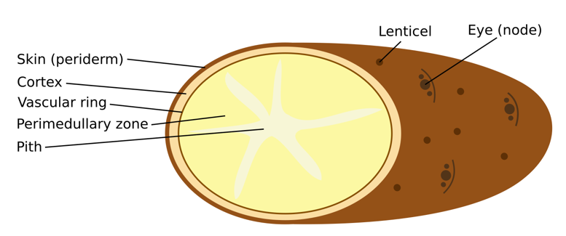
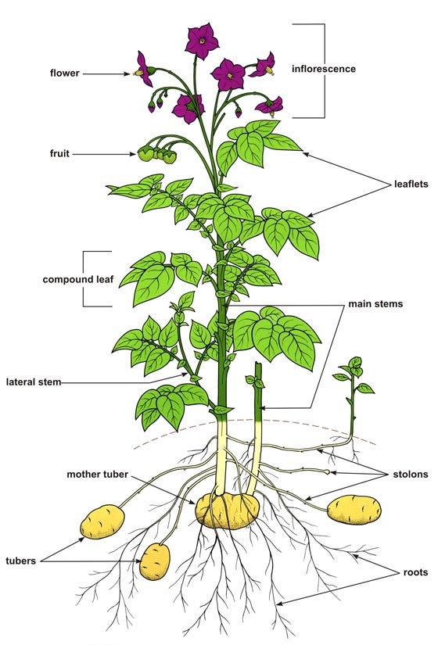
From CIP From Wikipedia

Strawberry (Family: Rosaceae or Rose)
Description: Compound leaves with three leaflets, sawtooth edged ; white or pink five-petaled flowers grow in clusters
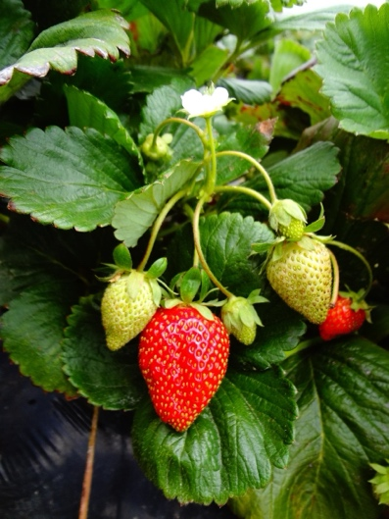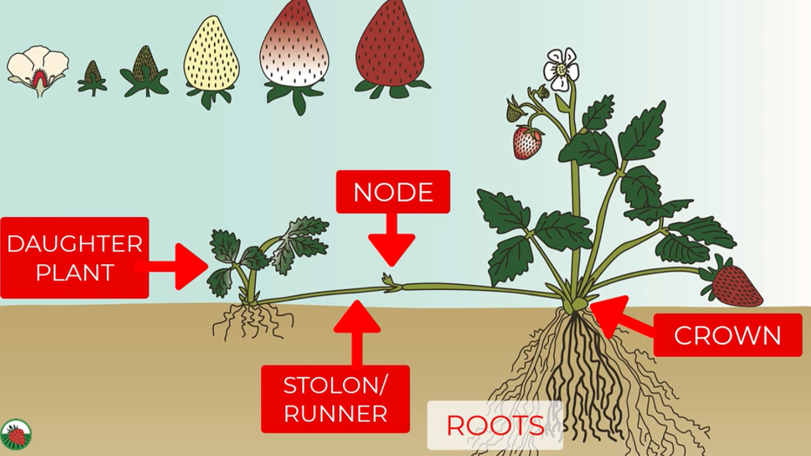
From pixabay From Cal Poly YouTube video

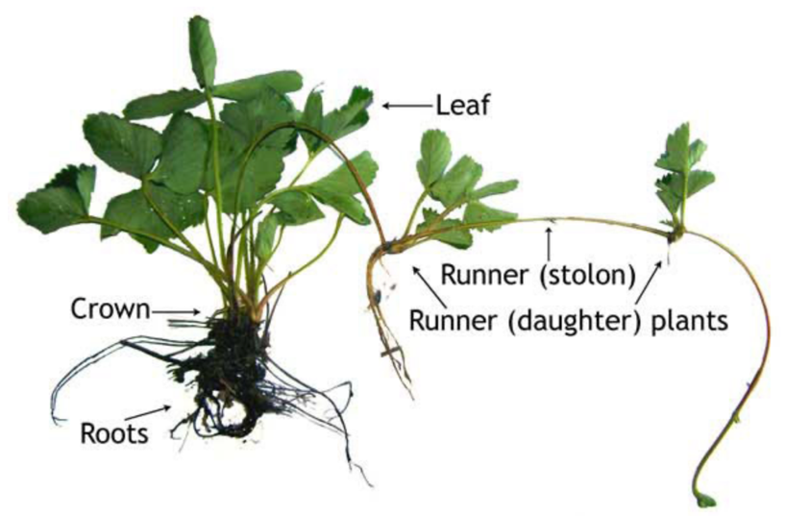
from University of Minnesota Extension

Red Clover (Family: Fabaceae or legume)
Description: Alternating compound leaves with usually three toothed leaflets with very small flowers densely packed into a spherical head
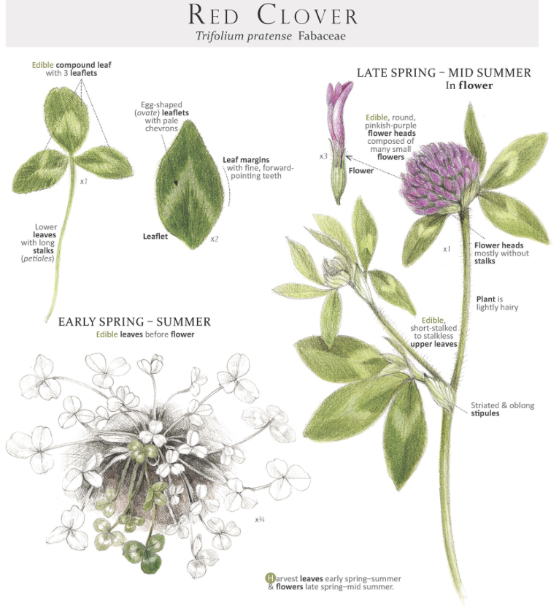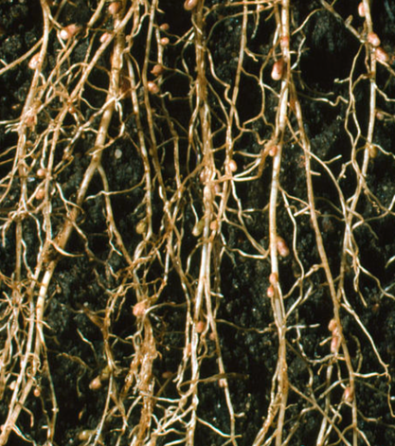
From botanicalartspress.com Nodules photo from science photo gallery

Tomatoes (Family: Solanaceae or Nightshade)
Description: Alternating pinnately compound leaves with between 5 and 9 leaflets. The 5 petaled flowers are clustered and pendulant (hang down)
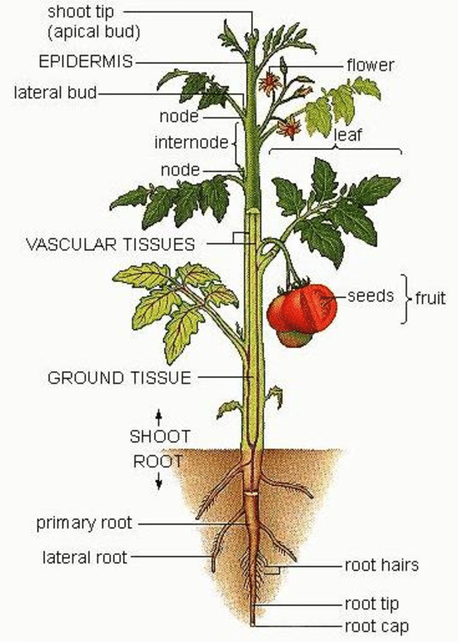

From ResearchGate

Basil (Family: Lamiaceae or Mint)
Description: Opposite smooth & glossy leaves are oval shaped on a square stems with small flowers in clusters on a terminal spike
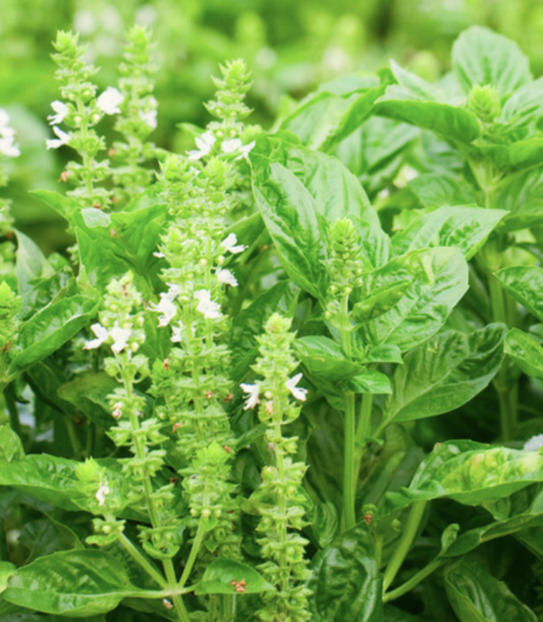

Grapes (Family: Vitaceae or Grape)
Description: Woody vine with tendrils with alternate palmately lobed tooth-edged leaves and small clustered flowers
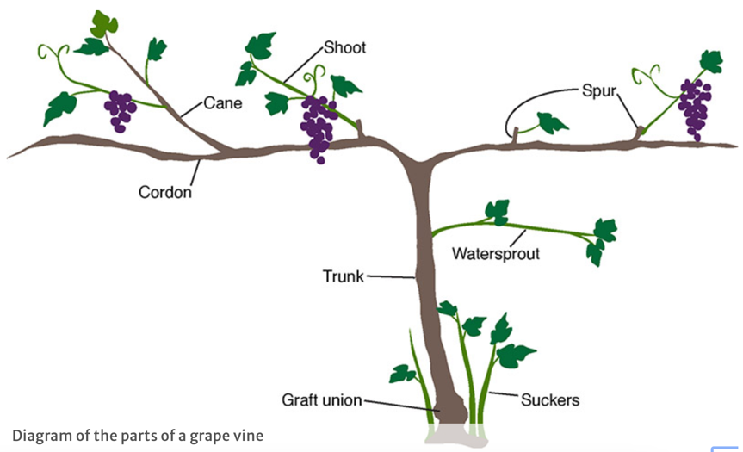
Grapes bear fruit on green shoots of one-year old canes
From University of Minnesota Extension

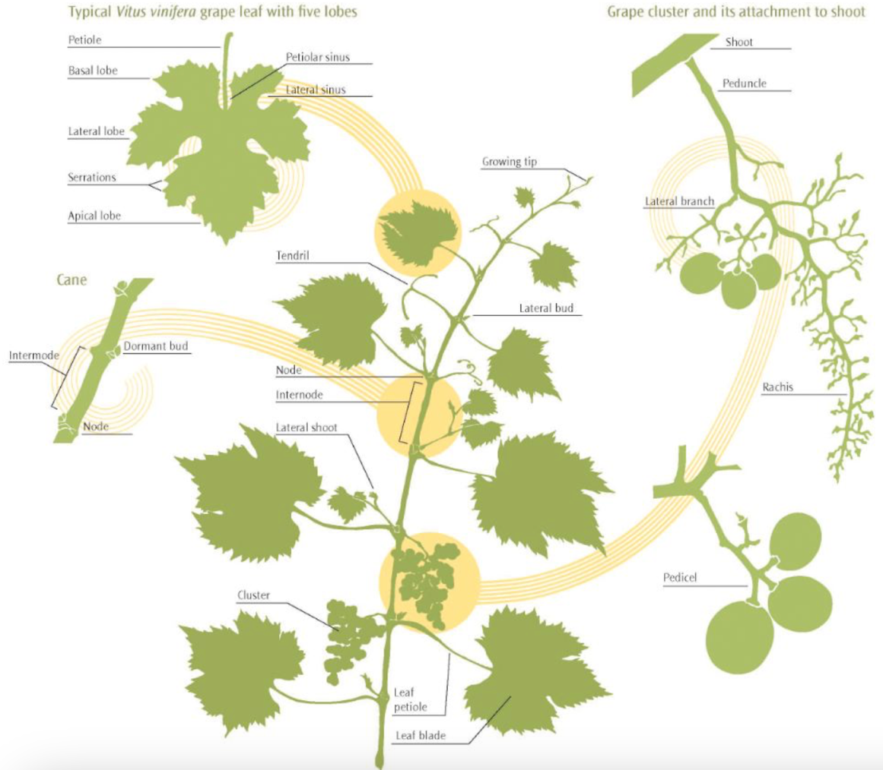
From Lodi Wine Growers

Green Onions or Scallions (Family: Amaryllidacaeae, Subfamily: Alliodeae or Onion)
Description: Monocot with a cluster of long thin leaves and cluster of flowers at the top of a leafless stalk. The leaf base swells to create a bulb.
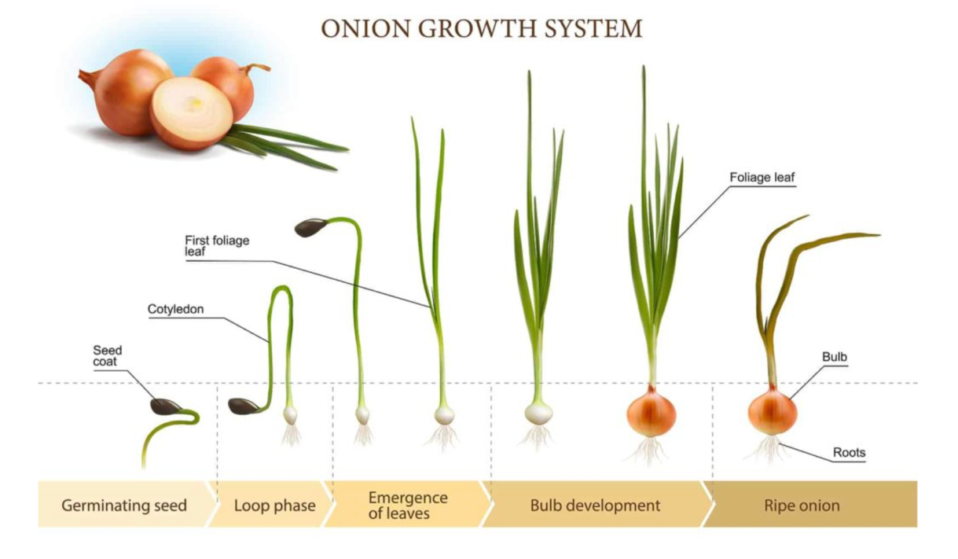
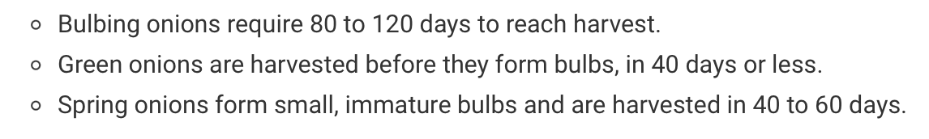
From Harvesttotable.com
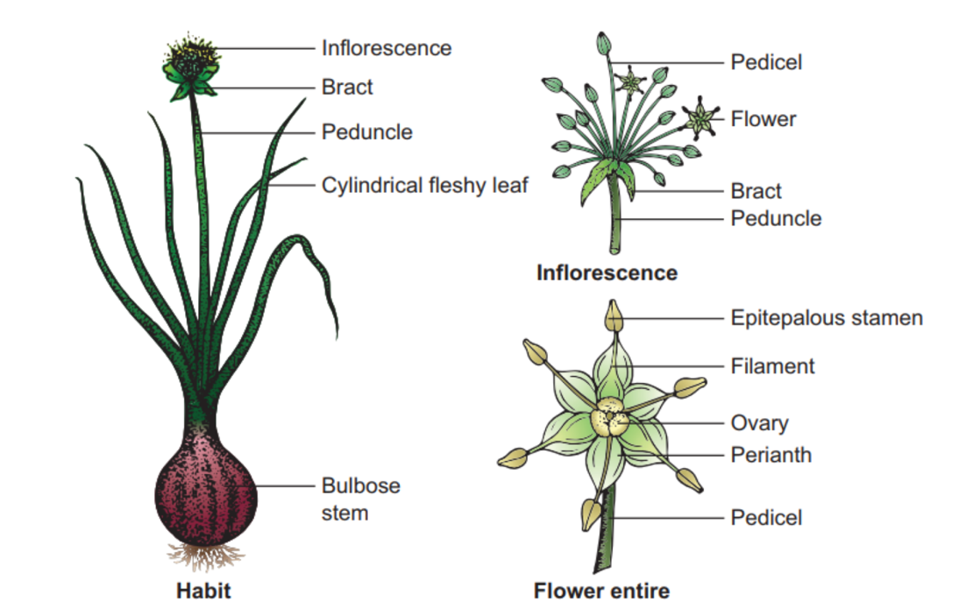
From brainkart.com

Peas (Family: Fabaceae or legume)
Description: Vine with terminal tendrils, alternately compound leaves, and “banner, wings, and keel” shaped flower growing 2 or 3 per stalk. The fruit is a pod with multiple seeds encased therein. Also note that the stem is hollow.
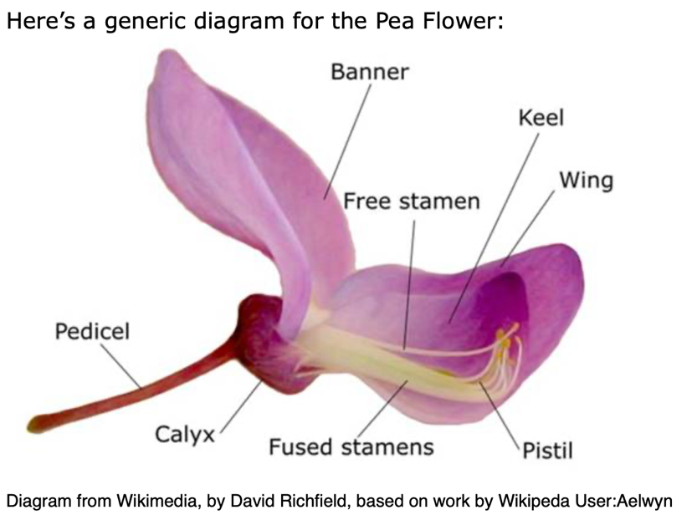
From plantid.net

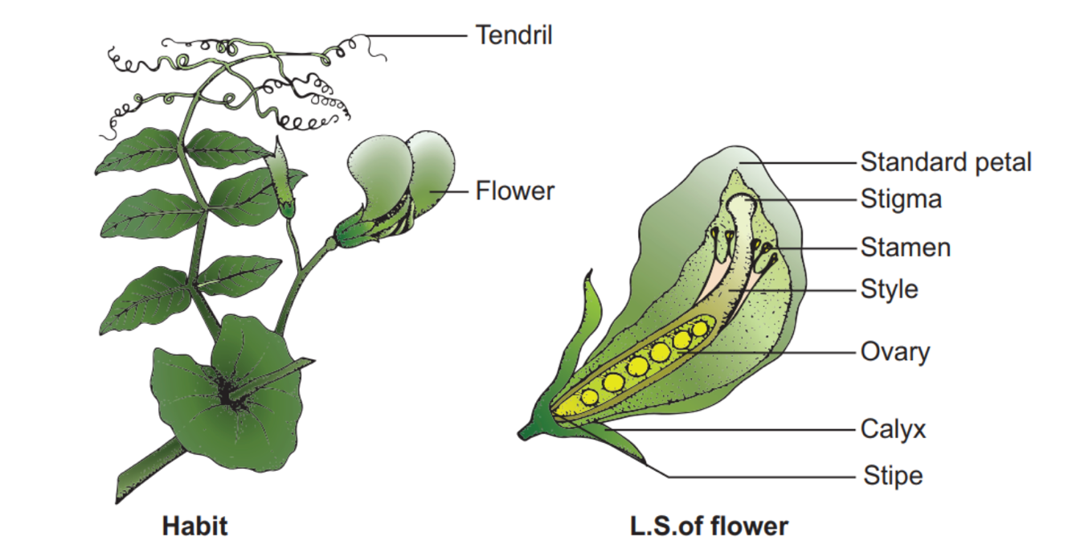
From brainkart.com

Pumpkin (Family: Cucurbitaceae or Gourd)
Description: Creeping, hollow, and hairy stems and heart shaped leaves. The large funnel-shaped flowers will be male or female.
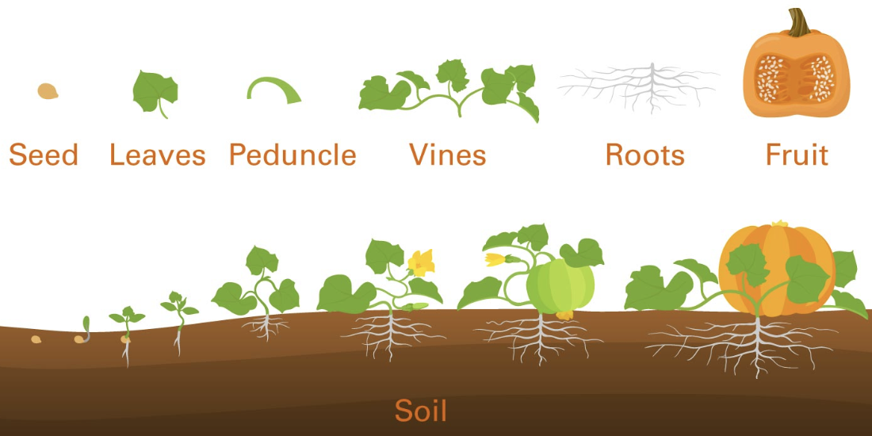
From NC State

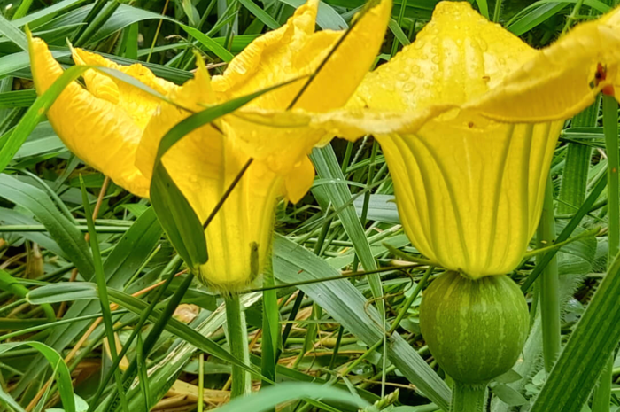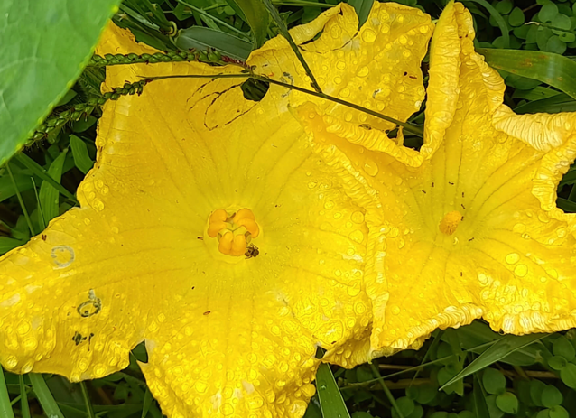
Female
Female
Male
Male
From permaculturenews.org

Cotton (Family: Malvaceae or Mallow)
Description: A lobed, heart-shaped leaf on branches coming off one main stem. The yellow or white flowers darken to pink after a day. The flower falls off to form the boll encasing the seeds.
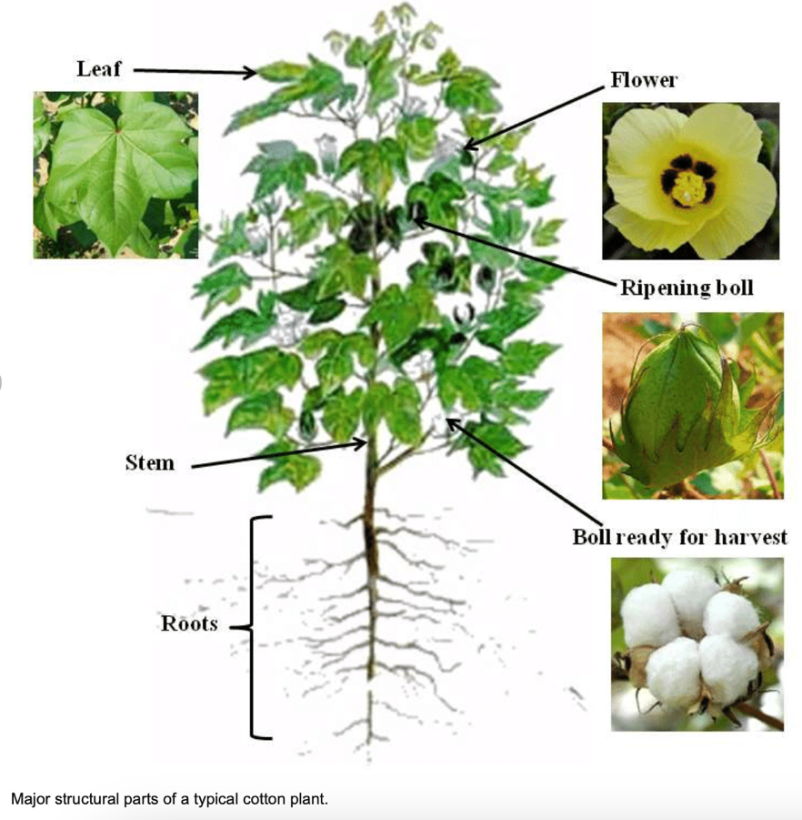
From Researchgate.net
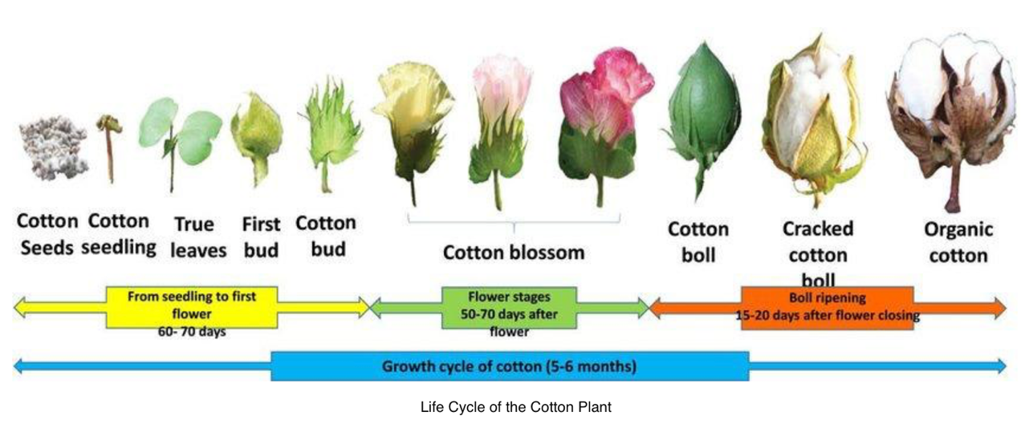
From Seminolesentinel.com

Lavender (Family: Lamiaceae or Mint)
Description: Woody branches with upright leafy shoots with silvery oblong leaves. The small purple flowers are spikes at the tip of long bare stalks.
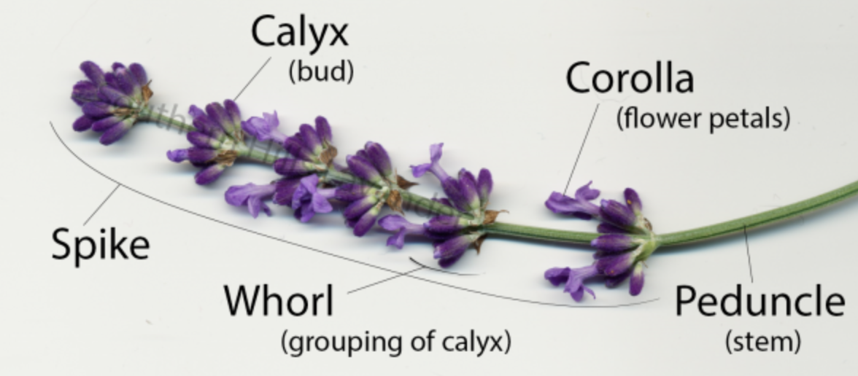

See diagram of full plant at Southern Grace Lavender Farms

Peaches (Family: Rosaceae or Rose)
Description: Elongated pointy and shiny alternating leaves that emerge after the flowers. The flowers are small pink or white with five petals.
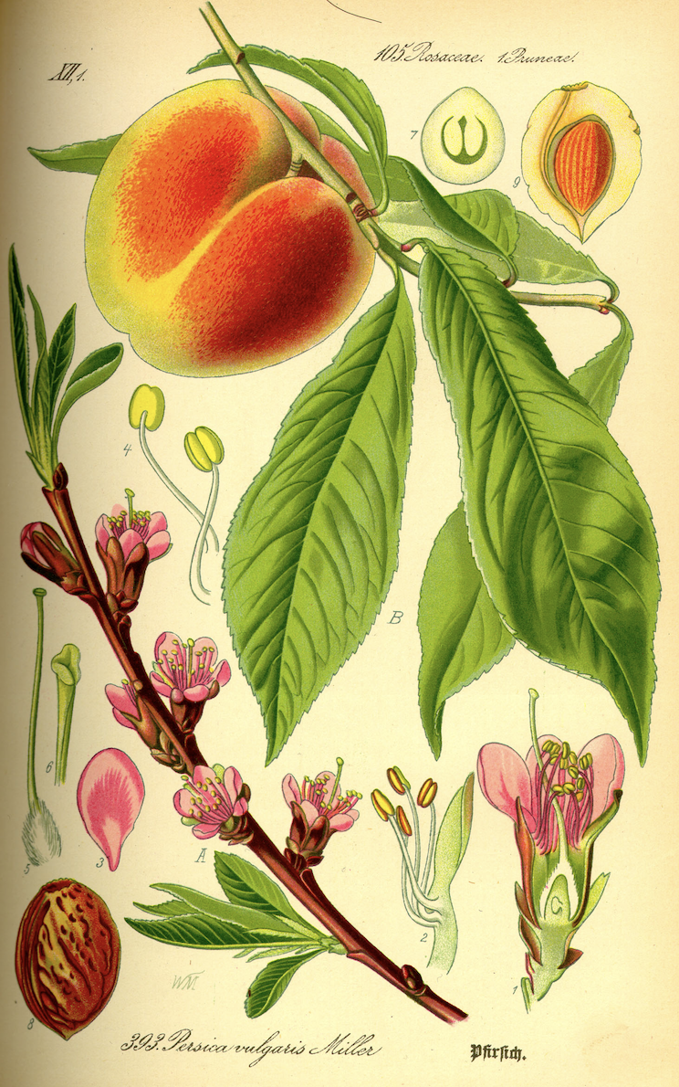
From Wikipedia

Corn (Family: Poaceae or Grass)
Description: Grass with a single stem, alternating long narrow leaves. The top of the stem has a male tassel and female flowers are further down the stem and is at first just the silks but turn into the ear or corn.
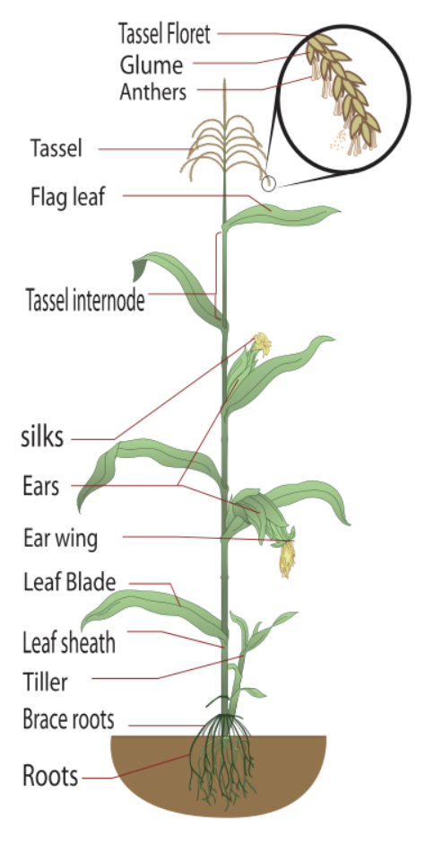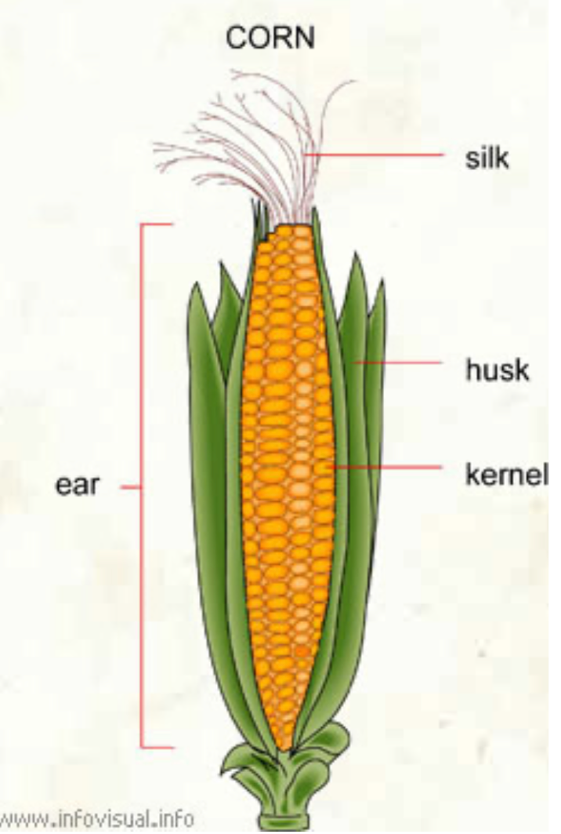
From Wikipedia From infovisual.info

