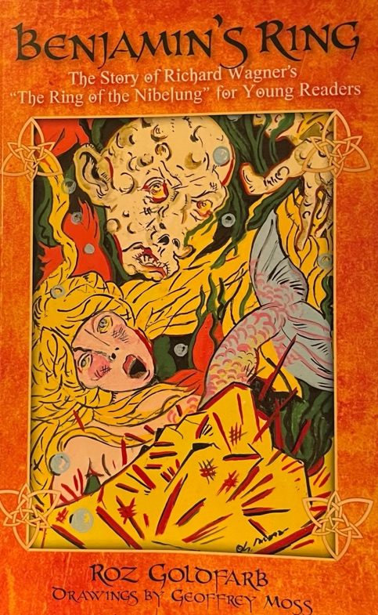
Listening Guide for
Benjamin’s Ring:
The Story of Richard Wagner’s
The King of the Nibelung
for Young Readers

by Roz Golofarb
Prepared by Lisa Cotting
amblingtogether.com

Table of Contents
The Story of the Rhinegold 3
The Story of the Walkure…and the Magic Sword 4
The Story of Siegfried 5
Gotterdammerung – The Death of the Gods 6
Gotterdammerung – The Death of the Gods, Continued 7

You Tube Playlist of all the videos here

The Story of the Rhinegold

Video: Opera North Das Rheingold-The Ring Cycle
Day 1 | Pg. 1-4
Day 2 | Watch 1:52-4:15
Day 3 | Read Pg 4-5
Day 4 | Watch 4:15 – 15:34
Day 5 | Watch 15:34 - 20:35
Day 6 | Read Pg 6 – top of 8
Day 7 | Watch 27:00 – 36:41
Day 8 | Watch 36:41 – 45:50
Day 9 | Watch 45:50 – 54:00
Day 10 | Watch 54:00 – 1:03:09
Day 11 | Watch 1:03:09 – 1:10:29
Day 12 | Read Pg 8-9
Day 13 | Watch 1:10:30 – 1:16:11
Day 14 | Watch 1:16:11 – 1:22:20
Day 15 | Watch 1:22:20 – 1:33:35
Day 16 | Watch 1:33:35 – 1:40:00
Day 17 | Read Pg 10 – 12
Day 18 | Watch 1:41:15 – 1:48:02
Day 19 | Watch 1:48:02 – 1:58:10
Day 20 | Watch 1:58:10 – 2:08:33
Day 21 | Watch 2:08:33 – 2:15:50
Day 22 | Watch 2:15:50 – 2:22:45
Day 23 | Watch 2:22:45 to end or watch “Entry of Gods into Valhalla”

The Story of the Walkure…and the Magic Sword

Video: Queen City Opera Richard Wagner: Die Walkure, Act 1
Day 24 | Read Pg 15 – halfway through 19
Day 25 | Watch to 9:27
Day 26 | Watch 9:27 – 18:01
Day 27 | Watch 18:01 – 29:33
Day 28 | Watch 29:33 – 39:45
Day 29 | Watch 39:45 – 47:41
Day 30 | Read Pg 19 – bottom of 21
Day 31 | Watch 47:41 – 55:00
Day 32 | Watch 55:00 – 1:05:40
Day 33 | Watch 1:05:40 – end
Video: Opera North Act II: Die Walkure – The Ring Cycle
Day 34 | Read Pg 21 – top of page 25
Day 35 | Watch to 8:56
Day 36 | Watch 44:50 – 51:05
Day 37 | Watch 51:05 – 1:01:30
Day 38 | Watch 1:02:33 – 1:11:40
Day 39 | Watch 1:11:40 – 1:21:40
Day 40 | Read Pg 25 – halfway through 26
Day 41 | Watch 1:21:40 to end
Video: Opera North Act III Die Walkure – The Ring Cycle
Day 42 | Read Pg 26 – bottom of 28
Day 43 | Watch to 10:33
Day 44 | Watch 10:33 – 18:08
Day 45 | Read Pg 28 – 31
Day 46 | Watch 23:35 – 30:52
Day 47 | Watch 50:07 – 1:01:55
Day 48 | Watch 1:01:55 – to end

The Story of Siegfried

Video: Opera North Act 1: Siegfried – The Ring Cycle
Day 49 | Read Pg 33 – halfway through 36
Day 50 | Watch 2:00 – 13:35
Day 51 | Watch 13:35 – 22:18
Day 52 | Watch 22:18 – 29:15
Day 53 | Read Pg 36 – Top of 38
Day 54 | Watch 29:15 – 43:44
Day 55 | Watch 43:44 – 54:00
Day 56 | Read Pg 38 – 39
Day 57 | Watch 54:00 – 1:07:10
Day 58 | Watch 1:07:10 to end
Video: Opera North Act II: Siegfried – The Ring Cycle
Day 59 | Read Pg 40 - top of 42
Day 60 | Watch 0:50 – 11:43
Day 61 | Watch 15:25 – 24:10
Day 62 | Read Pg 42 – 43
Day 63 | Watch 24:45 – 34:50
Day 64 | Watch 34:50 – 42:00
Day 65 | Watch 42:00 – 51:04
Day 66 | Read Pg 44 – 46
Day 67 | Watch 51:05 – 1:04:50
Day 68 | Watch 1:04:50 to end
Video: Oprah North Act III: Siegfried – The Ring Cycle
Day 69 | Read Pg 47 to halfway through 49 (stop at “I feel old.”)
Day 70 | Watch to 9:00
Day 71 | Watch 9:00 to 19:20
Day 72 | Read Pg 49 (start at “There was a stirring…”) – 50
Day 73 | Watch 19:20 – 31:25
Day 74 | Read pg 51 - 54
Day 75 | Watch 31:25 -40:00
Day 76 | Watch 40:00 - 49:30
Day 77 | Watch 49:30 – 59:40
Day 78 | Watch 59:40 – 1:08:32 (can be skipped)
Day 79 | Watch 1:08:32 to end

Gotterdammerung – The Death of the Gods

Video: Opera North Prologue & Act I: Gotterdammerung – The Ring Cycle
Day 80 | Read Pg 55 – halfway through 57
Day 81 | Watch 0:40 – 10:05
Day 82 | Watch 10:05 – 20:00
Day 83 | Read Pg 57 – top of 59
Day 84 | Watch 20:00 – 32:36
Day 85 | Watch 32:36 – 38:15 or Wagner: Siegfrieds Rheinfahrt (10:16 min)
Day 86 | Read Pg 59 – 60
Day 87 | Watch 38:15 - 51:00
Day 88 | Read Pg 60 – bottom of 62
Day 89 | Watch 51:00 – 58:50
Day 90 | Watch 58:50 – 1:08:50
Day 91 | Watch 1:08:50 – 1:18:10
Day 92 | Read Pg 62 – halfway through 65
Day 93 | Watch 1:23:30 – 1:31:30
Day 94 | Watch 1:31:30 – 1:39:07
Day 95 | Watch 1:39:07 – 1:48:50
Day 96 | Read Pg 65 – top of 66
Day 97 | Watch 1:48:50 to end
Video: Opera North Act II: Gotterdammerung – The Ring Cycle
Day 98 | Read Pg 66
Day 99 | Watch 2:10 – 12:20
Day 100 | Read Pg 66 – top of 71
Day 101 | Watch 12:20 – 19:35
Day 102 | Watch 19:35 – 28:00 (optional – not included in book)
Day 103 | Watch 28:00 – 39:00
Day 104 | Watch 39:00 – 51:00
Day 105 | Read Pg 71-72
Day 106 | Watch 53:06 – 1:01:25
Day 107 | Watch 1:01:15 - end

Gotterdammerung – The Death of the Gods, Continued

Video: Opera North Act III Gotterdammerung – The Ring Cycle
Day 108 | Read Pg bottom 72 - 73
Day 109 | Watch 0:50 – 11:40
Day 110 | Watch 11:40 – 21:00
Day 111 | Read Pg 75 – Top of 77
Day 112 | Watch 21:00 – 31:54
Day 113 | Watch 31:54 – 42:45
Day 114 | Watch 42:45 - 48:47 or London Philharmoic Gotterdammerung: Siegrieds Tod und Trauermarsch (9:57 min)
Day 115 | Read Pg 77 – 78
Day 116 | Watch 48:47 – 57:02
Day 117 | Watch 57:02 – 1:08:52
Day 118 | Read Pg 79 – 82
Day 119 | Watch 1:08:52 - end

