Robert S. Duncanson (Wikipedia biographical information)

1 | 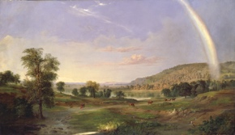 | Landscape with Rainbow, 1859, oil on canvas, 30 x 52 ¼ in, Smithsonian American Art Museum
2 | 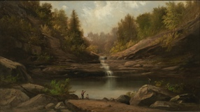 | Mountain Pool, 1870, oil on canvas, 11 1/8 x 19 7/8 in, Smithsonian American Art Museum
3 | 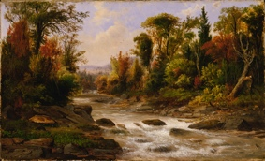 | On the St. Annes, East Canada, 1863, 1865, oil on canvas, 9 1/8 x 15 in, Smithsonian American Art Museum
4 | 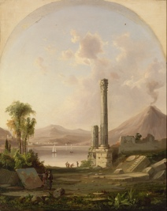 | Pompeii, 1855, oil on canvas, 21 x 27 in, Smithsonian American Art Museum
5 | 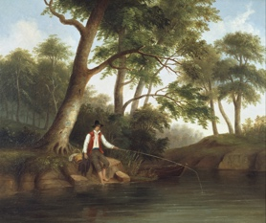 | Man Fishing, 1848, oil on canvas, SCAD Museum of Art
6 | 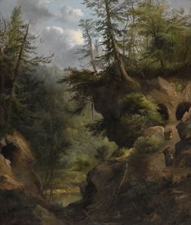 | The Caves, 1869, oil on canvas, 36 x 30 ¾ in, Amon Carter Museum of American Art
7 | 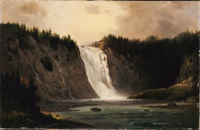 | Waterfall on Mont-Morency, 1864, oil on canvas, 18 x 27 7/8in , Smithsonian American Art Museum
8 | 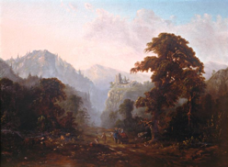 | And we will visit (but can’t find a good print of):  Landscape with Ruin, 1853, oil on canvas, 24 x 32 in, The Huntington Library, Art Museum and Botanical Gardens

Prepared by Lisa Cotting of amblingtogether.com ; I printed through FedEx on 100lb Gloss Cover professional paper
