Lisa Cotting
amblingtogether.com
South AMerica geography
Country by Country Study

Table of Contents
About This Guide 2
Why a continent study: 2
How we study a continent: 3
Schedule: 4
Blank Map of South America 5
Map of South America with Countries 6
South America Continent 7
Colombia (Republic of Colombia) 8
Venezuela (Bolivarian Republic of Venezuela) 9
Guyana (Co-operative Republic of Guyana) 10
Suriname (Republic of Suriname) 11
French Guiana 12
Brazil (Federative Republic of Brazil) 13
Ecuador (Republic of Ecuador) 14
Peru (Republic of Peru) 15
Bolivia (Plurinational State of Bolivia) 16
Chile (Republic of Chile) 17
Argentina (Argentine Republic) 18
Paraguay (The Republic of Paraguay) 19
Uruguay (Oriental Republic of Uruguay) 20
United Kingdom Territories: 21

About This Guide

Why a continent study:

Charlotte Mason describes the principle to be followed as the child gets older and starts studying other countries: “vivid descriptions, geographical principles, historical associations and industrial details, are afforded which should make, as we say, an impression, should secure that the region traversed becomes an imaginative possession as well as affording data for reasonable judgements.” (Book VI)

Inspired by this, I have made time in our Together Time to study the geography of other continents. For each continent we will study the major geographical features and boundaries and then do a brief study of each country therein. I try to find what will make “an impression” so that the country “becomes an imaginative possession” of each child. I decided to focus on mapping the physical features, reading a little about the culture, history, or nature of the state, and watching several videos to compliment these topics.

While using Miss Mason’s principles for teaching geography and choosing which features to map or which books to read and videos to watch, I consider the following goals: We will be familiar with major cities and landmarks – understanding how mountains and waterways divide and define, we will know a little about the original inhabitants of the land, we will have an understanding of what (some of) the country looks like and we will be familiar with some of the stories and culture from the area. I will not cover all of these topics for each country but hope that in general we’ll know our world and neighbors in it a little better by the time we’re finished.

How we study a continent:

I have spaced this study over 36 weeks and scheduled 15 minutes one morning a week to read the book, watch the videos, and draw the geographical features on our map. When time permits, we draw the country freehand to help us notice the features of the boarder. Each country has two or three weeks on the schedule.

We will be using the book South America by Nellie B. Allen as a sort of spine for our continent study. The book is dated but includes some great descriptions of the geography. Though I will only be reading aloud small portions of the book, I used it as inspiration for what to study. Because I am only reading excepts of the book, I have marked up my copy showing me where to start and stop to make the reading day easier.

The maps I have drawn below for some country are a basic rudimentary drawing for me to use as reference so I can easily find the landmarks in an atlas or “real” map. For some countries I found simple enough maps that I didn’t need to draw one. The children will use the “real” maps as reference for drawing their own maps.

I am hanging this map of South America on the wall for us to reference throughout the year.

Additional Resources:
- Maps of South America: burningcompass.com ; printablemaps.com ; Alabama Maps ; Seterra Map
- Outline maps of the countries: mapsofworld.com

Schedule:

Weeks | Topic
1, 2 | Overview of South American Geography
3, 4, 5 | Columbia
6, 7, 8 | Venezuela
9, 10 | Guyana
11, 12 | Suriname
13, 14 | French Guiana
15, 16, 17 | Brazil
18, 19, 20 | Ecuador
21, 22, 23 | Peru
24, 25 | Bolivia
26, 27, 28 | Chile
29, 30 | Argentina
31, 32 | Paraguay
33, 34 | Uruguay
35, 36 | U.K. Territories

Blank Map of South America
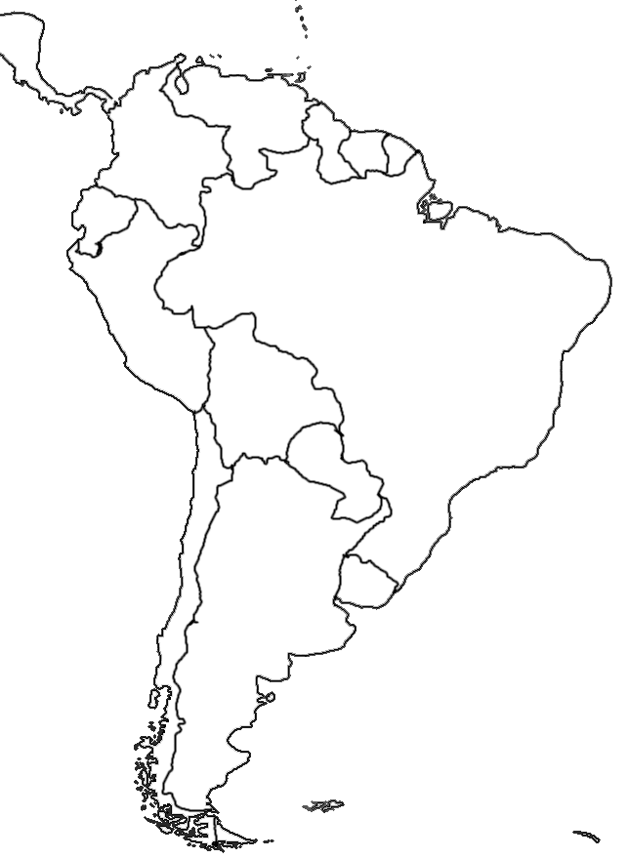

Map of South America with Countries
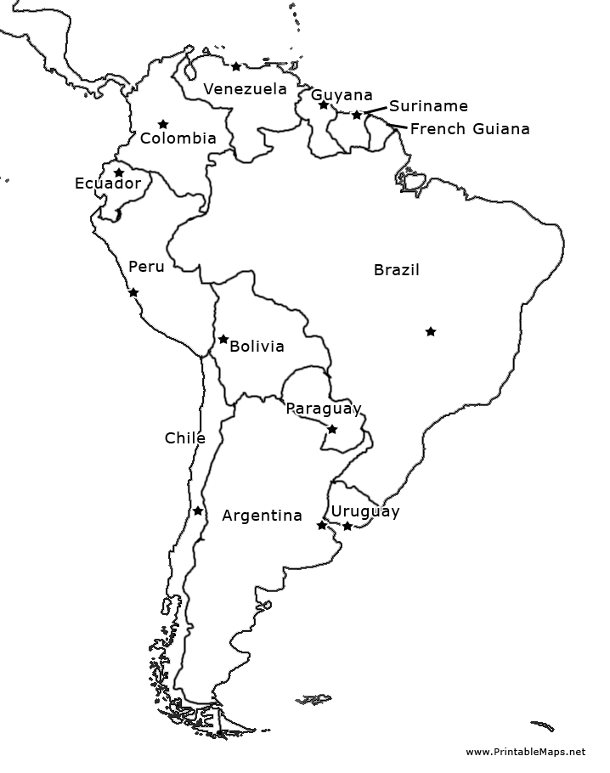

South America Continent

Schedule:

Week 1 | Read: S.A. pg. 1-3 and locate South America on the globe
Week 2 | Map: Identify features below on a map and draw

Major Geographical Features:
Caribbean Sea ; Pacific Ocean ; Atlantic Ocean ; Cape Horn ; Amazon River ; Andes ; Equator
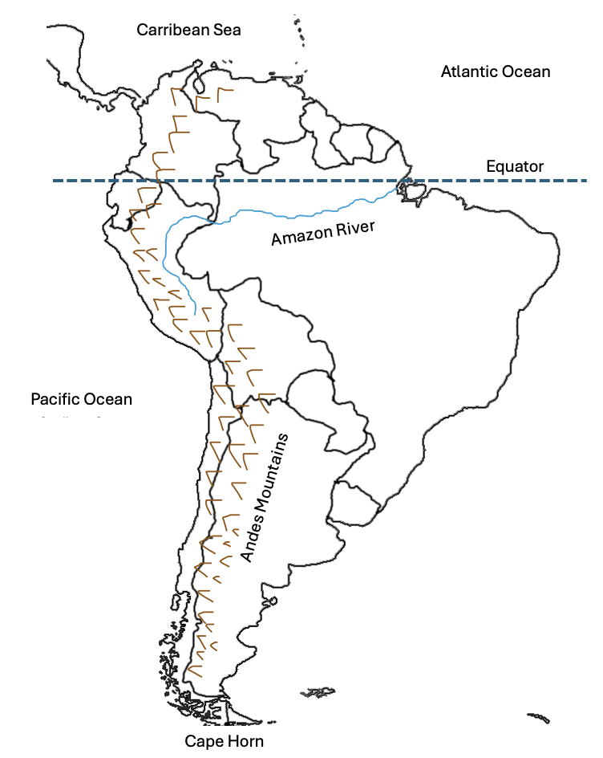

Additional Video Resources for older children (preview first): Earth’s Longest Mountain Range: The Andes (52:01 min) ; Long Way Up series (available on AppleTV)

Colombia (Republic of Colombia)

Schedule

Week 3 | Read: S.A. Pg 17 (from “Colombia is only…” to “…of rubber trees.”)  Find Columbia on the map of South America and notice what it boarders
Week 4 | Read: S.A. Pg 23 and Pg 26 (starting at “As we go…”) – 27 (stop at “…quantities of platinum.”)  Watch: Explore Colombia’s Magdalena River (3:25 min)  Map: Find some major rivers on the map and draw them and the Andes Mountains. Notice how the rivers work with the three mountain chains. Look at the source and mouth of the rivers. Draw the Inca Road.
Week 5 | Watch: These Cable Cars Transformed Medellin (3:46 min) Optional: one or more of the Smithsonian “Into the Wild Colombia” video from playlist  Map: Draw the shape of Colombia and fill in the geographical features

Capital: | Bogotá |  | Language: | Spanish
Geographical Features to Map
Andes Mountains (Cordillera Occidental, Cordillera Central, Cordillera Oriental) ; San Andres Island (and other islands) ; Gulf of Panama ; Pacific Ocean ; Caribbean Sea ; Rivers: Cauca, Magdalena, Meta, Putumayo ; Inca Road
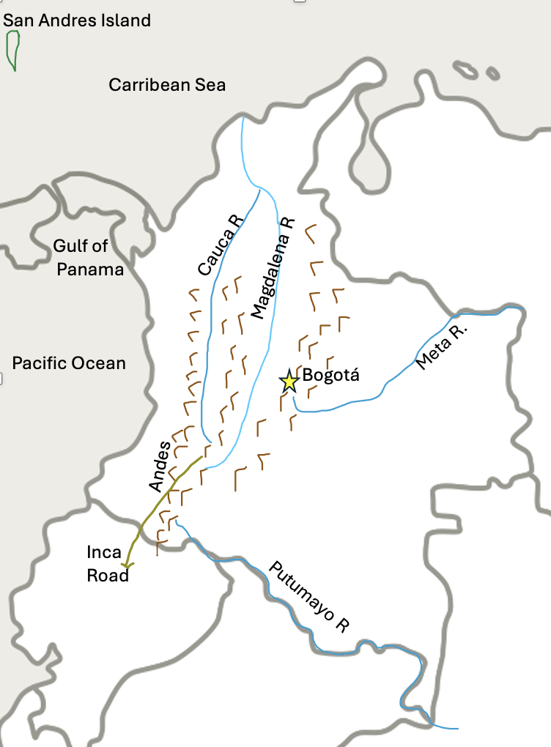

Venezuela (Bolivarian Republic of Venezuela)

Schedule

Week 6 | Read: S.A. Pg 38, 40 (start at “V. has a coast…”) to 41 (stop at “…wooded mountains.”), and 42 (start at “If we were…”) to 44 (stop at “…is situated.”)  Map: Find Venezuela on the map and notice its shape and what boarders it. Locate the capital city of Caracas.  Optional, Watch: Orinoco Basin, Venezuela (24:16 min)
Week 7 | Read: S.A. pg 54 (start at “Lake Maracaibo…” and stop at “…of the country.”)  Watch: Weird Places – The Endless Lightning at Lake Maracaibo (4:38 min)  Map: Locate Lake Maracaibo, the Gulf of Venezuela, and the mountain ranges. Draw them on your map.
Week 8 | Watch: Angel Falls (2:19 min)  Map: Locate the remaining items on the map and draw on your own.

Capital: | Caracas |  | Language: | Spanish
Geographical Features to Map
Cariibean Sea, Gulf of Venezuela, Lake Maracaibo, Andes Mountains, Orinoco River, Orinoco Delta, Angel Falls, Guiana Highlands, Llanos (The Plaines)
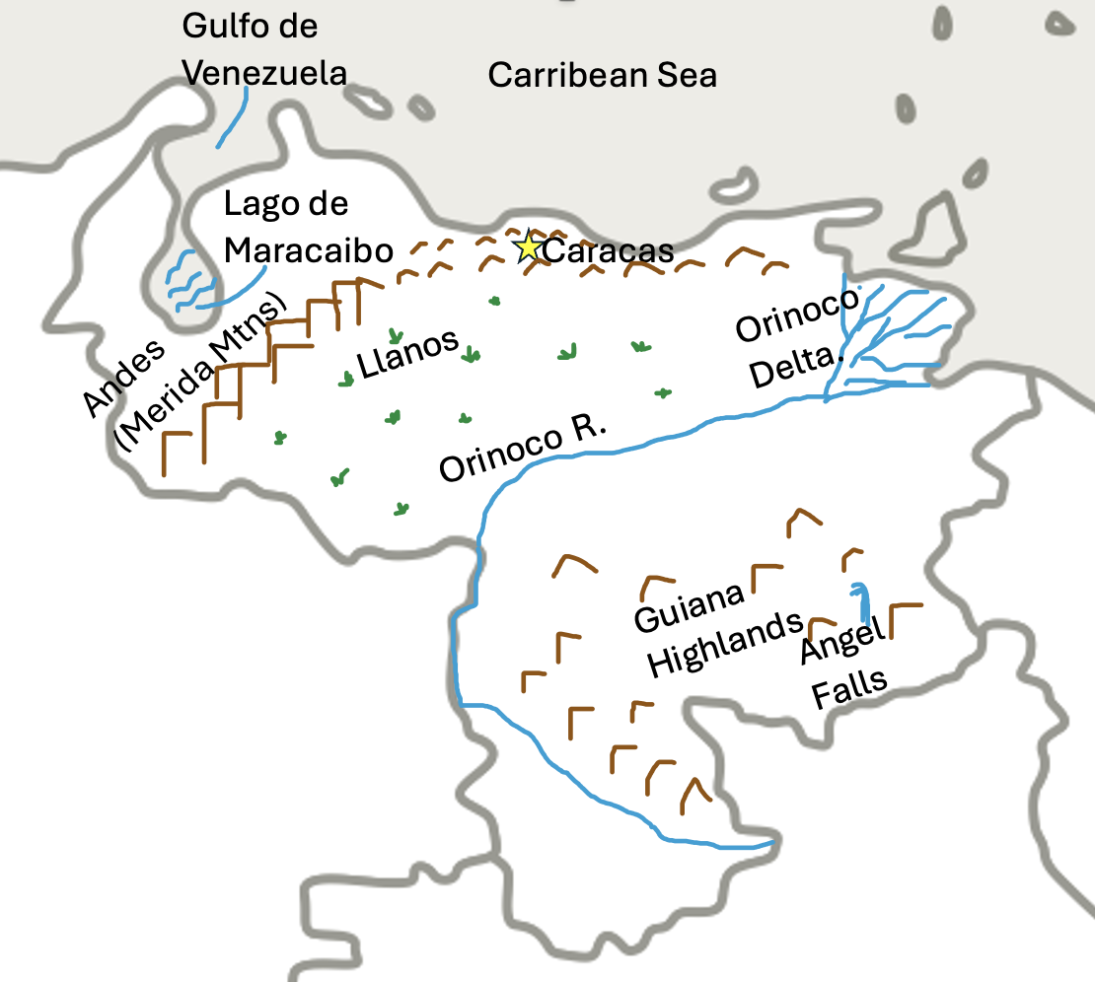

Guyana (Co-operative Republic of Guyana)

Schedule

Week 9 | Watch: 8 Guyanese foods influenced by its diverse population (5:48 min)  Map: Notice the boarders and shape of Guyana. Draw the country with capital city.
Week 10 | Watch: The Largest Single Drop Waterfall in the World (4:23 min)  Map: Locate the mountain ranges and rivers & Kaieteur Falls. Draw them on your map.  Optional Video: Into the Wild – the Untamed Rainforests and Unique Creatures of Guyana (51:58 min)

Capital: | Georgetown |  | Language: | English
Geographical Features to Map
Atlantic Ocean ; Pakaraima Mountains ; Kanuku Mountains ; Acarai Mountains ; Rivers: Cuyuni, Mazaruni, Essequibo, Corentyne ; Kaieteur Falls (additional map for reference) ; Note dispute territory on this map
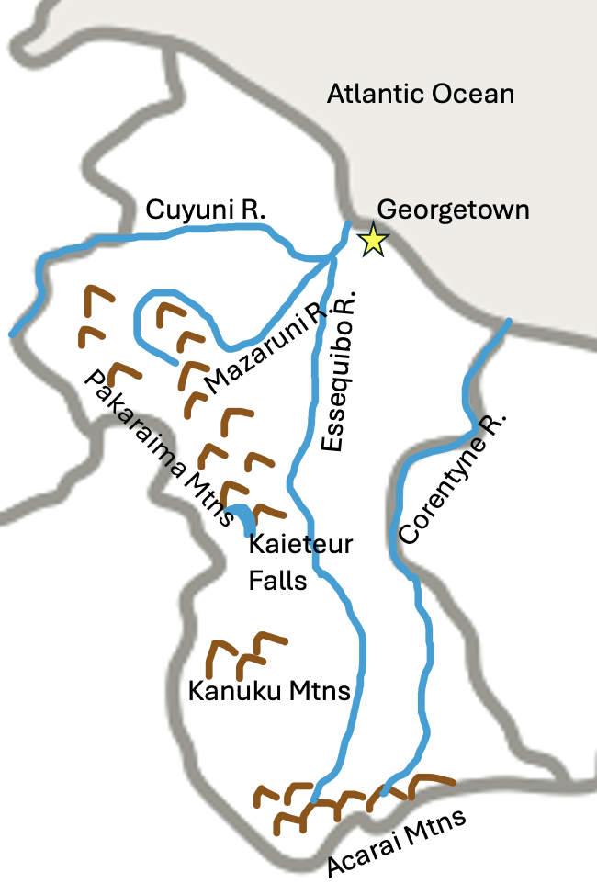

Suriname (Republic of Suriname)

Schedule

Week 11 | Watch: The Strange Demographics of Suriname (5:49 min)  Map: Locate Suriname and notice its boarders. Draw the shape and capital city.
Week 12 | Watch: The amazing wildlife of Suriname (11:23 min)  Map: Locate the mountains and rivers and draw on your map.

Capital: | Paramaribo |  | Language: | Dutch
Geographical Features to Map
Mountains: Bakhuis, Wilhelma, Tumuk-Hamuk ; Rivers: Suriname, Brokopondo, Courantyne, Maroni, Litani. Notice the disputed territory on this map.
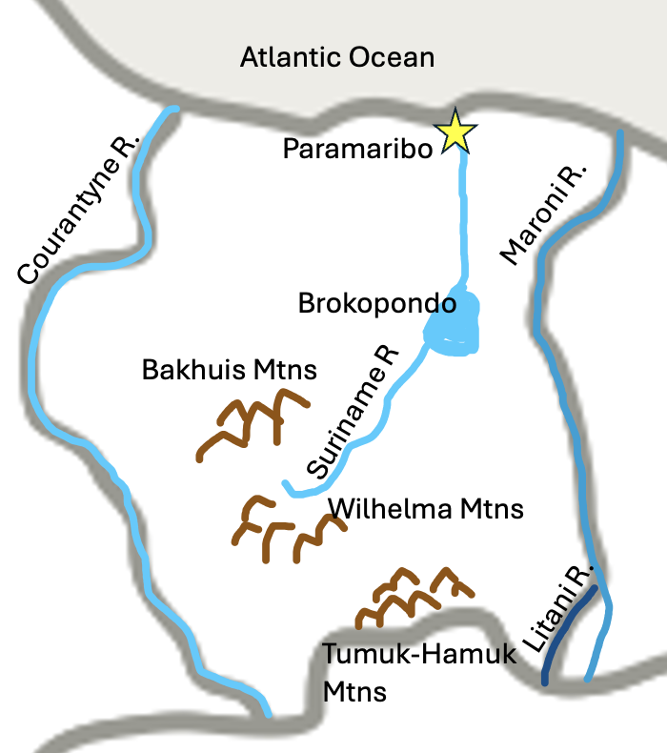

French Guiana
(An oversees department and region of France)

Schedule

Week 13 | Watch: French Guiana: A Tropical Overseas Territory (5:56 min)  Map: Locate French Guiana and notice its boarders. Draw the country and add the capital city
Week 14 | Watch: Europe’s Spaceport in French Guiana (8:34 min, at least through min 3:11)  Map: Locate the rivers and draw then on your map. Add all other items.

Capital: | Cayenne |  | Language: | French
Geographical Features to Map
Rivers: Maroni, Sinnamary, Oyapock ; Guyane Space Center ; Petit-Saut Resevoir. Additonal Map for Reference, notice the disputed territory
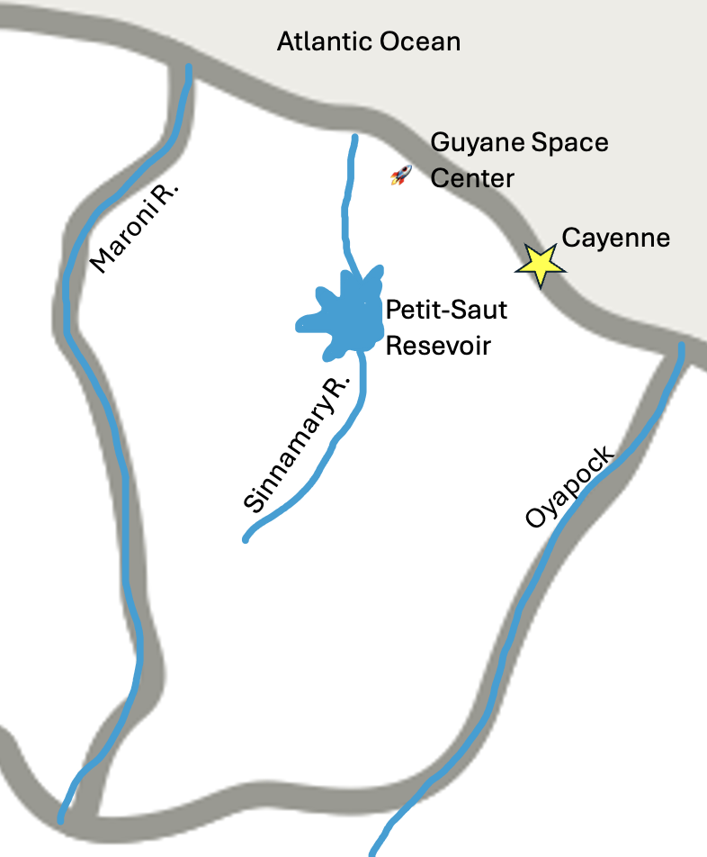

Brazil (Federative Republic of Brazil)

Schedule

Week 15 | Read: S.A. pg 85 (stop at “…southern boundary.”)  Watch: Diverse food and cultures of Brazil (3:40 min)  Map: Notice the boundaries of Brazil and its size. Draw Brazil and its mountains and cities listed below.
Week 16 | Read: S. A. pg 113 - 115  Watch: Life in the Amazon River (13:30 min) and/or Amazon Rainforest (3:30 min) and/or Amazon River Explained in under 3 minutes (3:00 min) Optional: Paraná – a river Like the Sea (43:07 min – watch first 3 min)  Map: Locate the Amazon River and other rivers listed below and trace them from source to mouth. Draw them on your map.
Week 17 | Read: Biomes in Brazil  Watch: Brazilian Cowboys (4:57 min) and/or Get to know the Cerrado (2:50 min) and/or Pantanal (8:49 min, at least through min 3:00) and/or The Atlantic Forest (3:40 min)  Map: Color or mark the different biomes on your map. Add in the remaining features to your map.

Capital: | Brasília |  | Language: | Portuguese

Geographical Features to Map
Rio de Janeiro, São Paulo, Salvador, Bay of All Saints, Espinhaço Mountains, Patos Lagoon, Amazon River, Marajó Archipelago, Paraguia River, Paraná River, Rio Sáo Francisco,
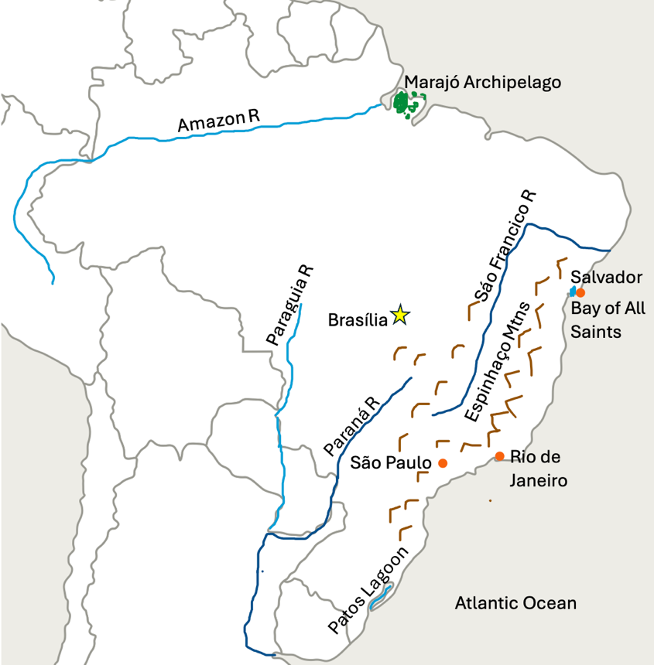

Ecuador (Republic of Ecuador)

Schedule

Week 18 | Watch: This Dormant Volcano in Ecuador is Very Much the Exception (2:11 min)  Map: Notice the boundaries, find the Andes and label along with Mount Chimborazo. Also draw the Inca Road and Quito.
Week 19 | Watch: Yasuni, The Most Biodiverse Place on Earth (2:23 min)  Map: Notice the three distinct regions – Coastal, Mountains, and Rainforest. Label the Amazon Rainforest and the Rivers.
Week 20 | Watch: National Geographic - Galapagos (4:45 min) Longer Option: 3 part BBC Galapagos series  Map: Label the Pacific Ocean, Galapagos and the Gulf of Guayaquil. Notice how you can identify the Gulf on a map of South America.

Capital: | Quito |  | Language: | Spanish
Geographical Features to Map
Pacific Ocean, Andes Mountains, Mount Chimborazo, Galapagos Islands, Gulf of Guayaquil, Inca Road, Amazon Rainforest, Rivers: Putumayo, San Miguel, Guayllabamba, Guayas, Babahoyo, Daule
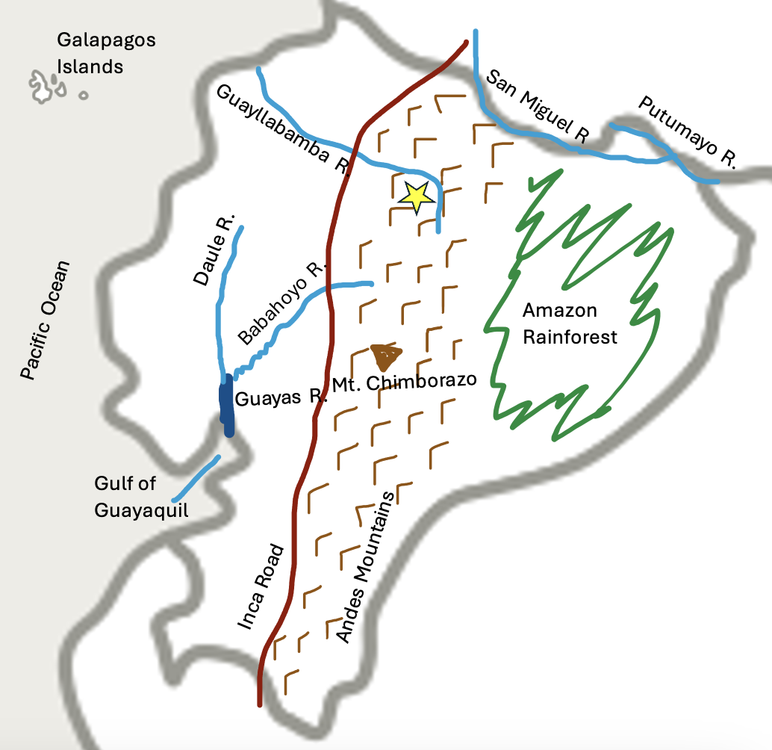

Peru (Republic of Peru)

Schedule

Week 21 | Read: S.A. Pg 332 (start at “Lake Titicaca is…”) – pg 337 (stop at “…to death.”)  Watch: This Titicaca Water Frog Breathes Oxygen Through its Skin (2:10 min) and/or Living on Lake Titicaca (11:28 min) and/or The Incredible Story of La Rinconada (2:44 min)  Map: Find Peru and notice its boarders. Find and draw the Andes, Lake Titicaca, and La Rinconada. Find Lake Titicaca on a South American map or atlas.
Week 22 | Read: S.A. Pg 337 (start at “At the Peruvian…”) – pg 338 (Stop at “…on earth.”)  Watch: Machu Picchu 101 (3:33 min) and/or The Inca, Masters of the Clouds: Terrace Farming (5:08 min)  Map: Locate and draw both Inca Roads, Machu Picchu and Lima.
Week 23 | Watch: Nazca Lines, History Channel (9:26 min, especially through min 4:08) and/or Iquitos Peru – Travel video (6:08 min)  Map: Notice the three main Regions of Peru – Desert Coast, Mountains and Plateaus, and Amazon Basin. Draw the Amazon Basin and the rivers and locate Iquitos and the Nazca Lines.

Capital: | Lima |  | Language: | Spanish
Geographical Features to Map
Pacific Ocean, Andes Mountains, Lake Titicaca, La Rinconada, Inca Roads, Machu Picchu, Iquitos, Nazca Lines, Amazon Basin, Rivers: Amazon, Ucayali, Maranón, Putumayo
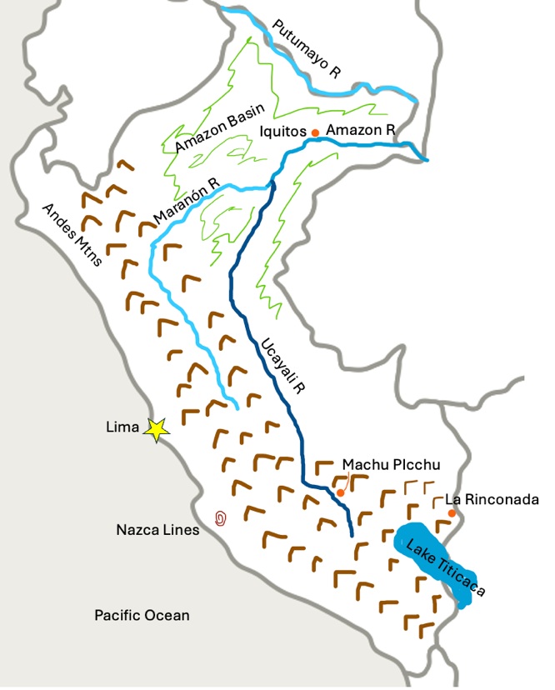

Bolivia (Plurinational State of Bolivia)

Schedule

Week 24 | Summarize: Wikipedia article  Map: Notice the boarders of Bolivia and the three main geographical regions (Andes – East & West, Altiplano, Amazon Basin). Notice the rivers that make the boarders. Draw the Andes and Altiplano and the capital cities.
Week 25 | Watch: Salar de Uyuni (3:00 min)  Map: Draw Salar de Uyuni, the Amazon Basin, and Lake Titicaca.

Capital: | Sucre (Capital)  La Paz (Admin Center) |  | Language: | Spanish
Geographical Features to Map
Andes (East & West), Altiplano, Amazon Basin, Lake Titicaca, Salar de Uyuni, Rivers: Abuna, Guapore, Beni, Mamore, Paraguay
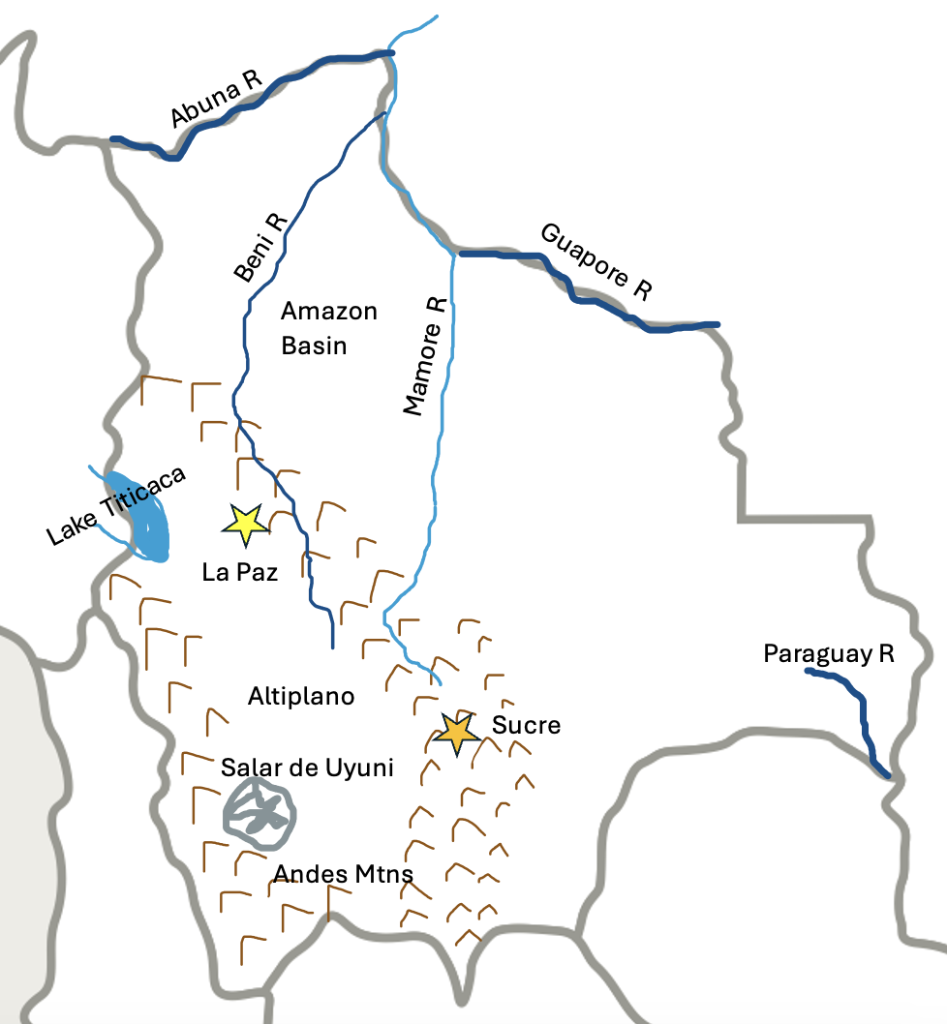

Chile (Republic of Chile)

Schedule
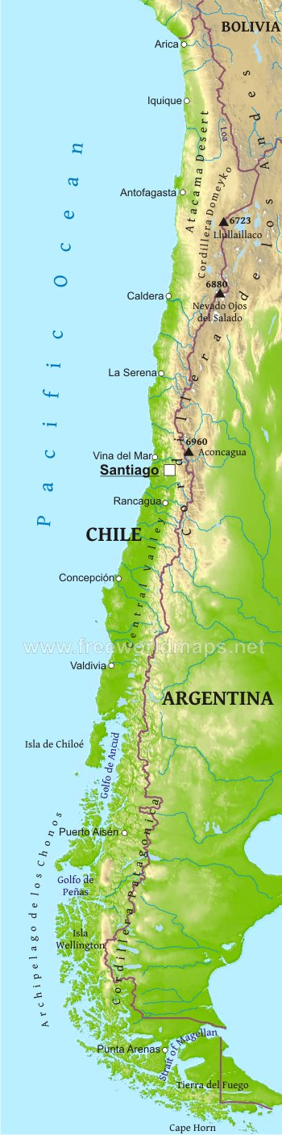
Week 26 | Read: S.A. Pg. 260 (start at “Today we will…”) – pg. 262 (stop at “…stone-walled pastures.”)  Watch: Life without Water (44:24 min – watch at least min 1:43 – 3:16 and 10:10 – 14:05)  Map: Notice the shape of Chile and its boundaries. Draw the two mountain ranges, the capital city, the Central Valley, and the Atacama Desert
Week 27 | Read: S.A. Pg. 267 (start at “We have visited…”). – Pg. 268 (stop at “…slopes are dry.”)  Watch: Wild Chile – A Country of Contrasts (min 10:00 – 19:06)  Map: Chiloé Island, Gulfs, Chonos Archipelago (note: Easter Island is part of Chile)
Week 28 | Read: S.A. Pg. 221 (start at “Now let us turn…”) – 226 (stop at “…land of fire.”) and S.A. Pg. 227 first full paragraph about Punta Arenas  Watch: Edge of the World (8:23 min); Exploring Cape Horn (2:07 min) or End of the World (2:50 min) ; The Man Who Decoded the Culture of Tierra Del Fuego (2:24 min) ; Find Your Bliss in Patagonia (3:13 min)  Map: Tierra del Fuego, Strait of Magellan, Cape Horn & Punta Arenas

Capital: | Santiago |  | Language: | Spanish
Geographical Features to Map
Andes, Coastal Range, Atacama Desert, Central Valley, Chiloé Island, Gulf of Ancud & Corcovado, Gulf of Peñas, Chonos Archipelago, Tierra del Fuego, Strait of Magellan, Cape Horn,
Punta Arenas

Argentina (Argentine Republic)

Schedule

Week 29 | Read: S.A. Pg. 171 – 173 (stop at “…”good airs,””)  Watch: Gauchos (2:03 min) ; Iguazú Falls (1:58 min)  Map: Notice the boarders. Find the 4 major regions and the capital city. Draw the Andes.
Week 30 | Watch: Patagonia: Valdés Peninsula (9:24 min) and/or Fascinating Patagonia (15:00 min). Optional: Last Wild Places: Iberá (19:57 min)  Map: Locate the rivers, gulfs, and the Valdez Peninsula

Capital: | Buenos Aires |  | Language: | Spanish
Geographical Features to Map
Regions: Andean, Pampas, Patagonia, Gran Chaco ; Rivers: Pilcomayo, Paraguay, Parana, Uruguay, Rio de la Plata (La Plata River), San Jorge Gulf, San Matias Gulf, Nuevo Gulf, Iguazú Falls
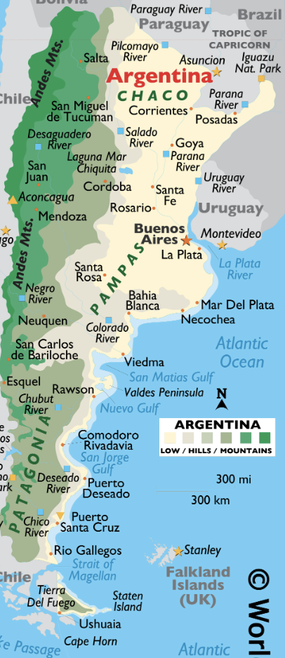

Map from WorldAtlas.com

Paraguay (The Republic of Paraguay)

Schedule

Week 31 | Read: S.A. Pg 209 (start at “We will leave…” and stop at “…swampy lakes, mosquitos”)  Watch: Wildlife of the Gran Chaco (20:07 min, to min 3:35 and min 12:57 – 13:30)  Map: Notice the boarders and how the Paraguay River divides the country. Draw The Paraguay River and the capital city and label the two major regions.
Week 32 | Read: S.A. Pg. 202 (start at The Paraná is…”) – 203 ; summarize info on Guaraní people  Watch: Tereré -national drink (5:45 min)  Check this YouTube Channel for Part 2 of documentary on the Paraná River maybe coming soon?  Map: remaining rivers

Capital: | Asunción |  | Language: | Spanish & Guarani
Geographical Features to Map
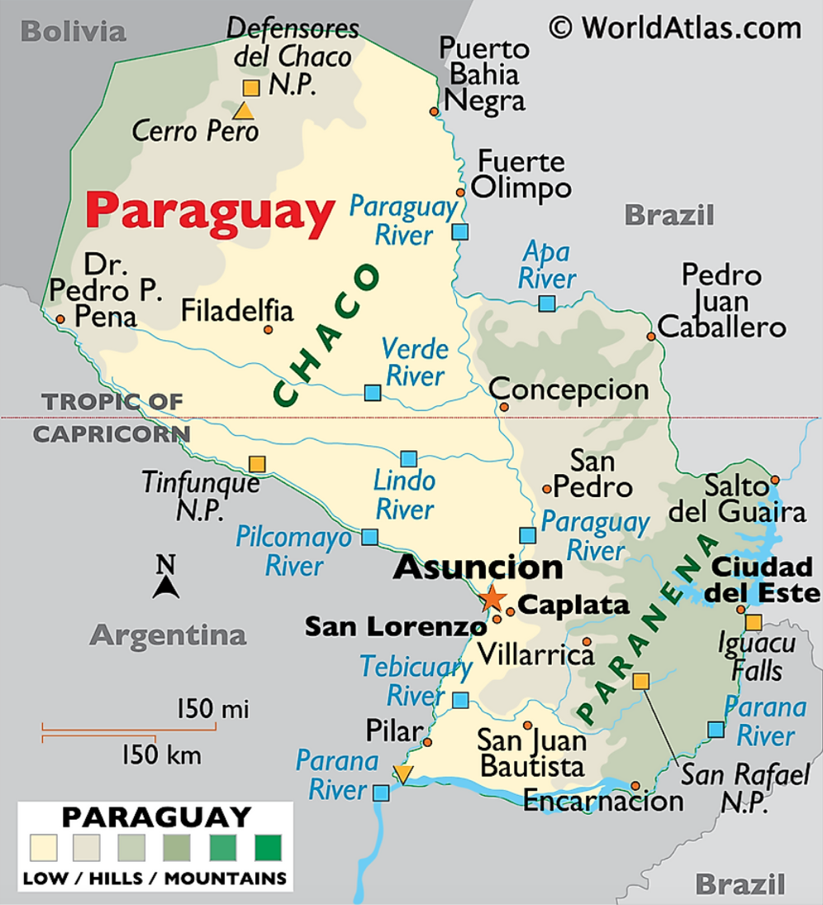
Regions: Paraneña, Chaco ; Rivers: Paraguay, Paraná, Apa, Pilcomayo

Uruguay (Oriental Republic of Uruguay)

Schedule

Week 33 | Read: S.A. Pg. 157 (start at “In our visit…”) - 159  Watch: The Music of Uruguay (6:47 min) ; For older kids, preview first: History of Candombe (11:22 min)  Map: Notice the boarders, find the capital city and Rio de la Plata
Week 34 | Read: Pg 161 (start at “Uruguay, the smallest…”) – 162 (stop at “…large quantities”)  Watch: Chivito Uruguayo (3:23 min) (Full 40 min Antony Bourdain episode – preview first)  Map: Find the rivers and Merin Lagoon and label the ocean

Capital: | Montevideo |  | Language: | Spanish
Geographical Features to Map
Rio de la Plata, Uruguay, Yaguaron, Negro ; Merin Lagoon ; Atlantic Ocean
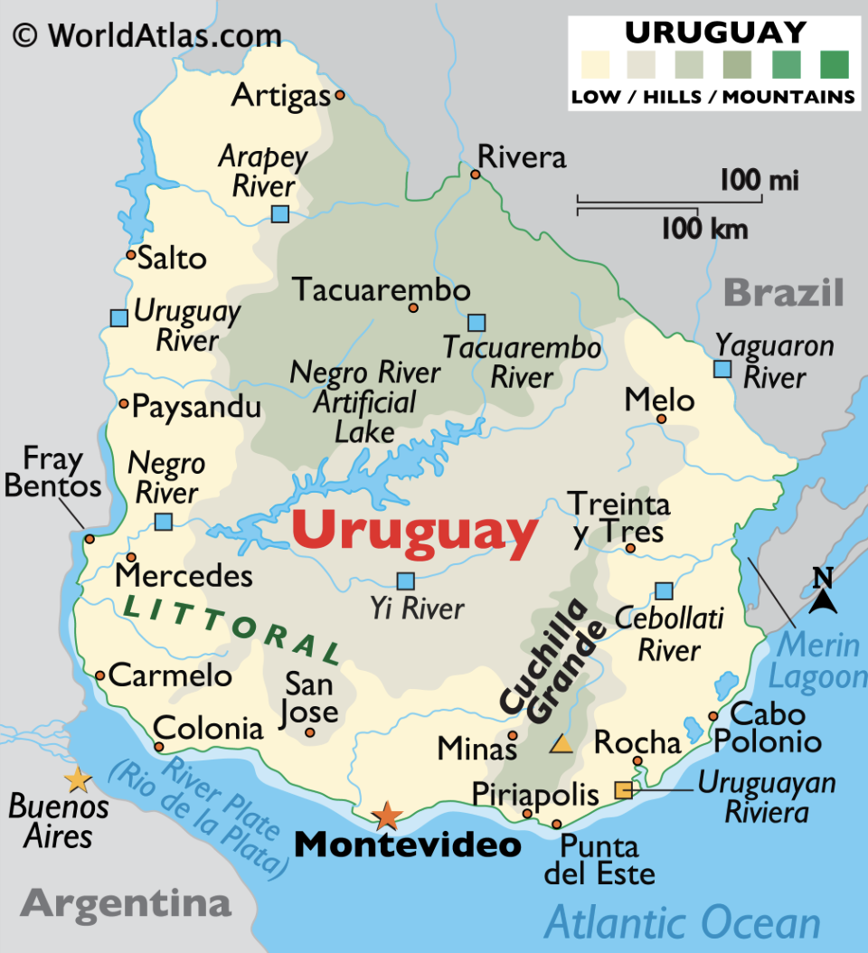

Map from worldatlas.com

United Kingdom Territories:
Falkland Islands, South Georgia & the South Sandwich Islands

Schedule:

Week 35 | Falkland Islands  Summarize: Wikipedia history / geography article  Watch: Falkland Islands (10:41 min) and/or The Origins of the Falkland Islands (3:48 min)  Map: Find Falkland Islands on the globe. Label East and West Falkland.
Week 36 | South Georgia and the South Sandwich Islands  Summarize: Wikipedia history and geography articles: South Georgia & South Sandwich Islands  Watch: History and Heritage of South Georgia and the South Sandwich Islands (10:40 min)  Map: Find the islands on the globe. Label Scotia Sea, South Atlantic Ocean
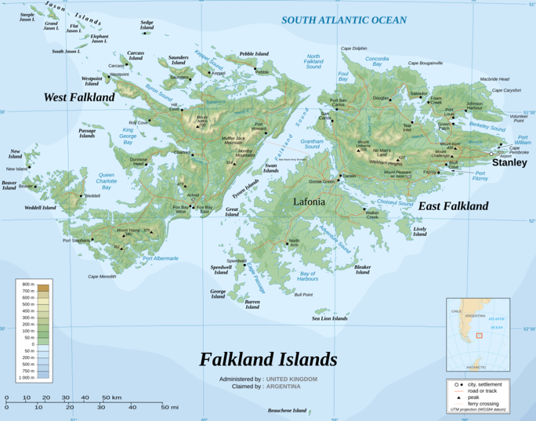
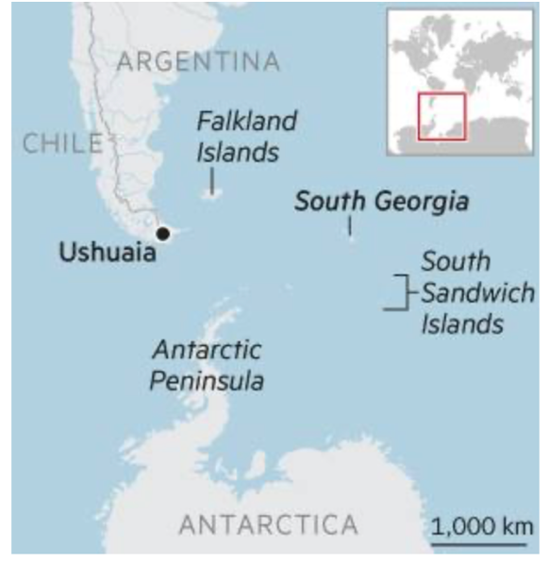

Map from Wikipedia
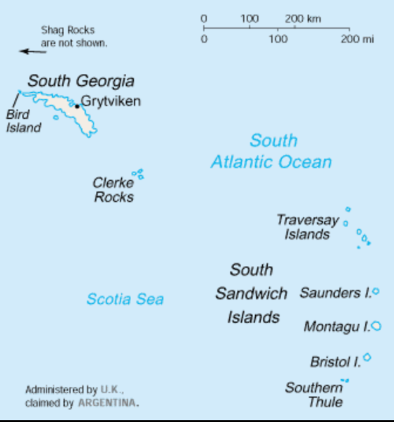
Map from here
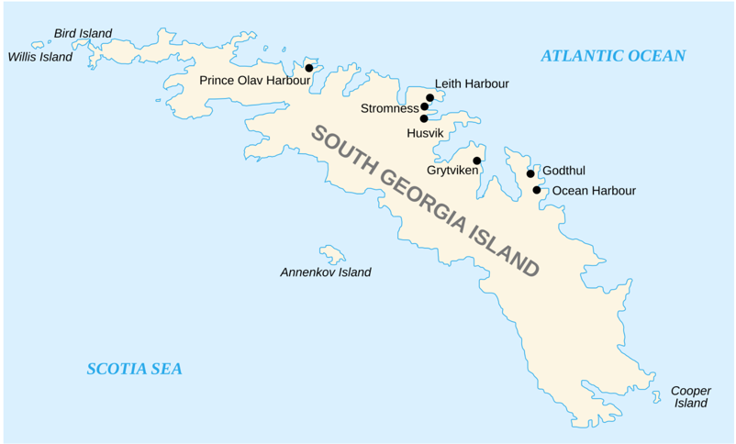

Map from Wikipedia
Map from Wikipedia

