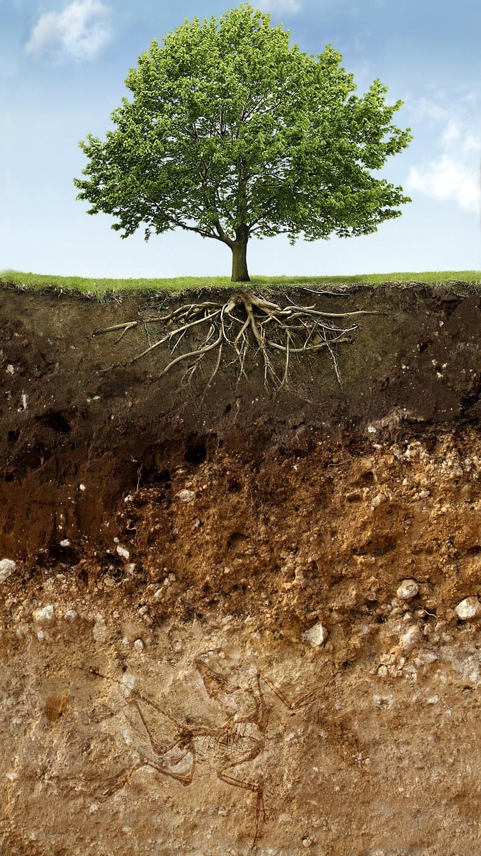
Soil
Nature Study Schedule
2024-2025 School Year
Prepared by Lisa Cotting
amblingtogether.com

Table of Contents
Week 1: Soil Formation 3
Week 2: Types of Soil 3
Week 3: Humus 3
Week 4: Soil Texture / Structure (arrangement of sand, silt, clay) 4
Week 5: Layers of Soil (Horizons) 4
Week 6: Compaction Layers 5
Week 7: Soil pH 5
Week 8: Water Filtering 6
Week 9: Soil Food Web / Nutrient Cycling 6
Week 10: Minibeasts in the Soil 7
Week 11: Earthworms 7
Week 12: Composting 8
Diagram for Week 5: Soil Horizon diagram 9
Diagram for Week 6: Compaction Layer diagram 10

Prepared for: 2024-25 Term 2 for AO 6 and AO 3 children who live in Southern California

Using these Main Resources:
- Handbook of Nature Study (HoNS – pages listed below are from this online version)
- The Soil that Feeds Us by Eleanor Heady (available on archive.com)
- Earthworms, Underground Farmers by Patricia Lauber (available on archive.com)
- Years of Dust: The Story of the Dust Bowl by Albert Marrin (available on archive.com) – will be using this for Nature Lore

Additional Resources:
- Growing a Revolution: Bringing Our Soil Back to Life by David R. Montgomery – this is a book I’ve read on my own to prepare me for this term. There are some sections I would assign to a high school student.
- Dirt by John Anthony Adams – a reference for me (available on archive.org)
- The Dirt Book by Eva Knox Evans
- Minibeasts in the Soil by Sarah Ridley (available on archive.org)
- Minibeasts in the Compost Heap by Sarah Ridley (available on archive.org)
- Soil Science Society of America – Resources for Teachers
- Soil Science Society of America – Dig It! The Secrets of Soil
- Soil Science Activities for Elementary Students

How I use this schedule:
My main focus in Nature Study, as prescribed by Charlotte Mason, is observation outside in nature – whether in the backyard, on neighborhood walks, on a hike, or at a garden, museum or other specially cultivated location. However, I find that without planning what I’m going to discuss or try to have them observe, nature study does not happen except by accident and rarely on topic. And since I often do not know much about the topic, I can’t answer many questions or direct the conversation to specific observations. So, I have created these 12-week schedules. But I use them loosely. Most weeks we get at least one day of object lessons in morning school and directed observations of the specific topic in afternoon walks, outings, or planned observation activity. I do not do all the readings or show all the videos. Just what ends up working for our schedule that week. And I make sure to prioritize actual observations over the readings and videos. I do not want Nature Study to turn into Science Lesson time.

Most of the work I do in preparing this schedule is for my own education so that I can then have more casual conversations as we come across the topic in the “wild.” I can only have more casual Nature Study time when I have studied and understand the topic myself. If I have a relationship with the information, it is easier for me to share that with my children.

Week 1: Soil Formation
Preparation: Read HoNS pg 760-763
Day 1: Overview | Day 2: Erosion and Weathering
Read: The Soil That Feeds Us, pg. 16-19 | Watch: Weathering and Soil (7:56 min)
Observation: On nature walks, notice where soil has been weathered or eroded. Notice the size of the particles. Find some soil in yard and see if you can notice the different sized pieces.
Nature Lore: Years of Dust pg. 2-4

Week 2: Types of Soil
Preparation: Read HoNS pg 763-765
Day 1: | Day 2:
Read: The Soil That Feeds Us, pg. 31-38 | Watch: Types of Soil (to min 5)
Watch: Types of Soil (2:02 min)
Observation: On nature walks or in yard, notice the three types of soil. Put a sample of the soil in a jar, add water and shake. Then wait a day or so to see the layers (video instructions or here). Document in your nature journal what you see as the soil settles.

If possible, collect a jar of sand, silt, and clay to keep for later weeks. Make a note of where you found each so you can observe the areas in the future.
Additional Resources: Video- Soil Basics: Capillary Rise (3:23 min)
Nature Lore: Years of Dust pg. 6-16

Week 3: Humus
Day 1: | Day 2:
Read: The Soil That Feeds Us, pg. 26-30 | Watch: Soil Series: Humus (5:07 min)
Observation: In your garden and on nature walks, see if you can find the humus layer in the soil. Feel it and compare it to other parts of the soil.
Additional Resources: Video – What is Humus (5:03 min)
Nature Lore: Years of Dust pg. 18-28

Week 4: Soil Texture / Structure (arrangement of sand, silt, clay)
Day 1: | Day 2:
Watch: Soil Series: Soil Texture (5:20 min) | Activity: Find your local soil structure - Smithsonian State Soils or NRCS or  NRCS Soil Conservation by State
Observation: Feel the soil in yard or on nature walk and observe then how quickly water is absorbed (See this Water Absorption Experiment). Notice which type of soil you are using for each experiment. Document in nature journal.
Additional Resources: Video - Building Structure in Soil (6:03 min) ; video - Soil Basics: Structure (4:38 min)
Nature Lore: Years of Dust pg. 30-40

Week 5: Layers of Soil (Horizons)
Day 1: | Day 2:
Read: The Dirt Book pg 77-81 | Watch: Layers of Soil (3:53 min) ; Follow along with this downloadable diagram or this one
Observation: On nature walks, or in yard, observe the layers of soil. Document soil layers in nature journal and document location. Document a soil profile from different locations using this method from NRCS.
Additional Resources: Video - Soil Basics: Soil Profiles (5:34 min) ; Graphic and Description - Soil Horizons from Soils4Teachers ; Video showing how to observers Layers of Soil on nature walks (from min 4:54) ; Soil Horizons printable diagram and description from ScienceFacts.net ; education.com worksheet
Nature Lore: Years of Dust pg. 42-50

Week 6: Compaction Layers
Day 1: | Day 2:
Watch: Soil Compaction (4:41 min) ; look at this diagram to understand compaction | Activity: Put soil into a bucket or clear liter container. Push (compact) it down. Pour a little water on top and observe. Try it again, but add a bunch of leaves and organic matter and observe the difference.
Observation: Measure soil compaction in different locations using this method.
Additional Resources: Video: The Science of Soil Health: Compaction (4:26 min)
Nature Lore: Years of Dust pg. 52- (top of) 64

Week 7: Soil pH
Day 1: What is pH | Day 2: Soil pH
Watch: Acids and Bases (2:42 min) | Watch: How to test for pH and what it means (6:03 min) and/or The Basics of Soil pH (2:15 min)
Observation: Do a soil pH test either from a test kit, a testing devise, or this homemade test
Additional Resources: Video - Acids and Bases for Kids (9:22 min) ; video – What is Soil pH and why is it so important? (10:31 min)
Nature Lore: Years of Dust pg. 76 – (bottom of) 84

Week 8: Water Filtering
Day 1: | Day 2:
Activity: Make a soil water filter like this one or this one | Activity: Compare the filtration of types of soil with this activity or this activity or this one
Observation: On nature walks and in your neighborhood, observe how (rain) water is flowing. Is it getting absorbed into the ground. Think back to soil compaction and the types of soil.
Additional Resources: Video – How Nature Makes Clean Water (4:06 min)
Nature Lore: Years of Dust pg. (bottom of) 84 - 92

Week 9: Soil Food Web / Nutrient Cycling
Day 1: | Day 2:
Watch: Nutrient Cycling (3:12 min) and/or What is the Soil Food Web? (5:56 min) | Watch: Science of Nitrogen Fixation (5:25 min)
Observation: Find some clover (or legumes such as peas) in the yard or at a park and look for the nodules on its roots.
Additional Resources: Video: Why soil is one of the most amazing things on Earth (4:40 min)
Nature Lore: Years of Dust pg. 94.- (bottom of) 99

Week 10: Minibeasts in the Soil
Day 1: | Day 2:
Read: The Soil That Feeds Us, pg. 20 - 25 | Watch: Meet the Cleanup Crew (3:40 min) and/or A close-up of creatures living beneath the soil (1:42)
Observation: In your yard or on nature hikes, dig in the soil and observe all the living creatures you can see. Notice different creatures in different areas or types of soil. Use a microscope if available.
Additional Resources: Video - The Living Soil Beneath our Feet (2:49 min) ; Decomposers Role in the Ecosystem (6:06 min) – includes activity idea ; Minibeasts in the Soil by Sarah Ridley (available on archive.org)
Nature Lore: Years of Dust pg. (bottom of) 99 - 104

Week 11: Earthworms
Day 1: | Day 2:
Read: Earthworms, Underground Farmers pg 29 - 33 | Read: Earthworms, Underground Farmers pg 35-42
Observation: Do a worm activity such as this one What animal helps the soil? (2:47 min) or purchase a Worm Hobby Kit
Additional Resources: How to Build a Wormery from Home Science Tools ; Starting your first Worm Bin ; Video – This is what happens when you put earthworms in your garden soil (3:43 min) ; Video - Earthworm Activities and Crafts for Kids (4:39 min) ; Video - Worm bin time-lapse (4:37 min)
Nature Lore: Years of Dust pg. 108 – (middle of) 116

Week 12: Composting
Day 1: | Day 2:
Watch: How does composting work? (7:48 min) | Watch: How Compost is Made (6:42 min)
Observation: Make compost using a method like this one (a small amount made in 2 months): How to make Compost at Home (8:30 min). Document the process in nature journal.
Additional Resources: Composting at Home - EPA ; Minibeasts in the Compost Heap by Sarah Ridley (available on archive.org)
Nature Lore: Years of Dust pg. (middle of) 116 - 122

Diagram for Week 5: Soil Horizon diagram
from wikimedia

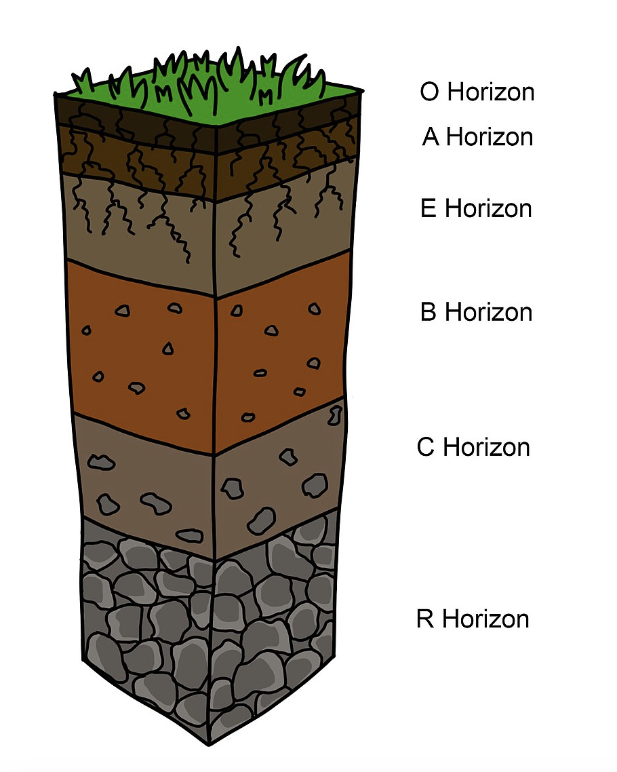

Diagram for Week 6: Compaction Layer diagram

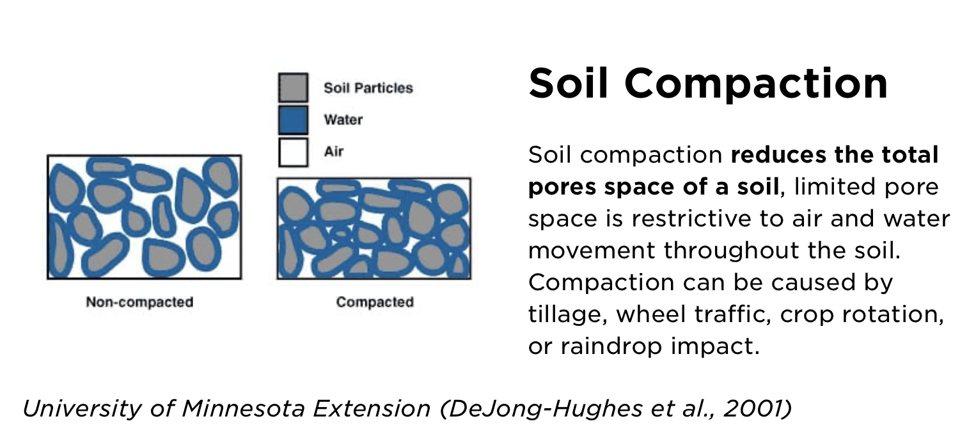
Diagram from NDSU

