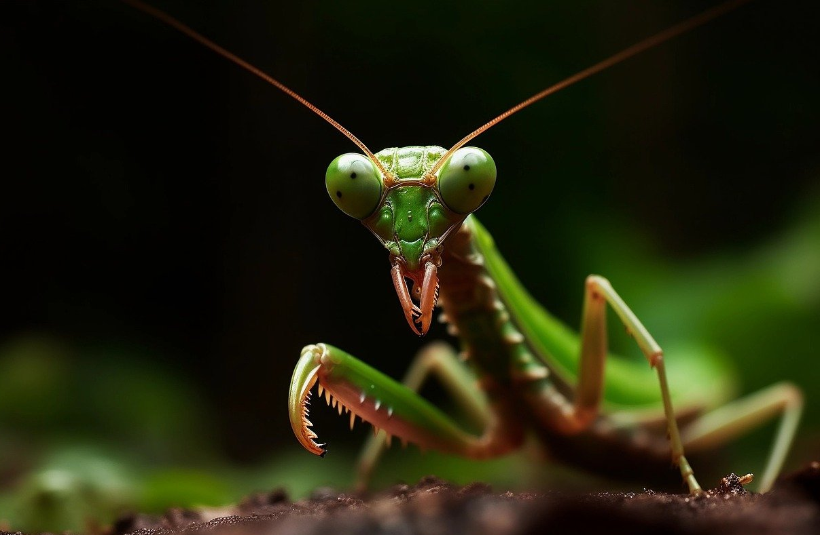
Prepared by Lisa Cotting
amblingtogeter.com
Insects

Nature Study Schedule
2024-2025 School Year
Lisa Cotting
[Company name]

TABLE OF CONTENTS

About this Guide 4
Week 1: Introduction - Taxonomy 5
Week 2: Introduction - Structure 5
Incomplete Metamorphosis 6
Orthoptera: Grasshopper 6
Orthoptera: Cricket 6
Orthoptera: Katydid 7
Mantodea: Praying Mantis 7
Odonata: Dragonflies and Damselflies 7
Dermaptera: Earwigs 8
Hemiptera (True Bugs): Cicada 8
Hemiptera (True Bugs): Pond Skater or Water Strider 9
Hemiptera (True Bugs): Aphids 9
Complete Metamorphosis 10
Lepidoptera: Moth - Yucca Moth 10
Lepidoptera: Butterfly - Painted Lady 10
Coleoptera: Eleodes Beetles (a.k.a. Darkling or desert stink beetle) 11
Coleoptera: Ladybug 11
Coleoptera: Lightening Bug / Firefly 11
Hymenoptera: Ants 12
Hymenoptera: Wasps 12
Hymenoptera (Cynipidae): Gall Wasps 13
Hymenoptera: Bees 13
Diptera: Flies 14
Diptera: Mosquitos 14
Resources and Diagrams 15
Class Insecta Taxonomy 15
Diagram: Grasshopper 16
Diagram: Cricket 17
Diagram: Katydid 18
Diagram: Praying Mantis 19
Diagram: Dragonflies and Damselflies 20
Diagram: Earwig 23
Diagram: Cicada 24
Diagram: Pond Skater 26
Diagram: Moth VS Butterfly 27
Diagram: Caterpillar Anatomy 28
Diagram: Yucca Moth 29
Diagram: Painted Lady Butterfly Lifecycle 30
Diagram: General Beetle Anatomy 31
Diagram: Darkling Beetle Lifecycle 32
Diagram: Ladybug 33
Diagram: Ants 34
Diagram: Wasps 35
Diagram: Bees 36
Diagram: Flies 37
Diagram: Mosquitos 38
Nature Lore Schedule 39

About this Guide
Prepared for: 2024-25 Term 3 for AO 6 and AO 3 children who live in Southern California

Using these Main Resources:
- Handbook of Nature Study (HoNS – pages listed below are from my paper copy)
- The Practical Entomologist by Rick Imes (available on archive.org)
- Backyard Hunter: The Praying Mantis by Bianca Lavies (available on archive.org)
- Plant Galls of the Western United States by Ronald Russo (alternates available on archive.org)
- The Grasshopper Book by Wilfrid S. Bronson - I have chosen this book for nature lore. It is included in the schedule below. (available on archive.org)

Additional Resources:
- Insects by Jen Green (available on archive.org)
- Insects: A Guide to Familiar American Insects by Herbert S. Zim and Clarence Cottam (available on archive.com)
- Amateur Entomologists Society
- The First Book of Bugs by Margaret Williamson (includes chapters on specific insects)
- Kwik-Key to Insect Orders by NC State Agriculture and Life Sciences
- Answers About Insects by Ronold N. Rood (available on archive.org)
- Firefly by Paul Sears (available on archive.org)
- Backyard Insects by Millicent E. Selsam and Ronald Goor (for younger children) – available on archive.org
- Buzzing with Questions: The Inquisitive Mind of Charles Henry Turner by Janice N. Harrington
- Evelyn the Adventurous Entomologist: The True Story of a World-Traveling Bug Hunter by Christine Evans (for younger children)
- Winged Wonders: Solving the Monarch Migration Mystery by Meeg Pincus (link includes activity pages)
- Bug container, Bug catcher, Bug leg slides, Bugs in Resin, or More Bugs in Resin

How I Use This Guide:
I intend to do object lessons on the on the insects we are actually observing. To be prepared, I came up with some of the most common insects that we are likely to be able to observe from a wide range of insect families. We will not get through all the material I have in this guide this term. I will decide each week which animal to study based upon what we are seeing. Nature Study is meant to be observing nature, not just reading or watching about nature. I am using these short lessons to better observe what we are seeing in nature. And since I am not certain what we will see, I have prepared many options to choose from over the twelve weeks. I will, however, start the first two weeks of the term learning basic insect terms and anatomy so we can have better conversations while on our nature walks.

Week 1: Introduction - Taxonomy
Day 1: Taxonomy | Day 2: Lifecycle
Look at taxonomy chart and discuss | Read: The Practical Entomologist pg 24-26
Watch: An introduction to Insect Orders (4:09 min) | Watch: Complete vs. Incomplete Metamorphosis (1:52 min)
Observation: On nature walks this week, try to identify the insects you see. Try to identify the order and the type of lifecycle they have.
Additional Resources: Amateur Entomologists’ Society – listing of insect orders ; Complete and Incomplete Metamorphosis (1:11 min) ; Defining Characteristics of the Insect Orders (8:18 min)

Week 2: Introduction - Structure
Preparation: Read HoNS pg 294-300
Day 1: Three main parts | Day 2: Mouth types
Read: The Practical Entomologist pg. 10 (exosckeleton), pg 14-15, pg 16 (abdomen) | Read: The Practical Entomologist pg. 18-21
Watch: Insect Anatomy (1:46 min) | Watch: The Wonderful World of Insect Mouths (7:42 min) ; Insect Vision Part 3 (3:22 min)
Observation: Use magnifying glass to inspect any insects you catch or observe in nature. Notice and document the three main body parts in nature journal.
Additional Resources: Video: Parts of an Insect (6:08 min), includes drawing tutorial ; Insect Head (2:57 min) Insect Mouthparts (7:57 mn) ; Insect Antennae (3:45 min) ; Insect Legs (3:43 min) ; Insect Respiratory System (2:31 min)

Incomplete Metamorphosis

Orthoptera: Grasshopper
Preparation: Read HoNS pg 338-343
Look at anatomy & lifecycle graphics ; Insects: A Guide to Familiar American Insects pg. 28 includes a detailed depiction of the grasshopper nymph stages.
Read: The Practical Entomologist pg. 74. or Field Guide of your choosing
Watch: The life cycle of a Grasshopper (2:45 min) and The Strange Thing that turns Grasshoppers into Locusts (6:08 min)
Observation: Start watching for grasshoppers when outdoors and on nature walks. Alternatively, purchase a grasshopper specimen or a dissection kit. Document in nature journal.
Additional Resources: Video: How to Draw a Grasshopper (4:35 min) ; Video: Everything You Didn’t Know About Grasshoppers (7:40 min) – compares Grasshoppers to Crickets & Katydids ; Video: These Swarming Locusts are Grasshoppers Gone Wrong (4:46 min) ; Diagram: American Museum of Natural History: Parts of an Insect (Grasshopper) ; Video: Locust Plague Devours 40,000 Tonnes of Vegetation (2:54 min)

Orthoptera: Cricket
Preparation: Read HoNS pg 334-350
Look at anatomy & lifecycle graphics
Read: The Practical Entomologist pg. 78 or Field Guide of your choosing
Watch: Why Crickets Just Won’t Shut Up (4:06 min)
Observation: Purchase (or just observe at the Pet Store) a cricket and observe its body parts, how it moves and chirps. Document in nature journal.
Additional Resources: Video: All About Crickets – Insect Facts for Kids (3:45 min) ; Video: Big, Bold Armored Crickets (3:13 min)

Orthoptera: Katydid
Preparation: Read HoNS pg 343-344
Look at anatomy & lifecycle graphics
Read: Insects: A Guide to Familiar American Insects pg. 18-19 or Field Guide of your choosing
Watch: Katydid facts (3:41 min) ; The Giant Malaysian Katydid (2:49 min)
Observation: Start watching for katydids when outdoors. Document in nature journal.
Additional Resources: Video: Giant Swarm of Mormon Crickets (2:54 min) ; Video: Giant Katydid – Cincinnati Zoo (1:20 min) ; Video: 10 Most Beautiful Katydids In the World (6:45 min) ; Video: Savage Katydid Lures Male Cicada with Fake Mating Call (4:01 min)

Mantodea: Praying Mantis
Look at anatomy & lifecycle graphics
Read: Backyard Hunter: The Praying Mantis by Bianca Lavies
Watch: Praying Mantis Life Cycle (2:37 min)
Vocabulary: ootheca (egg case)
Observation: Start watching for praying mantis when outdoors and on nature walks. Alternatively, purchase an egg case and watch them emerge. Document in nature journal.
Additional Resources: Video: How does a Praying Mantis lay its Eggs? (1:20 min) ; Video: The Complete Process of a Praying Mantis Hatching (3:47 min)

Odonata: Dragonflies and Damselflies
Preparation: Read HoNS pg 401-408
Look at anatomy & lifecycle graphics
Read: The Practical Entomologist pg. 68-69 or Field Guide of your choosing
Watch: From Nymph to wings: The Dragonfly Life Cycle (1:46 min) ; A Baby Dragonfly’s Mouth Will Give you Nightmares (4:00 min)
Observation: Start watching for dragonflies and damselflies when outdoors and on nature walks. Document in nature journal.
Additional Resources: Differences between Dragonflies and Damselflies (2:26 min) ; detailed infographic ; Video: Damselfly nymph eating (1:24 min) animation of dragonfly nymph eating ;Video: These Rare Damselflies Find Love with a Twist in Fog City (4:26 min) ; Video: Drawing Dragonfly Lifecycle (7:38 min) ; Worksheet: Color the Lifecycle

Dermaptera: Earwigs
Look at anatomy & lifecycle graphics
Read: Insects: A Guide to Familiar American Insects pg. 29 or Field Guide of your choosing
Watch: What do Earwigs Do with Those Pincers Anyway? (4:20 min) ; Life Cycle of Earwig (1:27 min)
Observation: Start watching for earwings when outdoors, or on nature walk – look under rocks and logs. Document in nature journal.
Additional Resources: Video: Earwig Wings are Origami-Like (2:40 min) ; Video: Why Sibling Rivalry is a Deadly Game for Baby Earwigs (2:20 min)

Hemiptera (True Bugs): Cicada
Choose a local true bug species
Look at anatomy & lifecycle graphics
Read: The Practical Entomologist pg. 88-90 or Field Guide of your choosing
Watch: Periodical Cicadas Overrun the Forest (4:03 min) and/or How do cicadas make so much noise? (6:57 min)
Observation: Start watching for cicadas when outdoors and on nature walks. Document in nature journal. For those of us who did not experience the Mass Emergence of 2024, It is possible to inexpensively purchase empty cicada cases to study by doing a Google or Etsy search.
Additional Resources: Resources about cicadas, including pictures, diagrams, and videos ; Video: SciSchow for Kids – Cicadas: The Loudest Bugs in the World (4:17 min) ; Smithsonian Video: Cicada Life Cycle Video (2:55 min) ; Video: A Guide to the Rare 2024 Cicada Co-Emergence (2:12 min) ; Why Are Periodical Cicadas So…Periodical? (4:08 min)

Hemiptera (True Bugs): Pond Skater or Water Strider
Choose a local true bug species
Look at anatomy & lifecycle graphics
Read: The Practical Entomologist pg. 82-84 or Field Guide of your choosing
Watch: This is Why Water Striders Make Terrible Lifeguards (3:33 min)
Observation: Start watching for Pond Skaters when outdoors near water. Document in nature journal.
Additional Resources: Blog article: 7 Cool Facts About Water Striders ; Video: How Water Striders Walk on Water (2:28 min) ; Video: What is Surface Tension? (3:50 min) ; Activity (with how-to video): How to Make a Water Strider ; Water Strider Info Graphic from Missoula Insectarium ; Information about Water Striders from Missouri Department of Conservation

Hemiptera (True Bugs): Aphids
Choose a local true bug species
Preparation: Read HoNS pg 351-354
Look at anatomy & lifecycle graphics
Read: Aphids by Georgianne Heymann pg 1-10 (available on archive.org)
Watch: Born Pregnant: Aphids Invade with an Onslaught of Clones (5:01 min)
Observation: Find aphids in your yard or neighborhood and observe. Document in nature journal.
Additional Resources: Video: The Weird Way Aphids Reproduce (5:50 min)

Complete Metamorphosis

Lepidoptera: Moth - Yucca Moth
Choose a local species or raise from a kit
Preparation: Read HoNS pg 310-334
Look at anatomy & lifecycle graphics
Read: Info about Yucca Moths with lifecycle diagram ; additional photos on this blog ; Yucca Moth lifecycle coloring page
Watch: Moths vs Butterflies: How Can I tell them apart (3:13 min) and Everything You Didn’t Know about Caterpillars (5:08 min) ; anatomy of a caterpillar (vocabulary) ; CNM Yucca & Yucca Moth (2:10 min) and/or Yucca Moth (2:32 min)
Observation: Visit a Joshua tree or yucca multiple times to try to observe the yucca moth’s lifecycle. Document in nature journal.
Additional Resources: Raise your own moths: Silkworm moth classroom kit or this one ; Video: Butterflies & Moths: Difference between Cocoons & Chrysalides (1:05 min) ; Video (preview first): Moths vs Butterflies (4:36 min) ; Video about Atlas Moth: A Marvelous Moth-Wild Thailand (3:02 min) ; Video: Watch this Caterpillar Turn Into a Hawk-Moth (3:36 min) ; Differences between Moths and Butterflies (2:17 min)

Lepidoptera: Butterfly - Painted Lady
Choose a local species or raise from a kit
Preparation: Read HoNS pg 301-310
Look at anatomy & lifecycle graphics
Read: Painted Lady Lifecycle description with photos
Watch: What REALLY Happens When a Caterpillar Turns into a Butterfly (6:04 min) ; The Lifecycle of the Painted Lady Butterfly (2:00 min)
Observation: Start watching for caterpillars and butterflies when outdoors and on nature walks. Alternatively, purchase a butterfly habitat and watch the caterpillars turn into butterflies. Document in nature journal.
Additional Resources: Monarch caterpillar anatomy and instars ; Video: Where do insects go during the winter (1:22 min)

Coleoptera: Eleodes Beetles (a.k.a. Darkling or desert stink beetle)
Choose a local beetle species or raise from a kit
Look at anatomy & lifecycle graphics
Read: The Practical Entomologist pg. 94 and 104 or Field Guide of your choosing
Watch: Beetle Elytra (1:02 min) ; Darkling Beetle Life Cycle (3:01 min) ; Darkling Beetles – Spray acid, play dead (8:28 min)
Observation: Start watching for caterpillars and butterflies when outdoors and on nature walks. Alternatively, purchase a Darkling beetle habitat and watch the larvae turn into adult beetles.
Additional Resources: Stink Beetle Eleodes (1:58 min) ; How this beetle could help solve our water crisis (5:13 min) ; The Engineering Secrets of the World’s Toughest Beetle (5:43 min)

Coleoptera: Ladybug
Preparation: Read HoNS pg 364-366
Look at anatomy & lifecycle graphics
Read: The Practical Entomologist pg. 94 and 102 or Field Guide of your choosing
Watch: Watch Ladybugs Go From Goth to Glam (5:14 min) ; The Ladybug Love-In (3:19 min)
Observation: Start watching for caterpillars and butterflies when outdoors and on nature walks. Alternatively, purchase a ladybug habitat and watch the larvae turn into adult beetles.
Additional Resources: Video: Ladybug facts (3:56 min) ; Video: Psst - Ladybugs Have a Killer Secret (11:34 min) ; Ladybird beetle lifecycle (3:08 min) ; Ladybug activities and worksheets

Coleoptera: Lightening Bug / Firefly
Preparation: Read HoNS pg 367-369
Look at anatomy & lifecycle graphics
Read: The Practical Entomologist pg. 94 and 101 or Field Guide of your choosing or Firefly by Paul Sears
Watch: What’s Behind the Firefly’s Glow? (5:29 min) ; Firefly Facts (3:23 min)
Observation: Start watching for fireflies when outdoors. Document in nature journal.
Additional Resources: Video: Fireflies Glowing in Sync to Attract Mates (2:28 min) ; Fireflies: Nature’s Femme Fatales (3:14 min) ; So…Sometimes Fireflies eat other Fireflies (3:32 min)

Hymenoptera: Ants
Preparation: Read HoNS pg 269-378
Look at anatomy & lifecycle graphics
Read: The Practical Entomologist pg. 136-137 & 140 or Field Guide of your choosing or Questions and Answers about Ants by Millicent E. Selsam (available on archive.org)
Watch: Ant Life Cycle (3:03 min) ; How an Ant Hill Looks Inside (9:00 min)
Observation: Start watching for ants when outdoors. Collect some to look at under magnifying glass. Document in nature journal. Alternatively, purchase an ant farm and observe over the term.
Additional Resources: Video: How is an ant born? (7:10 min) ; Video: When Ants Domesticated Fungi (9:45 min); What’s Inside an Anthill? (3:14 min) ; Arizona State University: Ask a Biologist, Face to Face with Ants ;

Hymenoptera: Wasps
Preparation: Read HoNS pg 378-384
Look at anatomy & lifecycle graphics
Read: The Practical Entomologist pg. 136-137 or this Britannica article. Note the two types of wasps: social and solitary (most are solitary) and that yellow-jackets and hornets are in the social group of wasps.
Watch: Video: Where do Wasps Go in the Winter? (7:46 min)
Observation: Start watching for wasps when outdoors, especially any nests (Be careful!). If you find a nest, notice how it grows. Alternatively, purchase a wasp nest online (google it, there are many options!)
Additional Resources: Arizona State University: Life and Death of a Fig Wasp ; Book on archive.org: Digger Wasp by George Mendoza ; Diagram: Color the Lifecycle- Wasps ; Video: The Extraordinary Life Cycle of the Hornet Colony (3:07 min) ; Video: Why wasps are just as wonderful as wasps (3:18 min) ; Video: What’s the Difference Between Bees, Wasps, Yellow Jackets, and Hornets? (8:04 min) ;; Video: What’s Inside a Wasp Nest (6:32 min) ; Diagram and Worksheets from Marin/Sonoma Counties: Yellowjacket School ; Video: Meet the Meat Bee…The Western Yellowjacket (3:37 min)

Hymenoptera (Cynipidae): Gall Wasps
Preparation: Read HoNS pg 335-338
Look at anatomy & lifecycle graphics
Read: Read about Galls in a field guide such as Plant Galls of the Western United States by Ronald Russo or other Gall Identifier found on archive.org such as this one. Alternatively, this post is a good overview.
Watch: What Gall! The Crazy Cribs of Parasitic Wasps (2:58 min) ; Oak Tree and Wasp Eggs – Life in the Undergrowth (5:05 min)
Observation: Start watching for gall on nature walks. Use a plant gall guide or internet search to find galls common in your area. Document in nature journal.
Additional Resources: Video: Citizen Science – What is a Gall (2:54 min) ; Video: Goldenrod Galls – What, How, and Why (2:23 min) ; Video: What’s Growing on: Oak Gall’s history & lifecycle (4:25 min) ; Video: Oak Gall Balls – South Carolina State Parks (2:43 min) ; Wikipedia Article with many photos ; Video: Fig and Fig Wasps (3:31 min) ; Video: Are There Dead Wasps in Figs? (5:03 min) ; Britannica Diagram: Fig Wasp Lifecycle

Hymenoptera: Bees
Preparation: Read HoNS pg 384-400
Look at anatomy & lifecycle graphics
Read: The Practical Entomologist pg. 144-145 or Field Guide of your choosing. Britannica’s article on Bees is also helpful. Note the seven types of bees and that most are solitary.
Watch: Watch This Bee Build her Bee-Jeweled Nest (5:01 min) ; How Do Honeybees Get Their Jobs?-National Geographic (3:22 min)
Observation: Start watching for bees while outside, noticing behaviour. Document in nature journal.
Additional Resources: Book: The First Book of Bees by Albert B. Tibbets ; Video: The Honey Bee Waggle Dance (4:36 min) ; Book: Bees and Beelines by Judy Hawes (available on archive.org) ; Book: The First Book of Bees by Albert B. Tibbets (available on archive.org) ; Article: How to Identify Different Types of Bees ; Video: This Vibrating Bumblebee Unlocks a Flower’s Hidden Treasure (3:48 min) – reproduction terms used ; Video: This Bee Builds Sandcastles at the Beach (4:29 min) ; Video: Carpenter Bee Facts (4:05 min) ; Video: This Fly Torpedoes a Bindweed Bee’s Nest (4:58 min)

Diptera: Flies
Preparation: Read HoNS pg 358-361
Look at anatomy & lifecycle graphics
Read: The Practical Entomologist pg. 126 and following examples or Field Guide of your choosing.
Watch: Fly Facts: Buzzing with two wings (4:30 min)
Observation: Start watching for flies, noticing behaviour. Document in nature journal.
Additional Resources: Video:; Video: Mayfly – a life story (4:19 min) ; Video: Mayfly Madness – Wild Mississippi (2:29 min) ; Video: Where do Fruit Flies come from, and Are You Eating Them? (5:33 min) ; Video: This Freaky Fruit Fly Lays Eggs in Your Strawberries (4:33 min) ; ASU Ask a Biologist: Fly Food Secrets

Diptera: Mosquitos
Preparation: Read HoNS pg 411-415
Look at anatomy & lifecycle graphics
Read: The Practical Entomologist pg. 126 and 128 or Field Guide of your choosing.
Watch: Lifecycle of a mosquito (4:35 min) ; How Mosquitoes Use Six Needles to Suck Your Blood (3:17 min)
Observation: Start watching for mosquitos, noticing behaviour. Document in nature journal.
Additional Resources: Book: Mosquitos by Charles L. Ripper (available on archive.org) ; Video: This Dangerous Mosquito Lays Her Armored Eggs (3:50 min)

Resources and Diagrams

Class Insecta Taxonomy for insects studied in this guide

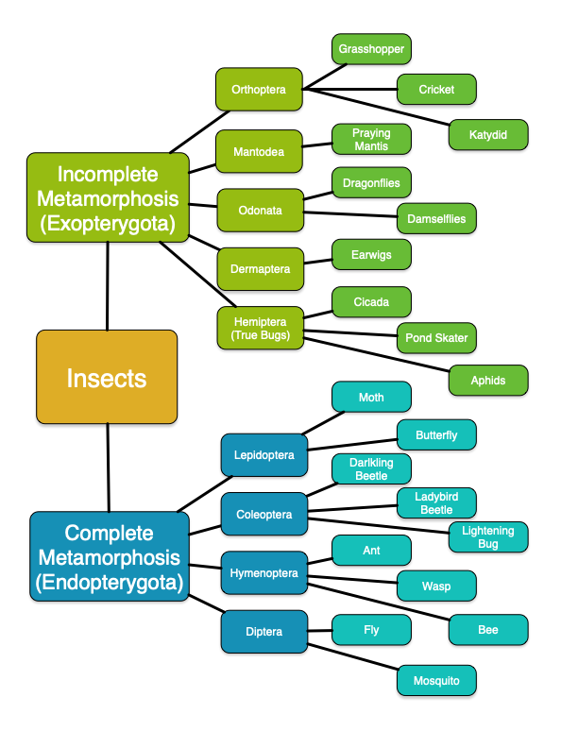

Diagram: Grasshopper
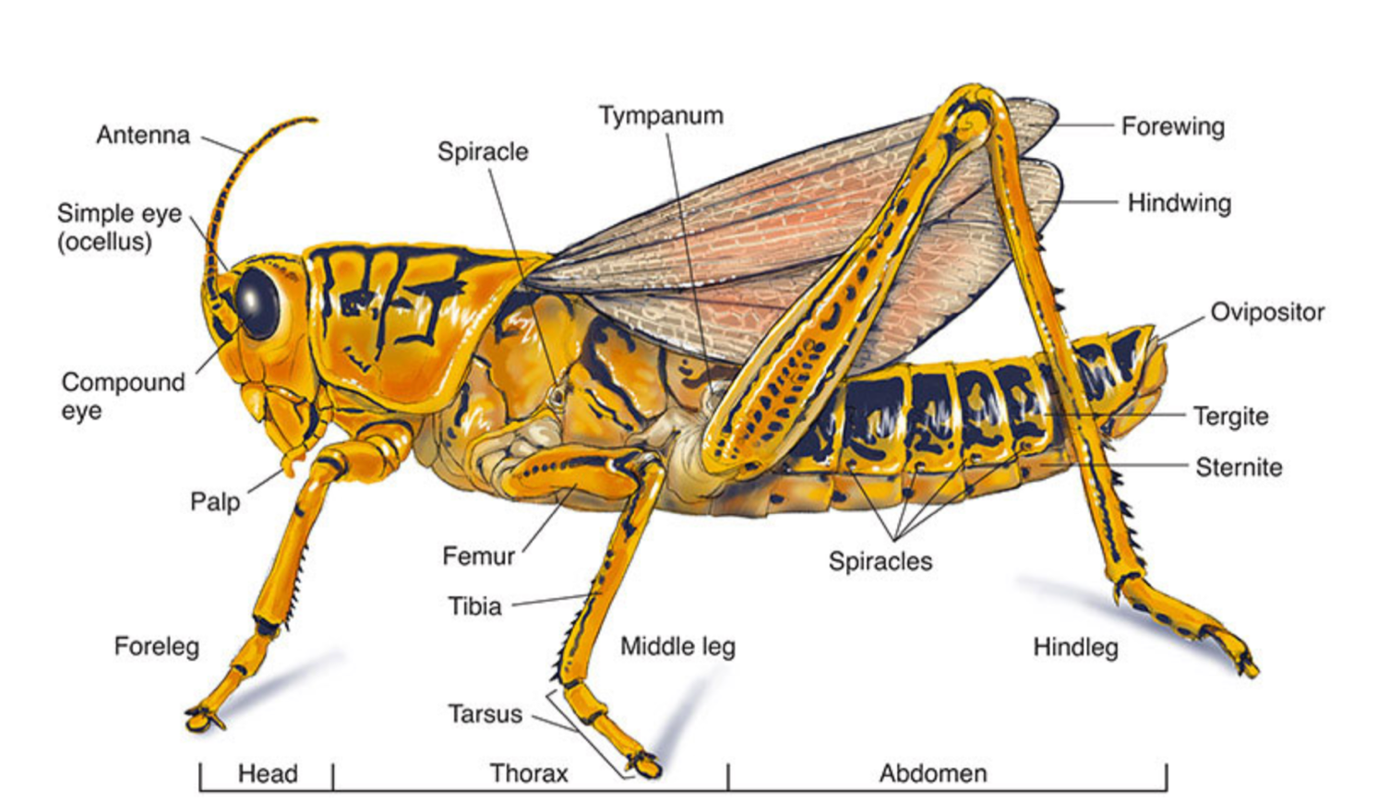

From: sciencediagrams.com (this link has internal and close-up diagrams too)

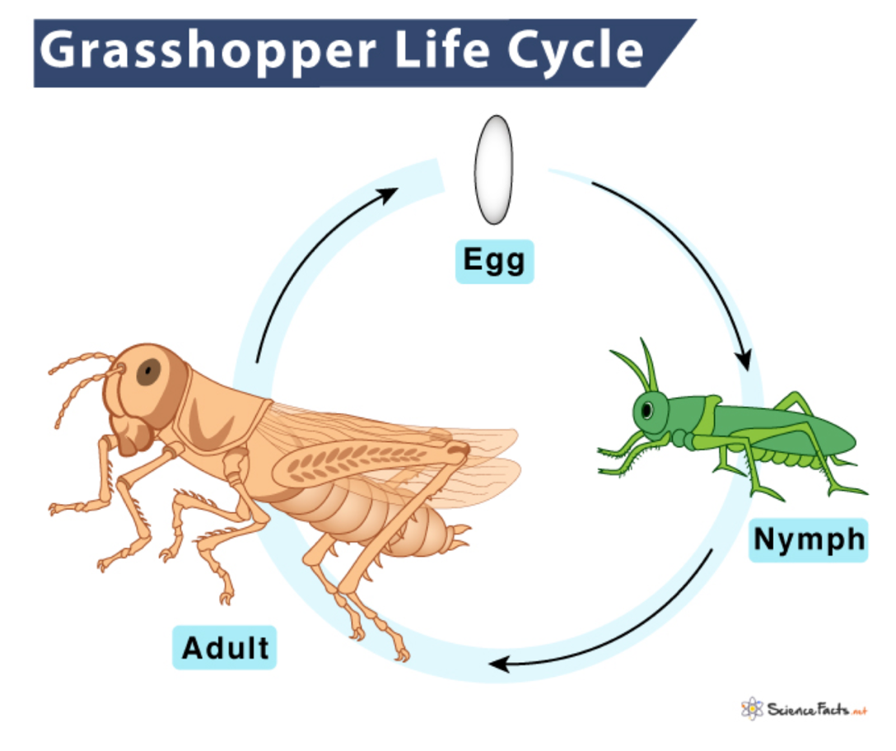

Diagram: Cricket

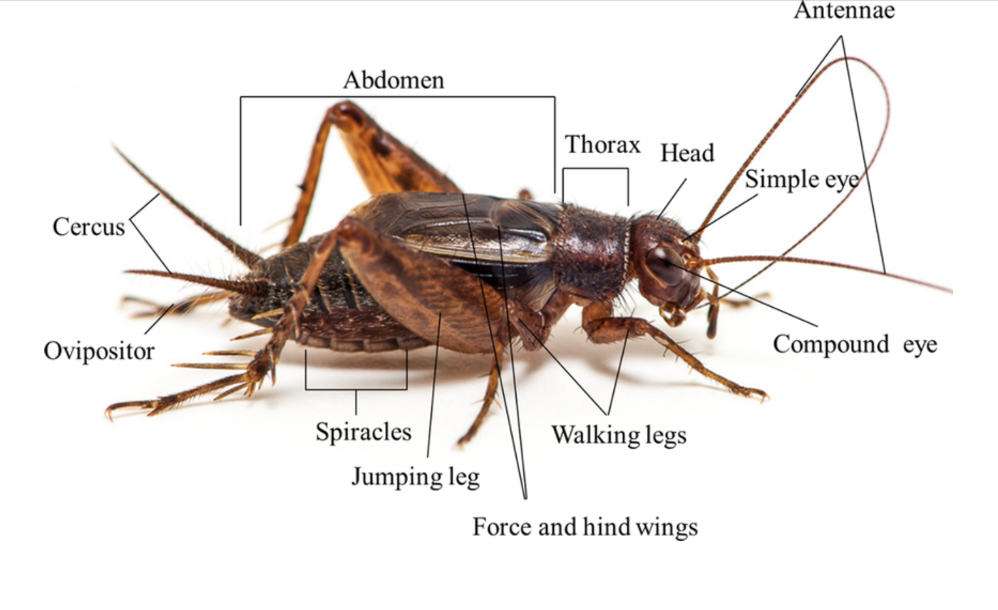
From: researchgate.com

Lifecycle
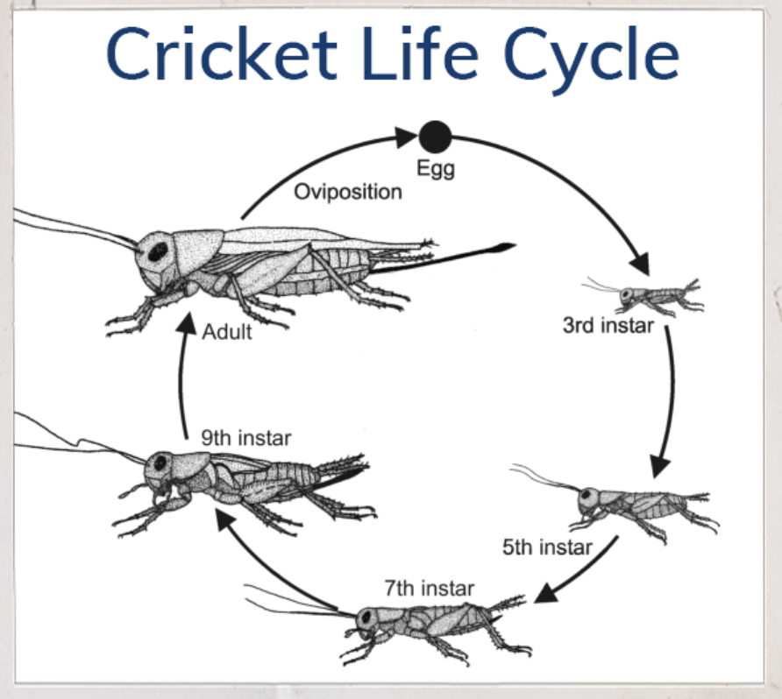 From:myaipm.com

Diagram: Katydid

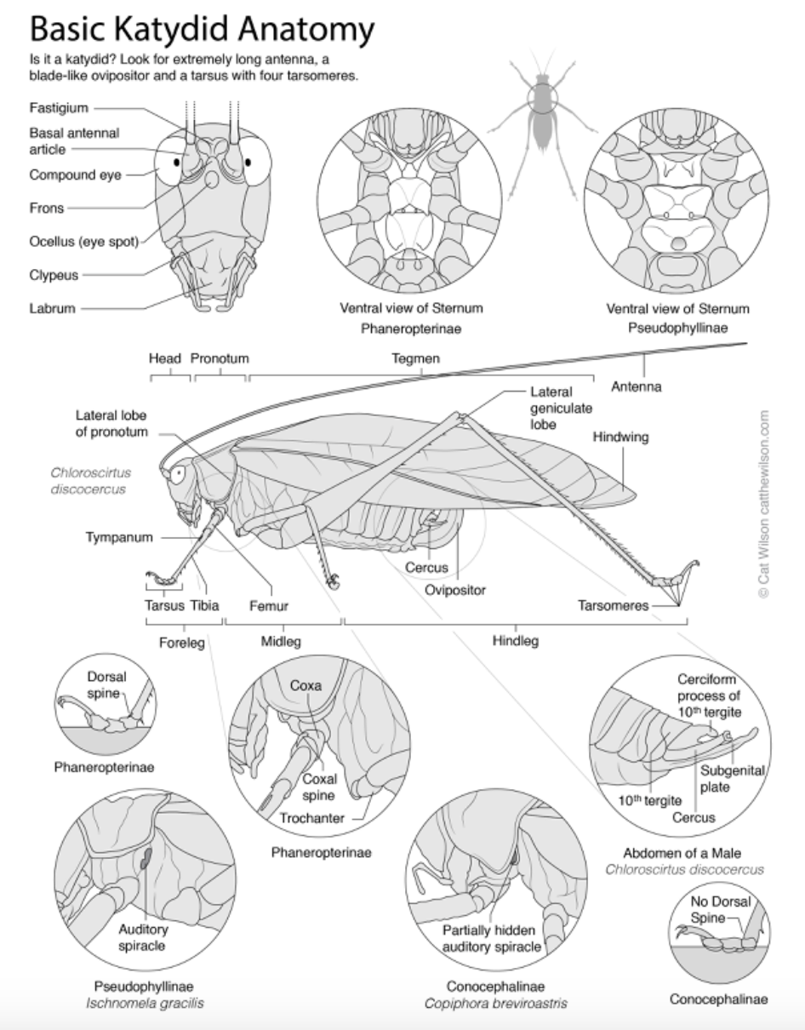
From: catthewilson.com

Diagram: Praying Mantis

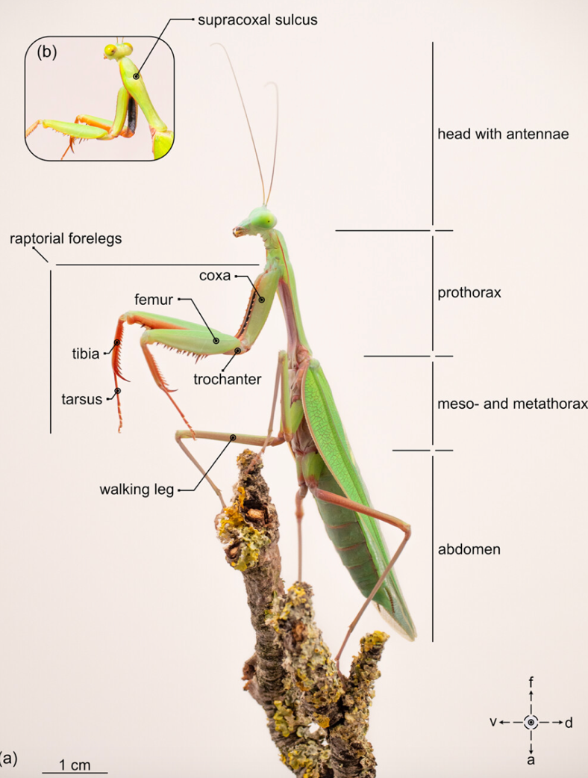 From: Wiley Online Library
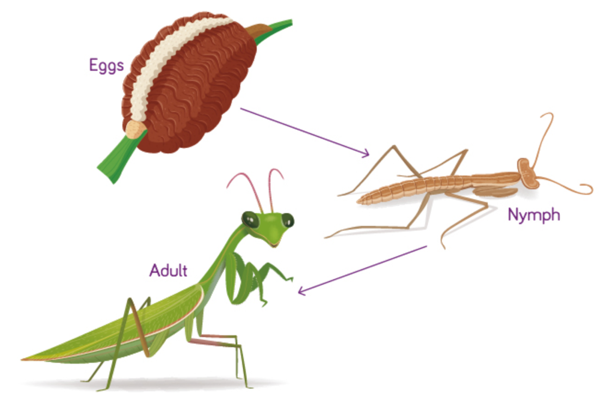From: tbfh.com
Praying Mantis Lifecycle

Diagram: Dragonflies and Damselflies

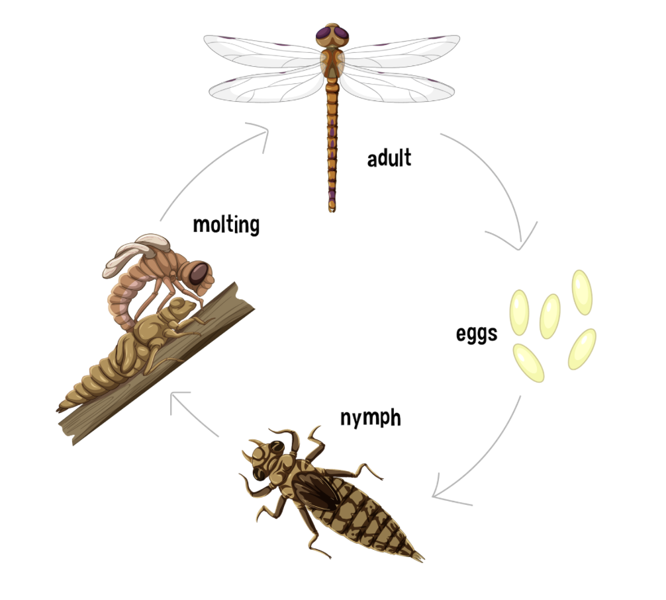
From: wildscapes.info

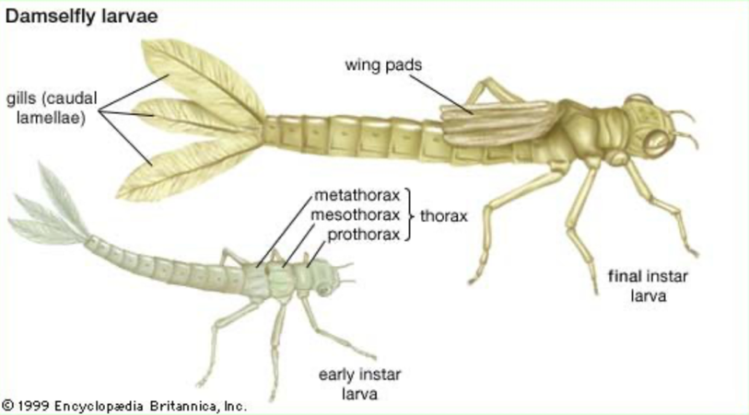 From: Britannica.com

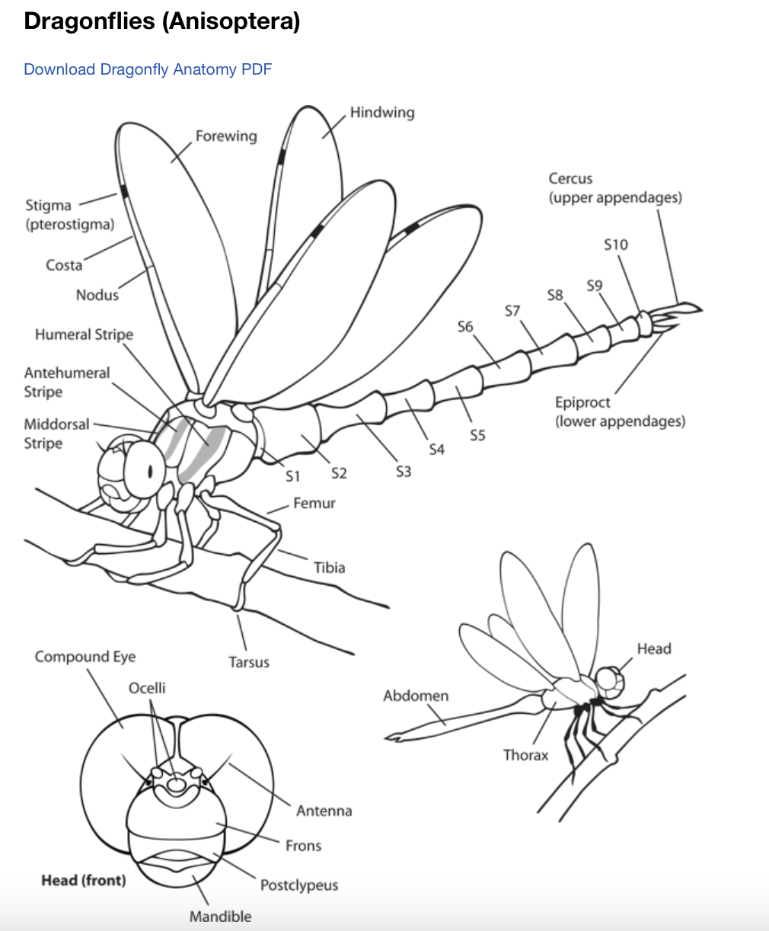
Downloadable Dragonfly Anatomy

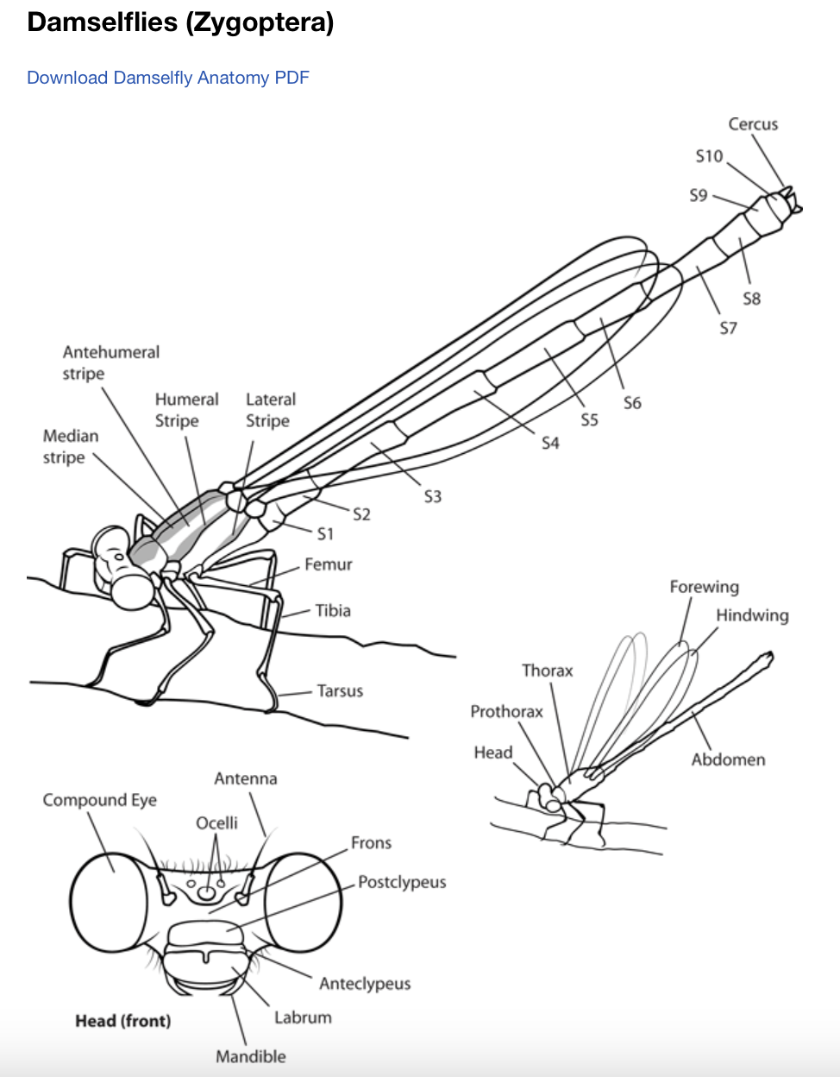
Downloadable Dragonfly Anatomy

From azdragonfly.org

Diagram: Earwig

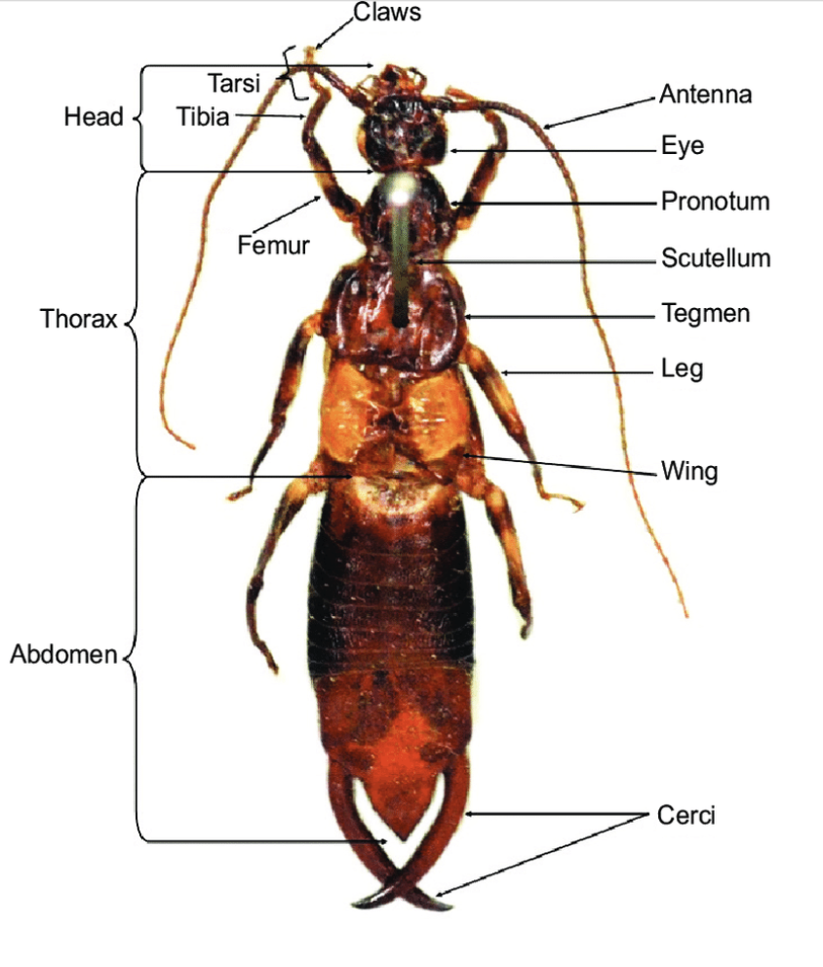 From: Researchgate.net

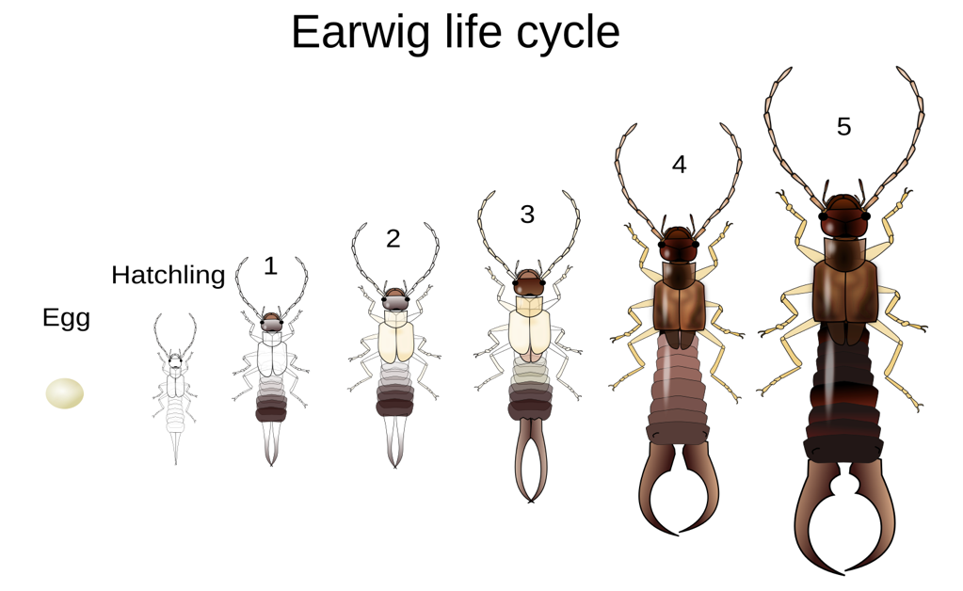 From commons.wikimedia.org

Diagram: Cicada

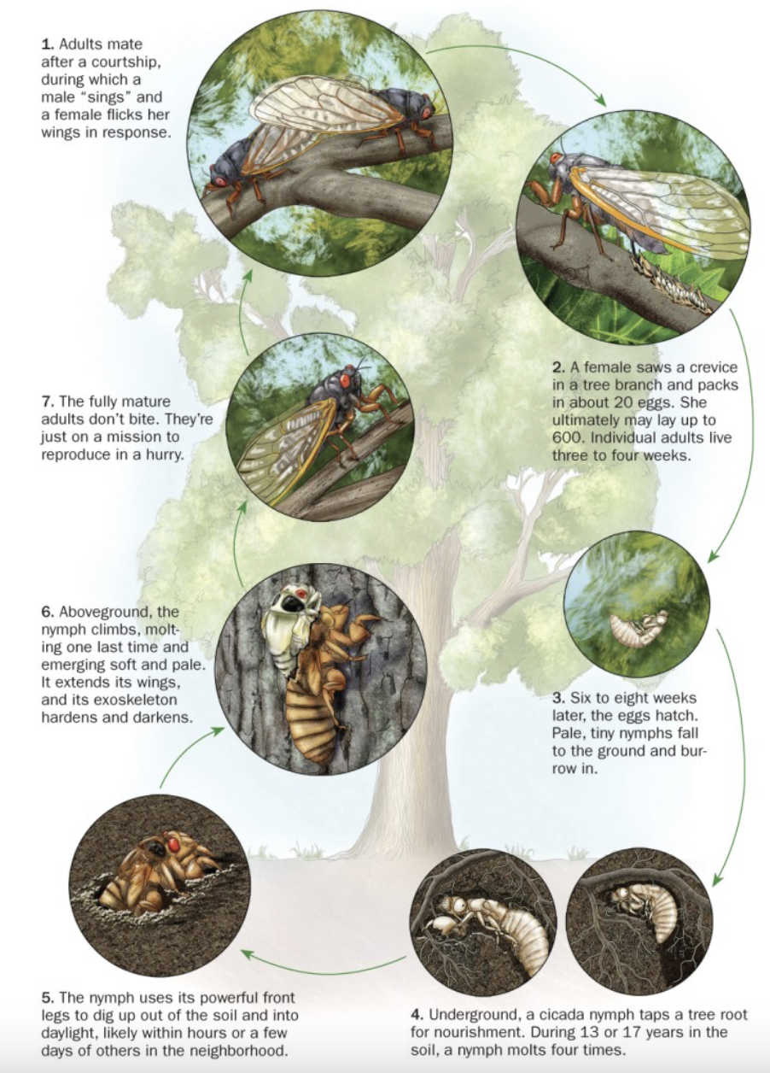
From: Sciencenews.org
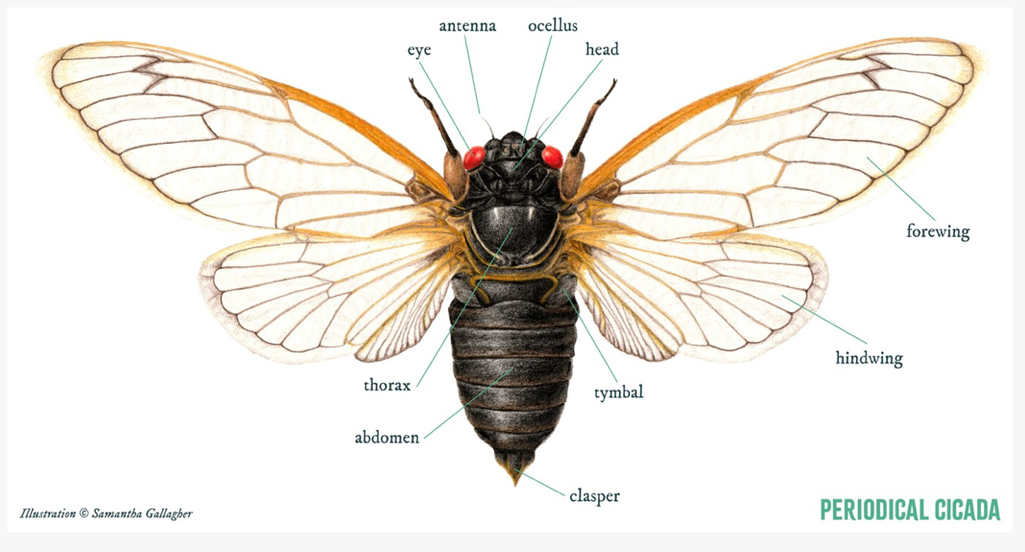

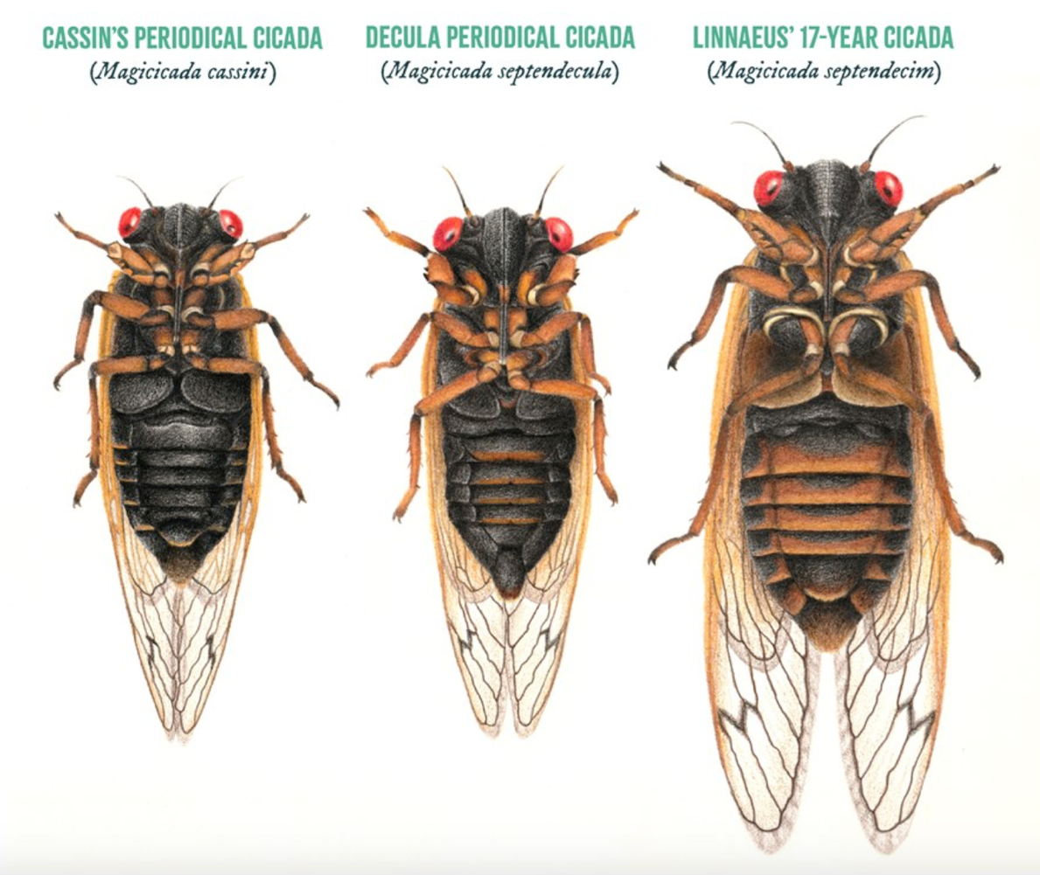

Both images above from: lcfpd.org

Diagram: Pond Skater

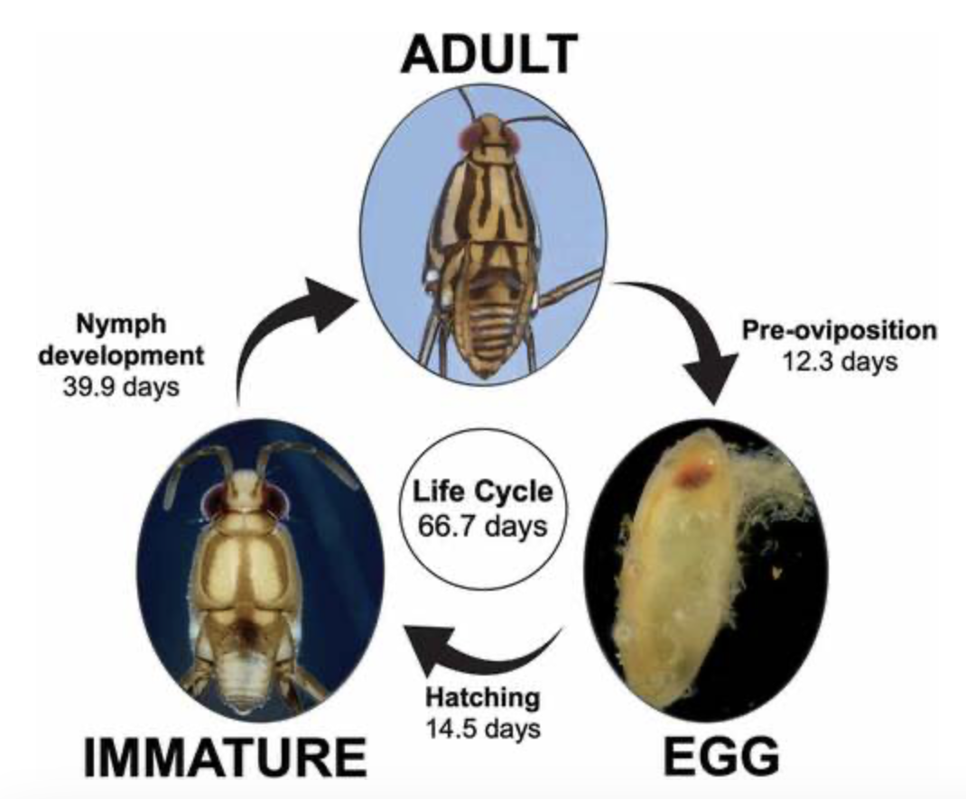
From: tandfonline.com

Diagram: Moth VS Butterfly

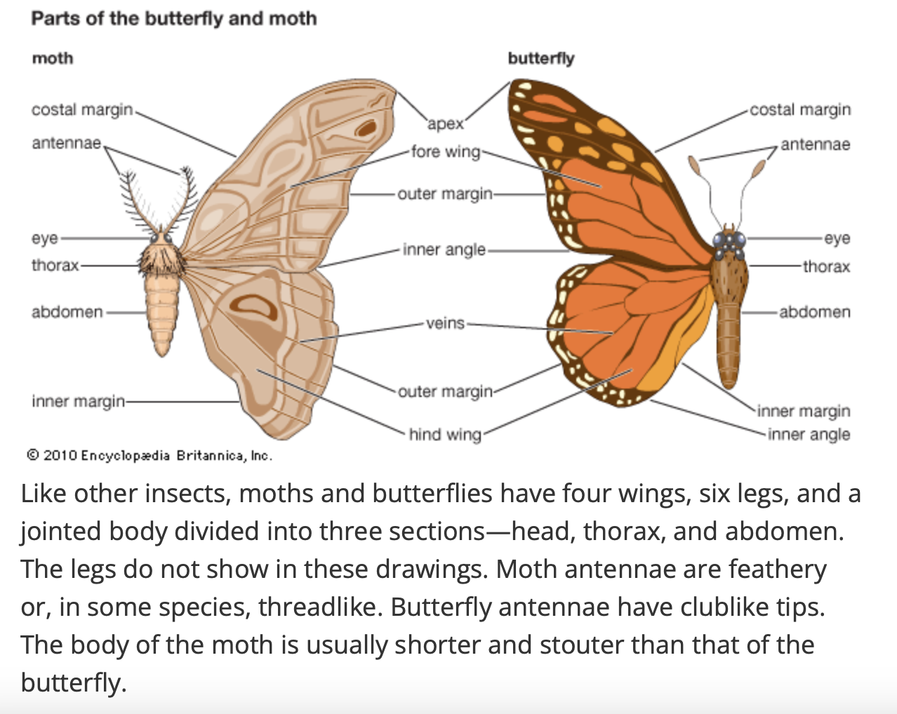
From kids.britannica.com

Diagram: Caterpillar Anatomy

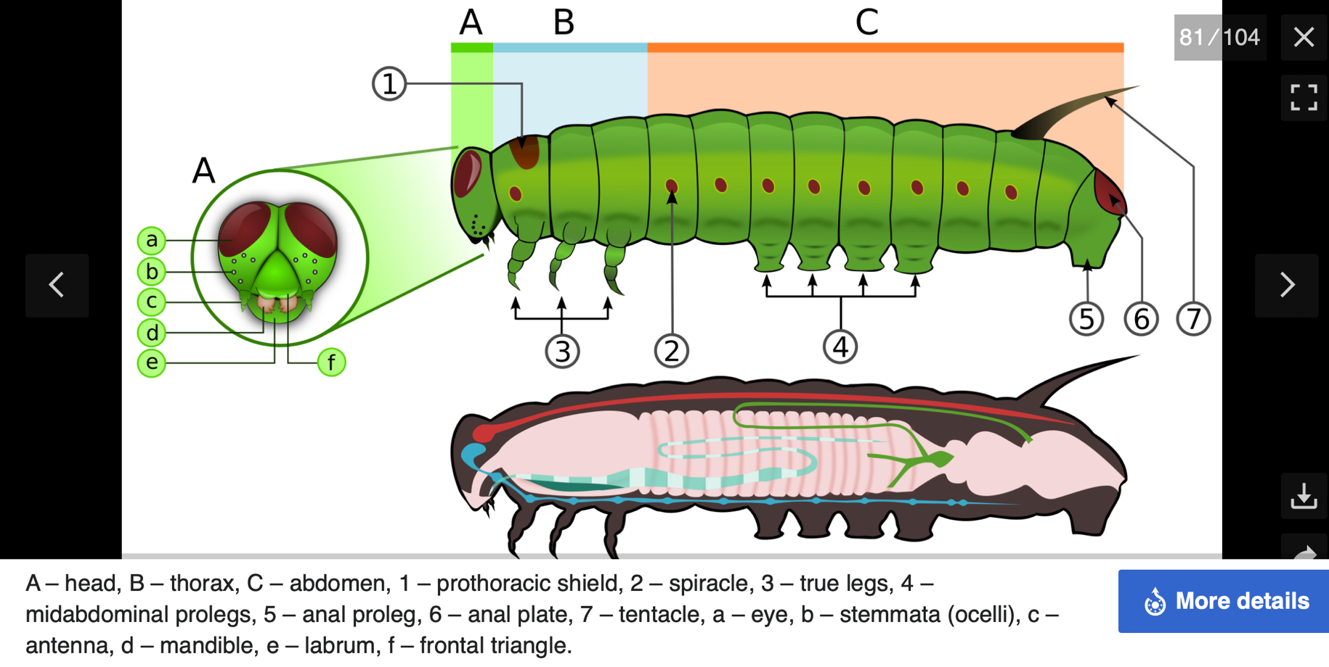
From Wikipedia (next on Wikipedia is a photo with parts labeled)

Diagram: Yucca Moth

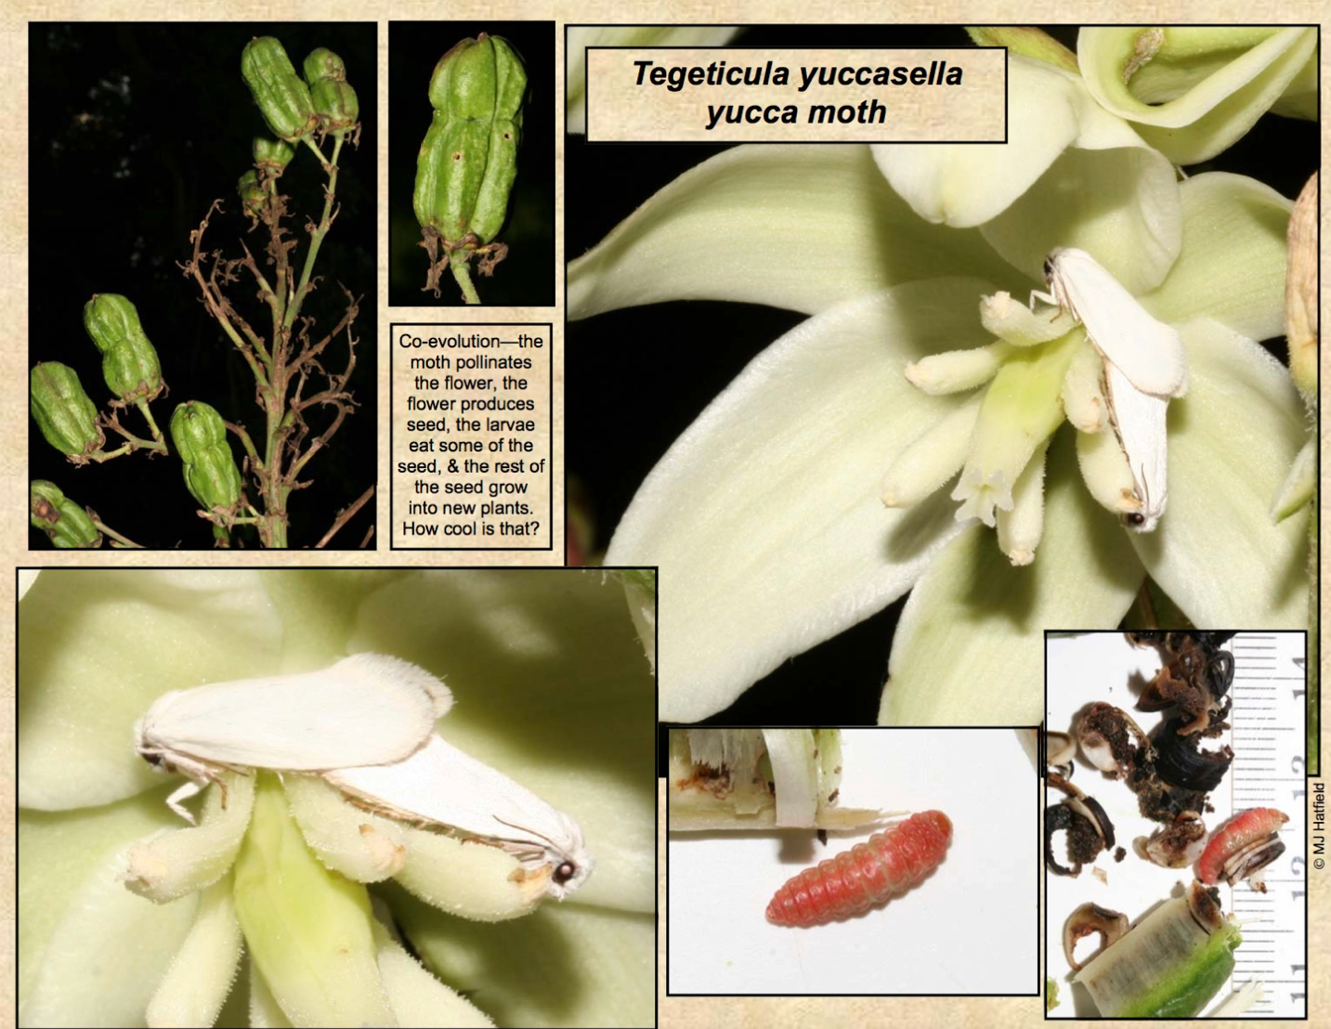

From: buglifecycle.com

Diagram: Painted Lady Butterfly Lifecycle

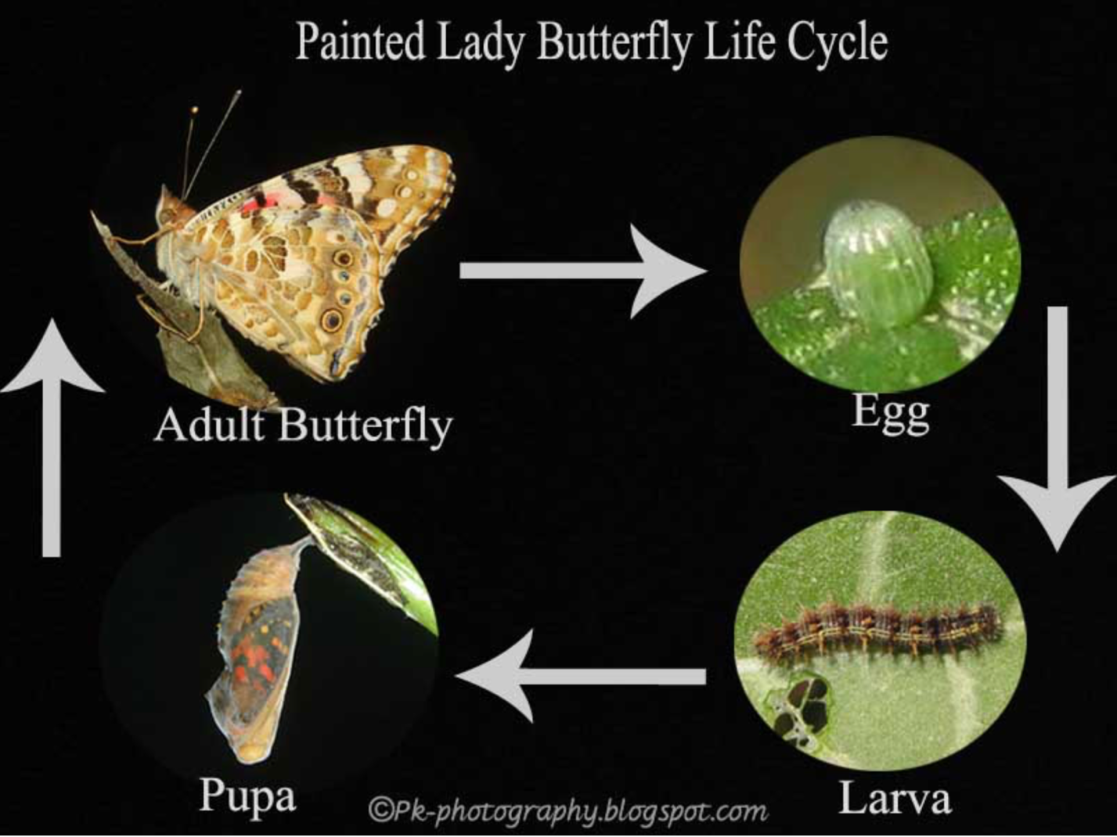

From: photography.blogspot (more detailed pictures on this sight)

Diagram: General Beetle Anatomy

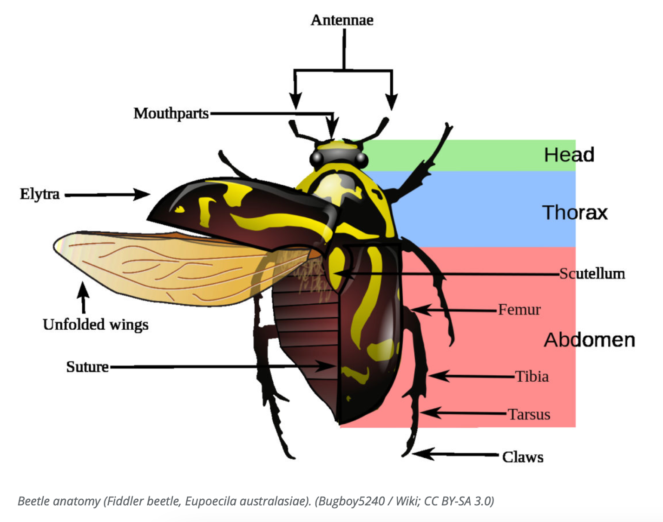

From: WelcomeWildlife.com

Diagram: Darkling Beetle Lifecycle

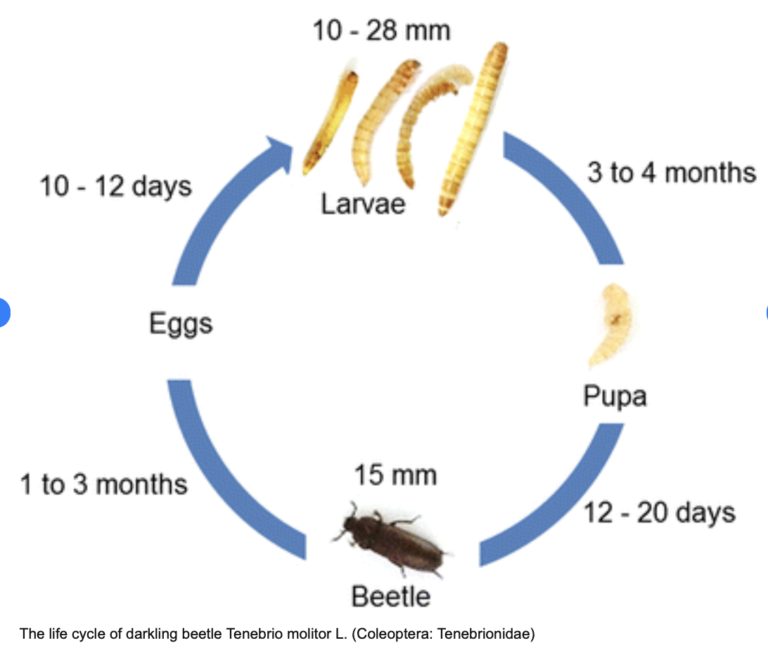
From: Researchgate.net

Diagram: Ladybug
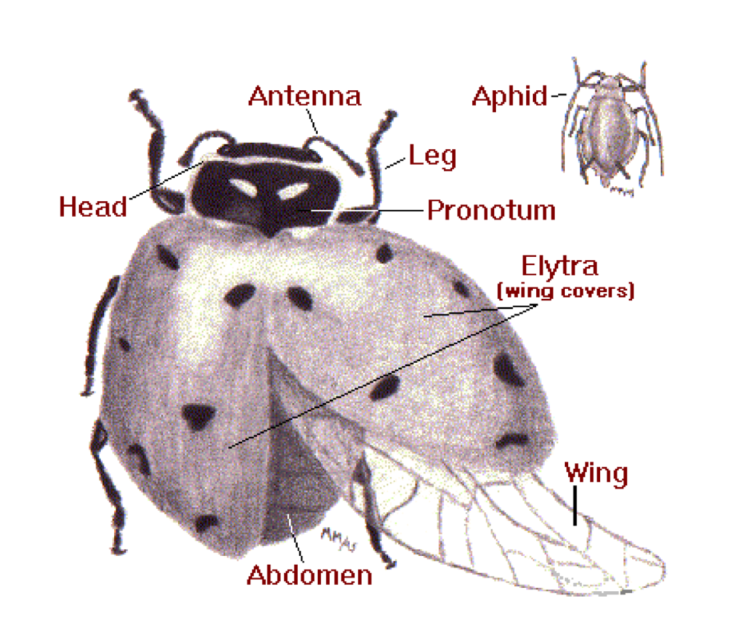
From: lostladybug.org more information at learnaboutnatue.com
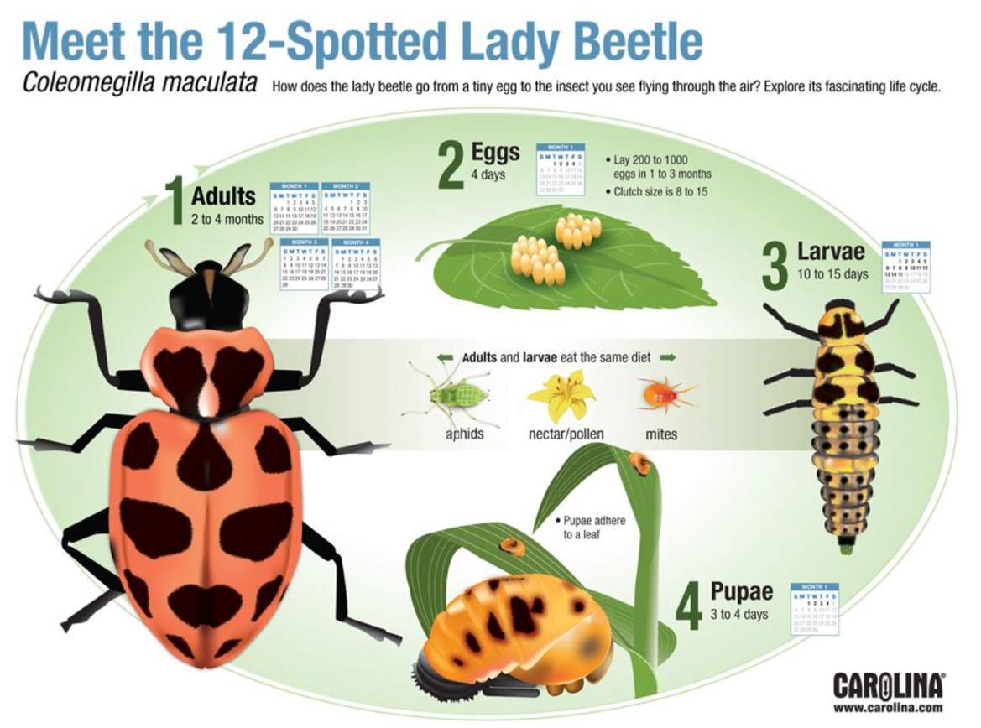
From: Carolina.com

Diagram: Ants

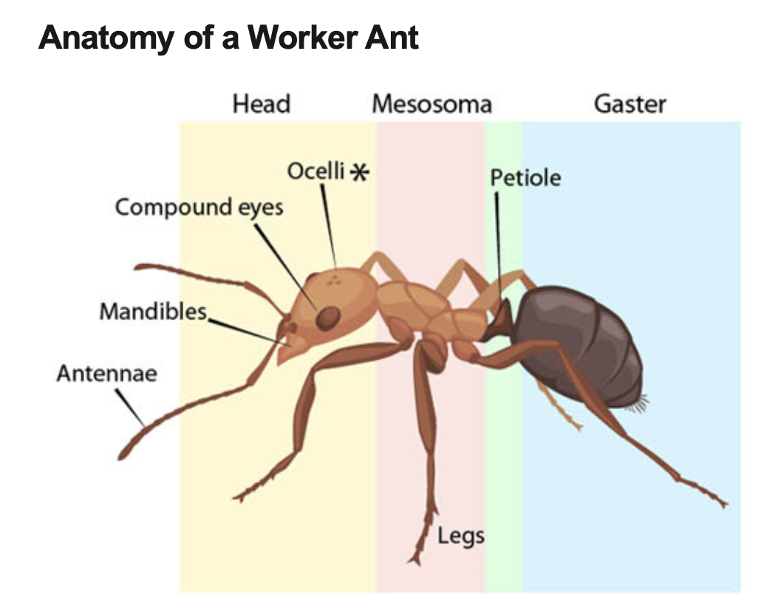 From ASU.edu

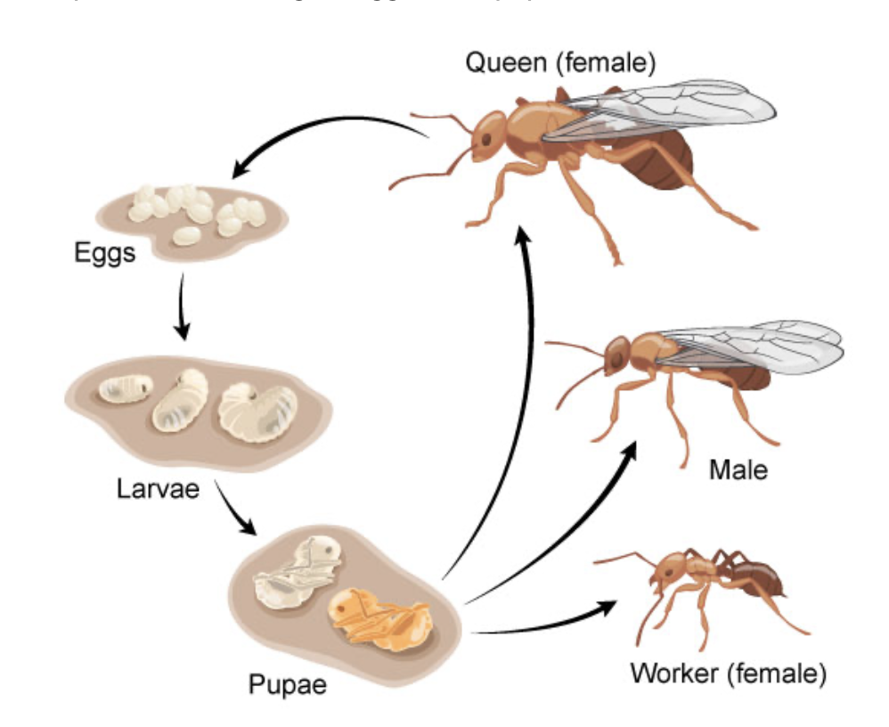 From ASU.edu

Diagram: Wasps

Yellow-Jacket Lifecycle from countryfile.com:
New queen overwinters

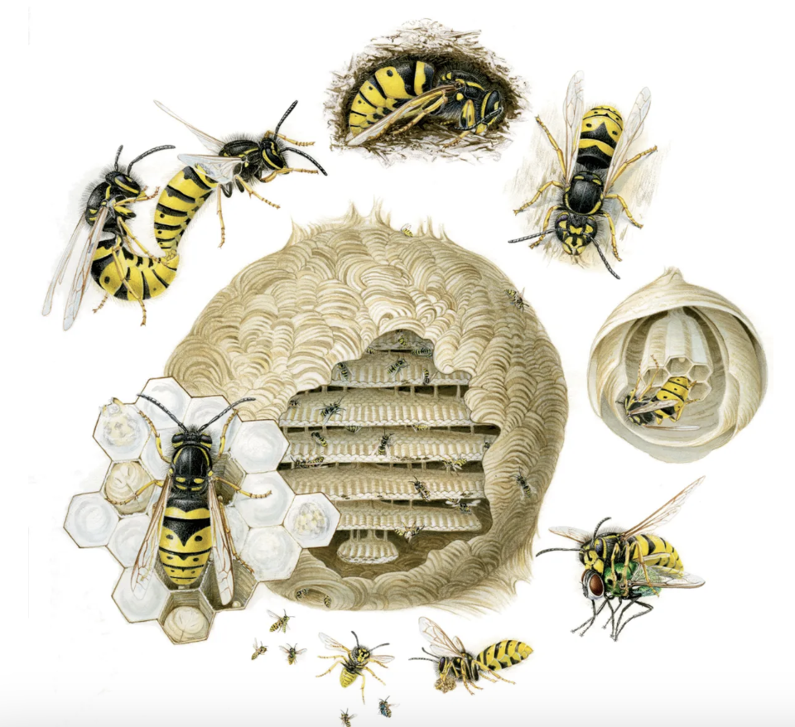
Queen starts laying eggs that will become males and new queens
Larva become workers and start building and feeding new larva
New queen feeds first larva
New queen lays first eggs
New queen starts building new nest
At the end of the season, new queens mate

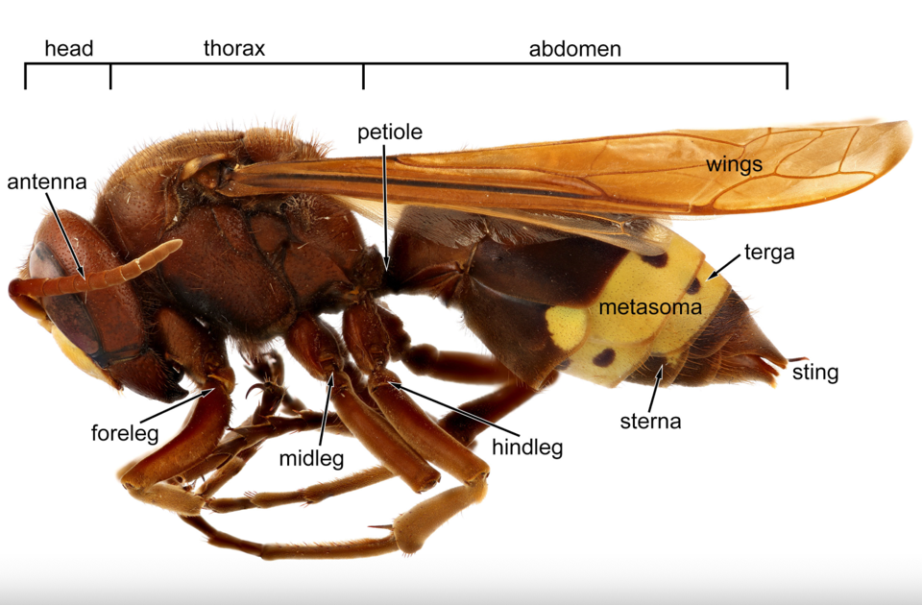 From idtools.org

Diagram: Bees
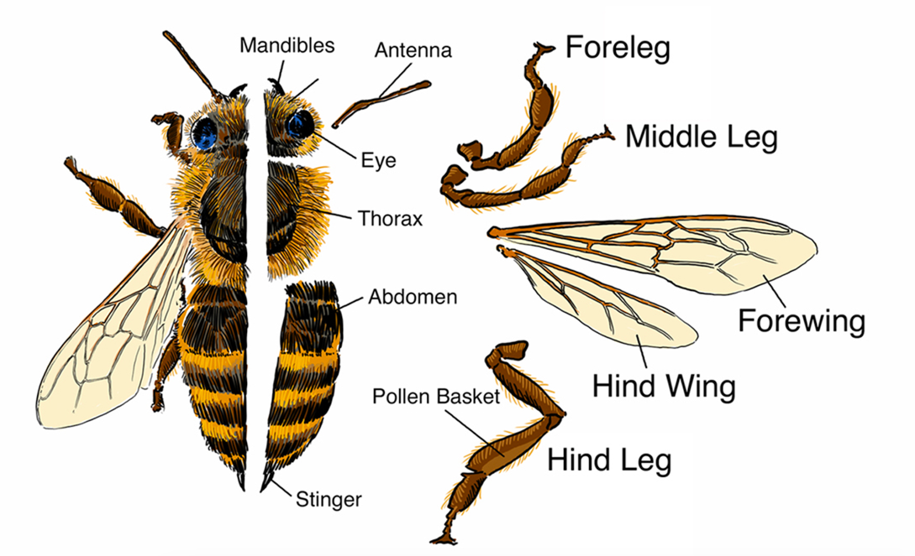
From: pbslearningmedia.org (more diagrams on this page)

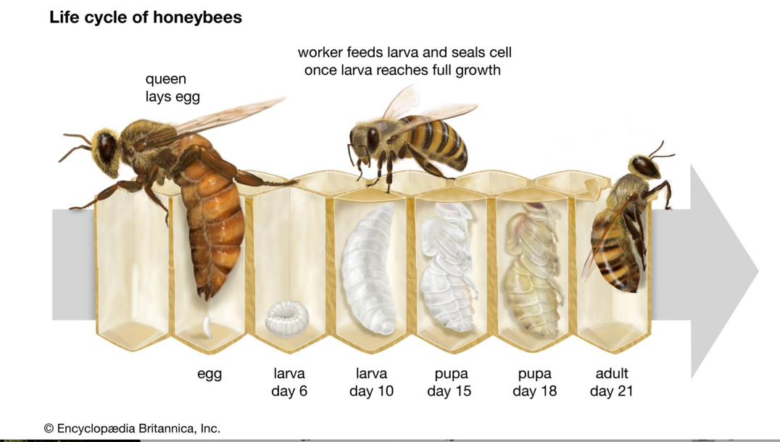
From: Brittanica.com (more diagrams on this page)

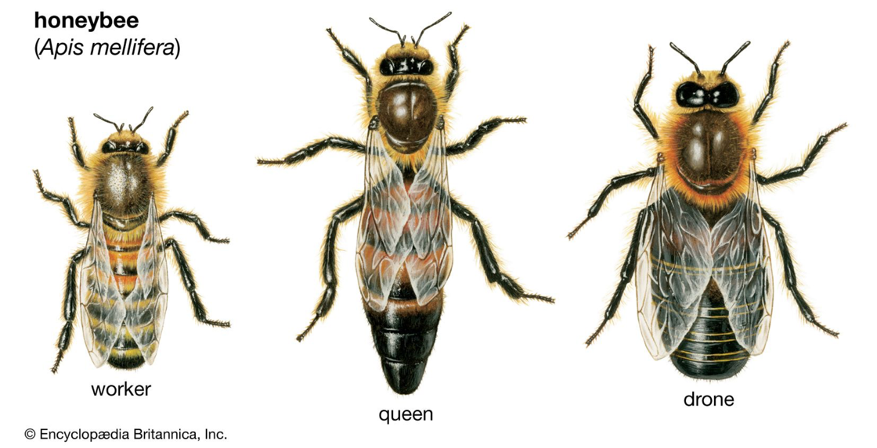

Diagram: Flies

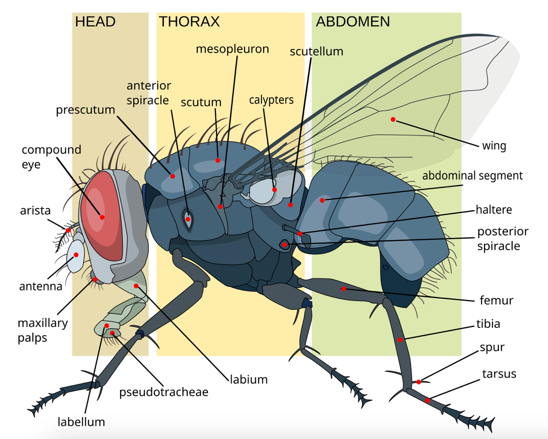
From Wikimedia

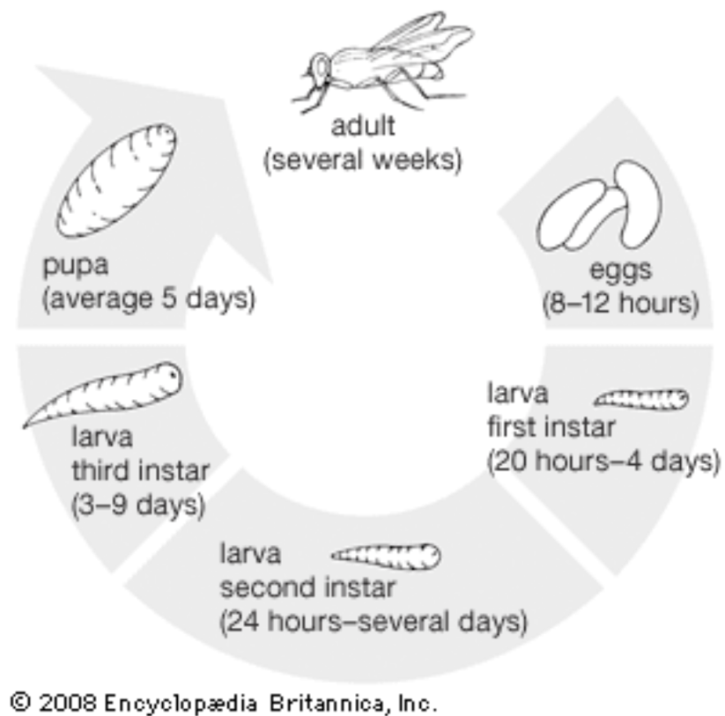From Brittanica.com

Diagram: Mosquitos

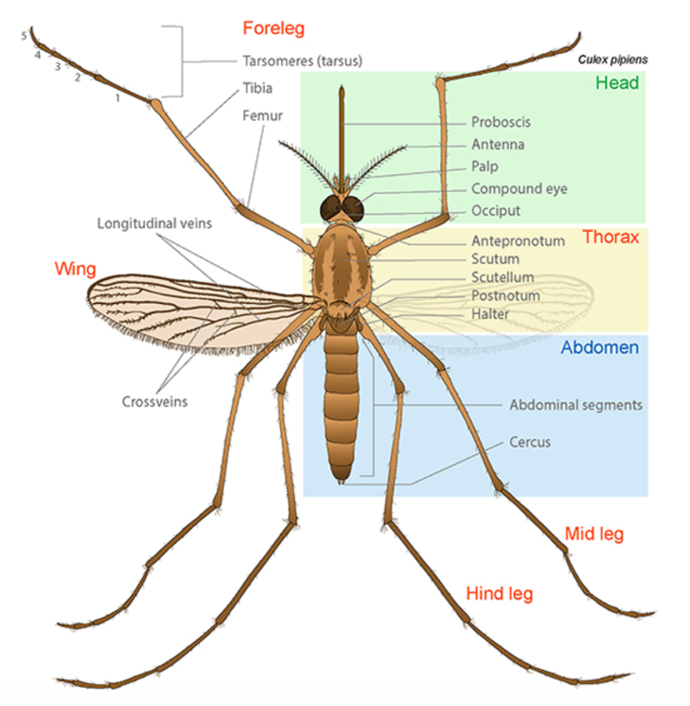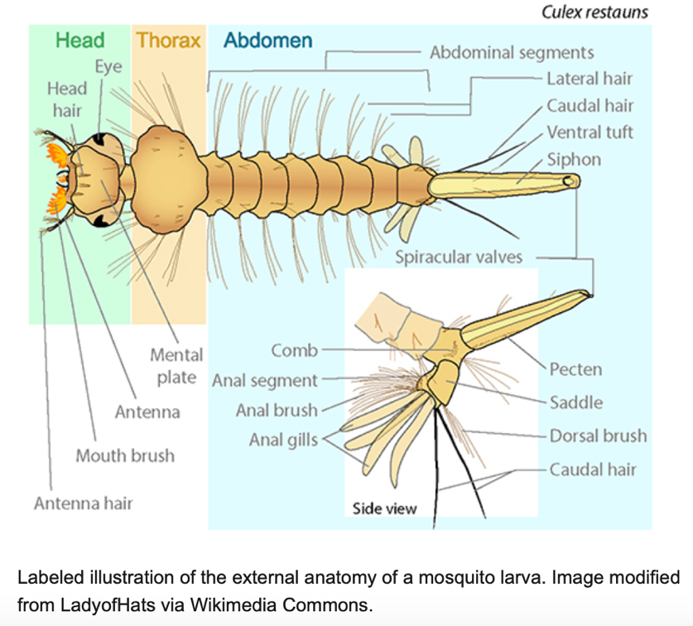
From: ASU Ask a Biologist

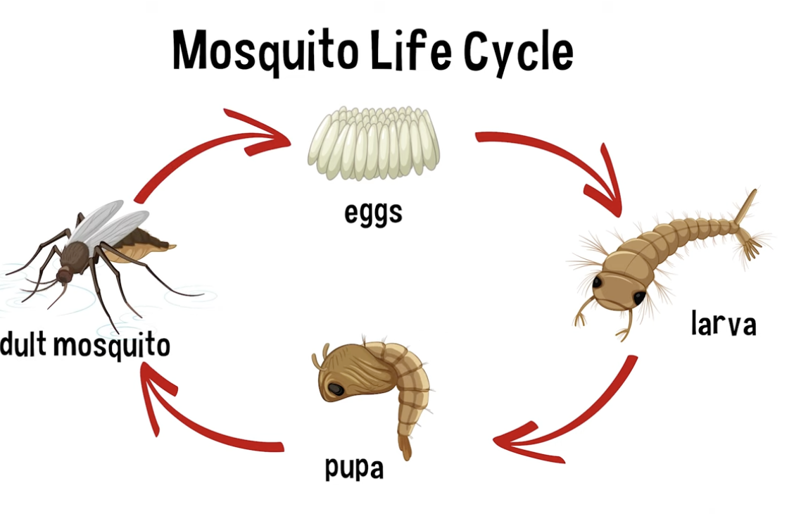
From YouTube Video

Nature Lore Schedule
The Grasshopper Book by Wilfred S. Bronson. (available on archive.org)

Week | Reading | Topics
1. | Ch. 1 | Intro: Aesop Didn’t Know – Grasshoppers get a bad rep from Aesop
2. | Ch 2 (to pg 20, stop at “…as well as enemies) | Grasshopper legs, music, feet, and feelers
3. | Ch 2 (start on pg 20 at “When my grandmother…”) | Grasshopper eyes, breathing, and egg laying
4. | Ch 3 | Grasshopper’s Growth
5. | Ch 4 (to pg 46, stop at “…wouldn’t know about.) | Grasshopper plagues (see Grasshopper resources above for more up to date info on grasshopper vs locust)
6. | Ch 5 (to pg 62, stop at “…fast-looking faces.”) | Carolina, Band-winged, and pygmy locusts
7. | Ch 5 (start on pg 62 at “Naturally some of…”) | Various other kinds of grasshoppers
8. | Ch 6 (to pg 81, stop at “…fastidious diners.”) | Katydid music and movement
9. | Ch 6 (start on pg 81 at “Katydid seem…”) – pg 87 ( stop at “…strange surroundings.”) or to end of chapter | Katydid eggs (Optional: and male fighting)
10. | Ch. 7 | Crickets
11. | Ch. 8 | Roaches
12. | Ch. 9 – 10 | Walking Sticks and Praying Mantises

