Lisa Cotting
amblingtogether.com
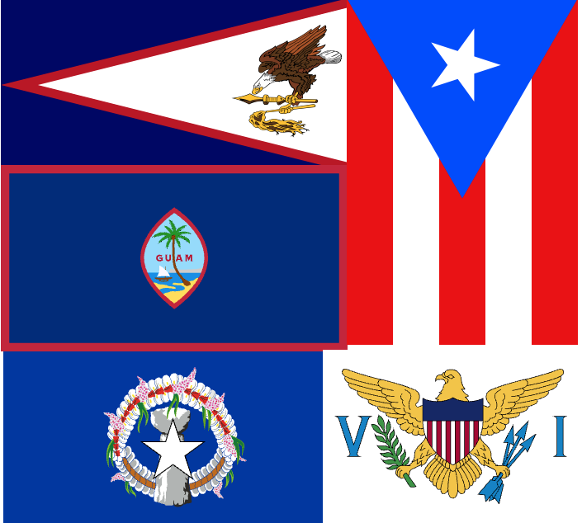
United states geography
Territories

Table of Contents
How I Used This Guide 2
Why a study of the U.S. Territories: 2
How we study each territory: 3
American Samoa 4
Guam 6
Northern Mariana Islands 8
Puerto Rico 10
U.S. Virgin Islands 12
United States Minor Outlying Islands 14

How I Used This Guide

Why a study of the U.S. Territories:

Charlotte Mason describes the principle to be followed as the child gets older and starts studying other countries: “vivid descriptions, geographical principles, historical associations and industrial details, are afforded which should make, as we say, an impression, should secure that the region traversed becomes an imaginative possession as well as affording data for reasonable judgements.” (Book VI)

Inspired by this, I have made time in our Together Time to study the geography the United States (see amblingtogether.com/OtherGuides). For each state we studied the major geographical features and boundaries and then did a brief study of each country therein. I try to find what will make “an impression” so that the state “becomes an imaginative possession” of each child. I decided to focus on mapping the physical features, reading a little about the culture, history, or nature of the state, and watching several videos to compliment these topics. When I finished the states, I realized I didn’t know much about the territories. So I decided we needed to do a term on them as well.

While using Miss Mason’s principles for teaching geography and choosing which features to map or which books to read and videos to watch, I consider the following goals: We will be familiar with major cities and landmarks – understanding how mountains and waterways divide and define, we will know a little about the original inhabitants of the land, we will have an understanding of what (some of) the territory looks like and we will be familiar with some of the stories and culture from the area. I will not cover all of these topics for each territory but hope that in general we’ll know our world and neighbors in it a little better by the time we’re finished.

How we study each territory:

I have spaced this study over 12 weeks and scheduled 15-20 minutes one morning a week to read the book, watch the videos, and draw the geographical features on our map. When time permits, we draw the territory freehand to help us notice the features of the boarder. Several territories have more than one week on the schedule.

Schedule:
Week(s) | Topic
1 | Intro to U.S. Territories
2-3 | American Samoa
4-5 | Guam
6 | Northern Mariana Islands
7-8 | Puerto Rico
9-10 | U.S. Virgin Islands
11-12 | Uninhabited Territories

For each territory, we will find it on the globe or atlas, answer questions about its location, look at the shape and geography of the territory, then draw and label it. We will also watch videos and/or read books or articles about the territory. We will spend more than one week on several territories, so we’ll split up the activities between the two weeks.

American Samoa

About
Located in the Polynesian region of the South Pacific Ocean in the Samoan archipelago, it is the most southern point of the U.S. The indigenous people are Polynesians. Claimed by U.S. in late 1800s and became an official territory in the early 1900s. Residents are not U.S. Citizens, they are “non-citizen nationals” and cannot vote and do not have representation.

To Read
* The Legend of Sina and the Eel by Rev Falefatu Enari (available on kindleunlimited)
- Fale Samoa by Dahlia Malaeulu (I have not been able to find this one reasonably priced, but I’m including because the description sounds like one I’d like to read so I have it here to remind me to look out for it.)

Links to View
* Know Your Mats (3 min)
* American Samoa Culture (5 ½ min)
- How to Perform a Samoan Si’I (Alofa) (4 ½ min)
- Rose Atoll Marine National Monument (10 min)
- The History of the Samoan fale (11 min)

Map Questions
- In which hemisphere is American Samoa?
- What can we guess about the climate?
- Which continent is it closest to?
- Which ocean is it in?
- How many islands and atolls are in American Samoa?
- Describe the location of Swain’s Island.
- Between which Latitude lines are the islands found?
- On which island is the capital?

Map Drawing
- Draw the relative locations of the 5 islands
- Draw the shape of Tutuila
Geographical Features to Map
Capital: Pago Pago ; Islands & Atolls: Tutuila, Aunu’u, Manu’a Islands (Ofu, Olosega, Ta’u), Rose Atoll, Swain’s Island
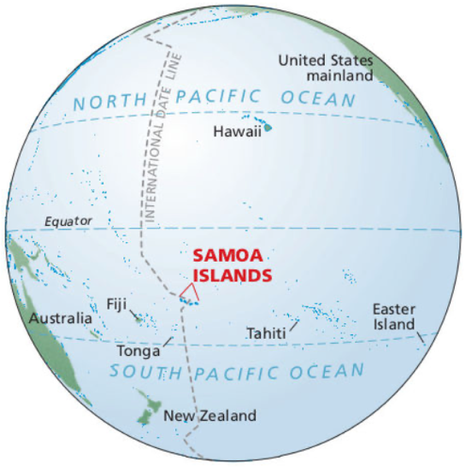
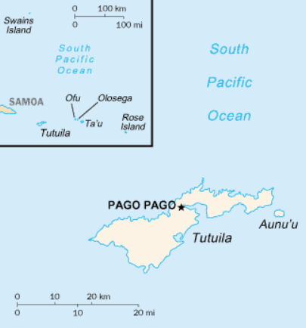
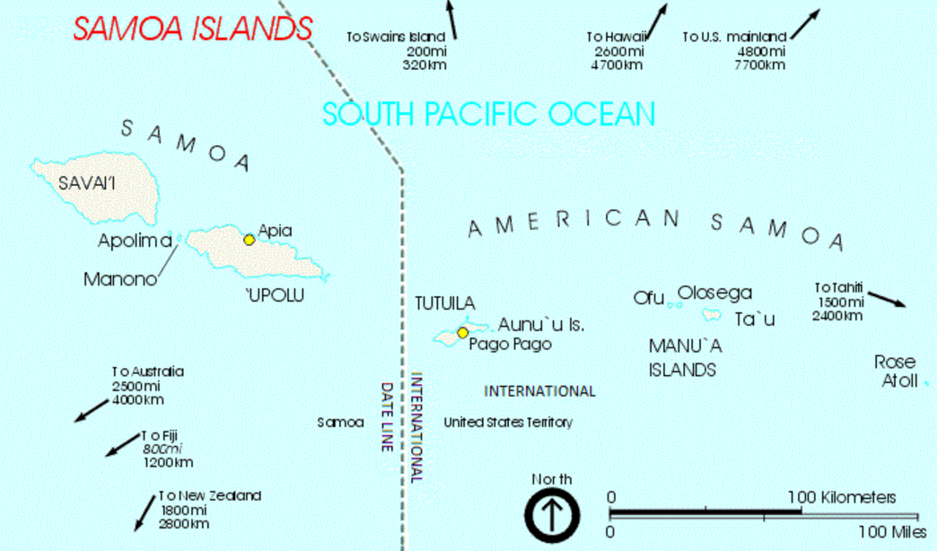
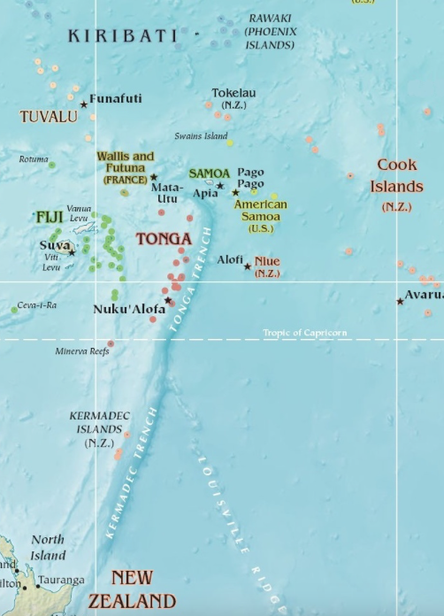
Map from Wikipedia: American Somoa
Map from Wikipedia: Swain’s Island

Guam

About
In Micronesia and part of the Mariana Island Archipelago of the Pacific Ocean, whose indigenous inhabitants are the Chamorro people. It was colonized by Spain in 1688 and was captured by the U.S. in 1898 during the Spanish-American war and was ceded to the U.S. at the end of the war. It is used extensively by the U.S. military. People born on Guam are U.S. citizens but the island does not vote in federal elections. The citizens do vote for one delegate to the House of Representatives that has limited voting rights.

To Read
* A collection of Folktales from Guam
* Guam’s Brown Tree Snakes by Kevin Blake (available on archive.org)

Links to View
* How Guam Became a US Territory (3:12 min)
*. Guåham (4:27 min)
* The Mystery Mats of the Pacific with Master Weaver Lia Barcinas (2:13 min)
* The Tallest Peak of Earth? - Hiking Mt Lamlam and Mt. Jumullong in Guam (7:54 min, but watch at least min 0:21 – 2:28 and 4:28 – 5:28)
* How These Snakes Caused Power Outages in Guam (2:06 min)
* Protecting native birds with Friends of Islan Dåno (min 3:10 – 5:44, and 9:20 – end)
* The Sihek (Guam Kingfisher) Finds Hope at Palmyra Atoll (multiple videos on this page)
* Hasso yan Onra: Mañenggon (11:03 min) – story of WWII Japanese occupation & camps

Map Questions
- In which hemisphere is Guam?
- Between which Latitude lines are the islands found?
- What can we guess about the climate?
- Which continent is it closest to?
- Which ocean is it in?
- What sea boarders it on the west?
- What is its highest mountain?
- Are there any islands close?
- What are the names of the natural bays?
- Name the oceanic feature it is near.

Map Drawing
- Draw the shape of the island
- Draw Cocos Island
- Draw the Mariana Trench
Geographical Features to Map
Capital: Hagatna ; Pacific Ocean ; Philippine Sea ; Apra Harbor ; Agat Bay ; Mount Lamlam ; Cocos Island ; Mariana Trench

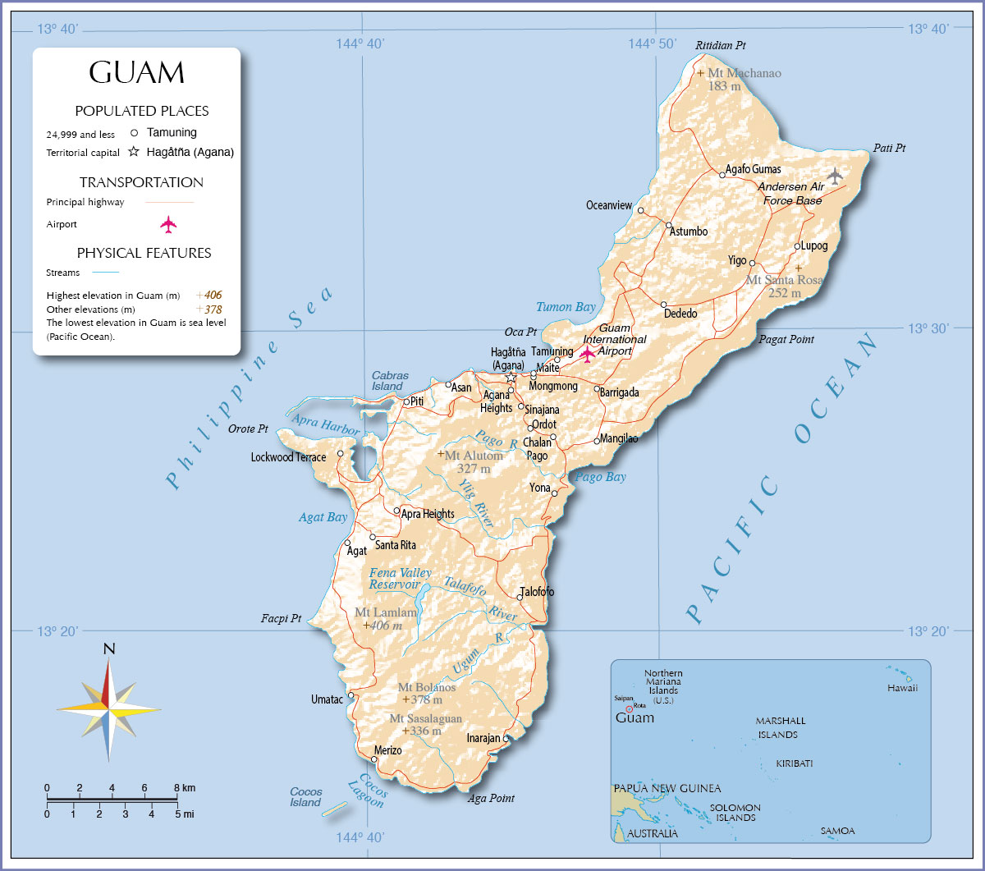
map from nationsonline.org

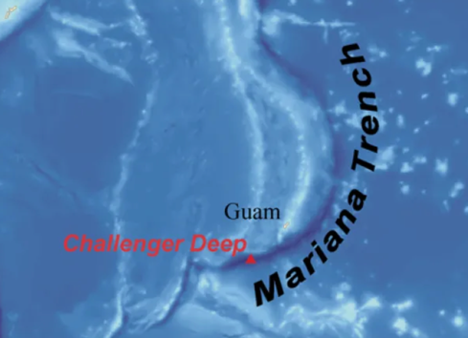

Map from: ocean.si.edu

Northern Mariana Islands

About
Fourteen islands of the Mariana Archipelago, located in the Northwestern Pacific. The indigenous inhabitants are the Chamorro people. They were conquered by Spain in the 1500s, sold to Germany in the 1800s, then given to Japan when Germany lost WWI. After WWII, they were taken from Japan and administered by the U.S. on behalf of the U.N. before becoming an official territory in the 1980s. The people on the island were granted U.S. citizenship when they became an official U.S. Territory, though they do not vote in federal elections. The citizens do vote for one delegate to the House of Representatives that has limited voting rights.

Links to View
* Luta (4:26 min)
* Tinian (4:08 min)
* Siapan (4:25 min)

Map Questions
- In which hemisphere are the Northern Mariana Islands?
- What can we guess about the climate?
- Which continent is it closest to?
- Which ocean is it in?
- Which Sea lies to their West?
- How many islands are there?
- Between which Latitude lines are the islands found?
- On which island is the capital?
- Where are NMI in relation to Guam?

Map Drawing
- Draw the shape of the archipelago
- Draw the three main inhabited islands, Saipan, Tinian, and Luta (Rota) as well as Pagan.
Geographical Features to Map
Capital: Capitol Hill on the Island of Saipan ; Pacific Ocean ; Philippine Sea, Mariana Trench

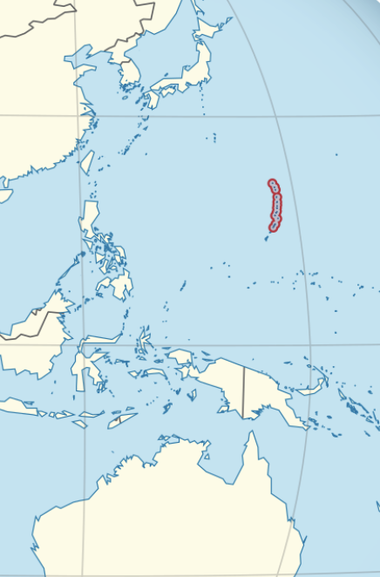
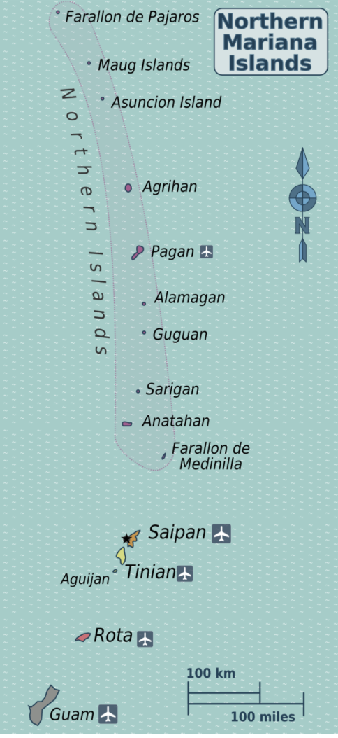
maps from wikipedia

Puerto Rico

About
Originally settled over 2000 years ago by the Ortoiroid, Saladoid, and Taino people, Puerto Rico is an archipelago of the main island and 143 small islands located in the Greater Antilles Archipelago of the Caribbean. Soon after Columbus, it was claimed by Spain. As a part of the settlement of the Spanish-American War, it was given to the United States. Puerto Ricans are U.S. Citizens, but since the island is not a state, they have only a nonvoting representative to Congress.

To Read
* A summary of the geography of Puerto Rico

Links to View
* Here’s Why Puerto Rico is Part of the U.S. (3:27 min)
* A Puerto Rico’s wildlife (3:54 min)
* Why This Giant Puerto Rican Fort Kept Growing (2:05 min)
*. Why Puerto Rico’s Cordillera Central Mountains are crucial to its survival (5:13 min)
* For teacher reference or older students: The Settlement of the Caribbean (24:56 min)

Map Questions
- In which hemisphere is Puerto Rico?
- What can we guess about the climate?
- Which continents is it closest to?
- Which ocean is it in?
- Which Sea lies to the South?
- How many major islands are there?
- Between which Latitude lines are the islands found?
- On which island is the capital?
- What island group is it a part of?

Map Drawing
- Draw the shape of the main island of Puerto Rico
- Draw the islands of Vieques, Culebra, Mona, Desecheo and Caja de Muertos
- Draw the central mountain chain, Cordillera Central

Geographical Features to Map
Capital: San Juan, islands of Vieques, Culebra, Mona, Desecheo and Caja de Muertos, Atlantic Ocean, Caribbean Sea

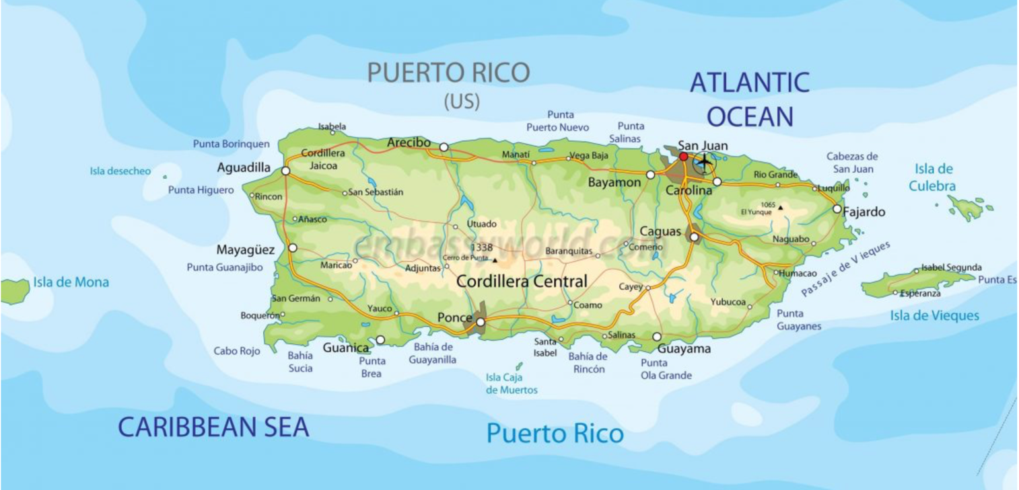
From Encyclopedia of Puerto Rico

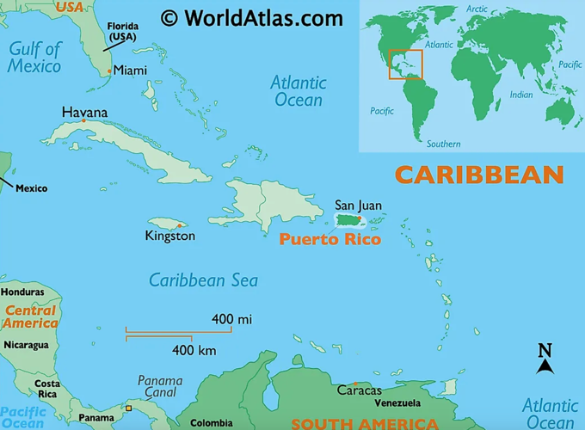

U.S. Virgin Islands

Territory Status
The U.S. Virgin Islands, located in the Leeward Islands of the Lesser Antilles, includes an archipelago with 3 main islands and over 50 smaller one. The islands have been inhabited for about 3000 years, and the Taino people have been there about 1000 years ago. While multiple European countries claimed the lands after Columbus, the Dutch gained control in the late 1600s. During World War I, the U.S. feared the islands could be taken by the Germans and the Dutch agreed to sell them to the U.S. in 1916. People born in the Islands are U.S. Citizens. Though they do not vote in federal elections, they do elect a non-voting member of Congress.

Book to Read
* Virgin Islands National Park Guide: Indigenous Peoples
* National Park maps of the islands

Links to View
* Black History in America – US Virgin Islands (3:33 min)
* Discover the Beauty of the U.S. Virgin Islands (4:14 min)
* USVI Coral Innovation Hub / The Nature Conservancy (4:00 min)
* Are the Taino extinct? (13:24 min) – possibly for teacher reference or older students

Map Questions
- In which hemisphere is the U.S. Virgin Islands?
- What can we guess about the climate?
- Which continents is it closest to?
- Which bodies of water is it between?
- How many major islands are there?
- Between which Latitude lines are the islands found?
- On which island is the capital?
- What island group is it a part of?
- Which island group is to the West? To the East?
- Which is the southernmost island?
- What is the Sound between the two main northern islands?

Map Drawing
- Draw the shape of each of the islands and their relative locations
- Draw the islands north and south of Pillsbury Sound
- Note where the coral reef national monuments are (see NPS map)

Geographical Features to Map
Capital: Charlotte Amalie, St. Thomas, St. John, St. Croix, Pillsbury Sound, Caribbean Sea, Atlantic Ocean

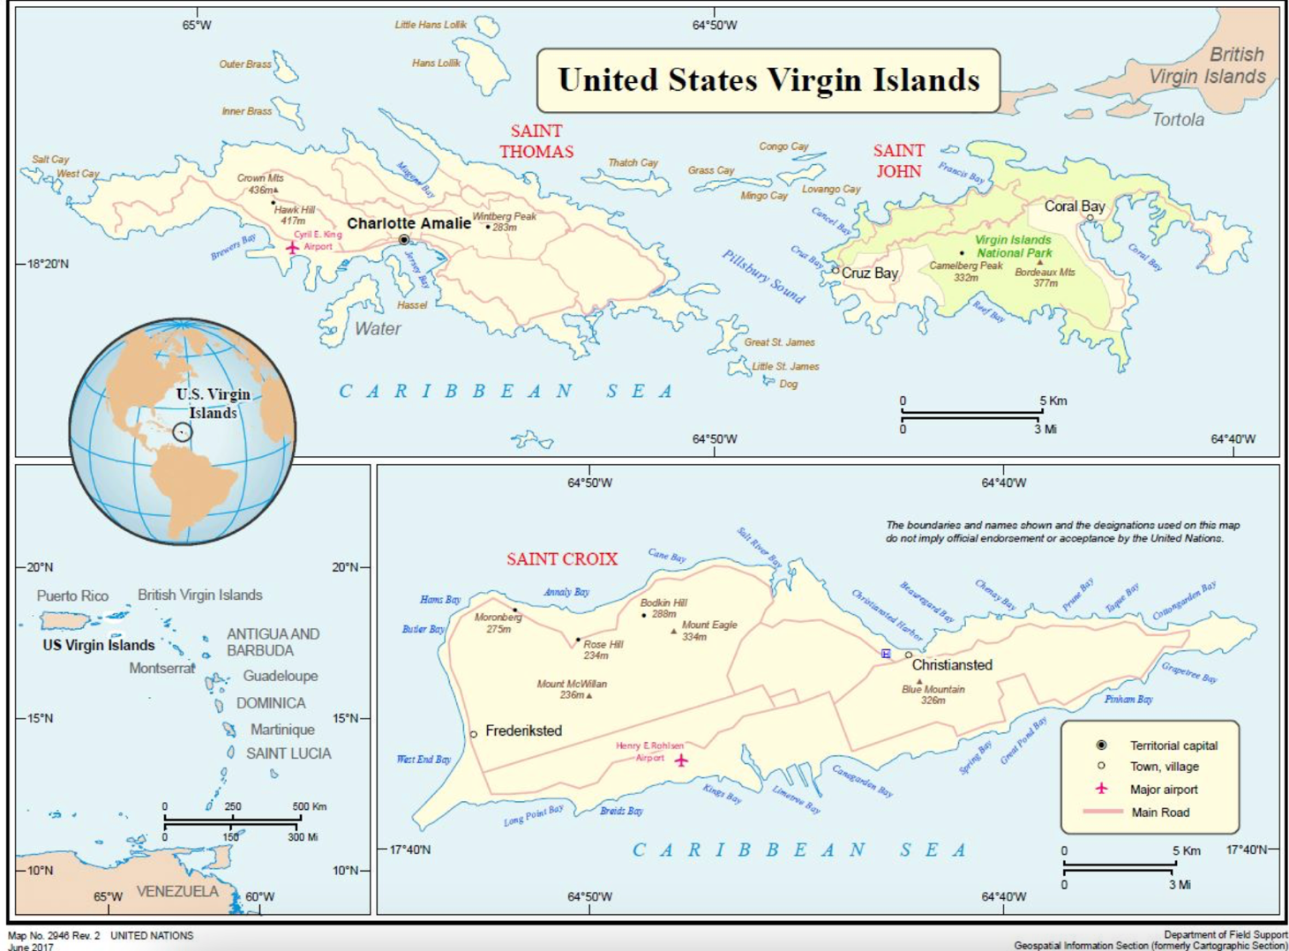
From UN.org

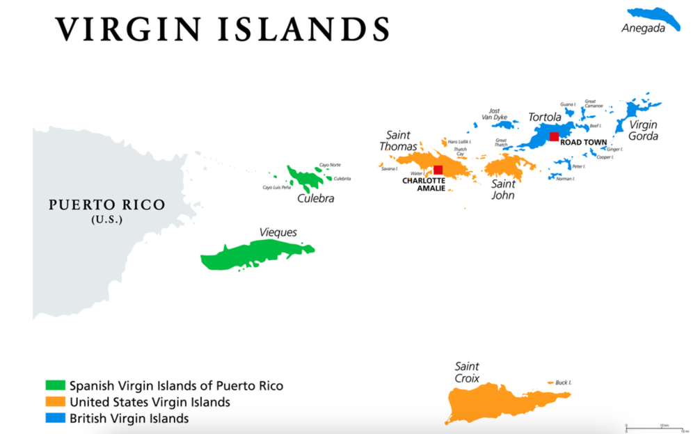 From Worldatlas.com

United States Minor Outlying Islands

The eight islands in the Pacific and one in the Caribbean of the United States Minor Outlying Islands (or UM) have no permanent residents. Some of the islands have military or wildlife personnel stationed on them.

- Why You Can Clain Islands for the US If They Have Bird Poop (5:00 min)
- Protect the Pacific Remote Islands Marine National Monument (1:58 min)

Questions to ask for each:
- In which ocean, or part of the ocean is it located?
- In which hemisphere is it located?
- What can we guess about the climate?
- Which continents or other islands is it closest to?
- How many islands are there?
- Between which Latitude lines are the islands found?
- Are there any geographical features of note on the island?

Midway Atoll – consists of several islands and a lagoon and is the only island in the Hawaiian Archipelago not in the state of Hawaii. It is famous for its role as a WWII base and is now occupied by wildlife staff.
- President Obama visits Midway Atoll (2:42 min)
- The Battle of Midway – History Channel (4:01 min)

Wake Island – a coral atoll in Micronesia consisting of three small islands around a lagoon. It was used in the 1930s as a stop-over point for Pan American Airways flights.
- Wake Island: Where America’s Day Really Begins (2:44 min)

Johnston Atoll – located southwest of Hawaii in the Northern Pacific, it originally consisted of only two islands but two additional artificial ones have been built. Used for military purposes and includes a large marine wildlife refuge.
- Johnston Atoll Through the Eyes of C.A.S.T. (2:51 min)

Kingman Reef – a mostly submerged coral reef halfway between Hawaii and American Samoa in Oceania as part of the Line Islands. It is an uninhabited wildlife refuge.
- Kingman Reef Pristine Coral Wilderness (1:43 min)

Palmyra Atoll – made up of reefs, lagoons, and many small islands in the Line Islands of Oceania, 34 miles south of Kingman Reef. It is part of a marine refuge where wildlife staff live and tourists visit.
- Palmyra Atoll. History, Recovery, and Hope (3:02 min)
- Working on Palmyra: A Pacific Outpost (2:48 min)

Howland Island – a small island near the equator in the Pacific Ocean Phoenix Islands near Baker Island. It is a nature reserve visited by wildlife staff. It is famous for being the island Amelia Earhart was aiming for before disappearing.
- A Deeper Look at the Howland and Baker Unit of PRIMNM (3:20 min)

Baker Island – a small island near the equator in the Pacific Ocean Phoenix Islands near Howland Island. It is a nature reserve visited by wildlife staff. During WWII it had an airfield and Long Range Navigation Radio. It is part of the Baker Island National Wildlife Refuge.
- Baker Island (1:05 min)
- Baker Island (1:21 min)

Jarvis Island - a small island near the equator in the Pacific Ocean Line Islands managed as a wildlife refuge.
- Bird and Bat Poop Island (3:00 min)
- Exploring the Uncharted: Mapping Jarvis Island’s Hidden Depths (3:34 min)
- Beautiful creatures of the deep, Jarvis Island (1:15 min)

Navassa Island – a small, uninhabited island in the Caribbean between Jamaica and Haiti in the Jamaica Channel. The U.S. claim is disputed by Haiti. It is a wildlife refuge.
- Navassa Island (4:36 min)
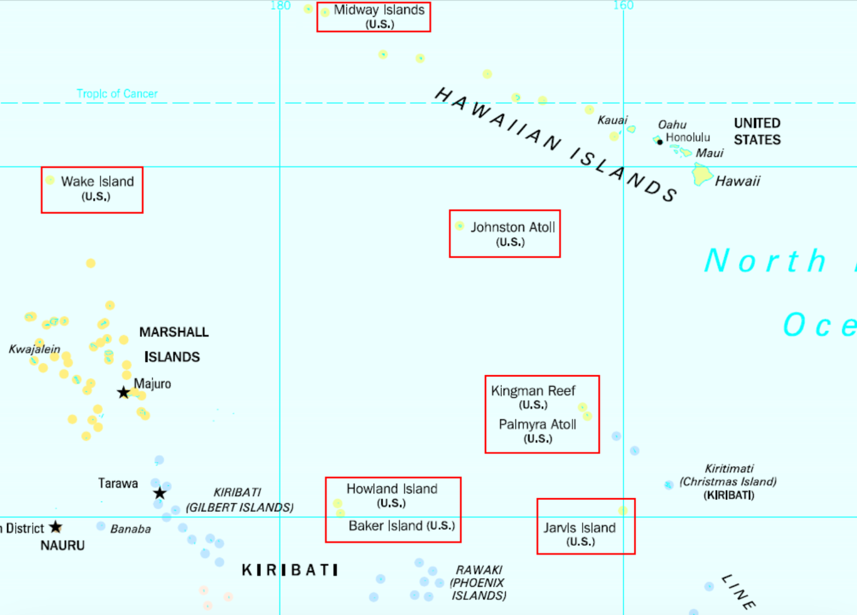
From simple.wikipedia.org
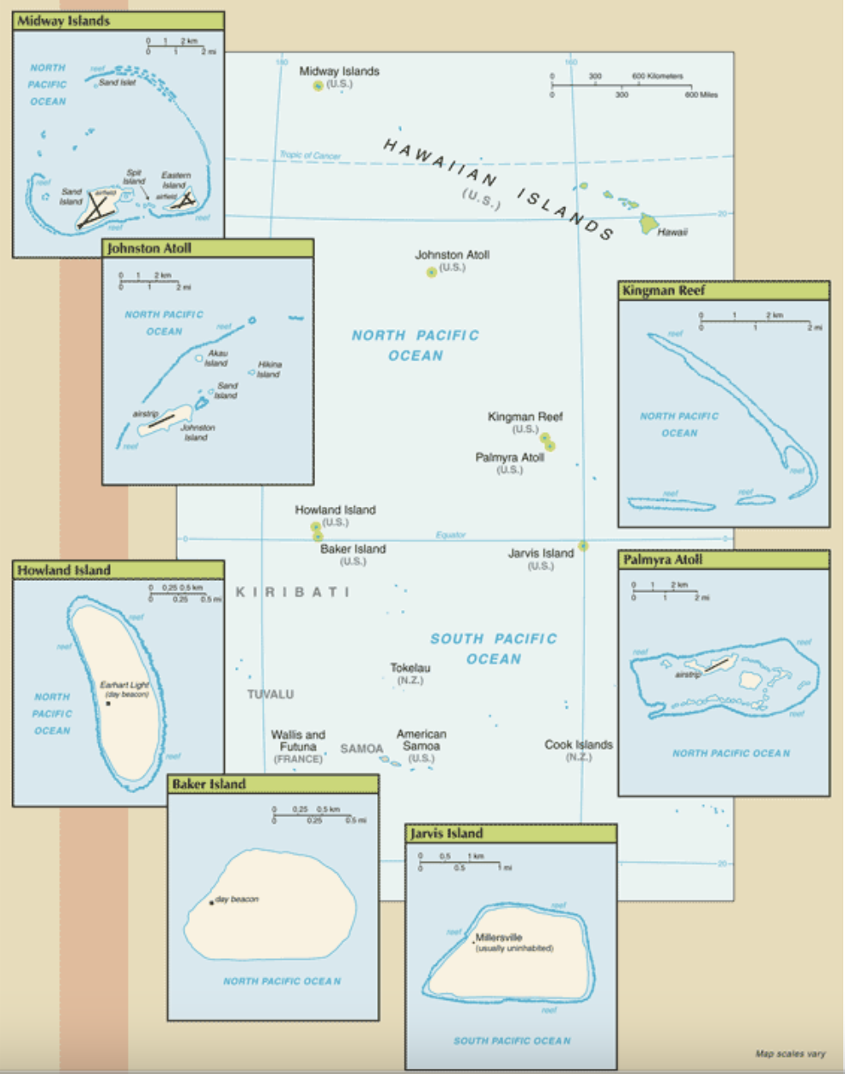
From this site
Navassa Island:
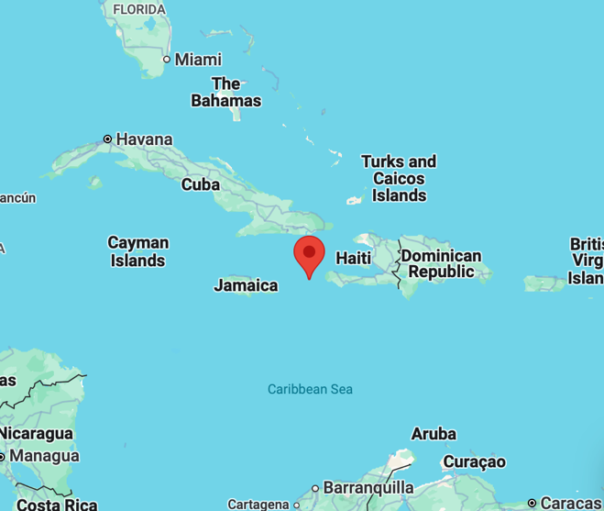
From google maps

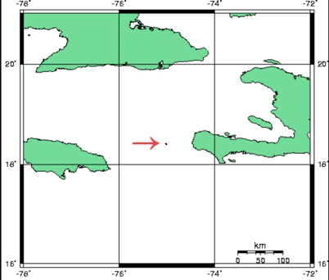
From commons.wikimedia.org

