Georgia O’Keeffe
12-week Picture Study
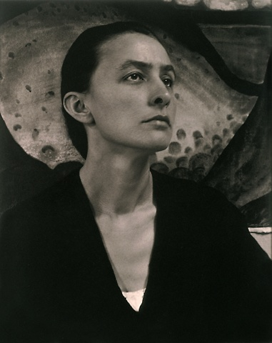
Prepared by Lisa Cotting of amblingtogether.com

Table of Contents
About this Guide 2
Week 1: Biography 3
Week 2: Flowers 3
Week 3: New York 4
Week 4: Bones 5
Week 5: Landscapes 6
Week 6: Hawaii 7
Week 7: Trees 8
Week 8: Other Objects 9
Week 9: Abstract 10

About this Guide

How I Use this Guide:
I have created 9 categories (or weeks) worth of paintings. In each, there are multiple paintings. I plan to have us look at all the painting in the group, but then to spend time reading about and closely observing only one.

Prints / How to Observe the Works:
We will use the links in this document to access the works. If we do not have a print of it (see below), we will view them on the computer screen or share to the large TV for viewing.
We are planning a vacation to Chicago, where we will tour the Art Institute. So, I purchased this collection of O’Keeffe’s paintings. I will also use a calendar for some other paintings.

Other books about Georgia O’Keeffe:
- Gifts from Georgia’s Garden: How Georgia O’Keeffe Nourished Her Art by Lisa Robinson and Hadley Hooper
- Through Georgia’s Eyes by Rachel Rodriquez, Illustrated by Julie Paschkis
- My Name is Georgia: A Portrait by Jeanette Winter
- Wideness & Wonder: A Life and Art of Georgia O’Keeffe by Susan Goldman Rubin – this would be good for older kids, maybe as a free read. I enjoyed getting a more detailed, yet still relatively short, biography.

Week 1: Biography
Read: Georgia O’Keeffe: She saw the world in a flower, Written by Gabrielle Balkan, Illustrated by Josy Bloggs

Week 2: Flowers
“When you take a flower in your hand and really look at it, it’s your world for the moment, I want to give that world to someone else.” – Georgia O’Keeffe
Options for Picture Study:
Jimson Weed 3, 1936
40 x 30 inches

Commissioned by cosmetics executive Elizabeth Arden to hang in the exercise room of the Arden Sports Salon in New York. It is the largest of O’Keeffe’s flower paintings

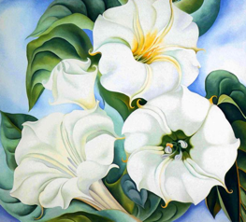

Jack-in-the-Pulpit II, 1930
40 x 30 inches

National Gallery of Art

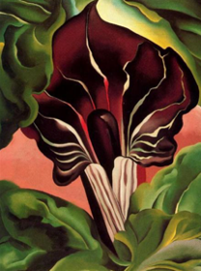

Red Poppy, 1927
7 x 9 inches
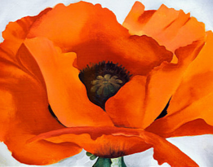

Week 3: New York
The Shelton with Sunspots, NY, 1926
48 x 30 inches

The Art Institute of Chicago – Gallery 271
Audiotour file ; A Closer Look
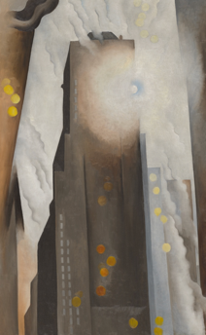
Radiator Building – Night, New York, 1927
48 x 30 inches

Georgia O’Keeffe Museum
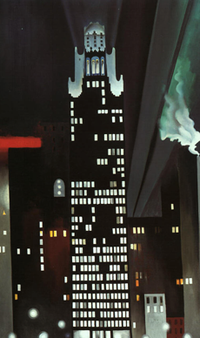

Week 4: Bones
Read: Georgia’s Bones by Jen Bryant, Illustrated by Bethanne Andersen
Options for Picture Study:
Cow’s Skull with Calico Roses, 1931
36 x 24 inches

Art Institute of Chicago, Gallery 265
Audiotour file
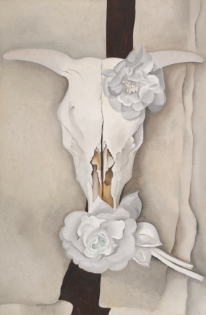
Ram’s Head, White Hollyhock-Hills, 1935
36 x 30 inches

The Brooklyn Museum
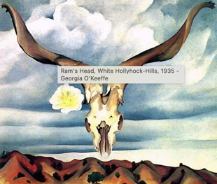
Pelvis IV, 1944
36 x 40 inches

Georgia O’Keeffe Museum
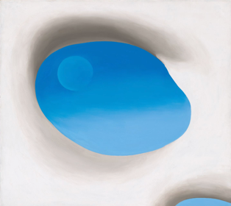
From the Faraway Nearby, 1938
36 x 40 inches

Metropolitan Museum of Art
Audiotour file available in link

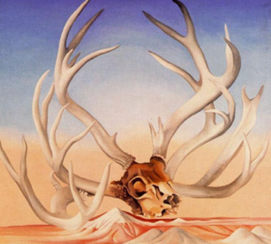

Week 5: Landscapes
Peru- Machu Picchu, Morning Light, 1957
24 x 18 inches

Art Institute of Chicago, Gallery 265
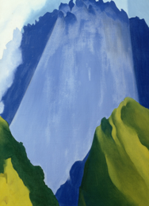
The White Place in the Sun, 1943
28 x 22 inches

Art Institute of Chicago, Gallery 265
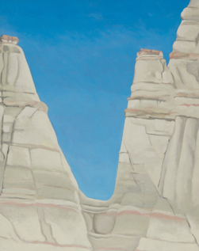
Abiquiu Sand Hills and Mesa, 1945

Art Institute of Chicago
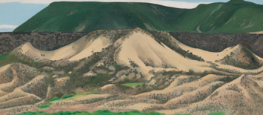
My Front Yard, Summer, 1941

Georgia O’Keeffe Museum
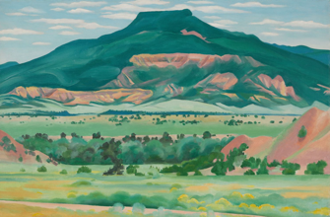

Week 6: Hawaii
Read: Georgia in Hawaii: When Georgia O’Keeffe Painted What She Pleased by Amy Novesky, Illustrated by Yuri Morales
Options for Picture Study:
Pineapple Bud, 1939
19 x 16 inches

Georgia O’Keeffe Museum
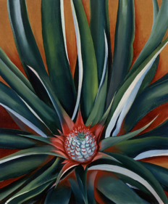
White Bird of Paradise, 1939
19 x 16 inches

Georgia O’Keeffe Museum

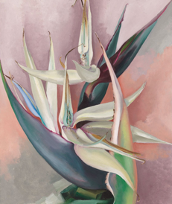
Black Lava Bridge, Hana Coast, No II, 1939

Georgia O’Keeffe Museum

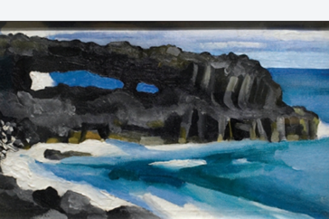

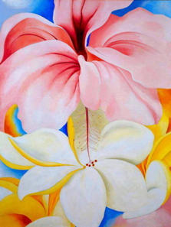
Hibiscus and Plumeria, 1939
40 x 30 inches

Smithsonian American Art Museum, Second Floor, North Wing

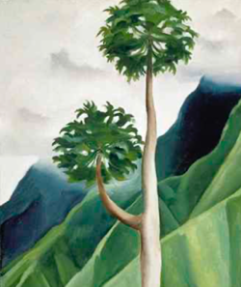
Papaya Tree-lio-valley, 1939
19 x 16 inches

Week 7: Trees

The Lawrence Tree, 1929
39 x 31 inches

Wadsworth Atheneum Museum of Art
A quote from Wideness & Wonder by Susan Goldman Rubin about a camping trip with Frieda Lawrence, widow of D.H. Lawrence:
“I often lay on that bench looking up into the tree – past the trunk and up into the branches,” she wrote. “It was particularly fine night with the stars above the tree.” Later Georgie painted that view from memory…It was one of her favorite paintings.
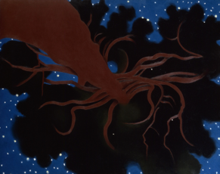

Dead Tree with Pink Hill, 1945
30 x 40 inches

The Cleveland Museum of Art
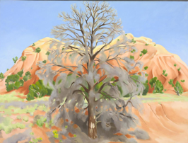
Stump in Red Hills, 1940
30 x 24 inches

Georgia O’Keeffe Museum
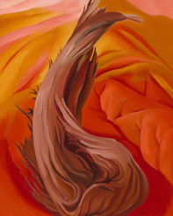

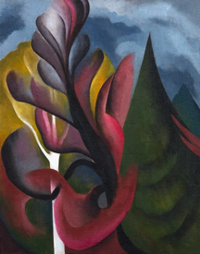
Maple and Cedar, Lake George, 1922
25 x 20 inches

Kemper Museum of Contemporary Art

Week 8: Other Objects
Sky above Clouds IV, 1965
96 x 288 inches
Art Institute of Chicago, Gallery 249


White Shell with Red, 1938
21 x 27 inches
Art Institute of Chicago
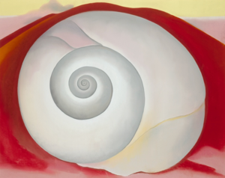
Yellow Hickory Leaves with Daisy, 1928
29 x 39 inches

Art Institute of Chicago
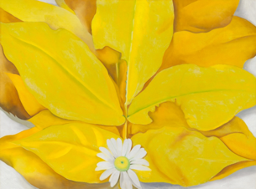
Black Rock with Blue Sky and White Clouds, 1972
36 x 30 inches

Art Institute of Chicago
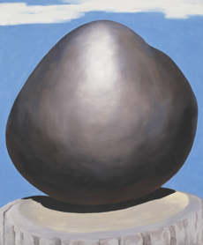
Apple Family-2, 1920
8 x 10 inches

Georgia O’Keeffe Museum
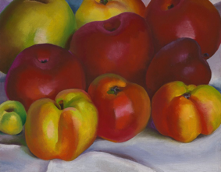

Week 9: Abstract
Blue and Green Music, 1919-1921
23 x 19 inches

Art Institute of Chicago, Gallery 271
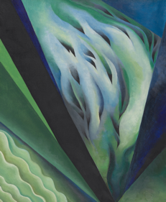
Music – Pink and Blue No. 2, 1918
35 x 29 inches

Whitney Museum of American Art
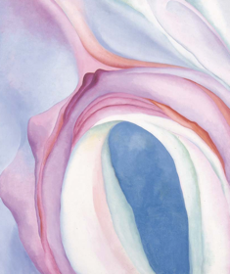
Grey Lines with Black, Blue and Yellow, 1923
48 x 30 inches

Museum of Fine Arts, Houston, Nancy and Rich Kinder Building, Gallery 203
