Picture Study
in Preparation for a Visit to the



Table of Contents
About this Guide 3
Gallery 171 4
Gallery 213 4
Gallery 216 4
Gallery 237 5
Gallery 240 5
Gallery 241 5
Gallery 243 6
Gallery 247 6
Gallery 249 6
Gallery 262 7
Gallery 263 7
Gallery 273 7
Gallery 391 8
Off View 8
Map and Tour Plan 10

About this Guide

We are taking a family vacation to Chicago and planning on visiting the Art Institute of Chicago. I love wondering a museum to see what we see, but since the Art Institute is so large and there are several pieces we want to make sure to see, I have made a plan.

This is a detailed plan showing which pieces we want to see, which gallery they are in, and which order to see them. I know we will not necessarily follow the plan exactly. This was an exercise to see if it would be possible to see our favorites without spending more time in the museum than is fun for the boys. I hope we can wonder around a little and discover new favorites as well.

I wrote this guide so that we can spend the several weeks leading up to our trip looking at one painting each day in Together Time. I hope that our museum visit will feel a little like a mix between a scavenger hunt and visiting old friends. I am sharing this as an example for how others might like to prepare for a special museum trip.

Gallery 171
The Herring Net by Winslow Homer
1885
30 x 48 inches

Auidotour file 352 and 421 ; Resource Packet ; American Art Teacher Manual

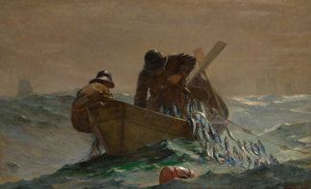

Zenobia, Queen of Palmyra by Harriet Hosmer
1859
34 x 22 x 12 inches

Biographical information
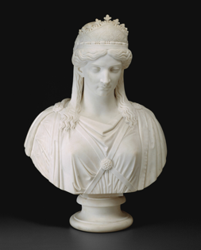

Gallery 213
Old Man with a Gold Chain by Rembrandt van Rijn
1631
32 x 29 inches

Auidotour file
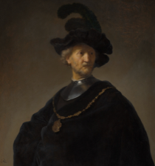

Gallery 216
Portrait of a Man in Costume by Jean-Honorė Fragonard
1767-68
31 x 25 inches

Auidotour file
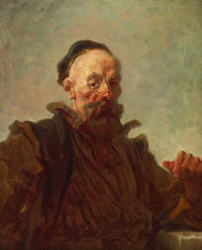

Gallery 237
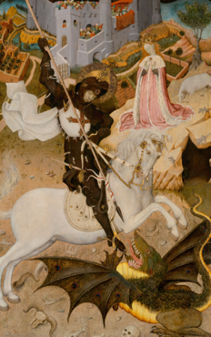
Saint George and the Dragon by Bernat Martorell
1434-35
61 x 38 inches

Auidotour file ; Educational Handout

Gallery 240
A Sunday on La Grande Jatte – 1884 by Georges Seurat
1884-1886
81 x 121 inches

Auidotour file ; A Closer Look
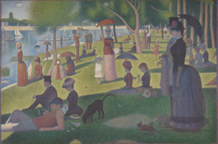

Gallery 241
Self-Portrait by Vincent van Gogh
1887
16 x 12 inches

Auidotour file
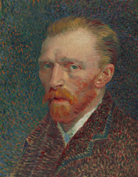

Gallery 243
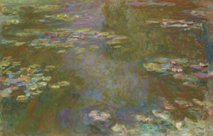
Water Lily Pond by Claude Monet
1917-1919
51 x 79 inches

AIC Video: Beyond the Surface – Discovering Monet (7:39 min)

Gallery 247
Te raau rahi (The Big Tree) by Paul Gauguin
1891
28 x 36 inches

Audiotour file

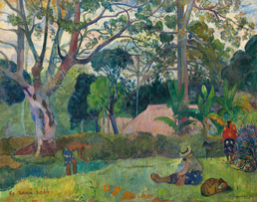

Gallery 249

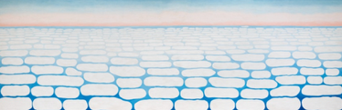
Sky above Clouds by Georgia O’Keeffe
1965
96 x 288 inches

Other O’Keeffe Paintings (See O’Keeffe Artist Study for more details):
Cow’s Skull with Calico Roses, Gallery 265
Peru – Machu Picchu, Morning Light, Gallery 265
Blue and Green Music, Gallery 271
The Shelton with Sunspots, N.Y., Gallery 271

Gallery 262
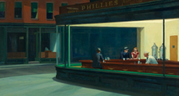
NIghthawks by Edward Hopper
1942
33 x 60 inches

Auidotour file ; American Art Teacher Manual

Gallery 263
American Gothic by Grant Wood
1930
30 x 25 inches

Auidotour file
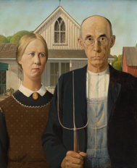

Musician and Dancer by Augusta Savage
1939
About 15 x 6 inches
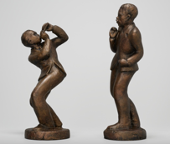
Weaving by Diego Rivera
1939
About 15 x 6 inches

Auidotour file ; A Closer Look
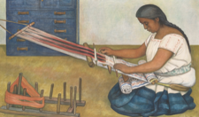

Gallery 273
The Child’s Bath by Mary Cassatt
1893
39 x 26 inches

Auidotour file ; American Art Teacher Manual
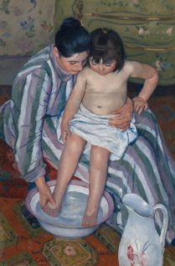

Gallery 391

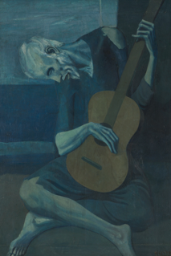
The Old Guitarist by Pablo Picasso
1903-4
48 x 32 inches

Audiotour file (also discusses Mother & Child in Gallery 394)

Off View
Starry Night and the Astronauts by Alma Thomas
1972
60 x 53 inches

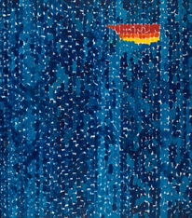
Under the Wave off Kanagawa by Katsuhika Hokusai
1830-33
10 x 14 inches

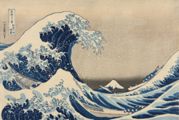

Map and Tour Plan
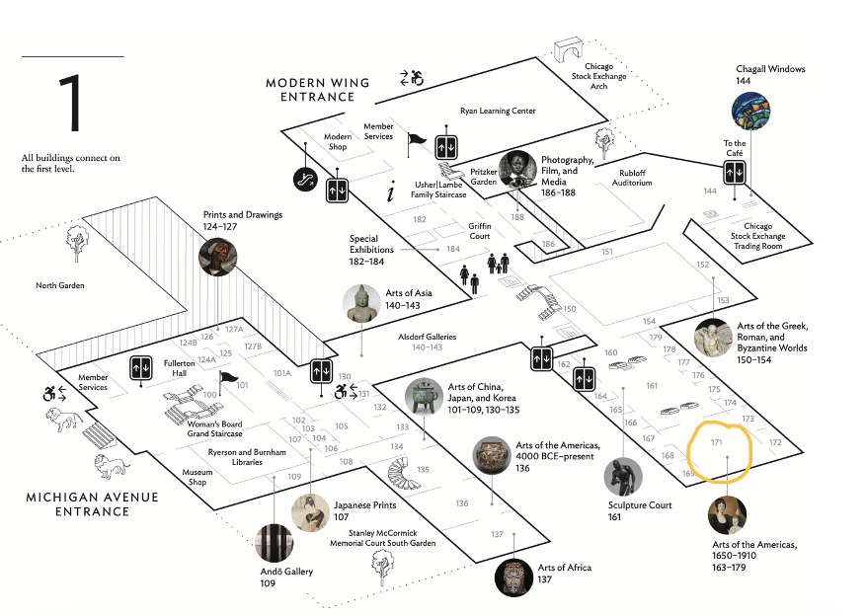
Museum Map and Visitor Guide
Walking Plan:
Start at Michigan Ave Entrance
Proceed through to Gallery 171
Go upstairs in Gallery 171 to Galleries 262 – 273
Descend back to Gallery 171 to stairs in Gallery 151 to Level 2 and Gallery 249
Proceed to stairs in Gallery 299
View Gallery 391
Descend back down the stairs and return to Gallery 249
Continue through Gallery 247 – 240
Turn right to get to Gallery 237
Back track to Gallery 234, turn right and proceed to the front of the building to view Gallery 213 and 216
Descend through Grand Staircase to Museum Store and Exit on Michigan Ave

