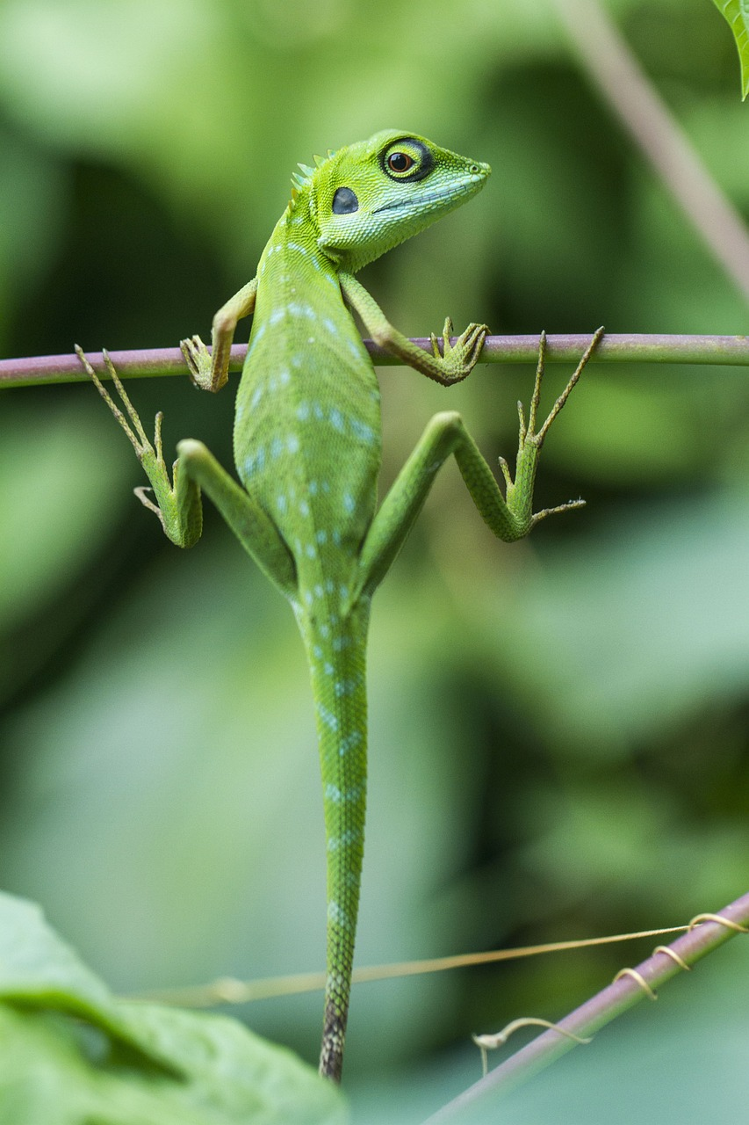
Prepared by Lisa Cotting
Amblingtogether.com
Reptiles
Nature Study Schedule
School Year 2025/26: Term 1

Table of Contents
About This Guide 2
Week 1: Reptile Taxonomy 3
Testudines - Characteristics 3
Testudines – Turtles 3
Testudines - Tortoises 4
Tuatara 4
Squamata – Lizards (characteristics) 4
Squamata – Lizards (types) 5
Squamata – Snakes (characteristics) 5
Squamata – Snakes (types) 6
Crocodylia 6
Crocodylia 7
Dinosaurs 7
Taxonomy chart 8
Reptile Characteristics 9
Anatomy Diagrams 10
Turtles 10
Lizards 11
Snakes 13
Crocodilians 15

About This Guide
Prepared for: 2025-26 Term 1 for AO 7 and AO 4 children who live in Southern California

How I will do the Reptile Study:
In its description of nature study, Ambleside Online states “Nature Study at its simplest is time in nature, observing the natural world around us. It is not a one-time event; rather, it is a habit of being outdoors on a regular, consistent basis over weeks, months, and years. It is a process of getting to know the natural world around us through first-hand, personal experience. Nature, or creation, is worth knowing personally. No textbook, no nature video can replace its significance in our children's lives.”

In order to keep with this idea, a “reptile nature study” where we live is going to have to be very flexible. We sometimes see lizards dash in front of us on nature walks, and my parents are caretakers to a desert tortoise. Other than that, we don’t have much contact with reptiles. But if I am not intentional about it, a “reptile nature study” will never happen. So, I am writing this 12-week object lesson schedule about reptiles so that when we get to see a reptile, we will have some language to describe them and hints on what to look for more closely. I plan to spend about 20 minutes a week learning a little about the types of reptiles, take 3 or 4 field trips to see reptiles in zoos, rescue centers or pet stores, and be as observant as possible on our nature walks.

Using these Resources:
- Handbook of Nature Study (HoNS – pages listed below are from my paper copy)
- Reptiles and Amphibians by Mark O’Shea & Tim Halliday
- Sea Turtles to Sidewinders: A Guide to the Most Fascinating Reptiles and Amphibians of the West by Charles Hood, Erin Websteen, and José Gabriel Martínez-Fonseca
- Junior Science Book of Turtles by Henry Hill Collins, Jr (available on archive.org) – for Free Read
- California Lizards and How to Find Them by Emily Taylor
- All About Snakes by Bessie M. Hecht
- Alligators and Crocodiles by John Wexo (1989 edition) – available on archive.org
- The Usborne World Atlas of Dinosaurs - available on archive.org
- Joan Procter, Dragon Doctor: The Woman Who Loved Reptiles by Patricia Valdez
- Reptiles do the Strangest Things by Leonaora and Arthur Hornblow - for Free Read
- The Moon of the Alligators by Jean Craighead George – for Nature Lore

Observation Ideas: Reptile house at zoos (Los Angeles Zoo, The Teaching Zoo at Moorpark College, The Reptile Zoo), Reptile rescues (Star Eco Station, Desert Tortoise Research Natural Area, TortoiseLand), local ponds for turtles, and local pet stores for lizards & lizards. For Dinosaurs, we’ll go to the Natural History Museum and/or the Alf Museum of Paleontology.

Week 1: Reptile Taxonomy
Preparation: Read HoNS pg. 193-194
Study: Characteristics of all Reptiles (see graphic at end) ; taxonomy chart (see graphic at end)
Watch: What Exactly is a Reptile? (1:39 min) ; All About Reptiles (2:11)
Additional Resources: Smithsonian National Zoo Video: I Wonder – What is a reptile (7:10 min) ; Video: All About Reptiles: Classification and Adaptation (8 min)

Testudines - Characteristics
Preparation: Read HoNS pg 204-209
Study: Turtle anatomy diagram (at end of document) ; Families of Turtles
Vocab: Carapace, Plastron, Scutes
Watch: Turtle Anatomy 101 (12:34 min)
Additional Resources: Article – What’s the difference between turtles, tortoises and terrapins? ;Video - Turtle, Tortoise, or Terrapin? (5:52 min) ; Turtle vs Tortoise graphic

Testudines – Turtles
Read (or assign as free read): Junior Science Book of Turtles by Henry Hill Collins, Jr (available on archive.org)
Watch: Pond Slider Turtle facts (3:45 min) ; How do turtles breath underwater? (1:20 min) ; Turtles breath underwater with Cloacal Respiration (1:24 min) ; What’s Inside a Turtle Shell? (3:37 min)
Observe: Draw the carapace pattern of the turtles you observe - how many scutes, what colors, what graphic pattern, are the edges smooth or scalloped. (see this photo for example of different patterns) Is the carapace flat or rounded? Notice how it walks – on its toes or flat? How does it retract into its shell?
Additional Resources: Book – Sea Turtles Hatching by Katherine Orr (available on archive.org) ; Book – Sea Turtle Swims the Ocean by William M. Stephens and Peggy Stephens (available on archive.org) ; Sea Turtle Identification Key graphic ; Sea Turtle shell and snout graphic ; Video: The Matamata Turtle (2:27 min)

Testudines - Tortoises
Observe: How does it walk? How does it move its head? Watch it bite, chew, and swallow. What are its teeth like? How many claws does it have? Notice its eyes and how it blinks (Questions based on HONS pg. 209)
Vocab: Brumation, Aestivation
Watch: Tortoises ARE Turtles (11:15 min) ; Video from Joshua Tree NPS: Desert Tortoise 101 (11:56 min, at least through min 5)
Additional Resources: Book: Galapagos George by Jean Craighead George ; Video: Do Tortoises Like Being Touched? (1:18 min) Video: The World Used to Be Full of Giant Tortoises (5:39 min) ; Video from Joshua Tree NPS: Desert Tortoise 101 (11:56 min) ; Video: Brumation vs Hibernation – What do Reptiles Do In the Winter? (4:30 min)

Tuatara
Read: The Lifecycle of the Tuatara by Betty Browlie (available on archive.org)
Watch: What On Earth Is A Tuatara? Modern Dinosaurs (7:40 min)
Additional Resources: Video: The Small, Slow Tuatara is Top Predator in its Ecosystem (2:19 min) ; Video: Hatching of Ancient Tuatara Reptiles (3:29 min) ; Video: Tuatara Time! Face to Face with a Living Fossil (8:36 min)

Squamata – Lizards (characteristics)
Preparation: Read HoNS pg. 210-213
Read: “What Are Lizards” section of California Lizards (start on pg. 5) or lizard info from other guidebook(s) ; Why Do Lizards Do Pushups
Study: Lizard anatomy (see diagrams at end of document)
Vocab: gular fold, dewlap, cloaca, tympanum (ear hole), autotomy (ability to regrow appendage)
Watch: Why is This Lizard Doing Push-Ups? (1:47 min) ; Why Do Lizards Lose Their Tails (1:00 min) This is Why Lizards Sunbathe (3:36 min)
Additional Resources: Home Science Tools Lizard Specimen ; Video: Why These Cute Little Lizards are Changing Colors to Survive (2:15 min) ; Video: These Lizards Have Been Playing Rock-Paper-Scissors for 15 million years (3:24 min) ; Video: How lizards balance keeping their tails on and peeling them off (4:13 min) ; How do lizards regrow their tales? (8:05 min) ; Definitions: Gular fold vs dewlap

Squamata – Lizards (types)
Study: Lizard families (also, see diagrams at end of document)
Read: Pick a couple of lizards you are likely to see and read the descriptions in a field guide
Watch (choose several): The Lizard’s Tale 101: Meet the Anoles (6:22 min) ; Why Geckos Are Sticky Without Being Sticky (8:54 min) ; Largest Lizard on Earth/ The Komodo Dragon (4:01 min) ; Monster Bites (3:02 min) ; Swimming Marine Iguanas (4:30 min) ; Jesus Christ Lizard (1:25 min) ; Flying Dragons of the Jungle (2:07 min) ; David Attenborough’s perplexing history of the chameleon (2:48 min) ; Blue Tongued Skink: The Dragon with a Blue Tongue (7:33 min)
Observe: What colors and patterns do you see? Was the top different from the bottom? How long is its tail compared to its body? Where did you find it (sun/shade)? How did it move? Describe its blinks. If you saw its tongue, was it forked?
Additional Resources: Video: The Difference Between Legless Lizards and Snakes (6:09 min) ; Meet the Ninja Gecko (1:37 min) ; Up Close with Gila Monster (1:36 min) ; USGS – Gila Monster (4:02 min) ; How This Lizard Performs a Miracle (16:13 min) ; Chameleons are Amazing (3:38 min) ; The Bizarre Beast with Glowing Bones (6:51 min); An Alpine Lizard? Meet the Guthega Skink (1:20 min)

Squamata – Snakes (characteristics)
Preparation: Read HoNS pg
Read: A description of snakes from your field guide ; read Ch 7 of All About Snakes (and/or assign book as Free Read)
Study: Snake Movement (see diagram at end) ; Anatomy (diagrams at end)
Vocab: Spectacles, Dorsal scales, Ventral scales, Subcaudal scales, Cloaca, Fangs, Glottis
Watch: How Snakes Move! (6:53 min) ; The Twisted Truth About Snake Tongues (4:31 min) ; How do snakes swallow big things? (3:02 min) ; The Incredible Way Snakes Shed Their Skin (2:34 min)
Additional Resources: Home Science Tools Snake Specimen ; Why do snakes shed their skin? (6:38 min) ; How a Snake Eats (1:30 min) ; How Do Snakes Digest Their Food? (5:33 min) ; How Do Female Snakes Pick a Mate? (2:50 min) ; Deadliest Job in America – Snake Milker! (11:25 min) ; Why do snakes have fangs (1:28 min)

Squamata – Snakes (types)
Read: choose a snake you might see and read the field guide description (For Western U.S., Sea Turtles to Sidewinders descriptions are engaging) ; take a look at the different snake families - Snake families
Watch (choose several): The adaptations of sea snakes (2:34 min) ; The Eastern Coral Snakes (7:34 min) ; Terrifying: The Venomous Sidewinder Snake Slithers at 18mph (3:09 min) ; The Anaconda is a Heavyweight of Snakes (3:36 min) ; The amazing grass snake (4:12 min) ; The Cascabel Rattlesnake (2:53 min)
Observe: How is the snake moving? What does its tongue look like? Notice its eye shape and lack of eyelids. Where did you find it? What shape was it in when you found it? Draw and/or describe the shape of its head and the pattern of its scales. If possible, what do its scales feel like? Can you tell where its tail starts?
Additional Resources: Look Inside a Rattlesnake’s Rattle (4:19 min) ; Watch Two King Cobras Romance Each Other (2:17 min) ; Rattlesnake Love (2:48 min) ; Male Garter Snake Tricks Other Males With His Female Scent (3:54 min) ; Awesome King Cobra (3:35 min) ; Sidewinder Snake Hides in Sand (1:45 min) ; Pythons 101 (4:37 min) ; Catching the Deadly Black Mamba (7:07 min)

Crocodylia
Read: Pg 8-11 and 20-21, Alligators and Crocodiles by John Wexo (1989 edition) – available on archive.org or Field Guide info on Crocodylia
Study: Differences in types (chart in Wexo book pg 8-11, or at end of document)
Watch: Crocodile vs Alligator vs Caiman vs Gharial (3:19 min) ; Crocodile Mom Scoops Up Babies in Mouth (2:29 min) ; Cameras Capture the Birth of 15 Alligators (3:24 min) ; Why Gharials Are the Best Dads Ever (2:23 min)
Additional Resources: Every Species of Alligator, Crocodile, Caiman and Gharial! (31:36 min) ; Wildlife Episode 2: Crocodiles, Alligators, Caimans & Gharials (52:00 min) ; Meet Henry, the world’s oldest crocodile (2:27 min) ; Moving the Biggest Croc At Australia Zoo (7:58 min) ; It’s a Rough Life for Baby Crocs (2:38 min) ; Sneaky croc camera captures incredible footage (3:02 min) ; Watch Baby Alligators Hunt at Night (3:03 min) ; Baby Caimans Face Exhausting “Marathon” To Find Safety (4:25 min)

Crocodylia
Read: Book on Archive.org: Alligators and Crocodiles by Erik Stoops and Debbie Stone
Watch: Amazing aestivation: Mugger Crocodile (2:37 min) ; Saltwater VS Freshwater Crocodiles (2:03 min) ; Gharials Are One of the Strangest and Rarest Crocodiles on Earth (5:54 min)
Observation Questions for the zoo: Can you tell if it’s a crocodile, alligator, or gharial without looking at the sign? What is the shape of its jaw? Can you see its teeth? What do its eyes look like? What are its feet like? How long is its tail compared to its body? How big is it? What color is it? Can you describe the scale pattern? Describe what it was doing when you saw it and how it interacted with other animals.
Additional Resources: Top 5 Killer Crocodile Moments (17:45 min) ; Male Croc Mating Dance (2:31 min) ; Giant Crocodilians (4:47 min) ; Robert Irwin feeds our awesome gators (3:22 min) ; An Alligator’s Gourmet Lunch (2:05 min)

Dinosaurs
Read: The Usborne World Atlas of Dinosaurs (available on archive.org), Pg 8-13, 32-38
Watch: The Age of the Reptiles in Three Acts (11:06 min)
Vocab: Mesozoic, Triassic, Jurassic, Cretaceous
Additional Resources: Alf Museum of Paleontology ; Graphic of Geologic Eras ; Dinosaurs 101 (3:47 min) ; The Facts About Dinosaurs & Feathers (10:00 min) ; Prehistoric Planet – Did Velociraptor Have Feathers? (4:32 min) ; Prehistoric Planet – Flamboyant Flyers (5:12 min) ; Prehistoric Planet – Could T.Rex Really Swim? (5:13 min) ; Prehistoric Planet Full Playlist

Taxonomy chart

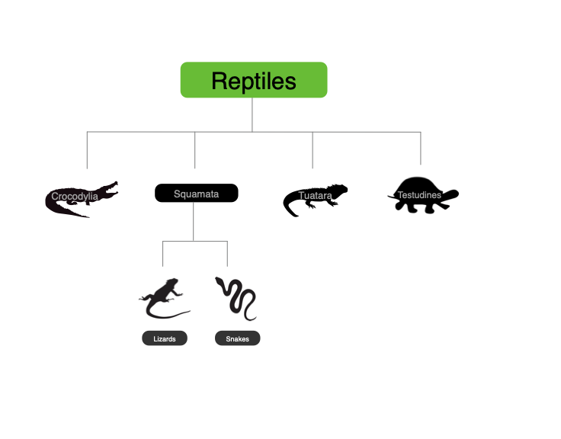

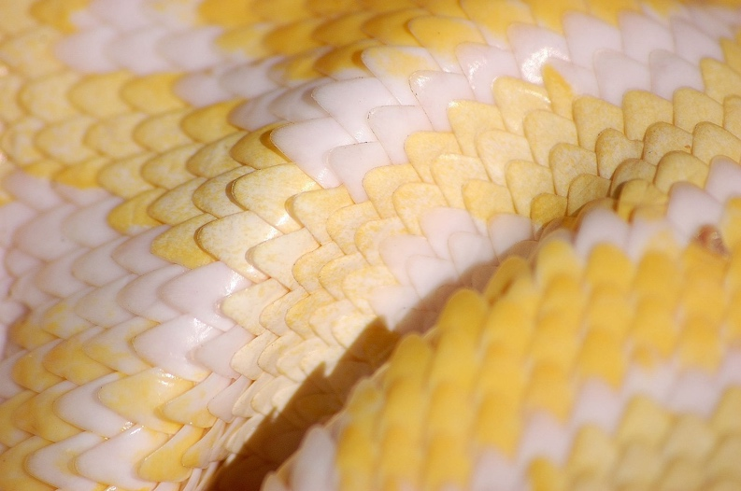
Reptile Characteristics
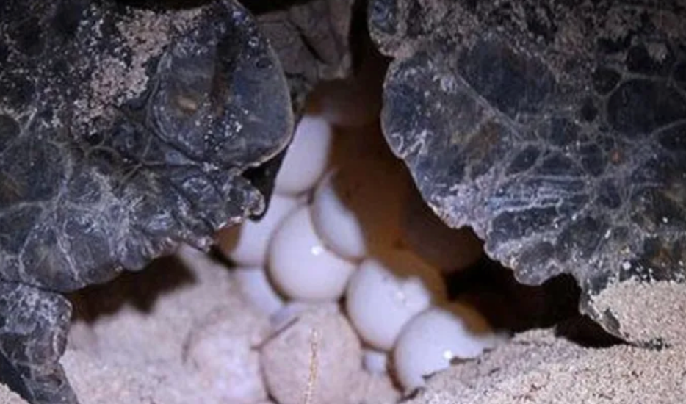
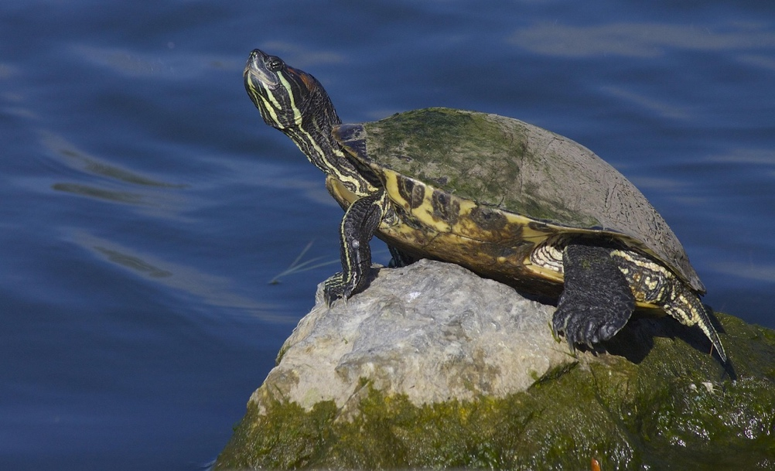
Leathery
Eggs
Scales
Ectothermic

Anatomy Diagrams

Turtles

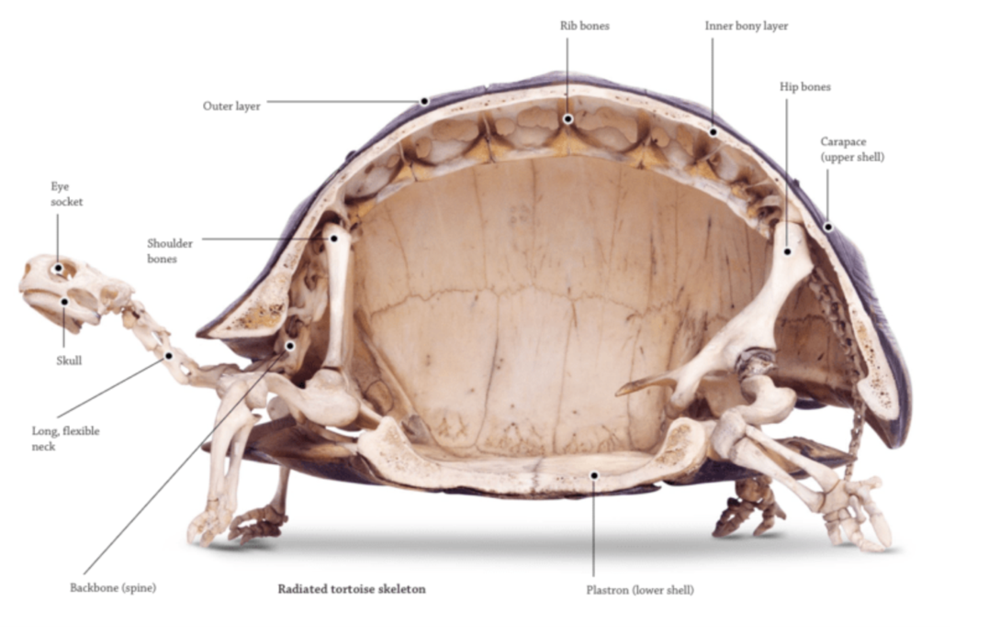
From Chattahoochee Nature Center

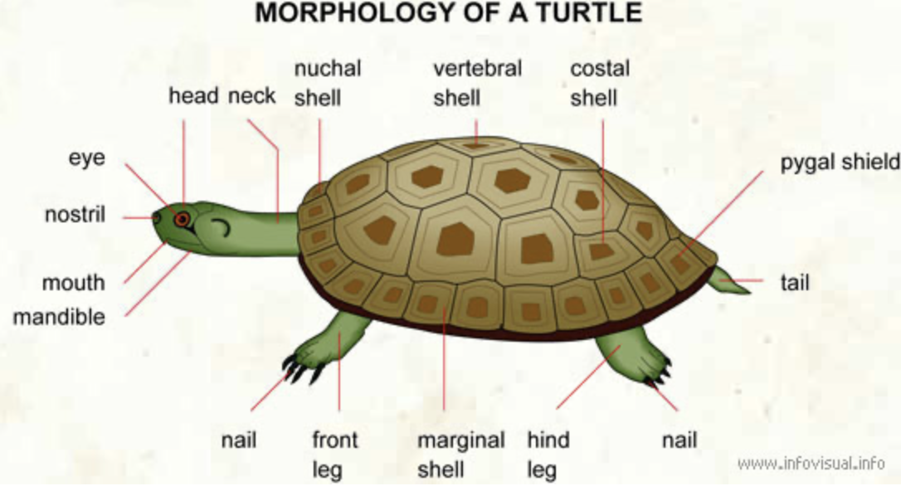
From Fort Collins Museum of Discovery

Lizards

Lizard Body Plans (from Britannica)

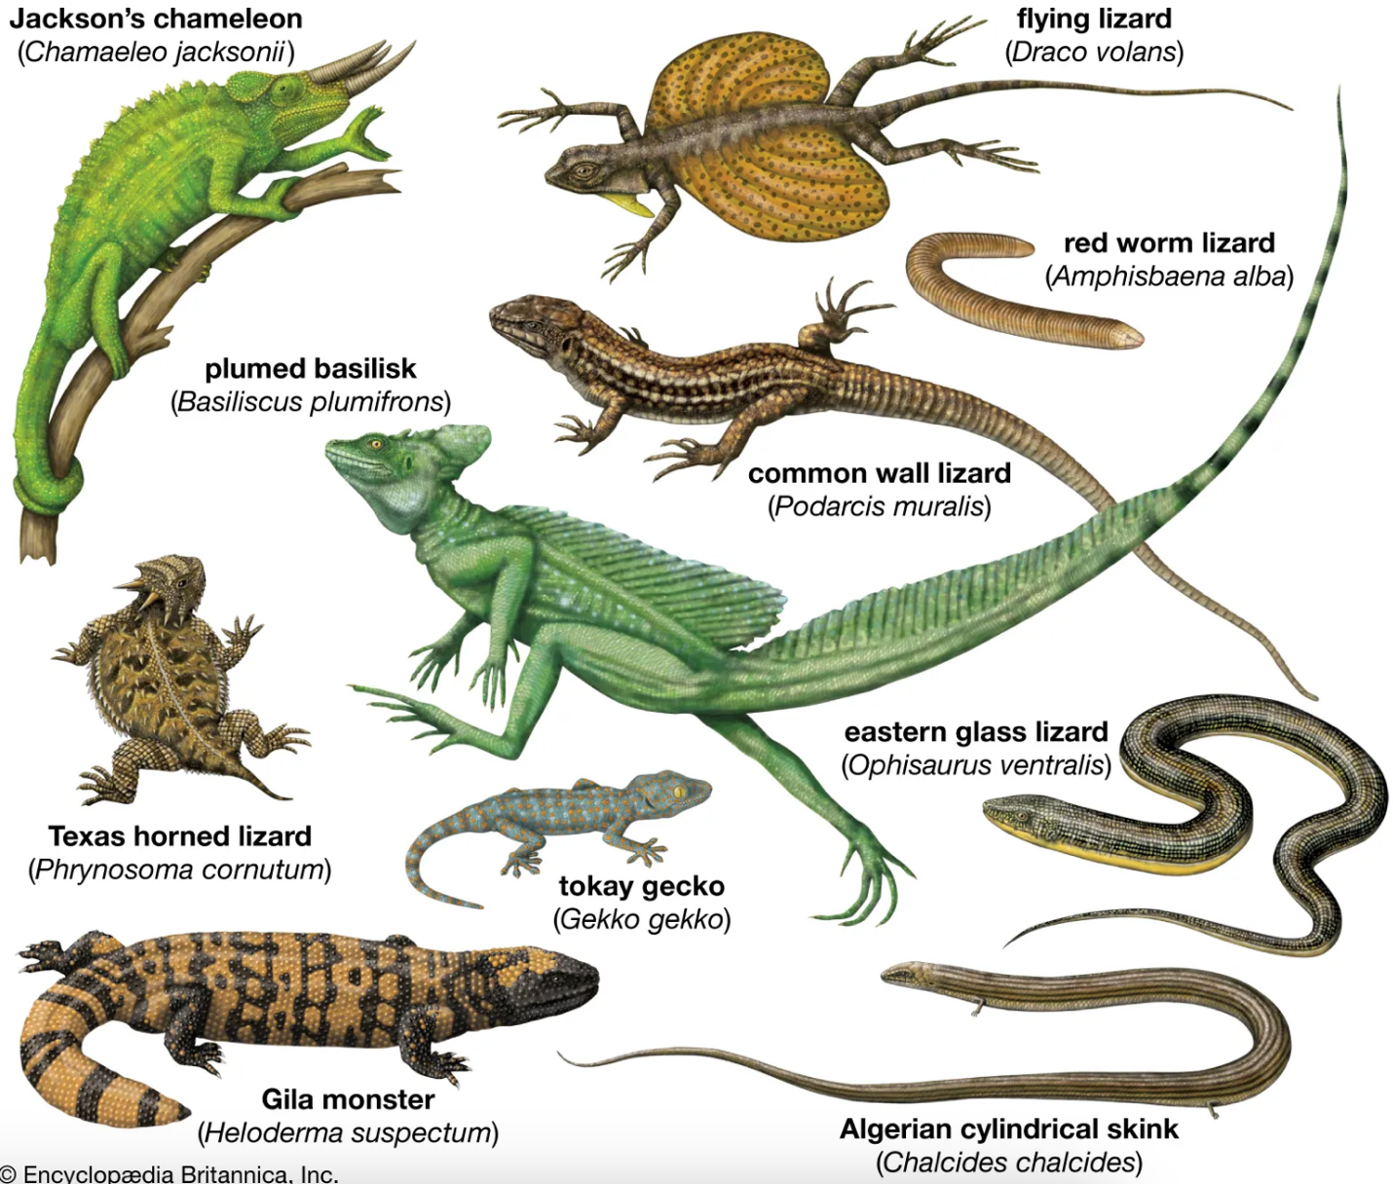

Lizard Anatomy:
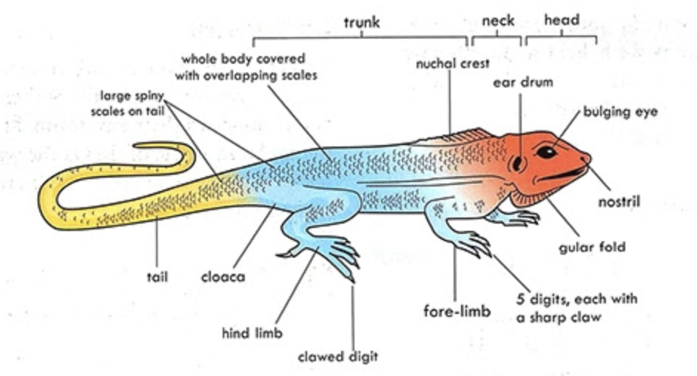
Agama Lizard (from notesforshs.com)

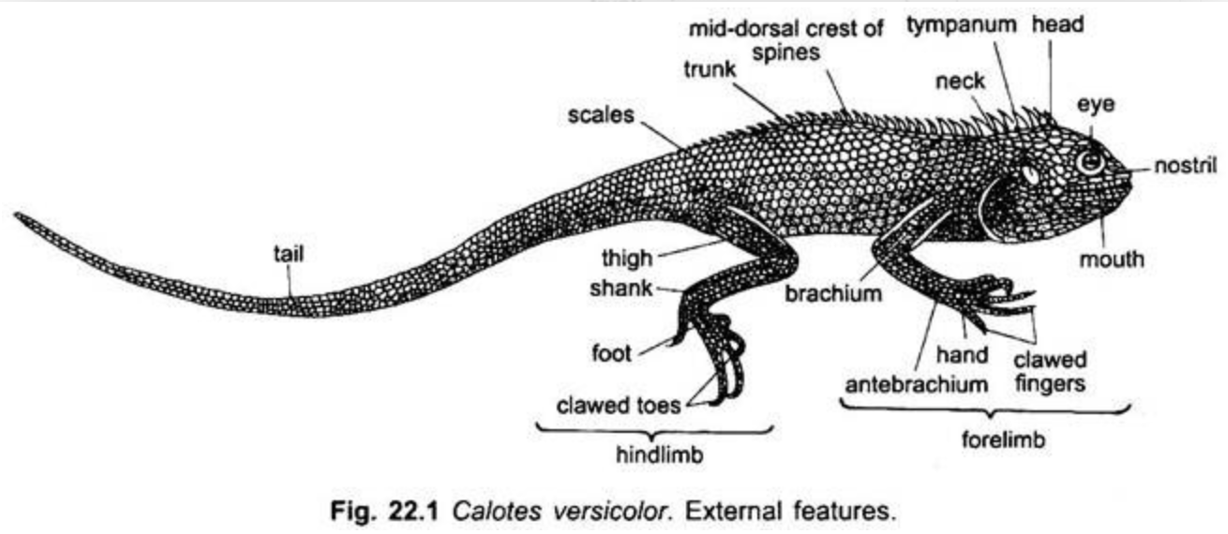
Garden Lizard (from notesonzoology.com)

Snakes

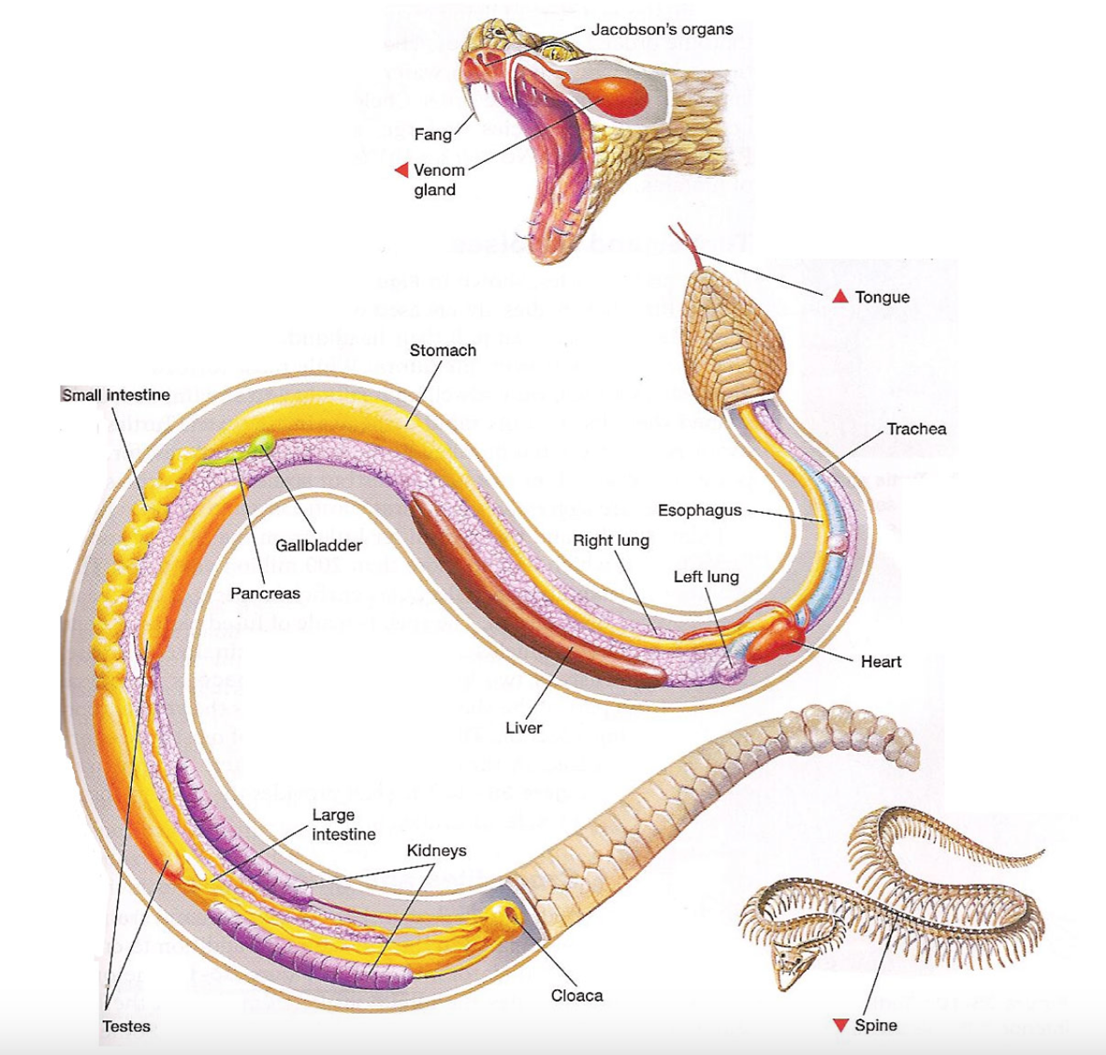
Glottis

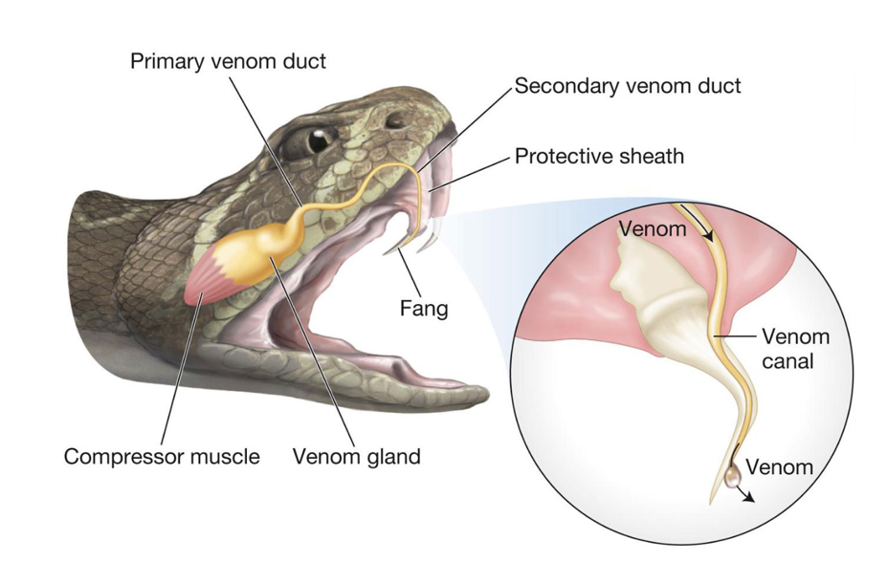

from sciencediagrams.com

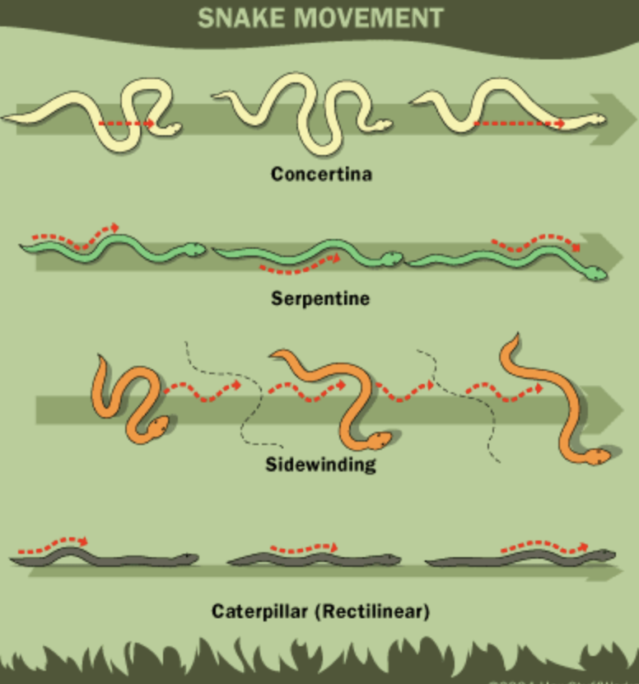

From snakelocomotion.wordpress.com

Crocodilians

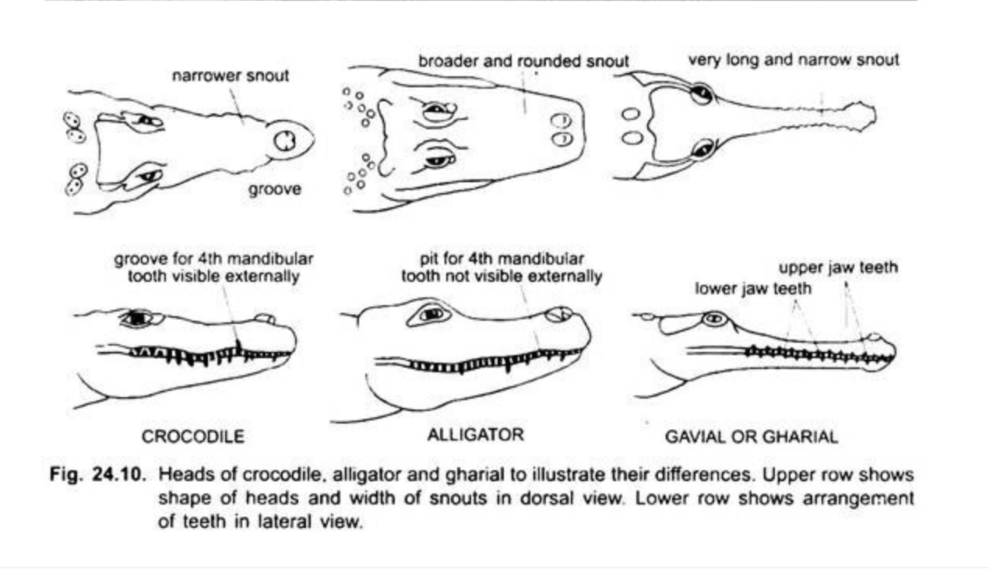

From notesonzoology.com (site includes other charts and helpful descriptions)

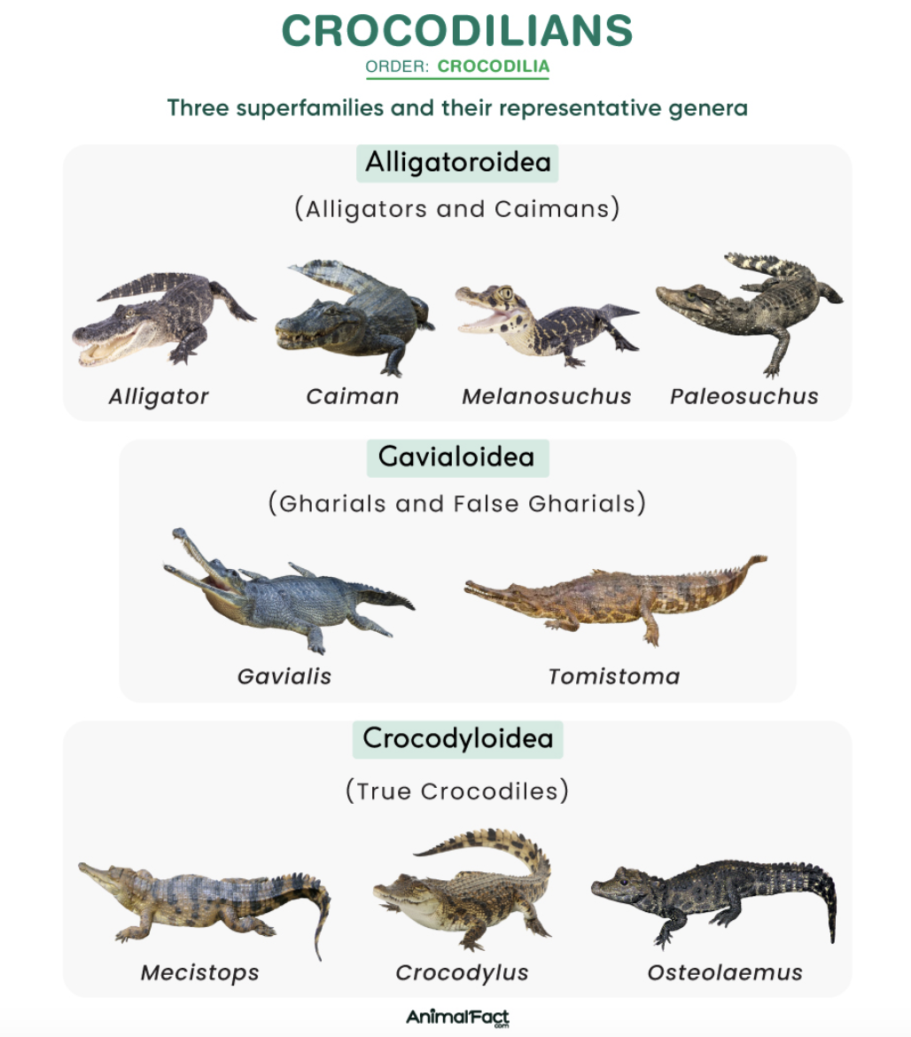

From animalfact.com (article includes other details)

