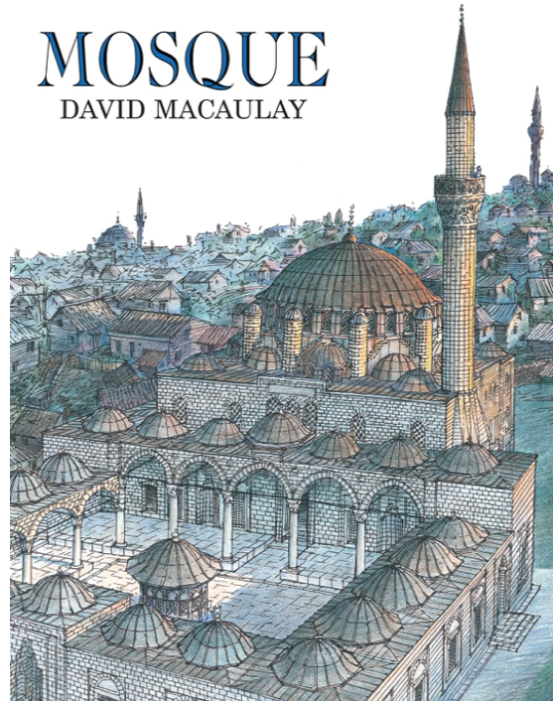

A Study Guide

Prepared by Lisa Cotting
Amblingtogether.com
Basic Mosque Diagram (or see page 12)

Week 1 | Reading: Page 7 | Ottoman Empire Map  Dardanelles & Sea of Marmara Map  Map with Istanbul
Week 2 | Islamic Geometric Patterns | Video: The Complex Geometry of Islamic Design (5:06 min) ; The Grid System of Islamic Patterns (3:07 min)  Tutorials: Geometric Circle, Geometric Mandala (Supplies needed: Paper, Compass)
Week 3 | Mimar Sinam, Architect | Videos: Ottoman Architect Mimar Sinan (3:22 min) ; Mimar Sinan: The Master Architect Who Shaped Turkish History (5:38 min)
Week 4 | Reading: Page 9 – 3rd paragraph on page 10 (end at “…of the prayer hall.”)
Week 5 | Reading: Page 10, start at “For Akif Agha…” – pg. 13
Week 6 | Reading: Page 15-16
Week 7 | Reading: Page 18 | Photos of Hamams and ruins on Wikipedia (last several show paintings of bathers) ; Video: Tour of Sultan Amir Ahmad Bathhouse in Kashan (4:46 min) ; Video: Roman bath heating with hypocaust demonstration
Week 8 | Reading: Page 20-24
Week 9 | Reading: Page 26-32
Week 10 | Reading: Page 34-39
Week 11 | Reading: Page 40-41 | Photo: Stairs inside a minaret
Week 12 | Reading: Page 43-45
Week 13 | Reading: Page 46-48 | Video: Call to Prayer from top of minaret in Sarajevo (1:21 min)
Week 14 | Reading: Page 51-52
Week 15 | Reading: Page 55-57 | Video: Step Inside Iran’s Kaleidoscopic Mosque (1:40 min)
Week 16 | Reading: Page 58 - 61
Week 17 | Reading: Page 62 - 66
Week 18 | Reading: Page 68-70
Week 19 | Reading: Page 73-74
Week 20 | Reading: Page 76-83
Week 21 | Reading: Page 85-87
Week 22 | Reading: Page 88-91
Week 23 | Reading: Page 93-95
Week 24 |  | Video: 15 most beautiful mosques in the world (9:54 min)

