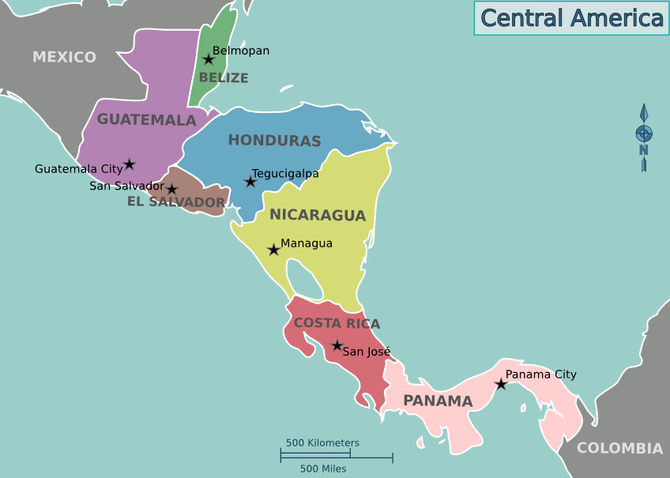
Geography Study:
Mexico &
Central America
Prepared by Lisa Cotting
Amblingtogether.com

Table of Contents
How I Used This Guide 2
Why a study of Central America: 2
How we study each country: 3
Mexico 4
Belize 8
Guatemala 12
El Salvador 15
Honduras 19
Nicaragua 23
Costa Rica 27
Panama 31

How I Used This Guide

Why a study of Mexico & Central America:

Charlotte Mason describes the principle to be followed as the child gets older and starts studying other countries: “vivid descriptions, geographical principles, historical associations and industrial details, are afforded which should make, as we say, an impression, should secure that the region traversed becomes an imaginative possession as well as affording data for reasonable judgements.” (Book VI)

Inspired by this, I have made time in our Together Time to study the geography the major regions or continents of the world (see amblingtogether.com/OtherGuides). For each continent or region, we study the major geographical features and boundaries and then do a brief study of each country therein. I try to find what will make “an impression” so that the country “becomes an imaginative possession” of each child. I decided to focus on mapping the physical features, reading a little about the culture, history, or nature of the country, and watching several videos to compliment these topics.

While using Miss Mason’s principles for teaching geography and choosing which features to map or which books to read and videos to watch, I consider the following goals: We will be familiar with major cities and landmarks – understanding how mountains and waterways divide and define, we will know a little about the original inhabitants of the land, we will have an understanding of what (some of) the country looks like and we will be familiar with some of the stories and culture from the area. I will not cover all of these topics for each territory, but hope that in general we’ll know our world and neighbors in it a little better by the time we’re finished.

How we study each country:

I have spaced this study over 2 terms and scheduled 15-20 minutes one morning a week to read the book, watch the videos, and draw the geographical features on our map. When time permits, we draw the country freehand to help us notice the features of the boarder.

Schedule Options:

2-Term Schedule |  | 1 Term | Country
Week |  | Week | Country
1-4 | 13-16 | 1-2 | Mexico
5-7 | 17-19 | 3 | Belize
8-10 | 20-22 | 4-5 | Guatemala
11-12 | 23-24 | 6 | El Salvador
13-15 | 25-27 | 7 | Honduras
16-18 | 28-30 | 8 | Nicaragua
19-21 | 31-33 | 9-10 | Costa Rica
22-24 | 34-36 | 11-12 | Panama

For each country, we will find it on the globe or atlas, answer questions about its location, look at the shape and geography of the country, then draw and label it. We will also watch videos and/or read books or articles about the country. If finishing in a single term, half of the countries will be done in a single week while the other half have two weeks. If using two terms to complete, each country will have three weeks assigned.

Blank Map of Mexico and Central America from d-maps.com
Placemat sized map for reference

Mexico

About
Mexico in not officially in Central America, but considered part of North America. It has been inhabited by native peoples for tens of thousands of years before European colonizers, the most famous of which are the Maya and Aztecs. In the 1500s, Spanish conquistadors conquer the native peoples and establish Mexico. The territory included much of the Southwestern U.S. and is administered by Spain. In the 1800s, Mexico wins its independence but also ends up ceding its northern territories to the U.S..

Capital: Mexico City
Language: While there is no officially recognized language of Mexico, Spanish is spoken by most of the population, but indigenous languages are also recognized

To Read
* Enchantment of America: Mexico by Frances E. Wood (available on archive.org), Pg. 9-17

Links to View
* Ancient Maya 101: National Geographic (3:52 min)
* Ancient Mayan city in Mexico jungle by accident (2:28 min)
* This Ancient Mayan City Was Home to a Legendary King (2:53 min)
* The Rise and Fall of the Aztec Civilization (3:18 min)
* Tenochtitlan – The Venice of Mesoamerica (8:12 min)
* The Legend of Quetzalcoatl: The Feathered Serpent God (4:16 min)
* Can We Save Mexico’s City Famous Axolotls? (12:10 min, at least through min 3:35)
* Andor’s Diego Luna Shares His Personal Guide to Mexico City (6:14 min)
* This is How America Annexed Most of Mexico (0:46 min)
* The Weird and Wonderful Wildlife of Mexico (7:55 min)
* Food Origin Myths, Debunked (2:47 min)
* Measuring Mangroves (5:31 min)
* The Mesmerizing Creatures of Baja California, Mexico (49:54 min)

Map Questions
- In which hemisphere is Mexico?
- What can we guess about the climate?
- Name the bodies of water around it (6).
- What are the two biggest peninsulas in Mexico?
- Name the mountain ranges (3).
- Between which Latitude lines is Mexico found?
- Locate the capital.
- Which countries boarder it?

Map Drawing
Baja California, Gulf of California, Pacific Ocean, Sierra Madre Occidental, Sierra Madre Oriental, Sierra Madre del sur, Yucatan Peninsula, Gulf of Mexico, Bay of Campeche, Caribbean Sea, Mexico City, Rio Bravo (a.k.a. Rio Grande), Isthmus of Tehuantepec, Gulf of Tehuantepec

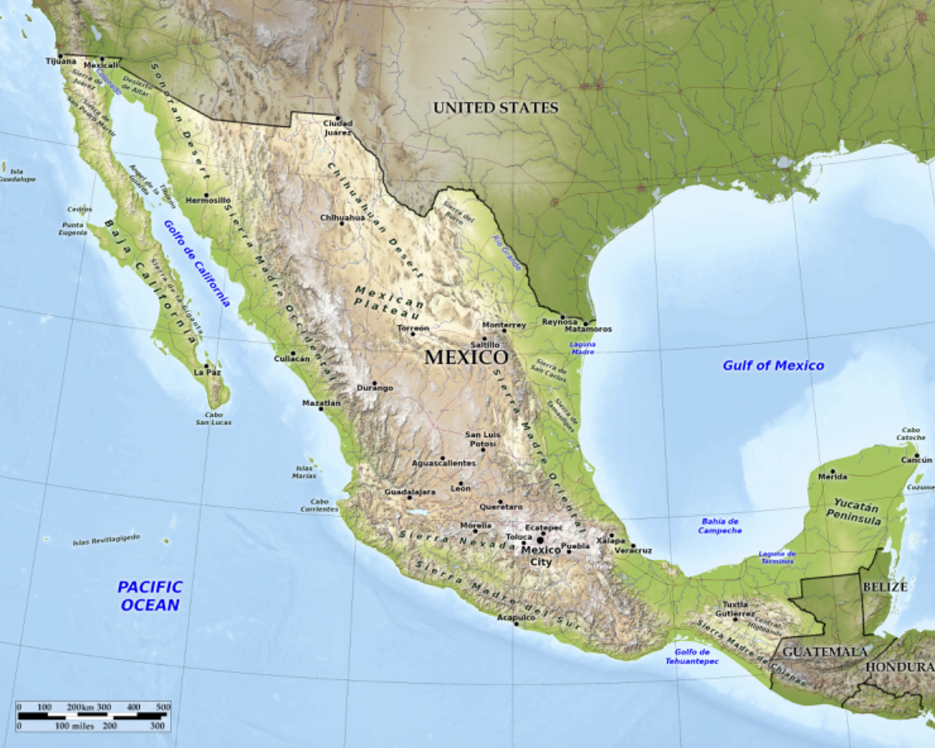

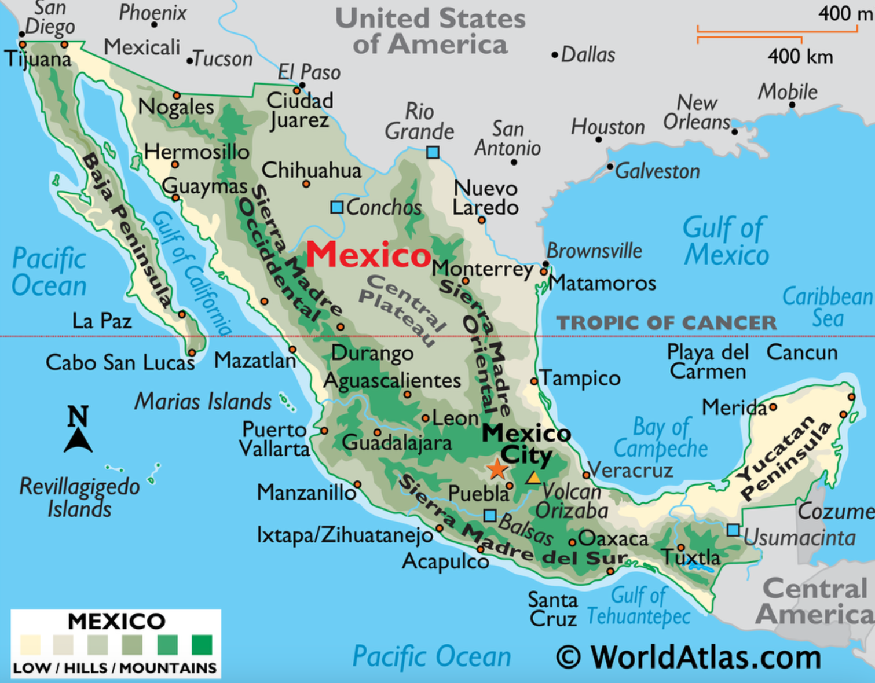

Map of Mexico to fill in

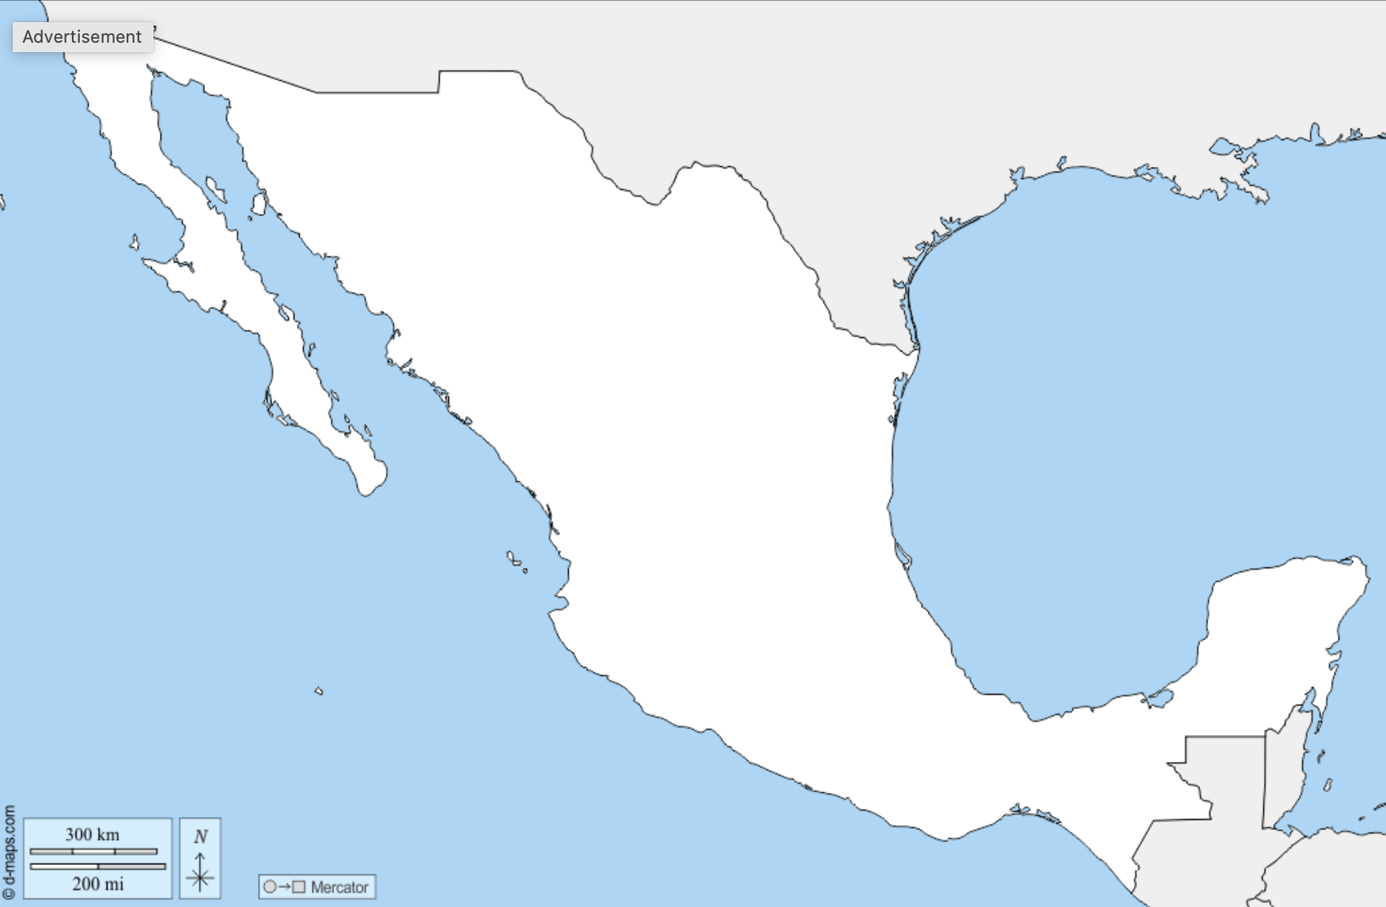

Map from d-maps.com ; also see this one with cities

Belize

About
Located in the south of the Yucatan peninsula, it is on the Caribbean Sea and one of only two Central American nations to have coast only in one Ocean/Sea. Original inhabitants included the Maya. It was a British Colony until 1981, thought it remains part of the Commonwealth. It is known for its tropical jungles and reefs. Its territory includes many islands and cayes (keys).

Capital: Belmopan
Language: English (official), Belizean Creole is considered its vernacular language

Links to View
- The History of Belize (6:37 min)
- Belize Barrier Reef Reserve System (2:48 min)
- What’s At the Bottom of the Great Blue Hole? (3:37 min)
- Climb Ancient Temples in Belize’s Maya Ruins (4:13 min)
- Protecting Jaguars in Belize’s Maya Forest Corridor (12:37 min, at least to 2:56)
- Is the Maya Forest Garden the key to sustainable agriculture? (7:50 min)

Map Questions
- In which hemisphere is Belize?
- Between which Latitude lines is it found?
- What can we guess about the climate?
- Name the bodies of water it is near.
- What is off its coast?
- What is the mountain range called and where is it located?
- Name some major island groups or areas.
- Name the oceanic feature it is near.
- Locate the Belize and Hondo Rivers.
- Which countries boarder it?

Map Drawing
Belmopan, Maya Mountains, Hondo River, Belize River, Caribbean Sea, Gulf of Honduras, Chetumal Bay, Ambergris Caye, Turneffe Islands, Great Blue Hole, Barrier Reef
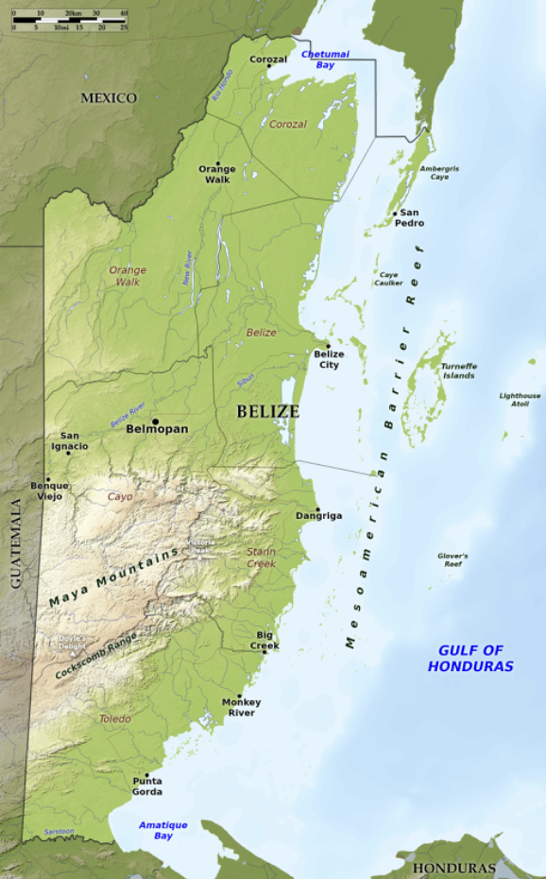

From bluegreenatlas.com

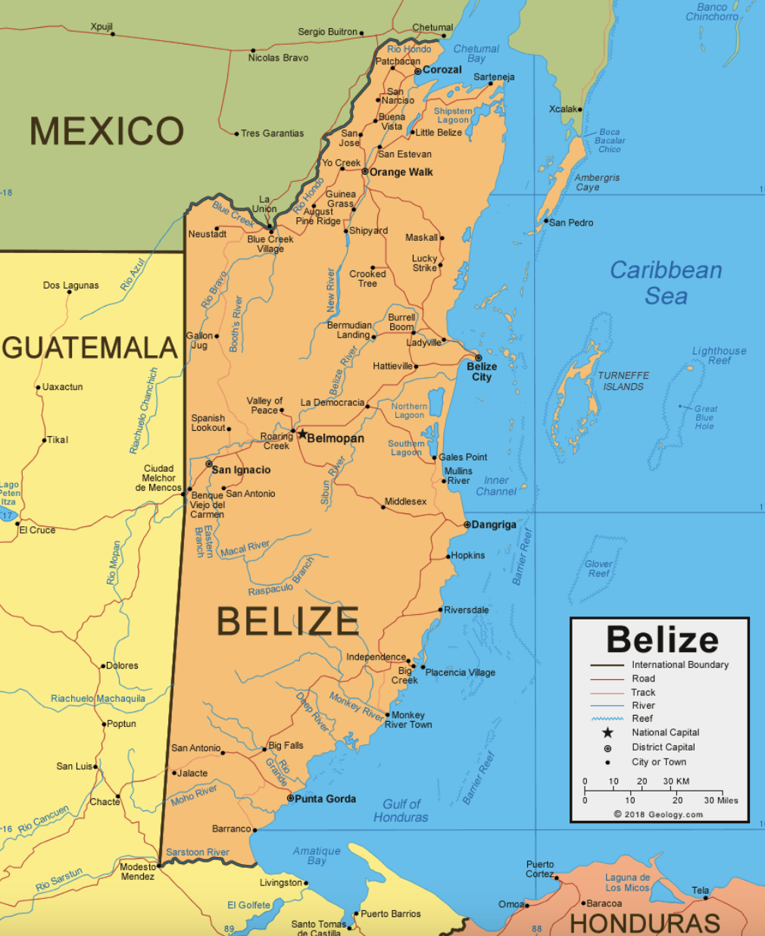

From geology.com ; This map has a clear view of rivers

Map of Belize to fill in:

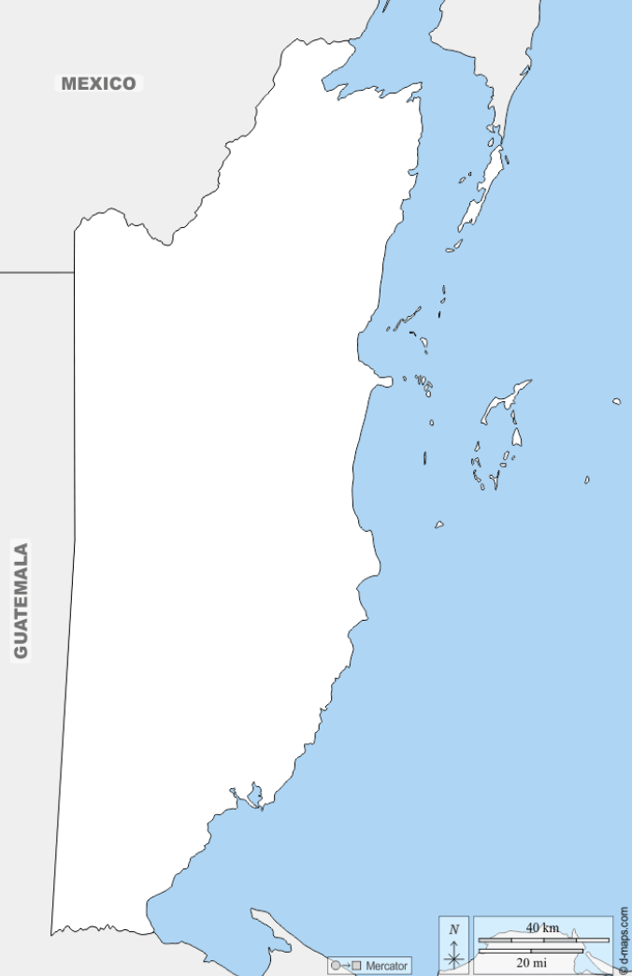

From d-maps.com

Guatemala

About
Located south of Mexico, Guatemala’s original peoples also include the Maya that were conquered by Spain. Though it became an independent nation in the 1800s, it was troubled by dictators and civil war through much of the 1900s. Its name is derived from a native Nahuati word meaning “place of many trees.” It is divided into three main geographical areas: the Pacific Lowlands, the mountainous Highland regions (with many volcanoes, 3 of which are still active), and the northern lowlands (Petén).

Capital: Guatemala City
Language: Spanish (Official) ; many Mayan and other indigenous languages are also recognized

To Read
- Tikal: The Center of the Maya World by Elizabeth Mann
- The Hummingbird King: A Guatemalan Legend by Agentina Palacios (available on archive.org)
- Gods and Goddesses of the Ancient Maya by Leonard Everett Fisher

Links to View
- The Secret Behind the Ancient Mayan Agricultural Prowess (2:44 min)
- Advanced Tech Reveals Shocking News About an Ancient Mayan City (2:53 min)
- Watch the Ancient Art of Chocolate-Making (1:53 min)
- Ixim: A Mayan Story About Corn (5:09 min)
- See How Indigenous Weaving Styles Are Preserved in Guatemala (2:15 min)
- Preserving Guatemala’s Ancient Dance of the Gods (3:28 min)
- Life on the Rim: Working as a Volcanologist (4:35 min)
- Wild Guatemala with Nigel Marven (2:22 min)
- The Sacred Quetzal Bird: Facing Extinction and the Need for Protection (13:02 min, at least through 4:04)
- Treasure of the Caribbean (53:33 min)

Map Questions
- In which hemisphere is Guatemala found?
- Between which Latitude lines is it found?
- What can we guess about the climate?
- Which countries boarder it?
- List the bodies of water it is near.
- Name and locate the three mountain ranges.
- Name and locate the three large lakes.
- What are the three geographical regions?

Map Drawing
Capital: Guatemala City ; Mountain Ranges: Sierra Madre, Sierra de los Cuchumatanes, Sierra de las Minas ; Pacific Lowlands, Northern Highlands (Petén) ; Lago de Atitlán, Lago de Izabal, Lago Petén Itza, Bay of Amatique, Pacific Ocean, Gulf of Honduras ; Tikal

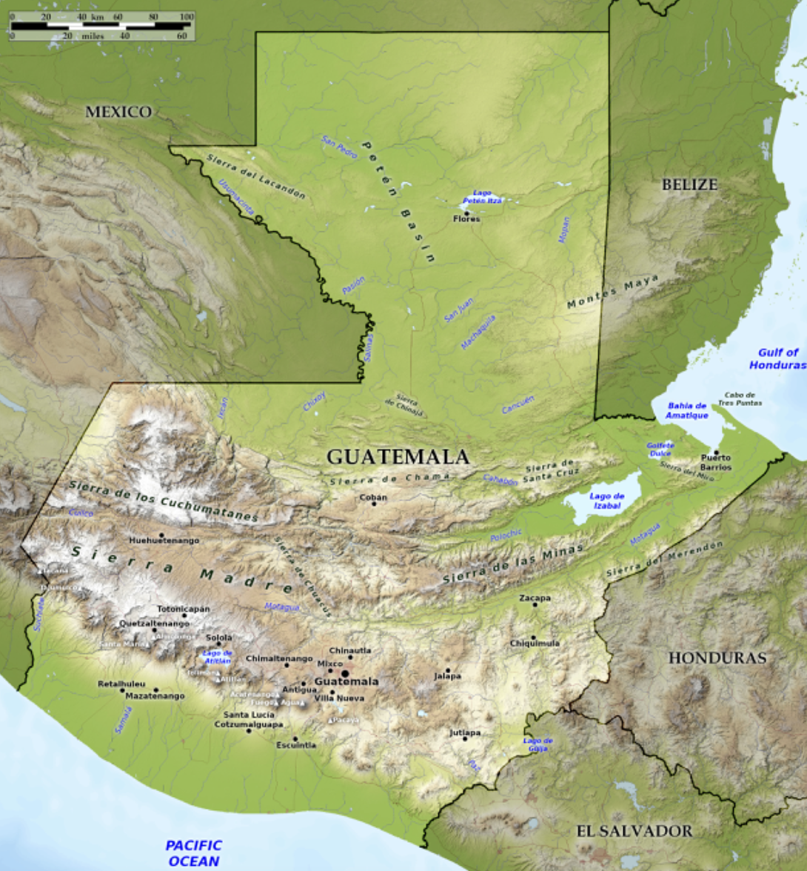

From bluegreenatlas.com ; map showing Tikal
Map of Guatemala to fill in:

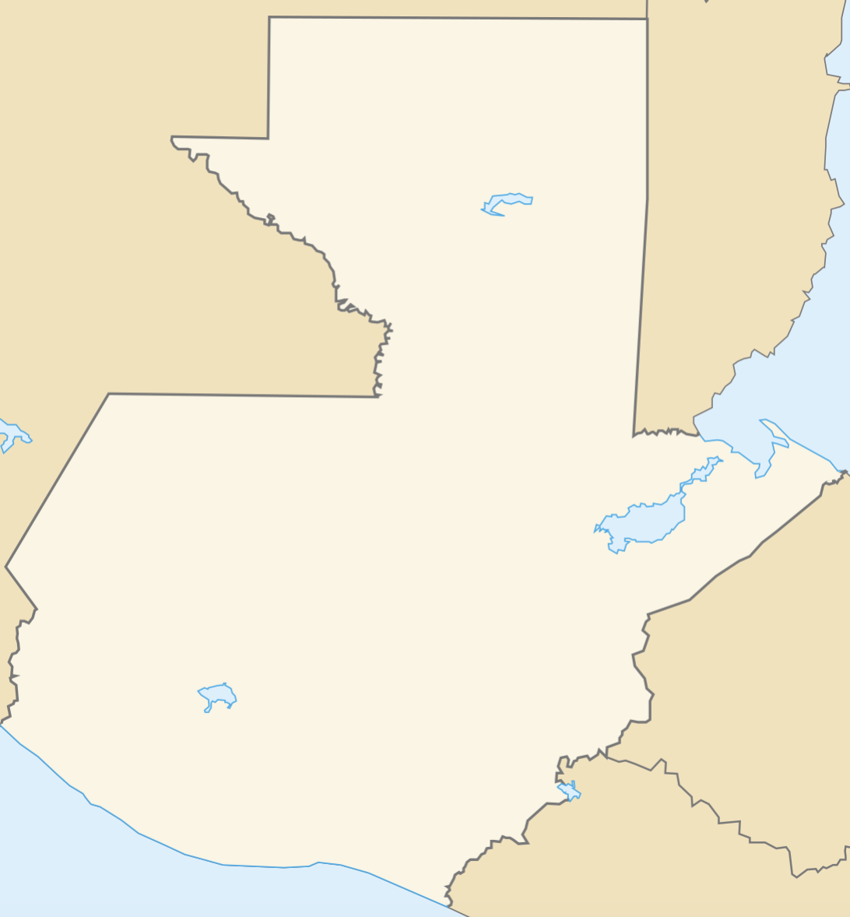

From Wikipmedia.org

El Salvador

About
The tropical country of El Salvador is located on the Pacific Coast, and one of only two Central American nations to have only one coastline. The Sierra Madre Mountain range runs through most of the country, including a central plateau, volcanoes, and tropical forests. There is also a coastal plain that has mangrove forests. Before Spanish conquerors, there were multiple indigenous peoples living in El Salvador, including the Olmec, Maya, and Pipil peoples.

Capital City: San Salvador
Official Language: Spanish

Links to View
- Exploring the Mysteries of Tazumal (2:11 min)
- It’s Not Just Food…It’s Salvadoran History (11:53 min, at least through 3:10)
- Exploring Santa Ana Volcano (2:47 min)
- Protecting the environment – Restoring Mangroves in El Salvador (2:56 min)
- Life Cycle of the Red Mangrove (2:57 min)

Map Questions
- In which hemisphere is El Salvador?
- What can we guess about the climate?
- Which countries boarder it?
- Which ocean boarders it?
- Name the major gulf and bay on its coast.
- Which mountain range runs through El Salvador?
- What are the names of three large natural lakes?
- Where is the capital city located?
- What is the major river splitting El Salvador in half?

Map Drawing
Capital: San Salvador, Sierra Madre Mountains, Gulf of Fonseca, Bay of Jaquilisco, Lake Güija, Lake Coatepeque, Lake Ilopango, Lempa River
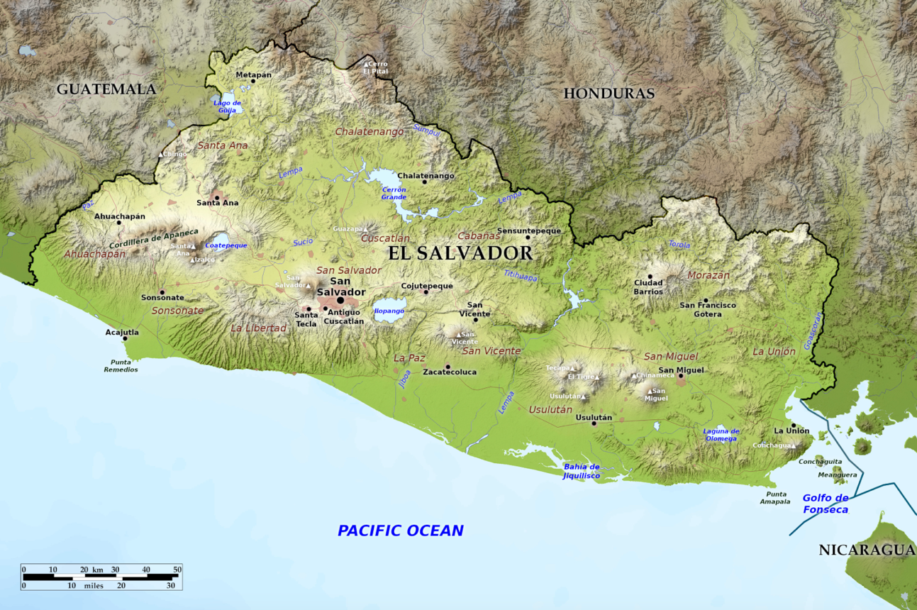
From greenblueatlas.com

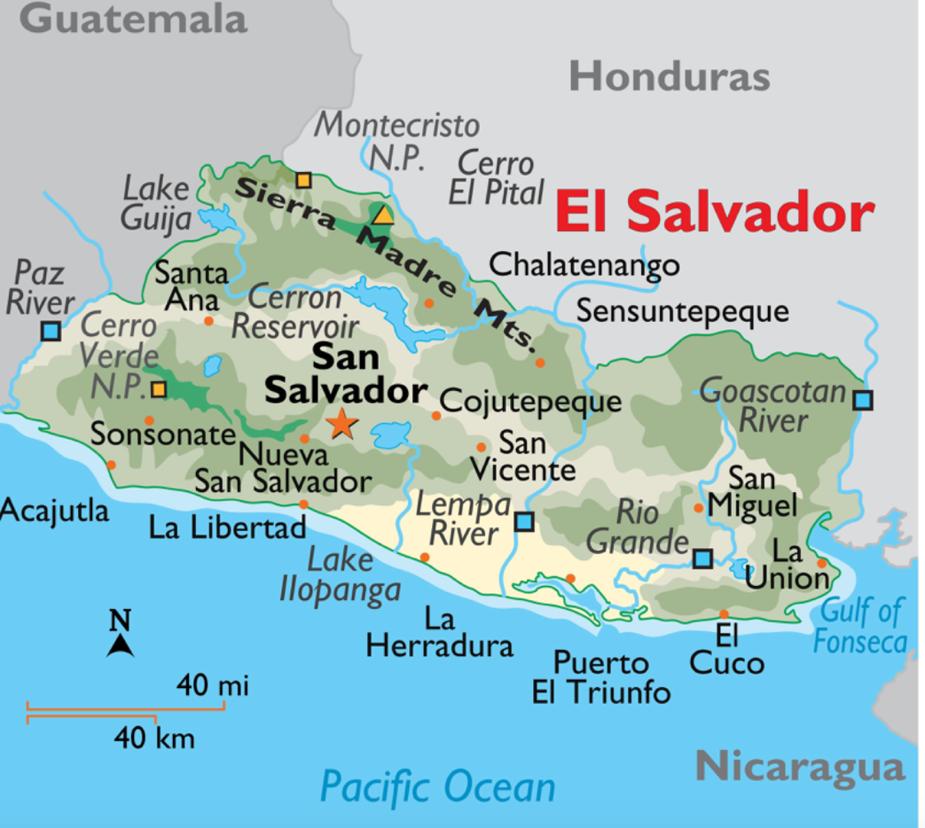
From worldatlas.com

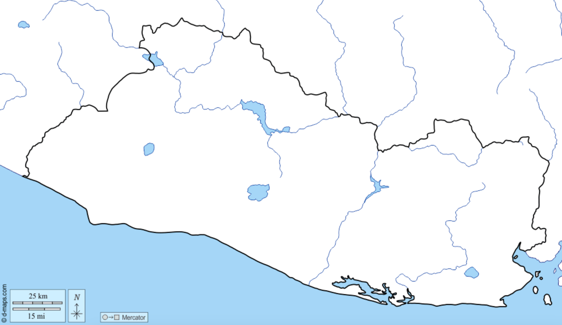

From d-maps.com

Honduras

About
A mountainous country with a large Caribbean coast and a small bay on the pacific. Honduras has many rivers, rainforests, coastal lagoons full of mangroves, and the Bay Islands in the Caribbean with coral reefs. There are several indigenous peoples of Honduras, including the Maya, Lenca, and Miskito. These people were conquered by Spain in their search for gold and silver in the 1500s and the country did not become an independent nation until the mid-1800s.

Capital: Tegucigalpa
Language: Spanish

Book to Read
* The Good Garden: How One Family Went from Hunger to Having Enough by Katie Smith Milway

Links to View
- Honduras Wildlife Conservation (4:59 min)
- Poachers and Protectors: The Story of the Scarlet Macaw in Honduras (8:16 min)
- Explore Honduras: Rainforests, Beaches, & Islands (52:04 min, watch at least 1:15 – 10:00, 15:55 – 19:00 – Lake Yojoa, 24:30- 28:18 - caves, 34:00 – 39:30 - mangroves, 39:40 – 43:40 - coral reefs)
- Maya Site of Copan (2:55 min)
- The Long Lost White City (1:53 min)

Map Questions
- In which hemisphere is Honduras?
- What can we guess about the climate?
- Which bodies of water boarder it?
- Find and name some of the islands belonging to Honduras.
- Where are the Bay Islands?
- Between which Latitude lines is Honduras found?
- Find and name the bay on the west coast.
- Where is the capital?
- Find and name the lagoon on the east coast.
- Which countries boarder Honduras?
- Name the mountain range in western Honduras.

Map Drawing
Capital, Gulf of Fonseca, Gulf of Honduras, Sierra Madre Mountains, Lago de Yojoa,Tiger Island, Bay Islands (Guanaja, Roatán, Utila, Cayos Cochinos), Caratasca Lagoon, Mosquito Coast, Coco River, Copán

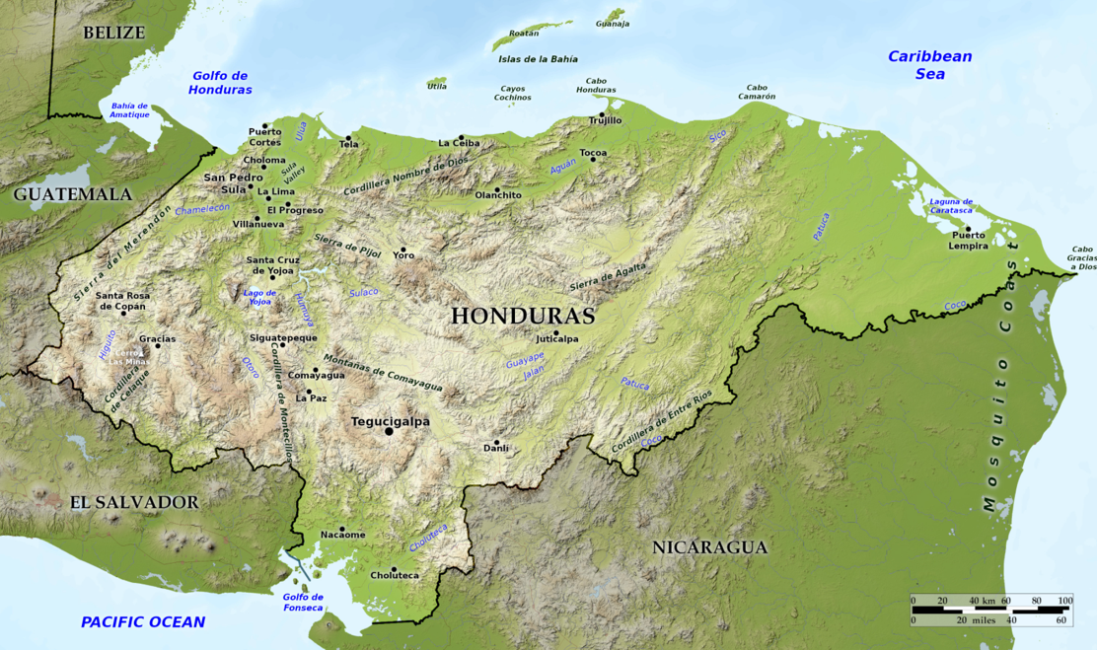

From bluegreenatlas.com

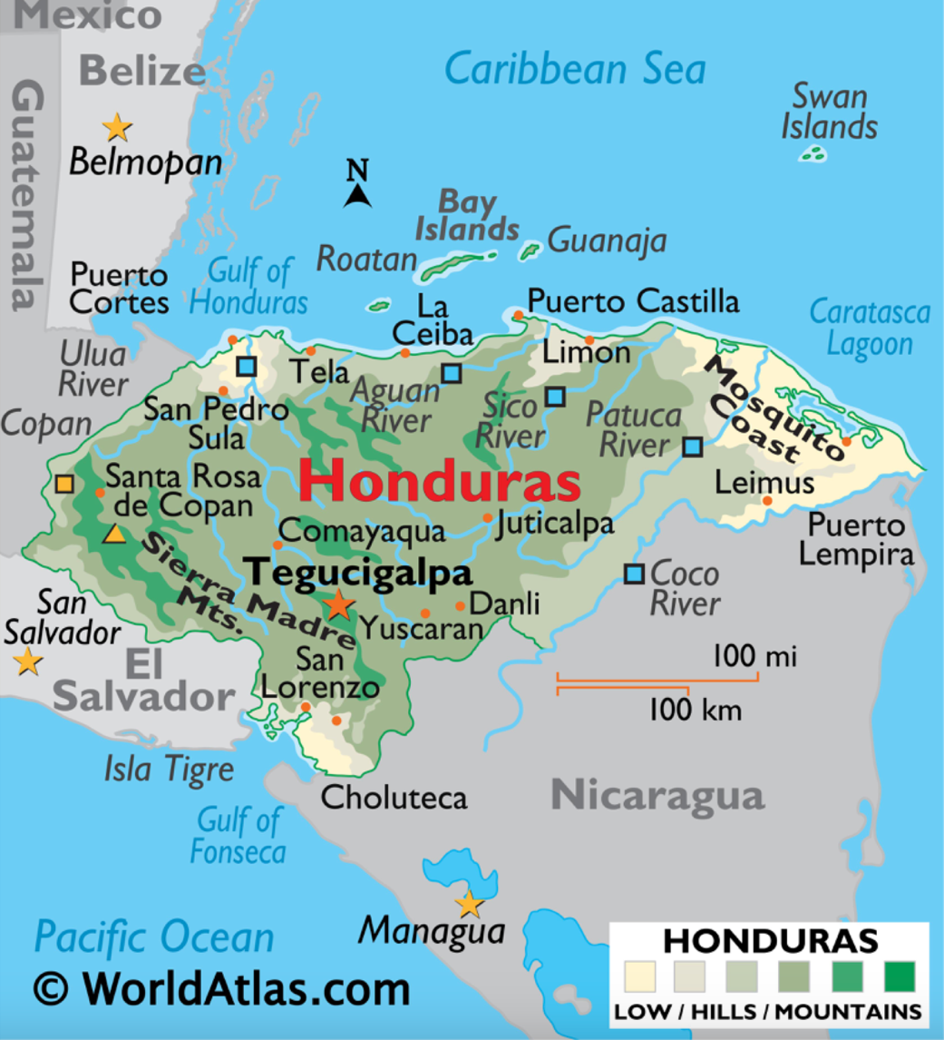
From Worldatlas.com

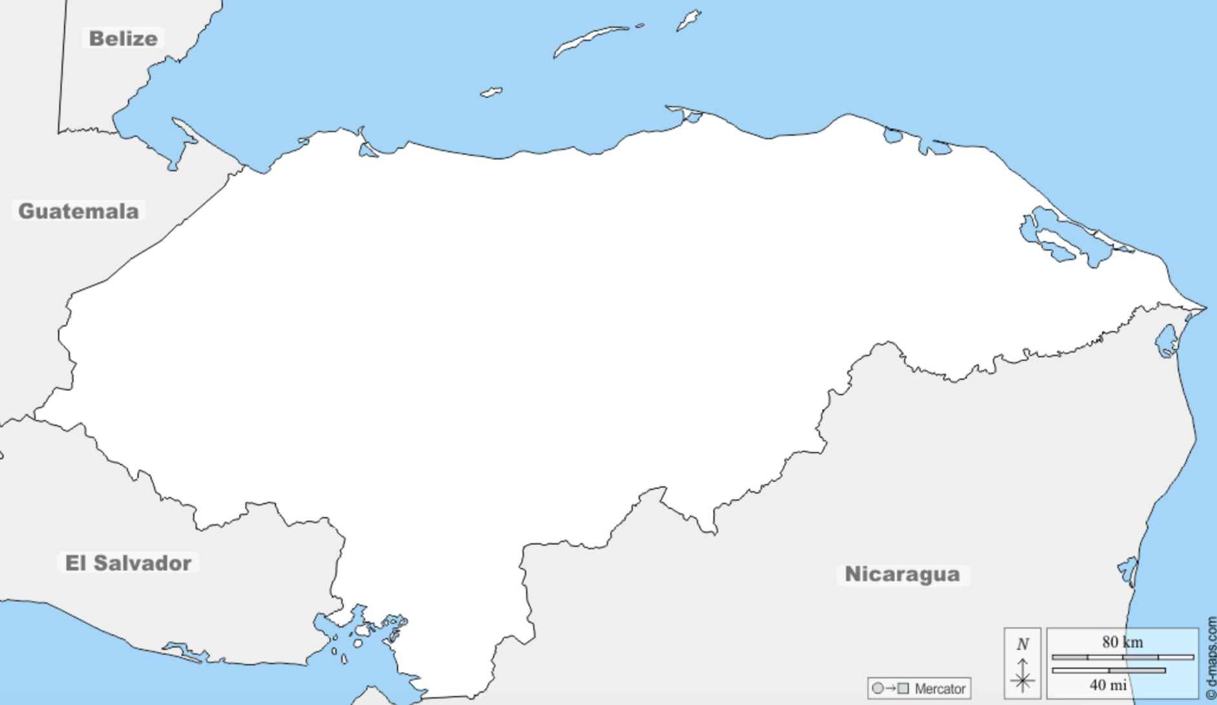
From d-maps.com

Nicaragua

About
The largest country in Central America, Nicaragua also has the two largest freshwater lakes in Central America. It has three main geographic areas: The fertile and volcanic Pacific lowlands, the temperate central highlands, and the tropical Mosquito Coast on the Caribbean side. When the Spanish conquered the area in 1500s, the indigenous peoples of the east coast were not subdued. These people included the Miskito people as well as other groups who were eventually colonized by the British. During the early 1900s, America occupied Nicaragua with hopes of establishing a canal.

Capital City: Managua
Official Language: Spanish and multiple regional languages

Links to View
- The Beauty of Nicaragua (52:03 min) – especially: 1:16-4:15, 8:11-10:55 (tapir), 13:12- 15:50 (Laguna de Apoyo & Mombacho volcano), 18:34-21:20 (Lake Nicaragua), 30:12-34:00 (Leon), 41:22-44:23 (Mangrove Forest), 45:50- end (Northern Nicaragua)
- History of Ometepe Island & the Pirates of Lake Nicaragua (8:45 min)
- Into Nicaragua’s Masaya Volcano (9:13 min)
- Anthony Humbled by Two Sides of Nicaragua – Anthony Bourdain (8:07 min, especially min 3:30 – 5:04)

Map Questions
- In which hemisphere is Nicaragua?
- What can we guess about the climate?
- Which bodies of water border it?
- Name the two largest lakes.
- Between which Latitude lines is it found?
- Describe and name the islands of Lake Nicaragua.
- Which rivers form its Northern and Southern boarders?
- Name the group of islands in the Caribbean.
- Which countries does it border?
- How many lagoons and large bays are on the east coast?
- With which Central American country does Nicaragua share only a maritime boarder?

Map Drawing
Capital: Managua, Amerrisque Mountains, Lake Nicaragua, Lake Managua, Coco River, San Juan River, Ometepe Island, Solentiname Archipelago, Corn Islands, Miskito Cays, Gulf of Fonseca, Pacific Ocean, Caribbean Sea, Pearl Lagoon, Bluefields Bay

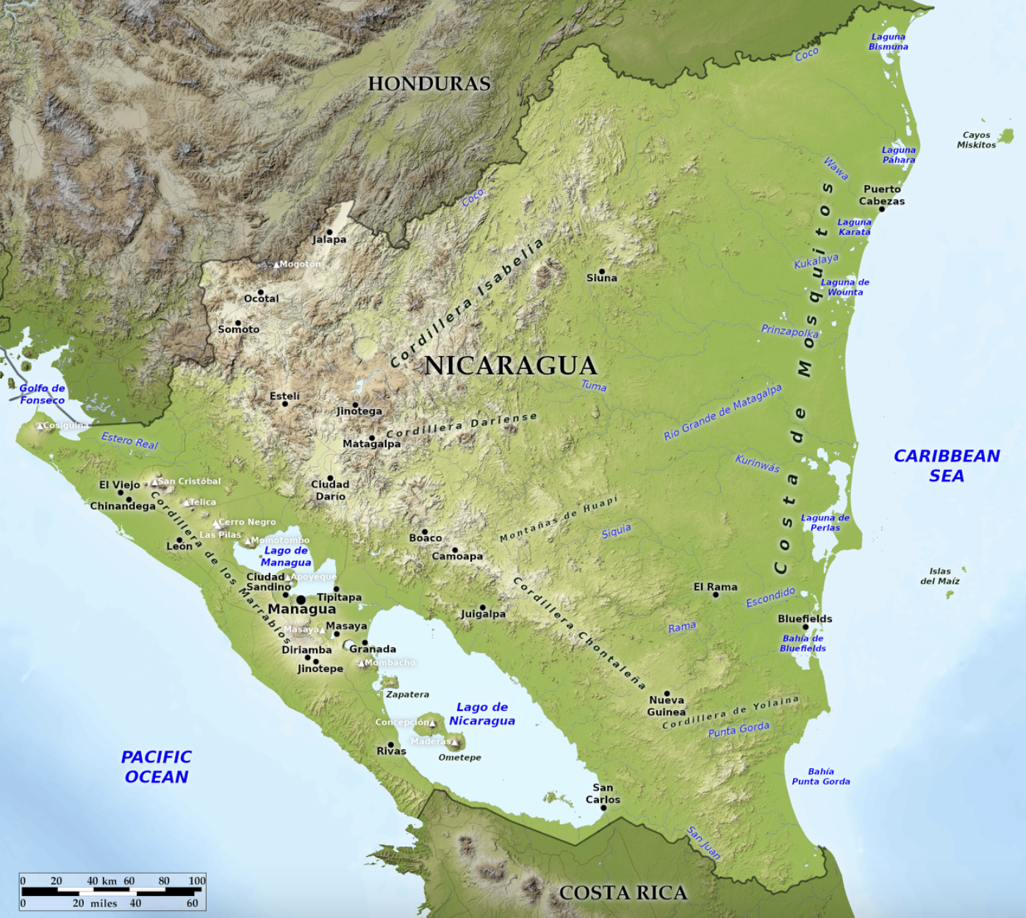
From bluegreenatlas.com

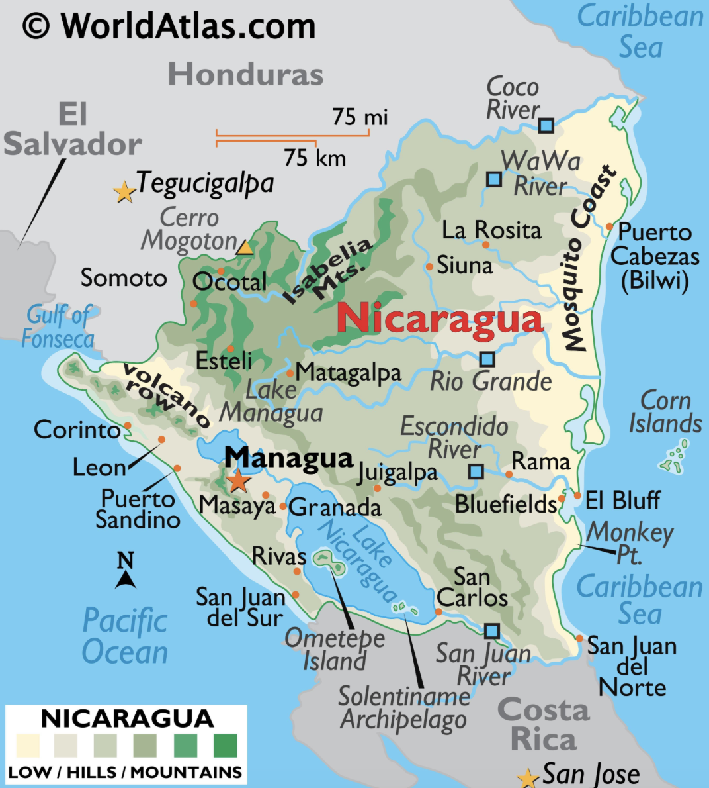
From worldatlas.com

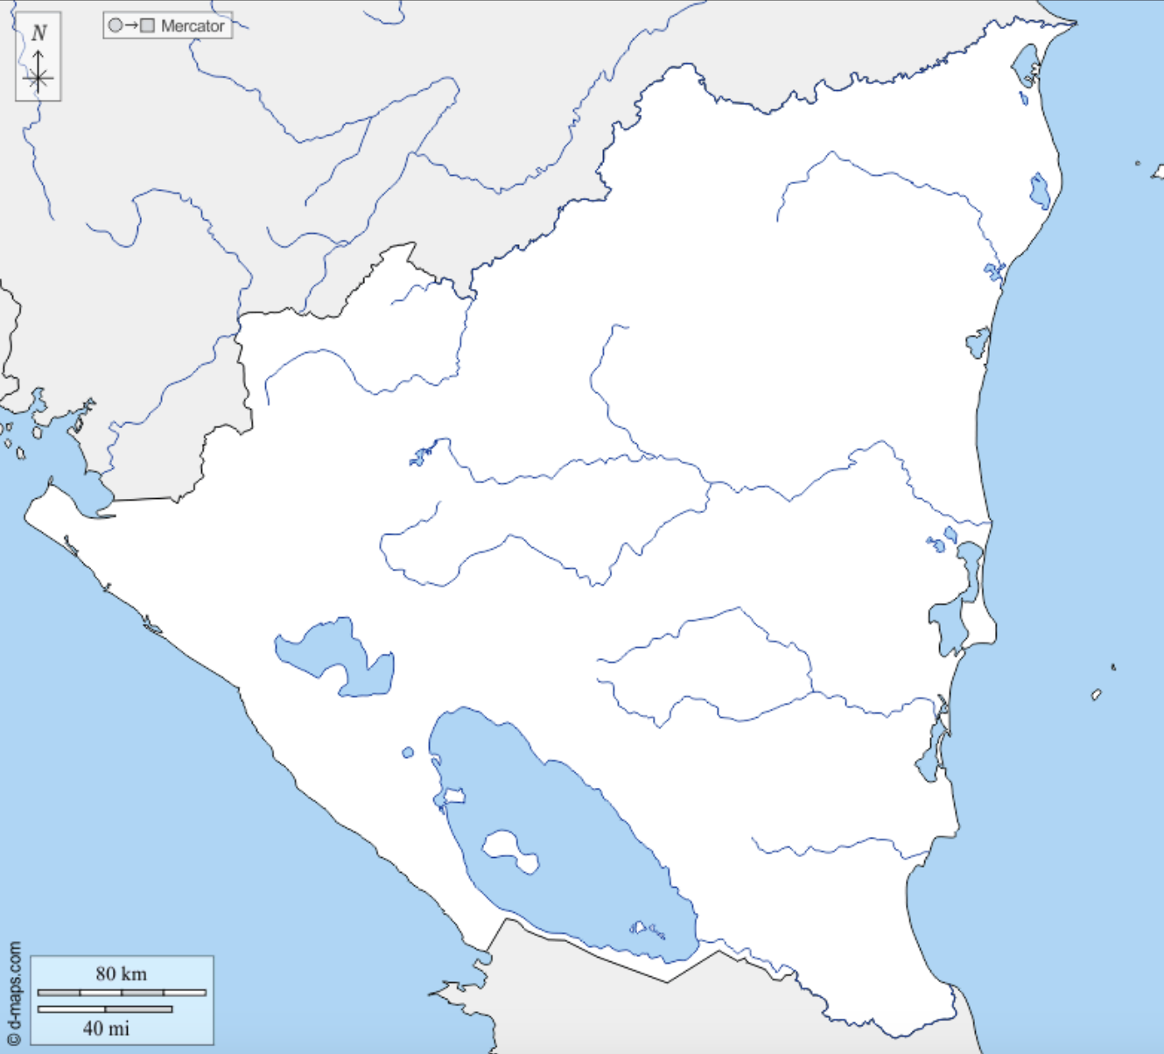
From d-maps.com

Costa Rica

About
Costa Rica was inhabited by indigenous peoples, including the Diquís, when the Spanish came in the 1500s. In the 1800s it became independent, and in the 1940s it abolished its army and focused on providing for its people. It has had a peaceful existence since, focusing on conservation and tourism. It is split in the middle by mountain ranges with coastal plains on either side.

Capital: San Jose
Official Language: Spanish and several regional languages

Links to View
- The Mysterious Diquís Spheres (9:48 min)
- The Weird Wildlife of Costa Rica (10:38 min)
- The Beautiful Birds of Costa Rica (9:41 min)
- Restoring Carbon-Capturing Mangroves in Costa Rican Wetlands (5:45 min)
- Costa Rica’s Golden Grain: The Coffee That’s Taking the World by Storm (8:33 min)
- Top 4 Volcanoes to see when you travel to Costa Rica (5:13 min)
- The Wildlife of Costa Rica (48:58 min)

Map Questions
- In which hemisphere is Costa Rica?
- What can we guess about the climate?
- Which bodies of water border it?
- Which countries boarder it?
- Between which Latitude lines is it found?
- How many gulfs are there on the western coast?
- What are the two large peninsulas on the western coast?
- Where is the capital located?
- What is the name of the large lake in the north?
- What are the four mountain ranges and where are they located?
- What river makes its northern boundary?

Map Drawing
Capital: San Jose, Caribbean Sea, Pacific Ocean, San Juan River, Lake Arenal, Guanacaste Mountains, Tilaran Mountains, Central Mountains, Talamanca Mountains, Nicoya Peninsula, Osa Peninsula, Gulf of Dulce, Gulf of Nicoya, Gulf of Papagayo, Coronado Bay,

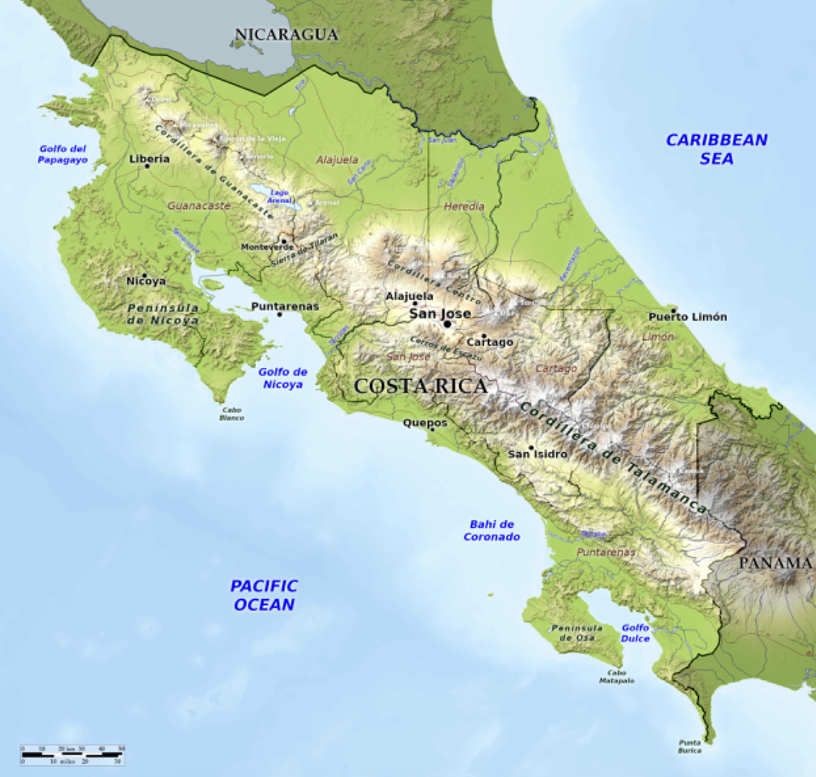

From bluegreenatlas.com

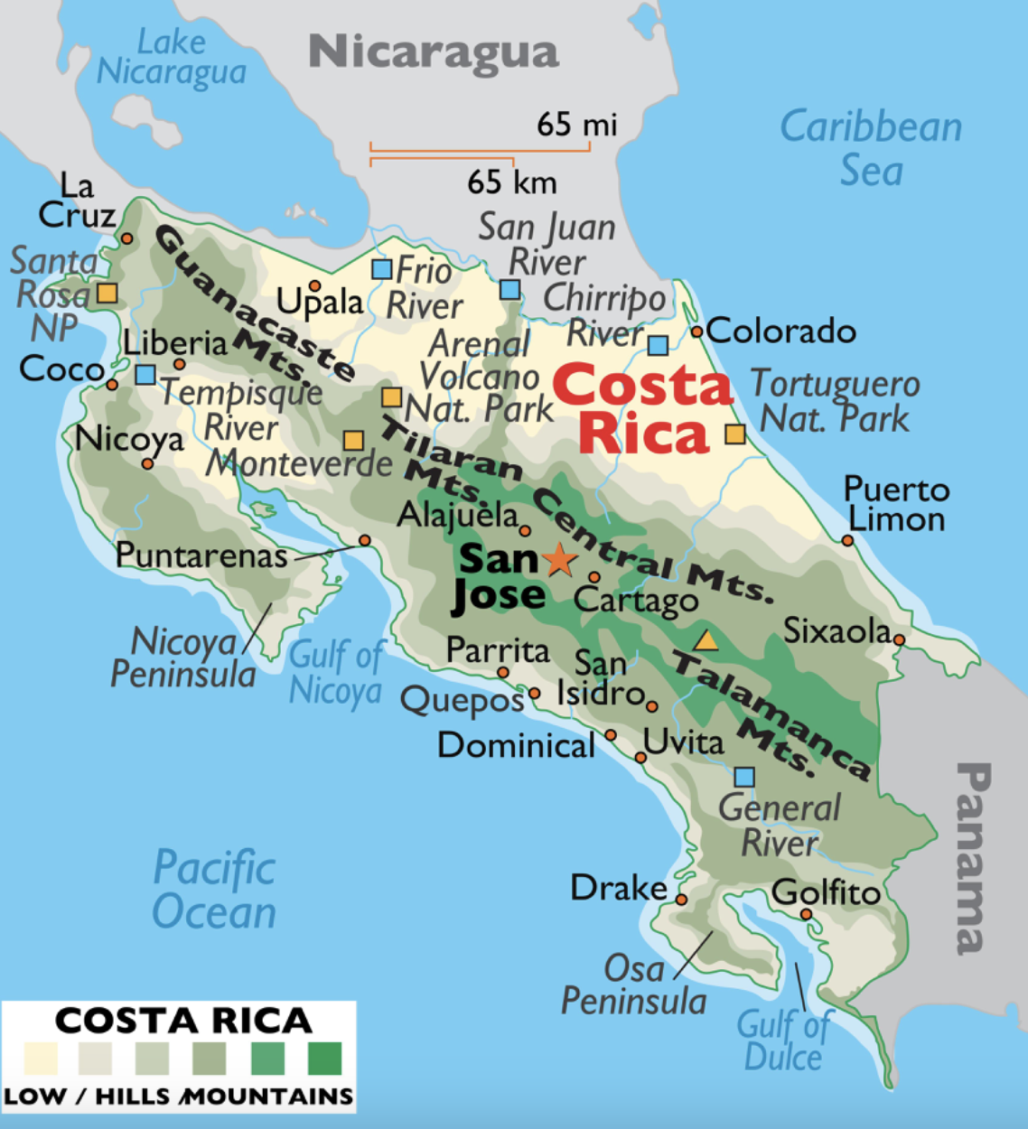

From worldatlas.com
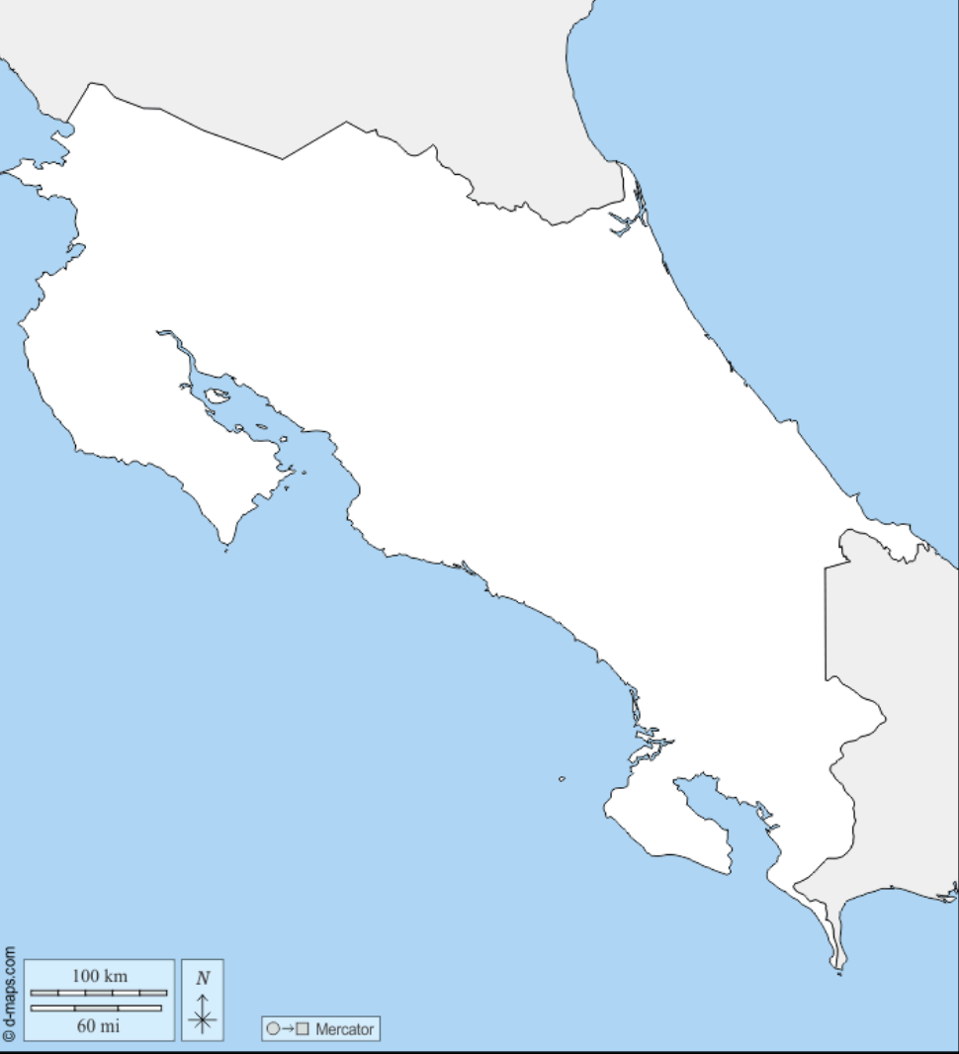

From d-maps.com

Panama

About
Panama was inhabited by several indigenous people for thousands of years before Columbus and other explorers invaded. After 1513, when Balboa made his way from the Atlantic to the Pacific, Panama became a shortcut to bring the plunder from South America through to the Atlantic and home to Europe. After separation from Spain in the 1800s, Panama was part of Columbia. It became independent with the help of U.S. President Teddy Rosevelt who intended to build a canal, which was completed in 1914. The U.S. turned over the canal to Panama in 1999.

Capital: Panama City
Official Language: Spanish and multiple regional languages

Book to Read
- The Case of the Vanishing Golden Frogs: A Scientific Mystery by Sandra Markle
- Is This Panama? A Migration Story by Jan Thornhill (available on archive.org)

Links to View
- Demolition, disease, and death: Building the Panama Canal (5:35 min)
- Panama: Mysteries of the Darien Gap (4:57 min)
- Best Fish & Ceviche Panama Has to Offer – Anthony Bourdain (8:01 min, at least through 3:10)
- Attenborough: Golden Frog: Fighting & Mating (3:38 min)
- Wildlife of Panama’s Tranquil Caribbean Coast (4:45 min)
- Inside a Baby Sloth Orphanage and Rescue Center (4:44 min)

Map Questions

- In which hemisphere is Panama?
- What can we guess about the climate?
- Which bodies of water boarder it?
- Which countries boarder it?
- Between which Latitude lines is it found?
- Where is the capital?
- Which gulf is on the north side?
- The gulf on the southwest? The southeast?
- Name the peninsula between the southern gulfs?
- Name the biggest islands in the southern gulfs.
- Locate and name the archipelagos in the north.
- Locate the Panama Canal.
- Which lake does the Panama Canal use?
- Name the other large lake in Panama.
- Locate the Darian Gap.
- Name the mountain ranges.

Map Drawing
Capital: Panama City, Caribbean Sea, Pacific Ocean, Gulf of Mosquitos, Gulf of Chiriqui, Gulf of Panama, Azuero Peninsula, Coiba Island, Cebaco Island, Pearl Islands, Taboga Islands, San Blas Archipelago, Bocas del Torro Archipelago, Panama Canal, Lake Gatun, Lake Bayano, Darian Gap, Talamanca Mountains, Central Mountains, San Blas Mountains

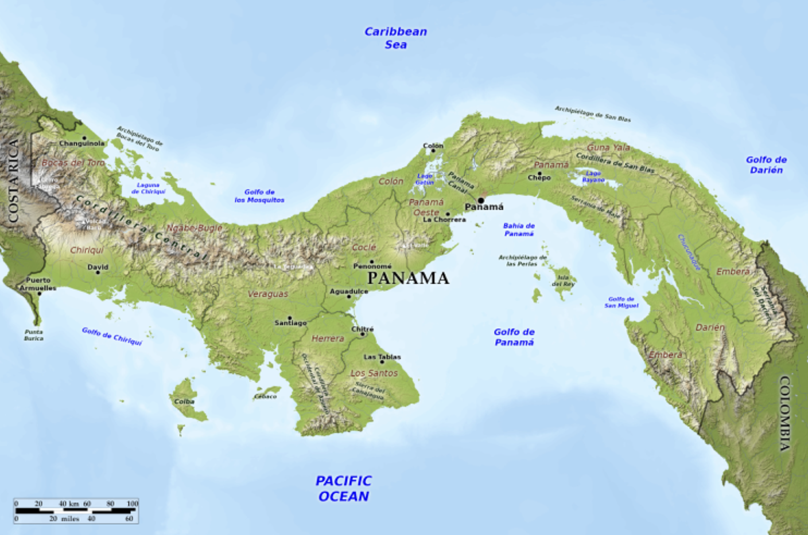

From bluegreenatlas.com

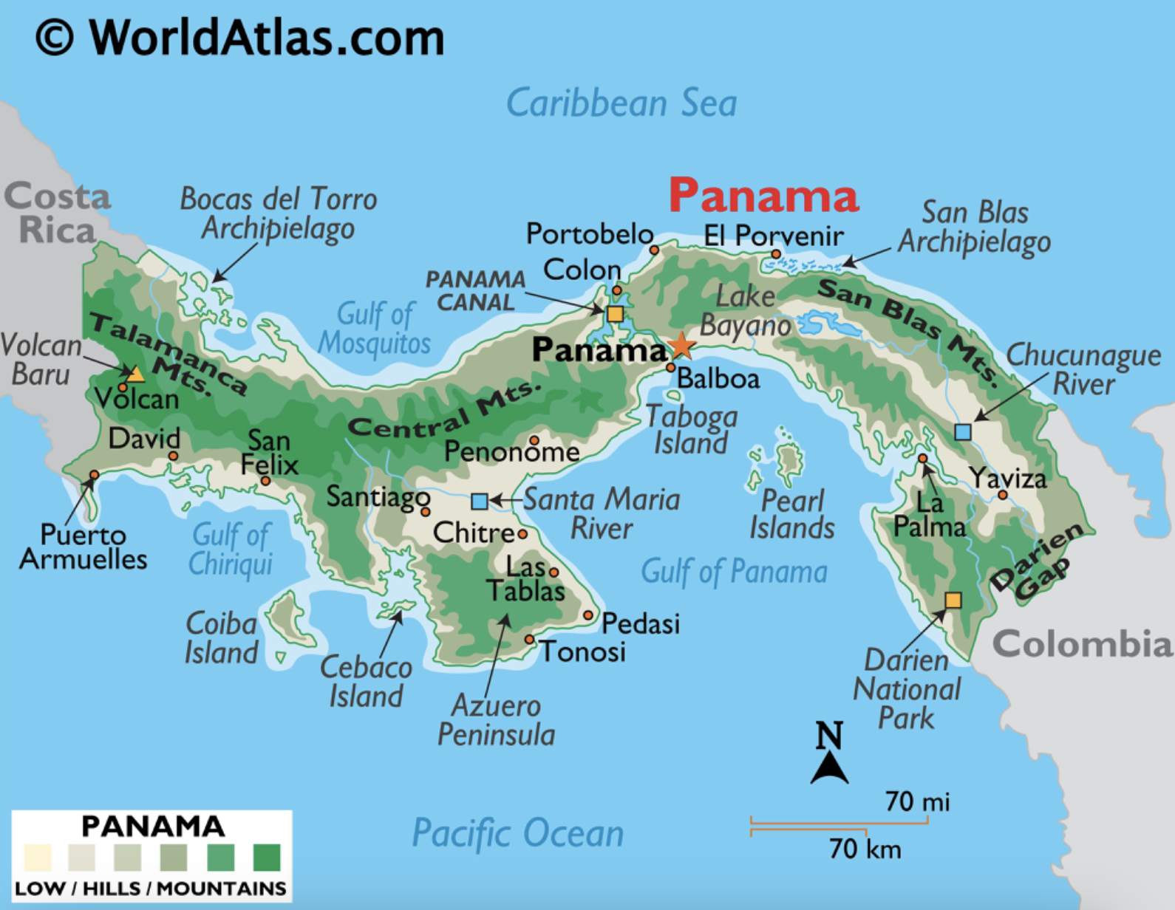

From worldatlas.com

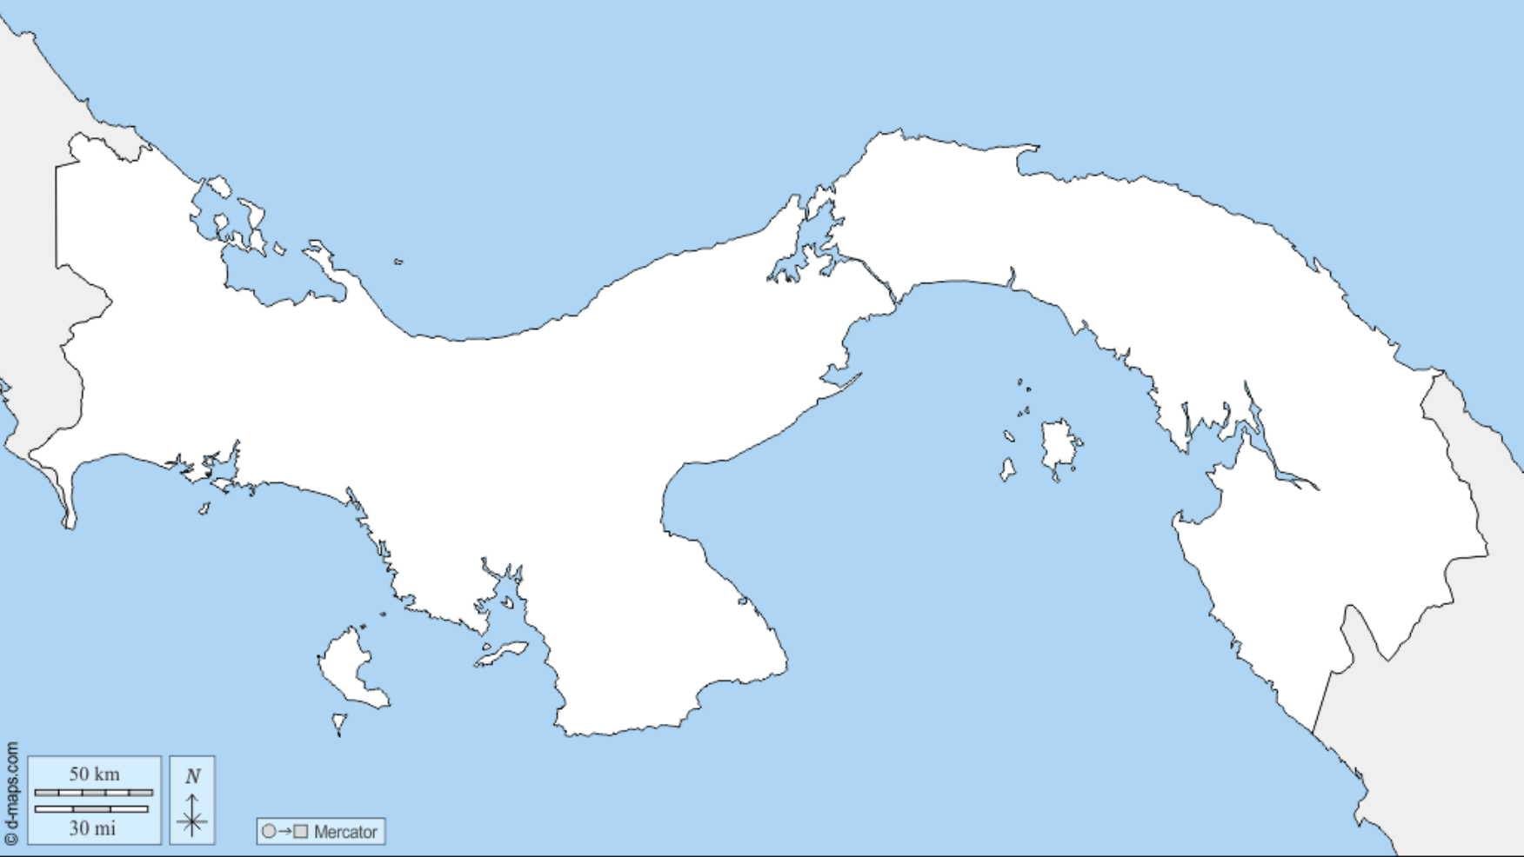

From d-maps.com

