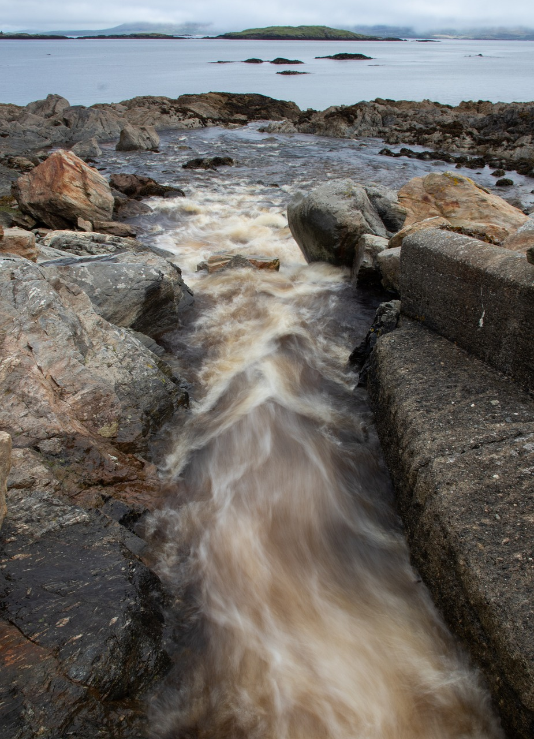
School Year 2025/26: Term 2
Ocean & Brook
Nature Study Guide
Prepared by Lisa Cotting
Amblingtogether.com

Table of Contents
About This Guide 2
Intro to The Ocean 4
Waves 4
Tides 4
Currents 5
Ocean Zones 5
Ocean Floor / Continental Shelves 5
Intertidal Zone: Tide Pools & Salt Marshes 5
Estuaries 6
Plankton & Phytoplankton 6
Glaciers 6
Icebergs & Sea Ice 7
Streams/Rivers & Watersheds 7
Stream/River Movement & Current 7
Stream/River Erosion 8
Stream/River Habitat 8

About This Guide

How I will do the Nature Study for Ocean and Brook:
In its description of nature study, Ambleside Online states “Nature Study at its simplest is time in nature, observing the natural world around us. It is not a one-time event; rather, it is a habit of being outdoors on a regular, consistent basis over weeks, months, and years. It is a process of getting to know the natural world around us through first-hand, personal experience. Nature, or creation, is worth knowing personally. No textbook, no nature video can replace its significance in our children's lives.”

In order to keep with this idea, a “Ocean and Brook nature study” where we live is going to have to be very flexible. We sometimes hike along small streams on nature walks, and depending on the season they can be dry or rushing. We live about a two-hour drive from the ocean, so it will also take planning to observe that. But if I am not intentional about it, a “Ocean/River nature study” will never happen. So, I am writing this 12-week object lesson schedule about general topics on the Ocean, Brooks, and Glaciers so that when we get to take a Nature Study Trip, we will have some language to describe what we’re seeing and hints on what to look for more closely. I plan to spend about 20 minutes a week learning a little about the ocean, brooks/rivers, and glaciers, take 3 or 4 field trips to the ocean, tide pools, or estuaries and focus our nature walks on brooks (as much as we can in the desert). I will also see if we can find any evidence of glacial erosion or movement on our nature walks.

For the weeks we look at “The Brook,” I will read a little directly from the Handbook of Nature Study. Though this book is intended as a teacher guide and resource, I have found no better description of what is happening with brooks. Therefore, I will read sections of the chapter to my students. I will also add in several videos to supplement the reading

I chose the topics below based upon the Nature Study Exam Questions from the AO website. The questions are general (such as “tell all you know about the ocean”), so I have picked topics that will give us the words to describe what we are seeing when we visit. But that will also help us understand the references when oceans and rivers are mentioned in books, news, and conversation.

Prepared for: 2025-26 Term 2 for AO 7 and AO 4 children who live in Southern California

Using these Main Resources:
- Handbook of Nature Study (HoNS – pages listed below are from my paper copy)
- The First Book of the Ocean by Sam and Beryl Epstein (available on archive.org)

Additional Resources:
- Seacoast Science Center in Odiorne Point State Park (many resources for student)
- Whale Fall: Exploring and Ocean-Floor Ecosystem by Melissa Stewart
- Ocean Atlas: A Journey Across the Waves and Into the Deep by Tom Jackson and Ana Djordjevic (good alternative if you want just one book for ocean topics)
- The Deep Blue by Charlotte Guillain and Lou Baker Smith
- Exploring An Ocean Tide Pool by Jeanne Bendick (available on archive.org)
- Glaciers by Sandy Sepehri

Observation Ideas:
- Name the types of waves (sizes) when at the ocean (or large lake)
- Document the tide over a day or two (or view virtually, see webcam suggestions below)
- Watch the King Tides and note how different they are from normal tides
- Observe the movement of water over a tide pool and notice the different creatures and plants at the different zones
- Estuary/ Salt Marsh (Bellona Wetlands, Bolsa Chica Ecological Reserve, Madrona Marsh Preserve and Nature Center, Carpentaria Salt Marsh Preserve)
- Walk along a stream from source to end, or as it goes through different geographical features and ask the questions from the HONS chapter on Brooks
- Visit the same stream multiple times and observe the seasonal changes

Intro to The Ocean
Read: All About the Sea by Ferdinand C. Lane (available on archive.org), pg. 8-14
Watch: How Big Is the Ocean? (5:25 min)
Vocabulary: ocean, sea, Atlantic, Pacific, Indian, Arctic, Southern
Additional Resources: Video: NOAA – Know Your Ocean (2:37 min) ; Oceans 101 – National Geographic (2:53 min)

Waves
Read: All About the Sea (AAS) by Ferdinand C. Lane pg 28-32 and/or The First Book of the Ocean (FBOO) pg 14-18
Watch: Where Do Waves Come From (6:38 min)
Vocabulary from Reading: AAS: crest, interval, fetch, swell FBOO: big fetch, storm waves, swells, breaker, surf
Additional Resources: Video: How Do Ocean Waves Work? (4:00 min) ; Demonstration: Waves Science Experiment (0:57 min) ;

Tides
Read: The First Book of the Ocean pg 18-21 AND All About the Sea by Ferdinand C. Lane pg 33-36 (stop at end of pg 36)
Watch: What Causes Tides? (3:33 min) ; How to Read Tide Charts 101 (4:09 min) ; The Hopewell Rocks (Bay of Fundy) timelapse of tide (0:54 min) ; Dave Explains King Tides (1:45 min)
Vocabulary: ebb, flow, high tide, low tide, tidal bulge
Activity: Read a tide chart, especially if you can observe the tide at the same time. If you are not near an ocean, observe remotely: Point Reyes National Seashore (or choose another beach cam ; California Coastal Webcams) and compare to Point Reyas tide chart (or tide chart of area you are viewing) ; If you are near the ocean, find the next King Tide in your area (search internet for “king tide” and your area)
Additional Resources: Ted-Ed Video – Why are there two tides a day? (5:20 min) ; Why the Bay of Fundy Has Earned Its Place in the Record Books (1:15 min) ; This Bay Moves 100 Billion Tones of Water Every Day (8:22 min) ; NOAA diagrams: What is a King Tide ; California King Tide Project

Currents
Read: The First Book of the Ocean pg 22-28 OR All About the Sea by Ferdinand C. Lane pg 40-48
Watch: How do ocean currents work? (4:33 min) An Ocean in Motion (5:26 min)
Vocabulary: equatorial currants, gyres, global conveyer belt, Gulf Stream
Additional Resources: Video: The Mysterious Sargasso (4:42 min) ; Wikipedia: Sargasso Sea ; Video: The Gulf Stream Explained (5:04 min) ; Video: 3 Times Scientists Did Weird Experiments with Rubber Ducks (6:25 min) ; Britannica Graphic: Ocean Currents ; Book – Tracking Trash:Flotsam, Jetsam, and the Science of Ocean Motion

Ocean Zones
Read: Woods Hole graphic
Watch: The Water Column (2:26 min) ; The 5 Ocean Layers (2:10 min)
Vocabulary: water column, sunlit zone, twilight zone, midnight zone, the abyss, trenches (hadalpelagic zone)
Additional Resources: Woods Hole Oceanographic Institute: Ocean Zones ; NOAA infographic: Layers of the Ocean ; NPS graphic ; Video: The otherworldly creatures in the ocean’s deepest depths (5:02 min) ; Video: This Incredible Animation Shows How Deep the Ocean Really Is (3:29 min) ; Video: Could you survive the real Twilight Zone? (4:42 min)

Ocean Floor / Continental Shelves
Read: The First Book of the Ocean Pg 36-42 (stop at “…several hundred fathoms.”), 44-48 (stop at “…over seven miles.”) ; Review diagram from Britannica.com
Watch: Finding water depth! Soundings, lead lines, fathoms and more! (2:54 min) ; How Echo Sounder Works (1:07 min)
Vocabulary: fathom, sounding, continental shelf, continental slope/rise, ocean floor/abyssal plain, Mid-Atlantic Range, Mariana Trench
Additional Resources: Book: Solving the Puzzle Under the Sea-Maria Tharp Maps the Ocean Floor by Robert Burleigh ; Video: NOAA – Deep-Ocean Volcanoes (1:50 min) ;Video: Underwater Vents and Volcanoes (2:34 min) ; Video: NOAA – The Depths Below: Life on a Vent (2:30 min) ; Video: Chip Log: How Colonial Ships Measured Speed – Knots (3:22 min) ; Video: Why Do We Still Use ‘Knots’? (10:05 min)

Intertidal Zone: Tide Pools & Salt Marshes
Read: And the Tide Comes In: Exploring a Georgia Salt Marsh by Merryl Alber (available on archive.org)
Watch: The Intertidal Zone (8:30 min) ; Getting to Know a Tidal Salt Marsh (7:31 min)
Vocabulary: Spray/Splash Zone, High Intertidal Zone, Mid Intertidal Zone, Low Intertidal Zone, salt marsh
Additional Resources: Handout:Intertidal Ecology (includes chart) ; NPS: Intertidal ; Video: The Intertidal (5:49 min) ; Video: Intertidal Biome (6:41 min) ; Intro to Salt Marshes (5:11 min) ; Salt Marshes: Nature’s ‘guardians of the coast’ (2:26 min)

Estuaries
Read: Types of Estuary (geological) Diagram from Britannica
Watch:; Estuary Water Demonstration – Hudson River (8:48 min) ; Types of Estuaries - geological (2:26 min)
Vocabulary: Brackish water ; salt front ; types by geological formation: Coastal Plain, Bar-Built, Fjord, Tectonic ; types by water circulation: salt-wedge, partially mixed, well-mixed
Additional Resources: Video: Estuaries. More than meets the eyes (2:17 min) – Washington State ; Estuarine Ecology – North Carolina (4:37 min) ; Dr. Science – What is an Estuary – Long Island Sound (4:47 min) ; Estuaries are hotbeds of biodiversity (1:16 min) ; What is an Estuary? – Netarts Bay, Oregon (8:03 min)

Plankton & Phytoplankton
Read: Ocean Sunlight: How Tiny Plants Feed the Seas by Molly Bang and Penny Chisholm
Watch: The Secret Life of Plankton (6:01 min) ; From Drifter to Dynamo: The Story of Plankton (3:01 min)
Additional Resources: Video: Why Are Plankton the Most Vital Organisms on Earth - BBC (3:36 min) ; Video: Why We Owe Our Lives to Phytoplankton (7:02 min) ; Video: Why Are Plankton So Crucial to Life on Earth (4:25 min) ; Video: Phytoplankton (2:02 min)

Glaciers
Read: Glaciers by Sandy Sepehri available on archive.org or Icebergs and Glaciers by Seymour Simon (available in L.A. County Library)
Watch: How Do Glaciers Move? (6:47 min) ; How do glaciers shape the landscapes? (2:30 min) ; The Secret of Why Glacier Ice is Blue (6:39 min) ; Glacial Landforms (6:34 min)
Vocabulary: ice field, alpine glaciers, ice sheets, cirque, crevasse, firn, glacial till, terminus (or terminal edge), moraine,
Observation / Activity: Look at this list of characteristics to watch for when searching for a landscape shaped by a glacier. See if you can find any of these in your area.
Additional Resources: Video: Glaciers – National Geographic (4:05 min) ; How Do Glaciers Move? (3:46 min) ; BBC Geography – Glaciers (3:55 min) ; How to Grow a Glacier (5:19 min) ; Glacial Depositional Landforms (2:15 min) ; List: Glaciers in U.S. ; Types of Glacier formed Valleys ; BBC Article – The before and after images showing glaciers vanishing before our eyes ; L.A. Times Article – As California glaciers disappear, people will see ice-free peaks exposed fo the first time in millennia ; Video: Classifying Glaciers (5:54 min) ; Book (for younger students) – Glaciers Are Alive by Debbie S. Miller

Icebergs & Sea Ice
Read: Iceberg size chart ; Iceberg Shape Classification Graphic or wikipedia ; Sea Ice Formation ; Brine Pocket formation
Watch: NOAA – The Role of Ice in the Ocean Part 1 (2:09 min) ; What’s below the tip of the iceberg (4:51 min) ; Sea Ice: The Science of Sea Ice (1:54 min) ; Why Do Hundreds of Icebergs Keep Visiting This Town? (7:05 min)
Vocabulary: calve, frazil ice, brine pocket
Additional Resources: Video: NOAA Part 2 – How we Measure Ice (2:29 min) ; Glaciers and Icebergs (2:08 min) ; Video: Why do Icebergs Float? (5:52 min) ; What is the difference between sea ice and icebergs? (1:53 min) ; Formation of an iceberg (1:52 min)

The Brook Part 1
Preparation: Read the question for this section on HoNS pg738-739
Read: Read HoNS pg. 736 (first page of “The Brook” chapter, start at second paragraph “Each brook has its own…”) – 738 (stop at Lesson 207)
Watch: The Journey of a River (2:53 min) and/or Life of a River (4:20 min)
Vocabulary: erosion, sediment, deposition
Observation Activity: (1) Try the demonstration described on page 737 with a pitcher of water poured onto sand from different heights. (2) Stick an arm into a stream to feel the dirt and gravel being moved by the steam as described on page 738. (3) Ask questions from HONS when on a nature walk near a brook.
Additional Resources: Video Instructions: Measuring the Flow of a Stream (1:48 min) ; Streamflow (6:39 min) – for older kids, through min 2:16 for younger ; For River Geography Terms, Rivers, Junior Cert Geography revision (5:30 min) ; Video: How Rivers Shape the Landscape (11:10 min) ; Video: Why Rivers Move (17:47 min) – for older students ; Video: The hidden balance that shapes rivers (5:55 min) – for older students

The Brook Part 2
Preparation: Read HoNS Lesson 208 pg 741-742
Read: Read HoNS pg 740-741, “How a Brook Drops Its Load”
Watch: Why Do Rivers Curve? (2:38 min)
Vocabulary: meander, current
Observation: (1) Follow the steps described in Lesson 208 to observe how the rocks and sand settle out of a jar of stream water (2) While on a nature walk, follow the steps for observation listed in Lesson 208
Additional Resources: The River Ecosystem part 1 (5:41 min)

River Habitat
Preparation: Read HoNS pg 739-740
Watch: The River Ecosystem Part 2 (7:43 min)
Observation: While on nature walk, notice what plant life is growing near the streams and where it growing (near, on, in the water), where its roots are, and if there are any creatures living on/near it above or below the water. Notice differences in what you find near the banks and in the middle of the stream. Use buckets, jars, or nets, to see what you can find living in the stream (and return it after observation).
Additional Resources: Video for younger students: River Habitats for Kids (11:53 min)

Watersheds
Read: My Water Comes from the Rocky Mountains by Tiffany Fourment (available on archive.org) ; What is a Watershed (visual helps)
Watch: How (and why) to find your watershed (6:22 min) ; The Only River That Flows Into Both the Atlantic and the Pacific (6:27 min)
Vocabulary: watershed, ridgeline, basin, Great Basin, groundwater, tributary
Observation: Discover which watershed you live in and map how your water gets to you (note: linked map & most others do not have accurate Great Basin & Ca boundaries). Visit the major body of water supplying your water or one of the routes it takes to get to you (i.e., aqueduct, local well)
Additional Resources: Video: What is a Watershed (1:17 min) ; Video: What is a Watershed – 7:03 min) Northern California Public Media (Video: What is a Watershed -Russian River, Ca (7:03 min) ; Virtual River- What is a Watershed? (2:47 min) ; Pennsylvania Watersheds (3:23 min) ; Build a Watershed Activity (6:21 min) ; Where is Your Watershed - Chesapeake Bay (2:49 min) ; The Importance of the Continental Divide (2:52 min)

