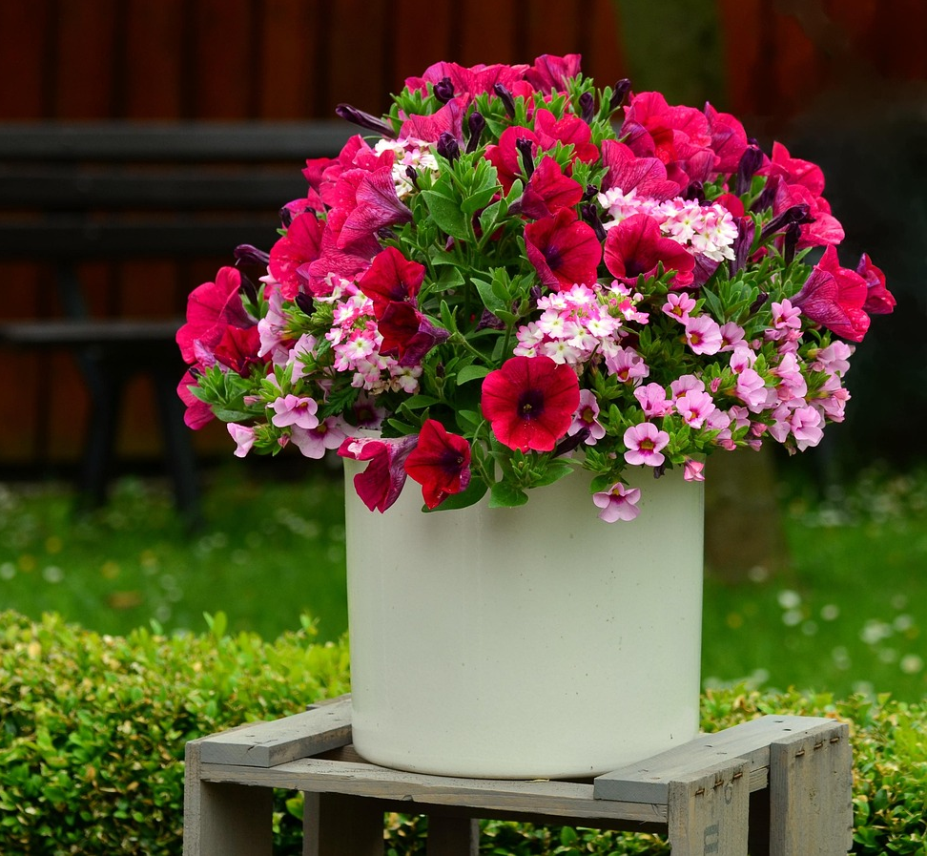

Garden Flowers & Weeds
Nature Study Guide
School Year 2025/26: Term 3
Prepared by Lisa Cotting
Amblingtogether.com

Table of Contents
About This Guide 2
Intro to Flowers 3
Intro to Gardening 3
Garden Flowers: Bulbs, Corms, Rhizomes, & Tubers 3
Garden Flowers: Geranium 4
Garden Flowers: Petunia 4
Garden Flowers: Roses 4
Garden Flowers: Black-Eyed Susans 4
Weeds: What is a Weed 4
Weeds: Dandelion 5
Weeds: Thistle 5
Weeds: Poison Ivy 5

About This Guide
This is an abbreviated guide from what I normally prepare. As we are getting ready to start Term 3, we have moved across country and are living in a temporary home while in the process of purchasing a new home. Therefore, I have relied heavily on the Handbook of Nature Study and very few additional resources. I plan on spending several weeks on the introduction to flowers, gardening, and weeds and then finding locations we can observe some of the flowers below. When we do, I will have the HONS questions with me to work through. I will be sure to refresh myself on the information in HONS about the plant so we can talk about it during the observation.

Prepared for: 2025-26 Term 3 for AO 7 and AO 4 children who just moved to Maryland

Intro to Flowers
Preparation: HONS pg 453-459 ; 457
Read: Look at a Flower by Anne Ophelia Dowden (available on archive.org) pg 6-8, especially diagram on page 9
Watch: Parts of a Flower (3:27 min)
Vocabulary: Petal, Sepal, Carolla, Calyx, Pistil, Stamen, , Pollen, Nector, Nectaries
Observation/Activity: In yard, park, or garden center notice the parts of the flowers ; do a flower dissection and journal
Additional Resources: Video for younger kids: Look Inside a Flower (4:13 min)

Intro to Gardening
Preparation: HONS pg 454-456 (Some Needs of Plants)
Read: n/a
Watch: Landscaping Tips: Annuals and Perennials (2:32 min) ; Sun exposure levels explained (2:56 min) ; Great Companion Plants (6:03 min)
Vocabulary: Perennial vs Annual ; Shade vs Sun ; Companion Planting
Observation/Activity: do one or more experiment from HONS pg 454-456 ;
Additional Resources:; Article: Sun or Shade: Understanding Sunlight and How it Affects Plants ; Comparing Sun and Shade Lesson Plan

Garden Flowers: Bulbs, Corms, Rhizomes, & Tubers
Preparation: HONS pg 547-555, 571-574
Read: Tubers, Corms, Rhizomes, and Bulbs…What’s the Difference?
Vocabulary: bulb, corm, rhizome, tuber
Observation/Activity: Observe the differences in a garden center ; dissect the different types and compare ; when found in a garden or florist, ask HONS questions, journal ; notice if they are annual/biannual and sun/shade loving
Additional Resources: What is a Bulb, Corm, Tuber, Rhizome, Tuberous Roots (12:25 min)

Garden Flowers: Geranium
Preparation: HONS 585-587
Observation/Activity: Find in garden or garden center and ask HONS questions from page 587, journal ; notice if they are annual/biannual and sun/shade loving

Garden Flowers: Petunia
Preparation: HONS pg 581-584
Observation/Activity: Find in garden or garden center and ask HONS questions from page 584, journal ; notice if they are annual/biannual and sun/shade loving

Garden Flowers: Roses
Read: Rose Family Characteristics
Observation/Activity: Find in garden or garden center and ask HONS like questions, journal ; notice if they are annual/biannual and sun/shade loving

Garden Flowers: Black-Eyed Susans
Preparation: HONS pg 523-524 (listed with weeds)
Observation/Activity: Find in garden or garden center and ask HONS like questions from pg 503 , journal ; notice if they are annual/biannual and sun/shade loving
Additional Resources: Maryland’s State Flower

Weeds: What is a Weed
Preparation: HONS pg 512-513
Read: selections from HONS pg 512-513 ; Introduction to Invasive Plants of Maryland (find similar for your area)
Watch: What makes a plant ‘invasive’ and how harmful are they? (1:34 min) ; Virginia’s Least Wanted: Invasive Species Explained (2:59 min)
Vocabulary: native vs non-native ; aggressive native vs invasive ; definition from HONS: A weed is a plant growing where we wish something else to grow, and a plant may, therefore, be a weed in some locations and not in others
Observation/Activity: Use questions from HONS page 513 for plants in your yard or local park
Additional Resources: The Threat of Invasive Species (4:45 min) ; Invasive Species 101 (3:31 min) ; Invasive Plants Overrun New York’s Parks (2:12 min) ; Invading Indiana: The Top invasive plants in our area (3:38 min)

Weeds: Dandelion
Preparation: HONS pg 531-535
Read: The Amazing Dandelion by Millicent Selsam (available on archive.org)
Watch: Dandelion: The Plant that Conquered the World (5:54 min) ; Dandelion Lifecycle (4:00 min)
Observation/Activity: Find in garden or field and ask HONS questions from page 534, journal
Additional Resources: Dandelions and Civilization: A Forgotten History (11:38 min) ; Growing Dandelion: 1 Year Time Lapse (3:46 min) ; The Secret Physics of Dandelion Seeds (2:19 min)

Weeds: Thistle
Preparation: HONS pg 524-527
Read: Canada Thistle Fact Sheet from Maryland Department of Agriculture
Observation/Activity: Find in garden or field and ask HONS questions from page 526, journal

Weeds: Poison Ivy
Preparation: HONS pg 514-515
Observation/Activity: When found, notice the characteristics without touching

