Movie: A Man for All Seasons (1966)
Book: A Man for All Seasons by Robert Bolt, First Vintage International Edition (1990)

Day 1:
Watch this summary of Thomas More’s life: St Thomas More (3:23 min)
Read “People in the Play” for relevant characters, pg. xxiii
Use character document to introduce all characters in movie (see end of document)
Day 2:
Watch movie through min 9:26
Summary: Wolsey writes a summons and send it to More. He receives it during a gathering of family and friends. We meet More, Duke of Norfolk, Rich, More’s wife and daughter. He says a nightly prayer with his family and travels via boat to Wolsey
Reference in Play: Act I, pg. 14-16
Day 3:
Watch movie from min 9:26-17:14
Summary: Wolsey asks More is he is going to support him in trying to influence the Pope to allow Henry VIII to have a divorce. He justifies it by saying England needs an heir. More refuses. Wolsey mocks him for following his conscience. On the way out, people hand him petitions to read and try to bribe him.
Reference in Play: Act I, pg. 17-24
Day 4:
Watch movie from min 17:14 – 26:21
Summary: More takes the boat home. Almost throws away the silver cup someone tried to bribe him with, but the boatman stops him. Rich meets him at the landing asking about a job. More offers Rich a teaching position, but Rich wants a place at court and says Cromwell will give him one. More gives the cup to Rich. Roper is at the house when More comes home, wanting to marry Margaret. More won’t give permission because Roper is a Lutheran.
Reference in Play: Act I, pg. 24-25, 28, 6-9, 29-35
Day 5:
Watch movie from min 26:21 - 34:34
Summary: Wolsey dies, More is made Lord Chancellor. King Henry VIII visits More’s home, informally. He is technically expected, but they pretend he was not.
Reference in Play: Act I, pg. 43-50
Day 6:
Watch movie from min 34:34 – 43:46
Summary: The King tries to convince More to support his request to the Pope for a divorce. The King says he’ll have no opposition and whoever calls Catherine his wife is a traitor, but he promises that he’ll leave More out of it. He leaves without eating dinner.
Reference in Play: Act I, pg. 50-58
Day 7:
Watch movie from min 43:46 – 54:56
Summary: King leaves. Rich does not go with Cromwell. Alice urges More to stay friends with the king. Roper comes again to ask to Marry Margaret, saying he has changed his mind since More stood up to the king. Rich comes in to again plead for a job and says Cromwell has been asking questions. More does not hire him and he leaves. His family & Roper argue that Rich should be arrested, but More says he must obey the law. Rich goes to Cromwell who gives him a job in return for reporting on More.
Reference in Play: Act I, pg. 59-66, 69-77
Day 8:
Watch movie from min 54:57 – 1:05:10
Summary: King Henry VIII breaks with the Pope and forms his own church. More resigns. Alice is upset. Roper supports him but is about to speak against the King when More stops him. Norfolk asks him to explain why he’s resigning. More dismisses his household staff. He then explains to Alice that he has and will not make a statement on what the King has done. And since he has not made a statement, even to her, then legally he cannot be said to be treasonous.
Reference in Play: Act II, pg. 89-97
Day 9:
Watch movie from min 1:05:11 – 1:12:46
Summary: Norfolk and Cromwell are discussing More. Norfolk says his silence is not traitorous, but Cromwell says it is and everything think so. He wants More to declare his loyalty to the king. Cromwell says he has proof More accepted bribes when he was a judge, Norfolk debunks the accusation and Cromwell says he’ll find something better. Cromwell tells Norfolk the king wants Norfolk to get More to bless his marriage by attending the wedding. More does not come to the wedding.
Reference in Play: Act II, pg. 98-103
Day 10:
Watch movie from min 1:12:46 – 1:22:43
Summary: Cromwell summons More. Cromwell tries to show he’s a traitor and More twice disproves him. Then Cromwell says the King wants More charged with treason unless he vows his loyalty. Cromwell lets More go for the present. The boatmen won’t take him home. He sees Norfolk and stages an argument so Norfolk isn’t associated with him anymore.
Reference in Play: Act II, pg. 112-124
Day 11:
Watch movie from min 1:22:43 – 1:35:28
Summary: Cromwell takes the bill to Parliament to require an oath of loyalty. More walks home and is met by Meg who tells him of the bill. More says the words are important and it might be possible to take the oath. More is taken to The Tower because he won’t take the oath. A year passes. He is taken again to swear the oath and he again refuses but will not say anything to legally implicate him as a traitor. He is sent back to The Tower without books and not allowed to see his family. Rich asks Cromwell for a position, but Cromwell puts him off. Cromwell says he must find a way to get More to submit as the king won’t allow torture.
Reference in Play: Act II, pg. 124-137
Day 12:
Watch movie from min 1:35:28 – 1:43:33
Summary: His family is allowed to visit to try to convince him to take the oath. He won’t agree and tells them to leave the country.
Reference in Play: Act II, pg. 137-148
Day 13:
Watch movie from min 1:43:33 - end
Summary: In court he is charged with treason with a punishment of death. More says he has never denied anything but been silence. Cromwell says More’s silence is denial. More says silence under the law is consent. Rich, wearing fine clothes, swears in court More did deny. More swears an oath that he never did. The jury unanimously says guilty and More is sentenced to death. Since he is already found guilty, he tells them what he believes. Before his death, he says “ I die his majesties good servant, but God’s first.” He forgives his executioner and is beheaded.
Reference in Play: Act II, pg. 148-end

Characters from Movie
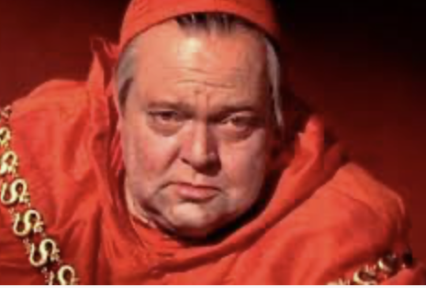 Cardinal Wolsey, Lord Chancellor of England – in charge of courts. Chastises More for not agreeing to pressure Pope to allow divorce
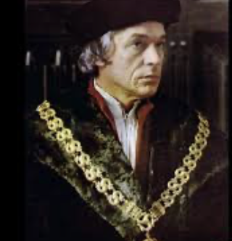 Thomas More – does not agree with King wanting divorce and won’t sign oath naming Henry VIII as head of the new church. But he never actually denies out loud the King’s authority, he is just silent
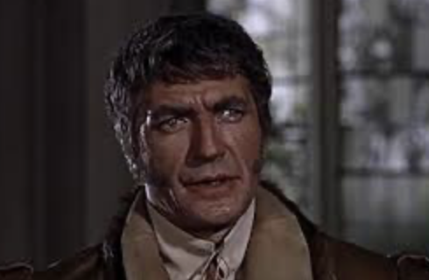 Thomas Howard, Duke of Norfolk, friend of More’s

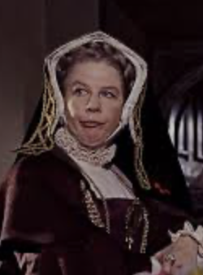 Lady Alice More, wife of Thomas More
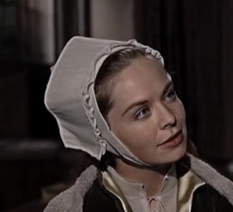 Margaret More, daughter of Thomas More
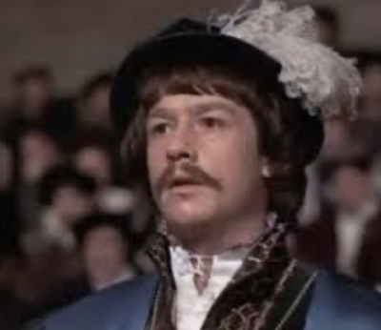 Richard Rich, wants a job at court so he can be famous, is bribed by Cromwell to spy on More and later lies about what More said
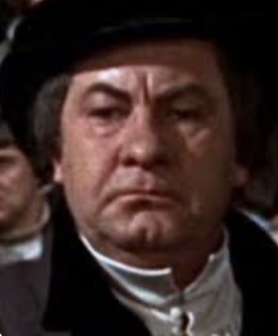 Thomas Cromwell – king’s friend who pretends to admire More but bribes Rich to spy on More by offering Rich a place at court, then orders the court to find More guilty
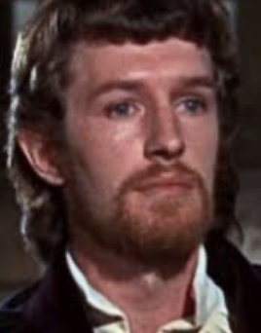 William Roper, a protestant who wants to marry More’s Catholic daughter
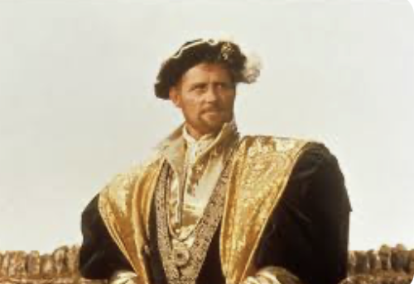 Henry VIII, king who wants a divorce the Pope won’t give him, so he makes the Church of England and himself head so he can give himself a divorce

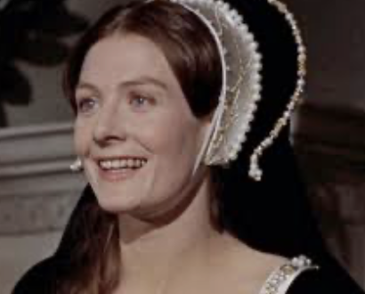 Anne Boleyn, woman Henry VIII wants to marry after he divorces Catherine

