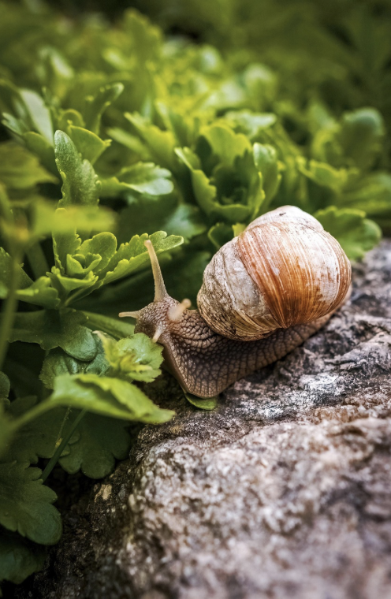
Invertebrates

Nature Study Guide
School Year 2026/27: Term 1
Prepared by Lisa Cotting
Amblingtogether.com
Table of Contents
About This Guide 3
*Week 1: Intro to Invertebrates / Classification 4
*Intro to Arthropoda 4
Arthropoda: Arachnids - Spiders 5
Arthropoda: Arachnid - Harvestmen (Opiliones) 5
*Arthropoda: Crustaceans (General) 6
Arthropoda: Crustaceans – Crabs 6
Arthropoda: Crustaceans – Crayfish 7
Arthropoda: Crustaceans – Shrimp 7
Arthropoda: Crustaceans – Pill Bugs/Roly-Polies 8
Arthropoda: Horseshoe Crabs 8
*Intro to Mollusca 9
Mollusca: Gastropods - Whelk 9
Mollusca: Gastropods - Slug 10
Mollusca: Gastropods – Land (Garden) Snails 10
*Mollusca: Bivalves (General) 11
Mollusca: Bivalves - Oyster 11
Mollusca: Bivalves – Clam 12
Mollusca: Bivalves – Scallop 12
Mollusca: Bivalves – Mussel 13
*Mollusca: Cephalopod (General) 13
Mollusca: Cephalopod - Squid 14
Mollusca: Cephalopods - Octopus 14
*Intro to Cnidaria 15
Cnidaria: Sea Jellies 15
Cnidaria: Anemone 16
*Intro to Echinoderms 16
Echinoderms: Sea Star 17
Echinoderms: Sea Urchin 17
*Intro to Annelids 18
Anatomy Diagrams 19
Spider Anatomy 19
Crustacean Anatomy (Specifically, Crayfish) 19
Shrimp Anatomy 20
Horseshoe Crab Anatomy 21
Whelk Anatomy 21
Slug Anatomy 22
Land Snail Anatomy 22
Oyster Anatomy 23
Clam Anatomy 23
Scallop Anatomy 24
Mussel Anatomy 25
General Cephalopod Anatomy 25
Squid Anatomy 26
Octopus Anatomy 26
Nematocyst (stinging cell) Anatomy 27
Sea Jelly Anatomy 27
Sea Anemone Anatomy 28
Sea Star Anatomy 29
Sea Urchin Anatomy 30
Earthworm Anatomy 30

About This Guide
Prepared for: 2026-27 Term 1 for AO 8 and AO 5 children who live in the Washington D.C. area

Using these Main Resources:
Handbook of Nature Study (HoNS – pages listed below are from my paper copy)
What is an Arthropod? By Kathryn Smithyman & Bobbie Kalmun (available on archive.org)
Spiders and Their Kin (A Golden Guide) by Herbert W. Levi and Lorna R. Levi (available on archive.org)
The Crusty Ones: A First Look at Crustaceans by Solveig Paulson Russell (available on archive.org)
Shells by S. Peter Dance (available on archive.org) or any shell field guide for its anatomy diagrams and reference
Junior Science Book of Seashells by Sam and Beryl Epstein

Additional Resources:
Sea Creatures Do Amazing Things by Arthur Myers (available on archive.org)
Who Lives at the Seashore: Animal Life Along the Shore by Slenn O. Blough (available on archive.org)
The Burgess Seashore Book for Children by Thornton W. Burgess (available on archive.org) – would be a good option for nature lore reading for the term
Bug Catcher – we have these and they work well.
Net Catcher (for bugs or water creatures)
Catch and Release beach aquarium
Beach Combing Bag
Ocean Animal Specimens (shells, crabs etc.)

Possible Field Trip Ideas:
O. Orkin Insect Zoo at the National Museum of Natural History
University of Maryland, Department of Entomology Insect Zoo
Check the local zoos and natural history museums as many have insect/spider houses.
National Aquarium (jellies, anemone, octopus, welks, horseshoe crabs, sea stars)
Glen Echo Park Aquarium (crabs, horseshoe crabs, sea snails)
Dupont Nature Center, Delaware (horseshoe crab spawning in May/June)

How To Use This Guide:
I compiled this guide to give me flexibility since I do not always know what we will be observing or when. I plan to do Intro to Invertebrates the first week, then start working my way through the different classifications. I’ve given myself options for the different specific animals and animal groups, choosing ones I think we might have a chance of observing either in the wild or captivity. You can customize to add in creatures you will see or spend more time on a group if those are the ones that you will be able to observe. Last time through I spent much more time on shells and tide pool creatures because we lived near beaches with tidepools (previous Invertebrates study is here). I have *stared the weeks that cover more general topics. Perhaps next time through I’ll go through the ones I didn’t have time to cover this year.

*Week 1: Intro to Invertebrates / Classification
Read: n/a
Watch: An Introduction to Invertebrates (2:34 min) ; Invertebrate Characteristics and Phyla (14:00 min, at least through min 1:48)
Vocabulary:
- Invertebrate: no backbone, often with external skeleton, but little else in common
- Exoskeleton: outer covering protecting soft tissue
- Bilateral Symmetry: two similar halves
- Radial Symmetry: arranged around a central point
Observation: When on hikes, nature walks, or in yard, observe creatures and determine if they are invertebrate and if they have an exoskeleton. Use a bug catcher (like this one) to observe closely before releasing. Draw or describe in your nature journal.
Additional Resources: Book for Younger Readers: A First Look at Animals Without Backbones by Millicent Selsam (available on archive.org) – when my boys were younger, we used this as the “spine” for the entire Invertebrates study ; Video: The Fascinating World of Exoskeletons (3:47 min)

*Intro to Arthropoda
Meaning: Jointed foot
Read: What is an Arthropod? By Kathryn Smithyman & Bobbie Kalmun (available on archive.org), pg.. 4-7 and 16-31
Watch: All About Arthropods (3:59 min) ; Arthropod Characteristics (2:35 min) ; What is an Arthropod? (2:41 min)
Characteristics: jointed foot/appendages, exoskeleton, bilateral symmetry
Observation: visit an “insect zoo” (many natural history museums have them) and an aquarium, use a bug catcher to observe spiders & pill bugs.
Additional Resources: Video: Exoskeletons – The Armor of Arthropods (3:21 min)

Arthropoda: Arachnids - Spiders
Preparation: Read HoNS pg.. 435-428
Read: Choose one of the following (I might use others as free read options)
- The Lifecycle of a Spider by Bobbie Kalman & Kathryn Smithyman (available on archive.org)
- Spiders by Dorothy Childs Hogner (available on archive.org), pg.. 6-19 and 34-38
- a shorter reading - What is an Arthropod? By Kathryn Smithyman & Bobbie Kalmun (available on archive.org), pg.. 10-11
Watch: Spiders: Eating, Enzymes, and Digestion (4:43 min) ; Discover the amazing diversity of Spider Webs (4:01 min)
Vocabulary: (see anatomy diagram at end of document)
- Cephalothorax – one of two parts of the spider body made up of the head and thorax
- Abdomen – one of two parts of the spider at the rear, usually the larger part
- Chelicerae – large jaw claws used to grasp pray that has venom ducts
- Spinneret – the organ on the abdomen that produces the web
Characteristics: Arthropoda plus - 4 pairs of legs, no antennae, one or two body regions
Observation: Consult your field guide and try to identify the spiders you see on walks and around the yard. Observe the non-dangerous types through the bug catcher. Alternatively, purchase a specimen kit (like this one) to observe preserved spiders. Ask the HONS questions on pg. 437, 442, 444, 445, such as: What does the web look like? Where does the spider stay in the web? What is the shape of its body? Describe any markings on the body. Draw or describe in your nature journal.
Additional Resources: A book for younger readers: A First Look at Spiders by Millicent Selsam and Joyce Hunt (available on archive.org) ; Video – Introducing the Tarantula (0:41 min) ; Video – David Attenborough Explains Spiders (9:24 min) ; Video: Daddy Long Legs / Cellar Spiders in Your Home (5:24 min) ; The Fascinating Science of Spider Webs (12:48 min) ; The fantastic anatomy of spiders (5:05 min)

Arthropoda: Arachnid - Harvestmen (Opiliones)
Preparation: Read HoNS pg.. 432-434
Read: Spiders and Their Kin pg.. 128-133 or Types of Opiliones diagram
Watch: Opiliones facts (4:30 min)
Characteristics: Arthropoda plus - 4 pairs of legs, no antennae, only one body region, no venom in chelicerae, does not make webs
Observation: Using your spider field guide, try to identify the type of Opiliones you find in your yard. Ask the HONS questions on pg. 434 such as: Where did you find it? How many leg segments can you see? Where is his mouth? Describe its movements. Draw or describe in your nature journal.
Additional Resources: Video – Daddy Long Legs: What Exactly Are They? (6:59 min)

*Arthropoda: Crustaceans (General)
Read: Choose One of the following
- The Crusty Ones: A First Look at Crustaceans by Solveig Paulson Russell (available on archive.org), pg.. 7-9, 14-21
- What is an Arthropod? By Kathryn Smithyman & Bobbie Kalmun (available on archive.org), pg.. 8-9
Watch: Facts: Crustaceans (9:39 min)
Vocabulary:
- Chitin – outer covering of crustaceans is made of this material and may be thick or thin
- Decapod – classification of crustaceans with five pair of legs
- Pleopods (swimmerets) – appendages under the abdomen mainly used for swimming
Characteristics: (see anatomy diagram at end of document)
Arthropoda characteristics plus: 2 pair of antennae, paired appendages near mouth to act as jaws, two body regions (abdomen & cephalothorax), 5 or more pair of legs (for decapods). See description on Britannica.com
Observation: At a beach, tide pool, or aquarium observe crustaceans such crabs, lobster, shrimp, and sand fleas. Alternatively, use specimens such as these Ocean Animal Specimens. Ask HONS -type questions such as: How many legs do you see? How many parts do the legs have? What does its head look like? Describe the body shape. Draw or describe in your nature journal.
Additional Resources: All About Crustaceans (9:17 min, at least through 2:40) ; A book for younger children – About Crustaceans by Catherine Sill (available on archive.org)

Arthropoda: Crustaceans – Crabs
Read: The Crusty Ones: A First Look at Crustaceans by Solveig Paulson Russell (available on archive.org), pg.. 34-41
Watch: Facts: The Crab (7:10 min) ; Chesapeake Bay Foundation: Blue Crab 101 (5:32 min)
Characteristics: Curled under tail, a carapace (shell on upper body), first pair of legs are pincers
Observation: At a beach, tide pool, or aquarium observe crabs. Alternatively, purchase a crab from a seafood vendor or use specimens such as these Ocean Animal Specimens. Ask HONS -type questions. Draw or describe in your nature journal.
Additional Resources: Video – The Crabs That Weaponize Fashion Against Their Predators (4:11 min) ; Video - This is What Peak Crustacean Looks Like (6:06 min) ; Perilous Red Crab Migration (5:04 min) ; Video – Crabs Can Lay ONE HUNDRED THOUSANS eggs at a time! (5:01 min) ; Book – Crabs by Herbert Zim (available on archive.org) ; Video – True Facts-The Sand Bubbler Crab (3:43 min) – note, please preview ; Video – For Pacific Mole Crabs It’s Dig or Die (3:51 min) ; Video – Facts-The Mole Crab (2:46 min) ; Book - Sea Creatures Do Amazing Things by Arthur Myers (available on archive.org) pg. 45-49

Arthropoda: Crustaceans – Crayfish
Preparation: Read HoNS pg. 425-429
Read: The Crusty Ones: A First Look at Crustaceans by Solveig Paulson Russell (available on archive.org), pg.. 32-33
Watch: Science Short – What is a Crayfish (5:11 min)
Characteristics: See anatomy diagram at end of document.
Observation: Use a net to find crayfish in your local streams. Alternatively, purchase from a seafood vendor or order a crayfish specimen (like this one) to observe or dissect. Ask HONS questions on pg. 429 & 432 such as: How many parts of the leg are there? Can you see the parts of its jaws? Can you see where the head is joined to the thorax? Describe the eyes. Draw or describe in your nature journal.
Additional Resources: Video - Learn About the American Crayfish (8:03 min) ; Crawfish Facts (4:02 min)

Arthropoda: Crustaceans – Shrimp
Preparation: Read HoNS pg.
Read: The Crusty Ones: A First Look at Crustaceans by Solveig Paulson Russell (available on archive.org), pg. 26
Watch: Facts: Shrimp (3:50 min)
Vocabulary:
- Telson – tail fan
- Rostrum – pointed section of carapace between the eyes
Characteristics: thin, flexible, and somewhat transparent exoskeleton. See anatomy diagram at end of document.
Observation: At a beach, tide pool, or aquarium observe shrimp. Alternatively, purchase a whole shrimp from a seafood vendor or use specimens such as these Ocean Animal Specimens. Another option is to grow your own Brine Shrimp (Sea Monkeys). Ask HONS -type questions such as: How many legs do you see? Where are the legs connected to the body? Do you see its eyes? Describe its shape. Draw or describe in your nature journal.
Additional Resources: Video - Shrimp: Amazing Animals (1:15 min) ; Video – Pistol Shrimp Facts (3:46 min) ; Video - Mantis Shrimp Facts (2:52 min) ; Facts: Brine Shrimp (3:15 min) ; How Do Brine Shrimp Survive in Packaging for Years (4:22 min)

Arthropoda: Crustaceans – Pill Bugs/Roly-Polies
Read: Pill Bugs Up Close by Greg Pyers (available on archive.org)
Watch: Roly Polies Came From the Sea to Conquer the Earth (3:29 min)
Observation: Find Roly Polies and observe. If you want to keep them for a while, make sure you follow these guidelines. Ask HONS -type questions such as: Can you see its legs? Where are its legs connected? Can you count the body segments? What does it do when it is started? Describe its head. Draw or describe in your nature journal.
Additional Resources: Video – Release the Brood! Roly-poly Birthing is Intense (3:52 min) ; Video - Roly Poly Facts (3:09 min) ; Book for younger children – A Pill Bugs Life by John Himmelman (available on archive.org)

Arthropoda: Horseshoe Crabs
Read: High Tide for Horseshoe Crabs by Lisa Kahn Schnell (available on archive.org) or one of the longer options in “additional resources” below. Use anatomy diagram at beginning of book.
Watch: Once a Spawn a Time: Horseshoe Crabs Mob the Beach (4:51 min)
Characteristics: See diagram in book (High Tide…) or diagram at end of document
Observation: Visit an aquarium or nature center. If doing study on the mid-Atlantic region in May or June, you can see them spawning. Ask HONS -type questions such as: Where are its legs? How many legs do you see? Describe the different types of legs. Can you find its mouth? Describe its tail. Draw or describe in your nature journal.
Additional Resources: Book – Horseshoe Crab by Robert McClung (available on archive.org) ; Book - Horseshoe Crabs and Shorebirds: The Story of a Food Web by Victoria Crenson (available on archive.org) ; Video – Why do we harvest horseshoe crab blood? (4:45 min) ; Why Are There 30 MILLION Horseshoe Crabs on This East Coast Beach? (8:15 min) ; Book - Sea Creatures Do Amazing Things by Arthur Myers (available on archive.org) pg. 51-52

*Intro to Mollusca
Read: n/a
Watch: All about Mollusks (2:25 min)
Vocabulary:
- Foot – “The foot forms an anteriorly elongated and slendered burrowing organ in scaphopods, is ax-shaped to vermiform in bivalves, and is modified to a siphon or funnel in cephalopods. Among gastropods of the subclass Opisthobranchia, the foot may be extended laterally to form swimming lobes (parapodia), or even flapping wings (in pteropods, or sea butterflies).” From Britannica.com
- Mantle – covering of the visceral mass (where the organs are)
- Radula – toothed-tongue
Characteristics: Soft body, bilateral symmetry, three body regions: head, visceral mass, foot ; shell (most) ; mantle ; radula
Observation: Identify the shells in your collection and learn about the type of animal that lives in them. See specific types of mollusks below for observation ideas.
Additional Resources: Video – What are Molluscs? (9:15 min) ; Video – Mollusks: More Than a Shell (26:42) ; Video - Mollusca (3:24 min) ; Book for younger children – A First Look At Seashells by Millicent E. Selsam and Joyce Hunt (available on archive.org) ; Book – Snails, Shellfish, & Other Mollusks by Daniel Gilpin (available on archive.org)

Mollusca: Gastropods - Whelk
Gastropod Meaning: Stomach Foot
Read: Junior Science Book of Seashells by Sam and Beryl Epstein pg. 12-18
Watch: Facts: Whelks (2:47 min) ; Whelk Facts: You May know Whelk Eggs (3:06 min)
Characteristics: spiral shell with aperture (opening), operculum attached to foot to “close the door” of the shell, siphon to draw in water to breath, eyes on tentacles, radula. See anatomy diagram at end of document.
Observation: Go to beach, tide pools ,or aquarium to observe. Alternatively, find or buy whelk shells (like these) or whelk eggs (like these) to observe. Ask HONS -type questions such as: What color is the shell? What side it the opening of the shell on? Do you see the operculum? Draw or describe in your nature journal.
Additional Resources: Video – Whelks – Scavengers that can drill into mussel shells (4:46 min) ; All About Lightening Whelks (5:18 min)
Other Sea Snail Options: Video - Watch These Cunning Snails Stab and Swallow Fish Whole (4:48 min) ; Video - Who’s Drilling Holes in the Clam Shells? (4:19 min) – about moon snails ; Video – This Snail Goes Fishing With a Net Made of Slime (4:05 min) – about the scaled wormsnail ; Video – Facts-The Abalone (2:35 min) – abalone are a type of sea snail ; Video – Facts: The Queen Conch (3:29 min) ; Video - Conch Facts: Snails with Attitude (2:50 min) ; Video – Every Type of Sea Snail Explained (7:15 min)

Mollusca: Gastropods - Slug
Gastropod Meaning: Stomach Foot
Read: n/a
Watch: Slug Facts: The Land Gastropod (3:35 min)
Characteristics: 2 pair of tentacles, mantle, pneumostome – breathing pore in mantle, radula. See anatomy diagram at end of document.
Observation: Find slugs in your garden or nature walk and observe. Ask HONS -type questions such as: What color is it? Can you see its head and/or eyes? Describe how it moves. Draw or describe in your nature journal.
Additional Resources: Video – This Little Guy Has More Teeth Than Your Entire Family – Banana Slugs (4:59 min) ; Video – Slugs! What they do and why are they here? (2:10 min) ; Slugs – 10 Facts You Never Knew (3:28 min)

Mollusca: Gastropods – Land (Garden) Snails
Gastropod Meaning: Stomach Foot
Preparation: Read HoNS pg. 416-422
Read: Snails by Herbert Zim (available on archive.org), pg. 34-43
Watch: Snail Facts: Learn About the LAND SNAIL (3:38 mi)
Observation: Find snails in your garden or nature walk and observe. Some pet stores may also have snails in the fish section. Ask HONS questions on page 42 such as: How does the snail walk? Where are its eyes? Can you find the opening through which the snail breaths? Describe how it eats. Draw or describe in your nature journal.
Additional Resources: Book – Snails by Dorothy Childs Hogner (available on archive.org) ; Video – Snails – Fantastic Creatures (5:11 min) – about mating and eggs ; Snail Hits Predator with its Shell (1:16 min)

*Mollusca: Bivalves (General)
Bivalve Meaning: Two Shells
Read: Junior Science Book of Seashells by Sam and Beryl Epstein pg. 27-38
Watch: Facts: Bivalves (3:25 min) ; Bivalve Shells: Parts of a Shell (4:19 min)
Characteristics: hinged shell, adductor muscle (to close shell), siphon, foot, filter feeders,
Observation: Sort through shell collection, making observations, identifying as many as you can with an field guide (if you don’t have your own collection, try something like this), discussing the kind of creature who lived in the shell. Try to find the hinge, growth lines, and adductor muscle marks on the shells. Draw or describe in your nature journal.
Additional Resources: Book for younger children – A First Look at Seashells by Millicent Selsam (available on archive.org) ; Video – Phylum Mollusca Part 3: Class Bivalvia (10:37 min) ; Video – Bivalves Could Be the New Lab Rats (6:02 min) ; Video – Bivalves-The Most Underrated Animals (10:21 min) ; Video - Oysters vs. clams vs. mussels: What’s the Real Difference? (8:49 min)

Mollusca: Bivalves - Oyster
Bivalve Meaning: Two Shells
Read: n/a
Watch: Facts: The Oyster (3:47 min) ; Oyster dissection (3:58 min)
Characteristics: See anatomy diagram at end of document
Observation: Find and observe oysters at the beach, aquarium or purchase from a seafood vendor. Ask HONS -type questions such as: Can you find the hinge? Where was the muscle attached? Describe the texture or outside of the shell. Draw or describe in your nature journal.
Additional Resources: Book - Junior Science Book of Seashells by Sam and Beryl Epstein pg. 50-54 ; Video – How Do Oysters Make Pearls? (2:28 min) ; Video - Eastern Oyster (3:15 min) ; Video - Exploring Oyster Reefs (2:05 min) ; Video - The Incredible Oyster Reef (10:08 min)

Mollusca: Bivalves – Clam
Bivalve Meaning: Two Shells
Read: n/a
Watch: What’s Inside a Clam? (4:30 min)
Characteristics: See anatomy diagram at end of document
Observation: Find and observe clam at the beach or aquarium or purchase from a seafood vendor. Alternatively, purchase a clam specimen (like this one) to observe or dissect. Ask HONS -type questions such as: Can you find the hinge? Where was the muscle attached? How old do you think the clam was? Draw or describe in your nature journal.
Additional Resources: Book - Sea Creatures Do Amazing Things by Arthur Myers (available on archive.org) pg. 30-32 ; Video – Facts-The Pacific Razor Clam (2:59 min) ; Video – Facts-The Giant Clam (3:15 min) ; Video – A unique look at clam larvae growth (0:53 min) ; Video - Clam Vs the World (1:56 min) ; Video - Facts: The Pacific Razor Clam (2:59 min) ; Video - Best Razor Clam Video Ever! (0:38 min) ; Video – Facts: The Pacific Geoduck (3:23 min)

Mollusca: Bivalves – Scallop
Bivalve Meaning: Two Shells
Read: n/a
Watch: Facts: The Scallop (4:12 min)
Characteristics: See anatomy diagram at end of document
Observation: Find and observe scallop at the beach or aquarium (alive or just shell). Alternatively, purchase a scallop specimen (like this one) to observe or dissect or a collection of shells (like this one). Ask HONS -type questions such as: Can you find the hinge? Where was the muscle attached? Describe the shape and color of the shell. Draw or describe in your nature journal.
Additional Resources: Book - Sea Creatures Do Amazing Things by Arthur Myers (available on archive.org) pg. 30-32 ; Video – Scallop Facts-they can swim (3:19 min) ; Video – There are Crystal Mirrors Hidden in Scallop Eyes (5:28 min)

Mollusca: Bivalves – Mussel
Bivalve Meaning: Two Shells
Read: n/a
Watch: Marine Mussel Facts (4:04 min)
Characteristics: See anatomy diagram at end of document ; Byssal Thread
Observation: Find and observe mussels at the beach or aquarium (alive or just shell). Alternatively, purchase mussels from a seafood vendor or a collection of shells (like this one). Ask HONS -type questions such as: Can you find the hinge? Where was the muscle attached? Describe the texture or outside of the shell. Can you see any byssal or where it was attached? Draw or describe in your nature journal.
Additional Resources: Book - Sea Creatures Do Amazing Things by Arthur Myers (available on archive.org) pg. 30-32 ; Video – California Floater Mussels Take Fish for and Epic Joyride (4:46 min) ; Facts: California Mussels (2:25 min) ; Video – How Does the Mussel Grow Its Beard? (4:00 min)

*Mollusca: Cephalopod (General)
Cephalopod Meaning: Head Foot
Read:
Watch: The Unique Biology of Cephalopods (10:25 min)
Characteristics: Mantle, Funnel (hyponome), Large Eyes, Arms, Mouth at center of arms with Beak & Radula
Observation: Visit an aquarium, zoo, or natural history museum to observe. Ask HONS -type questions such as: Does it have arms or tentacles? How many? What do you notice about the suckers? Can you see its mouth? Describe its eyes. What color is it? Draw or describe in your nature journal.
Additional Resources: Video – Cephalopods Have a Totally Wild Way of Adapting (6:08 min) ; Video – Sparkling Clouds and Other Wild Ways Cephalopods Use Ink (5:23 min) ; Video – The ABCs of Cephalopods (5:39 min) ; Video - Baby Cephalopods’ First Moments (2:31 min) ; Video – How is a nautilus different from a squid? (4:07 min) ; Video – Phylum Mollusca Part 4: Class Cephalopoda (20:53 min) ; Video - What is the Difference Between Squids and Octopuses? (11:43 min)

Mollusca: Cephalopod - Squid
Cephalopod Meaning: Head Foot
Read: n/a
Watch: Facts: The Squid (6:06 min)
Characteristics: Mantle, Pen (small skeleton in mantle), funnel, 8 arms, 2 tentacles, beak with radula. See diagram at end of document
Observation: Visit an aquarium, zoo, or natural history museum to observe. Alternatively, purchase a squid specimen (like this one) to observe or dissect. Ask HONS -type questions such as: Does it have arms or tentacles? How many? What do you notice about the suckers? Can you see its mouth? Describe its eyes. What color is it? Draw or describe in your nature journal.
Additional Resources: Video – How squids outsmart their predators (5:12 min) ; Video - The Insane Biology of The Squid (15:08 min) ; Video - Why did it take so long to find giant squids? (5:34 min) ; Video - These squids can fly…no, really (4:56 min) ; Video - Squid: The Deep Sea Devils (2:59 min) ; Video – Facts: The Glass Squid (2:13 min)

Mollusca: Cephalopods - Octopus
Cephalopod Meaning: Head Foot
Read: n/a
Watch: Facts: The Octopus (7:19 min)
Characteristics: See anatomy diagram at end of document
Observation: Visit an aquarium, zoo, or natural history museum to observe. Ask HONS -type questions such as: Does it have arms or tentacles? How many? What do you notice about the suckers? Can you see its mouth? Describe its eyes. What color is it? Draw or describe in your nature journal.
Additional Resources: Book - Sea Creatures Do Amazing Things by Arthur Myers (available on archive.org) pg. 8-13 ; Book - Octopus Lives in the Ocean by William M. Stephens and Peggy Stephens (available on archive.org) ; Book – Octopus by Evelyn Shaw (available on archive.org) ; Video – Octopus facts: What is an octopus? (4:34 min) ; Octopuses 101-Nat Geo Wild (4:09 min) ; Video – Why are octopi so insanely intelligent? (4:25 min)

*Intro to Cnidaria
Cnidaria Meaning: stinging creature
Read: n/a
Watch: All About Cnidarians (2:22 min)
Characteristics: Radial Symmetry, tentacles, stinging cells (nematocyst), no head ; Two body types: medusoid (mouth and tentacles pointing down) or polypoid (mouth and tentacles facing up with other side fixed to substrate)
Observation: Visit an aquarium, zoo, or natural history museum to observe. Ask HONS -type questions such as: Is it a medusoid or polypoid form? How many tentacles does it have? Can you see its mouth? What color is it? Describe its body form. Draw or describe in your nature journal.
Additional Resources: Book - Sea Creatures Do Amazing Things by Arthur Myers (available on archive.org) pg. 64-69 ; Video – The Fascinating World of Cnidarians (11:12 min) ; Video – The Fascinating World of Cnidarians (5:03 min) ; Video - Cnidarians: Squishy Stingy Animals! (6:42 min) ; Video – The Secret Life of Velella: Adrift with the by-the-wind-sailor (4:27 min) ; Video – Facts: The By-The-Wind-Sailor (3:23 min)

Cnidaria: Sea Jellies
Cnidaria Meaning: stinging creature
Read: n/a
Watch: All About Jellyfish (8:10 min) and/or Jellyfish 101 (3:56 min)
Characteristics: See anatomy diagram at end of document (Arms vs Tentacles info here)
Observation: Visit an aquarium, zoo, or natural history museum to observe. Ask HONS -type questions such as: Is it a medusoid or polypoid form? How many tentacles does it have? Can you see its mouth? What color is it? Describe its body form. Draw or describe in your nature journal.
Additional Resources: Book - Sea Creatures Do Amazing Things by Arthur Myers (available on archive.org) pg. 64-69 ; Book (Picture book) – Jellyfish Scientist: Maude Delap and Her Mesmerizing Medusas ; Video – The Deadly Portuguese Man O’ War (5:31 min) ; Video – How does a jellyfish sting? (4:16 min)

Cnidaria: Anemone
Cnidaria Meaning: stinging creature
Read: n/a
Watch: All About Cnidarians (2:22 min)
Characteristics: Radial Symmetry, tentacles, stinging cells, no head. See anatomy diagram at end of document.
Observation: Visit a beach, aquarium, zoo, or natural history museum to observe. Ask HONS -type questions such as: How many tentacles does it have? Can you see its mouth? What color is it? Describe its body form. Draw or describe in your nature journal.
Additional Resources: Book - Sea Creatures Do Amazing Things by Arthur Myers (available on archive.org) pg. 36-40 ; Video: All About Jellyfish (8:10 min) ; Book - Sea Creatures Do Amazing Things by Arthur Myers (available on archive.org) pg. 64-69 ; Video – The Fascinating World of Cnidarians (11:12 min)

*Intro to Echinoderms
Echinoderm Meaning: Spiny skinned
Read: n/a
Watch: All About Echinoderms (1:36 min) and/or Echinoderms 101: Sea Stars, Sea Urchins, Sea Cucumbers, and More (9:59 min)
Characteristics: marine only, radial symmetry, body segmented in fives, endoskeleton, tube feet, spines
Observation: Visit a beach, aquarium, zoo, or natural history museum to observe. Ask HONS -type questions such as: How many arms does it have? Can you see its mouth? What color is it? Can you see the radial symmetry or five segments? Draw or describe in your nature journal.
Additional Resources: Book - Sea Creatures Do Amazing Things by Arthur Myers (available on archive.org) pg. 22 – 25 (sea cucumber), pg. 33-35 (sea star) ; Book – Sea Stars and Their Kin by Herbert S. Zim and Lucretia Krantz (available on archive.org) ; Starfish, Urchins, & Other Echinoderms by Daniel Gilpin (available on archive.org) ; Video – Phylum Echinodermata Part 1: Form and Function (10:13 min) ; Video – The Wonder of Deep Sea Echinoderms (11:21 min) ; Video – The Spiny World of Echinoderms! (8:41 min)

Echinoderms: Sea Star
Echinoderm Meaning: Spiny skinned
Read: n/a
Watch: Sea Stars (8:29 min)
Characteristics: See anatomy diagram at end of document.
Observation: Visit a beach, aquarium, zoo, or natural history museum to observe. Alternatively, purchase sea star skeletons (like this). Ask HONS -type questions such as: How many arms does it have? Can you see its mouth? What color is it? Can you see the radial symmetry or five segments? Can you see its tube feet? Draw or describe in your nature journal.
Additional Resources: Book - Sea Creatures Do Amazing Things by Arthur Myers (available on archive.org) pg. 33-35 (sea star); Book – Sea Stars and Their Kin by Herbert S. Zim and Lucretia Krantz (available on archive.org) ; Sea Star by Robert McClung (available on archive.org) ; Video – Sea Star Facts (3:51 min) ; Video – Ever Seen a Starfish Gallop? (4:33 min) ; Video – Watch This Starfish Protect Her Babies From Danger (5:15 min) ; Video – Every Type of Starfish Explained (7:06 min)

Echinoderms: Sea Urchin
Echinoderm Meaning: Spiny skinned
Read: Sea Urchins page from Key West Aquarium
Watch: Facts: The Sea Urchin (3:35 min) and/or Sea Urchin Facts (3:08 min)
Characteristics: Spines, Feet, Pinchers (for grooming), Test (skeleton), Aristotles Lantern (Mouth part). See anatomy diagram at end of document.
Observation: Visit a beach, aquarium, zoo, or natural history museum to observe. Alternatively, purchase sea urchin tests (like this). Ask HONS -type questions such as: What color is it? Can you tell the difference between its feet and spines? Can you see its mouth? On the dead test, can you see where its mouth was? Can you see where its anus was? Can you see where its spines were? Can you see the radial structure on the test? Draw or describe in your nature journal.
Additional Resources: Book – Sea Stars and Their Kin by Herbert S. Zim and Lucretia Krantz (available on archive.org) ; Book – Sea Urchin by Tori Miller (available on archive.org) ; Video – Facts: The Red Sea Urchin (2:54 min) ; Video – Every Type of Sea Urchin Explained in 6 minutes (6:18 min) ; Video – Sea Urchins Pull Themselves Inside Out to be Reborn (3:22 min) ; Video – Sea Urchin Dissection (14:37 min) ; Video - Army of Sea Urchins? (3:49 min) ; Video – Are Sea Urchins Using Tools?! (4:12 min)

*Intro to Annelids
Annelid Meaning: Little Ring
Preparation: Read HoNS pg. 422-425
Read: Earthworms by Dorothy Childs Hogner (available on archive.org), pg. 4-7 and 11-14
Watch: What are Annelids (6:28 min) ; Earthworm Facts (4:19 min)
Characteristics: segmented, bilateral symmetry, setae (for locomotion), mouth, anus, clitellum. See anatomy diagram at end of document.
Observation: Find and observe an earthworm. One video suggests mixing 2 tablespoons mustard powder with a liter of water and pouring it over a small area to irritate the worms a little to make them come to the top. Alternatively, purchase bait worms (like this) or one for observation and dissection (like this one). Ask HONS questions on page 425 such as: How does it crawl? Compare the length of it extended and contracted. Describe its body. Draw or describe in your nature journal.
Additional Resources: Video - All About Worms (2:30 min) – not just about annelids ; Book – Earthworms: Underground Farmers by Patricia Lauber (available on archive.org) ; Video – Phylum Annelida Characteristics (2:01 min) ; Video – Phylum Annelids Part 1: General Characteristics (6:59 min) ; Video – The Amazing World of Earthworms in UK (4:38 min) ; Video – Earthworm Love is Cuddly…and Complicated (4:10 min)

Anatomy Diagrams

Spider Anatomy

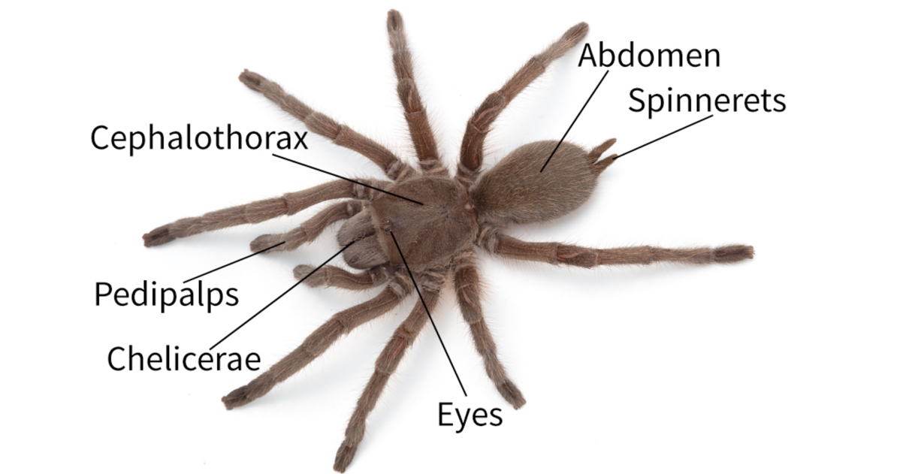
From identify-spiders.com

Crustacean Anatomy (Specifically, Crayfish)

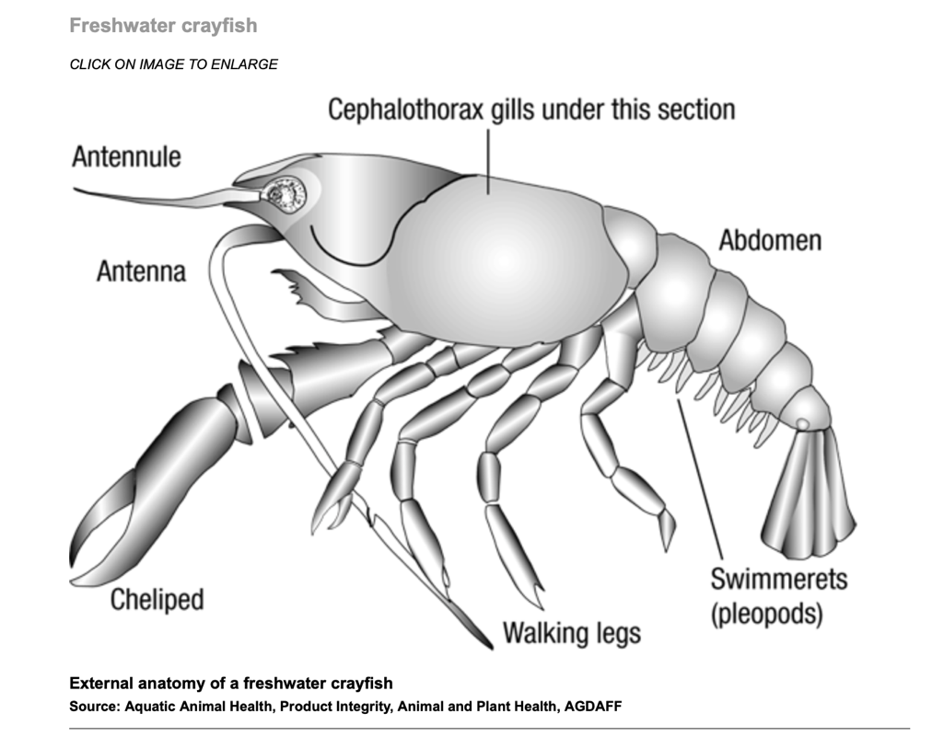
From library.enaca.org

Shrimp Anatomy

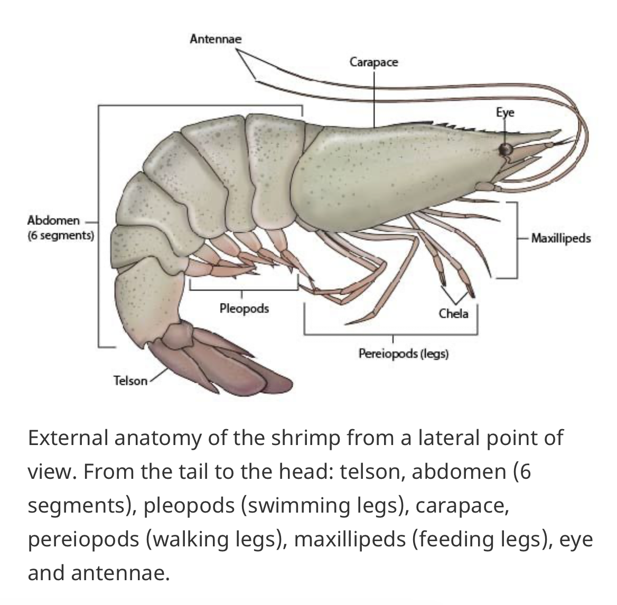

From dfo-mpo-gc.ca

Horseshoe Crab Anatomy

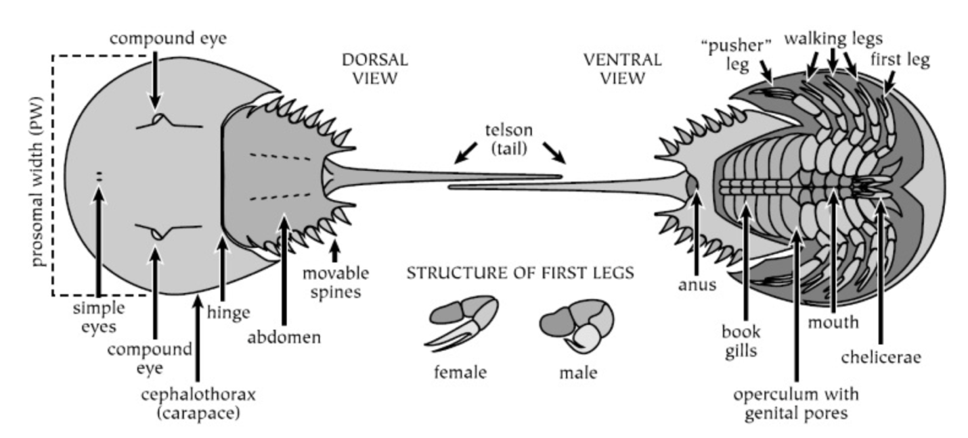

From dnr.sc.gov

Whelk Anatomy
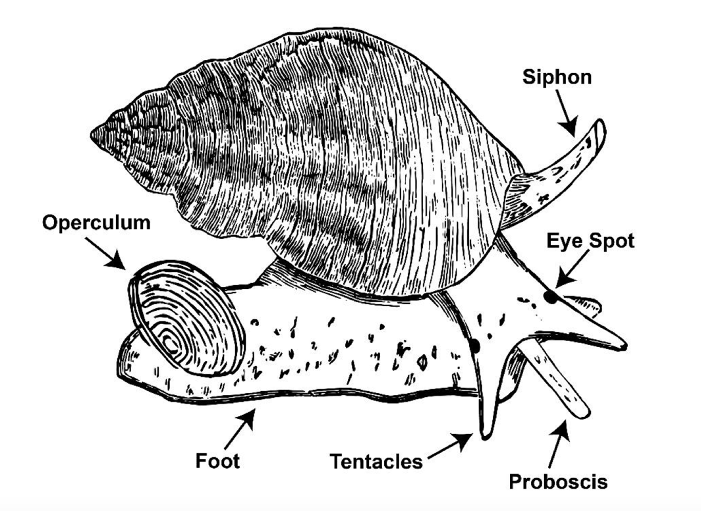
From vanderbiltmuseum.org

Slug Anatomy
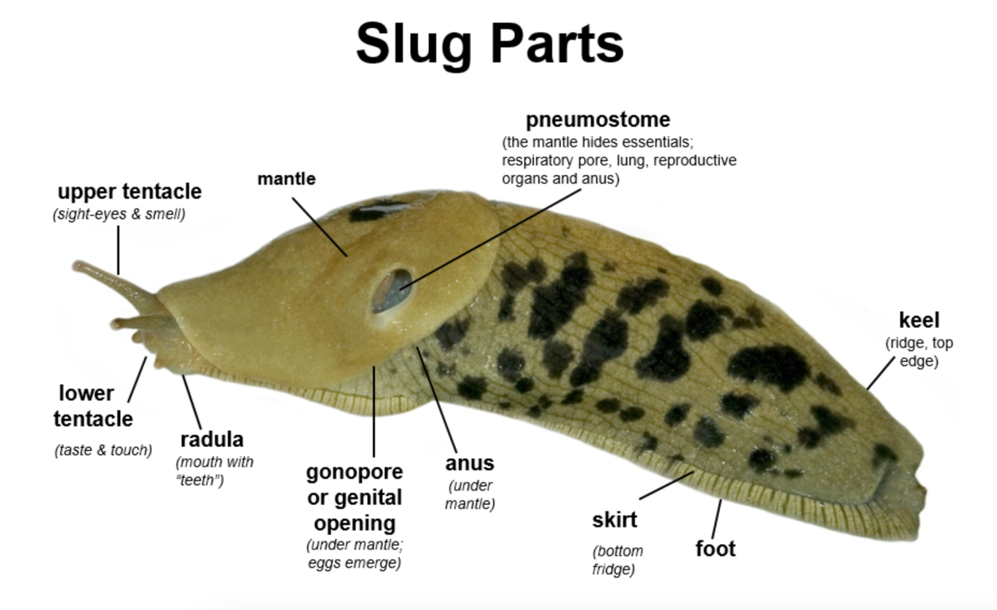

From agsci.oregonstate.edu

Land Snail Anatomy

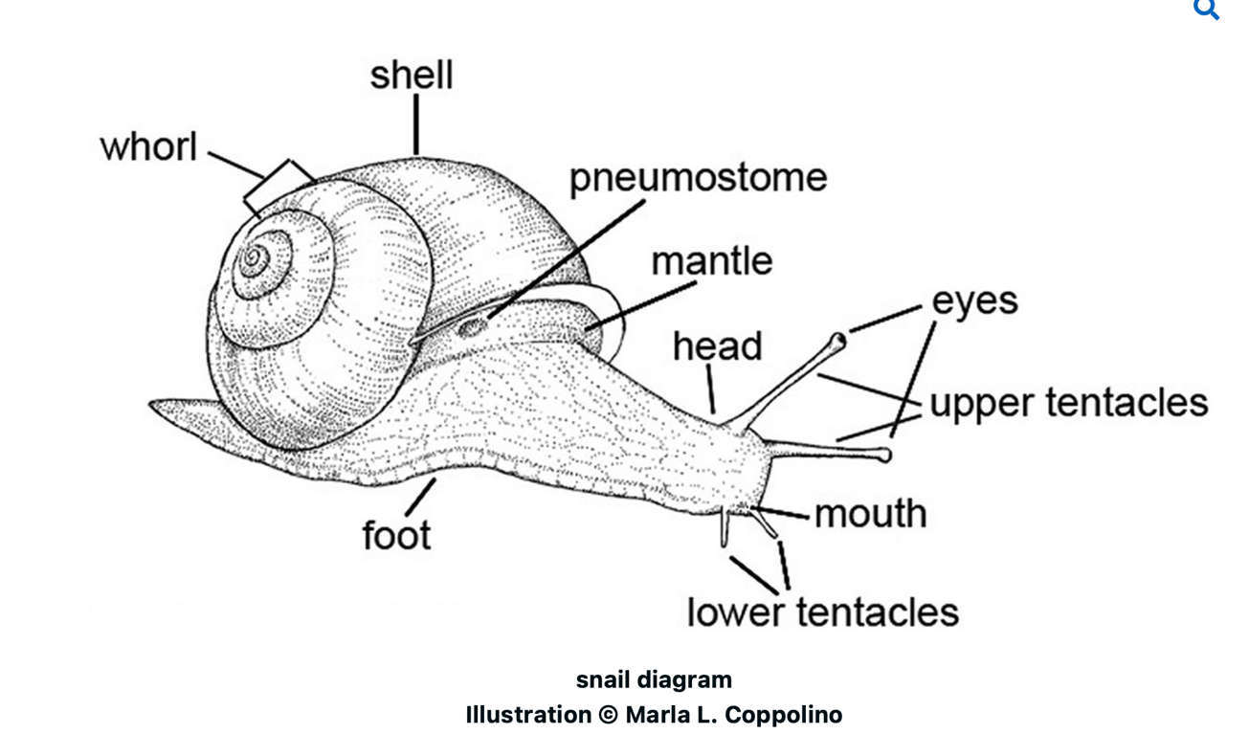
From dnr.illinois.gov

Oyster Anatomy

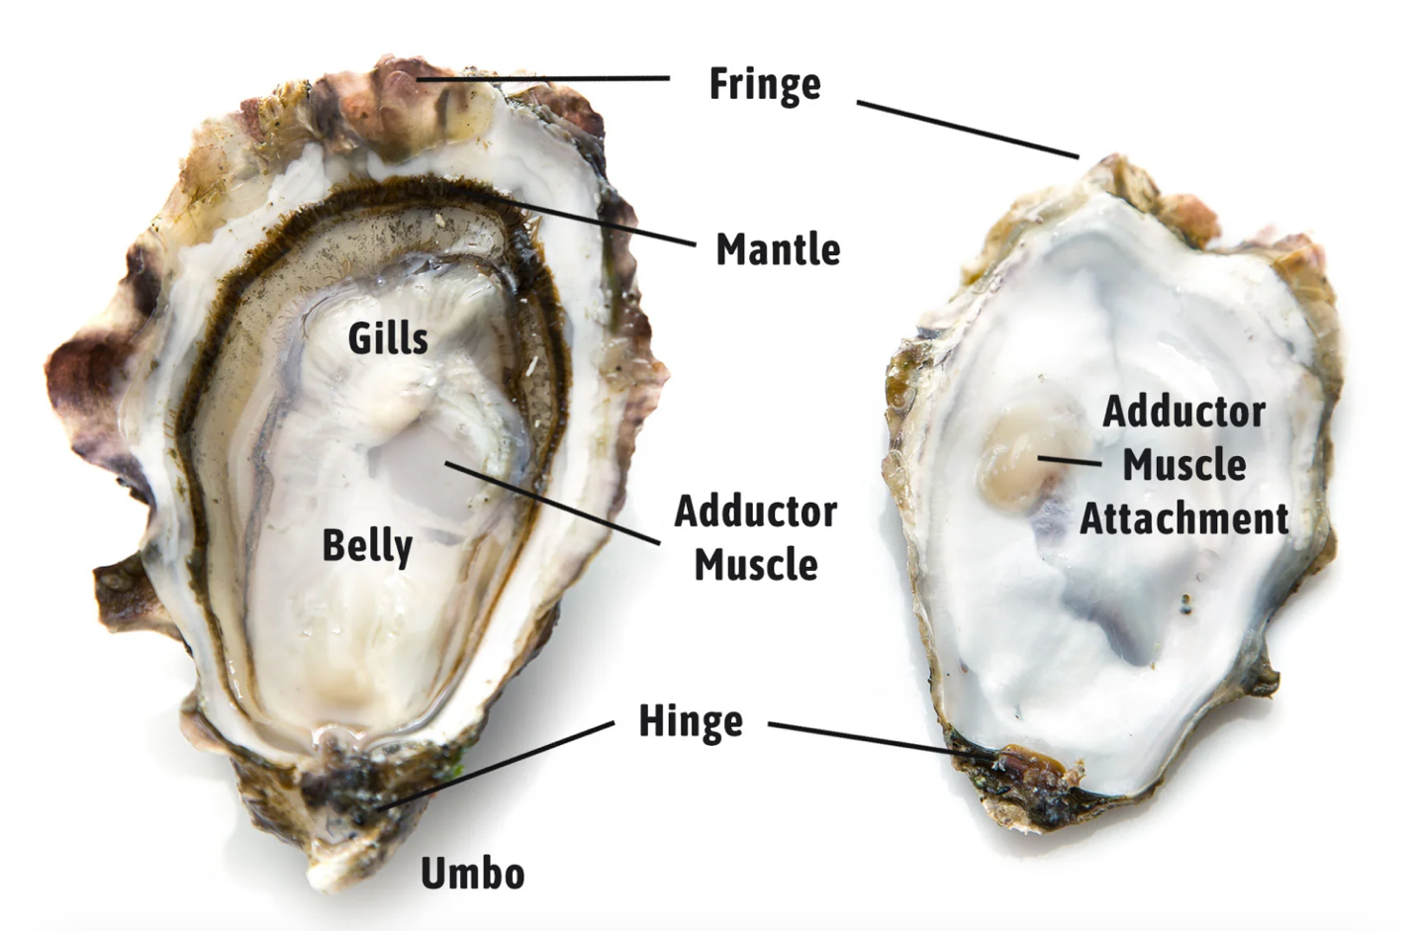
From hamahamaoysters.com
Another option for diagram and description is here

Clam Anatomy
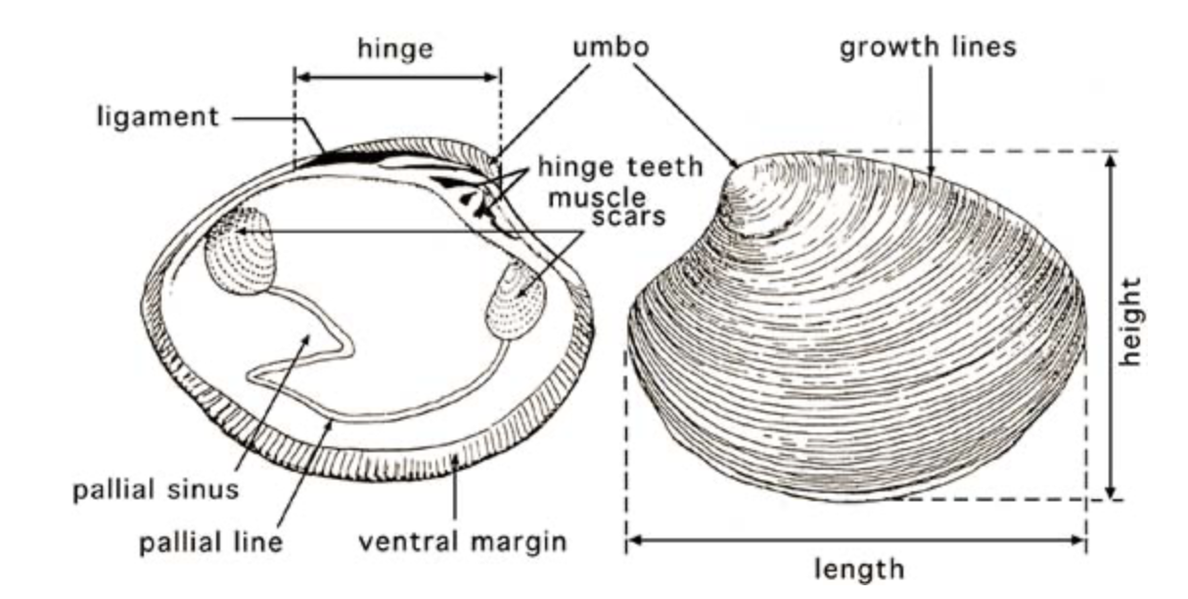
From fao.org

Scallop Anatomy

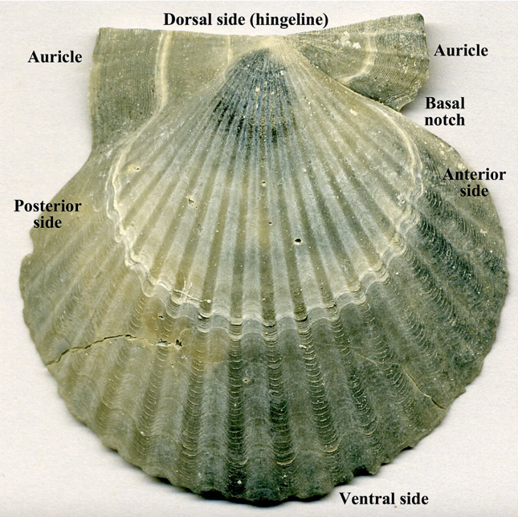 From Wikimedia.org

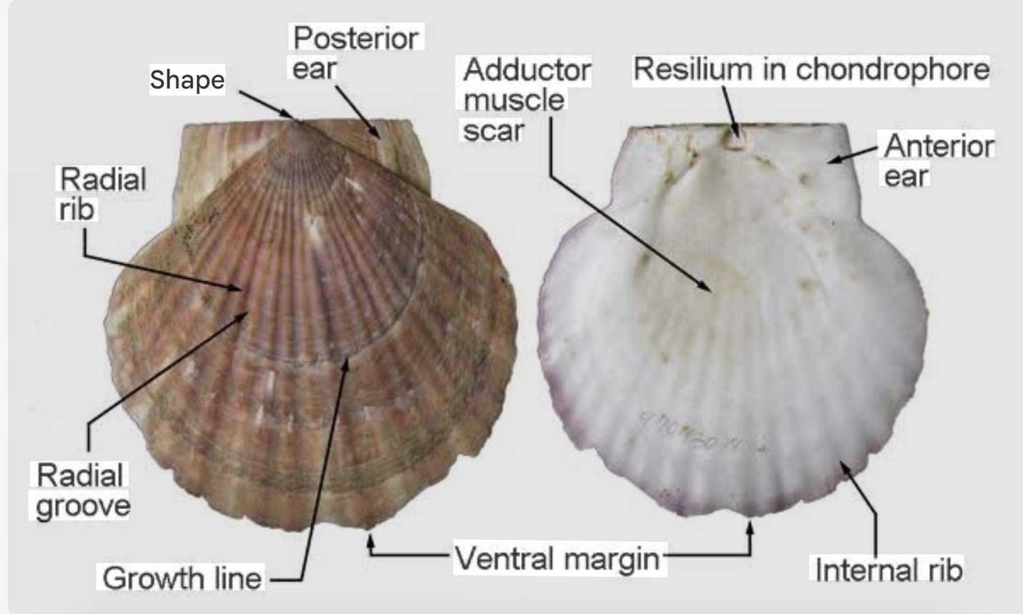
From cabidigitallibrary.org

Mussel Anatomy

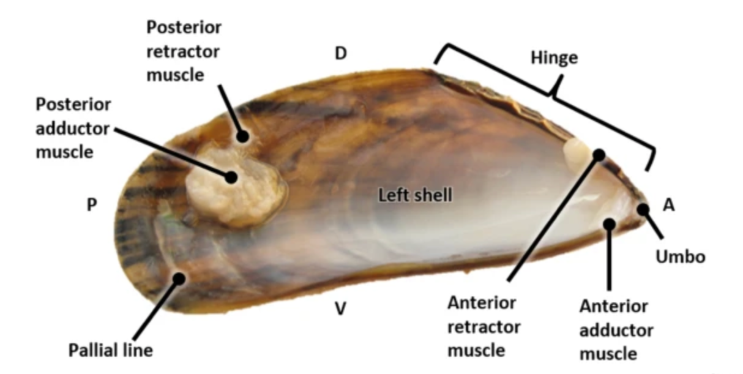

From nature.com

General Cephalopod Anatomy

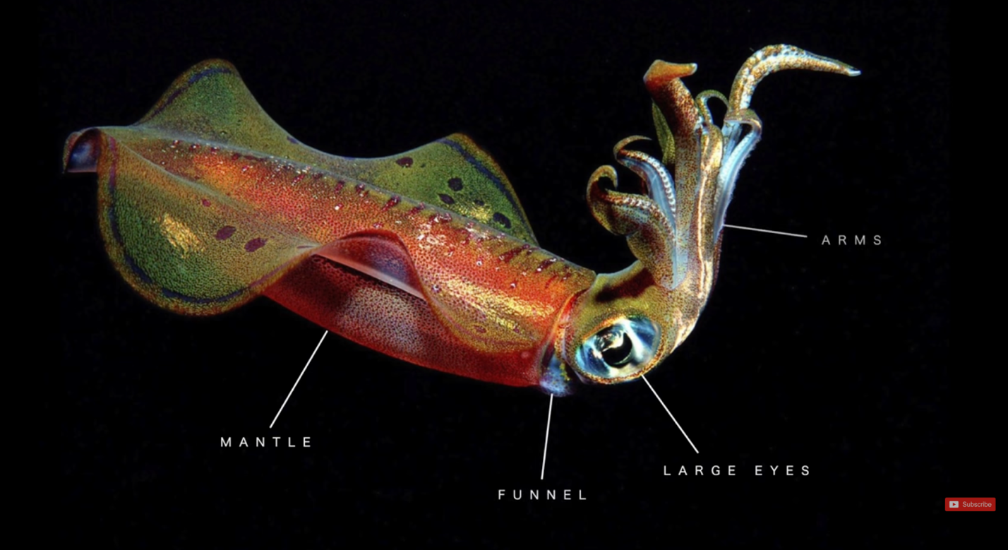

From YouTube Video

Squid Anatomy

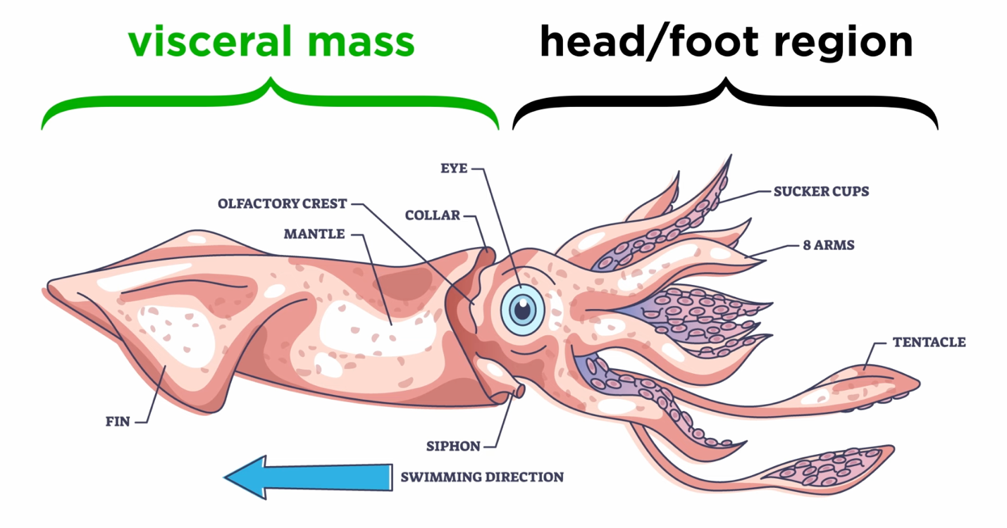
From YouTube video

Octopus Anatomy
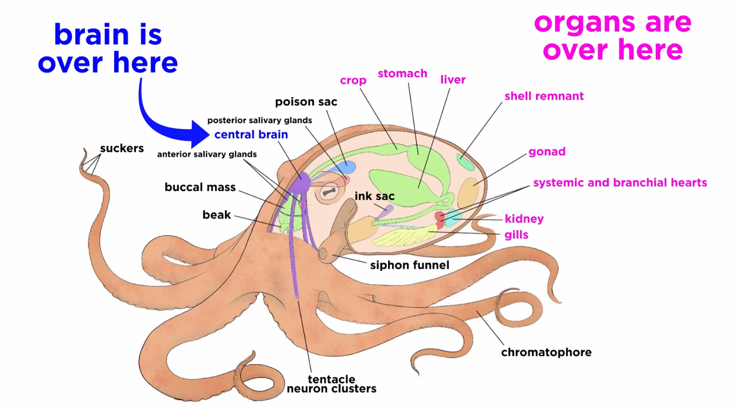

From YouTube video

Nematocyst (stinging cell) Anatomy
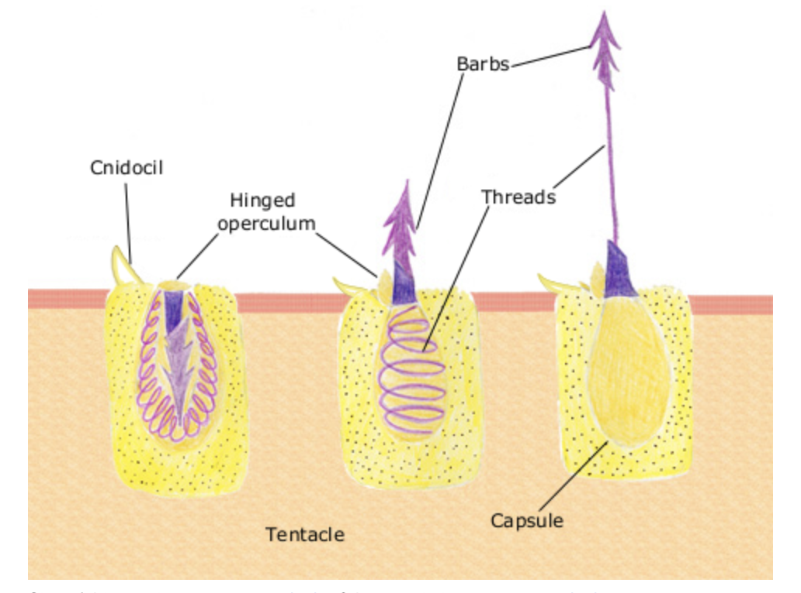
From Wikimedia.org

Sea Jelly Anatomy
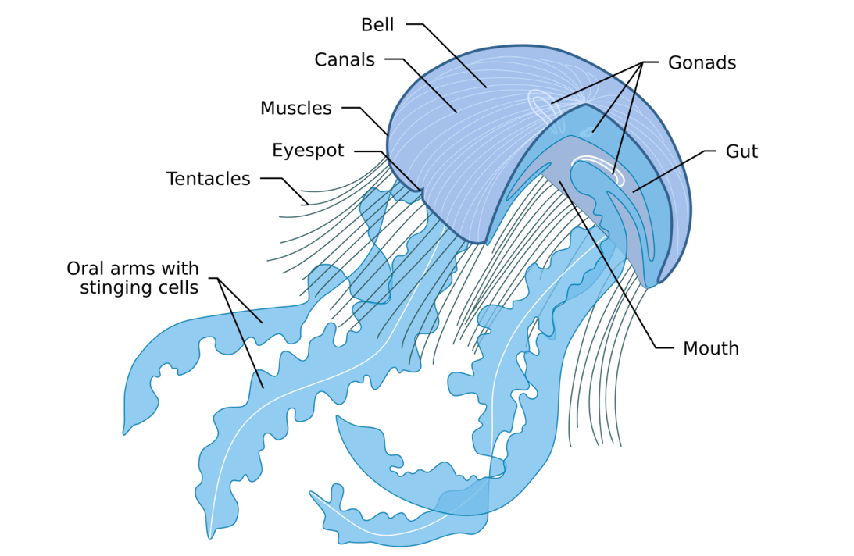
From Wikimedia.org

Sea Anemone Anatomy

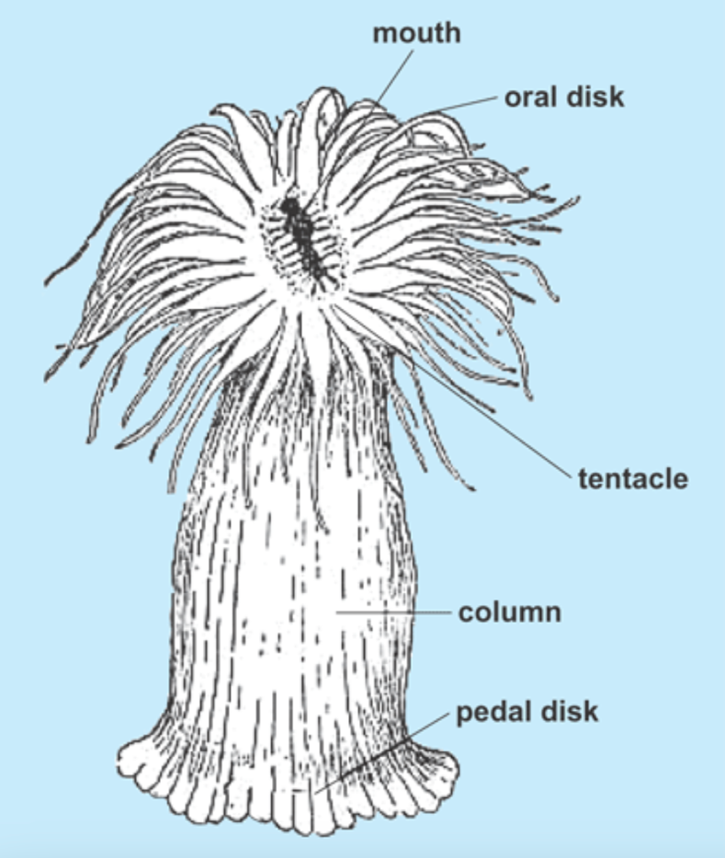

From accessscience.com

Sea Star Anatomy
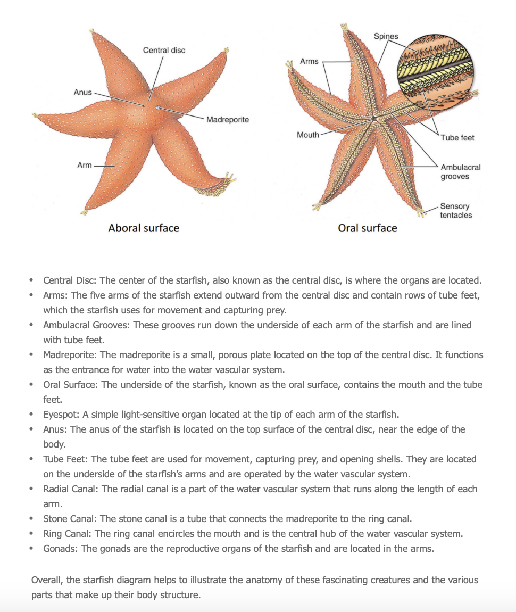

From sciencediagrams.com (more diagrams on this site)

Sea Urchin Anatomy

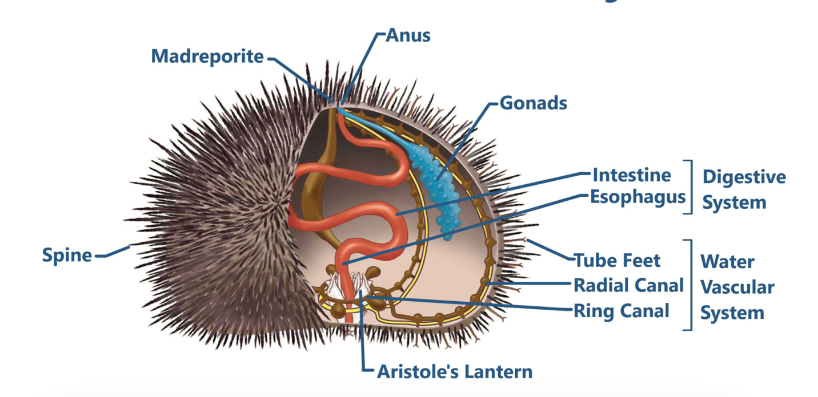

From Keywestaquarium.com

Earthworm Anatomy

