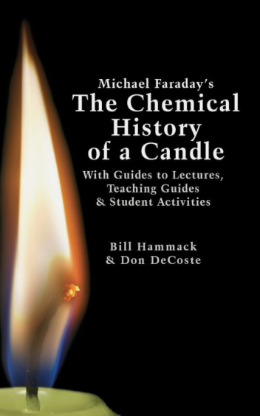

The Chemical History of a Candle
Teaching Guide for my Special Ed Year 8

Prepared by Lisa Cotting of amblingtogether.com

How I am teaching Michael Faraday’s The Chemical History of a Candle

My son is autistic and is not able to easily follow more complex science concepts. However, I want to “spread the feast” for him to partake in as much as he is able. I want him to enjoy science and learning how the world around him works without getting frustrated because he doesn’t understand the vocabulary or the way a concept is explained. I have sifted through the text, including the guide to the lectures, the teaching guides, the student activities as well as the videos, and found lessons that I think may interest M and still challenge him a little.
The following are 14 lessons starting with “The Big Ideas of Chemistry” section that are recommended to review with students before watching or reading the lectures. Though we have covered some of these topics in earlier years, I think it important to review with M, especially from a new perspective. This takes us through the first term. In the second term we start looking at the candle and go through the first and part of the second lecture.
I have scheduled every third week to be our microscope science week (since AO recommends 4 microscope lessons be done each term).

Free pdf of book and teaching resources

YouTube playlist of lectures

Schedule:
Week | Chemical History of a Candle Lesson
1 | Read Burn: Michael Faraday’s Candle by Darcy Pattison
2 | “Seeing” Atoms in everyday life
3 | -----
4 | Physical vs. Chemical Changes Pt 1
5 | Physical vs. Chemical Changes Pt 2
6 | -----
7 | Cohesion and Adhesion
8 | Molecules are “Sticky”
9 | -----
10 | Convection Currents and Density
11 | Capillary Action
12 | -----
13 | Observations of a Candle
14 | How a Candle Works
15 | -----
16 | Lecture 1: “A Candle: Source of Its Flame” Part 1
17 | Lecture 1: “A Candle: Source of Its Flame” Part 2
18 | -----
19 | Lecture 1: “A Candle: Source of Its Flame” Part 3
20 | Lecture 2: “Brightness of the Flame” Part 1

Week 2: “Seeing” Atoms in everyday life
Teacher Prep | Read Pg. 125-128
Supply List | Molecular modeling kit (Optional) or use diagram on pg.127  Liquid Food Coloring  Glass of Water  Glass of Hot Water  Glass of Cold Water
Teach or Read to Student | Pg. 126: Beach analogy  Pg. 127-128: Food coloring doesn’t just fall to bottom, but is “shoved” by moving water molecules  Pg. 128: This happens faster in hot water and slower in cold water because the molecules are moving faster in the hot water and more slowly in the cold water.
Demonstration | Pg. 127-128: Drop food coloring in room temp glass of water and watch as it spreads around all the water. Do the same in the hot water and cold water to demonstrate how the speed of the spread of food coloring differs.
Additional Resources | What is a Molecule? (3:08 min)  The Science of Macaroni Salad: What’s in a molecule? (3:14 min)  Thermal Energy in Water (3:15 min)

Week 4: Physical vs. Chemical Changes Pt 1
Teacher Prep | Read Pg. 128-131
Supply List | Warm water  Sugar  Pot or other method of boiling sugar water
Teach or Read to Student | Pg 129 “In its liquid state…” to end of pg. 131
Demonstration | Dissolve sugar in warm water. Dip in finger to taste different parts to show sugar is all throughout the water. Then boil water to see sugar left behind.
Additional Resources | n/a

Week 5: Physical vs. Chemical Changes Pt 2
Teacher Prep | Read Pg. 132-133 and 183-186  Video: The SciGuys- Electrolysis of Water (7:25 min) – explains well what is happening  Electrolysis of Water-Easiest Method (1:34 min) – easier experiment
Supply List | Distilled water  Glass or Beaker  Two graphite pencils, sharpened at both ends  Small piece of cardboard  9-volt battery
Teach or Read to Student | Review what a physical change was from last lesson.  Pg. 132-133 (as much as student will understand)
Demonstration | Split hydrogen and oxygen molecules of water: add salt to water, put two pencils through cardboard to hold them in place. Put 9-volt battery on top of pencils and watch bubbles form in water, splitting out the water into separate gases. Use Molecular modeling kit to reinforce what is happening to the oxygen and hydrogen in the water.  Alternative demonstration with baking soda and vinegar described on pages 183-186. Supplies not listed above.
Additional Resources | n/a

Week 7: Cohesion and Adhesion
Teacher Prep | Read Pg. 133-134
Supply List | Fingernail polish remover WITH acetone  Water dropper  Clean glass slide  Water and oil to mix together
Teach or Read to Student | Pg. 133-134  Paragraph 1: “The degree of attraction…” to end of paragraph.  Paragraph 2: “The acetone molecules in the…” to “…more than do acetone molecules.”  Paragraph 3: All but second sentence addressed to teacher  Video: Cohesion and Adhesion (5:45 min)
Demonstration | Notice room temperature items around home (water, juice, sugar, butter, candle, air in balloon, etc.). Discuss how the attraction of different molecules to each other is different.  Open the fingernail polish remover and notice how you can smell it across the room. Then put a drop of water and a separate drop of acetone on a glass slide and notice the shapes.  Mix water and oil together and notice how they behave.
Additional Resources | Heating Matter and Changes of State (2:40 min)  State of matter (6:37 min)

Week 8: Molecules are “Sticky”
Teacher Prep | Read Pg. 161-169
Supply List | Water  Water dropper  Penny  Wax paper taped to cardboard  Alcohol  Paper Towel
Teach or Read to Student | Review cohesion and adhesion from week 5
Demonstration | Follow the steps 161-165
Additional Resources | n/a

Week 10: Convection Currents and Density
Teacher Prep | Read Pg. 147-152  Video: Warm Air Rises - The Spinning Paper Plate (2:37 min)  “Extension” activity on pg. 153-154
Supply List | Print drawing on page 149 (or paper plate)  Thread or (straight pin)  Candle
Teach or Read to Student | Warm air rises because it is less dense (molecules are farther apart). Read paragraph 5 on pg 152
Demonstration | Cut spiral and hang on thread or pin (as in video above). Place over candle or other heat source and observe what happens. Move it off the candle and observe.
Additional Resources | Video: Why Does Hot Air Rise and Cold Air Sink (5:54 min)  Video of extension activity: Hot vs Cold Water Experiment (5:30 min)

Week 11: Capillary Action
Teacher Prep | Read Pg. 155-159
Supply List | Two glasses  Water  Blue and yellow liquid food coloring  Paper towel
Teach or Read to Student | Review what we learned in week 5 about cohesion and adhesion (cohesion – attracted to self, adhesion-attracted to other)  Pg 155 Paragraph 2  Video: What is Capillary Action of Water? (3:28 min)
Demonstration | Set up demonstration at beginning of lesson time, do reading/video, then come back to observe
Additional Resources | Capillary Tube set  Video: Capillary Action demo and science experiments (6:40 min)

Week 13: Observations of a Candle
Teacher Prep | Read Pg. 137-146
Supply List | Multiple size candles  Lighter
Teach or Read to Student | Pg 137 – importance of observations and goals for the day
Demonstration | Light candles and ask questions on page 138-139 and using teacher guide info on pages 142-146
Additional Resources | n/a

Week 14: How a Candle Works
Teacher Prep | Read Pg. 5-10
Supply List | New Candle  Lighter  Diagram of Candle from page 10 and from Lecture 1 Video (end of document)
Teach or Read to Student | Pg 5-6 “Quick Overview” and review diagram. Main point: “A candle, then, simultaneously carries out two actions: its flame burns vaporized wax and it delivers wax to that flame to sustain it.”  Read through page 9 for students who can understand. I have underlined specific concepts to read to or discuss with M. Pre-read and pick what will work for your student.
Demonstration | Light candle and observe how flame consumes the wick until it reaches just above wax. Have student observe flame during reading.
Additional Resources | Video: What is Fire (3:38 min)

Week 16: Lecture 1 -“A Candle: Source of Its Flame” Part 1
Teacher Prep | Read Pg. 13-15 (stop at “…all of these lectures.”)  Lecture 1: Pg 21-23 (stop at “…find out the reason.”)
Supply List | Candle  Lighter  Odd-shaped candle or birthday candle that will “gutter”
Watch Video | Lecture 1 to min 3:22
Demonstration | Notice the flame does not touch the wax. Notice on the “good” candle, the cup that is formed by the heat radiating down from the flame. The sides of the wax are cooled by the cool air being drawn up as the hot air rises.  Notice on the “bad” candle how a cup is not formed and the wax leaks out and cools at it goes down the side.
Additional Resources | n/a

Week 17: Lecture 1 -“A Candle: Source of Its Flame” Part 2
Teacher Prep | Read Pg. 15 -18 (stop at “…smoke its white color.”)  Lecture 1: Pg 23-26 (stop at “…matter gets disturbed.”)
Supply List | Candle  Lighter
Watch Video | Lecture 1 min 3:22 to 5:40 stop for narration  min 5:40 to 7:03
Demonstration | Notice that the solid wax is not burning. Discuss capillary action moving wax up to the flame. Discuss how the melted wax cools the flame and stops it from coming close to the solid wax. Note that it is only the vapor that is burned. Discuss how the smoke has small unburnt parts of the vapor in it - that is why it could be used to relight the candle.
Additional Resources | n/a

Week 19: Lecture 1 -“A Candle: Source of Its Flame” Part 3
Teacher Prep | Read Pg. 18-end  Lecture 1: Pg 26-end
Supply List | Candle  Lighter
Watch Video | Lecture 1 min 7:03 to end
Demonstration | Discuss the shape of the candle flame and how the air moves around it to form the tear drop shape. See screen shot at end of document to review how we can see that air in the shadow. Discuss how other flames, not from candles, do not have the tear drop shape because the air moves irregularly, making irregular fingers of flame.
Additional Resources | n/a

Week 20: Lecture 2 -“Brightness of the Flame” Part 1
Teacher Prep | Read Pg. 31 – 34 (stop at “…particular parts of the candle.”)  Lecture 1: Pg 42 – very top of pg. 44
Supply List | Candle  Lighter
Watch Video | What we will see:  - What happens in the different parts of the flame  - Two things are happening – the production of the vapor and the burning (combustion) of it  - In the middle of the flam the liquid wax on the wick is changing form into a vapor (physical change)  - In the outer part of the flame where the vapor hits the air, a chemical change occurs when the vapor is burned (combustion) and light and heat are produced  Lecture 2 to min 3:58
Demonstration | Optional – try to see the ring on a paper lowered into the flame as demonstrated in the video. Discuss how it is the heat in the outer part of the flame that can burn the paper. The inner part is not hot enough.
Additional Resources | n/a

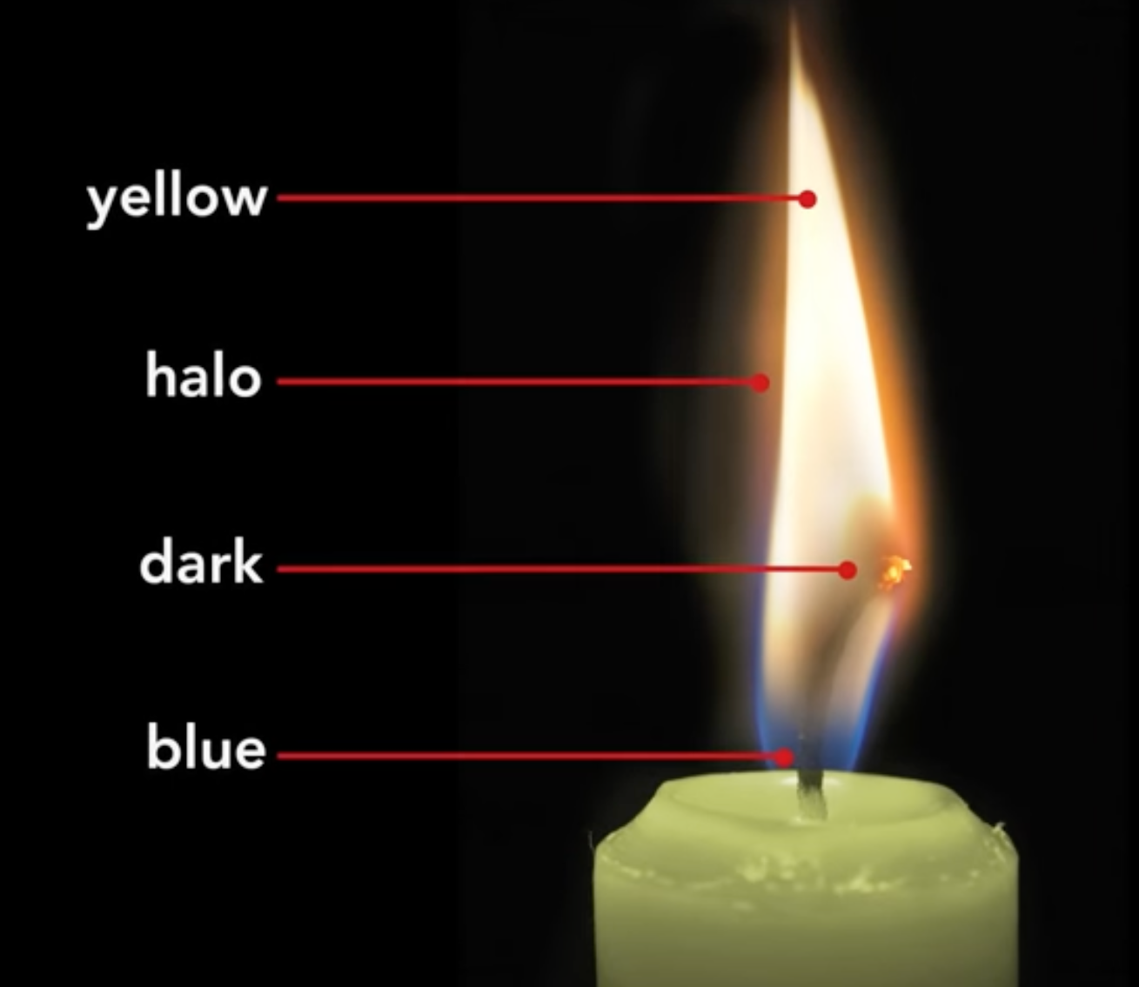
From Lecture 1 Video

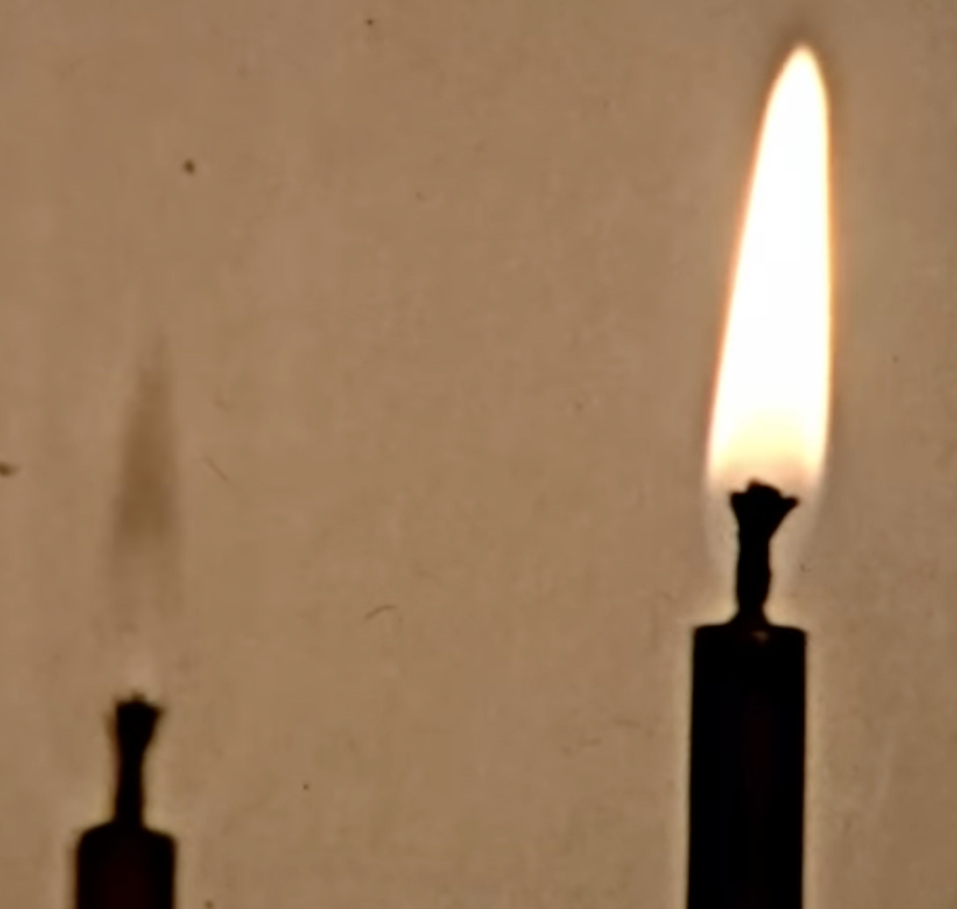
From Lecture 1

