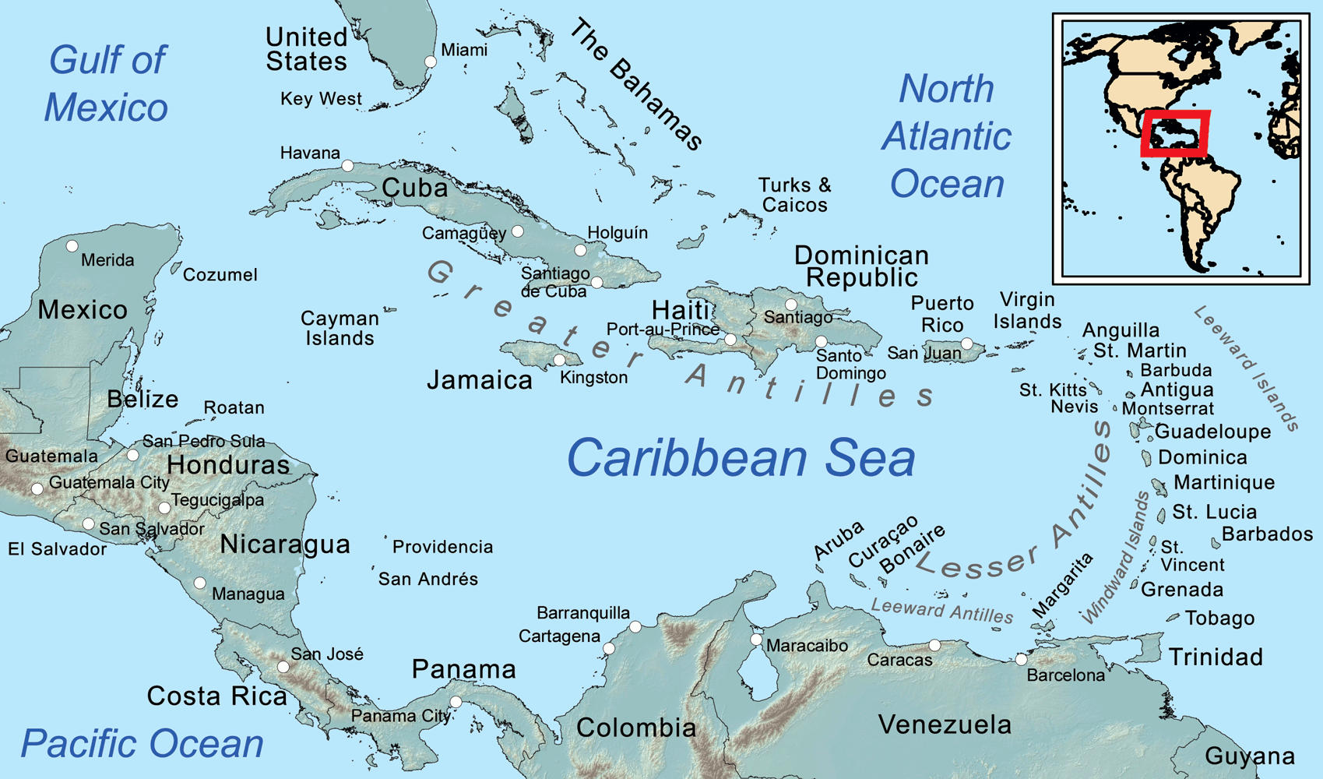
Geography Study:
Caribbean Islands
Prepared by Lisa Cotting
Amblingtogether.com

Table of Contents
How I Use This Guide 2
Caribbean Islands Overview 3
Lucayan Archipelago: Bahamas 4
Lucayan Archipelago: Turks and Caicos 6
Greater Antilles: Cuba 8
Greater Antilles: Hispaniola - Haiti 10
Greater Antilles: Hispaniola - Dominican Republic 13
Greater Antilles: Cayman Islands 15
Greater Antilles: Jamaica 17
Greater Antilles: Puerto Rico & Navassa 19
Leeward Islands: Virgin Islands – U.S. 3
Leeward Islands: Virgin Islands – British 5
Leeward Islands: St. Martin 7
Leeward Islands: Saint-Barthélemy 9
Leeward Islands: Saba & Sint Eustatius 11
Leeward Islands: Antigua and Barbuda 13
Leeward Islands: Montserrat 15
Leeward Islands: Guadeloupe 17
Leeward Islands: St. Kitts and Nevis 20
Windward Islands: Dominica 22
Windward Islands: Martinique 24
Windward Islands: Saint Lucia 26
Windward Islands: Barbados 28
Windward Islands: Saint Vincent and the Grenadines 30
Windward Islands: Grenada 33
Leeward Antilles: Trinidad and Tobago 35
Leeward Antilles: Bonaire 37
Leeward Antilles: Curaçao 39
Leeward Antilles: Aruba 41

How I Use This Guide

Why a study of the Caribbean:

Charlotte Mason describes the principle to be followed as the child gets older and starts studying other countries: “vivid descriptions, geographical principles, historical associations and industrial details, are afforded which should make, as we say, an impression, should secure that the region traversed becomes an imaginative possession as well as affording data for reasonable judgements.” (Book VI)

Inspired by this, I have made time in our Together Time to study the geography of the major regions or continents of the world (see amblingtogether.com/OtherGuides). For each continent or region, we study the major geographical features and boundaries and then do a brief study of each country therein. I try to find what will make “an impression” so that the country “becomes an imaginative possession” of each child.

How to study each island group / country:
Once a week we will spend 15-20 minutes on our Caribbean geography study. We will look at the map, answer the map questions, learn a little about its history, watch a video or two, and draw the country for ourselves. I plan on spending more than one week on some of the larger countries and extending this into a 36-week year-long study. It could also be condensed into a 2-term study by combining the smaller countries into one week.

I plan on using blank journals (like these) as our Caribbean Geography Journals. There are enough pages for us to use a two-page spread for each country or island group. For each we will write the name of the island at the top, stick on a small printout of the Caribbean to mark where the island is located (see stickers to print onto sticker paper at end of document), and draw anything else to help us remember a bit about this specific island (such as flag, animal, plant, food, etc.). We could also use these French, British, and Dutch flags to indicate if it is a territory.

Caribbean Islands Overview

General Caribbean Videos
- History of the Caribbean: The First Islanders of the Caribbean (2:02 min)
- The Caribbean Explained (8:16 min)
- The West Indies Explained (2:02 min)

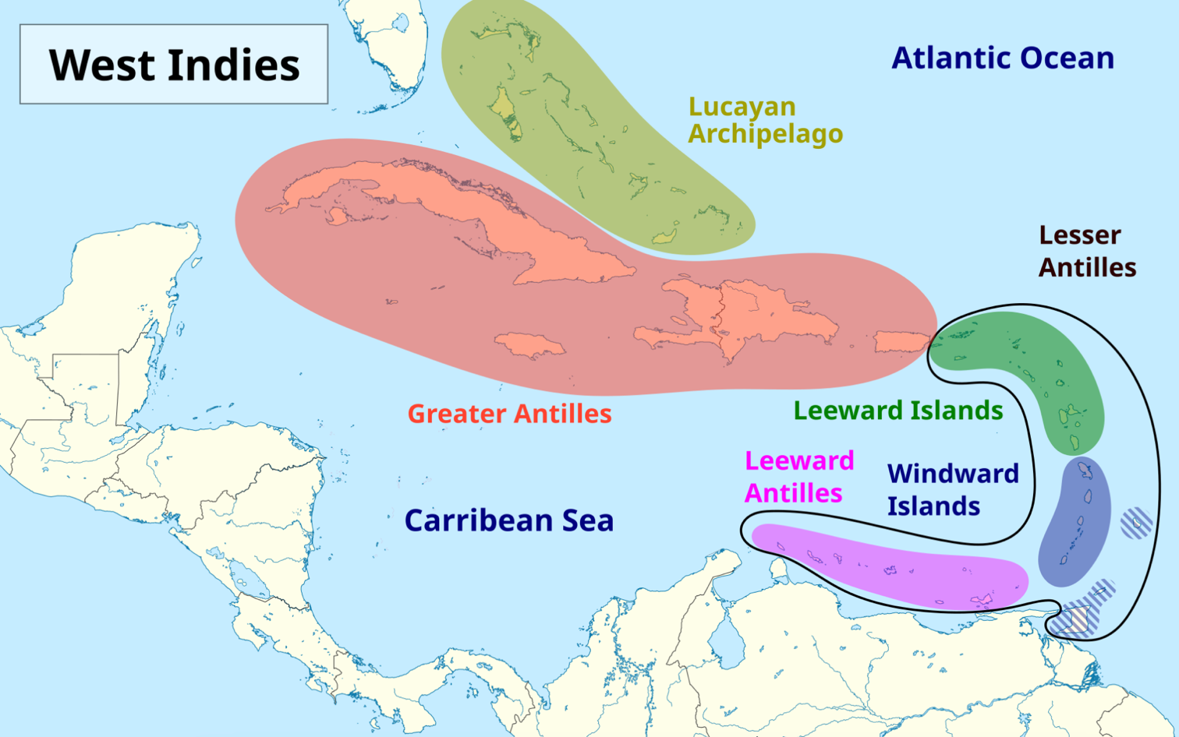
From Wikipedia

Other Useful Maps:
Caribbean Island Map - Wikipedia
Seterra maps

Lucayan Archipelago: Bahamas

About
Comprised of about 700 coral islands, 30 of which are inhabited (info from thecommonwealth.org). It is a fully independent nation and a member of the British Commonwealth of Nations. Originally inhabited by a Tiano people called the Lacayans, which roughly translates to “people of the islands.” The Bahamas was colonized by Spain after Christopher Columbus landed on an island there, probably San Salvador. The Spanish called the islands “bajamar” or “shallow sea.” The Tiano were enslaved, killed, and became sick, leaving the Bahamas with few inhabitants and later a base for piracy. The British took over in the eighteenth century and ruled until the Bahamas became independent in 1973.

Capital: Nassau on the island of New Providence
Language: English

To Read
* Overview of the Bahamas from Bahamas.gov official website
- Islands of the Bahamas from Bahamas.gov official website
- The Bahamas by Colleen Madonna Flood Williams (available on archive.org)
- They Found Burned Pirate Ships Beneath Nassau (6:32 min)

Links to View
- A Super Quick History of the Bahamas (3:14 min)
- Braving the Waters of Bimini with Shark Girl (2:15 min)
- What Made the Bahamas’ “Atlantis” Rocks? (4:57 min)
- Exumas Land and Sea Park (2:31 min)
- These Swimming Pigs Live a Cushy Lifestyle in the Bahamas (3:18 min)
- Pirate Ships of the Caribbean (47:12 min)

Map Questions
- In which hemisphere is The Bahamas located?
- What can we guess about the climate?
- Name the bodies of water around it.
- Name countries near the Bahamas.
- What is the largest island?
- On which island is the capital located?
- Name the northernmost island, southernmost, easternmost, & westernmost
- Between which Latitude lines is the Bahamas found?

Map Drawing
Draw the largest island (Andros), and the shape the other islands make, draw where Cuba and Florida are. Mark the capital.

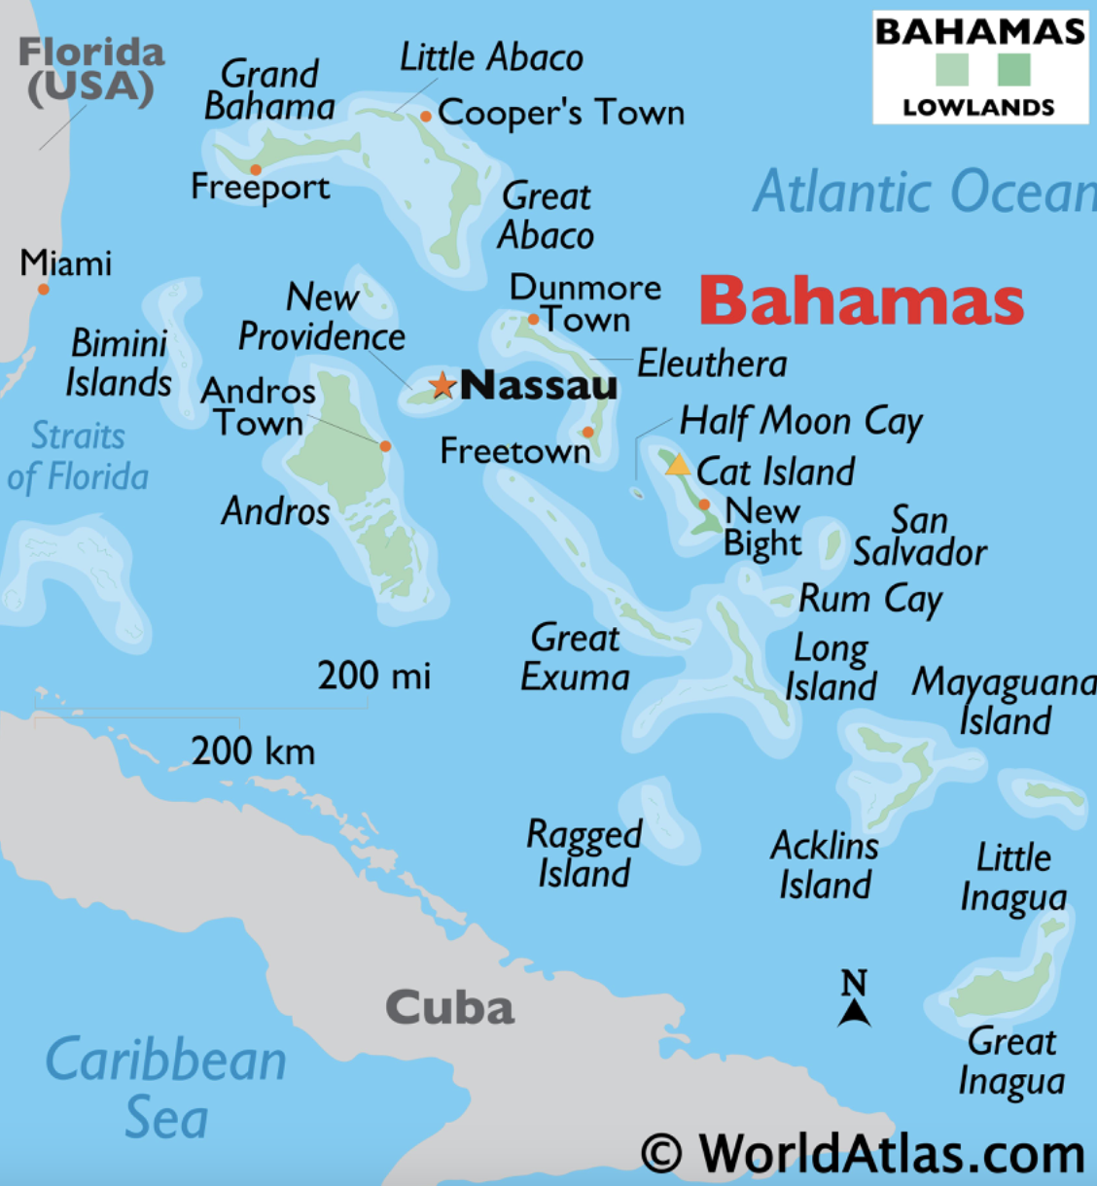
Map from WorldAtlas.com

Lucayan Archipelago: Turks and Caicos

About
Two smaller groups of islands south of the Bahamas and originally occupied by the Lucayan people. After Spanish occupation of the area, the British eventually claimed the islands. The islands became an integral part of the salt trade as the shallow waters made harvesting it possible. It is still a British Crown Colony today.

Capital: Cockburn Town on Grand Turk
Language: English

Read
- Read the overview of the islands from the official government site (click visitors link and “TCI History and Culture” option)
- Explore the “About our Islands” site linked from the official government site

Links to View
- Turks and Caicos Islands – wildlife and heritage (8:51 min)
- History of the Salt Industry in Grand Turk (8:47 min, especially min 4:26 – 6:02)

Map Questions
- In which hemisphere is Turks and Caicos?
- Between which Latitude lines is it found?
- What can we guess about the climate?
- Name the bodies of water it is near.
- Name the bodies of water around and between the islands.
- Which is the largest group of islands called?
- What is capital and where is it located?
- Name the northernmost island, southernmost, easternmost, & westernmost
- Which countries boarder / are near it?

Map Drawing
Draw the overall shape of the Turks and Caicos island, indicate where Bahamas, Haiti, & Dominican Republic are located. Add in the capital.

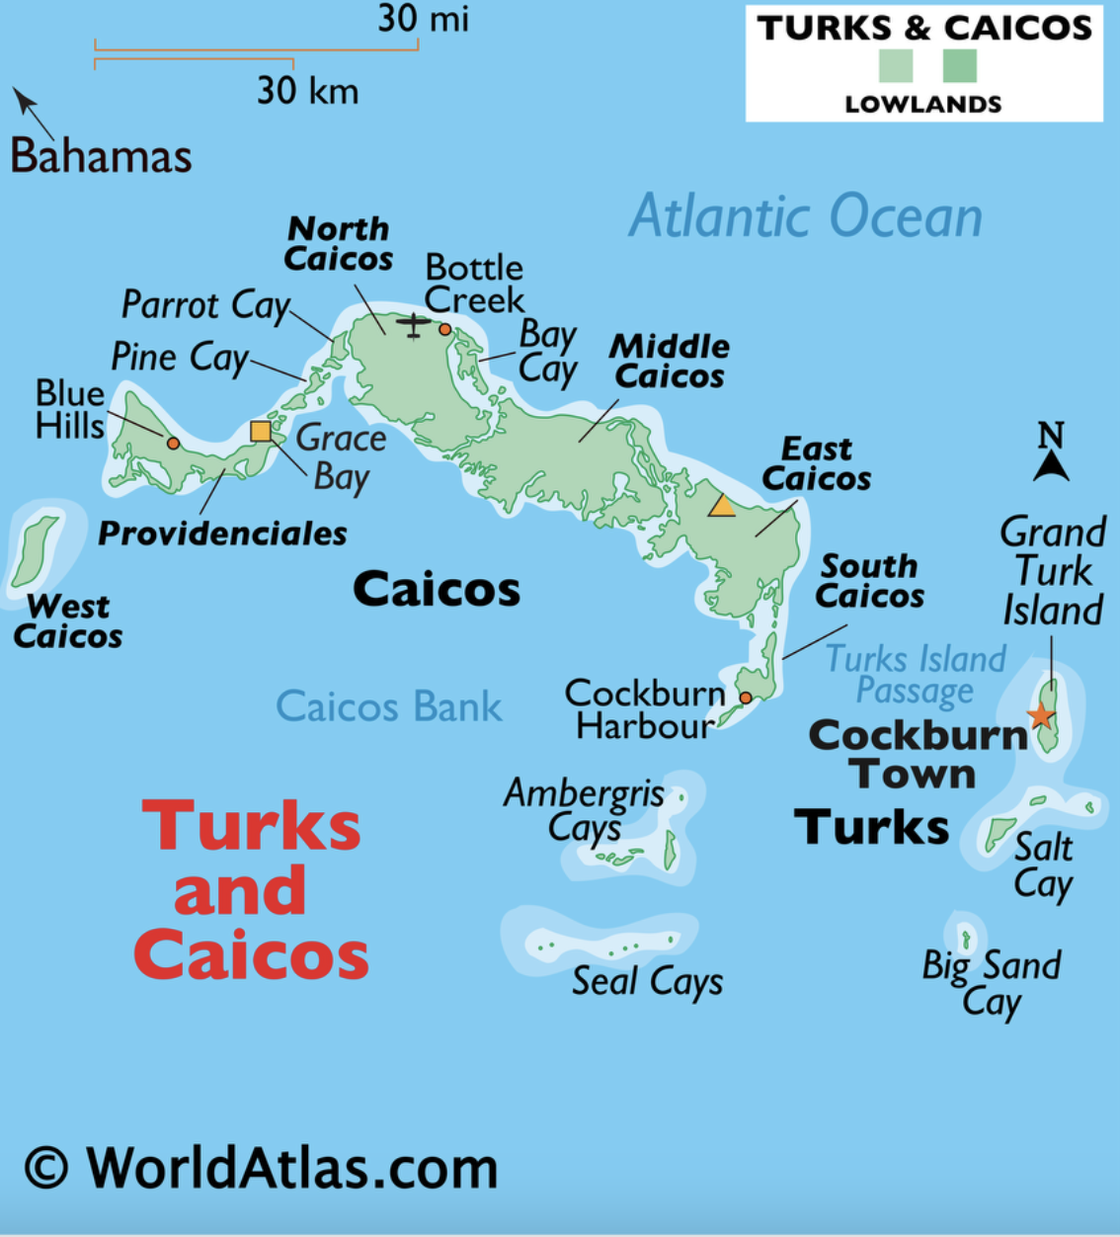
Worldatlas.com

Greater Antilles: Cuba

About
Comprised of one main island and several thousand smaller islands, Cuba is located just south of Florida between the Atlantic, Gulf of Mexico, and Caribbean. The island was originally inhabited by the Tiano and Guanahatabey peoples. Spain colonized it, bringing enslaved peoples to the island. After the Spanish-American war in 1898, it was under the control of the United States until it became independent in 1902. When Cuba aligned with the Soviet Union in the 1950s, it became a hot spot of the Cold War especially due to its proximity to the U.S.

Capital: Havana
Language: Spanish

Links to View
- A brief history of America and Cuba (6:13 min) – note, this video was made in 2016 so is a little outdated, but give a good understanding of history before that
- Journey Into Old Havana’s Vibrant History (2:52 min)
- Why Cuba’s Streets Are Filled With Classic Cars (3:44 min)
- Culture and Natural History in Cuba (4:36 min)
- Cuba’s Animal Underworld (4:44 min)
- The Birds of Cuba (6:34 min)
- Cuba’s Gardens of the Queen (6:39 min)

Map Questions
- In which hemisphere is Cuba?
- Between which Latitude lines is it found?
- What can we guess about the climate?
- Name the major bodies of water it is near
- Name the bodies of water around and between the islands.
- Which are the two main mountain ranges called and where are they located?
- What is capital and where is it located?
- Name the second largest island of Cuba
- Name the archipelagos on the northern coast
- Name the archipelagos on the southern coast
- Which countries boarder / are near it?

Map Drawing
Draw the shape of the main island and add the other main islands. Add in the mountains. Note where Florida, Jamaica, and Haiti are. Add in the capital.

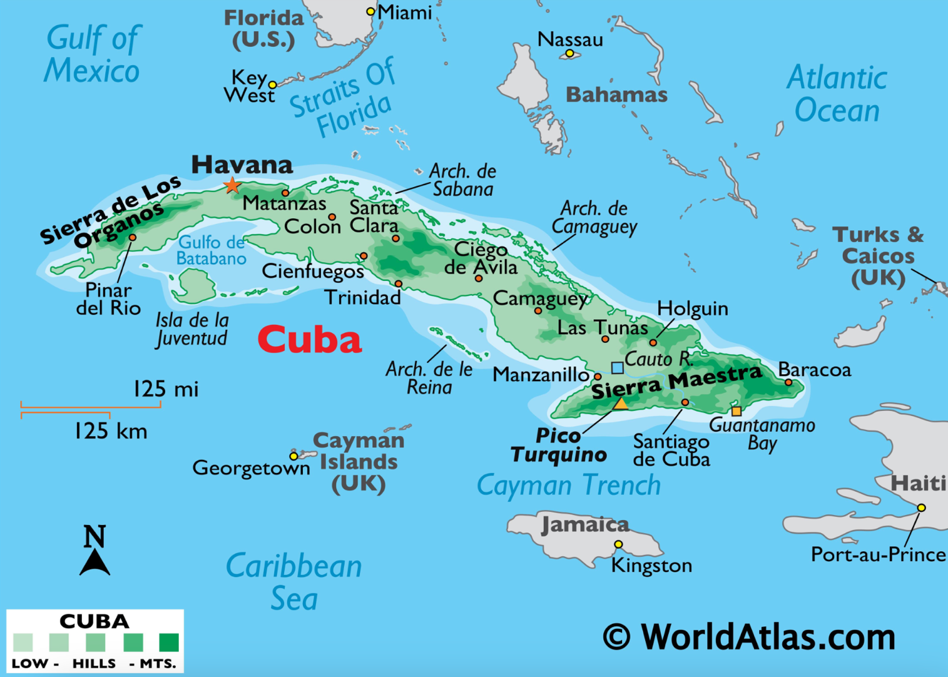
Worldmaps.com

Greater Antilles: Hispaniola - Haiti

About
On the western half of the island of Hispaniola, its name comes from the indigenous Taino word meaning “land of high mountains.” Columbus claimed the island for Spain on his first voyage. In the 1600s the French took control of the western side of the island to establish Haiti where coffee and sugar plantations were worked by enslaved peoples. A slave revolt from 1791-1804 established Haiti as an independent republic.

Capital City: Port-au-Prince
Official Language: French and Haitian Creole

To Read
- Running the Road to ABC by Denize Lauture, Illustrated by Reynold Ruffins
- Freedom Soup by Tami Charles
- Auntie Luce’s Talking Paintings by Francie LaTour, Illustrated by Ken Daley

Links to View
- History of Haiti and Hispaniola: The Island that Changed the World (8:13 min)
- In Haiti, One Man’s Trash is Another’s Art Supplies (4:07 min)
- The Revolutionary Roots of Haitian Soup Joumou (12:48 min, especially min 5:25 to end) and/or UNESCO recognizes Haiti for its ‘freedom’ soup (1:45 min)

Map Questions
- In which hemisphere is Haiti?
- What can we guess about the climate?
- Which island is it on and which country does it share that island with?
- Which bodies of water boarders it?
- Locate and name the three mountain ranges.
- Name the major gulf on its coast and the island in the gulf.
- Locate and name other islands of Haiti
- What is the name of its largest lake?
- Where is the capital city located?
- What countries are close to Haiti?

Map Drawing
Draw the shape of the island of Hispaniola. Draw the shape of Haiti, including the smaller islands. Label the mountains and bays. Mark the capital.
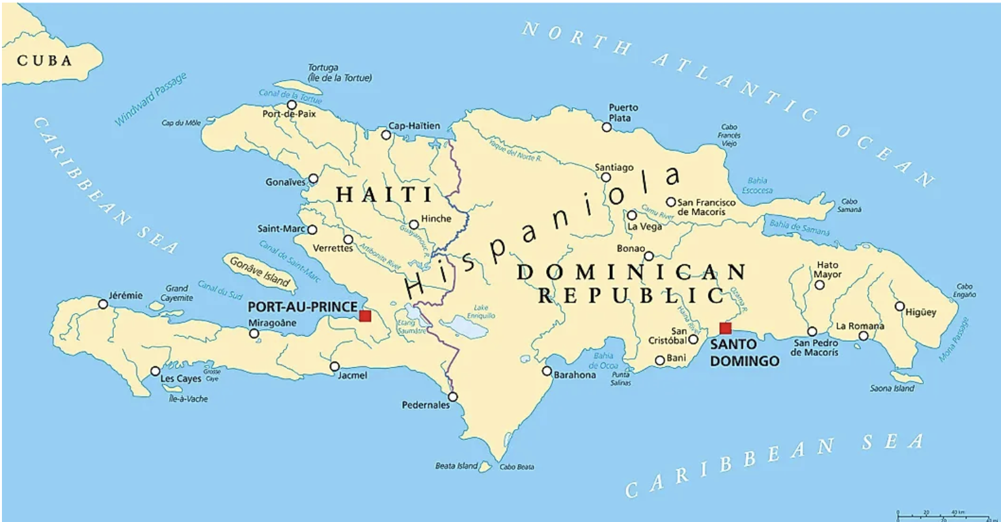 From worldatlas.com
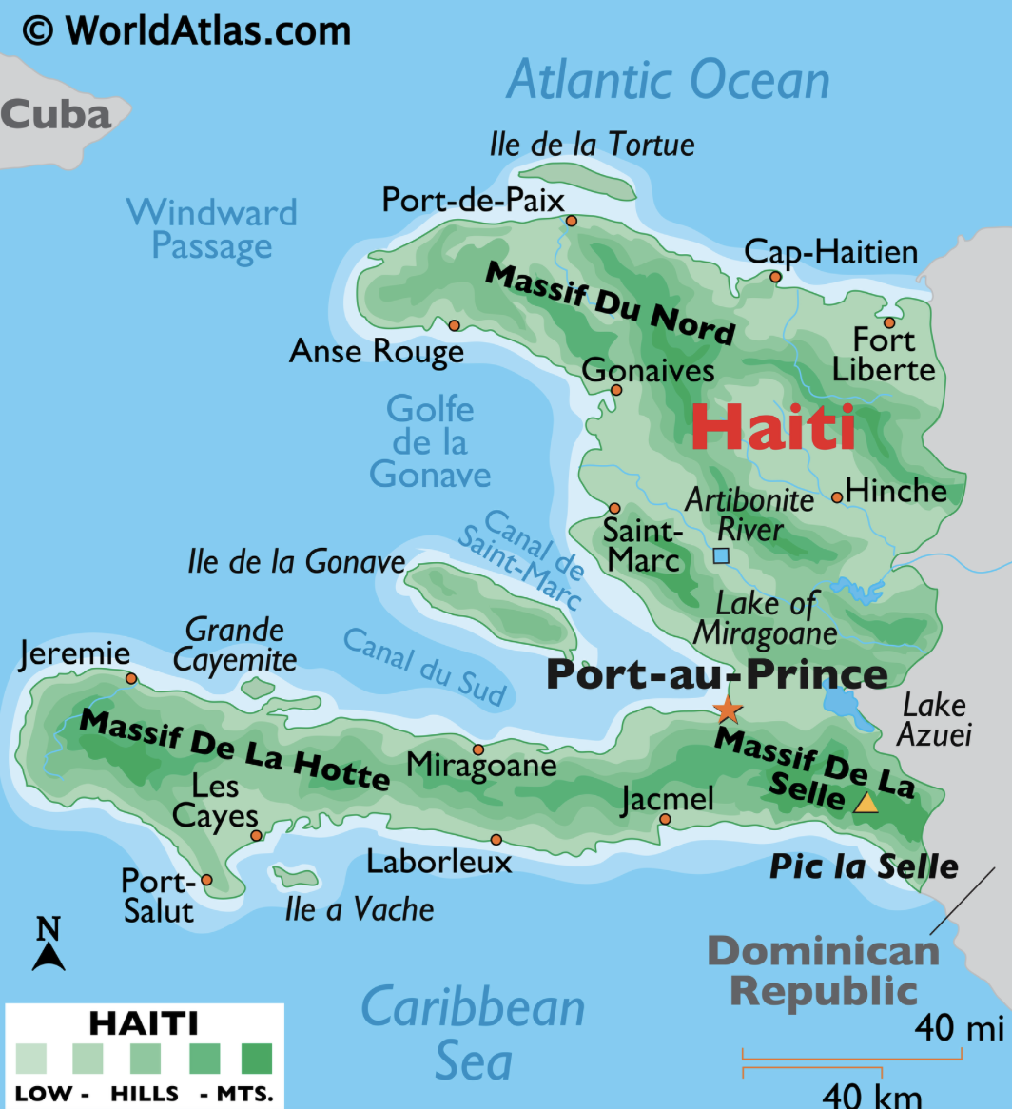
From worldatlas.com

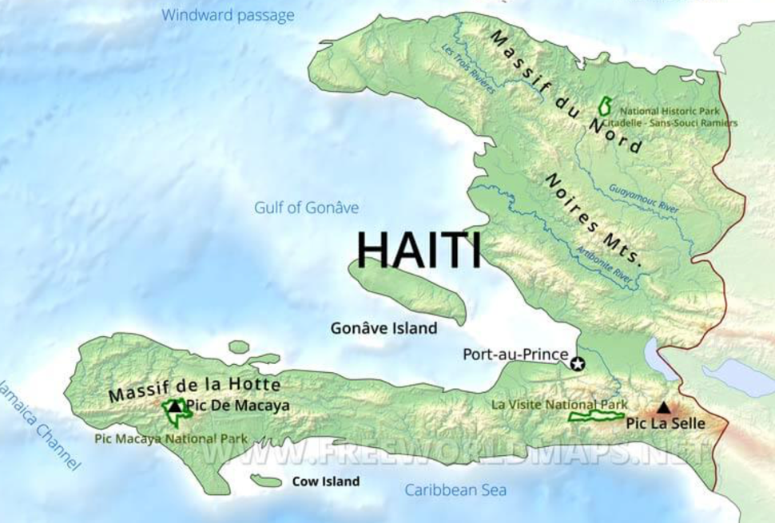 From freeworldmaps.net

Greater Antilles: Hispaniola - Dominican Republic

About
On the western half of the island of Hispaniola, it was originally inhabited by the Taino people and the first European colony after being claimed by Columbus for Spain as Santo Domingo. During the 1800s and after several wars, Dominican Republic gained its independence.

Capital: Santo Domingo
Language: Spanish

Links to View
- How Taino Culture Affects Us Today (5:43 min)
- Dominican Republic’s Tradition of Mask Making (2:44 min)
- Five Natural Wonders to Visit in the Dominican Republic (5:46 min)

Map Questions
- In which hemisphere is Dominican Republic?
- What can we guess about the climate?
- Which island is it on and which country does it share that island with?
- Which bodies of water boarders it?
- Name the major gulf on its east coast.
- Locate and name other islands of Dominican Republic
- What is the name of its largest lake?
- Where is the capital city located?
- What countries are close to Dominican Republic?

Map Drawing
Draw the shape of the island of Hispaniola. Draw the shape of Dominican Republic, including the smaller islands. Label the mountains and bays. Mark the capital.

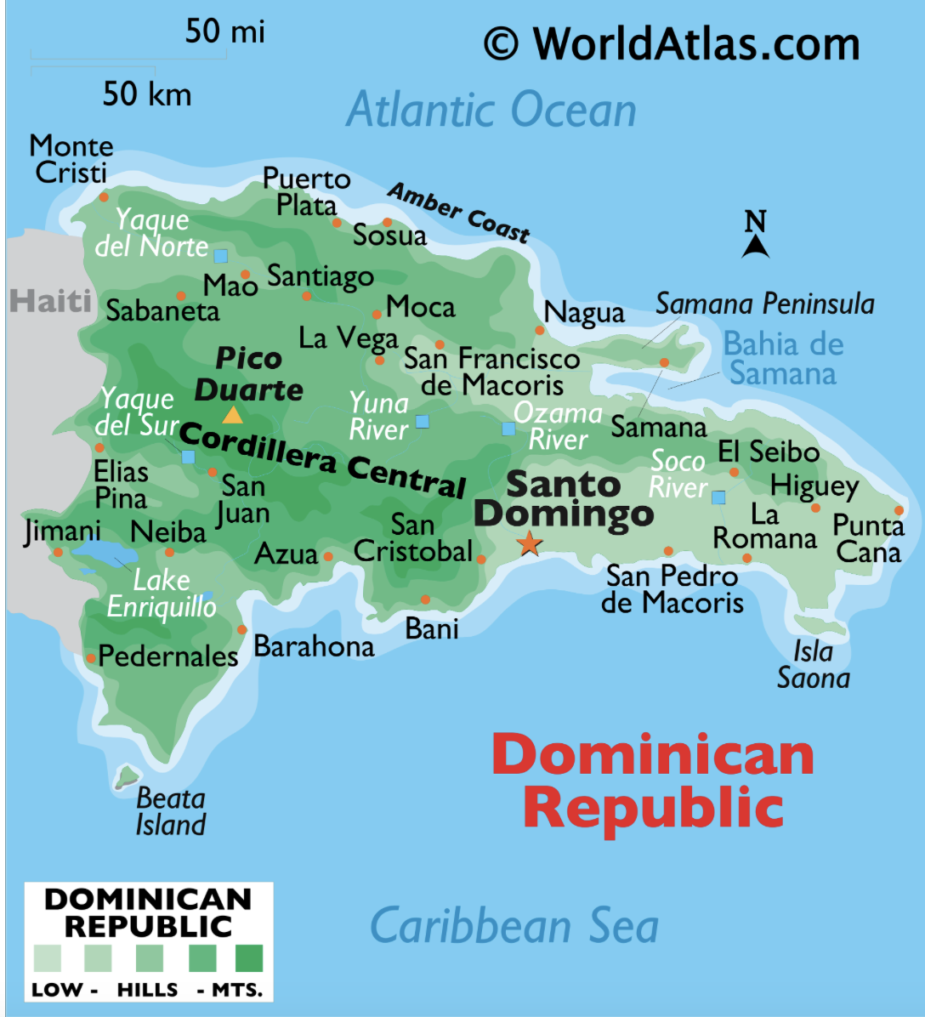

From worldatlas.com

Greater Antilles: Cayman Islands

About
There seems to be no evidence of people on these islands until Columbus saw them and named them Las Tortugas after the turtles. The name was later changed to Cayman using the Tiano name of the crocodiles. Used by pirates and claimed by the English in the 1600s though they did not settle until the 1700s. The islands are still an English colony.

Capital City: George Town
Official Language: English

Links to View
- Cayman Islands – wildlife and heritage (10:18 min)
- Blue vs. Green: The Battle of Iguanas on Cayman Islands (4:09 min)

Map Questions
- In which hemisphere is the Cayman Islands?
- What can we guess about the climate?
- Find Cayman Islands on a larger map of the Caribbean.
- Which bodies of water border it?
- Name the three islands and describe their relative positions.
- Between which Latitude lines is it found?
- Locate and name the bay on the largest island.
- Which countries is it close to?
- On which island is the capital located?

Map Drawing
Draw the shape of the three islands and their relative positions. Mark the capital. Show where in the Caribbean they are located by drawing Cuba, Jamaica, and the Yucatan Peninsula and Central American

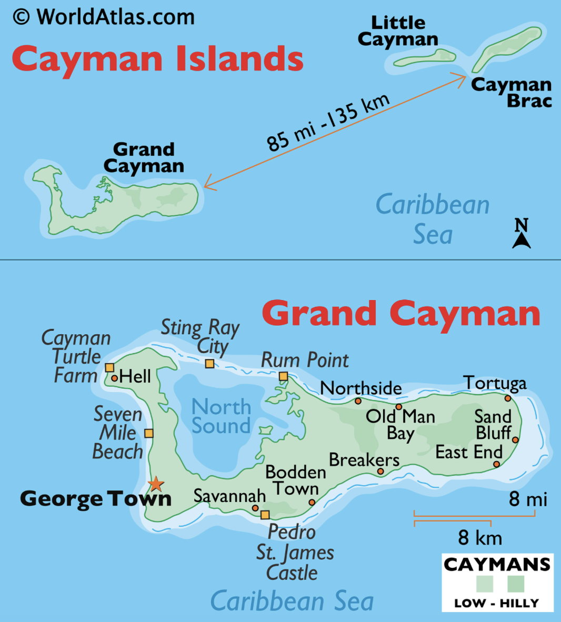
From worldatlas.com

Greater Antilles: Jamaica

About
Originally inhabited by the Tiano peoples, it was colonized by Spain and called Santiago until England conquered it in the mid 1600s. They changed the name to Jamaica, from a native word meaning “Land of Wood and Water.” The island was used for sugar plantations worked by enslaved Africans. It became independent in 1962 but is still a Commonwealth realm.

Capital: Kingston
Official Language: English, also spoken Jamaican Patois

To Read
- Longer chapter book for free read: Queen of Freedom: Defending Jamaica by Catherine Johnson

Links to View
- A Super Quick History of Jamaica (3:39 min)
- The Reall Story of Nanny of the Maroons (7:20 min)
- Reggae Music.- A Brief History (3:18 min) ; Bob Marley – Three Little Birds
- Jamaican Patois Expressions (2:27 min)
- In Jamaica – The origins of world famous pepperpot soup (

Map Questions
- In which hemisphere is Jamaica?
- What can we guess about the climate?
- Which bodies of water border it?
- Which countries are near it?
- Between which Latitude lines is it found?
- Locate and name two bays.
- What are its mountains called?
- Where is the capital located?

Map Drawing
Draw the shape of Jamaica. Mark the capital. Show where Cuba is located

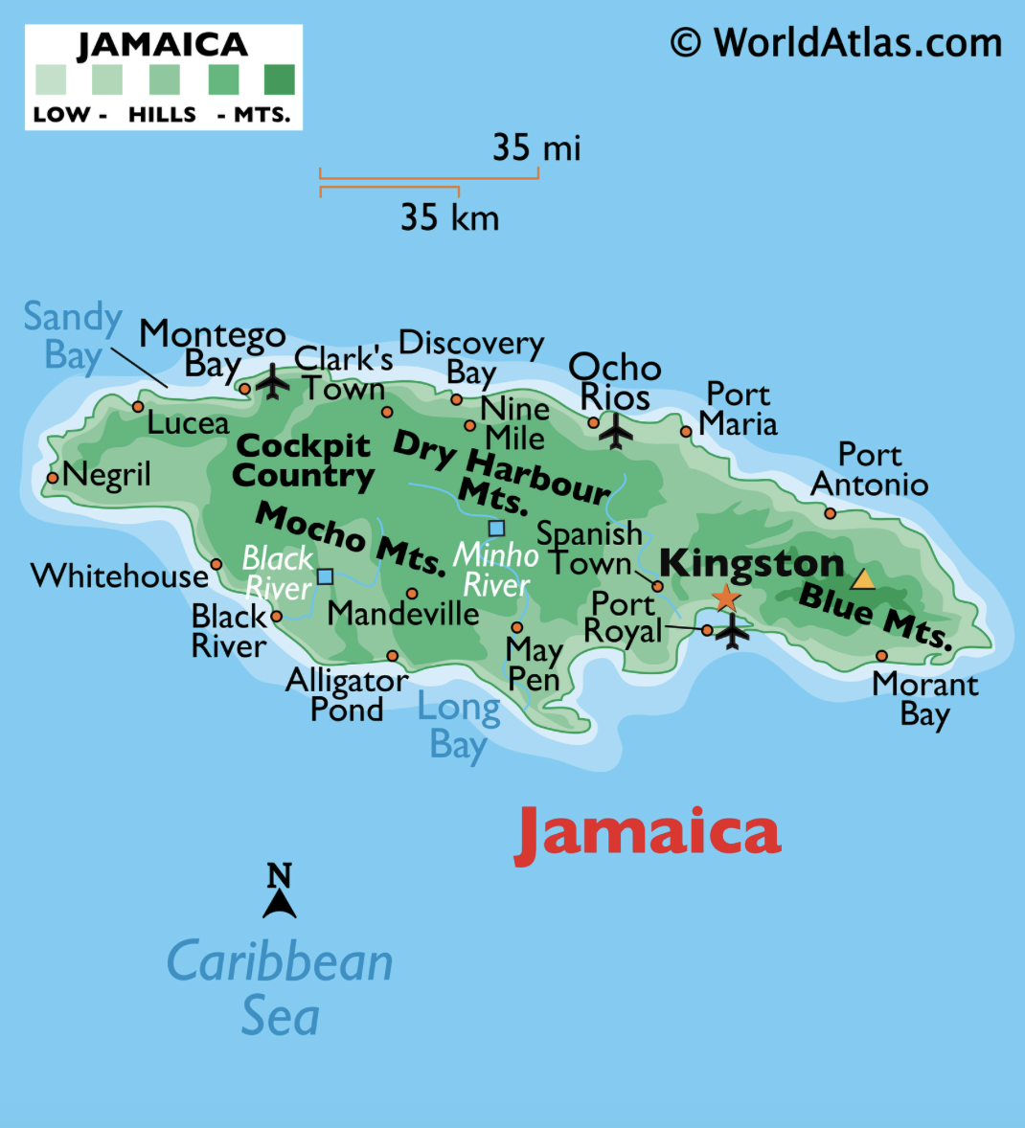

Greater Antilles: Puerto Rico & Navassa

About
Originally settled over 2000 years ago by the Ortoiroid, Saladoid, and Taino people, Puerto Rico is an archipelago of the main island and 143 small islands located in the Greater Antilles Archipelago of the Caribbean. Soon after Columbus, it was claimed by Spain. As a part of the settlement of the Spanish-American War, it was given to the United States. Puerto Ricans are U.S. Citizens, but since the island is not a state, they have only a nonvoting representative to Congress.

Capital: San Jaun
Official Language: Spanish and English

Links to View
- Here’s Why Puerto Rico is Part of the U.S. (3:27 min)
- A Puerto Rico’s wildlife (3:54 min)
- Why This Giant Puerto Rican Fort Kept Growing (2:05 min)
- Why Puerto Rico’s Cordillera Central Mountains are crucial to its survival (5:13 min)
- For teacher reference or older students: The Settlement of the Caribbean (24:56 min)

Map Questions

- In which hemisphere is Puerto Rico?
- What can we guess about the climate?
- Which continents is it closest to?
- Which ocean is it in?
- Which Sea lies to the South?
- How many major islands are there?
- Between which Latitude lines are the islands found?
- On which island is the capital?
- What island group is it a part of?

Map Drawing
Draw the shape of the main island of Puerto Rico. Add the islands of Vieques, Culebra, Mona, Desecheo and Caja de Muertos. Mark the capital. Draw the central mountain chain, Cordillera Central.

Navassa Island – a small, uninhabited island in the Caribbean between Jamaica and Haiti in the Jamaica Channel. The U.S. claim is disputed by Haiti. It is a wildlife refuge.
- Navassa Island (4:36 min)

From bluegreenatlas.com

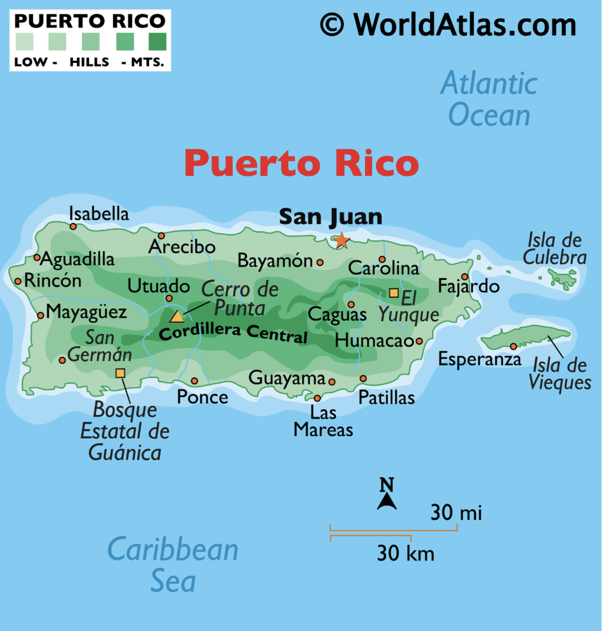

From worldatlas.com

Navassa Island:

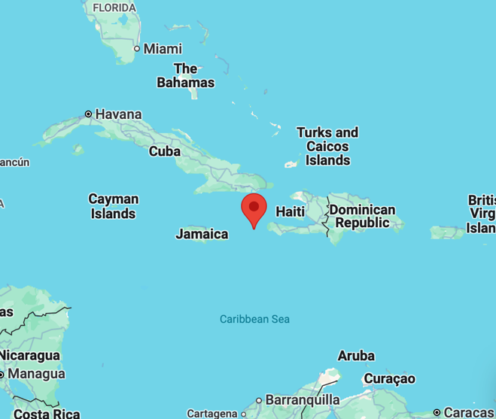
From google maps

Leeward Islands: Virgin Islands – U.S.

About
The U.S. Virgin Islands, located in the Leeward Islands of the Lesser Antilles, includes an archipelago with 3 main islands and over 50 smaller one. The islands have been inhabited for about 3000 years, and the Taino people have been there about 1000 years ago. While multiple European countries claimed the lands after Columbus, the Dutch gained control in the late 1600s. During World War I, the U.S. feared the islands could be taken by the Germans and the Dutch agreed to sell them to the U.S. in 1916. People born in the Islands are U.S. Citizens. Though they do not vote in federal elections, they do elect a non-voting member of Congress.

Capital: Charlotte Amalie
Official Language: English

Links to View
* Black History in America – US Virgin Islands (3:33 min)
* Discover the Beauty of the U.S. Virgin Islands (4:14 min)
* USVI Coral Innovation Hub / The Nature Conservancy (4:00 min)
* Are the Taino extinct? (13:24 min) – possibly for teacher reference or older students

Map Questions
- In which hemisphere is the U.S. Virgin Islands?
- What can we guess about the climate?
- Which continents is it closest to?
- Which bodies of water is it between?
- How many major islands are there?
- Between which Latitude lines are the islands found?
- On which island is the capital?
- What island group is it a part of?
- Which island group is to the West? To the East?
- Which is the southernmost island?
- What is the Sound between the two main northern islands?

Map Drawing
Draw the shape of each of the islands and their relative locations. Draw the islands north and south of Pillsbury Sound. Note where the coral reef national monuments are (see NPS map)

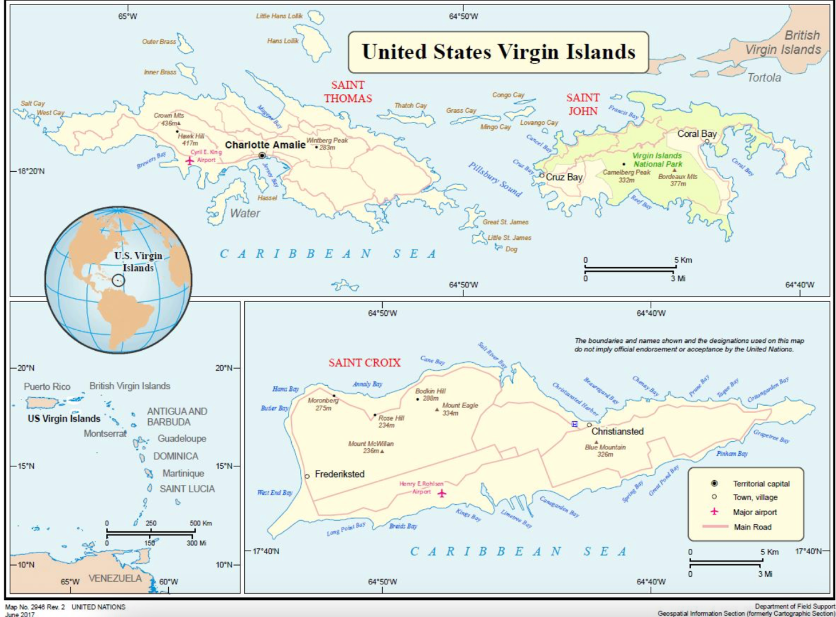
From UN.org

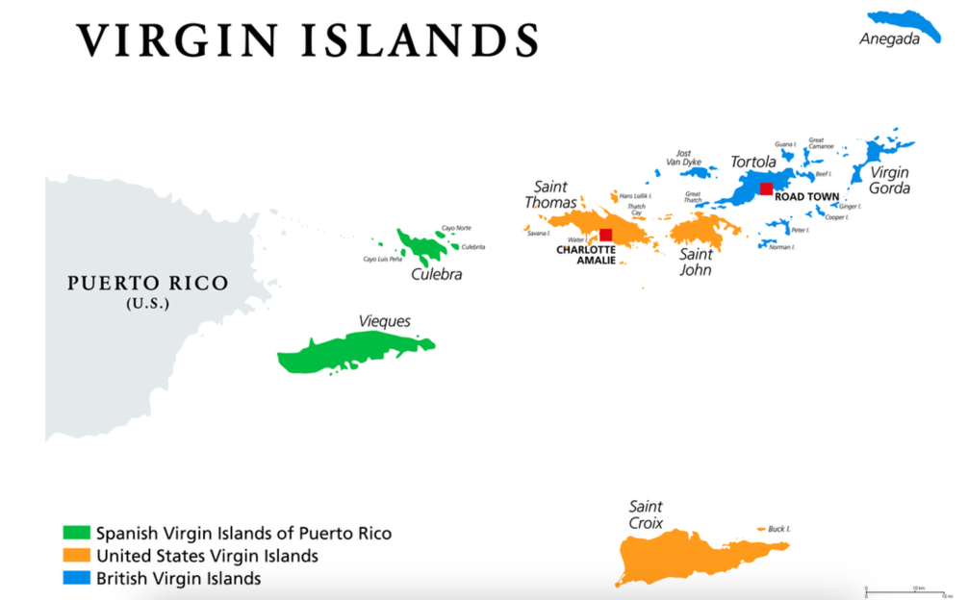 From Worldatlas.com

Leeward Islands: Virgin Islands – British

About
Originally inhabited by the Arawak people there are four main islands and about fifty smaller ones. Columbus landed on the islands on his second voyage and they were later claimed by Spain. No permanent settlements, only pirate, were on the islands for many years as the European countries fought for control. The British finally gained control of the islands and used them as sugar plantations. In the 1960s the islands became independent overseas territory.

Capital: Road Town
Official Language: English

Links to View
- British Virgin Islands – wildlife and heritage (9:03 min)

Map Questions
- In which hemisphere is the British Virgin Islands?
- What can we guess about the climate?
- Which continents is it closest to?
- Which bodies of water is it between?
- How many major islands are there?
- Between which Latitude lines are the islands found?
- On which island is the capital?
- What island group is it a part of?
- Which island group is to the West? To the East?
- Which is the northernmost island?
- What is the Sound between the two main northern islands?

Map Drawing
Draw the shape of Jost Van Dyke, Tortola, Guana Island, Grand Camanoe, Anegada, Virgin Gorda, and the Southern Islands and their relative locations. Mark the capital.

Anguilla – a 35 square mile island with multiple smaller islands of the British overseas territories. It was inhabited by indigenous peoples who left petroglyphs and other artifacts. The territory was disputed by European powers and finally claimed by Britain. The Valley is the capital city on the island.
- Anguilla Heritage Museum (2:40 min)

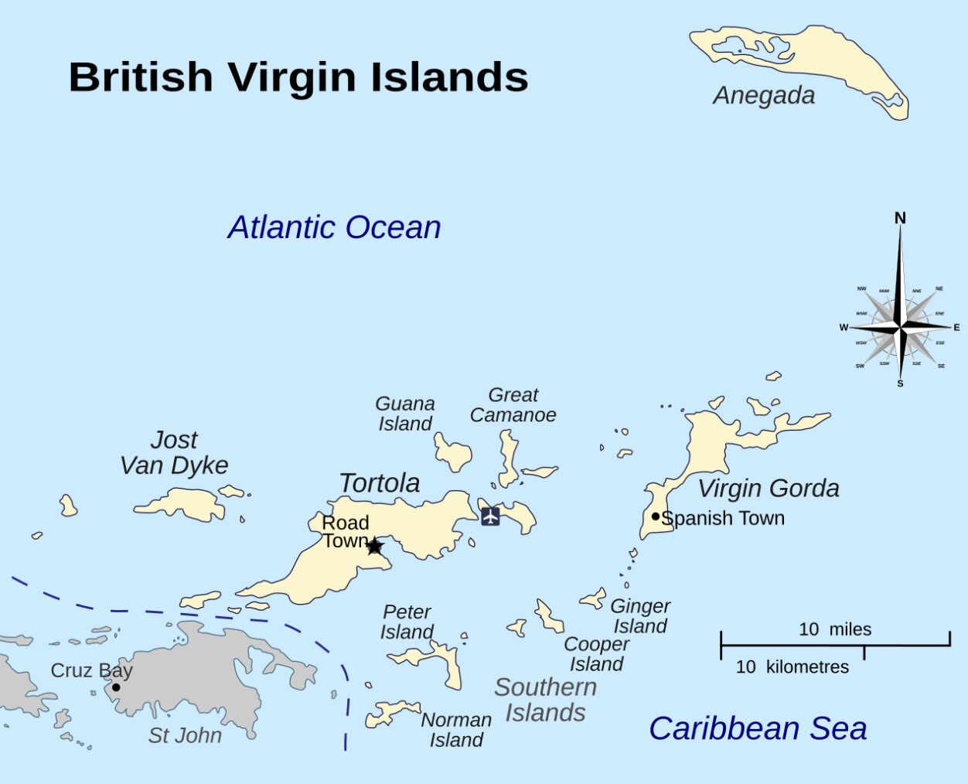

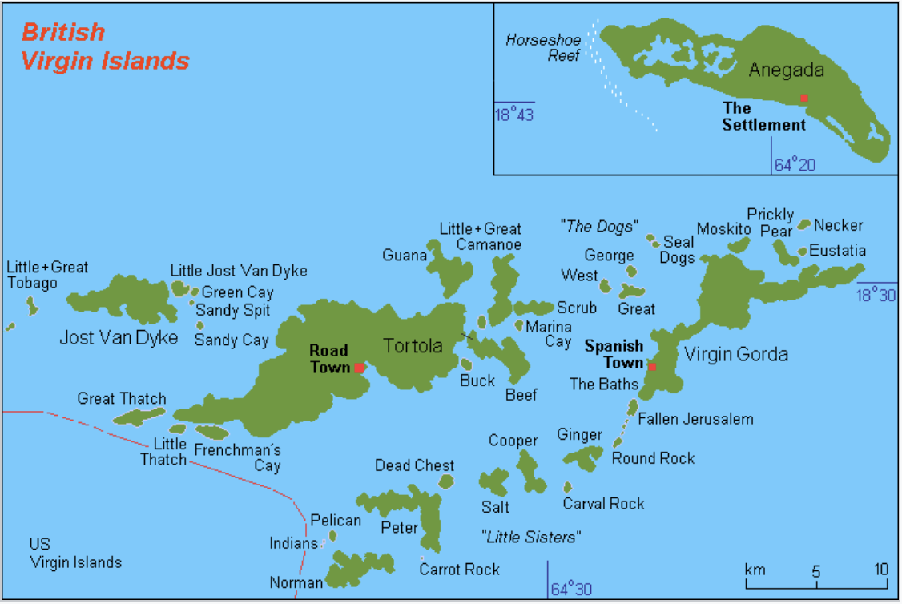
Both maps from Wikipedia

Leeward Islands: St. Martin

About
A group of islands possibly visited by Columbus, though he gave the name to another island that was later mistaken for this one. The Netherlands and France both claimed the island but agreed to split it in the 1600s. The northern half is known as Saint Martin and belongs to France and the southern half is known as Sint Maarten and belongs to the Netherlands. Sint Maartin is part of the “SSS Islands” as the three Dutch territories in the Leeward Islands are known.

Capital: Philipsburg (Dutch), Marigot (French)
Official Language: Many including Dutch, French, & English

Links to View
- Why is this island divided? (3:06 min)
- A mixture of French and Dutch culture on the Caribbean island of St. Martin (6:00 min)

Map Questions
- In which hemisphere is St. Martin?
- What can we guess about the climate?
- Which bodies of water border it? Including the channels on the north and south.
- Which countries boarder it? Or which islands are closest to it?
- Between which Latitude lines is it found?
- Locate and name several large “ponds.”
- Can you tell from the map which half of the island has the highest point?
- Where are the capitals located?

Map Drawing
Draw the shape of the island, including Tintamarre Island and the large ponds. Label the bodies of water and channels surrounding it. Mark the capitals of both sides.

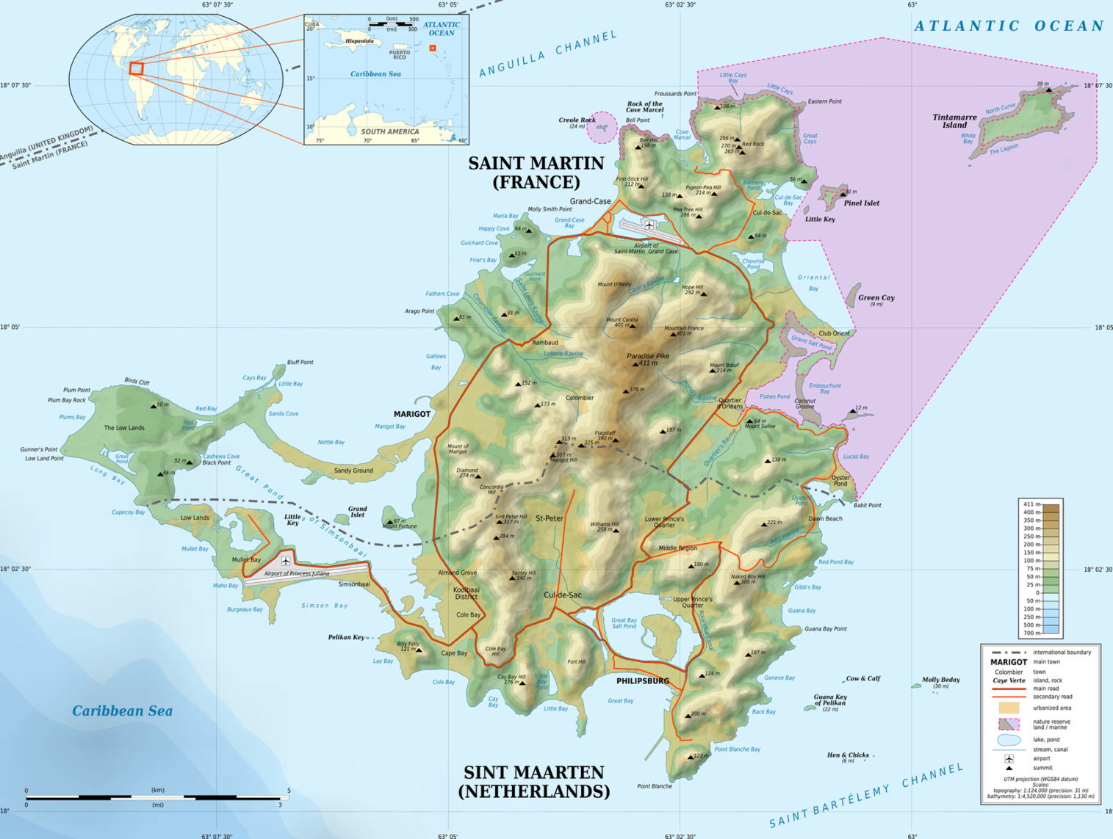
From Wikipedia

Leeward Islands: Saint-Barthélemy

About
Because this group of small islands has no fresh water sources, it is thought that it was only visited by the indigenous peoples of the Caribbean but not inhabited. Columbus visited the island and named it, but it was not colonized until the mid 1600s by the French. In the 1700s France traded it to Sweden who named its capital after their king and then sold it back to France a hundred years later. The island is still a French territory and in known as a luxury tourist destination and often referred to as St. Barths.

Capital: Gustavia
Official Language: French

Links to View
- St. Barths Wasn’t Always Like This (8:31 min)

Map Questions
- In which hemisphere are the islands?
- What can we guess about the climate?
- Which bodies of water border it?
- Which countries boarder it? Or which islands are closest to it?
- Between which Latitude lines is it found?
- Where are the capitals located?
- How many islands are part of St. Barts?
- What is the name of the small island to the south?
- What is the northernmost island called?
- What is the name of the highest point?

Map Drawing
Draw the shape of the islands and their relative positions to each other. Mark the capital and highest point.

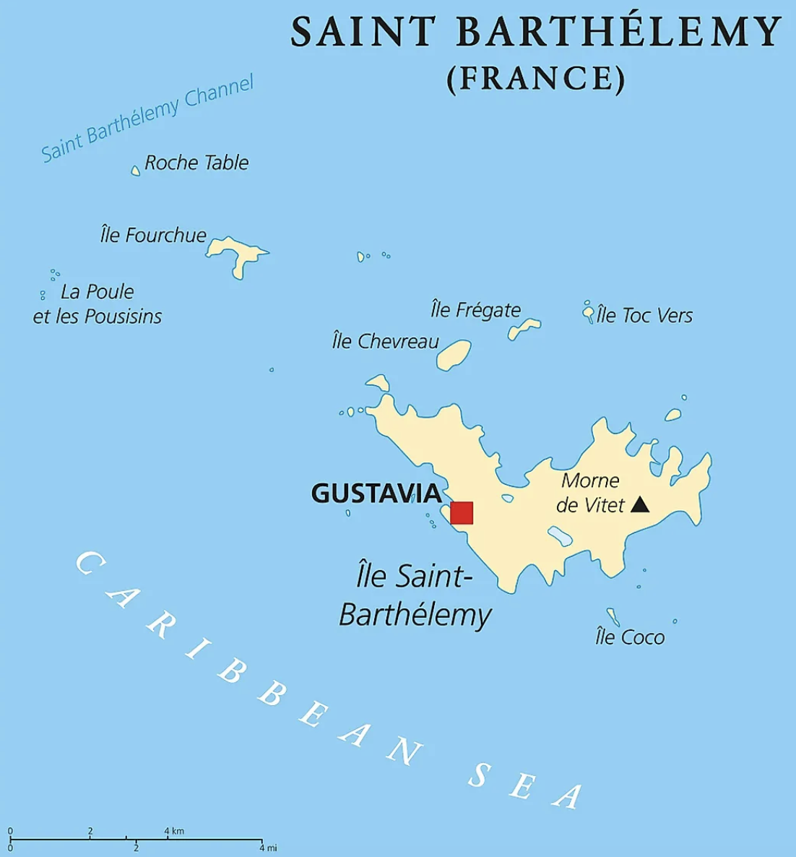
From worldatlas.com
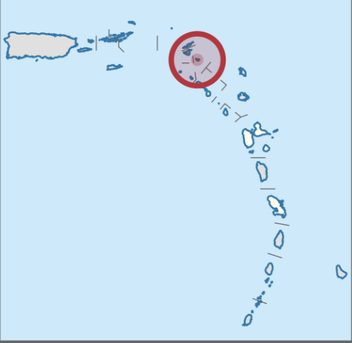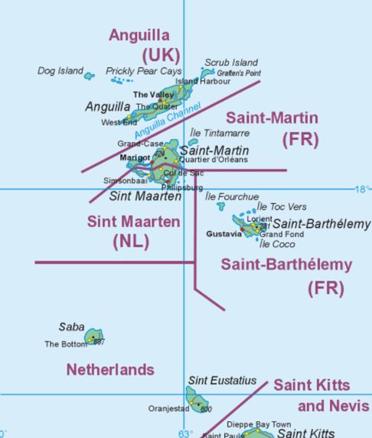
From Wikipedia

Leeward Islands: Saba & Sint Eustatius

About
Both islands were inhabited by Arawak and Carib peoples who left many archeological sites around the islands. Columbus was probably the first European to see Saba, but Francis Drake was the first to see Sint Eustatius. Saba was colonized by the English and Dutch and Sint Eustatius by the Dutch, French, and English and both islands were used for plantations. Saba also has a history of pirates. The Netherlands gained control of Saba in the 1800s, but Sint Eustatius changed hands 21 times before finally landing with the Netherlands. Both islands are still territories of the Netherlands and are included are part of the “SSS Islands” as the three Dutch territories in the Leeward Islands are known (Sint Maarten being the third).

Capital: Sabe - The Bottom ; Sint Eustatius - Oranjestad
Official Language: English, Dutch

Links to View
- The Untouched Paradise of the Caribbean: Saba (6:43 min)
- The First to Salute America: Sint Eustatius (7:51 min)

Map Questions
- In which hemisphere are the islands?
- What can we guess about the climate?
- Which bodies of water border them?
- Which countries boarder it? Or which islands are closest to it?
- Between which Latitude lines is it found?
- Where are the capitals located?
- Name a bay on the east of Saba and one on the west side of St. Eustatius.

Map Drawing
Draw the shape of the islands and their relative positions to each other. Mark the capital/main city of both.

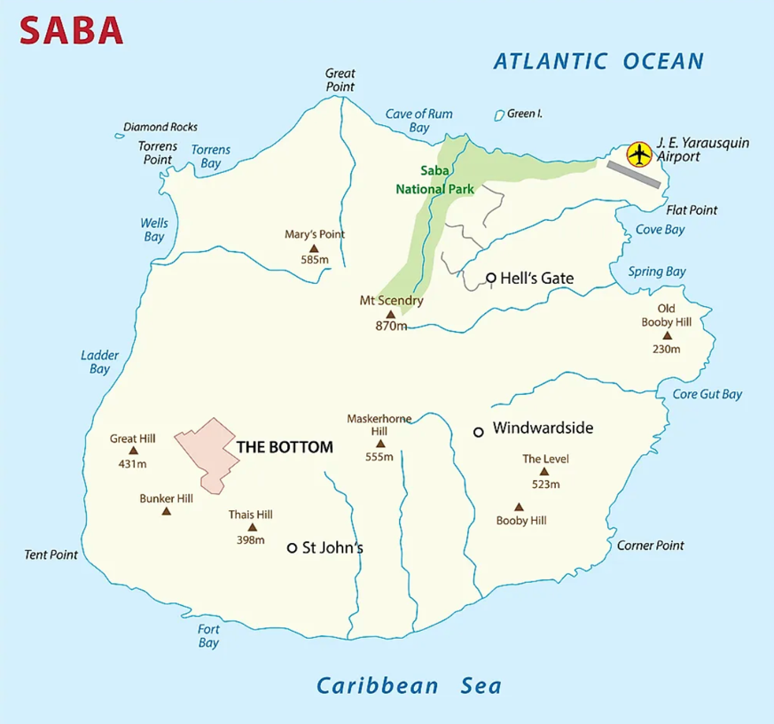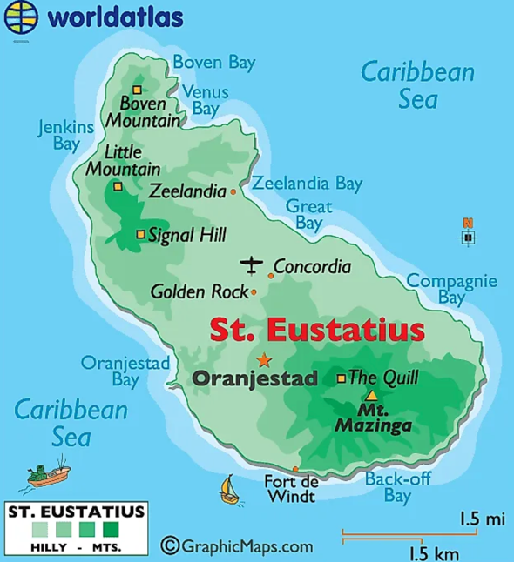
From worldatlas.com From worldatlas.com

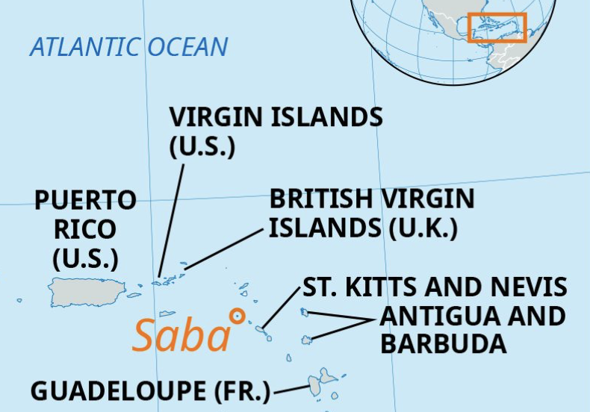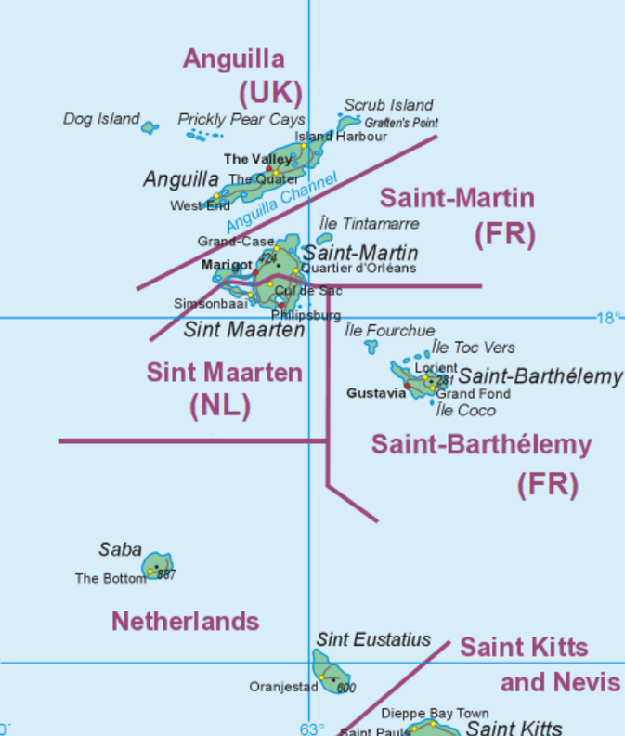
From Britannica From Wikipedia

Leeward Islands: Antigua and Barbuda

About
Comprised of two main islands of Antigua and Barbuda, the uninhabited island of Redonda, and multiple small islands that were originally inhabited by the Ciboney, Arawak, and then the Carib peoples. Though it was sighted by Columbus, it was not colonized until the 1600s after most of the natives had died of imported diseases. The British brought slaves to work the land. It was a British colony until 1981 when it became fully independent, though it chose to remain in the British Commonwealth.

Capital: St. John’s
Official Language: English and Spanish

Links to View
- Antigua and Barbuda explained in 12 minutes (12:36 min)
- Joel learns how to make Fungee in Antigua (7:18 min)
- Rewilding Redonda Island (1:29 min)

Map Questions
- In which hemisphere is Antigua and Barbuda?
- What can we guess about the climate?
- Which bodies of water border it?
- Which other islands boarder it?
- Between which Latitude lines is it found?
- Which island is northernmost? Which southernmost?
- What is the large bay on Barbuda?
- Are there other islands included in Antigua and Barbuda?
- Name the bays on the south side of Antigua. On the east and north side.
- Where is the capital located?
- Where is the largest city on Barbuda located?

Map Drawing
Draw both islands and their relative positions to each other, including bays and larger islands (especially Redonda). Mark the capital city.

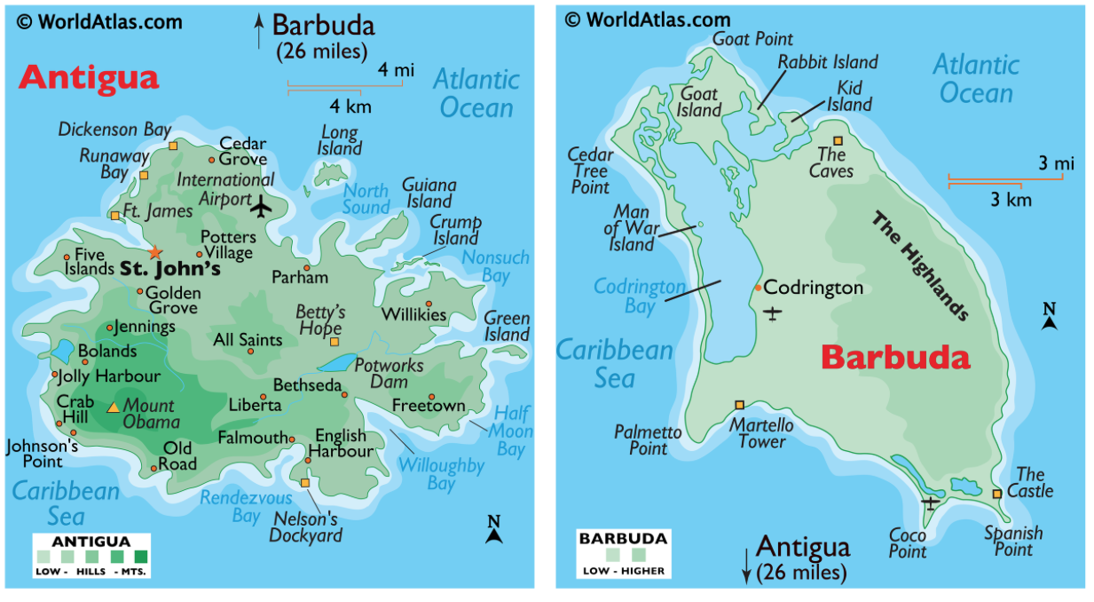
From worldatlas.com
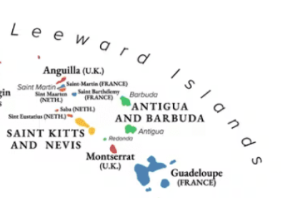
From Caribbeancompass.com

Leeward Islands: Montserrat

About
There is evidence of inhabitants going back several thousand years, including petroglyphs found in a cave. Though named by Christopher Columbus after the Spanish monastery, it was colonized by Irish settlers in the 1600s. Though France tried multiple times to claim it, Britain retained control. It was used for plantations and after the abolition of slavery, key limes became a major export. In 1995 a volcano erupted and buried the capital and much of the southern half of the island which is still an exclusion zone today.

Capital: Brades (new capital since volcano buried Plymouth)
Official Language: English

Links to View
- The Day Montserrat Vanished: The Volcano That Buried a Caribbean Capital (3:33 min)
- Montserrat – wildlife and heritage (10:32 min)

Map Questions
- In which hemisphere is Montserrat?
- What can we guess about the climate?
- Which bodies of water border it?
- Which other islands are close and in which direction?
- Between which Latitude lines is it found?
- Where is the capital located?
- What is the name of the volcano in the south?
- What is the name of the highest peak in the north?

Map Drawing
Draw the shape of the island and where Katy Hill and Soufriere Hills are located. Mark the capital. Draw where the exclusion line is.

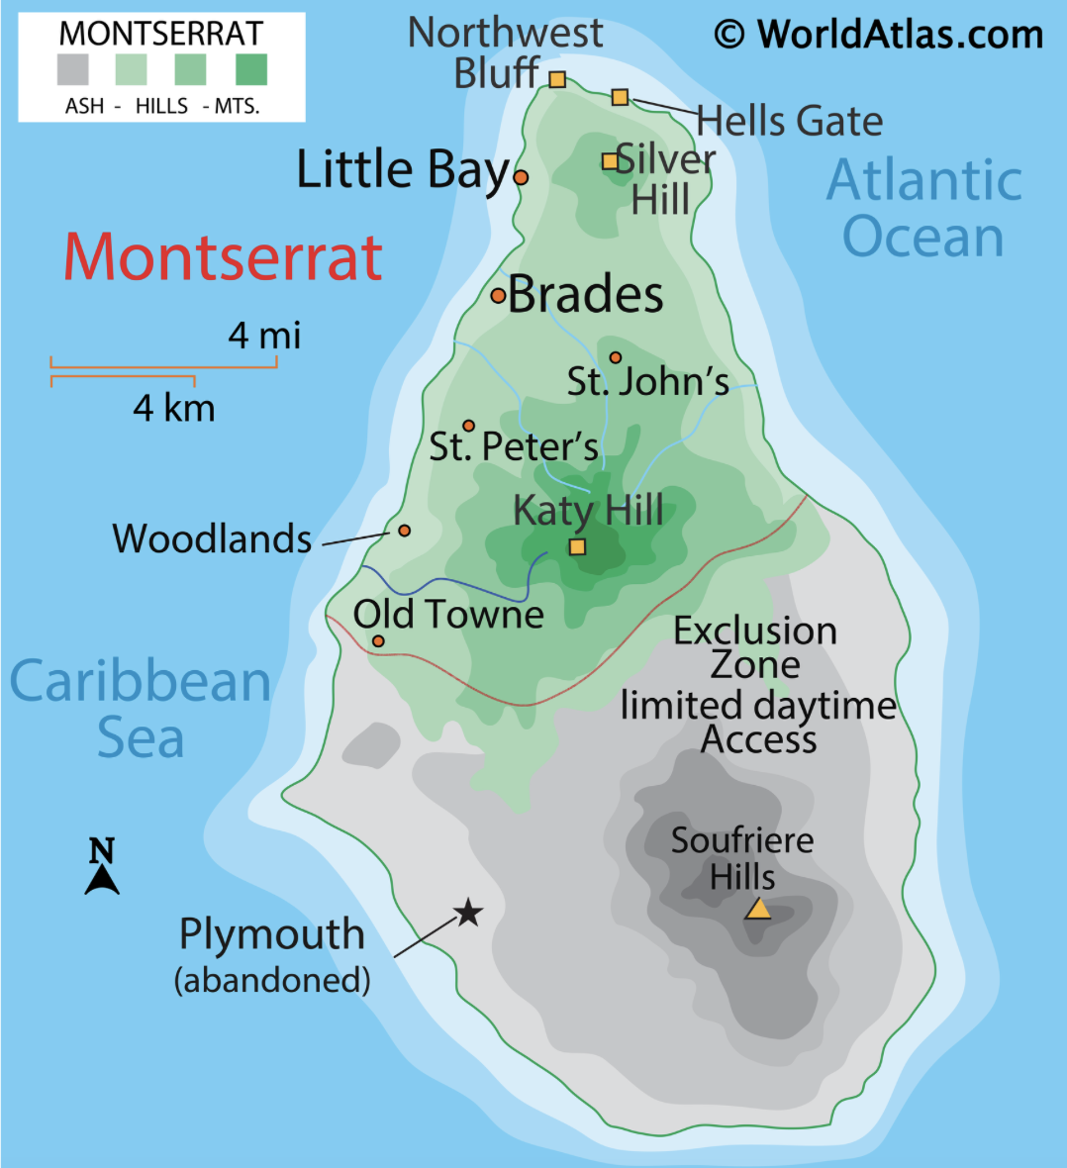

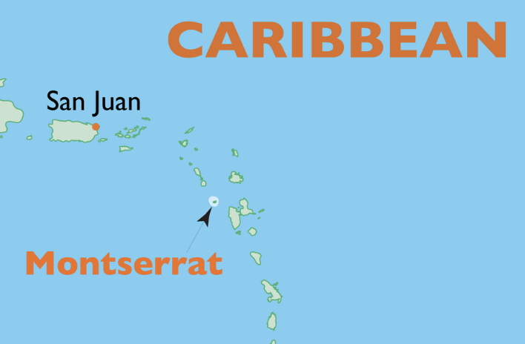

Both from Worldatlas.com

Leeward Islands: Guadeloupe

About
Originally populated by the Arawak then Carib peoples, there is archeological evidence dating back thousands of years. Guadeloupe consists of two main islands and about 30 smaller islands. Given its current name by Columbus and sparsely colonized by the Spanish, Guadeloupe was taken by the French in the 1600s. Plantations and enslaved people were brought to the island and though the British had brief periods of rule, it is still a French territory today. It is nicknamed the butterfly islands for its shape.

Capital: Basse-Terre
Official Language: French and local Creole

Links to View
- Guadeloupe: Treasures of the butterfly archipelago (6:08 min)
- Guadeloupe’s Unique Caribbean Story: Creole Culture, Cuisine & Islands (2:23 min)
- Traditional Foods of Guadeloupe (2:09 min)
- Sugar and Spice: The flavours of the French Caribbean (6:01 min)
- Guadeloupe: A Wildlife Journey Through Paradise (16:32 min)

Map Questions
- In which hemisphere is Guadeloupe?
- What can we guess about the climate?
- Which bodies of water border it? What are the channels around it?
- What are the two main islands called? Can you see the butterfly shape?
- Name the major islands and island groups and where they are located.
- Which other islands are close? And in which direction?
- What is the body of water separating the two main islands called?
- Between which Latitude lines is it found?
- How many gulfs are there and where are they?
- Where is the capital located?

Map Drawing
Draw the main islands and their relative positions to each other, including bays and larger islands and island groups. Identify the Rivière Salée. Mark the capital city.

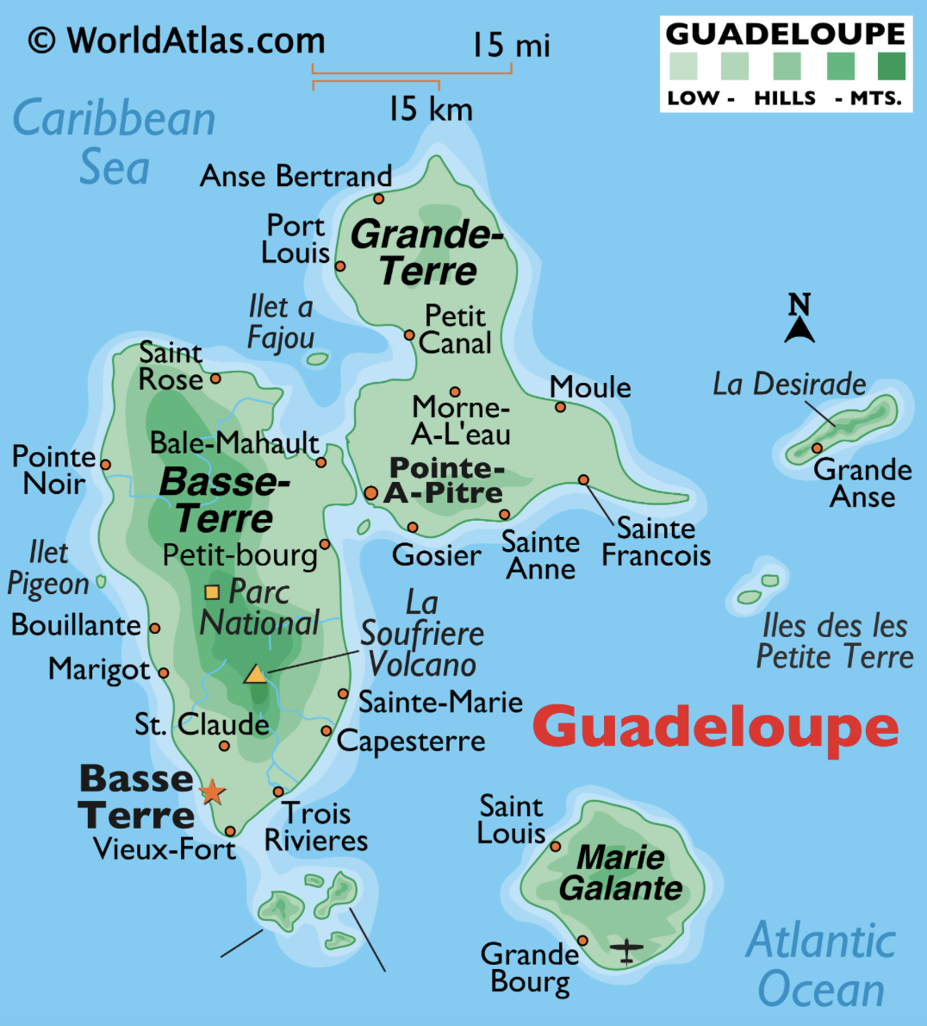
Note: the strait separating the two main islands is called the Rivière Salée

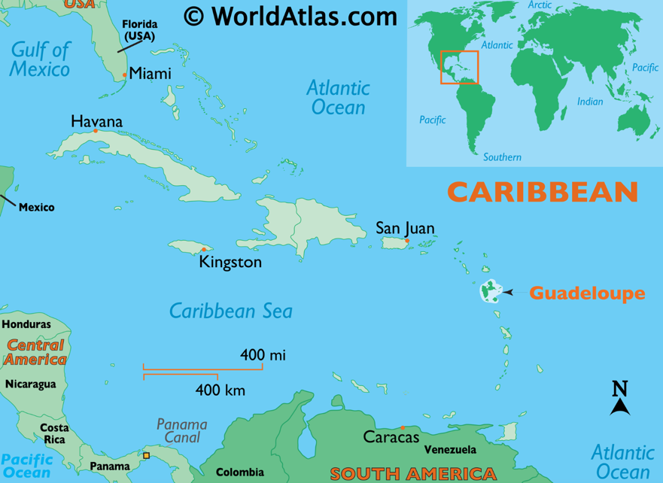 Both from worldatlas.com

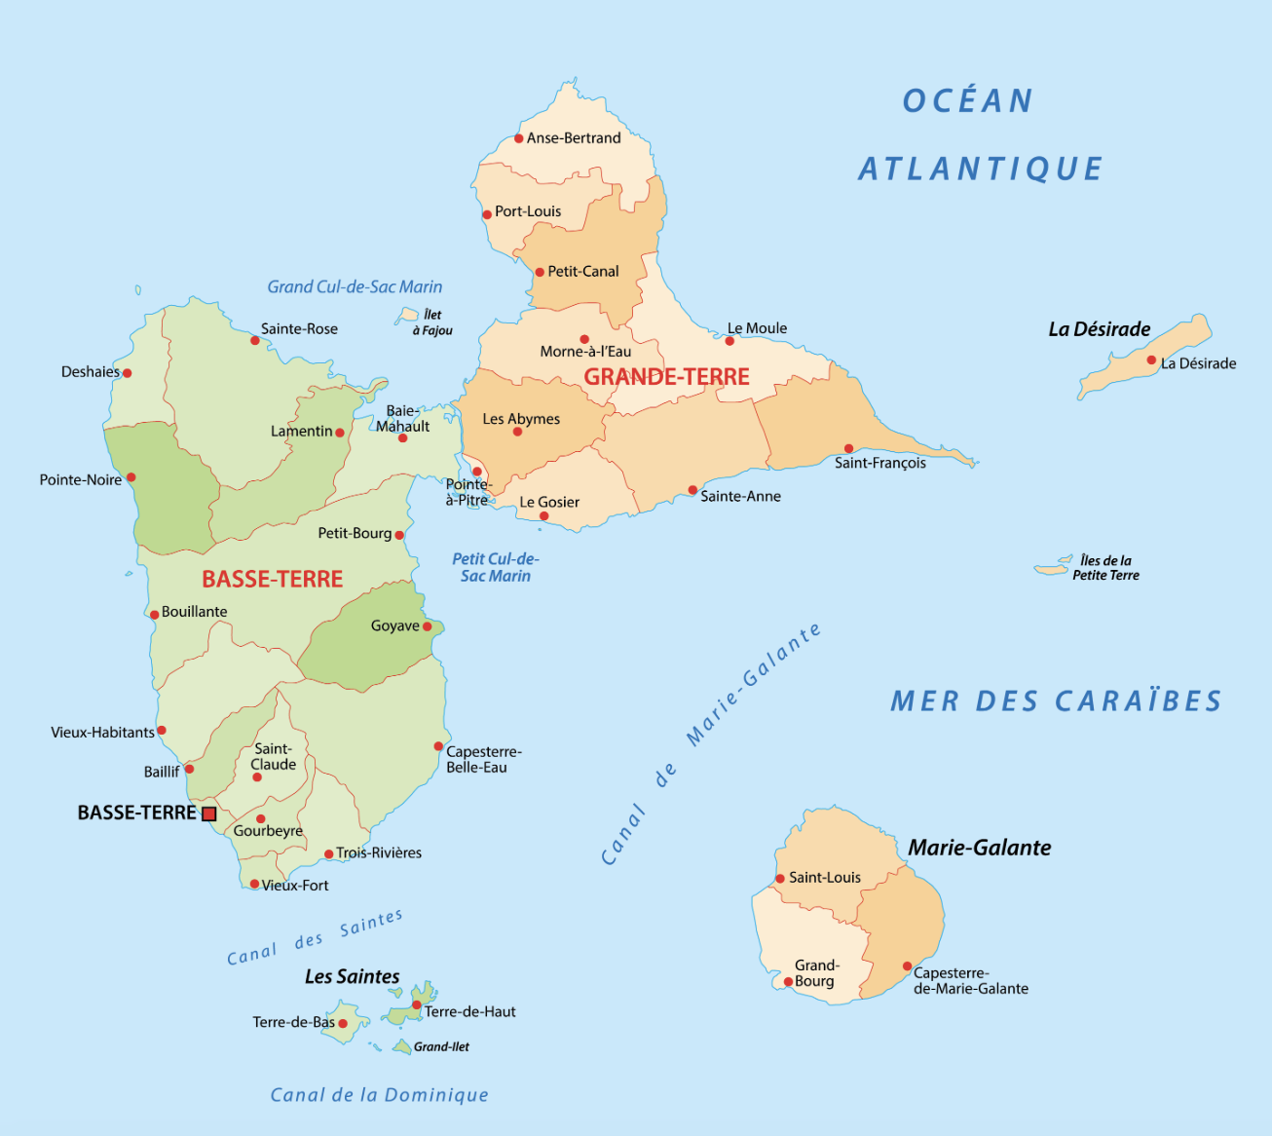

From worldatlas.com

Note: cul-de-sac is translated bay and canal could be sound or channel

Leeward Islands: St. Kitts and Nevis
Official name: Federation of Saint Christopher and Nevis

About
Consisting of two small islands that were originally inhabited by the Saladoid, Igneri and Caribs, it is thought to be the first islands of the Caribbean colonized by Europeans. Though seen by Columbus, it was the British who took over the island from the indigenous peoples and used the islands for plantations. The British, French, and Spanish fought over possession, but the British succeeded and it is still a Commonwealth realm today. Interesting fact: Alexander Hamilton was born on Nevis.

Capital: Basseterre
Official Language: English and local creole

Links to View
- A Super Quick History of Saint Kitts & Nevis (2:07 min)
- St. Kitts Culture and Heritage (3:02 min)
- Stew Salt Fish and Coconut Dumplings – National Dish St Kitts and Nevis (3:17 min)

Map Questions
- In which hemisphere is St. Kitts and Nevis?
- What can we guess about the climate?
- Which bodies of water border it?
- Which other islands are nearby?
- Between which Latitude lines is it found?
- What is the water separating the islands called?
- Describe the relative positions of the islands.
- What is the body of water in the south of St. Kitts called?
- Name the highest points on both islands.
- What is the capital and where is it located?

Map Drawing
Draw the islands and their relative positions to each other. Label The Narrows. Indicate and label the high point on both islands. Mark the capital city.

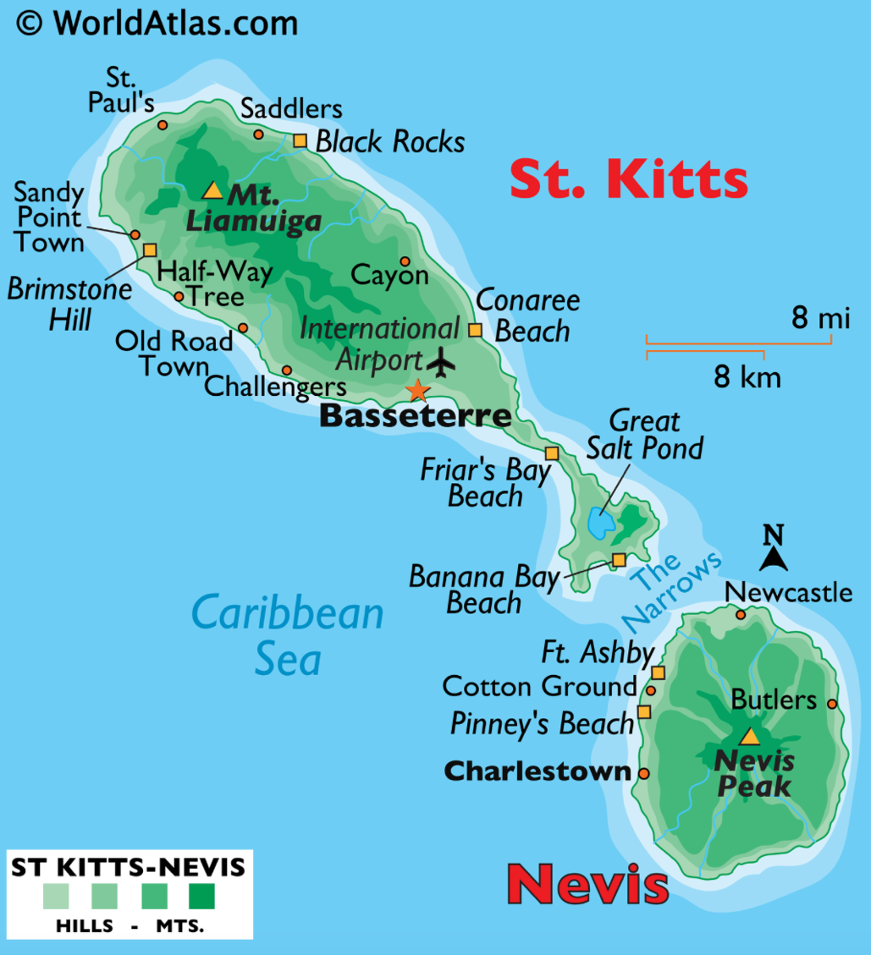

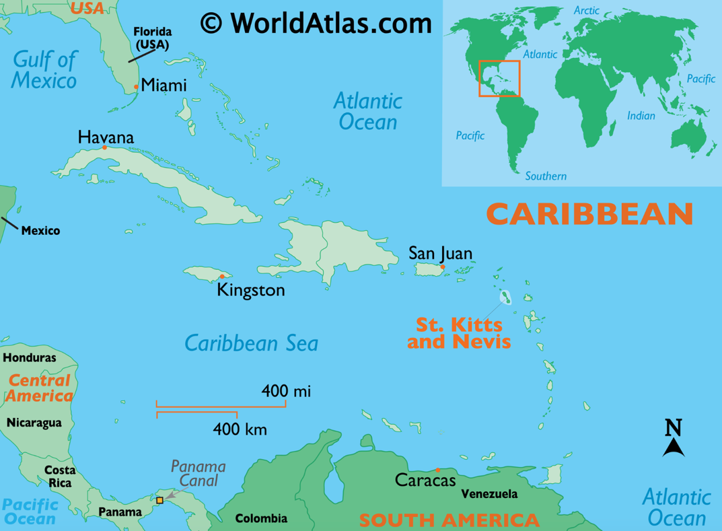 Both from worldatlas.com

Windward Islands: Dominica

About
The single island was originally settled by Arawak (of the Tiano) and Kalinago (of the Carib) peoples. Though Columbus saw and named it, it was he French who colonized it in the late 1600’s and used the island for coffee plantations. Britain gained control after the Seven Year’s War and kept it until the island became independent in 1978.

Capital: Roseau
Official Language: English, Dominican Creole, French, Kokoy

Links to View
- The National Bird of Dominica: The Sisserou Parrot (2:06 min)
- The National Dish of Dominica: Callaloo (1:55 min)
- Kalinago Cassava Documentary (5:01 min)

Map Questions
- In which hemisphere is Dominica?
- What can we guess about the climate?
- Which bodies of water border it?
- Which other islands are near it?
- What is the name of the bay on the north side? On the south side?
- Locate and name three mountains?
- Where is the capital located?

Map Drawing
Draw the shape of the island. Indicate and label the major mountains. Mark the capital city.

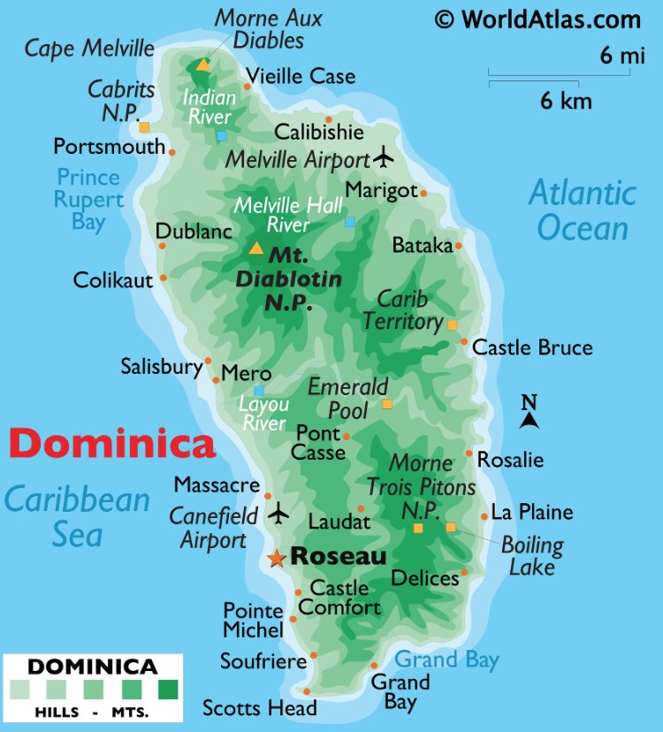

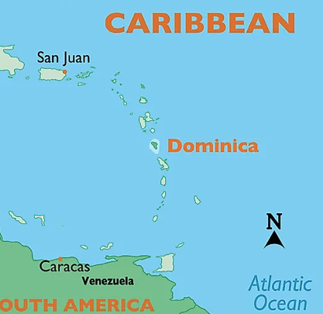

Windward Islands: Martinique

About
Consisting of one big island and several smaller ones, Martinique was originally inhabited by the Saladoid then Kalinago people. Columbus made a short stay on the island and claimed it for Spain. French took over in the 1600s, though the British and Dutch fought tried to take control. Pirates, including the famous Blackbeard, used the island. The first coffee plantation in the western hemisphere was on the island. The island remains an overseas territory of France.

Capital: Fort-De-France
Official Language: French, Martinican French Creole

Links to View
- The Influential History of Martinique (5:39 min)
- Top 10 Martinique Foods (6:13 min)

Map Questions
- In which hemisphere is Martinique?
- What can we guess about the climate?
- Which bodies of water border it?
- Which other islands are near?
- Between which Latitude lines is it found?
- Name the bay on the west coast. Name the one on the east coast.
- What are the three large peninsulas?
- Where is the capital located?
- What is the name of the mountain in the north?

Map Drawing
Draw the shape of the island. Indicate and label the major bays and harbors. Mark the capital city.

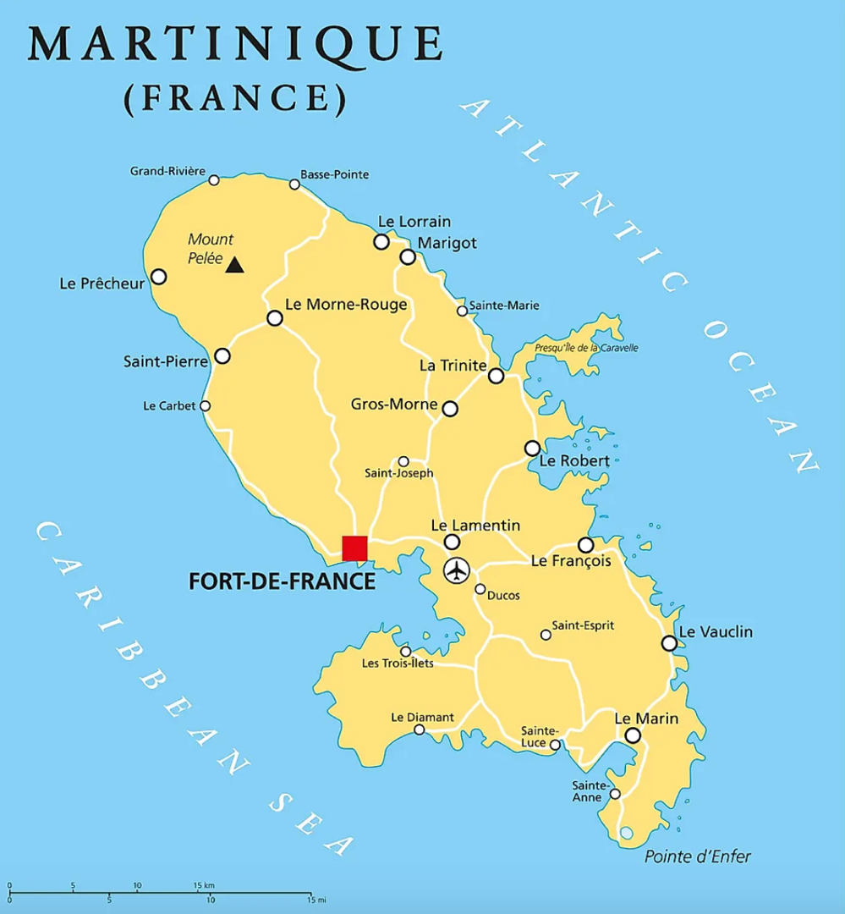 From Worldatlas.com
Robert’s Harbor
Galion Bay
Bay of Fort-de-France
Trois-îlets Peninsula
Sainte-Anne Peninsula
Caravelle Peninsula

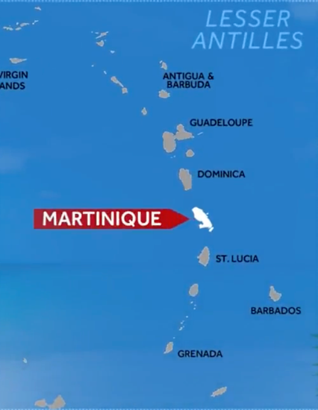 screenshot from video

Windward Islands: Saint Lucia

About
The country is one main island with several smaller ones. It was originally inhabited by the Arawak and then Kalinago peoples. When Europeans came to the Caribbean, the island was fought over by English and French and used by pirates. Because the control over it changed so many times, it is sometimes called the “Helen of the West” after Helen of Troy. While they were fighting, both the British and the French used the island for sugar plantations. It wasn’t until 1814 that the British finally gained control. In 1979 the island became independent while remaining in the British Commonwealth.

Capital: Castries
Official Language: English, Saint Lucian French Creole

Links to View
- Saint Lucia History in 3 minutes (2:34 min)
- Exploring the Pitons Management Area in Saint Lucia (9:53 min, through min 1:40)
- 8 Foods Born in St. Lucia (8:50 min)
- Saint Lucia’s Thrasher Bird Gains Recognition as Endemic Species (2:56 min)

Map Questions
- In which hemisphere is Saint Lucia?
- What can we guess about the climate?
- Which bodies of water border it?
- Which other islands are near it?
- Between which Latitude lines is it found?
- What is the name of the small islands in the south?
- Where is the volcano located and what is it called?
- Where are the Pitons located?
- Where is the capital located?
- Name one river emptying into the Atlantic.
- Name one river emptying into the Caribbean Sea.

Map Drawing
Draw the shape of the island. Indicate and label Mt. Gimie and the Soufriere Volcano. Mark the capital city.

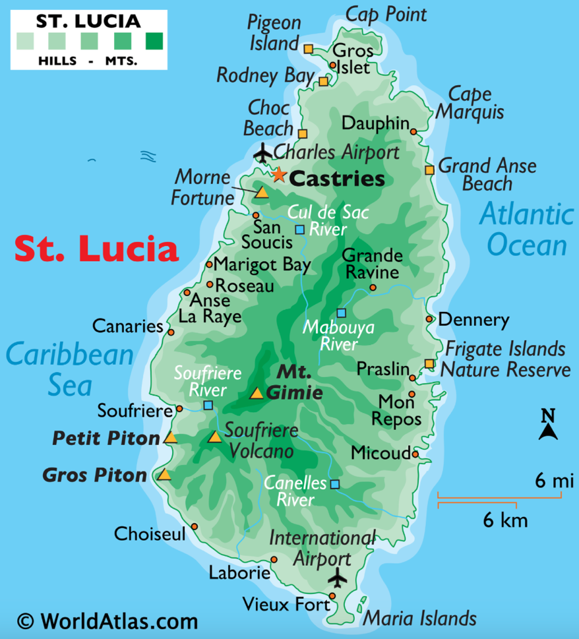

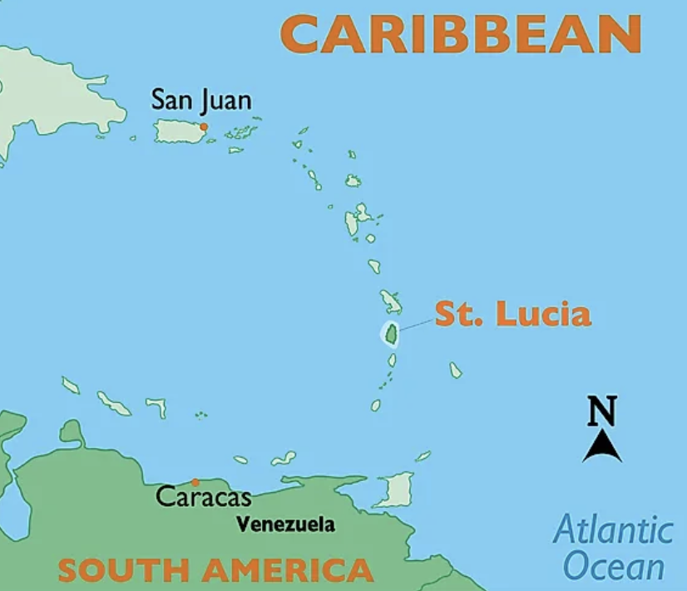
Both maps from worldatlas.com

Windward Islands: Barbados

About
A single island located a hundred miles east of the other Caribbean islands, it was inhabited by the same peoples as the other islands – The Saladoid, Arawaks, and then Kalinago. The Portuguese may have been the first Europeans on the island, but it was the British who colonized and brough sugar plantations to the island. In 1966 became independent but stayed in the British Commonwealth.

Capital: Bridgetown
Official Language: English, Bajan Creole

Links to View
- Geography Now! Barbados (8:33 min)
- A Super Quick History of Barbados (1:57 min)
- 8 Foods Born in Barbados (9:28 min)

Map Questions
- In which hemisphere is Barbados?
- What can we guess about the climate?
- Which bodies of water border it?
- Which other islands are near?
- Between which Latitude lines is it found?
- Describe the location of Barbados to the other Caribbean islands.
- What are the two bays on the western coast?
- Where is the capital located?
- What is the name of the largest mountain?
- What is located just off the southern coast?

Map Drawing
Draw the shape of the island. Indicate and label Mt. Hillaby, Cobbler’s Reef, and the two bays. Mark the capital city.

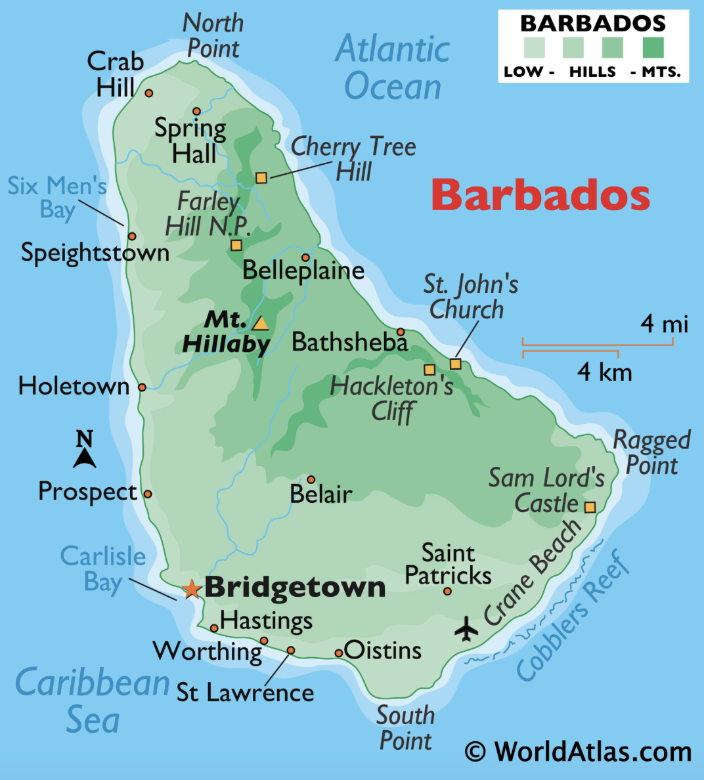

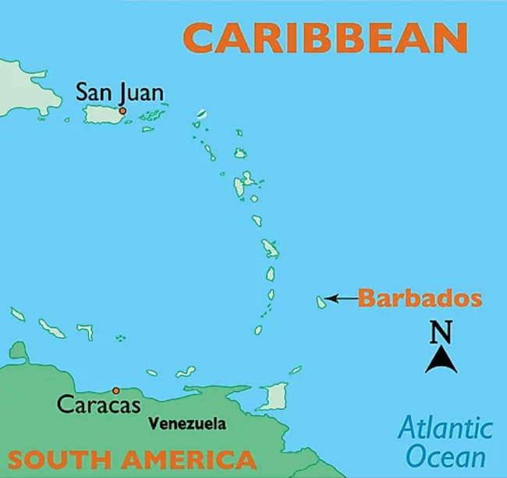
Both maps from worldatlas.com

Windward Islands: Saint Vincent and the Grenadines

About
The islands have been inhabited for thousands of years, including by the Arawak and Kalinago peoples. There are still petroglyphs on the islands. It is thought that Columbus sailed by and named the island. Though when the British and Dutch tried to colonize, the Kalinago people fought them off. It wasn’t until the 1700s that the French managed to settle in and bring enslaved peoples to work their plantations. The British took control after the seven years’ war but the native peoples fought them for many years. The island became independent in 1979 (coincidentally the year the volcano also erupted.). The country consists of one main island and 32 smaller islands and cays though only 9 are inhabited.

Capital: Kingstown
Official Language: English, Vincentian Creole

Links to View
- A Super Quick History of Saint Vincent and the Grenadines (2:15 min)
- The Uniqueness of the Petroglyphs of St. Vincent (1:07 min)
- St. Vincent and the Grenadines, and Dominica – Caribbean Moments (23:59 min, at least to min 6:23, 10:10-12:00)

Map Questions
- In which hemisphere is St. Vincent & the Grenadines?
- What can we guess about the climate?
- Which bodies of water border it?
- Which other islands are near it?
- Between which Latitude lines is it found?
- How many islands are there?
- What is the name of the largest island? The name of the large Grenadines?
- Where is the capital located?
- What is the name of the volcano in the north of St. Vincent Island?
- What is the most southern island? The most northern island?

Map Drawing
Draw the shape of the main island. Mark the capital city and tallest point. Draw Bequia, Mustique, Canouan, and Union Island as well as the general shape of the remaining archipelago.

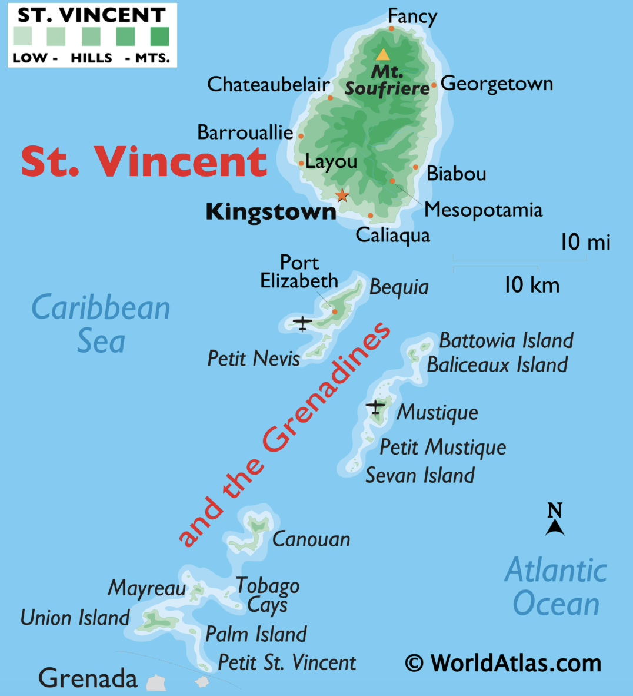

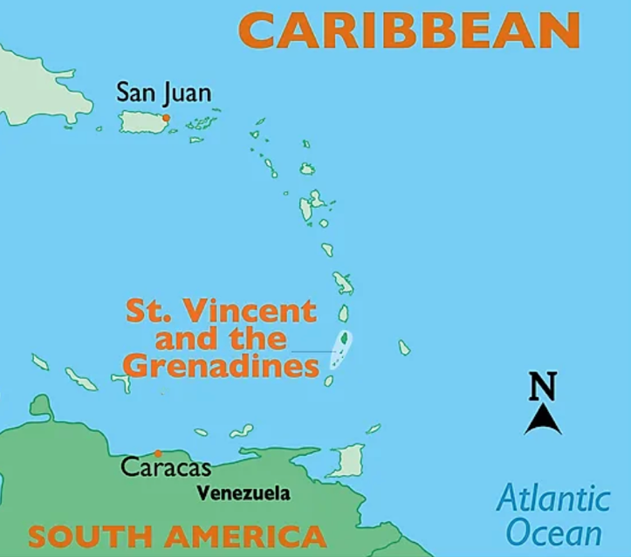
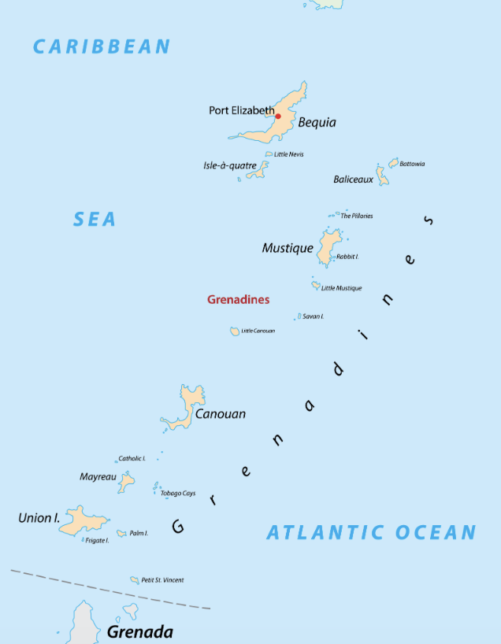

All maps from worldatlas.com

Windward Islands: Grenada

About
Grenada consists of the island of Grenada, the smaller islands of Carriacou and Petite Martinique and several even smaller islands. It was first inhabited thousand of years ago by unknown peoples and then the Kalinago. Though sited by Columbus, it wasn’t colonized until the French in the mid 1600s and used as sugar and indigo plantations. The British and the French traded control several times in the 1700s with British succeeding in 1783. Grenada became independent in 1974

Capital: St. Geroge
Official Language: English

Links to View
- A Super Quick History of Grenada (2:27 min)
- The Grenada Nutmeg Industry (3:41 min)
- Traditional Foods of Grenada (2:28 min)

Map Questions
- In which hemisphere is Granada?
- What can we guess about the climate?
- Which bodies of water border it?
- Which countries boarder it?
- Between which Latitude lines is it found?
- How many islands are there?
- What are the two large peninsulas on the western coast?
- Where is the capital located?
- Which continent is it closest to?
- What is the name of the largest peak and where is it located?
- Using the scale, can you tell about how long Grenada island is?

Map Drawing
Draw the shape of the main island. Mark the capital city and tallest point. Draw Carriacou and Petit Martinique as well as the general shape of the remaining archipelago.

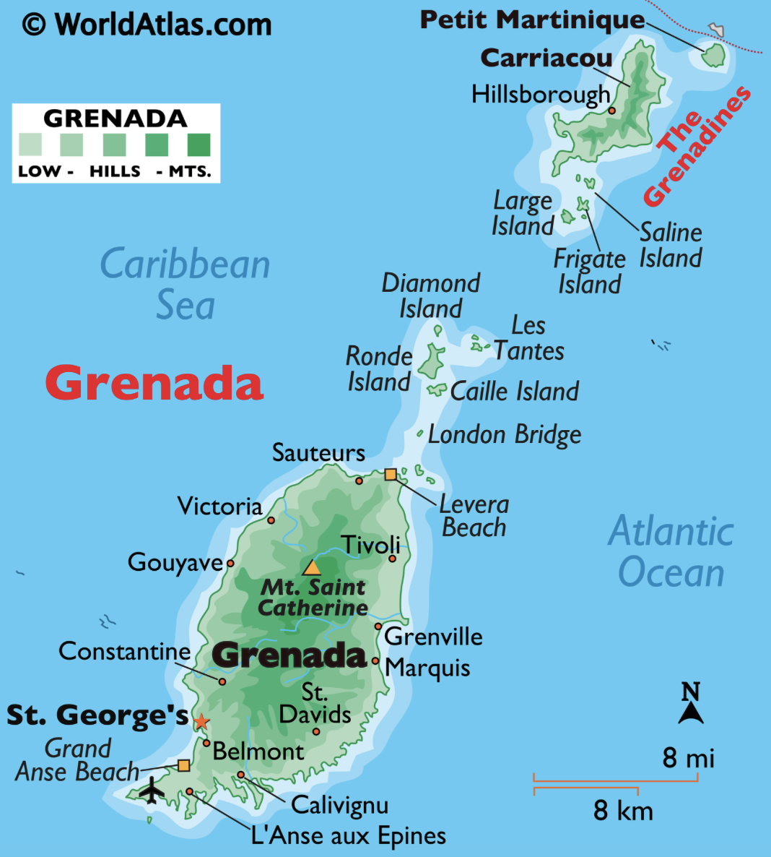

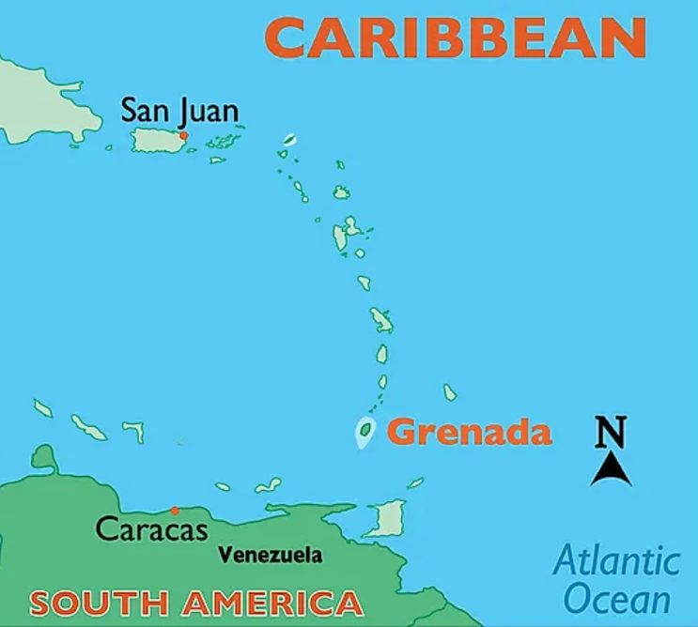 Both maps from worldatlas.com

Leeward Antilles: Trinidad and Tobago

About
Inhabited for thousands of years by Arawak and Carib peoples, Trinidad and Tobago have some of the oldest archeological sites in the Caribbean. Columbus saw both islands and Spain attempted to colonize them. While the Spanish, French, Dutch, and English all fought over the islands, they all used it for plantations. Britain finally gained control in the 1800s. When slavery was abolished, the British brought indentured laborers from India. In the 20th century oil was found and the islands still rely mostly on gas and oil for their economy. The islands became independent in 1962 but remained a part of the British Commonwealth.

Capital: Port of Spain
Official Language: English

Links to View
- A Super Quick History of Trinidad and Tobago (2:46 min)
- Dancing with 10-foot stilts (2:32 min)
- Banwari Trace Archaeological Site (2:25 min)
- Caurita Petroglyphs (3:23 min)
- Learning Music from Around the World: Trinidad and Tobago – Calypso (4:07 min)
- Why is Calypso Music So Tropical? (5:05 min)
- 8 Foods Born in Trinidad and Tobago (8:59 min)
- Exotic Castaways of Trinidad – BBC Earth (4:59 min)
- Caroni Swamp and Bird Sanctuary: Trinidad and Tobago (4:12 min)
- Nariva: Guardian of Trinidad’s Wildlife (25:03 min, to min 8:42)

Map Questions
- In which hemisphere is Trinidad and Tobago?
- What can we guess about the climate?
- Which bodies of water border it?
- Which countries and islands boarder it?
- Between which Latitude lines is it found?
- Which continent is it closest to?
- Where is the capital located?
- What is the name of the largest mountain and which range is it part of?
- What is the gulf on Trinidad’s west coast?
- Name the two straights separating Trinidad from Venezuela.

Map Drawing
Draw the shape of the islands and their relative positions to each other and Venezuela. Mark the capital city and highest point. Label the waterways around Tobago.

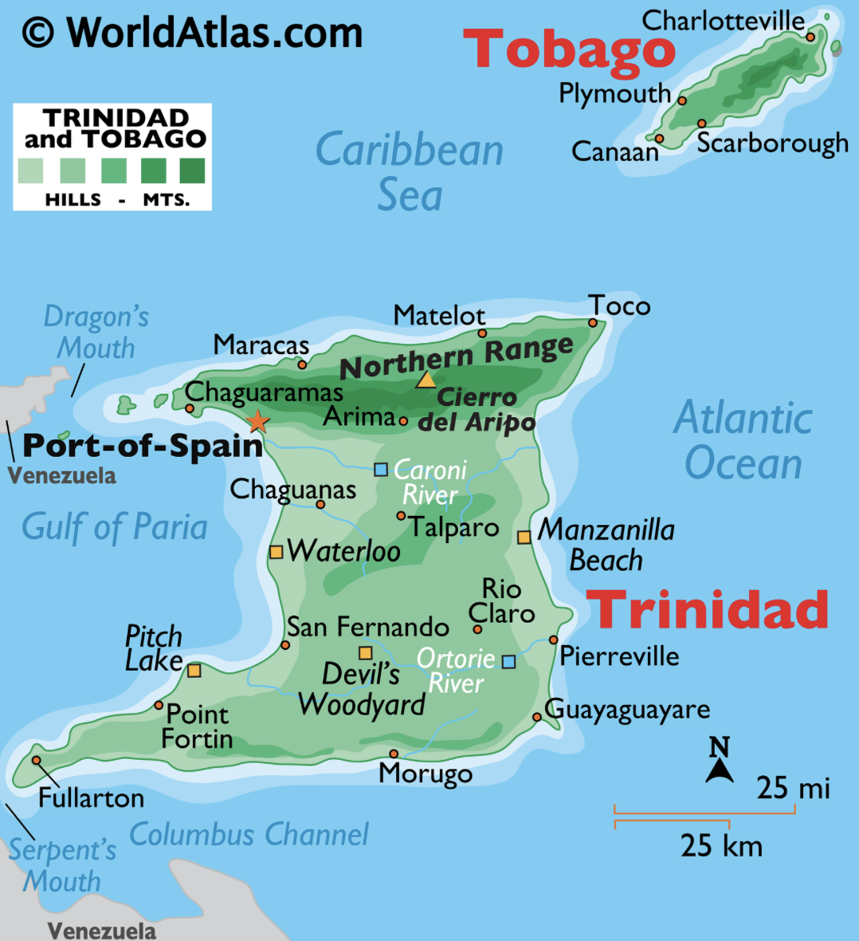

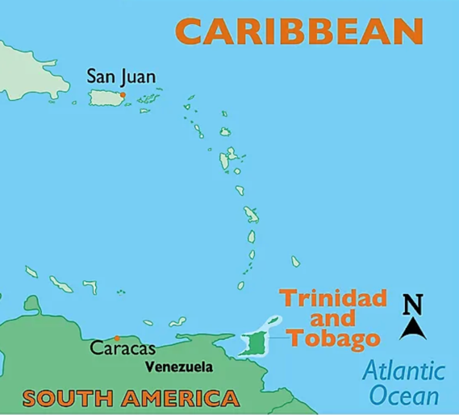
Both maps from worldatlas.com

Leeward Antilles: Bonaire

About
The island has been inhabited for thousands of years with many archeological sites for the later Caquetío peoples (a branch of Arawak) found around the island. Spain colonized it starting in 1499, though they took most of the inhabitants as slaves to work on other islands before using them on Bonaire for cattle plantations. Starting in the mid 1500s the Dutch fought Spain for 80 years before finally gaining control. They used it mainly as a salt plantation. Though they lost control several times, the Dutch ultimately regained control, and it is still a territory of the Netherlands today. It is part of what is referred to as the ABC islands along with Curaçao and Aruba.

Capital: Kralendijk
Official Language: Papiamentu (Portuguese based Creole), Dutch

Links to View
- The Dazzling Marine Life of the Salt Pier in Bonaire (2:19 min)
- Flamingos find sanctuary on the island of Bonaire (2:31 min)
- Animals of the ABC Islands – BBC Earth (3:43 min)

Map Questions
- In which hemisphere is Bonaire?
- What can we guess about the climate?
- Which bodies of water border it?
- Which other islands are near it?
- Between which Latitude lines is it found?
- Name the small island on the west side?
- What is the name of the bay on the east side?
- Where is the capital located?

Map Drawing
Draw the shape of the island. Indicate and label Klein Bonaire, Lac Bay and the capital.

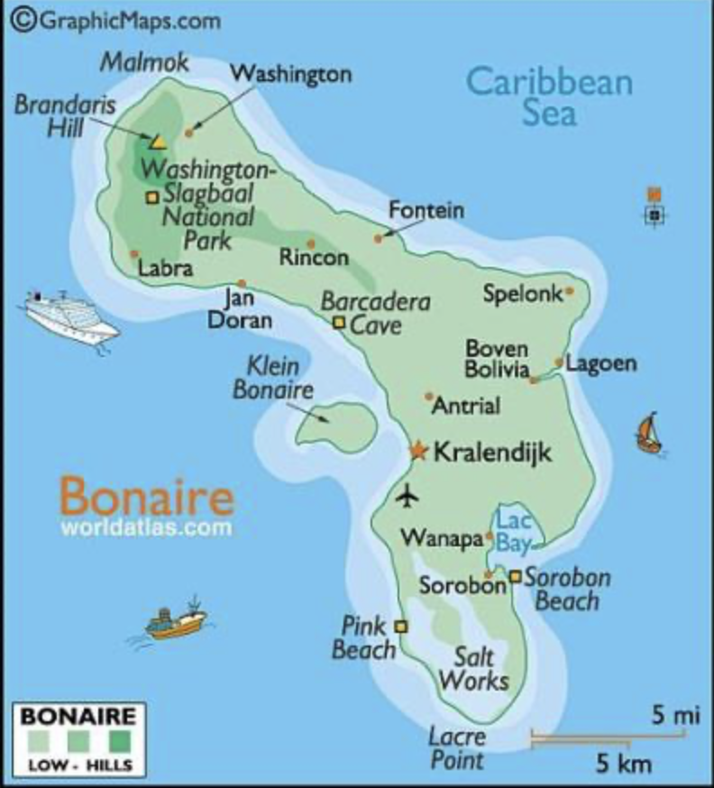
From scubadivingsmiles.com

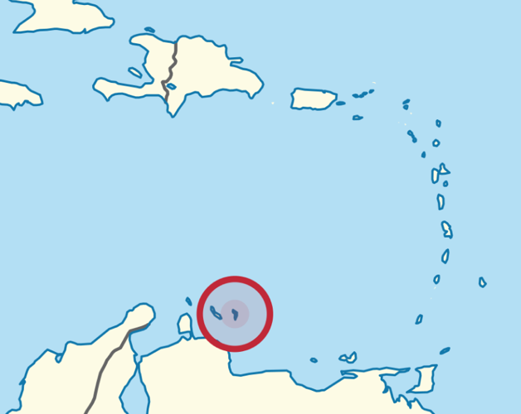
From Wikipedia

Leeward Antilles: Curaçao

About
Curaçao consists of one main island and a tiny uninhabited desert island to its south. The original inhabitants were Arawak and Caquetio peoples. The Spanish attempted to colonize it, but it is too dry for much agriculture so was used mainly for cattle. The Dutch took control in the mid 1600s and used it for a trading post, specifically for the slave trade. With a brief time under British control, the Netherlands regained control and the island is still a Dutch territory today. It is part of what is referred to as the ABC islands along with Bonaire and Aruba.

Capital: Willemstad
Official Language: Papiamentu, Dutch, English

Links to View
- The Euro-Caribbean Island of Curaçao (8:02 min, to min 4:42)
- Try the Cheesy Keshi Yena (1:38 min)
- Impressive Curacao – Blue Wonder of the Caribbean (43:47 min, to min 6:22)
- How to speak Papiamentu – Curacao (2:22 min)

Map Questions
- In which hemisphere is Curaçao?
- What can we guess about the climate?
- Which other islands or countries are near?
- Which bodies of water boarder it?
- Between which Latitude lines is it found?
- Name the bay on the western side.
- Name the bay on the eastern side.
- Where is the capital located?
- What is the highest peak?
- Can you estimate how long the island is from north to south?

Map Drawing
Draw the shape of the island. Indicate and label Bullen Bay, St. Joris Bay and the capital.

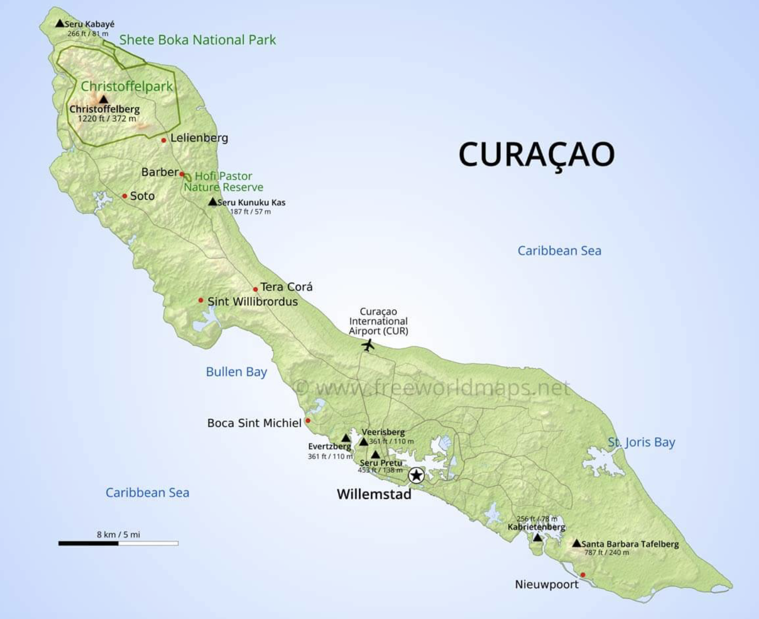
From freeworldmaps.net

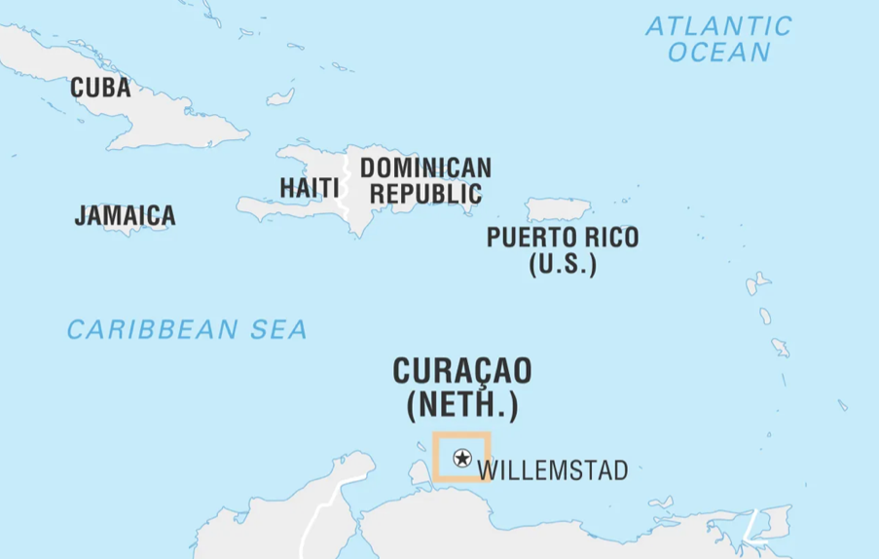
From Britannica.com

Leeward Antilles: Aruba

About
The island has been inhabited for thousands of years by multiple groups, the last of which were the Caquetio people. The Spanish captured the native people and took them as slaves to other islands, leaving Aruba to be used mainly for cattle with few inhabitants. When the Dutch captured Curaçao for the salt in the 1600s, they also took Aruba and Bonaire. Oil was found in the 20th century and became a major source of income. The island was briefly under British control, but the Netherlands regained control and it is still a Dutch territory today. It is part of what is referred to as the ABC islands along with Bonaire and Curaçao.

Capital: Oranjestad
Official Language: Papiamento, Dutch

Links to View
- Aruba – History (3:30 min) – note: this is from 2008
- Aruba Local Tips: Cultural Adventures in Aruba (4:07 min)
- Aruba Local Tips: Culinary & Foodie Adventures in Aruba (4:54 min)
- Aruba’s Flora & Fauna: Shoco (Burrowing Owl) (7:24 min)

Map Questions
- In which hemisphere is Aruba?
- What can we guess about the climate?
- Which bodies of water border it?
- Which countries and islands boarder it?
- Between which Latitude lines is it found?
- Which continent is it closest to?
- What are the two keys on the west coast called?
- Where is the capital located?
- What is the name of the largest mountain?
- Can you estimate how long it is?

Map Drawing
Draw the shape of the island. Indicate and label the keys, tallest point, and the capital.

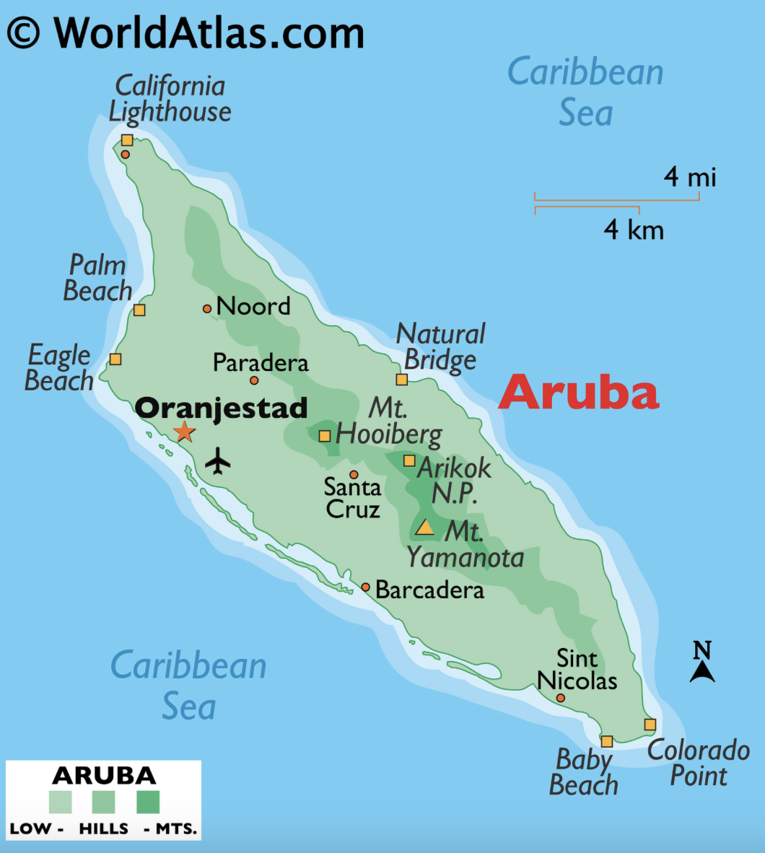

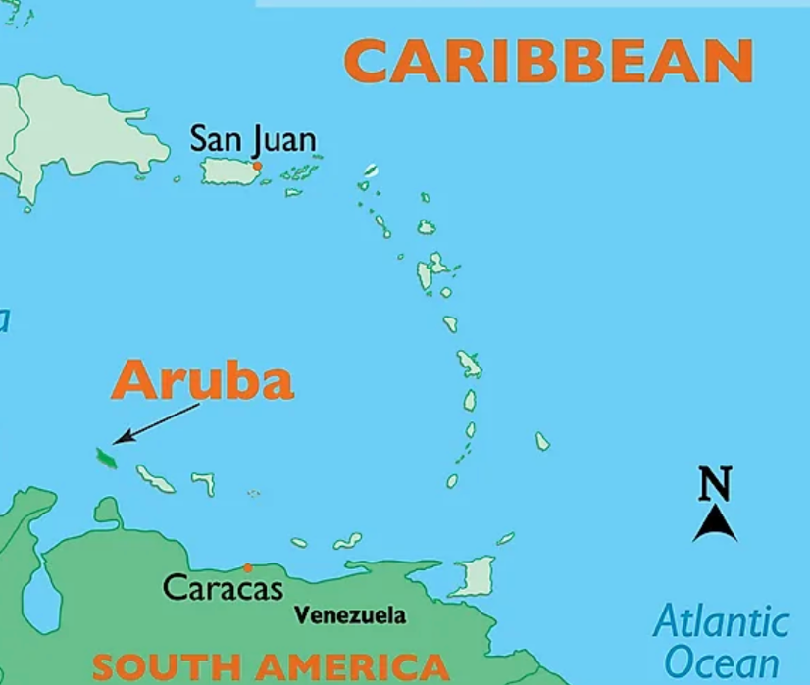 Both maps from worldatlas.com
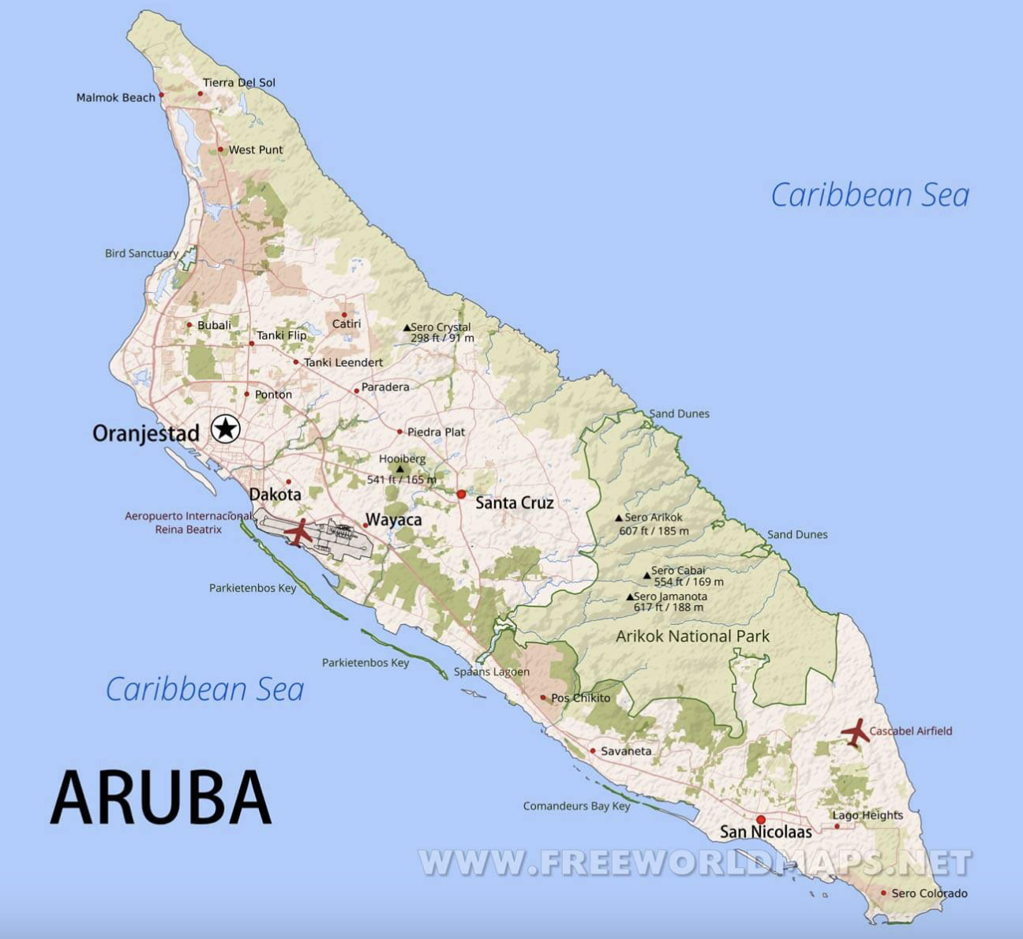
From freeworldmaps.net

Print these on sticker paper to put in Geography Journal so you can mark where the island is in the Caribbean.

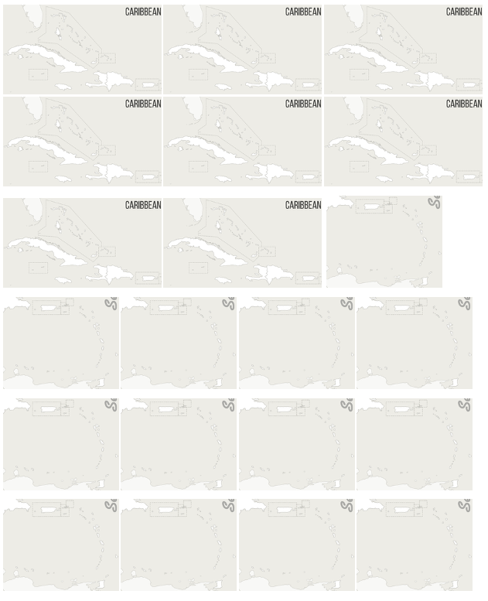
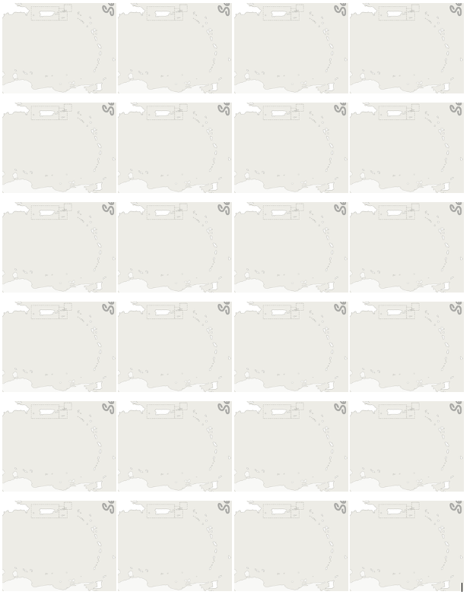

Bahamas Turks and Caicos
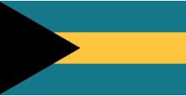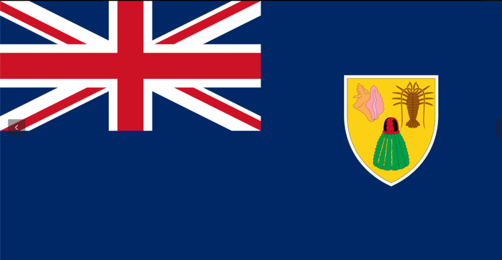

Cuba Haiti
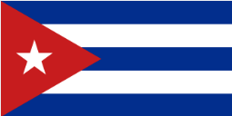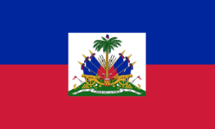

Dominican Republic Cayman Islands
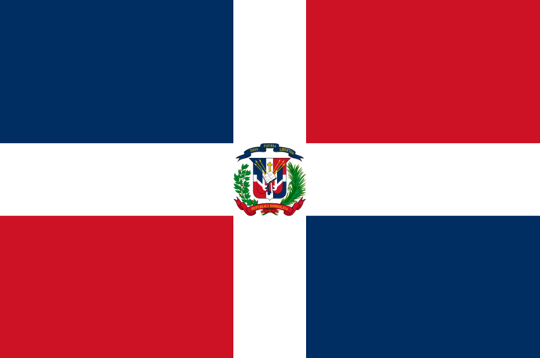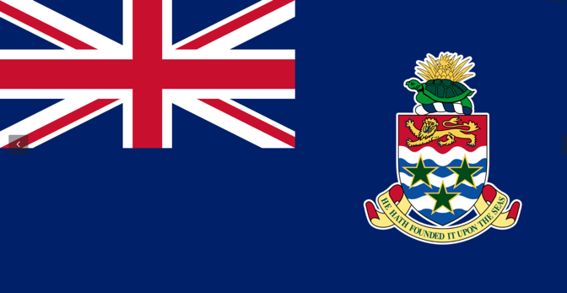

Jamaica Puerto Rico
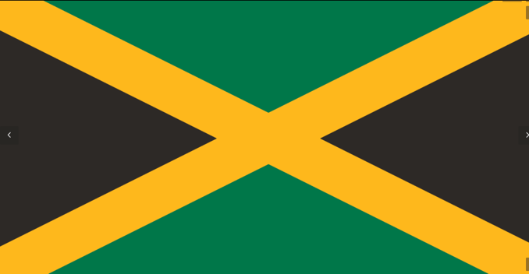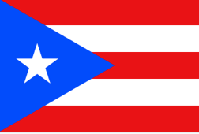

Virgin Islands (U.S.) Virgin Islands (British)
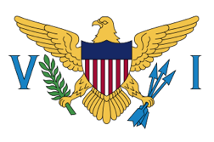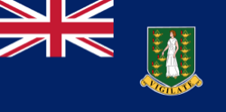

St. Martin (Unity Flag) Saint-Barthélemy (French Flag)
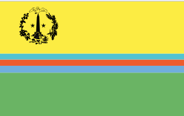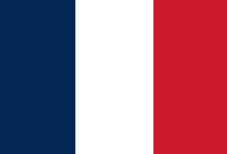

Saba Sint Eustatius
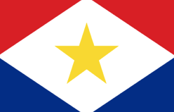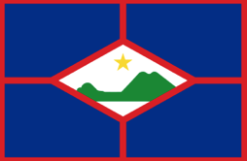

Antigua dn Barbuda Montserrat
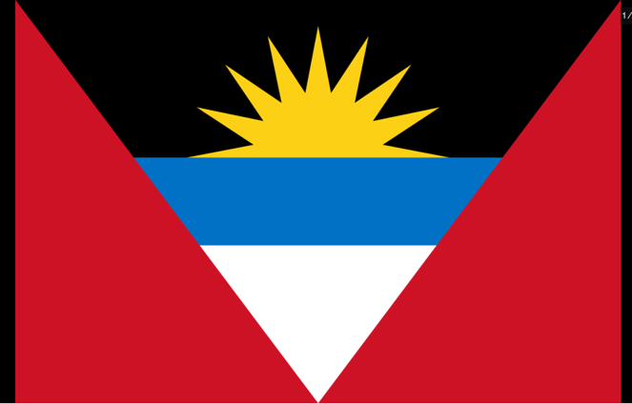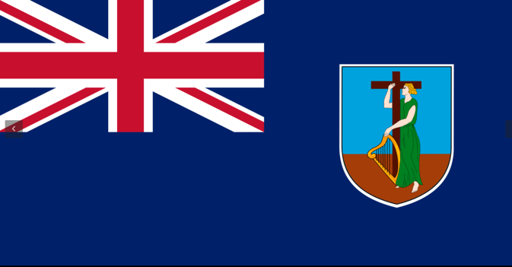

Guadeloupe (French Flag) St. Kitts and Nevis
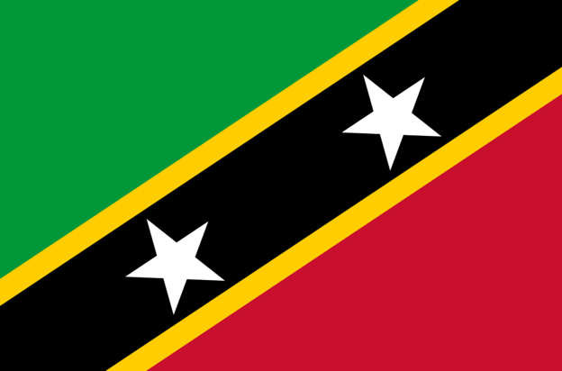

Dominica Martinique. (French Flag)
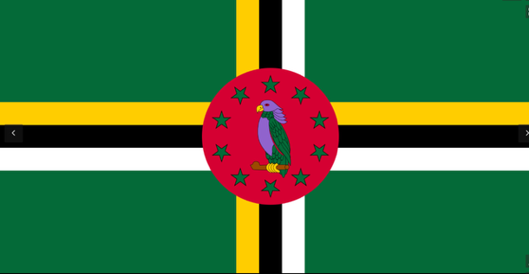

Saint Lucia Barbados
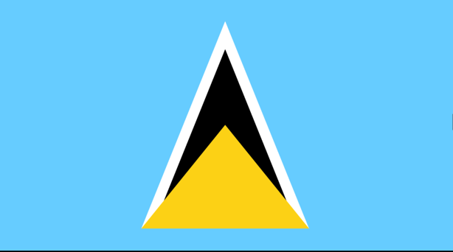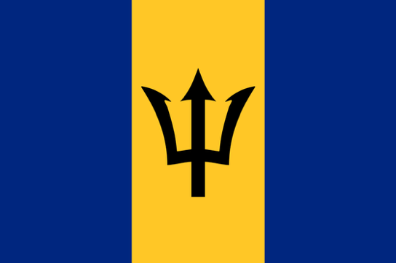

Saint Vincent and the Grenadines Grenada
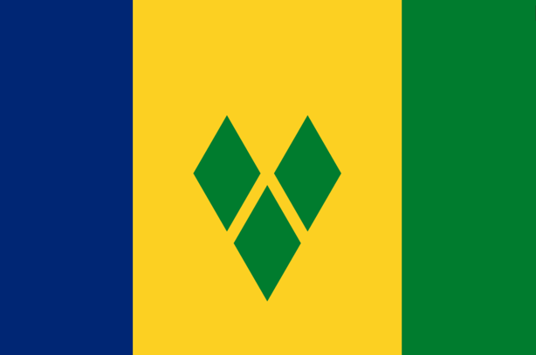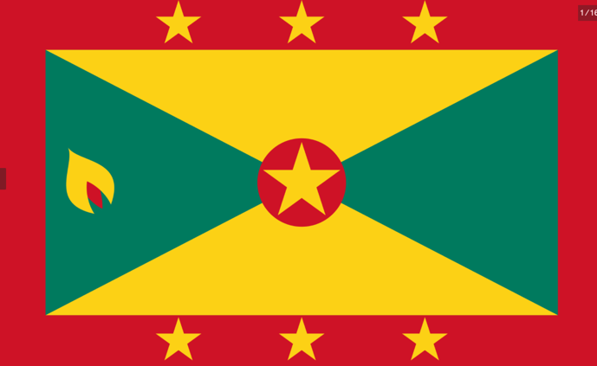

Trinidad and Tobago Bonaire
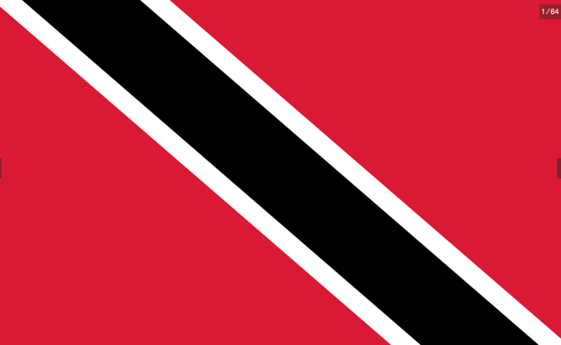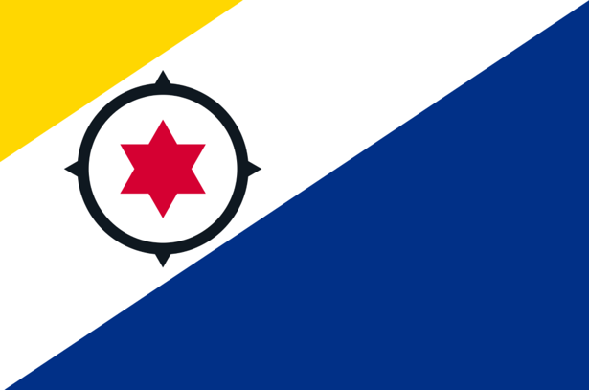

Curaçao Aruba
